Name: Stefano Di Guida
Business Plan for:
Hiraeth
A 15-bedroom boutique hotel combining sustainability, wellness and luxury

Lecturer: | Charlotte Joyner
Date: | 31st May 2024
Team members: | Stefano Di Guida
Business plan contents

Executive Summary…………………………………………………………………………………………………………….3
1 Executive summary 3
2 Business details 4
3 Key personnel 5
Vision 6
4 The business idea 6
5 Business goals 6
6 What the business does 7
7 What makes the business different 7
8 Legal requirements 7
Marketing 8
9 Market research 8
10 Profiling customers 8
11 Profiling competitors 9
12 Managing market risks 9
13 Pricing 9
14 Promotion and advertising 10
Running the business 11
15 Staff 11
16 Premises 11
17 Suppliers 11
18 Equipment 12
19 Managing operational risks 12
Finance 13
20 Start-up costs 13
21 Profit and loss forecast 15
22 Sourcing finance 16
23 Managing financial risks 16
24 Cash flow forecast 17

1 Executive summary

This business plan discusses a pioneering sustainable boutique concept hotel in Wales and outlines a comprehensive strategy from development until operation. Based in Lammas Eco Village, the vision is the fusion of luxury and sustainability, offering guests a unique experience in Wales. The plan delves into Hiraeth's value proposition, highlighting its commitment to wellness experiences, being the first fully plant-based hotel in Wales. Targeting a diverse clientele, including luxury seekers, food enthusiasts, and wellness enthusiasts, the plan emphasises the importance of aligning with contemporary trends in sustainability and health-conscious living. Through an analysis of market trends, customer preferences, and industry research as well as competitors, the plan identifies key opportunities and challenges for Hiraeth's success. It outlines a detailed business model encompassing revenue streams, channels, cost structure, organisational structure, and key activities. In order to kick start our activity, we would need to obtain funding of £5mil. With a focus on leveraging local partnerships, community engagement, and sustainable practices, the plan aims to position Hiraeth as a leader in eco-luxury hospitality, setting a new standard for sustainable tourism in Wales.

2 Business details

Company name:
Hiraeth- meaning (especially in the context of Wales or Welsh culture) deep longing for something, especially one's home.

Address:
Lammas Ecovillage
Tir y gafel, Glandwr, Whitland SA34 0YD, North Pembrokeshire

Primary contact method:
Phone: 01437 770343
Email: hello@hiraeth.co.uk

The business will:
Hiraeth will be a 15-bedroom boutique hotel in North Pembrokeshire, Wales, emphasising luxury and sustainability. Built near Llamas Eco Village, it will collaborate with local farmers to provide fresh, seasonal ingredients and offer wellness activities like yoga, hiking, and meditation. Hiraeth will be Wales' first fully plant-based hotel, featuring high-quality accommodations with woodland views and a fine dining menu of seasonal, locally sourced produce. The hotel will also have an in-house vineyard for natural wine. By hiring local employees, Hiraeth will support the local economy and provide guests with a unique, eco-friendly, and luxurious experience, targeting a market who is interested in wellness and weekends away from technology.

3 Key personnel

Details of owner(s):
Name: Stefano Di Guida
Position/main responsibilities: General Manager
Oversees all hotel operations, ensures guest satisfaction, manages staff, and handles financial aspects.
Experience and knowledge of our industry: At least 5-10 years of progressive experience in the hospitality industry, with a significant portion in management roles
Previous employment: The Celtic Manor Resort,
Key skills brought to the business: Leadership and communication, Team Management, Sales and Marketing, Cultural Fit, Financial Expertise, Operations Management, Problem Solving
Business experience and any training undertaken: Experience from starting various SME
Academic/professional qualifications: A bachelor’s degree in hospitality management, hotel administration with a sustainability related course or module typically preferred due to the nature of the business.
Salary expectations £80,000/ yearly

Name: Alexia Burgess
Position/main responsibilities: Hotel Service Manager (FOH, Housekeeping)
Experience and knowledge of our industry: A bachelor’s degree or diploma in hospitality management, hotel administration, Certifications in hospitality management or specialized areas e.g health and safety, housekeeping
Previous employment: Hilton, IHG, Accor
Key skills brought to the business: Customer service experience, operational knowledge in housekeeping, laundry services, knowledge of housekeeping standards and procedures, team management, strong background in managing guest relations
Business experience and any training undertaken: Carbon Literacy and Planning for Sustainability training, training for emotional intelligences
Academic/professional qualifications: Bachelor’s in hospitality

Salary expectations £ 600000

Name: Yvonne Andres
Position/main responsibilities: Food & Beverage Manager: staff recruitment, menu planning, managing inventory, training
Experience and knowledge of our industry: 5–10-year experience in hospitality industry in managing restaurants, with particular interest in fine dining and sustainable knowledge
Previous employment: IHG Hotels
Key skills brought to the business: Planning, Leadership, Industry Knowledge
Business experience and any training undertaken: Carbon Literacy and Planning for Sustainability training, training for emotional intelligences

Academic/professional qualifications: Bachelors in hospitality
Salary expectations £ 500000

Name: Drew Kelly
Position/main responsibilities: Wellness and activity coordinator / Coordinate and plan all wellbeing workshops and spa activities
Experience and knowledge of our industry: 5 year’s experience in the wellbeing sector
Previous employment: St Brides Spa Hotel
Key skills brought to the business: Planning, knowledge of the industry and latest trends in wellbeing
Business experience and any training undertaken: Courses in community development and society wellbeing
Academic/professional qualifications: Bachelors Health and Wellbeing in Society
Salary expectations £ 40000k / yearly

Vision

4 The business idea

Sum up your business idea:

Hiraeth will be Wales' first fully plant-based, sustainable boutique hotel. Merge simplicity with luxury, providing guests with a unique experience. We will offer wellness experiences that align with contemporary trends in sustainability and health-conscious dining (Mintel, 2023). Hiraeth will be an oasis of relaxation, wellness, and sustainability, offering homesteading workshops, meditation, yoga, and beauty treatments, catering to the growing demand for holistic self-care across all age groups, particularly baby boomers, Gen X, and Gen Z (Osti and Goffi, 2021).

We will target a diverse clientele, including luxury seekers and food enthusiasts who appreciate top-quality, plant-based cuisine, young adults looking to disconnect from technology and improve their well-being, individuals interested in sustainable living and cooking, and wellness enthusiasts seeking holistic workshops. We will list our hotel-on-hotel guides like Vegan Welcome plus major booking platforms such as Booking.com and Expedia. We will actively engage on social media, create targeted ads, and maintain a presence on review sites like Tripadvisor.

We will build strong customer relationships through personalised experiences and exceptional service. Our primary revenue streams will come from room bookings and food and beverage sales. Additional income will be generated through wellness workshops unique private experiences like cooking classes. Collaborations with Llammas Eco Village and the One Planet Council will be crucial. Llammas Eco Village will provide food, employees, and workshop facilitators, while the One Planet Council will assist with planning and sustainable development.

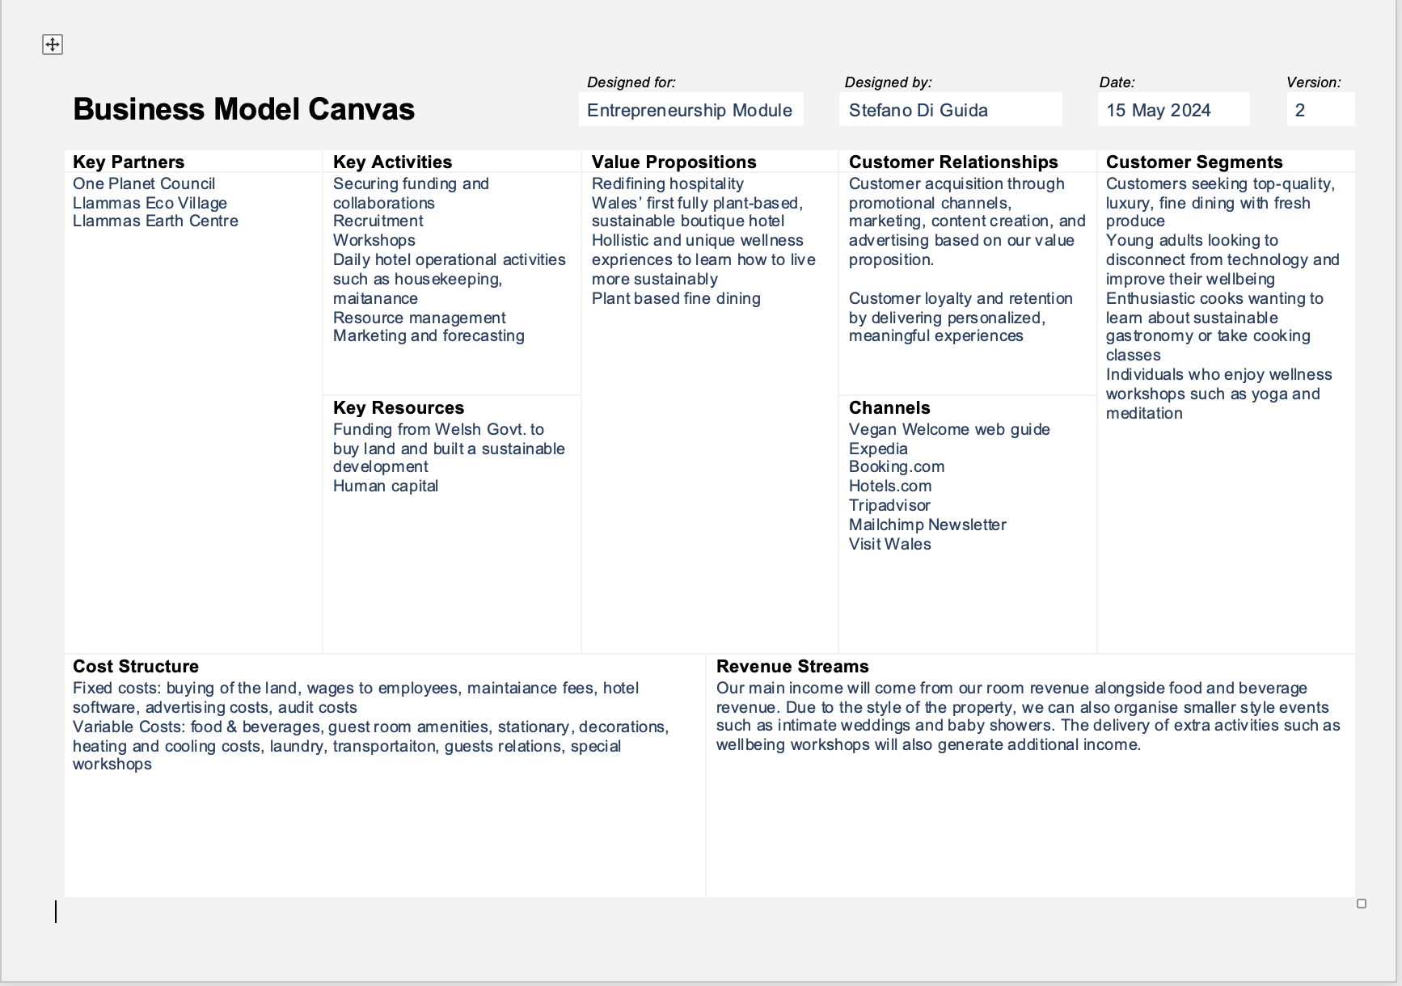

5 Business goals
- What do you want to achieve in your first year of business
1. Reach a £3.65 million annual turnover by year-end, tracking monthly and quarterly revenue for progress monitoring.
2. Sustain 85% room occupancy rate through strategic marketing, partnerships with ongoing monitoring of daily, weekly, and monthly occupancy.
3. Attain a 30% share of direct bookings in the inaugural year via targeted marketing, website enhancements, and incentives, with a focus on improving booking processes.
4. Increase social media followers (Instagram, Facebook, Twitter) to 10,000 by year-end through engaging content tracking growth weekly and monthly.
5. Host 150 wellness workshops in the first year, scheduling weekly sessions, promoting through various channels, and monthly tracking to ensure goal achievement.

- Where do you see your business in 3-5 years’ time?
Klofsten (2010) outlines essential factors for a startup's progression to stability and resilience. Yencken and Gillan (2006) and Kirwan et al. (2008) support this perspective, offering a framework for organizational reflection and goal setting.
At the Cornerstone Level (L), Hiraeth is refining its business idea, securing funding, and identifying market niches. Roles overlap in our current structure, with employees multitasking.
Moving to the Intermediate Level (I) in 1-2 years, we'll define our product's uniqueness based on feedback, delineate customer categories, and streamline operations. Strengthening community ties and team expertise is crucial.
At the High Level (H) in 3-5 years, Hiraeth aims for maturity and success, offering sustainable luxury hospitality. We'll communicate our vision clearly, offering high-quality, sought-after products and services. With a diverse customer base and efficient operations, backed by skilled professionals and industry partnerships, we'll gain customer loyalty.

6 What the business does

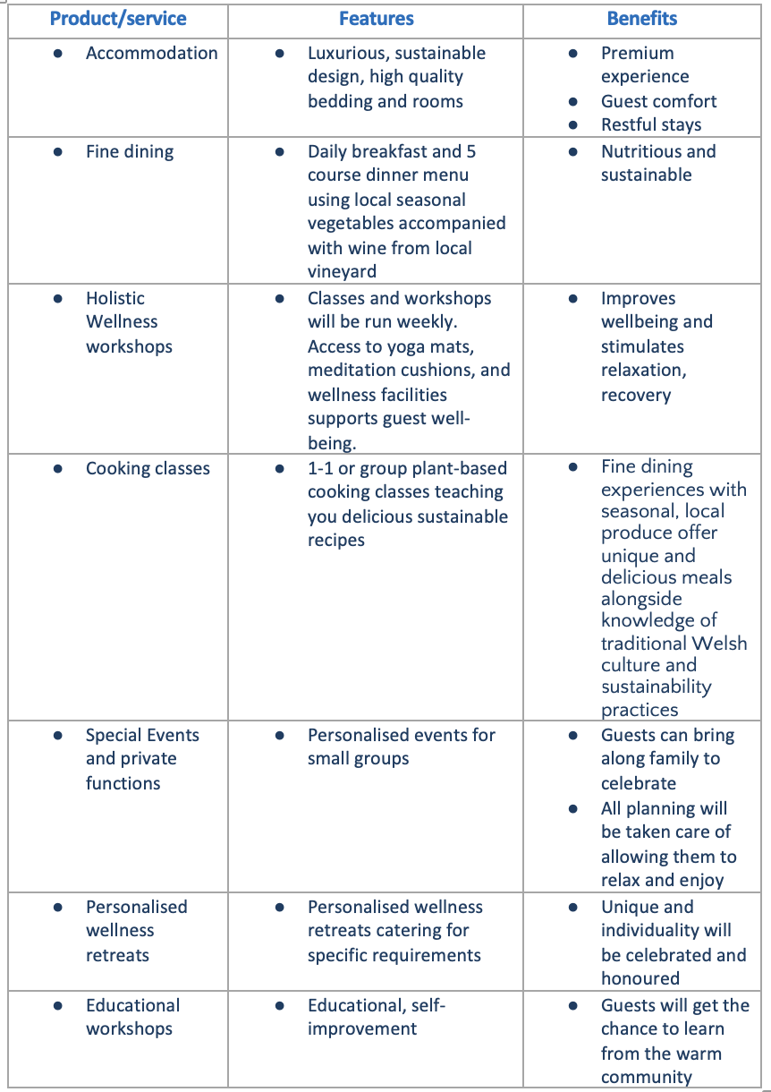

7 What makes the business different (Value Proposition)
Your product/service is unique or different compared with the competition because:
- Hiraeth is the first hotel in Wales that offers a completely plant-based experience
- The hotel is built with sustainability at its core, utilising green technologies such as solar panels and reclaimed materials.
- The business merges simplicity with luxury, providing high-quality comforts and services in an environmentally conscious setting.
- The wellness programs are not just standard offerings but include unique experiences such as digital detox retreats provided in partnership with the Llamas Earth Centre.
- Hiraeth’s fine dining menu will be curated with seasonal, locally sourced produce from the village.
- We prioritise hiring employees from the nearby Lammas Eco Village, creating a connection with the local community.

8 Legal requirements (including regulations and licences particular to your business)
The legal and insurance requirements that apply in your business are:

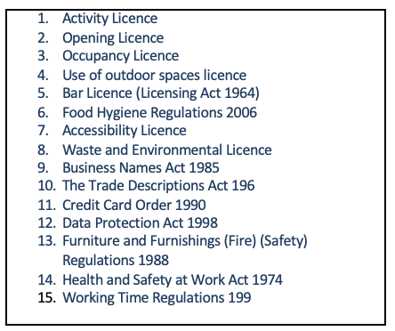

You will meet your legal and insurance requirements by:
Once land is secured and planning permission obtained, the company will seek an activity license from the local council to offer wellness workshops and yoga sessions. An opening license, ensuring safety and health regulations compliance, will precede hotel operations. To secure necessary licenses and comply with regulations, the hotel will undergo inspections and approvals from relevant departments. Maximum occupancy limits, zoning laws, and environmental regulations will be adhered to. Responsible alcohol service and accessibility for disabled guests will be ensured. Waste management will follow environmental protection guidelines. Marketing materials will be accurate, payment processing secure, and customer data protected. Safety measures include fire hazard inspections, staff training, and regular audits. Compliance with work hour regulations and food safety practices will be maintained.

Marketing

9 Market research

Trends in your chosen market are:
- Self-care is important among generations like baby boomers, Gen X, and Gen Z (Patterson & Balderas-Cejudo, 2022).
- More people are buying food/drink with sustainable claims in 2024 than in 2022, (Mintel, 2024)
- According to Mintel (2024), two major trends dominate the UK food scene: a shift towards sustainable, plant-based dining and a preference for innovative, health-conscious local British cuisine.
- Many people, particularly women, seek more leisure time to disconnect from technology. Mintel (2023)
- Older adults are a significant market segment, looking to reduce loneliness and enjoy leisure activities. Mintel (2023)
- Relaxation and mental health benefits are the most popular motivations for leisure activities. Mintel (2023)

How you know this:
- Major hospitality trends have been discussed in two important industry reports by Mintel. Based on surveys carried out by Mintel (2023) we know that in 2024 leisure and wellness trends are on the rise, especially amongst elderly or younger people looking to escape technology. Additionally, Safdar et al (2022) as well as Mintel (2024) discuss a shifting trend towards plant-based dining and how financial health has led to people being more cautious with what they buy and eat.

10 Profiling customers

The customer groups you will be selling to are:

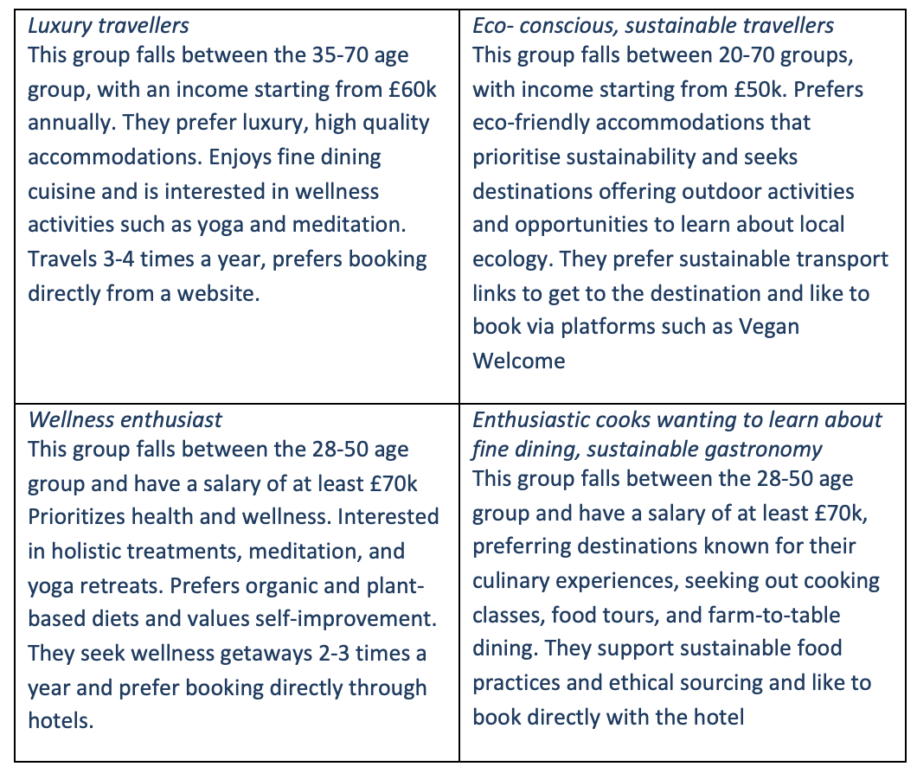

Your customer research has shown what your customers want is:

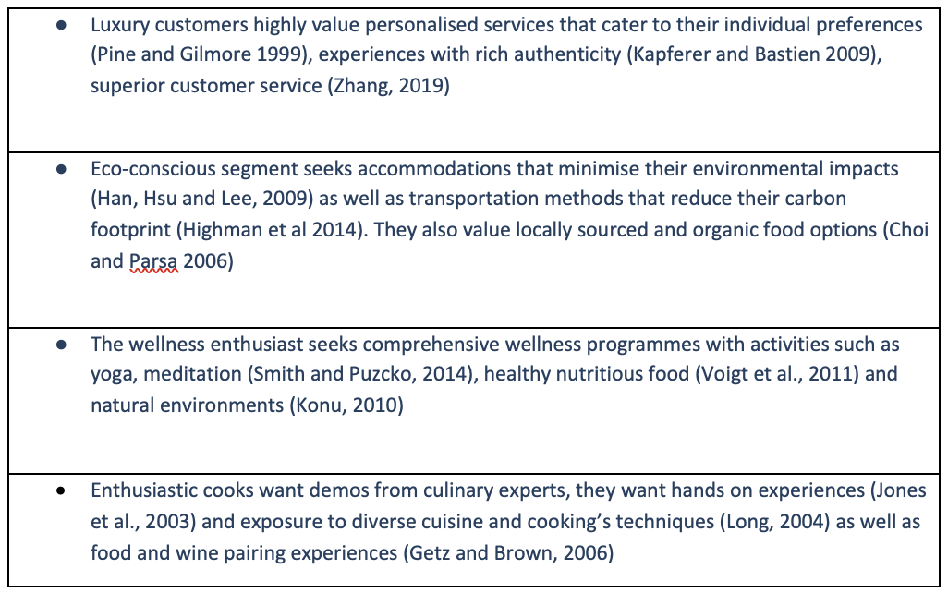

How you know this:
These findings were based on in depth academic research on each individual customer profile as well as recent reports from Mintel on leisure trends and customer demands (Mintel, 2023, Mintel 2024)

Number of customers you expect to win in each group and what they might pay:
Group | Number of customers | Price they might pay per unit
1 | 650 | £500/night  £150/ dining experience per evening
2 | 1200 | £500/night  £150/ dining experience per evening
3 | 1240 | £500/night  £150/ dining experience per evening
4 | 1268 | £500/night  £150/ dining experience per evening

11 Profiling competitors
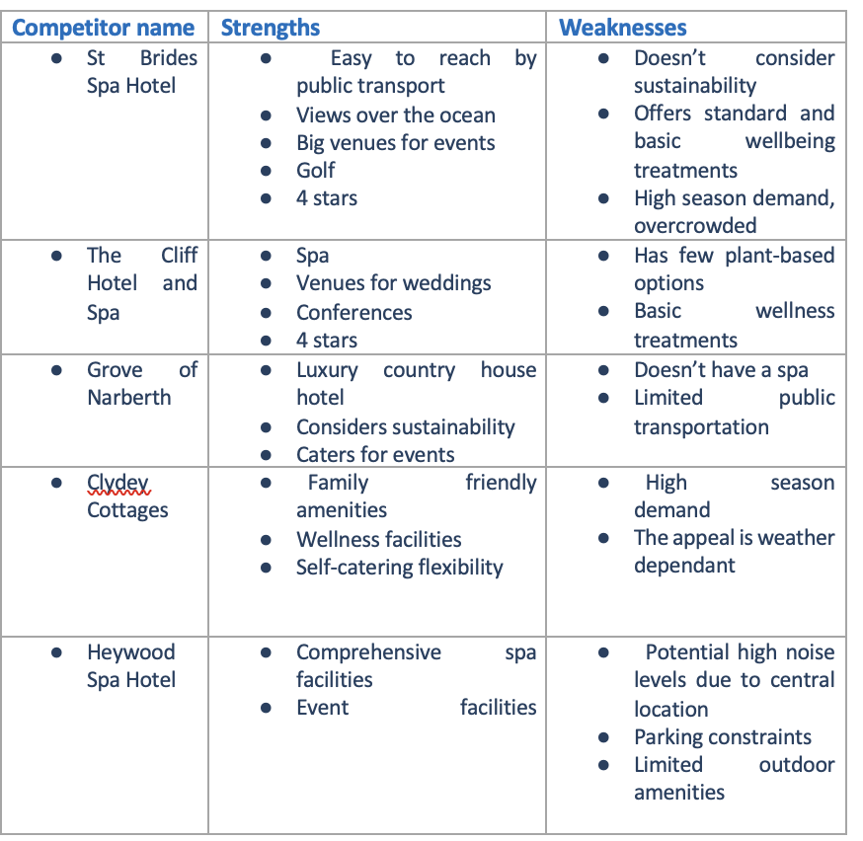

How you can improve on their offer and/or price(s) unique offerings:

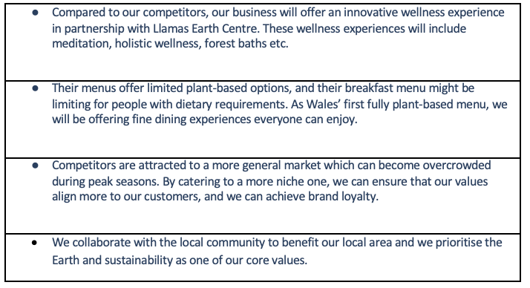

12 Managing market risks

Write down the risks you have identified:

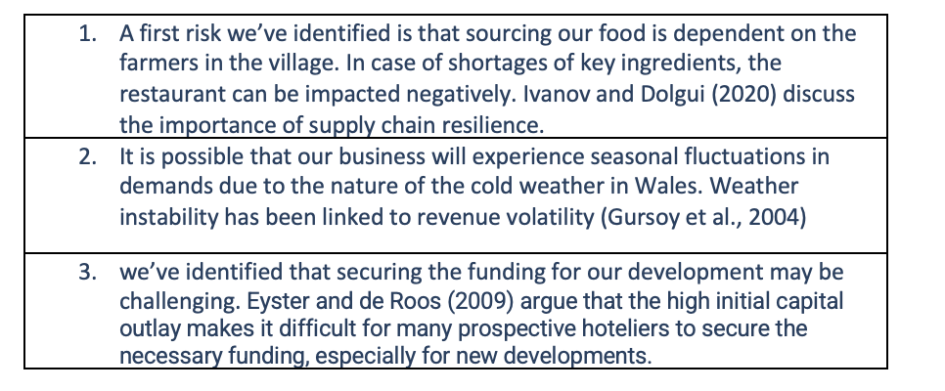

How will you manage these risks so that they become less of a threat:
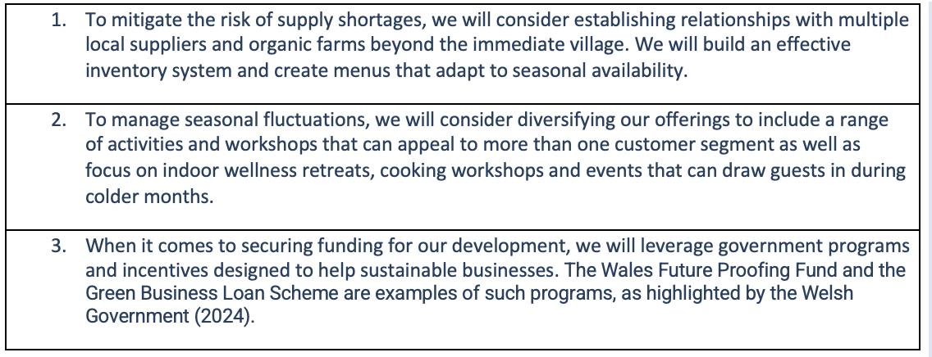

13 Pricing

How you can calculate your prices:
Our room rate of £500 per night was determined considering:
- We were benchmarked against competitors such as Grove of Narberth who take sustainability into consideration and are a luxurious boutique hotel. Their room pricing averages between £318 -£418 per night.
- We justified the increase in price as the price per night includes access for spa facilities and group wellness workshops that are scheduled daily such as yoga, meditation classes. We also took into consideration the market willingness to pay.
- Because we add sustainable, unique and luxury aspects to our offering which also justify the price increase.

How your prices compare with the competition:
- Hiraeth’s room rate of £500 per night is positioned at the high end of the market. This rate is higher than most competitors, reflecting the unique value proposition of being the first fully plant-based, luxury, and sustainable boutique hotel in Wales. The higher price is justified by the premium features, sustainability focus, and comprehensive wellness offerings. The dining rate of £150 for a 5-course meal with wine pairing is on par with the upper range of fine dining experiences at other high-end boutique hotels in Wales.

Product/service | Your price(s) | Range of competitor prices (per unit)
1 night stay including access to group wellness workshops e.g.: yoga, meditation, hiking | £500 | £ 220-450/per night
Dining | £150/ per person | £ 70-120 per person
Private cooking Class | £140/ 2 hours | N/A

Reasons for the difference between your price(s) and your competitors’ price(s):
- Our rates are higher than our competitors reflecting our unique value proposition, being the first fully plant-based luxury, sustainable hotel in Wales. Our dining prices are on par with the ones from our competitors, and whilst our room rate is higher, it includes group wellbeing classes which competitors charge per session per person. Additional income comes for our ability to provide personalised, private sessions of cooking classes and wellbeing, thanks to our partnership with Llamas Earth Centre.

14 Promotion and advertising

How and where will you promote your product/service?
- We will list Hiraeth on vegan and sustainable tourism platforms such as Vegan Welcome and Eco Hotels where travellers specifically seek plant-based and eco-friendly accommodations. Social media channels, including Instagram, Facebook, and YouTube, will be used to showcase Hiraeth’s unique features and engage with potential customers (Schultz et al., 2012). Additionally, online travel agencies like Booking.com and Expedia will broaden our reach and enhance our online visibility (Buhalis & Law, 2008). Collaborations with local wellness influencers and sustainable travel bloggers promote our business h through their networks (Hjalager, 2010). Email marketing campaigns via platforms like Mailchimp will keep potential and past guests informed about special offers and new experiences. Finally, we will leverage travel review sites such as Tripadvisor and Google Reviews to build credibility and trust (Litvin et al., 2008)

Running the business

15 Staff

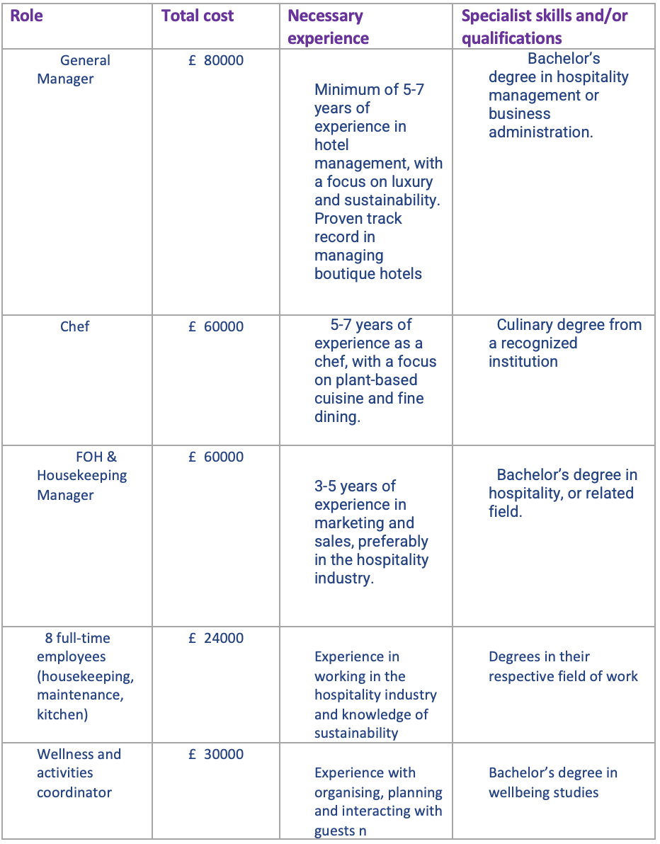

16 Premises

 | Cost £
Premises required at start-up: 15 acres of land, main hotel building (reception, lobby, 15 guest rooms, dining areas, kitchen facilities, laundry rooms, staff offices) Spa building, Vineyard | £ 4mil
Premises required in the future (if different): | £ 0

17 Suppliers

Your key suppliers and their credit terms
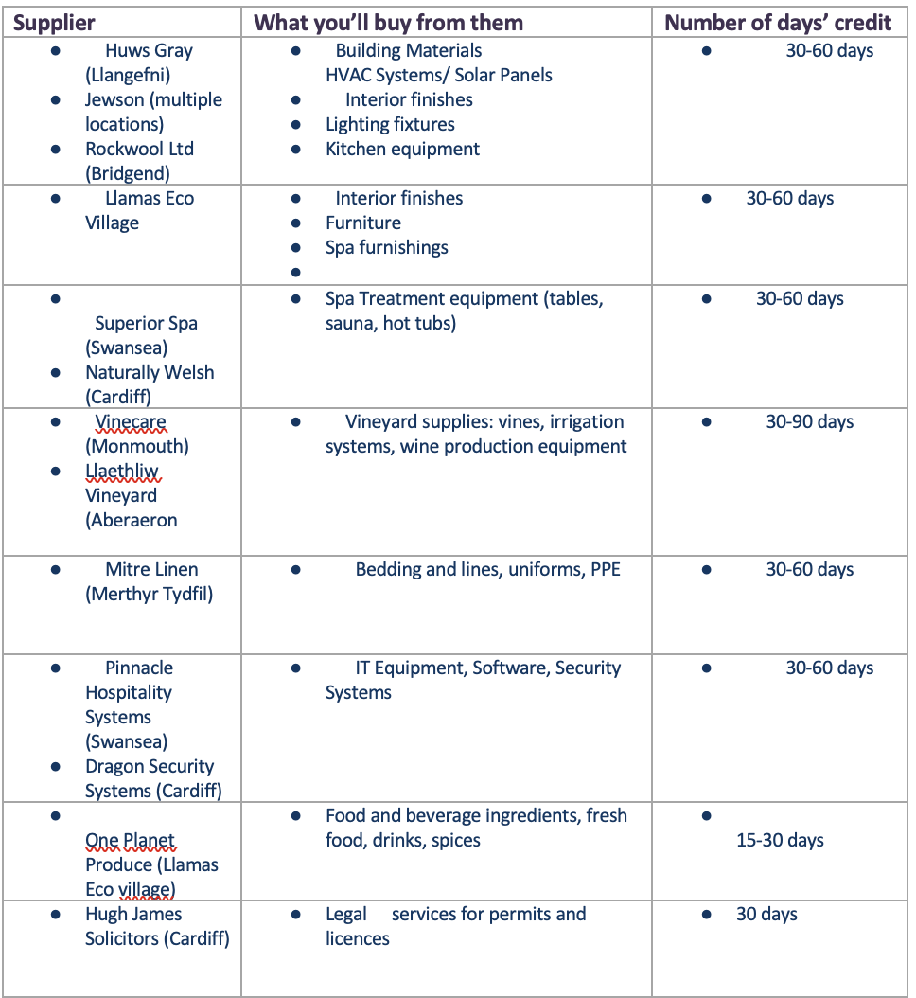

18 Equipment
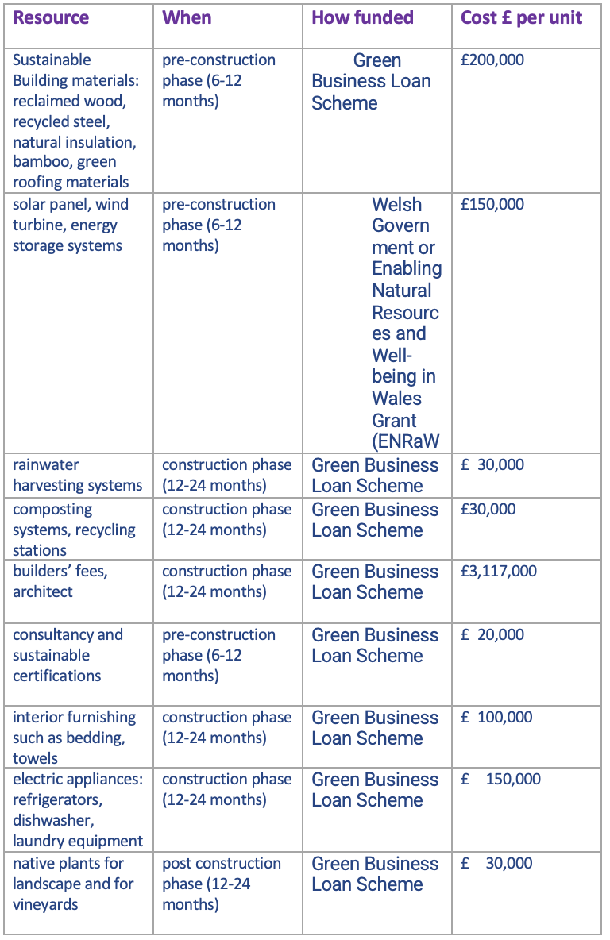

19 Managing operational risks

Risk | Solution
Staff  - High Turnover  - Cultural Fit  - Training and development | - Offer competitive salaries and benefits  - Comprehensive training about sustainability and hotel values  - Offer self-improvement opportunities through training
Suppliers  - Dependence on single suppliers  - Quality inconsistencies | - Engage with multiple local suppliers for key products and reduce pressure on single suppliers  - Developing long term relationship with suppliers based on performance

Finance
Please double click in the table below to access the embedded Microsoft Excel sheets to input your figures, Microsoft Excel will automatically update the total for you. If you do not have access to Microsoft Excel you can use the link below this table and save the file onto your PC. You can then use Open Source Software such as Google Docs or OpenOffice to access the information by uploading the file into this software. Please note that all tables can be customised and additional rows and categories can be added.

20 Start-up costs

Calculate how much money you need before you start trading

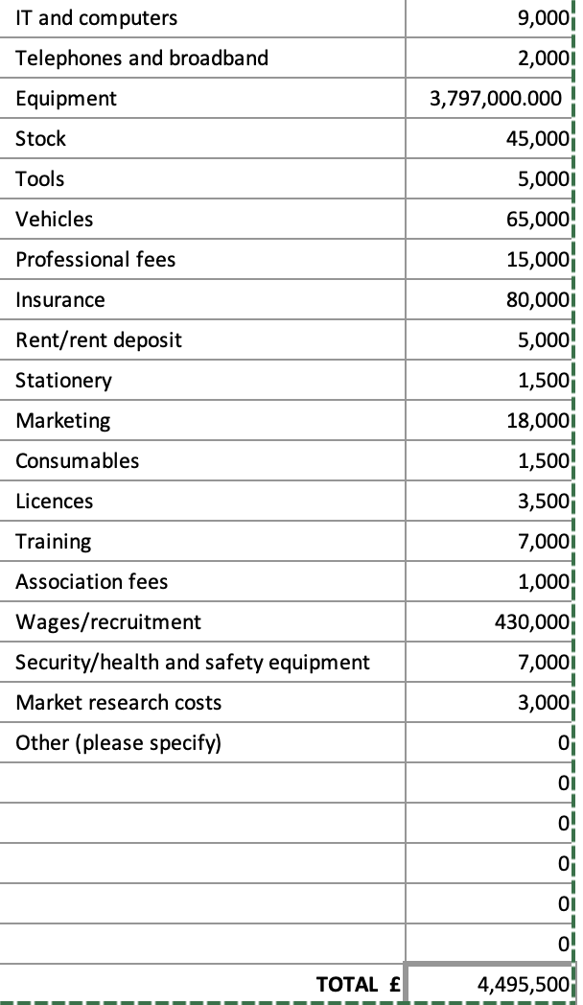
* Total from here should be used in 22 Sourcing finance below

21 Profit and loss forecast

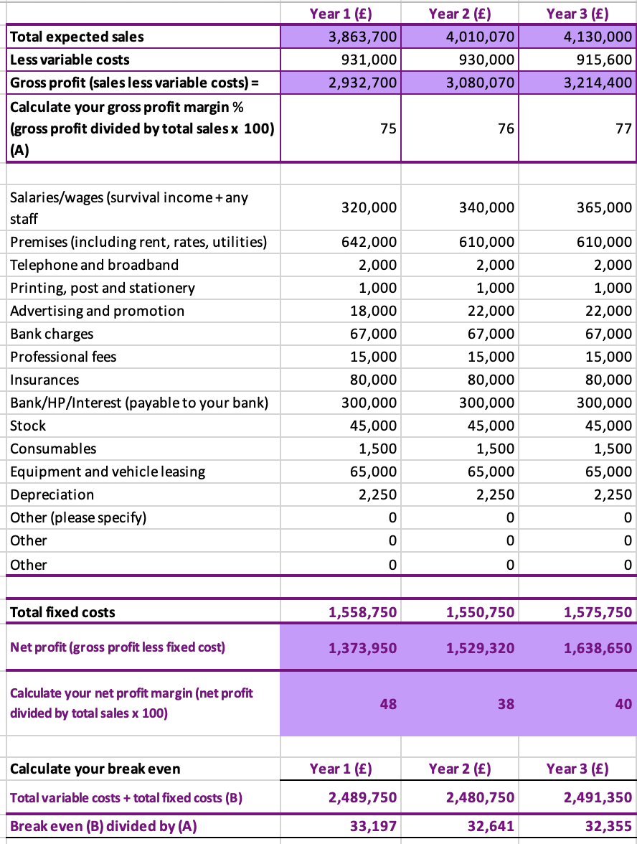

22 Sourcing finance

Total borrowing requirement for the business
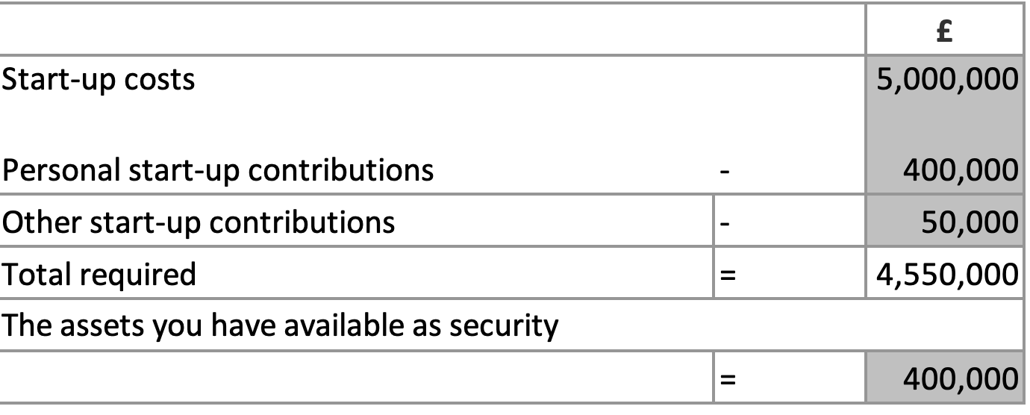

23 Managing financial risks

The risks that you have identified for your financial forecast are:
Challenges in Securing Funding Eyster and de Roos (2009) argue that the substantial upfront costs associated with hotel developments often make it difficult for prospective hoteliers to obtain necessary funding. This risk is exacerbated by the current economic climate and competition for investment. Additionally, there may be a delay in the business obtaining this funding due to application process and competition.

How you will minimise their impact:
- To address challenges in securing funding, Hiraeth could explore various funding sources for sustainable businesses available in Wales such as Green Business Loan Scheme, Green Growth Wales from Welsh Government or Enabling Natural Resources and Well-being in Wales Grant (ENRaW). Additionally, we will allow more time between obtaining funding and starting to build the development to ensure all funds have cleared into our accounts.

24 Cash flow forecast (Click on the tabs within the Microsoft Excel sheet to view the second 6 months and summary)

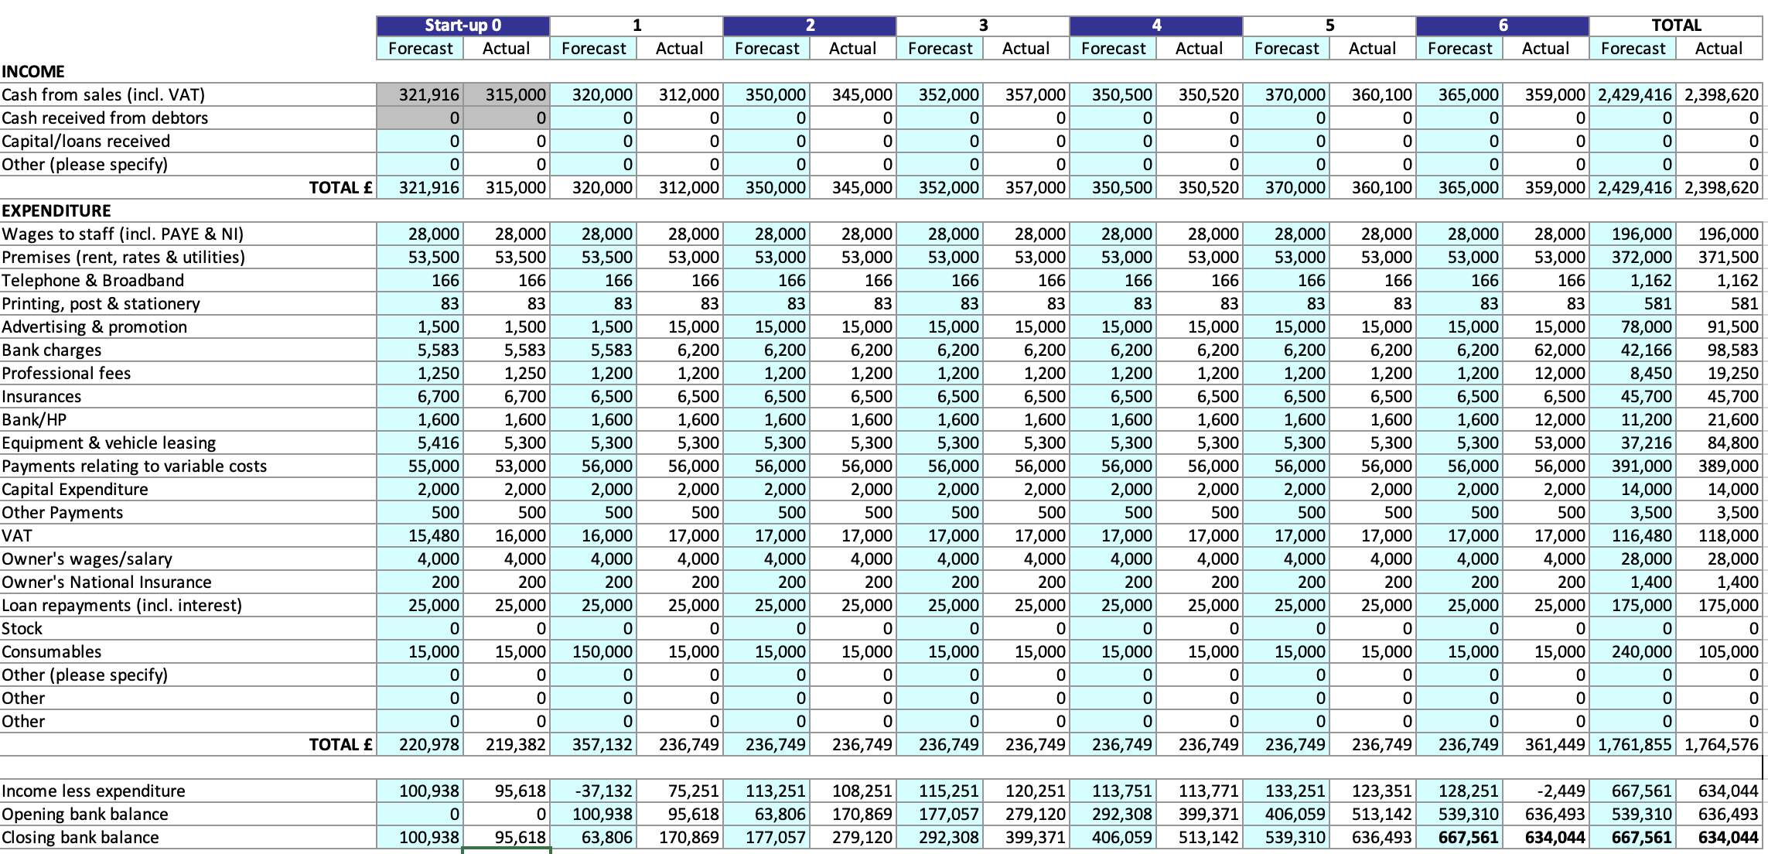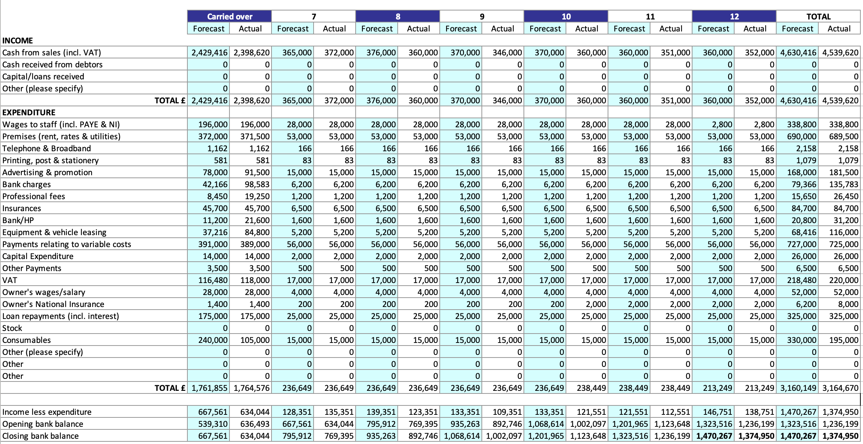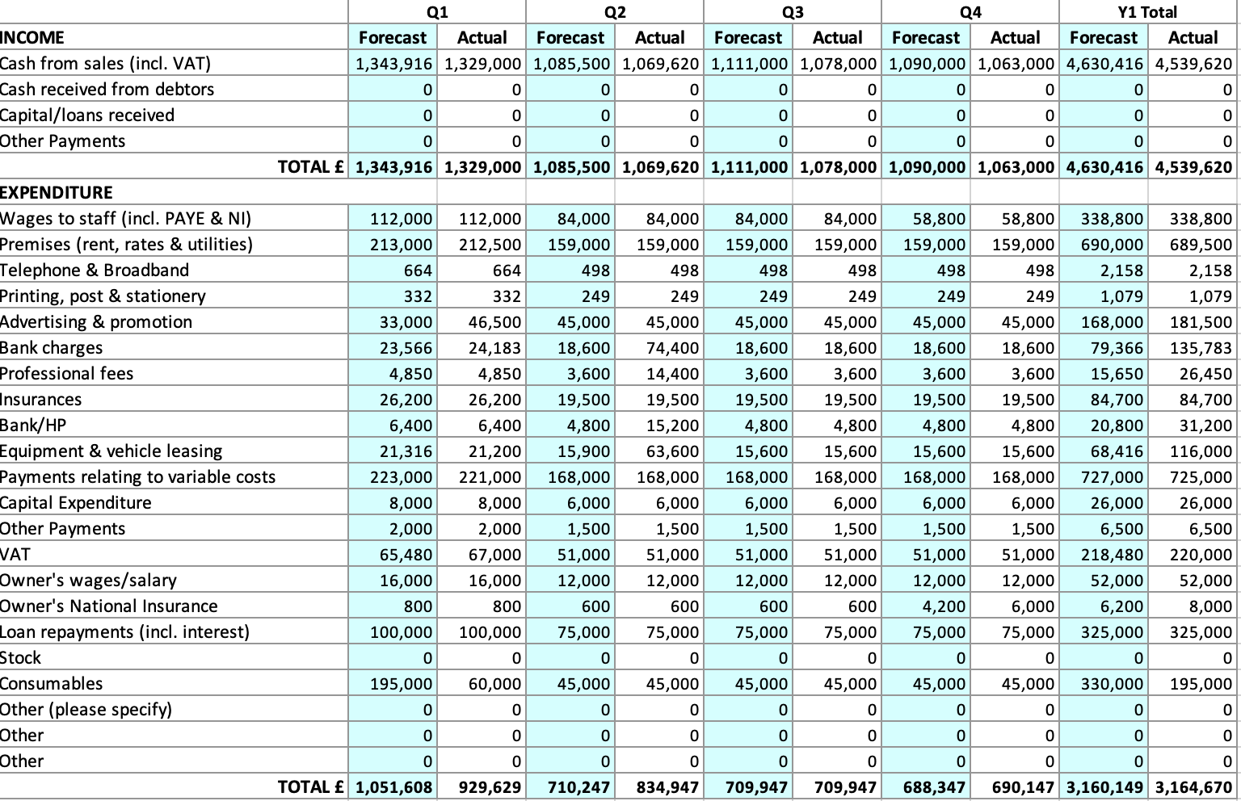

25 Conclusion.
In summary, our boutique hotel business plan outlines a promising venture. With secured funding, we aim to invest in the local community while ensuring financial stability through meticulous forecasting. There's notable interest in our business, bolstering confidence in its success despite inherent uncertainties and risks. Our commitment to sustainability, including the use of solar panels from the outset, positions us well to weather economic fluctuations and resource challenges. By prioritizing community engagement and financial prudence, we anticipate a resilient and prosperous future for our boutique hotel.

26 References
Buhalis, D., & Law, R. (2008). Progress in information technology and tourism management: 20 years on and 10 years after the internet—The state of eTourism research. Tourism Management, 29(4), 609-623.
Choi, G., & Parsa, H. G. (2006). Green practices II: Measuring restaurant managers’ psychological attributes and their willingness to charge for the “green practices”. Journal of Foodservice Business Research, 9(4), 41-63.
Eleven Madison Park. (2024). Eleven Madison Park [online] Accessed 10th May 2024: Retrieved from https://www.elevenmadisonpark.com/
Eyster, J. J., & de Roos, J. A. (2009). The Negotiation and Administration of Hotel Management Contracts (4th ed.). American Hotel & Lodging Educational Institute.
Getz, D., & Brown, G. (2006). Critical success factors for wine tourism regions: A demand analysis. Tourism Management, 27(1), 146-158.
Gursoy, D., Jurowski, C., & Uysal, M. (2004). Resident attitudes: A structural modeling approach. Annals of Tourism Research, 29(1), 79-105.
Han, H., Hsu, L. T., & Lee, J. S. (2009). Empirical investigation of the roles of attitudes toward green behaviors, overall image, gender, and age in hotel customers’ eco-friendly decision-making process. International Journal of Hospitality Management, 28(4), 519-528.
Highman, J., Cohen, S. A., Peeters, P., & Gössling, S. (2014). Climate change, tourist air travel and radical emissions reduction. Journal of Cleaner Production, 111, 336-347.
Hjalager, A. M. (2010). A review of innovation research in tourism. Tourism Management, 31(1), 1-12.
IHC Hotel Consulting. (2024). Licenses for opening a hotel [online] Accessed on 15 May 2024. Retrieved from https://www.ihcshotelconsulting.com/blog/licenses-for-opening-a-hotel/
Jones, P., Hillier, D., & Comfort, D. (2003). In the public eye: Sustainability and the UK’s leading retailers. International Journal of Retail & Distribution Management, 31(10), 530-538.
Kirwan, P. M., van der Sijde, P., & Klofsten, M. (2008). Supporting high-tech companies: Using the business platform as a practical instrument. The International Journal of Innovation and Regional Development, 1(1), 48-65.
Konu, H. (2010). Identifying potential wellbeing tourism segments in Finland. Tourism Review, 65(2), 41-51.
Litvin, S. W., Goldsmith, R. E., & Pan, B. (2008). Electronic word-of-mouth in hospitality and tourism management. Tourism Management, 29(3), 458-468.
Mintel. (2023). Leisure Trends – UK – 2023.
Mintel. (2024). Sustainability in Food – UK – 2024.
Osti, L., & Goffi, G. (2021). Lifestyle of health & sustainability: The hospitality sector's response to a new market segment. Journal of Hospitality and Tourism Management, 46, 360-363.
Pine, B. J., & Gilmore, J. H. (1999). The Experience Economy: Work Is Theater & Every Business a Stage. Harvard Business Review Press.
Safdar, B., Zhou, H., Li, H., Cao, J., Zhang, T., Ying, Z., & Liu, X. (2022). Prospects for plant-based meat: Current standing, consumer perceptions, and shifting trends. Foods, 11(23), 3770.
Safdar, N., Khan, M. A., & Butt, A. S. (2022). Influence of green supply chain integration on sustainable performance: The mediating role of innovation capabilities. Sustainable Production and Consumption, 30, 130-143.
Schultz, P. W., Nolan, J. M., Cialdini, R. B., Goldstein, N. J., & Griskevicius, V. (2012). The constructive, destructive, and reconstructive power of social norms. Psychological Science, 18(5), 429-434.
Smith, M., & Puczkó, L. (2014). Health, Tourism and Hospitality: Spas, Wellness and Medical Travel. Routledge.
Voigt, C., Brown, G., & Howat, G. (2011). Wellness tourists: In search of transformation. Tourism Review, 66(1/2), 16-30.
Welsh Government. (2024). Support for Sustainable Businesses.[online] Accessed on 15 May 2024. Retrieved from https://gov.wales/support-for-sustainable-businesses
Yencken, J., & Gillian, M. (2006). The Klofsten Business Platform Model as a self-diagnostic tool for New Technology Based Small Firms. Paper prepared for HTSF Conference 2006.
Zhang, Y. (2019). Why do people travel in luxury?: A means-end investigation of Chinese luxury travelers.

