Dissertation Proposal

By Dylan Thomas
P151729
Word Count: 1,808
List of Illustrations
- W Magazine, Jason Kibbler, 2016
- @shudu.gram, Instagram, 2018
- Selfish, Kim Kardashian, 2015

Context

This proposal will look at how the way we view portraiture has changed through the use of modern technology and social media. Portraiture has changed drastically due to technological advances and art movements, and with the help of the internet, can be shared all over the world with millions of people in seconds. I will be looking at how egotism plays a role in how we view our own portraits that we share with others, how portraiture is captured through the use of smartphones as ‘selfies’ and also look at how advertisement has changed how to look at and respond to portraiture. I will analyse work by Roland Barthes, Susan Sontag and John Berger, and explore how narcissism, vanity and cyber hedonism all play a role in how portraiture is viewed today.

Narcissism

Throughout history portraits have been seen as a medium that shows power, class and wealth. Many important and famous people had portraits painted of themselves and family members that were hung around their homes as decoration that exhibits their wealth and status. When photography was invented only the wealthiest families could afford to own a camera and have their photograph taken to be decorated in their homes, such as the paintings in earlier years. But when early cameras were becoming cheaper and more regularly available for working class households, portraiture developed a different meaning. Portraits that were taken to show power and status now turned into family outings, holidays and events that the photographer wanted to treasure in more than their memories. Portraits of individuals captured a single frame of their life that could be cherished forever as a photographed memory instead of viewed as a symbol of affluence and egotism. In more modern times almost anyone has the capability of capturing a portrait on a device they carry around in their pockets and have the ability to share it with millions of people around the world in seconds. Portraiture has changed throughout the ages and is continuing to change, with the influence of social media and smartphones. Portraiture is evolving with current modern technology and has become a major influence on our online presence.
Photo sharing social media apps such as instagram and snapchat are massive platforms that millions of people use daily to share images, mainly selfies or portraits of themselves. Portraiture is viewed every time the apps are used with each having a different meaning to the individual that uploaded it. But most portraits that are shared on these apps usually have one ulterior motive, maintaining the ego of the individual who posted it by gathering likes from their followers. This hedonistic drive to capture a portrait of yourself to gain a brief sense of gratification from hollow online appreciation has changed the way we capture and view portraiture drastically. Roland Barthes states in his text Camera Lucida ‘Photography transformed subjects into object , and even, one might say, into a museum object’ (2000: 13). This extract coincides with image sharing social media apps and their platform that allows users to upload countless images of themselves onto their profile. These portraits become objects that are mindlessly viewed at every day, with the context of each being lost through the aim of it being uploaded as a quick way to satisfy a fragile ego. Image sharing social media apps have changed portraits in to a catalogue of repetitive, uninteresting images with little to no context behind them. ‘A Niagara Falls of selfies is cascading down on us from the heavens as every nobody on the planet is handed a tool with which to turn themselves into a somebody’ (2017: 19). This text from the From Selfie to Self Expression text by the Saatchi Gallery illustrates perfectly how through the popularity of smartphones and selfies that we are swamped with repetitive and mundane portraits of people on a daily basis, with each portrait losing its original dominant and powerful nature.

Selfies

In recent years a camera has become an object that many people feel uneasy to see, with many being apprehensive of the unforgiving nature of a photograph. A single captured frame can deal a blow to the individuals self esteem when they view the photograph and the camera didn't portray them in a flattering way or not in the way they had visualised they would look. Susan Sontag wrote in her text On Photography
‘Many people are anxious when they’re about to be photographed: not because the they fear, as primitives do, being violated but because they fear the cameras disapproval. People want the idealised image; a photograph of themselves looking their best. They feel rebuked when the camera doesn’t return an image of themselves as more attractive than they really are’ (1977: 85).

We have become a society that is obsessed with our own self image to the point that we fear an object that could depict us in a critical way. And with smartphones that have cameras built in being owned by essentially everyone, the chances of having a candid photograph of yourself taken are quite high but yet there is still an underlying anxiety in us that we will be captured in a way that tarnishes the perception of the way we portray ourselves. Before the invention of cameras people would have their portraits painted, creating a representation of the individual at their best or painted to look powerful and important. Photography has made people fear being captured looking anything but how they perceive themselves.
In recent years the smartphone has brought about the “selfie”, a self portrait captured through the front facing camera. The act of taking a selfie carries very little fear from the individual taking it as there is a level of control to them, unlike a portrait captured by someone else. This level of control shows up in selfies in almost the same way as old painted portraits. There is a degree of dominance and power in a selfie, especially when compared to a regular image of themselves, a selfie can be looked at in a similar way to how artists painted self portraits, or when people had portraits painted of themselves with special instruction on how they wanted to be shown. The control of how one looks, what lighting to use and what position to be in can create a powerful self portrait that shows confidence in the eyes of the individual taking it. This extract is taken from the From Selfie to Self Expression text by the Saatchi Gallery ‘The selfie has emphatically become one of the most significant expansionist forms of visual expression’ (2017: 5). Every smartphone user has the ability to capture a self portrait of themselves that can be viewed by thousands of people, and as I mentioned in the first chapter, is catalogued into an online profile where they lose their significance and meaning. The act itself of taking a selfie has underlying connotations of control, power and confidence but also incites narcissism and conceitedness when mixed with the cyber hedonistic ways of social media apps.

Advertisements

Portraiture is also viewed on a daily basis not only through images we take ourselves on our cameras and smartphones, but through advertisements and media too. We see portraits used to sell skin care products, food products, clothing and more through various different means. But many of these portraits have been manipulated and the individuals who are in them have airbrushed or photoshopped into what is deemed as the perfect beauty standard. Images selling skincare products with individuals that have flawlessly airbrushed skin compel the public to buy the product to achieve similar results for themselves, under the illusion that the portrait they are seeing is reality.
fig. 1.

This image from a magazine in fig. 1. features two models posing with pets for a 10th anniversary art issue. The knees of both of the models have been manipulated and made to be completely smooth, removing any signs of a natural knee cap. Image editing for advertisements such as this may seem extreme and meaningless, why remove a part of the body which most people have? But some individuals may see this photograph and let it fuel their own insecurities on how they view their own bodies. Advertisements with portraits that have been manipulated such as the one in fig. 1 can be very coercive in how we choose to portray ourselves in society. With many free apps available to edit images on our smartphones, the confident selfies that are taken can be manipulated further by simulating the same perfected airbrushing that we see every day through advertisements. Advertisements that manipulate portraits to achieve this ideal look of beauty feed on our societies’ narcissism and egotism by making us want to attain this exact appearance that we see, in order to share it with our own followers to gain a few cyber likes to satisfy our hedonistic needs. Portrait advertisements targets susceptible members of society that will be easily influenced by the flawless faces that they see each day.

fig. 2.

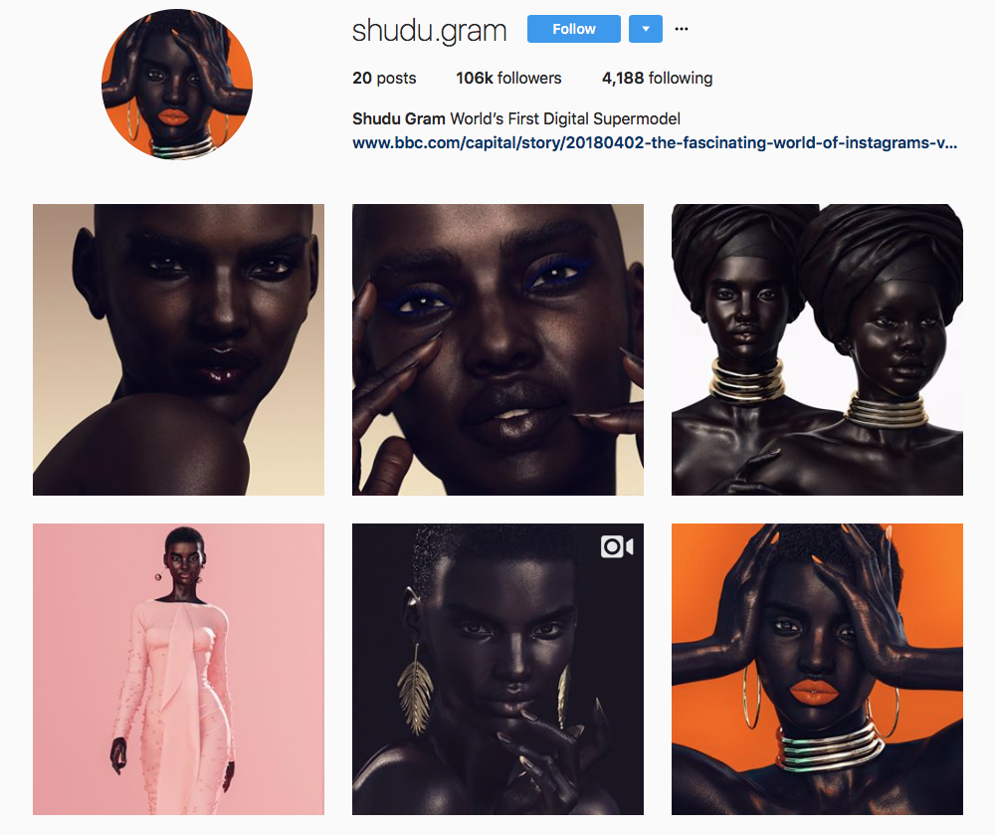
The image in fig. 2 is from the Instagram account of a digitally created ‘supermodel’ called Shudu Gram. In my final dissertation this image could be used to show how easily manipulated portraits can be and how society can be influenced by someone who isn’t even real’s social media account. Narcissism and envy can play a big role in how we view other individuals’ portraits that are shared through social media.
fig. 3.
The image in fig. 3. is the cover page from Kim Kardashian’s ‘Selfish’ a photo book series entirely of her own selfies. In my final dissertation this image could be discussed further under the chapter on selfies and the connotations of power and confidence, and the correlation between classic painted portraits of individuals with power and status and the super wealthy celebrities of today who share selfies of themselves to their followers online.
CONTEXTUALISING A QUESTION

Exploring these three keywords and researching work by the thinkers I mentioned at the start of the essay, I have come to the conclusion that I will be writing my dissertation on how modern technology has changed the way we take and view portraits. There are many interesting aspects to how modern technology has impacted on the portraiture of today that I have not researched a lot into for this proposal but I would like to look more in to for my dissertation, such as completely digital portraits renderings and also look more into how advertisement has had an impact on portraiture too, looking at the correlations between older advertisements with illustrated posters to modern advertisements with manipulated images targeted at a certain demographic. To finalise this proposal I will structure the question that my research has led me to below:

How has modern technology shaped the way we view and take portraits?

Reference List

Barthes, R.Camera Lucida (Vintage, 2000
Berger, J. Ways of Seeing (Penguin Books, 1972)
Huawei. From Selfie to Self Expression (Saatchi Gallery, 2017)
S, Sontag. On Photograph (Penguin, 1977)

Bibliography

Barthes, R.Camera Lucida (Vintage, 2000)
Berger, J. Ways of Seeing (Penguin Books, 1972)
Haywood Gallery About Face, Photography and the Death of the Portrait (Haywood Gallery Publishing, 2004)
Huawei. From Selfie to Self Expression (Saatchi Gallery, 2017)
S, Sontag. On Photograph (Penguin, 1977)
Kardashian, K. Selfish (Universe Publishing, 2015)

