

DSR TERM 2 RESEARCH REPORT
  - IMPACT OF VIRTUAL LEARNING ENVIROMENT

  - YAZMIN VEGA RODRIGUEZ |DIGITAL SKILLS | 09-2020
  - STUDENT NUMBER 1917100

  - LECTURER: SUNETH FERNANADO

TABLE OF CONTENT
Contents
1.0 INTRODUCTION VLE 2
1.1 Overview of virtual learning enviroment 2
2.0BACKGROUND 3
3.0 AIM AND OBJETIVES 6
4.0 METHOD 6
5.0 RESOULTS 6
6.0 DISCUSION 11
7.0 CONLCUSION 11
8.0 References 12
9.0APPENDIX 13

1.0 INTRODUCTION TO VLE
Virtual Learning Environment is based on learning through technological resources such as internet, videoconferencing and management applications in the process of de education reducing time and space between students and teachers. (KANIMOZHI, 2018)

1.1 Overview of virtual learning enviroment

Internet is crucial in our society nowadays, facilitating the interaction around the world in a second, being accessible for everyone. Internet has a huge impact the way how we learn and maximize the time without physical interaction, called Virtual Learning, supported by a specific computer software to achieve our knowledge and an effectively progression. Reducing the needs of teachers during the development of virtual learning, in a conventional classroom.
This concept appeared in 1990 implementing new technology sources VLE focused on learning and teaching, it took place on the schools where pupils and teachers exchange information toward to gain specific skills. (KANIMOZHI, 2018)
In this way allow to the lectures have more proactivity in terms of more resources with a quick access and very diverse information that they can offer to the users.
Internet is an invaluable source that combined with technology is a powerful tool that open a possibility to work on their own and extend the ability to improve Writing skills, research methods, new networks relevant to our professional carrier to communicate more effectively supported by technology resources. (KANIMOZHI, 2018)

2.0BACKGROUND

Is evident the significant impact that online learning has in our lives, which has been booming with the current period of crisis, replacing the traditional classroom for virtual education and opens the challenge to interact with the new technologies.
VLE combine knowledge and practice to be used in the methodology of distance learning, exploring an extensive range of sources available on the internet providing, changing the way how students learn and how lectures teach such as:

Computer-based: In this method, there is no need a tutor, the information stored on a local computer or server, and it is provided by software adjusting to the needs of each student with the corresponding instructions. (KANIMOZHI, 2018)
Internet base: Refers to training done on the internet by software that used the information to be delivered through the web and stored on a server.
Remote teacher online: The learning program provided by the teacher but not physically, the interaction between student and lectures is via online using different sources such as online video, online forums, e-mail and instant messaging.
Blended learning: This modality is composed of the traditional education guided by a teacher that is presential and technological no presential classes.
Facilitated virtual learning: The internet allows to design a specific platform of learning for teachers through the computer that is complemented by a facilitator. The facilitator provides tutoring and support to the learner helping to the process via online face to face or thought other forms of electronic communications. (KANIMOZHI, 2018)
Online learning: It referred to any instructions that need internet, with a wide variety of technological options, that permit the interaction between teachers and students via online using a web of computers.
Full time online: This learning does not require face to face instructions; it based on the remote teacher that can be occasionally supported by human teachers and facilitators.

Advantages of virtual learning for students
VLI allows students to access a verity range of resources with a high quality of material, including external information from outside, that support the perspective in a specific subject to be implemented consistently in academic performance. (Mohammad, 2012)
Flexibility in terms of managing our own time to prioritize our responsibilities effectively. With the facility that we can connect anytime and anyplace. (KANIMOZHI, 2018)

Traffic problems, for most of the students virtual learning, solve and safe a lot of time in terms of commute, depending on where they live, causing several inconveniences for the student, reverberating in their attendance, that with VLI can be solved. And at the same time students that have work and family responsibilities, it is easy to combine them, without losing the content of the class. Also, the opportunity to progress gaining knowledge. (KANIMOZHI, 2018)

The tutor guides the learning Practicing in different types of digital technologies supported in a real-time, such as university platforms, Microsoft, videos, presentations, to encourages students to participate in class, the purpose is the interaction in both parts to end in a reciprocate feedback. (KANIMOZHI, 2018)

Lectures Advantages
Through distance education, teachers can evaluate the learning process of students and monitor their progress through questionnaires, tasks, assessment using different digital tools to measure the understanding of the cognitive levels combined with monitoring of student performance. (Nikhilesh Barik, 2012)

Virtual learning allows lectures to replace the traditional classroom in terms of technology tools and presential classes.
For lectures that their mobility is not possible, using a laptop or any device they can still give the content for the students from anywhere mainly at universities.

Institutions Advantages
Some of the benefits for institutions is quality of the structure platform suitable for most people, for small and rural schools that cannot afford advanced or specialized courses,
VLE is facilitating the opportunity to access from anywhere and anytime, expanding the process of learning and gain specific diplomas giving by an educational institution conferring a degree to many students. (KANIMOZHI, 2018)
Technical support measured the performance of the students and progress, collecting data through the platforms, analyzing plagiarism on the assignments in their own words, using paraphrasing and citing, exploring multiple sources.
One of the most used is Turnitin developed for internally used in benefit of the students and the institutions to evaluate somewhat the level of commitment with the studies. (KANIMOZHI, 2018)
Students Challenges
Lack of face to face- interaction
Presential classes are useful for both sides between teachers and students because it combines different tools and ways to learn; there is more commitment to gain skills and knowledge. But, somehow lack of face to face interaction affect the motivation, especially those that have difficulties searching by themselves without any support.
Can be notorious on exams, class participation and attendance, the habit is connected to the computer via online, afterwards they back to spent time on different activities but no focusing on classes. Pluss if the teacher is doing the same, the results ended in a bad mark or suspended. (KANIMOZHI, 2018)
Digital skills are vital to have a successful performance in high education.
Will be an obstacle if we do not have the necessary knowledge to lost information, especially with the files that we have to deal at university every day in terms of productivity using all the sources that VLE facilitate for us. (CRAIG, 2017)
The VLE has multiple risks for the users, for instance, malicious programs that can damage the others, causing virus. The files that are digital storage can be a risk for the privacy of the students and lecturers when they correct the assignments no just one person; it is a team; they don’t know the progress of the students only the teachers. Marks can be unbalanced. (Nikhilesh Barik, 2012)
Developing cost, it must be structured to ensure the quality of the software and guarantee the levels of security to rich goals of VLE. (Nikhilesh Barik, 2012)

3.0 AIM AND OBJETIVES
- Develop Digital Skills
- Finish this course of higher education
- Obtain U.K degree
OBJETIVES
Implement new strategies of studies that allow me to practice, and understand, in order to expand my skills, maximizing my time, that will be reflected in my professional and personal life.
This current course allows me to progress and recognize my disadvantages to culminate my studies and projecting myself in a real scenario to rich my goals. taking into consideration external and internal factors.as a result of U.K degree.

4.0 METHOD
This survey conducted to collect data to analyze to understand the impact of the Virtual Learning Environment.
This research approached all the advantages and disadvantages that technology affects the performance, of the students, teachers and admin and how they faced the challenges at university, this information has supported by journals, magazine and articles referred to collect statics data.
Through the module university and the teacher have been possible used other types of sources available on the internet to be reflected in this research.

5.0 RESOULTS
As a result of this research, based on the current situation and experience from the participants, the survey was composed of ten questions and thirteen responses.
The results were consistent regardless of how students and institutions have been influenced by this current situation COVID-19, with a general overview how we can face and possible solution to facilitate the learning of the students and what kind of actions could take in the future.

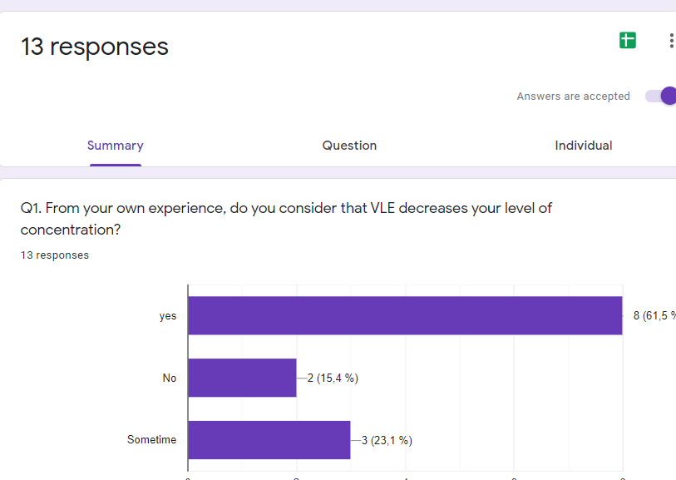
Questions | Responses  Never | Responses  Rarely | Responses  sometimes | Responses  Often | Responses  always |  |  | Maximum  score | Minimum score
Q4 | 0 | 0 | 4 | 4 | 5 |  |  | 5 | 0
Q5 | 0 | 0 | 4 | 5 | 4 |  |  | 5 | 0
Q10 | 4 | 1 | 8 | 0 | 0 |  |  | 8 | 0
Total score | 4 | 1 | 16 | 9 | 9
Average score | 1.33 | 0.33 | 5.33 | 3 | 3

We can observe all respondents have been affected negatively experienced more anxiety using VLE, with 38,05 % during the pandemic affecting their concentration considerably, as a result, they prefer the conventional method.

Questions | Responses  Yes | Responses  No | Responses  Sometimes | Maximum  Score | Minimum score
Q1 | 8 | 2 | 3 | 8 | 2
Q2 | 12 | 1 | 0 | 12 | 0
Q8 | 6 | 2 | 3 | 6 | 2
Total score | 26 | 5 | 6
Average  Score | 8.7 | 1.67 | 2

The majority of respondents experienced Hight lack of concentration, during classes online, the dynamic in general should be more didactic to engage the students; the content is more interactive.

Question | Responses | Responses | Responses | Responses | Responses | Maximum | Minimum
Question | 1. Agree | 2 | 3 | 4 | 5. Disagree | score | Score
Q3 | 9 | 2 | 0 | 0 | 2 | 9 | 0
Q6 | 3 | 4 | 2 | 1 | 3 | 4 | 1
Q7 | 6 | 5 | 0 | 0 | 2 | 6 | 0
Total score | 18 | 11 | 2 | 1 | 7
Average | 6 | 3.67 | 0.67 | 0.33 | 2.33
Score

The responses by students consisted of evaluating the support that the university provides extra support to the students, during exams or assignments, 69% .is necessary more guide on the students. The lack of Engagement with 46% that means VLE is not an effective way to learn.

6.0 DISCUSION
Based on the results and experiences about the impact on VLE, during this current situation, we have a variety of opinions, on how the students face online courses, replacing presential classes. What type of support they need in terms of institutional level, during this transition, the metrology used have been positives to improve digital skills and practice with more confident, digital tools that are easy to implement during our process of learning. On the other hand, negatives result in a personal achievement to pass the course. And lack of motivation and support from lectures to guide better the assignments.

My experience has been extremely negative, affecting me in health and time management from external aspects as company changes regarding with the pandemic, that it did not help at all to improve as I expected increasing my lack of time, and concentration.
To highlight the lecture SUNNETH FERNANDO, on digital skills on this term has been fantastic, his support and commitment to help the students is the best experience since I started university.

7.0 CONLCUSION
This statistics graphs show, the repercussion of virtual learning environment, most in a negative experience from students been crucial to implement and face new technologies on different approaches to facilitate the learning process focusing on individual perspective, in this case, the student-facing plenty of inconvenient to be proactive.

8.0 References
CRAIG, A. C. J. G. A. a. B. J., 2017. DRO DEAKING UNIVERSITY RESEARCH REPOSITORY. [Online]
Available at: http://hdl.handle.net/10536/DRO/DU:30044909
[Accessed 25 AUGUST 2020].
KANIMOZHI, 2018. VIRTUAL LEARNING ENVIRONMENT. International Journal of Advanced Research in Computer Science. [Online]
Available at: https://search-proquest-com.ezproxy.uwtsd.ac.uk/docview/2101249819?accountid=130472&rfr_id=info%3Axri%2Fsid%3Aprimo
[Accessed 28 06 2020].
Mohammad, E. B. N., 2012. Impact of E-Learning on Learning and Realizing Information Society. Research Journal of Applied Sciences, Engineering and Technology, 4(23), pp. 5016-5020.
Nikhilesh Barik, N. B., 2012. RISKS AND REMEDIES IN E-LEARNING SYSTEM. International Journal of Network Security & Its Applications, Volume 14, p. 58.

9.0APPENDIX


