Name: Aleksandr Badger
Student Number: 2308404
Course Name: Applied Computing
Module Name: Advanced Software Development ACCB5011
Assignment: Maze Pathfinding Implementation
Table of Contents
Dijkstra’s Algorithm 2
A* Search 3
Comparison 4
Implementation 5
Reflection 8
References 9

Dijkstra’s Algorithm
Dijkstra's algorithm is a greedy algorithm that solves a single-source shortest-path problem using a weighted directed graph, exploring each vertex using a breadth-first search and then assigning a weight to each edge based on the cost to the desired node [1]. For example, see the graph below:
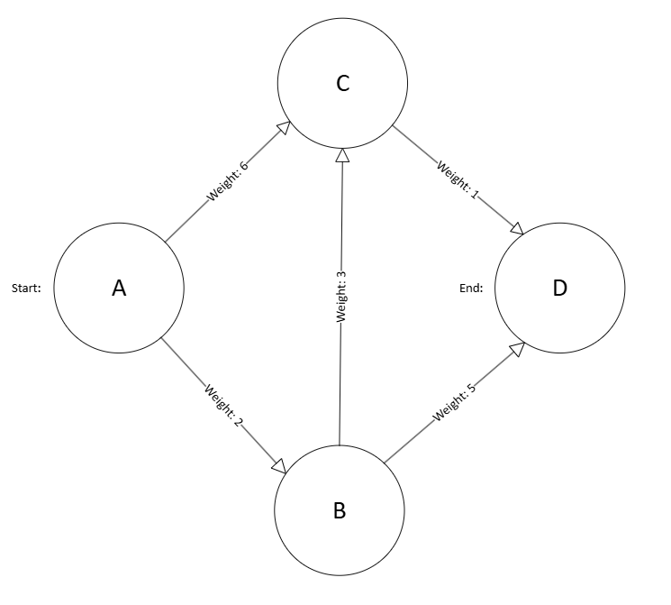
Figure 1:Vertex Tree
This graph shows how the algorithm adds a weight to each edge, from the start point to the end point, by adding those weights together. In Dijkstra’s Algorithm the start is zero and all other distances are infinity initially, then we visit a vertex and once it has been visited, also sometimes marked as black (and white when not visited), it will be marked as such, and a weight will be given along the edge travelled, this continues until all vertices have been explored and each edge has a value assigned to it, with certain exceptions (i.e. vertices that do not lead to the end node) [2].
Dijkstra’s will choose the current cheapest unvisited node to get to the end point, then it will “relax”, which means that it will inspect the branches of the current node and check if there is a cheaper path has been found to them, if yes then it will update its weight and change its parent node [3]. The Big O notation for Dijkstra’s in the average case is O(n log n).

A* Search
The A* search is an algorithm that is a best-first search that includes a heuristic intelligence to help guide the search, as otherwise it will explore every possible vertex/node, even those of no relevance [4]. It uses this intelligence to approximate what will be the best path at the current branching step, as a heuristic will rank decisions based on the current available information, this makes it a greedy algorithm. Furthermore, due to the heuristic function, it will create an estimate of the distance to the goal, which helps create a sense of direction for the search [3]. This search is often used in pathfinding and AI.
The star in the name indicates that this algorithm is admissible, which means that it will always find the optimal solution where this is a path to the goal, this can even be true when the graph is infinite, but only under certain conditions [3]. It will also never overestimate the cost to reach the goal, which makes this a cost-optimal approach.
The formula for A* node evaluation is:
f(n) = g(n) + h(n)
Where g(n) is the shortest path cost from the initial state to node n and h(n) is the estimated cost of the shortest path from n to the goal [5].
When A* picks a node and adds it to closed it will still update the weight of the “closed” nodes, as it can find a shorter path to that node, this is because it chooses each node based on based on the above equation, where h(n) might underestimate the distance to the goal [3].
While literature does not give a fixed Big O notation for the A* search due to its approach, Khemani and Heineman et al agree that the worst-case time and space complexity is exponential, and the average case is problem dependant.

Comparison
Both Dijkstra’s Algorithm and A* search are greedy algorithms, which means that it will solve a problem by doing the best action at that time, which can result in scenarios where it made the correct local judgement, but globally it was not the most effective option, however this does not greatly harm the accuracy and can lead to improved computing efficiency as it will not spend a long deal of time searching for the best possible solution [6].
When talking about performance, both are relatively similar as they both may not find the most optimal path, but it will still be an acceptable overall path, however Dijkstra may explore more irrelevant nodes, as it does not have a guiding force whereas A* is heuristic [3].
Interestingly, in A* search when h(n) = 0, it will degenerate to Dijkstra’s algorithm, as this removes the heuristic guidance to the node, which results in node selection being based on the shortest known path from the start, further highlighting the similarities between both [5].
Furthermore, A* is capable of completing infinite graphs as long as it has an admissible heuristic, while Dijkstra is only capable of completing finite graphs, due to there being a possible closer node indefinitely [3].
Finally, due to Dijkstra being a breadth-first search, it will explore the tree evenly as it moves outwards and relaxing when it marks a node as black/visited, whereas A* will head straight towards the goal due to the heuristic function providing it with an estimate of how much weight there should be at the goal, and thus choosing paths based on that estimate, updating with each node [4].

Implementation
During the development process, the biggest challenge was how to make the code more object oriented, within the constraints of a single .cpp file. Originally, all the code was contained within the Navigate() function, which for the scope of the assignment was acceptable, however due to needing to implement a second solution, and to follow best practices, it now uses three additional classes, one for an parent class containing the function, and two child classes that override that function to use their differing solutions.
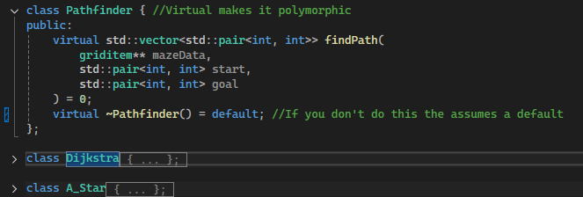
Figure 2: Class abstraction
Here we can see how the original implementation was all in the Navigate() method, and had no modularity nor OO practices in mind:
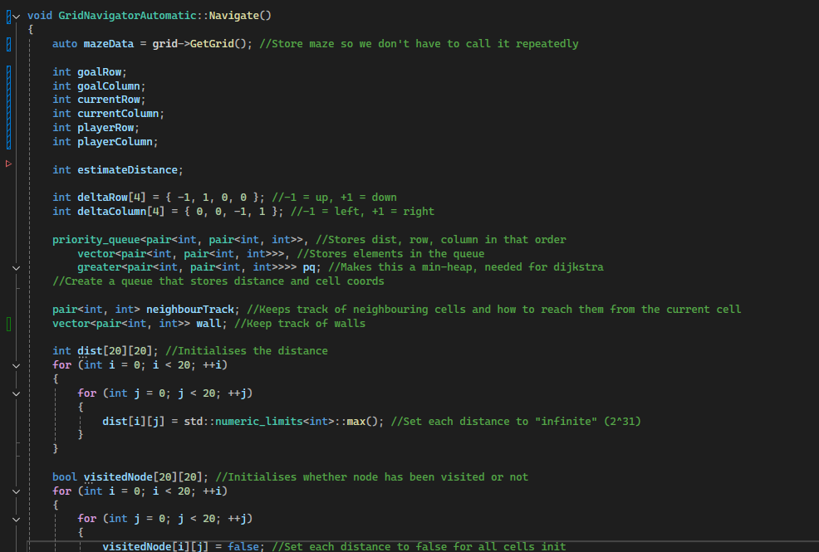
Figure 3: Original implementation
Another issue that occurred with was passing through the original GetGrid() data to the other classes, due to its type, as before abstraction into classes this was not an issue, which resulted in an attempt to pass it through as an array, a pointer grid, a vector and eventually using a pointer to a pointer, instead of trying to pass it through as a copy or a reference.
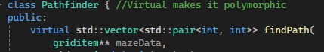
Figure 4: Pointer to a pointer
While implementing the search for the differing cells in the maze, walls were eventually almost entirely ignored, as originally they were stored in a pair vertex, so that their coordinates could be passed to the algorithm, however this is a human perspective of a maze, the algorithm instead uses an out of bounds check and the neighbouring cell properties to check for a wall instead [5].
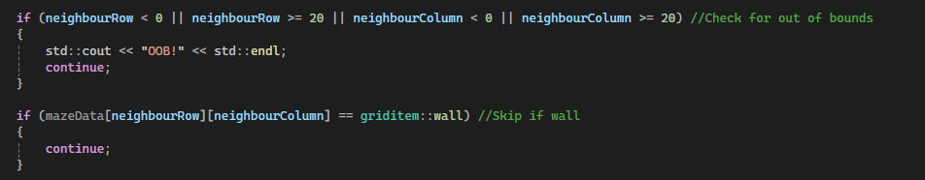
The implementation of the initialising of neighbouring, previous and visited cells, was easier than expected due to multiple pieces of literature stating how their initial states should be set, such as to infinite distance, zero cost and all nodes as unvisited to explain a few [3].
Interestingly, the A* search and Dijkstra performed similarly in the benchmarking tests, this could be due to the scope of the maze, or a poor implementation of A*, as it will degrade to Dijkstra when improperly implemented [5]. 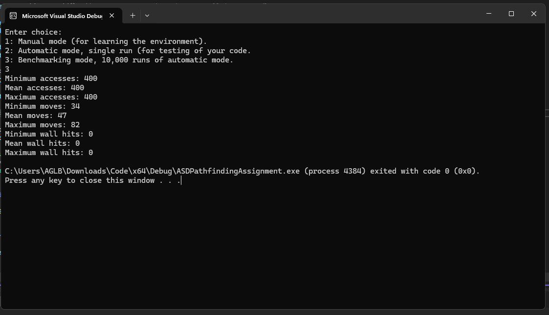
Figure 5: Dijkstra's Algorithm
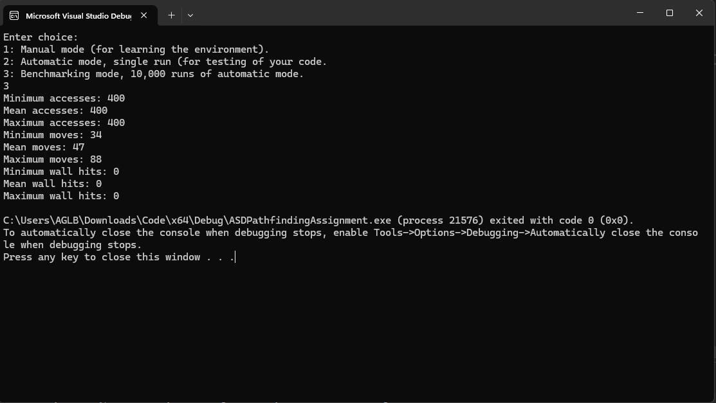
Figure 6: A* Search

Reflection
One improvement made is that the two classes Dijkstra and A_Star almost the exact same code, spare for the heuristic function which separates the two, a more appropriate solution would have been to abstract the shared code and then inherit it.
Furthermore, creating two algorithms was extremely time-consuming and mentally taxing, for the scope of this assignment, one algorithm that is better implemented with more legible code would have been a better use of time and while separation of classes aligns with best practices, for this assignment it could be seen as a waste of time due to knowing it won’t be worked upon further and by other developers.
Overall, there is room for improvement in the program, and a possible reimplementation of A* may be necessary, however it does align with best practices for OOP and modularity.
Below are additional references used to create the program: [7][8][9].

References

References
[1] T. H. Cormen, C. E. Leiserson, R. L. Rivest and C. Stein,Introduction to algorithms, Cambridge, Massachusetts: The MIT Press, 2022.
[2] R. Sedgewick and K. Wayne,Algorithms, 4th Ed. Upper Saddle River, NJ: Addison-Wesley, 2011.
[3] D. Khemani, Search Methods in Artificial Intelligence, 1st Ed. Cambridge University Press, 2024.
[4] G. T. Heineman, G. Pollice and S. Selkow,Algorithms in a nutshell, Sebastopol, CA: O'Reilly, 2008.
[5] S. J. Russell, P. Norvig and M. Chang,Artificial intelligence : a modern approach, Harlow: Pearson, 2022.
[6] Weiss Mark, Data Structures and Algorithm Analysis in C++, 4th Ed. Pearson, 2013.
[7] JDSherbert. "A-Star-Pathfinding." Github. Accessed: 09/11 2025. [Online]. Available: https://github.com/JDSherbert/A-Star-Pathfinding
[8] Red Blob Games. "Implementation of A*." Accessed: Dec 2 2025. [Online]. Available: https://www.redblobgames.com/pathfinding/a-star/implementation.html
[9] A. Javaid, "Understanding Dijkstra Algorithm," 2013, doi: 10.2139/ssrn.2340905.

