‘Sketches in Sierra Leone’
This essay will comment on an illustrated page from the Illustrated London News (hereafter ILN), a periodical from the nineteenth century. Called Sketches in Sierra Leone (Sketches hereafter), it features in the image gallery on the Liberated Africans Database, and was found during research for the previous project on slave voyages.
The ILN was a weekly magazine founded in 1842 (and ran until the 21st century, though monthly after 1971). It was the first illustrated periodical and achieved enormous success and popularity. It reported on aspects of social life and current and world events, sent artists around the world to record other places, people and customs and ran serialised fiction stories. Improvements in printing technology, reducing cost, and a more literate public drove a ‘second print revolution’ in which ILN set the trend with other magazines such as The Penny (and other ‘Penny Press’ periodicals) being produced in Britain, and similar publications appearing in other European countries and the United States. These periodicals, or at least the ILN, were designed to be collected and bound together; it is worth noting that though each issue ran to around thirty pages, the page number for Sketches is given as 434. This collectability will be examined in more detail presently. The ILN marked the rise of illustration, which undoubtedly aided its accessibility to a wider audience, and this was enabled through the new technique of wood engraving, which allowed printed text and illustration to be integrated and reproduced at scale. Though Sketches is at least a reproduction of first-hand artistic accounts, the images are printed using this technology.
Liberated Africans erroneously dates Sketches to c.1881, which registered at first view as unlikely (though not impossible), given its implied relevance to the transatlantic Slave Trade. Since the text on the page describes Seira Leone as a place where captives liberated from slave ships by the Royal Navy made their new lives, the connection to the Slave trade was clearly strong. It was therefore necessary to verify the year, not least in order to find the full ILN issue so as to place in in its full context. The ILN is fully digitised at the British Newspapers Archive, so it was possible to view every issue for every year. Sure enough, this page did not feature in any of the 1881 issues. A reverse Google Image search found another reference to this image placing it in the ILN edition of 25th October 1856, which that issue in the archive confirmed. This makes it much more relevant to matters relating to the Slave Trade, and therefore better explains its inclusion as a resource for understanding it on the Liberated Africans Database. It is also useful for analysing depictions of Africans and Africa in the post-slave trade British view of the world, although a later 19th century date would have placed it interestingly within the period of the ‘Scramble for Africa.’ It nonetheless offers a resource for understanding representations of Africa in the decades before this particular chapter in European colonialism. It also allows us to gain something of a view into the sorts of places the liberated captives for which data is available for made their new lives in.

Critical Appreciation
The first sketch is an eye-level group view of the ‘Egg-gu-gu,’ an ‘itinerant necromancer,’ with a crowd observing. It must have been a strange and unfamiliar image to the readers, but it could be argued that the crowd of Africans gathered around the necromancer are also mixed in their comprehension or appreciation of it. The addition of musicians transforms what might have once been a relatively normal visit from an important cultural figure is by this time more of an event, perhaps even an example of the traditional culture performed for urban citizens and tourists in many places in the world even today.
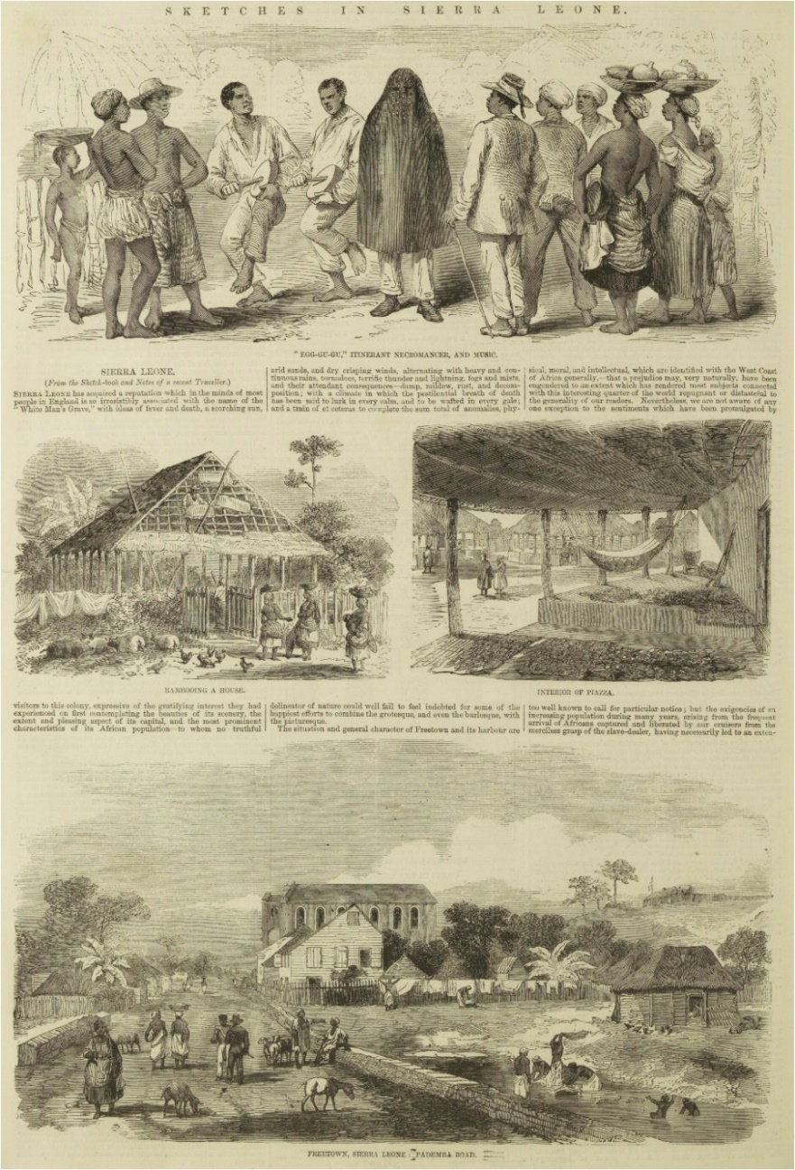
Figure 1: ‘Sketches In Sierra Leone’, Illustrated London News, 25th October 1856
The contrast of black and white in the clothing and skin of the characters is visually interesting, but also creates meaning: note the white clothes of the African man dressed in the more Europea fashion. The Egg-gu-gu is the only character shown dressed in black, and though its attendant musicians are dressed all in white, the general pattern of colour seem to be that the more white clothing the character is shown as wearing, the further they appear – culturally - from the Egg-gu-gu, and the closer to the European-style man, who is the most ‘white’.
Combined with the text immediately below it, which refers to inhospitable weather and landscapes, and the risk of disease, the sketch arguably taps into ideas of the ‘Dark Continent’ and its danger and strangeness.
The second pair of sketches offer something less strange, but still different enough to satisfy curiosity. They show a house being ‘bamboo[ed]’ – that is, under construction - and a ‘piazza;’ both these scenes could be seen as technologically inferior analogues to the industrial and the urban of the ‘civilised’ world. But their purpose may well be to settle to reader after the alien-ness of the first image. Indeed, the text below challenges the perceptions of West Africa previously outlined, describing the ‘beauties of its scenery;’ indeed these sketches could be read as idyllic, bucolic even, with the exotic foliage detailed around the house and the almost idealised (and fully clothed, in comparison to the first sketch) figures of women carrying baskets on their head. Such a setting, and the figures within them, could be seen as examples of the ‘modern moral subject’ of the English School of art, which at this time was only just falling out of taste; indeed, the direct observational approach seen in these sketches also invokes this style. Indeed, it compares closely with not only other examples of English School works, but its deployment in illustrated pages, as evidenced by Figure 2.
The final sketch, which offers a much wider – and perhaps slightly elevated - perspective, is perhaps the most familiar to domestic readers, with more robust looking buildings of planks and hard roofs rather than bamboo and straw; though the two types of building cohabit the scene, the more traditional style buildings are shown in an agricultural context while the more European style buildings – including what looks from its arched windows like a church – are shown in a more urban layout. The scene is bordered with roads and fences, giving a world of order and neatness where the jungle is tamed (but still close enough to enjoy aesthetically). The tell-tale detail of a curved sword and uniform on one of the figures is a subtle nod to the military character of the overseas colony; indeed it could easily be a scene from a Caribbean colony. The text suggests Freetown was quite well-known and in some ways unremarkable, and draws more attention to its import as a place for liberated captives to settle.
The sketches, taken together, perhaps present a meaning-making journey from the mysterious, unfamiliar scene of the Egg-gu-gu, through more understandable, but still different, traditional buildings (and their construction) to the far more familiar and comfortable, almost European order of the Freetown vista. This is a narrative of civilising and taming the strange, mysterious and barbaric places of the world by ordered and cultured Britishness. The message is not only presented in the subjects of the sketches but also in the introduction across them as a set of more ordered lines and frames for the scenes. Collier considers this a process of bounding the peripheries of the Empire in order for those readers in the Imperial core to make sense of it (and therefore locate themselves within it, which will be discussed further), to ‘…make…vast territory legible by bringing it down to size.’
While this is one reading of the layout, its interactivity must also be acknowledged. It is for the reader to make meaning of it, perhaps informed by the narratives of the day and the suggestion of the editor(s). Collier observes of the ILN that while each image it employs individually holds a ‘classical perspective’ which emphasises foreground or background with its use of high or low angles (as in the eye or even ground level perspective of the central sketches), grouped together they form an ‘enlarged but…fragmented’ view that requires the ‘active construction of the reader in order to convert it into coherent narrative.’
Briefly it must be noted that these sketches are actually part of a longer, multi-page spread, and it is worth considering the meaning created - and lost – by presenting just one page on the Liberated Africans database. The second page includes more sketches of interiors and exteriors of traditional houses, as well as people dancing in a village, which takes up the bottom of the page. This changes the ratio of ‘traditional’ scenes to modern/European influenced ones, which in turn changes our understanding of the potential central focus of the piece. Rather than simply showing the civilising effects of British rule and Christian religion, the possibility must be considered of the subject of day to day life in Sierra Leone being presented for its own interest and value to readers. Liberated Africans also trims the image, removing the issue date and page number, which also changes our understanding of it, these details only being revealed through further reading.
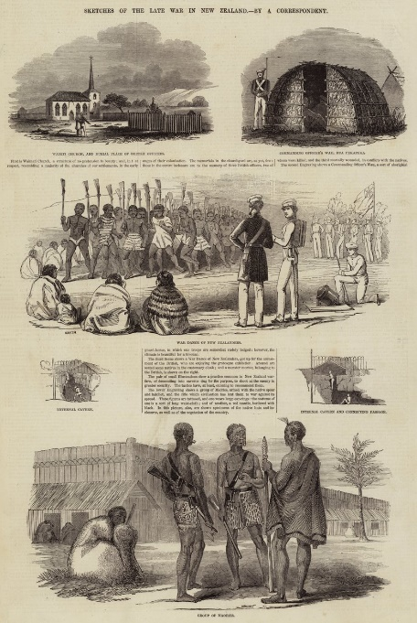
Figure 2: 'Sketches of the Late War in New Zealand' in ‘English School’ style
Historical and social context, Visual Culture
Weller observes that political stability in the preceding decade or so, as well as the advances in technology and reading mentioned previously were necessary for the illustrated periodical to come about. However, despite a despite a general sense that wider sections of the public found them accessible due to price, literary and the prevalence of illustrations, Weller notes there is little evidence for the composition of the audiences of the ILN and publications like it. Events such as the funeral of the Duke of Wellington, and coverage of the Crimean War in the 1850s drove up readership of the ILN; but this period is also characterised by wider access to knowledge, with the proliferation of encyclopaedias, dictionaries, museums and libraries, so we can have some confidence that readers may have included the working class. Indeed, there is evidence in letters to the editor that ‘working men’ were keen to hold complete collections of the ILN. Collecting these periodicals, argues Weller, would have been driven by goals of social status as well as auto-didacticism. Such self-learning would drive many institutions in the following decades, from libraries to Working Men’s Institutes.
The image should also be placed within both the age of scientific exploration as well as missionary work in the colonies of the Empire, which was also expanding. At this time, both would have acted as complementary, twin ‘civilising’ forces and this is borne out in the naturalist curiosity addressed in Sketches, as well as the contrast between strange and un-Christian folk figures and an ordered, European style town with a church.
Since a large part of the readership would not necessarily be either enrolled in, or even aware of, prevailing theories and narratives of meaning negotiated across art by the more elite sections of society, the open-ended and fragmented nature of collaging illustrations in the ILN would have lent itself to a diverse audience of differing education, this polysemic approach ‘turn[ing] printing from a static into an interactive medium.’ Even as this new polysemic approach to the use of image in knowledge creation widened access, however, the dominant narrative of the superiority of the Christian, Imperial core over the stranger and still developing periphery was reinforced by the treatment of subjects like Sierra Leone in both individual sketches and in the construction of layout and use of space and text in publications like ILN.
This is especially true for representations of the ‘other,’ which Smits argues served to build national identity, an ‘imagined community,’ via its reinforcement of the location of even the lower classes of society in the enlightened and civilised core, and that this was true for publications in other European countries also.
Additional Notes
The British Newspaper Archive did not appear to be one that UWTSD has a subscription for. Therefore, high-quality downloads of individual pages of the ILN issue of focus were restricted to three. This inhibited greater comparative study of the periodical’s treatment of other topics across other years (although a cursory Google Image search did enable a general appreciation of consistency of style and form) and is something that would be interesting and useful to do in greater detail in the future. Moreover, a more in depth reading of art history as it relates to this time would be beneficial in developing a more sophisticated critical appreciation.
Bibliography
Archives/databases
‘The Illustrated London News, (25th October 1856)’, on The British Newspaper Archive. Accessed 22/12/24: https://www.britishnewspaperarchive.co.uk
‘Sketches in Sierra Leone’, image section on Liberated Africans Database. Accessed 21/12/24: https://www.liberatedafricans.org/digital-resources/image-gallery.php#
Secondary Literature
Collier, P., Imperial/Modernist Forms in the Illustrated London News, Modernism/Modernity, Vol 19, No. 3, (Hopkins University Press: 2012), pp. 487–514.
Hultzsch, A., The Crowd and the Building: Flux in the Early Illustrated London News, Architecture and Culture, Volume 6 No. 3 (2018), pp. 371-386.
McKendry, V., The "Illustrated London News" and the Invention of Tradition, Victorian Periodicals Review, Vol. 27, No. 1 (Johns Hopkins University Press, on behalf of the Research Society for Victorian Periodicals: 1994), pp. 1-24.
Smits, T., Looking for The Illustrated London News in Australian Digital Newspapers, Media History, Vol 23: No. 1 (2017), pp. 80-99.
Weller, T., Preserving Knowledge Through Popular Victorian Periodicals: An Examination of The Penny Magazine and the Illustrated London News, 1842–1843, Library History, Vol. 24 No. 3, (2008), pp. 200–207.
Websites
English School, Encyclopedia Britannica Website. Accessed 20/12/24: https://www.britannica.com/art/English-school
Illustrated London News, Encyclopedia Britannica Website. Accessed 20/12/24: https://www.britannica.com/topic/Illustrated-London-News
Sketches of the Late War in New Zealand, Meister Drucke Fine Art Prints. Accessed 28/12/24: https://www.meisterdrucke.ie/fine-art-prints/English-School/1096441/Sketches-of-the-Late-War-in-New-Zealand-%28engraving%29.html
The Scramble for Africa, St John’s College (Cambridge), Online School Resource. Accessed 21/12/24: https://www.joh.cam.ac.uk/library/library_exhibitions/schoolresources/exploration/scramble_for_africa

https://www.britannica.com/topic/Illustrated-London-News
Hultzsch, A., The Crowd and the Building: Flux in the Early Illustrated London News, Architecture and Culture, Volume 6, No. 3 (2018), pp. 371-386., p.. 371.
Hultzsch, The Crowd and the Building, p. 372.
https://www.joh.cam.ac.uk/library/library_exhibitions/schoolresources/exploration/scramble_for_africa
All quotations without footnoted references are taken from the ILN page itself.
https://www.britannica.com/art/English-school
Collier, P., Imperial/Modernist Forms in the Illustrated London News, Modernism/Modernity, Vol 19, No. 3, (Hopkins University Press: 2012), pp. 487–514., p. 492.
Collier, Imperial/Modernist Forms in the Illustrated London News, p. 499.
The other pages of the piece of focus here were unfortunately not available to include as images in this essay.
No date for this image is given by the art seller which features it. It seems likely from the form and style that this, too, is from the ILN. The source is notable in its labelling of the style as English School: https://www.meisterdrucke.ie/fine-art-prints/English-School/1096441/Sketches-of-the-Late-War-in-New-Zealand-%28engraving%29.html
Weller, T., Preserving Knowledge Through Popular Victorian Periodicals: An Examination of The Penny Magazine and the Illustrated London News, 1842–1843, Library History, Vol. 24: No. 3, (2008), pp. 200–207., p. 201.
Weller, Preserving Knowledge Through Popular Victorian Periodicals, pp. 201-202.
Ibid., p. 202.
Ibid., p. 203.
Ibid., pp. 204-205.
Hultzsch, The Crowd and the Building, p. 371.
Smits, T., Looking for The Illustrated London News in Australian Digital Newspapers, Media History, Vol 23: No. 1 (2017), pp. 80-99., pp. 81-82.

