Video Review: How the Holocaust Began (59 minutes)

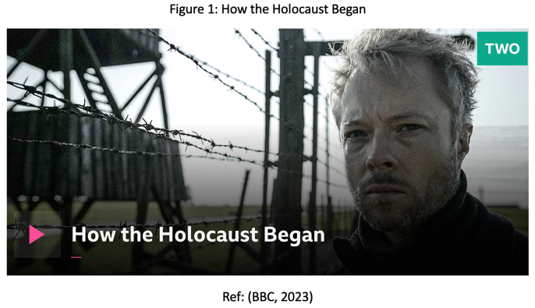
The BBC documentary How the Holocaust Began (BBC, 2023), first broadcast on 23 January 2023, offers a reinterpretation of the Holocaust’s early stages, challenging the assumption that the genocide began with extermination camps and gas chambers (See Figure 1). It contends that the genocide began earlier, during the June 1941 German offensive into the Soviet Union, called Operation Barbarossa, when mass shootings of Jewish civilians became systematic (BBC, 2023). Produced for the BBC by Caravan, an award-winning independent company specialising in factual programming (Caravan, 2023), the programme targets a general, educated audience interested in history and Holocaust remembrance. Broadcast as part of the BBC’s Commemorating the Holocaust collection for Holocaust Memorial Day (BBC Media Centre, 2023), it presumes a basic knowledge of the subject while challenging the narrative that genocide was primarily enacted through concentration camps. Its well-paced narration makes it accessible to students, educators, and viewers seeking critical engagement, and its inclusion in Holocaust Memorial Day programming further emphasises its role in public commemoration and understanding.

The documentary is presented by James Bulgin, British historian and Head of Public History at the Imperial War Museums (IWM). Bulgin led the development of the IWM’s Holocaust Galleries and authored The Holocaust (IWM, 2023). He has appeared on programmes such as Rise of the Nazis and Secrets of the Imperial War Museum, collaborating with the United States Holocaust Memorial Museum and Yad Vashem (Celeb Agents, 2026). It was written and directed by Nic Young, whose work has earned accolades, including an Emmy for scriptwriting (Talent Manager, 2026), and produced by Ben Holgate, known for major factual series (Talent Manager, 2026a). Howard De Lestre served as Historical Advisor, though little is publicly available about his credentials (De Lestre, 2026). The team’s expertise, combined with Bulgin’s scholarship, lends the documentary authority. Expert commentary frames the interpretation, but the strongest evidence comes from black-and-white footage recorded by the perpetrators themselves. Originally intended to document their actions, these images powerfully corroborate Nazi atrocities, and their repeated use reinforces both the immediacy and credibility of the events.

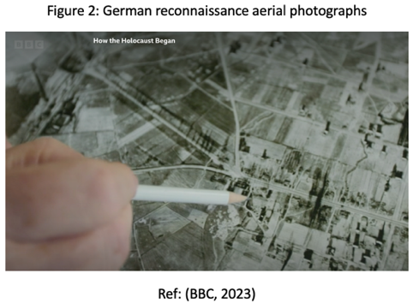
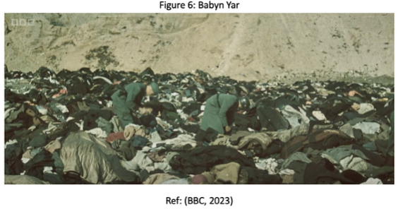
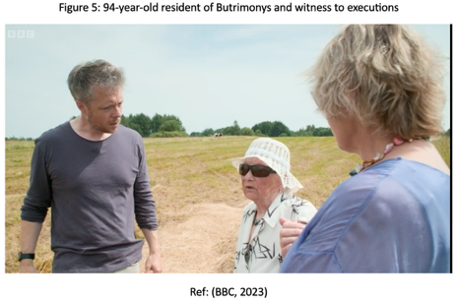
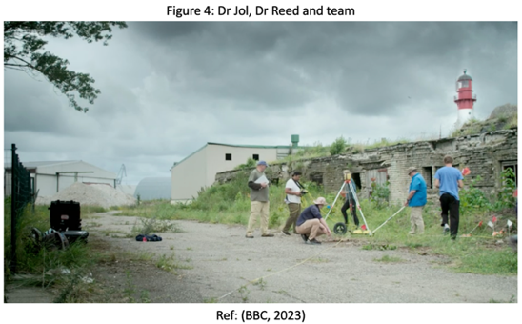
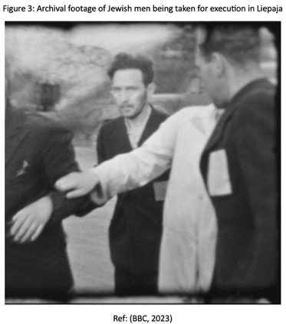
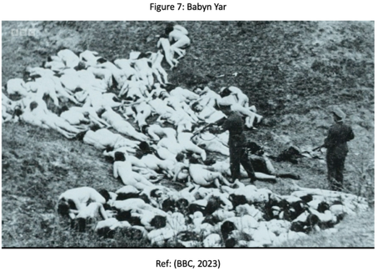
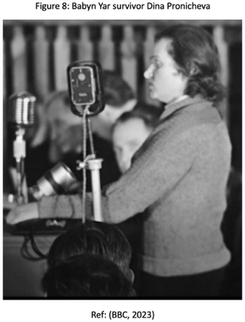
The documentary opens with Bulgin asking viewers what they associate with the term ‘Holocaust’, noting that most think of concentration camps. He argues that the Holocaust was not a single, pre-planned operation by Hitler but a chaotic, evolving process that began earlier, during the German invasion of the Soviet Union in June 1941. Early atrocities by the Einsatzgruppen, often called the ‘Holocaust by Bullets’, systematically murdered entire Jewish communities. Bulgin emphasises that widespread collaboration facilitated the genocide, and ongoing forensic investigations continue to reveal its scale (BBC, 2023). In Gargzdai, Lithuania, within a day of the invasion, the Einsatzgruppen destroyed homes and executed residents, with mass graves documented in German aerial photographs (See Figure 2) and eyewitness accounts. Similar atrocities in Liepaja, Latvia, are illustrated through harrowing archival footage (See Figure 3) (BBC, 2023). A key theme of the programme is the integration of forensic science with historical sources. Geomorphologists Dr Jol and Dr Reeder combine execution footage, German wartime aerial photographs, and non-invasive ground-penetrating radar to identify mass graves (See Figure 4). They locate execution trenches, with forensic results indicating that tens of thousands of victims remain buried (BBC, 2023), using methods that adhere to Halacha, the Jewish law governing human remains (Sturdy Colls and Colls, 2023). The documentary also examines local responsibility, featuring Lithuanian writer Rūta Vanagaitė, who faced harassment and exile for exposing Lithuanian collaboration, highlighting enduring political and cultural tensions. Eyewitness testimony reinforces civilian involvement, including a 94-year-old resident of Butrimonys recalling the murder of 740 Jews by neighbours (See Figure 5) (BBC, 2023). Bulgin shows how these killings escalated with Babyn Yar, where 33,771 Jews were murdered over two days, including testimony from survivor Dina Pronicheva (See Figures 6-8) (BBC, 2023).

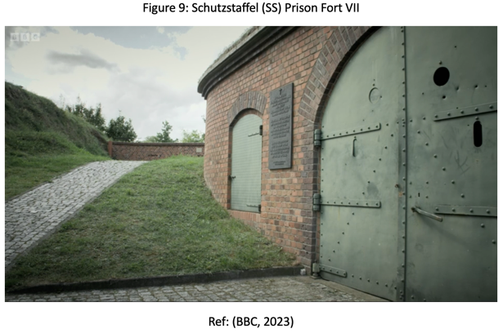
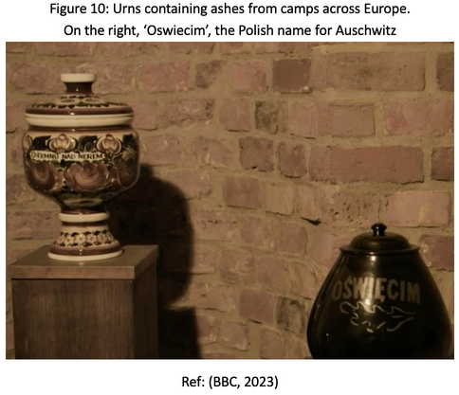
The documentary then examines how the Nazis sought more efficient methods to exterminate Jews, experimenting in locations such as the Kazimierz Biskupi forest in Poland, where lime pits and mobile gas vans caused thousands of deaths. The documentary concludes at Schutzstaffel (SS) Prison Fort VII in Poznań, Poland (See Figure 9). Associated with the T4 euthanasia programme, the site contained a sealed chamber in which victims were murdered using carbon monoxide, described as the ‘world’s first gas chamber’ (BBC, 2023). From November 1939, mentally ill patients and other victims were killed in this adapted bunker, which served as a testing ground for methods later used on an industrial scale (Topolska, 2017; Gluszek, 2023). Urns containing ashes from camps across Europe are displayed in the chamber, symbolising the transition from early experimentation to the industrialised genocide of the concentration camps (See Figure 10). One urn bears the name ‘Oświęcim’, the Polish name for Auschwitz (Auschwitz, 2026), reinforcing Bulgin’s conclusion that the mechanisms of industrialised killing commonly associated with the Holocaust originated here (BBC, 2023).
The documentary situates its argument within broader Holocaust historiography, contrasting intentionalist interpretations, which emphasise Hitler’s ideology, with functionalist perspectives highlighting local initiative and institutional dynamics (Draper, 1999). Bulgin’s focus on cumulative radicalisation aligns with Kershaw’s (1993) concept of ‘working towards the Führer’, whereby subordinates escalated violence, anticipating Hitler’s goals, without a single extermination order. While the programme illustrates the escalation of mass killings during Operation Barbarossa, it also acknowledges that such violence began earlier in occupied Poland. This supports Bulgin’s view of the Holocaust as a complex, multi-stage process. Historians continue to debate its origins, for example, Browning (2004, pp. 25–36) identifies the 1939 invasion of Poland as an early phase, marked by executions of Polish elites and some Jewish civilians during the Intelligenzaktion.
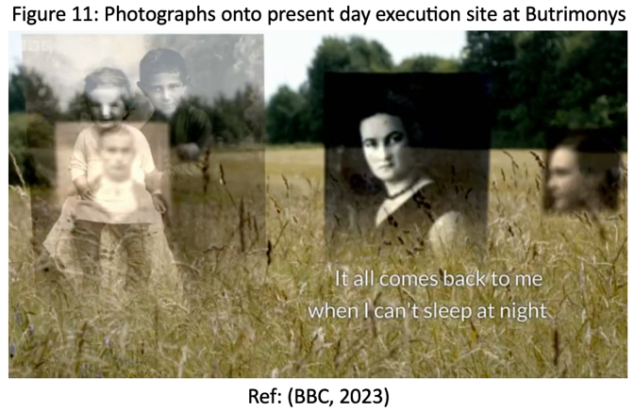
The programme’s use of archival black-and-white footage of Jewish persecution and executions is particularly striking. Photographs are overlaid onto present-day images of execution sites, creating a poignant continuity between past and present (See Figure 11). Repeated images of victims’ faces bear witness to those who can no longer testify. The restrained, sombre musical score, often a single violin or piano, and near silence draw attention to the presenter, contributors, and locations, heightening the emotional impact. Together, archival footage, photographic overlays, forensic evidence, and understated sound design reinforce historical authenticity and convey the gravity of events without sensationalism.

Overall, How the Holocaust Began challenges the conventional view that the Holocaust began with concentration camps. While historians continue to debate its origins, this well-researched documentary effectively educates and challenges viewers, showing how genocide unfolded in stages shaped by local initiative, collaboration, and Nazi ideology.

BIBLIOGRAPHY
Auschwitz (2026) Auschwitz-Birkenau – The past and present. Available at: https://www.auschwitz.org/ (Accessed: 10 February 2026).
Bartrop, P.R. and Jacobs, S.L. (2010) Fifty key thinkers on the Holocaust and genocide. London: Routledge.
BBC (2023) How the Holocaust Began. Available at: https://www.bbc.co.uk/programmes/m001hj7n (Accessed: 4 February 2026).

BBC Media Centre (2023). BBC marks Holocaust Memorial Day with three new documentaries. Available at: https://www.bbc.com/mediacentre/2023/holocaust-memorial-day-documentaries#:~:text=Published:%209:00%20am%2C,disasters%20of%20the%20twentieth%20century (Accessed 9 February 2026).

Browning, C.R. (2004) The Origins of the Final Solution: The Evolution of Nazi Jewish Policy, September 1939–March 1942. London: Hodder Arnold [Kindle edition].

Bulgin, J. (2021) The Holocaust. London: Imperial War Museum.

Bulgin, J. (2025) Nuremberg. London: Imperial War Museum.

Bulgin, J. (2026) James Bulgin PhD [LinkedIn profile]. Available at: https://www.linkedin.com/in/james-bulgin-phd-8b80b594/ (Accessed: 6 February 2026).

Bulgin, J. and Lease, B. (2024) ‘Curating the Experiential: The Imperial War Museum’s Revised Holocaust Galleries’, in M. Kobialka, B. Lease, and M.M. Delgado (eds.) Staging Difficult Pasts. 1st ed. United Kingdom: Routledge, pp. 53–71. Available at: https://doi.org/10.4324/9781003315827-4

Bulgin. J. (2026) The Holocaust and the Apocalyptic Cultural Imagination of the Cold War. Available at: https://pure.royalholloway.ac.uk/en/publications/the-holocaust-and-the-apocalyptic-cultural-imagination-of-the-col/ (Accessed: 6 February 2026).

Caravan (2023) BBC How the Holocaust Began. Available at: https://caravan-media.com/production/how-the-holocaust-began/ (Accessed: 8 February 2026).

Celeb Agents (2026) James Bulgin – Historian & TV Presenter. Available at: https://celebagents.co.uk/clients/james-bulgin-historian-tv-presenter/ (Accessed: 6 February 2026).

Cherkaska, D., Sturdy Colls, C. and Colls, K. (2022) ‘Archaeological approaches in investigations of Holocaust-related mass graves: A Ukrainian perspective’, Ukraina Moderna, 35(1). Available at: https://eprints.staffs.ac.uk/7496/ (Accessed: 9 February 2026).

De Lestre, H. (no date) Howard De Lestre [LinkedIn]. Available at: https://www.linkedin.com/in/howard-de-lestre-a22260200/ (Accessed: 6 February 2026).

Draper, R. (1999) ‘Decoding the Holocaust’, The New Leader, p. 14. Available at: https://www.proquest.com/docview/225680580?accountid=130472&parentSessionId=UoK7IQ1o7ebKfXxw%2Fzqdj1GYxIS4vfu9PB3qHZA%2Fphs%3D&pq-origsite=primo&sourcetype=Magazines (Accessed: 6 February 2026).

Friedlander, H. (1994) ‘Step by Step: The Expansion of Murder, 1939-1941’, German Studies Review, 17(3), pp. 495–507. Available at: https://doi.org/10.2307/1431896

Głuszek, P. (2023) Fort VII in Poznań. Laboratory of Murder. Available at: https://eng.ipn.gov.pl/en/digital-resources/articles/10597,ARTICLE-Fort-VII-in-Poznan-Laboratory-of-Murder.html (Accessed: 10 February 2026).

IWM (2023) How the Holocaust Began. Available at: https://www.iwm.org.uk/commercial/curator-consultancy/how_the_holocaust_began (Accessed: 5 February 2026).

Jaeger, S. and Bulgin, J. (eds.) (2025) The New Holocaust Galleries at the Imperial War Museum London: Conception, Design, Interpretation. Berlin: De Gruyter.

Kershaw, I. (1993) ‘“Working Towards the Führer.” Reflections on the Nature of the Hitler Dictatorship’, Contemporary European History, 2(2), pp. 103–118. Available at: https://doi.org/10.1017/S0960777300000382

Landau, R.S. (1998) Studying the Holocaust : issues, readings and documents. 1st edn. London: Routledge.

Meldijana Arnaut Haseljić (2022) ‘Genocide(s) in World War II – Towards the Genocide Convention (origins, definition, processing)’, Historijski pogledi (Online), V(8), pp. 239–273. Available at: https://doi.org/10.52259/historijskipogledi.2022.5.8.239

Pettitt, J. (2021) ‘Introduction: new perspectives on Auschwitz’, Holocaust Studies, 27(1), pp. 1–11. Available at: https://doi.org/10.1080/17504902.2019.1625110

Russell, N. (2019) ‘Operation Barbarossa and the Holocaust by bullets—top-down forces’, in Understanding Willing Participants, vol. 2. Cham: Palgrave Macmillan. https://doi.org/10.1007/978-3-319-97999-1_4

Sturdy Colls, C. and Colls, K. (2023) ‘Holocaust victims, Jewish law and the ethics of archaeological investigations’, Heritage, Memory and Conflict, 3, pp. 25–30. Available at: https://doi.org/10.3897/hmc.3.69978

Talent Manager (2026) Nic Young. Available at: https://www.thetalentmanager.com/talent/29664/nic-young#:~:text=About%20Me,from%20the%20same%20extraordinary%20story (Accessed: 9 February 2026).

Talent Manager (2026a) Ben Holgate. Available at: https://www.thetalentmanager.com/talent/80529/ben-holgate (Accessed: 9 February 2026).

Topolska, A. (2017) ‘Visualizing the Memory of World War II: Photographs from Fort VII in Poznań, Poland’, The Polish Review (New York. 1956), 62(2), pp. 55–72. Available at: https://doi.org/10.5406/polishreview.62.2.0055

USHMM (2026) International Holocaust Remembrance Day. Available at: http://ushmm.org/remember/international-holocaust-remembrance-day (Accessed: 6 February 2026).

Westermann, E. (2026) Einsatzgruppen. Available at: https://www.britannica.com/topic/Einsatzgruppen (Accessed: 7 February 2026).

