Digital Strategy for Wales – setting the context
Posted on December 1, 2020
Post by Lee Waters MS, Deputy Minister for Economy and Transport
Darllenwch y dudalen hon yn Gymraeg
It’s not just about computers. Let’s just be clear about that at the start.
The term ‘digital’ covers a lot, but in essence it’s about using technology to make things better – to make firms more productive or to create new products and markets. And to develop services that meet the needs of customers.
Two years ago, I chaired an expert panel for the Welsh Government to look at how we could harness the power of digital to improve public services. Our System Reboot report put it like this: “digital change isn’t just about technology, it’s about a change of culture. It’s about being open. It’s about using data to solve problems. Instead of designing services from the viewpoint of what organisations think a citizen needs, a digital approach involves designing services that meet the needs of the end user”.
Being able to access the everyday things we need digitally is now normal. But as the COVID pandemic showed us, that was not the case for many key public services. We saw rapid adaption to change the way we work and live, and the experience has raised awareness and expectations of how we must continue to innovate.

Our vision
We want people in Wales to experience modern, efficient and streamlined public services and at the same time stimulate innovation in our economy and support outcomes today and for future generations.
Our vision is that “Digital in Wales will improve quality of life, sustainability and economic growth, creating user-centred public services supported by effective leadership, data and a culture of innovation and collaboration.”
We are creating a digital strategy for Wales that will help us deliver against that vision. It must set out clearly our ambition for Wales, the outcomes we want to see and the actions that will deliver them.
We are quite advanced in our thinking but we want to test where we’ve got to and crowdsource ideas to strengthen it. We are therefore sharing our draft openly to get your input to help shape the final version.
The strategy is separated into missions which sit below the vision. The missions describe what we want to achieve.
- 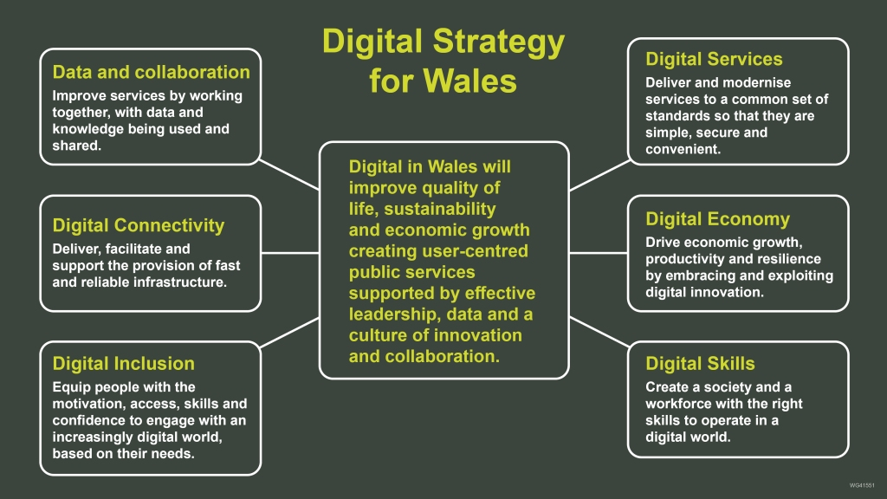

Sharing our thinking
This is the first of a series of posts that we will be publishing over the coming weeks. We’ll blog about each mission in turn, providing context, the outcomes each mission will achieve and some of the actions that have been identified to deliver these. We hope that in taking this approach we can get feedback to help us ensure we’re focusing on the right things to achieve the right outcomes.
Our aim is to publish the final strategy next year. That doesn’t mean action is on hold until then. There’s already a huge amount of work going on across organisations in Wales to deliver better services and create a better Wales. We plan to showcase some of these in our upcoming posts and events. The newly created Centre for Digital Public Services (CDPS) is also testing new approaches, developing common standards and focusing on skills and digital capability.

Delivering the strategy
While the Welsh Government has a clear leadership role in delivery, we cannot do this alone. Our ambition will only be delivered through partnership working and collaboration with all of the organisations responsible for providing public services in Wales and with the support of the Chief Digital Officers in the Welsh Government and Local Government and CDPS. The CDPS, which has helped develop this strategy, will also have a role in monitoring and reporting on progress once the strategy is launched.
To achieve our outcomes we need a clear roadmap for delivery. Work has already taken place to identify some of the actions that are needed and what needs to change for each mission. In parallel to the engagement work we will turn the actions we have identified into a delivery plan, highlighting roles and responsibilities across the Chief Digital Officers, Centre for Digital Public Services and public sector organisations. This will be a living document, outlining a realistic plan for actions we will take in the short and medium term, flexible depending on resources and priorities. Progress against it will be monitored and reported.

Well-being of Future Generations
This is our opportunity to build collaboration between citizens, public services and business to deliver better services, grow the economy and support the well-being of our current and future generations. We want services to be designed to support people whatever their background, and in way which means people can use the Welsh language on a day-to-day basis.
We expect the strategy to contribute to progress against the seven national well-being goals, primarily towards a Prosperous Wales, A More Equal Wales, A Wales of Cohesive Communities and A Wales of Vibrant Culture and a Thriving Welsh Language. More fundamentally, achieving real digital transformation in how we deliver public services provides huge opportunity for public bodies to support the five ways of working required by the Act. We will design joined-up digital public services through collaboration and integration. Through good engagement we will design user-facing services that prevent inefficiencies and inconsistent experience for the citizen. Finally by designing services in an agile and user-focused way we will be ensuring services are designed for the long-term.
Because, digital is not just about computers – it’s about people.
We would like to hear your views, you can do this by filling in the online form for the relevant Missions. The online form will be open until 31 January 2021. You can now read the first blogs in this series on Mission 1 – Digital Services and Mission 2 – Digital Economy with the other mission blogs to follow.

