PROGRAMME: MASTER OF BUSINESS ADMINISTRATION
MODULE: FINANCIAL MANAGEMENT
MODULE CODE: LCMB7002
VOLKSWAGEN
STUDENT NAME: Nicolae Mihai
STUDENT ID: 2124103@student.uwtsd.ac.uk
Lecturer: Dr Patrick Yeboah

Table of Contents
Introduction 3
Company Overview and Strategic Context 3
Volkswagen Group Overview 3
Industry and Market Context 4
Financial Health Check: Five-Year Performance Analysis 5
Overview of Financial Performance 5
Profitability Ratio Analysis 8
Liquidity Ratio Analysis 9
Efficiency Ratio Analysis 9
Gearing and Solvency Ratios 10
Investment and Cash Flow Ratios 10
Key Trends, Strengths, and Financial Risks 11
Working Capital Management Analysis 11
Cash Operating Cycle Analysis 11
Liquidity Management Challenges 12
Strategies to Improve Working Capital Efficiency 13
Short-Term vs Long-Term Financing Options 13
Strategic Financial Restructuring Plan 14
Rationale for Financial Restructuring 14
Proposed Restructuring Options 15
Impact on Shareholder Value 15
Impact on Capital Structure and Flexibility 16
International and Ethical Considerations 16
Investment Appraisal and Capital Budgeting 17
Comparative Evaluation of Projects 17
Project Recommendation 18
Capital Rationing Decision (£100m Constraint) 19
Conclusion 20
References 21

Introduction
The report addresses the strategic financial issues of Volkswagen Group in the context of changing from a conventional internal combustion engine manufacturer to a global electric mobility leader. The intention of the report is to analyse the recent financial activities of Volkswagen, its critical financial and operational problems, and suggest financially viable solutions that can help it stay afloat at a market that is becoming more competitive with electric vehicles (EVs). The analysis is characterised by a five-year financial statement review, and the narrowed down range of financial performance, liquidity management, capital structure, and the investment decision-making. The analysis is made on the basis of the assumed Chief Financial Officer (CFO), who must guarantee the financial stability, as well as allow the willingness to invest on the scale of electrification, digitalisation, and sustainability.
VW is chosen as the case organisation because of its international size, the EV strategy is capital-intensive, its brands are diversified, and the company is strategically located in the context of the low-carbon shift of the automotive industry. The report proceeds to follow a systematic analytical procedure that brings forth four fundamental elements including a thorough financial health analysis through ratios analysis, analysis of working capital management and efficiency, development of strategic financial reorganisation plan and investment appraisal of initial capital project estimates through adopted capital budgeting practises. The report has been structured into well delineated parts that lead gradually to diagnosis of financial position and plans of strategy and investment.

Company Overview and Strategic Context

Volkswagen Group Overview
The Volkswagen Group is based on diversified and multi-brand business model of passenger cars, commercial cars, power engineering and financial service. The operating structure of the Group has been segmented into the Automotive Division and the Financial Services Division which are the two major divisions. Mass-market, premium, and luxury-based brands, which are covered by the Automotive Division, allow Volkswagen to cater to various groups of customers as well as take advantage of platform sharing, economies of scale, and modular production systems (VWGroup, 2026). Financial Services Division that supplement core manufacturing operations by financing vehicles, leasing, insuring, and mobility services, results in recurrent streams of income and the volume of vehicle sales.
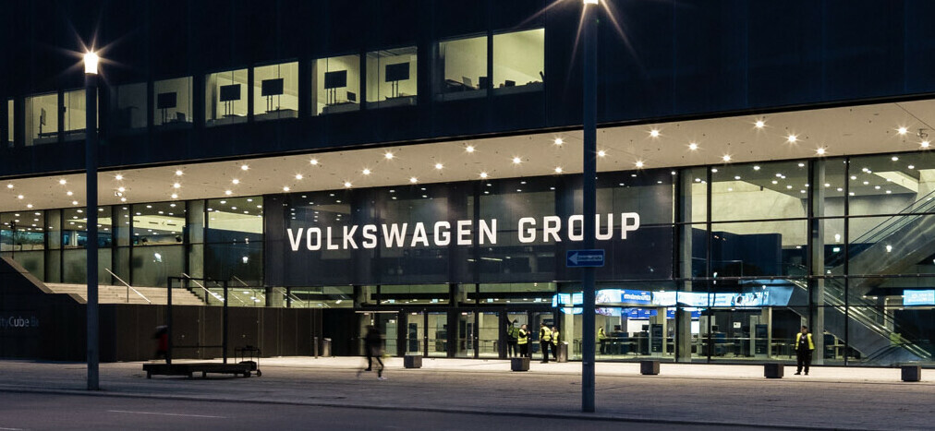
Figure 1: Volkswagen Group
(Source: Volkswagen, 2026)
Volkswagen has a global presence in the rest of Europe, China, North America, and emerging markets, and China is a strategically important country in terms of both volume and profitability. As a part of dealing with structural changes in the automotive business, the Group has made electrification a core element of its long-term plan (VWGroup, 2026). This will involve investing considerable amounts of money into battery technology, such as dedicated EV platforms, charging infrastructure, and software development. The shift toward electricity vehicles is embedded in more generalised goals of digitalisation and carbon neutrality, which needs a significant investment of capital and a long-term investment.

Industry and Market Context
Global EV market is dominated by stiff competition, high rates of technological dynamism, and changing consumer demands. Incumbents and pure-play EV manufacturers face each other and put more pressure on pricing, innovation cycles and cost efficiency. In the case of Volkswagen, it is necessary to balance the cost-based advantages achieved on a large scale and the agility and computer features that EV customers demand more and more (Almehairbi et al., 2024). Regulatory forces are determining factors in terms of industry dynamics. Tighter emissions standards, carbon cut incentives and state subsidies to take up EVs have brought about a faster demise of internal combustion engine-powered cars, especially in Europe and some regions of Asia.
Moreover, compliance cost and policy uncertainty adds financial risk and complexity to the planning. The technological forces consist of the fast developments of battery efficiency, autonomous driving, and digital vehicle architecture, which require the continuous research and development investment (Máté, and Péter, 2022). Regulatory, investor, and consumer sustainability requirements also dictate that Volkswagen must synchronise financial performance with social, environmental, and governance goals, which adds weight to the importance of financial discipline in the first few years of EV transition.

Financial Health Check: Five-Year Performance Analysis

Overview of Financial Performance
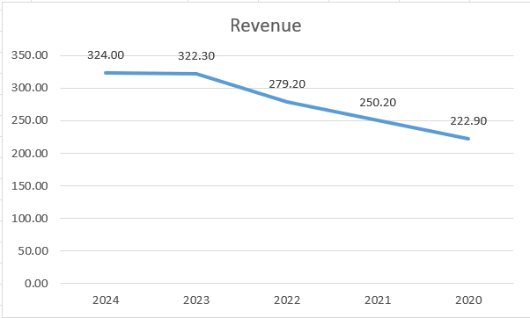
Figure 1: Revenue
(Source: Learner)
The Volkswagen Group had a firmly positive financial recovery and following stabilisation during the period 2020 to 2024 despite being in an environment disrupted by the pandemic, supply chain pressures, inflationary pressures, and a rapid response to investment in electric mobility. Group revenue had an evident upwards trend and increased to over £320 billion as compared to around £223 billion in 2020 (VW Financial reports, 2026). The sequence of sharply decreased revenue during the year 2020 because of the combination of global lockdowns and a decreased need in vehicle demand gave way to the steady increase in revenue since the year 2021 because of better pricing and product mix optimisation alongside greater sales of vehicles with higher profit margins, such as those with electric and premium organisations.
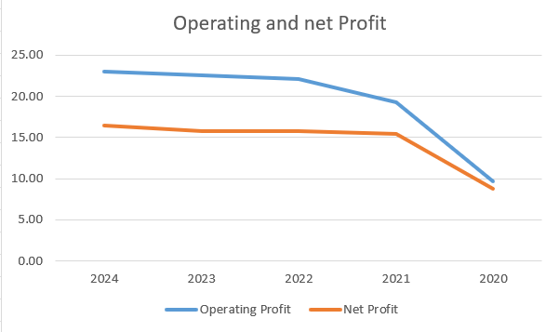
Figure 2: Operating profit and net profit
(Source: Learner)
The trends of profitability show that there will be a massive recovery following 2020. Operating profit grew to over the year 2022 and continued to be generally stable through 2023 and 2024, rising to more than that of less than £10 billion in 2020. The same trend was observed in Net profit that increased to about £15-£16 billion in the later years of the period following an increase to about £8.8 billion in 2020 (VW Financial reports, 2026). This recuperation is a pointer of suitable expenses, upgraded functional effectiveness, and enhanced margins, yet the development of revenue slowed in the later years as the cost of inputs increased and expenditures on electrification, software development, and battery technologies continued.
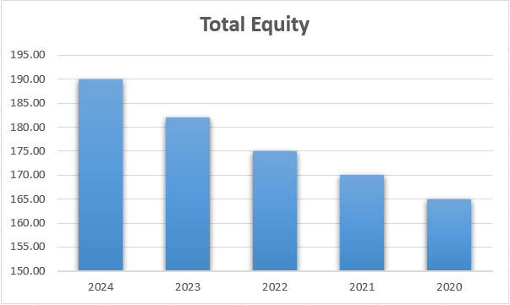
Figure 3: Total equity
(Source: Learner)
The asset base continued to grow during the last five years and was approximately around £560 billion in 2024, compared to 2020, which was slightly less than £490 billion (VW Financial reports, 2026). This expansion underscores how capital-intensive Volkswagen has been especially in production plants, battery plants, research, and development as well as digital infrastructure. Both the growth of total assets represents its long-term strategic investment where commitment to the electric vehicle transition is provided, and it enlarges depreciation and capital usage.
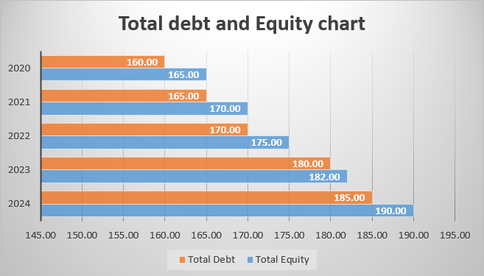
Figure 4: Total debt and total equity
(Source: Learner)
In case of the capital structure, Volkswagen has had a fairly consistent debt- equity ratio. Total equity grew slowly through the years as it grew to between the years 2020 and 2024 to between £165 billion to about £190 billion with the help of retained earnings and a better profitability (Barth et al., 2022). The increase in total debt was also moderate with it ending up being about £185 billion in 2024. The debt-to-equity ratio was kept at a close 1.0 over the period of time indicating a balanced approach towards financing. This stability represents a sign of sound financial management, which will enable Volkswagen to allocate significant sums of money on strategic investment, and maintain financial health and creditworthiness in the process of moving toward electric mobility.
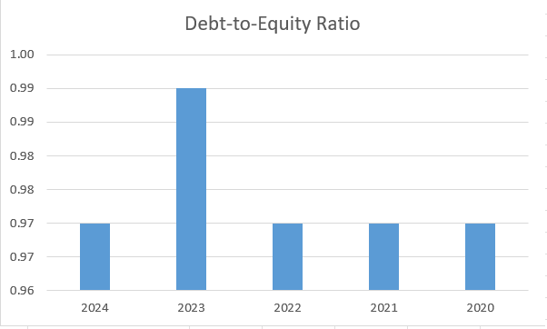
Figure 5: Debt to equity ratio
(Source: Learner)

Profitability Ratio Analysis
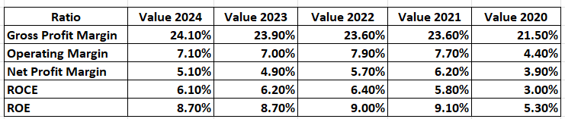
Figure 6: Profitability Ratio
(Source: Learner)
The profitability ratios reveal that the Volkswagen Group has been able to increase its financial standing considerably since 2020. Gross profit margin increased by 21.5% in 2020 to 24.1% in 2024, with good pricing policy and better product mix especially in higher margin products (Ding et al., 2023). The operating margin also rebounded favourably with a margin of 4.4% and 7.1% and this is an indication that the expenses are being managed well despite the increase in electrification and input prices. There was an improvement in bottom-line resilience as the net profit margin rose to 5.1% against 3.9%. However, the returns are still average, with ROCE levelling off at 6.1% in 2024 and ROE at 8.7% indicating that profitability has recovered but still, capital-intensive investments in EV syndicate hold returns down (Welc, 2022).

Liquidity Ratio Analysis
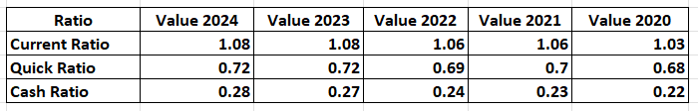
Figure 7: Liquidity Ratio
(Source: Learner)
The liquidity ratios indicate that Volkswagen Group has sufficient and somewhat strained short-term liquidity. The current ratio stood at a steady 1.08 in 2024 which is slightly better than 1.03 in 2020, reflecting a potential minor strengthening of the working capital position in Syria (Vuojela, and Rascon, 2022). However, the quick ratio remained under 1.0 and increased marginally by 0.68 in 2020 to 0.72 in 2024, which is further indication of still having recourse to inventory to settle the liabilities. The cash ratio also increased slightly with the ratio of 0.22 then shifting to 0.28, which may mean that the cash buffers are stronger whereas liquidity remains low due to the investment needs, which are still capital-intensive.

Efficiency Ratio Analysis
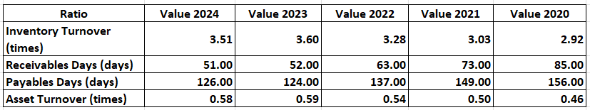
Figure 8: Efficiency Ratio
(Source: Learner)
The efficiency ratios indicates that the Volkswagen Group has made advancements in terms of its operational efficiency in the go. The increase of the inventory turnover is also indicative of improvement in management and production planning, as the turnover was 2.92 times in 2020, and 3.51 times in 2024 (Che, Katayama, and Lee, 2023). The receivables days becoming much lower, 85 to 51 days indicated a better control of the credit and faster cash collection. The number of days payable was reduced to 126 days, which is an indication of decreased dependence on supplier credit, which can have a minor impact of straining short-term cash. The asset turnover has improved to 0.58 which has been 0.46 such that they are making better use of the increasing asset base to create revenue (Poth et al., 2023).

Gearing and Solvency Ratios
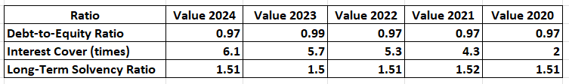
Figure 9: Gearing and Solvency Ratio
(Source: Learner)
Both the gearing and solvency ratios represent that the Volkswagen Group have a stable and manageable capital structure. Debt-to-equity ratio was kept at a fairly steady level of 0.97 between 2020-2024, which indicates the experience of balanced debt and equity financing (Ko et al., 2022). The interest cover has also improved greatly on the 2.0 times in the year 2020 to 6.1 times in the year 2024 indicating an enhanced capability in covering the finance expenses as operating profitability rose. Long term solvency has been very strong and total assets have been able to absorb total liabilities more than 1.5 times in the course of the period which gives in sound long term financial health despite heavy capital investment commitment in the process (Jong, and van, 2022).

Investment and Cash Flow Ratios
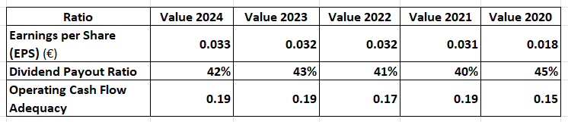
Figure 10: Investment and Cash Flow Ratios
(Source: Learner)
Investment and cash flow ratios indicate that, Volkswagen Group has also performed better returns to shareholders and maintained cash flow discipline. The net profitability recovered and earnings per share went up to an average of 0.033 in 2024 compared to 0.018 in 2020 (Ding et al., 2024). Dividend payout was relatively steady, ranging between 40 and 43, which is a good sign of a decent compromise between rewarding the shareholder and retaining funds to make investment in electrification. The operating cash flow adequacy rose to 0.19 as of 2024 compared to the previous 0.15 in 2020 indicating and improved operations cash generation, but the flow of cash is still limited in relation to short-term obligation as there is still a long-term demand on capital expenditures (Rahmati et al., 2022).

Key Trends, Strengths, and Financial Risks
The financial analysis highlights several key strengths for Volkswagen Group. Profitability has improved significantly since 2020, as operating margin increased to 7.1% against 4.4% and net profit margin rose to 5.1% (Hasan, Noth, and Tonzer, 2023). Indicators of liquidity also improved slightly because the current ratio increased to 1.08, whereas the cash ratio went to 0.28, which reflects better short-term financial health. The improvement in the efficiency is seen in the closing receivables days versus 85 days and growth in inventory turnover to 3.51 times, which leads to healthier conversion of cash. Moreover, the gearing was not changing significantly and the debt to equity ratio was almost fixed at 0.97 and the interest cover was raising to 6.1 times, which represented manageable financial risk (Li et al., 2023).
Regardless of such strengths, some significant weaknesses and new threats exist. In 2024, its quick ratio remained at 0.72 below 1.0, which shows that the company has continued to rely on inventory to cover its short-term liabilities. Capital returns are not high, and ROCE is only steady at 6.1%, indicating the capital-intensive aspect of EV investments (Babangida, Light, and Szemes, 2023). The financial risk associated with continuing capital spending and inflation of inputs as well as technical uncertainty in the development of batteries and software is a continuing threat to finances which may limit returns going forward.

Working Capital Management Analysis

Cash Operating Cycle Analysis
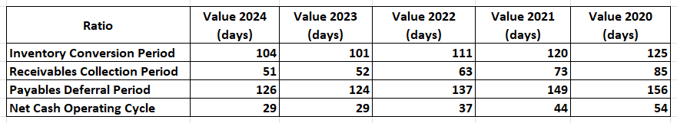
Figure 11: Cash Operating Cycle
(Source: Learner)
The cash operating cycle analysis shows that Volkswagen Group has been very efficient with its working capital throughout the period. Compared to 125 days of inventory conversion in 2020, the inventory conversion period in 2024 is lower, 104 days, demonstrating stricter control over the inventory, and more manageable production planning. The collection also improved as the days of collection improved to 51 days as compared to 85 days, and the fastened flow of cash. Even though the period of the payable’s deferral decreased 156 days to 126 days, cutting down the level of supplier financing, the same was outweighed by the improvement in inventory and receivables management (Mohanty et al., 2023). This had a significant impact on the net cash operating cycle which is reduced by 54 days in 2020 to 29 days in 2024.
This narrowing indicates an improved liquidity management and less dependency on short term external financing. However, the positive cash cycle balance is that Volkswagen continues to capture cash in operations that, as well as its current capital-intensive investments on EVs, continues to exert strain on internal cash generation and supports the significance of internal cash discipline.

Liquidity Management Challenges
Liquidity management is one of the most critical aspects of Volkswagen Group since the process of switching to electric vehicles cannot be provided in the short term and involves significant capital expenditures. The growth of the asset base up to circa £560 billion in 2024 compared to circa £488 billion in 2020 is an indication of the heavy spending in the area of battery plants, software platforms, and the construction of EV manufacturing premises (Habib, and Dalwai, 2024). As the operating profit is restored to approximately £23 billion in 2024, liquidity ratios are still very narrow as the current ratio is fixed at 1.08 and the quick ratio is at 0.72, indicating a lack of short-term financial flexibility. Adequacy of cash flow also was less than 0.20 that means that internally generated cash is inadequate to comfortably meet the short-term credit requirements in making strategic investments.
Complexity in the supply chain also enhances the liquidity risk. The content of inventory is one of the significant working capital and the inventory turnover days are 104 in 2024 which makes Volkswagen vulnerable to semiconductor scarcity, fluctuations in battery material prices, and geopolitical interference (Aldubhani et al., 2022). Despite the increased efficiency of inventory as compared to the situation observed in 2020, the decreased payables deferral to 126 days restricts the capabilities of the Group to depend on supplier financing. Combined, both high and capital expenditure requirements and persistent uncertainty in supply chains exert pressure on the short-term liquidity requirements and forces the need to optimise the working capital with diligence to maintain financial stability throughout the EV transition process.

Strategies to Improve Working Capital Efficiency
In the effort to increase efficiency in the working capital, Volkswagen Group shall concentrate on greater control over its inventory, receivables, and payables in support of its EV growth strategy. The issue of inventory optimisation is paramount, since inventory continues to tie cash of about 104 days in 2024. Additional cuts can be realised by more efficient demand prediction of EV model, increased modular platform consumption, and better coordination with battery and semiconductor suppliers (Mandipa, and Sibindi, 2022). A 10% decrease in inventory days would also liberate a lot of cash and would also reduce the cash operating cycle to less than its current level of 29 days. The management of a receivable should be concerned with maintaining the current gains, and the level of 51 days in 2021 already outperforms current receivables days, which were 85days in 2020 (Habib, and Kayani, 2022).
This could be enhanced by tightening credit evaluation conditions, difficult invoicing in digital form, and enhancement of advance payments or leasing arrangements in the Financial Services Division, which would accelerate the cash flow. There is also the need of a more strategic approach towards paying. Even though the payables days decreased to 126 days, it was possible to negotiate supplier terms selectively to cover the high-value EV components and to some degree reestablish supplier financing without causing a relationship to be damaged (Jaworski, and Czerwonka, 2022). Improving the balance between payables extension and stability of the supply chain would offset liquidity pressure resulting as a consequence of continued investment intensive investment.

Short-Term vs Long-Term Financing Options
The Volkswagen Group faces the challenge of striking a balance between short-term and long-term financing to manage the liquidity aspects in the EV transition. The short-term facilities like trade credit, overdraft and short-term loans bring in the flexibility in the management of day to day working capital requirements. Trade credit is also important with the payables days standing at 126 days in 2024 and are conducive in aiding the operations partly (Kotcharin, and Jantadej, 2024). Nevertheless, the overdependence on short-term borrowing would raise the refinancing risk and leave the Group vulnerable to interest rate volatility with the current ratio being only 1.08 and the operating cash flow being sufficient 0.19. Capital intensive investments made by Volkswagen on EV are better aligned when it comes to long term financing.
Long-term assets such as battery plants and EV platforms can be matched with finance maturity through the use of bonds and long-term debt. The Group has the stable debt-to-equity ratio of about 0.97 and interest cover of 6.1 times, which means that there is no additional capacity to cover more long-term debt without the essential deterioration of the solvency (Rodeiro et al., 2023). Equity financing is dilutive but it provides greater strength to the balance sheet and enhances long term strength. In general, Volkswagen is more favourable to use long-term sources as the main approach to strategic investments and utilise short-term sources to occasionally hedge the working capital variability and maintain the financial stability.

Strategic Financial Restructuring Plan

Rationale for Financial Restructuring
Electric mobility has radically changed the financial profile of Volkswagen Group and thus restructuring the finances has become a strategic priority, but not a desire decision. The shift to EV is very capital-intensive, which can be measured by the increase of the asset base up to about £560 billion in 2024 in comparison to the asset base of nearly £488 billion in 2020 (Huang, Chan, and Chung, 2022). There is a heavy investment in battery gigafactories, EV platforms, software development, and charging infrastructure which have added to the fixed costs and amount deployed. Although the operating profit is recuperating, at about £23 billion was reached in 2024, the margins are under strain since the increasing input costs, stiff competition, and the original lower profitability of EV models over internal combustion vehicles (Mufti, Awan, and Islam, 2023). Further pressure in cash flow is also an independent indicator of the necessity of restructuring.
The improved operational performance also resulted in the inadequacy of operating cash flow of less than 0.20, which implied that the company had little internal capacity to finance both short-term and long-term strategic investments at the same time (Anorue, and Ugwoke, 2022). This together with a net cash operating cycle of 29 days emphasises the liquidity pressure of the EV conversion. Restructuring of financial methods is consequently needed to re-equilibrium capital distribution, safeguard margins, and provide definite financial flexibility to remain competitive in the long run.

Proposed Restructuring Options
Asset Divestiture
Selective protection is an effective tool of restructuring to release the capital confined in non-core or lower-paying operations. Volkswagen has an extensive range of business divisions and brands that imply relatively low margins or insufficient strategic compatibility with the EV shift. The disposal of mature or non-core assets may also result in instant cash flows, decreased capital employed and an enhanced return on capital employed which currently stands at about 6.1 (Rudacogora, Kihooto, and Muhimpundu, 2022). These divestments would also reduce depreciation and fixed cost expenses, relieving the operating margin pressure.
Strategic Partnerships or Mergers
Strategic alliances provide an alternative to direct such a divestment and still retaining long-term growth prospects. Cooperation in battery technology, software development or charging infrastructure would decrease duplication of investment and distribute financial risk. Partnerships allow cost-sharing and accelerating innovation without significant changes to leverage because of the amount of investment needed in such areas (Lefebvre, 2022). Mergers or joint venture could also be used in the selected markets or technology segments to enhance market positioning and minimise competition, as well as enhance economies of scale.
Equity Injection or Debt Refinancing
Equity injection either done via retained earnings or selective issue would shore up the balance sheet and will enable the company to have long term funding without the need to pay out more in terms of debt service (Balaban, Stoiljković, and Madžar, 2023). Even though the equity financing is dilutive, it enhances the financial stability at the time of a strategic transition. Refinancing of debts can also be considered, especially through increasing the maturities and fixing of the interest rates. As the interest cover has risen to 6.1 times in 2024, with the debt-equity ratio remaining at around 0.97, Volkswagen is able to optimise its debt position without compromising solvency (Lubis, Riyadi, and Suharmiati, 2024).

Impact on Shareholder Value
Solvency reorganisation would result in better shareholder value mainly in terms of improved earnings stability and a lower financial risk. The asset divestitures and partnerships can stabilise operating earnings by reducing the exposure to the very volatile or low-return segments. The enhanced cost efficiency and lower capital intensity would facilitate more steady margins as the net profit margin decreased in 2021 and then 2024, the margin stood at 6.2% and 5.1%, respectively (Aniebonam, 2024). Another important advantage is the improvement of risk profiles. Restructuring minimises the amount of refinancing risk and liquidity risk through reducing short-term financing dependence and liquidity buffers. Stable dividend payout ratios of approximately 40% to 43% indicate that Volkswagen has already assumed the balance between shareholder payouts and reinvestment requirements (Krzywdzinski et al., 2023). In the long term, a more disciplined and focused organisation will be in a better position to create sustainable cash flows which will help create long term values other than short term fluctuations in earnings.

Impact on Capital Structure and Flexibility
The capital structure and financial flexibility will be significant implications of the restructuring measures. Sale of assets and common share offers would lower gearing or avert over leverage build up, and keep the debt-to-equity ratio near its present level of 0.97. This compromised parity is essential in maintaining investment grade credit quality and access to capital markets. The main consideration of restructuring is the cost of capital. Other debt can be relatively cheap in short term but fluctuation of interest rates and unpredictability in the long term can lead to increasing cost of finance (Singh, Hamid, and Garza, 2023). Through increased operational efficiency and reduced capital intensity, Volkswagen can reduce the weighted average cost of capital in the long run. Further financial freedom means the management will be able to respond to market shocks, regulatory changes or a technological disruption better without the sacrifice of strategic goals.

International and Ethical Considerations
The international business that Volkswagen experiences has exposed the company to risks of currency and inflation especially in markets where the exchange rates are volatile or the costs of inputs are high. Restructuring of finances must therefore be accompanied by more balance of funding to revenue streams so that exposure in foreign currency is decreased. Inflationary prices particularly on battery materials and energy also support the necessity of long-term rates of financing which creates cost certainty (Singh, Hamid, and Garza, 2023). Taxation factors also play a bigger role. The restructuring of decisions like divestments or intra-group financing must be made in a way that does not violate international tax laws but would not create reputational risk of an aggressive tax planning. To sustain investor and stakeholder confidence, transparency and regulatory compliance are critical issues.
Moreover, financial restructuring is connected to ESG, sustainability, and CSR responsibilities. The EV movement overlays the environmental goals and social and governance issues must be taken into account. Responsible restructuring must reduce the negative employment effects, harmonise ethical supply-chain operations, and facilitate long-term environmental undertakings (Zhao et al., 2022). A focused alignment of the financial restructuring with the sustainability objectives enhances the credibility of companies and facilitates access to the green financing, which bolsters the long-term sustainability of Volkswagen in terms of both strategy and financial matters.

Investment Appraisal and Capital Budgeting
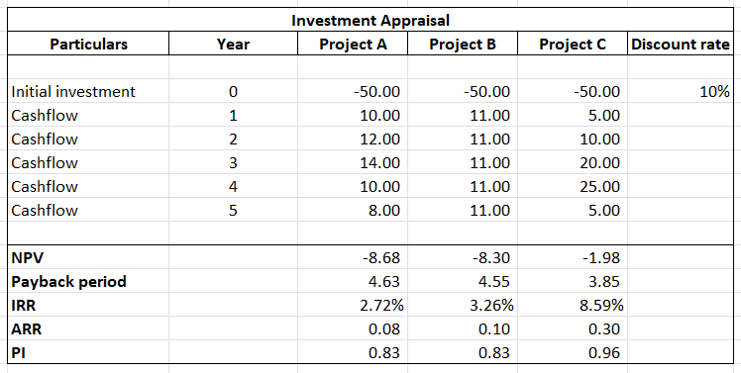
Table 12: Investment Appraisal
(Source: Learner)

Comparative Evaluation of Projects
A comparative investment analysis reveals that there are evident variations in the financial competence and the risk profile of the Projects A, B, and C. On the value creation side, none of the three projects pass the cost of capital as they result in negative net present values at a 10% discount rate. Project C has the strongest performance with NPV of -£1.98 million and a comparison of -£8.68 million of Project A and -£8.30 million of Project B. This implies that the Project C approximates to breakeven and applies the least value reduction (Pulignano, Hauptmeier, and Frans, 2023). An evaluation of the profitability index also confirms this estimation, and Project C was rated at 0.96, which is much greater than the index at 0.83 in the case of Projects A and B.
Regarding measures based on returns, Project C once again fares much better with a return of 8.59% internal, as opposed to 3.26% on project B and 2.72% on project A. The capital efficiency seems rather high in Project C as the project shows a higher IRR, despite the fact that all of these IRRs are lower than the 10% hurdle rate. The accounting rate of returns findings also give Project C a better position over Project B and Project A at 30% and 10%, respectively. Payback analysis shows that Project C will recover its initial investment within an approximate of 3.85 years, compared to 4.55 and 4.63 years with project B and A, respectively. The projects also have differences based on risk and cash flow timing. Project B has predictable and consistent annual cash injections of £11 million which minimise volatility risk but do not have a high potential (Yu, Li, and Wang, 2024).
Project A is characterised by moderate variability and Project C is characterised by an increased volatility in the early stages but with much bigger cash flow in year three and four. Even though this back-loaded structure exposes the Project C to forecasting and market risk, it also makes the Project C to be more financially appealing compared to Project D as it generates stronger cash in the middle of the term.

Project Recommendation
According to comparative investment appraisal and the current financial state of Volkswagen, the best alternative is Project C although all three projects have registered negative NPVs at a discount rate of 10%. Financially, Project C is the best performing of the three, having the least negative NPV of -1.98m, in comparison to -8.68m of Project A and -8.3 of Project B. It also provides the greatest internal rate of return at 8.59 and that is much higher as compared to the Project B of 3.26 years and Project A of 2.72 and has the shortest payback period of 3.85 years, finishing the capital recovery faster. Profitability index of 0.96 is another factor that depicts that Project C creates more value per pound invested as compared to the alternatives.
The recommendation is consistent with the financial standing of Volkswagen group, which, though better off, is at work because of capital-intensive investments in EVs (Grundy, Johnson, and Scholes, 2022). The operating margin came back to 7.1% in 2024, and the ROCE levelled off to 6.1%, implying a shortness of tolerance to projects whose returns are much lower than the cost of capital. There is a tight liquidity situation with a current ratio of 1.08 and adequacy of operating cash flows at 0.19, which supports the urgency of faster payback and higher levels of medium-term cash inflows. In project C, the increased cash inflows in years three and four, which peaks at £25 million, contribute to a better liquidity positioning over the less flatter and lower cash flows in Projects A and B. Even the factors that are not financial have been addressed.
The issue of political risk is up to date since Volkswagen operates all over the world, and it is exposed to the shifts in the policies on EV subsidies and trade. The greater cash generating profile of project C offers greater protection against changes in regulations thus allowing faster payback on the invested capital in case of a change in policies (Ahmadian, Alabdullah, and Motaghian, 2023). The threat of market demand is especially high in the EV industry because technology is changing rapidly, and consumer preferences will change as well. A higher return on project C indicates that it is more service-based on growth-oriented segments of the EV and will be a lot more robust in the event that the demand is realised.
Recommendation can also be supported by the customer loyalty. Volkswagen enjoys a good international brand and an existing customer base that makes the use of new EV-related projects less risky (Ramos, and Ruiz, 2024). The better financial projections of project C imply more opportunities to capitalise on such loyalty with the help of differentiated or value-added propositions. Therefore, Project C is the most strategically and financially justified investment option in that it has greater forecasting risk owing to later cash inflows, better financial standing owing to its stronger financial performance, swift payment, as well as its alignment with the constrained, yet improving financial position of Volkswagen.

Capital Rationing Decision (£100m Constraint)
Project Combination | Total Investment (£m) | Combined NPV (£m) | Average PI | Rationale
Project A only | 50 | –8.68 | 0.83 | Weak returns and low IRR make it unattractive as a standalone option
Project B only | 50 | –8.30 | 0.83 | Stable cash flows but low overall value creation
Project C only | 50 | –1.98 | 0.96 | Best standalone project with highest IRR and shortest payback
Project C + Project A | 100 | –10.66 | 0.90 | Higher total NPV loss due to weak performance of Project A
Project C + Project B | 100 | –10.28 | 0.90 | Lower combined NPV loss and more stable cash flow profile
Project A + Project B | 100 | –16.98 | 0.83 | Poorest combination with weakest aggregate returns
Table 13: Capital Rationing Decision
(Source: Learner)
The best investment portfolio under the condition of capital limitation of less than £100 million is Project C and Project B. This combination uses all the capital available with minimum negative total NPV (-£10.28m) in comparison with other portfolios. Project C will offer higher returns and quicker payback whereas Project B offers a stable and predictable cash flow will decrease the overall risk.

Conclusion
In 2024, the financial analysis indicates that Volkswagen Group has made a strong upward trend since 2020 as the revenues have increased to more than £320 billion, and the operating margin has also increased to 7.1. The cash operating cycle was decreased to 29 days because of the efficiency, whereas the solvency also improved, to 6.1 times interest cover; however, liquidity is limited with a current ratio standing at 1.08. As a CFO, such results emphasise the necessity of disciplined allocation of capital, prudent liquidity utilisation, and discriminating financial restructuring in order to facilitate the EV transition. Project C along with Project B under capital rationing presents the most balanced investment portfolio, which provides comparably high returns and which does not imply extreme cash flows. The financial sustainability of Volkswagen would rely on cost discipline, working capital optimisation, and the focus of investing in the creation of long-term in value.

References
Ahmadian, S., Alabdullah, T.T.Y. and Motaghian, I., (2023). Maintenance and repairs system of automotive industry for sustainable internationalization. International Journal On Advanced Technology, Engineering, And Information System, 2(2), pp.106-123.
Aldubhani, M.A., Wang, J., Gong, T. and Maudhah, R.A., (2022). Impact of working capital management on profitability: evidence from listed companies in Qatar. Journal of Money and Business, 2(1), pp.70-81.
Almehairbi, K., Al Suwaidi, O., Alfalahi, M., Ali, M. and Nobanee, H., (2024). Tesla Vs Volkswagen Group: A Financial Statement Analysis. Available at SSRN 5073919.
Aniebonam, E.E., (2024). Strategic management in turbulent markets: A case study of the USA. International Journal of Modern Science and Research Technology, 1(8), pp.35-43.
Anorue, H.C. and Ugwoke, E.O., (2022). Prevention of financial risk: Cash and inventory as a catalyst for working capital management for lifelong learning of small-scale operators. SEDME (Small Enterprises Development, Management & Extension Journal), 49(4), pp.368-384.
Babangida, A., Light Odazie, C.M. and Szemes, P.T., (2023). Optimal control design and online controller-area-network bus data analysis for a light commercial hybrid electric vehicle. Mathematics, 11(15), p.3436.
Balaban, S., Stoiljković, B. and Madžar, L., (2023). Role of working capital management in achieving profitability in Serbia. Ekonomika preduzeća, 71(7-8), pp.388-399.
Barth, F., Eckert, C., Gatzert, N. and Scholz, H., (2022). Spillover effects from the Volkswagen emissions scandal: An analysis of stock and corporate bond markets. Schmalenbach Journal of Business Research, 74(1), pp.37-76.
Che, X., Katayama, H. and Lee, P., (2023). Product-harm crises and spillover effects: A case study of the Volkswagen diesel emissions scandal in eBay used car auction markets. Journal of Marketing Research, 60(2), pp.409-424.
Ding, J., Xu, M., Tse, Y.K., Lin, K.Y. and Zhang, M., (2023). Customer opinions mining through social media: insights from sustainability fraud crisis-Volkswagen emissions scandal. Enterprise Information Systems, 17(8), p.2130012.
Ding, H., Jiang, F., Zhang, S. and Zhang, Z., (2024). Managerial myopia and corporate social responsibility: Evidence from the textual analysis of Chinese earnings communication conferences. Journal of Behavioral and Experimental Finance, 41, p.100886.
Grundy, T., Johnson, G. and Scholes, K., (2022). Strategic Financial Management. Bachelor of Business Administration Programme Code: BBA Duration–3 Years Full Time, 2(1), pp.1-575.
Habib, A.M. and Dalwai, T., (2024). Does the efficiency of a firm’s intellectual capital and working capital management affect its performance?. Journal of the Knowledge Economy, 15(1), pp.3202-3238.
Habib, A.M. and Kayani, U.N., (2022). Does the efficiency of working capital management affect a firm’s financial distress? Evidence from UAE. Corporate Governance: The international journal of business in society, 22(7), pp.1567-1586.
Hasan, I., Noth, F. and Tonzer, L., (2023). Cultural norms and corporate fraud: Evidence from the Volkswagen scandal. Journal of Corporate Finance, 82, p.102443.
Huang, C., Chan, F.T. and Chung, S.H., (2022). The impact of payment term extensions on the working capital management of an automotive supply chain. International Journal of Production Research, 60(24), pp.7360-7383.
Jaworski, J. and Czerwonka, L., (2022). Profitability and working capital management: evidence from the Warsaw stock exchange. Journal of Business Economics and Management (JBEM), 23(1), pp.180-198.
Jong, W. and van der Linde, V., (2022). Clean diesel and dirty scandal: The echo of Volkswagen’s dieselgate in an intra-industry setting. Public Relations Review, 48(1), p.102146.
Ko, H., Son, B., Lee, Y., Jang, H. and Lee, J., (2022). The economic value of NFT: Evidence from a portfolio analysis using mean–variance framework. Finance Research Letters, 47, p.102784.
Kotcharin, S. and Jantadej, K., (2024). Behavior of small and medium shipping enterprises’ working capital management: moderating role of firm-specific characteristics in times of crises and geopolitical risk. Cogent Business & Management, 11(1), p.2396544.
Krzywdzinski, M., Lechowski, G., Ferdinand, J. and Schneiß, D., (2023). The German path to electromobility and its impacts on automotive production and employment. On the way to electromobility–a green (er) but more unequal future, pp.179-206.
Lefebvre, V., (2022). Performance, working capital management, and the liability of smallness: a question of opportunity costs?. Journal of Small Business Management, 60(3), pp.704-733.
Li, M., Guo, Y., Luo, D. and Ma, C., (2023). A hybrid variable weight theory approach of hierarchical analysis and multi-layer perceptron for landslide susceptibility evaluation: a case study in Luanchuan County, China. Sustainability, 15(3), p.1908.
Lubis, B.P., Riyadi, R. and Suharmiati, S., (2024). Analysis Influence Management Capital Work, Company Size and Capital Structure To Profitability. Jurnal Ilmiah Akuntansi Kesatuan, 12(2), pp.303-312.
Mandipa, G. and Sibindi, A.B., (2022). Financial performance and working capital management practices in the retail sector: empirical evidence from South Africa. Risks, 10(3), p.63.
Máté, G.B. and Péter, F., (2022). Volkswagen Group marketing, economic and financial analysation. In Proceedings of FIKUSZ Symposium for Young Researchers (pp. 603-621). Óbuda University Keleti Károly Faculty of Economics.
Mohanty, A., Venkateswaran, N., Tripathi, M.A. and Boopathi, S., (2023). Innovative Strategy for Profitable Automobile Industries: Working Capital Management. In Handbook of Research on Designing Sustainable Supply Chains to Achieve a Circular Economy (pp. 412-428). IGI Global.
Mufti, M.A., Awan, Z.H. and Islam, J., (2023). Examining The Critical Role of Working Capital Management and Capital Structure on Financial Performance of Manufacturing Firms: An Empirical Assessment. International Journal of Business and Economic Affairs, 8(3), pp.192-199.
Poth, A., Kottke, M., Mahr, T. and Riel, A., (2023). Teamwork quality in technology‐driven product teams in large‐scale agile organizations. Journal of Software: Evolution and Process, 35(8), p.e2388.
Pulignano, V., Hauptmeier, M. and Frans, D., (2023). Determinants of union strategies towards the twin digital and green transitions in the German and Belgian automotive industry. Transfer: European Review of Labour and Research, 29(1), pp.121-138.
Rahmati, S., Mahdavi, M.H., Ghoushchi, S.J., Tomaskova, H. and Haseli, G., (2022). Assessment and prioritize risk factors of financial measurement of management control system for production companies using a hybrid Z-SWARA and Z-WASPAS with FMEA method: a meta-analysis. Mathematics, 10(2), p.253.
Ramos, M.R. and Ruiz-Gálvez, M.E., (2024). The transformation of the automotive industry toward electrification and its impact on global value chains: Inter-plant competition, employment, and supply chains. European Research on Management and Business Economics, 30(1), p.100242.
Rodeiro‐Pazos, D., Fernández‐López, S., Rios‐Rodríguez, R. and Dios‐Vicente, A., (2023). Working capital management and firm sales growth: Evidence from fish processing industry. Agribusiness, 39(4), pp.1254-1278.
Rudacogora, B.R.U.C.E., Kihooto, E.M. and Muhimpundu, M.A.R.T.H.E., (2022). Effects of working capital management on profitability of manufacturing companies in Rwanda. The Strategic Journal of Business & Change Management, 9(1), pp.1-15.
Singh, J., Hamid, A.B.A. and Garza-Reyes, J.A., (2023). Supply chain resilience strategies and their impact on sustainability: an investigation from the automobile sector. Supply Chain Management: An International Journal, 28(4), pp.787-802.
Volkswagen (2026). https://www.volkswagen-group.com/en (Accessed on: February 2, 2026).
Vuojela, J. and Rascon, A., (2022). Too Big to Fail Applied to Non-Financial Companies. In Resilienz durch Organisationsentwicklung: Forschung und Praxis (pp. 315-336). Wiesbaden: Springer Fachmedien Wiesbaden.
VW Financial reports (2026). https://www.volkswagen-group.com/en/financial-reports-18134#2024 (Accessed on: February 2, 2026).
VWGroup (2026). https://www.volkswagen-group.com/en/about-us-16013 (Accessed on: February 2, 2026).
Welc, J., (2022). Financial statement analysis. In Evaluating corporate financial performance: tools and applications (pp. 131-212). Cham: Springer International Publishing.
Yang, Y., (2024). Transformation and Development of New Energy Vehicle Industry Based on Social Policy Inquiry. Advances in Economics, Management and Political Sciences, 109, pp.8-13.
Yu, H., Li, Y. and Wang, W., (2024). Does the dual-credit policy promote the technological development of new energy vehicles? An industry chain reconstruction perspective. Heliyon, 10(10).
Zhao, F., Liu, X., Zhang, H. and Liu, Z., (2022). Automobile industry under China’s carbon peaking and carbon neutrality goals: challenges, opportunities, and coping strategies. Journal of Advanced Transportation, (2022)(1), p.5834707.

