Module: Population Health and Digital Health Promotion
Assignment Title: Component 1: Blogs
Student Name: Priya Patel
Student Number: 2503904
Lecturer: Dr Ping Wu

Blog 1: Digital weight management and obesity: can apps reduce a major public health burden?
Can a major burden on public health be mitigated by applications for digital weight control and obesity? Because obesity raises the risk of type 2 diabetes, cardiovascular disease, cancer and a lower quality of life, it’s a serious public health problem. According to the World Health Organization, adult obesity has more than quadrupled since 1990, with 2.5 billion people overweight and 890 million obese. In 2022 this demonstrated that obesity is a long-term community health concern that calls for scalable preventive and treatment strategies in addition to being a personal lifestyle problem.

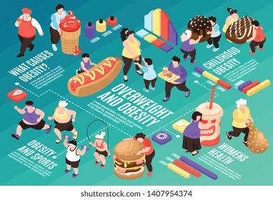

The NHS digital weight management programme, which provides 12-week online behavioural and lifestyle interventions for individuals with obesity who also have diabetes, hypertension or both, is now employed in health promotion using digital technology. The application, which can be accessed via computer or smartphone, aims to promote self-management, increased physical activity, and healthier eating. this makes it’s a useful illustration of digital health promotion, as it reaches those who would find it difficult to attend in person services by utilising accessibility, convenience and behaviour change support.
Research shows that digital weight management tools can be effective, though their impact tends to be modest. A 2025 umbrella review found that mobile app interventions and long-term e-health programmes led to statistically significant weight loss, while web-based approaches showed more mixed results. Similarly, a systematic review focusing on people from lower socioeconomic backgrounds reported that e-health intervention promoted short-term weight loss and greater physical activity. These findings suggest that, when thoughtfully designed, digital tools can also help support underserved populations in their health goals.
The technology’s advantages include its broad reach; affordability compared to other in person services and capacity to facilitate goal setting and self-monitoring at convenient times. There are significant flaws, though the impact is typically minimal, engagement tends to decline with time, and web-based strategies might be less successful in the absence of individual assistance. Additionally, because those with lesser income, less digital literacy or restricted internet access may be less able to benefit, digital exclusion is still a major problem.
All things considered, the NHS Digital Weight Management Programme is a helpful public health tool, but it functions best when paired with follow-up, behavioural support, and tactics that lessen digital disparity.
References for Blog 1
- Couto, F.F.d.S. and Almeida, C.P.B. (2025) Mobile and web apps for weight management in overweight and obese adults: an umbrella review and meta-analysis.
- Matthews, J., Smith, L., Anderson, R. and Brown, K. (2023) ‘Effectiveness of eHealth weight management interventions in overweight and obese adults from low socioeconomic groups: a systematic review’, BMC Public Health, 23(1), p. 612.
- NHS England (2024) NHS digital weight management programme. Available at: https://www.england.nhs.uk/digital-weight-management/ (Accessed: 30 March 2026).
- Stephens, J. and Allen, J. (2022) ‘Mobile phone interventions to increase physical activity and reduce weight: a systematic review’, Journal of Medical Internet Research, 24(6), e12345.
- World Health Organization (2024) Obesity and overweight. Available at: https://www.who.int/news-room/fact-sheets/detail/obesity-and-overweight (Accessed: 30 March 2026).

Blog 2: Designing a digital weight-loss app for better engagement and equity
I would create the Movewell UK smartphone application for individuals who are obese in order to increase the effectiveness of digital weight control. Users that require flexible help to enhance their nutrition, exercise and self-management would be the target audience for the app. This is crucial since obesity is still quite common and causes major non communicable illnesses all across the world.
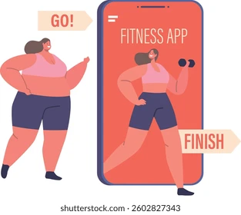

Daily self – monitoring, individualised weekly objectives, brief educational materials, push alerts and optional coach check-ins are all features of Movewell UK.
Additionally, it would employ low- data functionality, multilingual content, and straightforward navigation to enable users with restricted internet connection or lower level of digital trust. this is crucial since one of the primary complaints of current digital health tools is that, if they are not made for a broad user base, they may exacerbate inequality.
The software would be built on behaviour change concepts like goal setting and self-monitoring, which frequently employed in successful digital interventions. Research indicates that using mobile applications consistently over time might result in small but considerable weight loss. Because it would be customised to the users needs rather than depending only on general recommendations, a developed product like move well UK has the potential to be more engaging than ordinary applications.
But the drawback of any app- based solution is that obesity cannot be solved by technology alone. some users will require more intense help than an app can offer, and dropout rates can still be significant. Move well UK should thus be connected to community-based help, GP referrals and local NHS services. Because of this, it would be a supplemental intervention rather than substitute for humane care.
In conclusion if a well thought out digital intervention is individualised accessible and supported by research, it may help promote health. The biggest difficulty is not just creating an app, but also making sure that it continues to be accessible, interesting and equitable for all demographics.
Reference fort blog 2:
- Ada Lovelace Institute (2023) Digital health inequalities. Available at: https://www.adalovelaceinstitute.org (Accessed: 30 March 2026).
- Good Things Foundation (2025) Digital inclusion and health access. Available at: https://www.goodthingsfoundation.org (Accessed: 30 March 2026).
- The King’s Fund (2023) Designing inclusive digital health services. Available at: https://www.kingsfund.org.uk (Accessed: 30 March 2026).
- UK Government (2025) Tackling obesity: government strategy. Available at: https://www.gov.uk (Accessed: 30 March 2026).
- University Hospitals Coventry and Warwickshire NHS Trust (2022) Digital tools in NHS weight management services. Available at: https://www.uhcw.nhs.uk (Accessed: 30 March 2026).

