

THE DEVELOPMENT OF INFOGRAPHICS AND WHAT EFFECT THEY HAVE HAD

Joshua Munn - P144540

BA Graphic Design

Total Word Count : 5057 Words

List Of Illustrations

Illustration 1 : Diagram of the causes of mortality in the army in the East, Florence Nightingale, 1859 [online] Available at: https://upload.wikimedia.org/wikipedia/commons/1/17/Nightingale-mortality.jpg [Accessed 11 Nov. 2017].

Illustration 2 : Deaths In The British Army (A take on Florence Nightingale’s Coxcomb in the form of a bar graph) By Hugh Small (2010), [online] Available at: http://www.florence-nightingale-avenging-angel.co.uk/?p=462 [Accessed 11 Nov. 2017].

Illustration 3 : Mapping The 1854 Cholera Outbreak, John Snow, 1854, By Hugh Small (2010), [online] Available at: http://www.florence-nightingale-avenging-angel.co.uk/?p=462 [Accessed 14 Nov. 2017].

Illustration 4 : Temperature and Mortality of London. William Farr, Report on the Mortality of Cholera in England, 1848-1849. London, 1852 [online] Available at : https://i.pinimg.com/originals/77/c6/6a/77c66a07fb30cd46105bedde41b399c6.jpg [Accessed 28 Nov. 2017].

Illustration 5 : Business Insider - Election 2016 [online] Available at:
http://static3.businessinsider.com/image/583c8f50ba6eb69a018b66b9/heres-the-final-2016-electoral-college-map.jpg [Accessed 3 Dec. 2017].

Illustration 6 : Associated Press - Election 2016 [online] Available at:
https://d3i6fh83elv35t.cloudfront.net/newshour/wp-content/uploads/2016/11/electoral-map.png [Accessed 3 Dec. 2017].

Illustration 6 : American Election 2012 Actual [online] Available at:
https://www.270towin.com/historical_maps/2012_large.png [Accessed 3 Dec. 2017].

Table Of Contents

Introduction | Page 4
Chapter 1 | Page 5
Chapter 2 | Page 12
Conclusion | Page 19
Bibliography | Page 21

INTRODUCTION:

This dissertation investigates the development of infographics, what effect they have had on society and what kind of change they have brought about throughout history. Infographics aren’t a new concept, they have been around for thousands of years, in the earliest forms of cave paintings and Egyptian hieroglyphics. Both of these examples were a way of telling a story through the use of images and symbols. Infographics have developed a lot since, however the core premise remains the same, Infographics are a way of providing the viewer with a lot of information in a very easy to read format. The famous saying; A picture is worth a thousand words very much applies to Infographics.

Chapter 1 will consider the historical aspect of Infographics, It will focus on examples of the most revolutionary Infographics, examples of Infographics that led to real change and that had a genuine effect on the lives of people and the world in general. It will look at such as examples as Florence Nightingale’s Crimean War Statistics, which influenced the Secretary of War to improve the medical facilities. This infographic showed that more Crimean War soldiers had died from preventable diseases such as cholera and typhus than in combat. As a result of these findings, the sanitary commission was sent out to improve the conditions and the facilities in the military hospitals. It will also look at John Snow’s Cholera map which helped make Doctors & Scientists understand that diseases such as Cholera and Typhoid weren’t caused by “bad air” and that in fact cholera was a result of contaminated water.

The second chapter will analyse Infographics from different time periods and analyse the visualisation techniques that were used. In this chapter I will touch upon how Infographics became as popular as they are now and discuss the reasoning behind it.

CHAPTER ONE: THE HISTORY OF INFOGRAPHICS & WHAT EFFECT THEY HAD

As I stated before, forms of Infographics have been around for thousands of years, however one of the earliest and most revolutionary forms of modern infographics is that of the legendary nurse Florence Nightingale. The National Archives (2017) states that while Britain was at War with Russia, on the 4th of November, Nightingale accompanied by 38 nurses arrived in Turkey. Upon her arrival she caught her first glimpse of the appalling conditions in the British military hospitals on the Crimean front. Wounded soldiers lay sleeping on hard floors in overcrowded rooms without sheets to cover them. Soldiers lacked even the basic necessities such as basic food and medicine and soldiers that were arriving at the military hospitals often had already contracted diseases such as cholera, typhus and dysentery [1]. Nightingale and her team of nurses did what they could in improving the wellbeing of the soldiers in the military hospitals, however it wasn’t until almost six months after she had originally arrived that the Sanitary commission was sent out, as a result of her work in raising awareness of the importance for sanitation, in order to clean up the hospitals, dispose of the sewage and revamp the ventilation [2]. As well as being a renown nurse in the British Military, Nightingale was also an excellent mathematician and statistic enthusiast, Bostridge, Mark (2008) noted in his book that even at an early age, she excelled at mathematics [3], it was her raw natural talent for mathematics and enthusiasm for statistics accompanied by her the data she collected during the Crimean war that resulted in her creation of her Coxcomb chart, Lewi, Paul J. (2006) stated that Nightingale was an essential figure in the use of medical statistics and that she believed that statistics were a way for politicians to make rational decisions based from sufficient data [4]. After the war when the Secretary Of War asked her to report on the conditions in the military hospitals in the Crimea, using the data she had collected during the Crimean war, she drafted a 830-page report filled with tables, charts and graphs. Nightingale truly feared that Queen Victoria would simply pass off a large medical report, in order to help even the most illiterate politician understand Julie Rehmeyer (2008) describes how Nightingale developed intricate ways to visualise the data gathered in her report [5]. Through her developments and data visualisation techniques Nightingale created the medical statistical infographic titled “Diagram of the causes of mortality in the army in the East”, one of the first iterations of what is now called the Polar Area Diagram or Coxcomb Chart in which she is credited for [6].
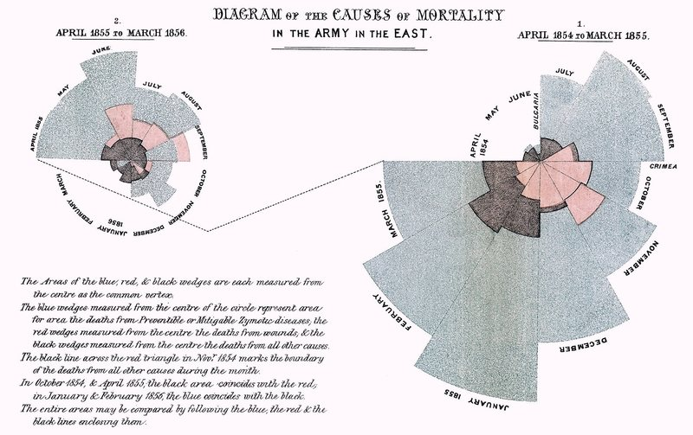
Diagram of the causes of mortality in the army in the East, Florence Nightingale, 1859
The diagram showed soldiers who died in the military hospitals by preventable diseases in blue, soldiers who died from battle wounds in red, and other causes of death in black. John H ,Lienhard (2000) describes how similar to a modern day Pie chart, Nightingale’s Coxcomb was divided into 12
equal sections and are displayed in a typical clockwise direction, each of the 12 sections accounting for a single month of the year. The outward lengths of the sections accounts for the number of deaths in that particular month [7]. This infographic was included in her 1859 report to the Secretary Of War titled : Contribution to the Sanitary History of the British Army, data had only been visualised in such a way a number of times in that time period, however Rehmeyer (2008) argues that she was one of the first to visualise data in order to persuade social change. Nightingale’s infographic had a huge impact, the Royal Sanitary Commission acted on the findings and the clean up resulted in the practices and the design of hospitals being completely revamped. As a result, the death rate plummeted, soldiers were provided with clean clothes and bed sheets and were also given the time to clean themselves [8] , Rehmeyer (2008) even goes as far as stating that as a result of the changes in hospital procedures and sanitation, that by the end of the century, Military mortality was lower than civilian mortality in contrast to times even before the war, Military mortality was still twice the amount of civilian mortality.

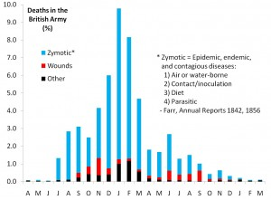
Despite Nightingale’s Coxcomb infographic being a universal success and bringing about social change, critics have often questioned her methods and also disputed despite being successful whether the Coxcomb chart really the best method of displaying information for the specific data she was portraying. Rehmeyer, (2008) questions whether a bar graph would have dramaticized Nightingale’s findings even more so and points out it certainly would have been a more conventional way of visualising the data, however states that the reasoning that Nightingale opted to go for the Coxcomb design method was because it allowed for easier comparison between the two graphs as the Coxcomb design meant that specific months of different years could be placed in the exact same place. Hugh Small (2010) in a paper to the Royal Statistical Society Of London, arguments counter Rehmeyer (2008)’s criticism regarding the usage of the coxcomb chart instead of a bar graph. Small (2010) notes in his paper that there is one fundamental rule when it comes to the design of statistical data, “time series data should be presented with time running on a horizontal axis from left to right” [9], A fundamental rule which Nightingale’s Coxcomb does not follow.
Deaths In The British Army (A take on Florence Nightingale’s Coxcomb in the form of a bar graph) By Hugh Small (2010)

Despite Nightingale’s design not following this rule, once Small created his own bar graph using Nightingale’s data he discovered that the bar graph while displaying the exact same data, simply did not tell the same story. Small (2010) notes that there are 2 main issues. Nightingale’s main aim with her original Coxcomb design was to show a clear comparison before and after the arrival of the Sanitary commission to emphasise the effect that sanitation had on the death rate. Small (2010) argues that the in order to do that with a bar graph there would have to be two side by side, and that it would not be as easily read as the side by side Coxcomb diagrams. The second issue with the bar chart that Rehmeyer (2008) believed would have worked better is that the bar graph displays the incredibly high death rate in the month of January so much so that it overshadows the rest of the data, giving the impression that the winter was the cause of the high death rate.
Small (2010) argues that the reason that the Coxcomb diagram is able to avoid giving this impression is because Nightingale used square root transformations in order to downplay the severity of the section height. Meaning that in the Coxcomb diagram, January doesn’t necessarily overshadow the rest because it has a wider area and the viewer’s eye isn’t immediately drawn to that particular month.
In summary, I personally agree with Small (2010)’s findings and believe that Nightingale’s use of the Coxcomb diagram was far more appropriate than the bar graph despite countless claims by critics. I believe she is still as revolutionary as she was when she first created the Coxcomb diagram as she is still sparking artistic debate on her methodology.

Nightingale wasn’t the only one to change the world using infographics, another revolutionary infographic that had a huge impact on the world as we know it was Dr. John Snow,
Simon Rogers (2013) stated that during the time of the 1850s, a time in which knowledge about germs and bacteria was scarce, society believed that diseases such as cholera were spread through the air [10]. This theory was called the Miasma Theory, the theory that claimed that diseases were spread via a form of toxic air, toxic air that was a result of Miasma, originating from decomposing organic matter [11]. J. Snow was skeptical of the Miasma theory and the Germ Theory Of Disease had to not been conceptualised at that time. Despite being a Doctor, like many others in his profession he did not understand how diseases manifested and transmitted. In September 1854, there was a cholera outbreak centered in Soho district, close to where he lived, because of his proximity to the outbreak he took it upon himself to investigate. He located all 13 water pumps that were in the Soho district and then noted all the Cholera deaths in the district, his notes showcased a significant number of deaths were located around this one particular water pump that was located near the intersection of what is now Broadwick Street. This particular water pump on Broad Street was located near a cesspit which was leaking cholera contaminated fecal matter. Snow analysed samples of water from the Broadwick Pump (and various other pumps) under the view of a microscope and discovered the presence of a then unknown bacteria in the water samples originating from the Broadwick Street pump. Snow’s findings received strong criticism and authorities were skeptical, however despite this the water pump was removed and as a result, Cholera cases in the Soho district decreased [12].

To further support his findings, he drafted his world famous Cholera map, the map showcased the locations of all 13 public wells and marked all 578 cholera deaths that he had noted during his investigation and organised them on the map as black bars perpendicular to the streets by home address.

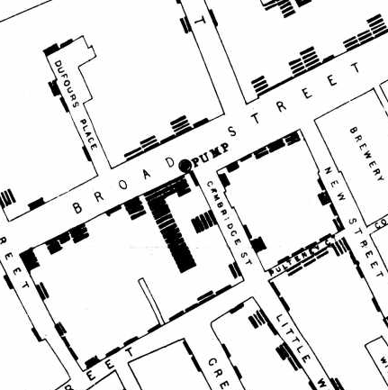
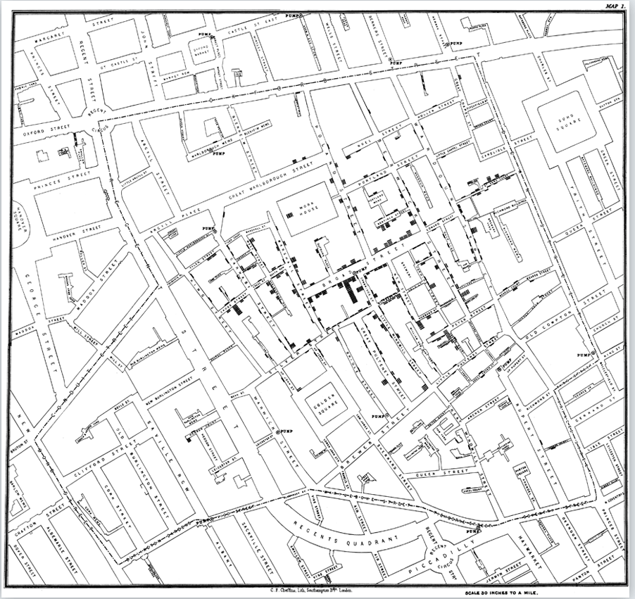

Mapping The 1854 Cholera Outbreak, John Snow, 1854
The map on the left is Snow’s Cholera map in full, the picture on the right is a close up view of Broadwick Street which showcases all the recorded cholera deaths and also the water pump which resulted in the outbreak in the Soho District.

The Miasma theory as it was originally believed that diseases were spread through “bad air” and since poverty stricken areas usually smelt of raw sewage it made the theory even more plausible, however Snow’s map helped further dispel the Miasma theory as it shows that just north of Broad street, where the contaminated pump was, there was a large warehouse in which over 500 paupers lived, the map shows that the warehouse had very few Cholera deaths, and that is because the warehouse had its own water supply, uncontaminated from the Cholera bacteria. Therefore despite being overcrowded with the poor, there were very few cholera deaths which contradicts the then accepted Miasma theory. Snow’s findings were not without its controversy however, despite successfully having the water pump removed, once the outbreak had subsided as a result, many were quick we're reject Snow’s findings.
Frank Chapelle (2005) argues that to accept Snow’s findings, would have to meant to accept to the fact that the public had been orally ingesting fecal matter and that was the way that the disease was transmitted, a fact that Chapelle (2005) argues was too much for the public to accept [13]. Deborah Cadbury (2003) states that it wasn’t until 7 years after Snow had originally published his report that his findings had began to take effect. This was because William Farr, another statistical journalist was investigating another Cholera outbreak at Bromley, an inner-city district of East London that he realised the validity of Snow’s findings. Once he accepted Snow’s theory, William Farr made an immediate order that water that had not been boiled first was not to be drunk [14]. In summary to this point, Snow’s map resulted in the downfall of the Cholera outbreak in the Soho District and the understanding that Cholera was a waterborne disease, and further paved the way for the conceptualisation of the Germ Theory Of Disease in the 1880s.

Similarly to Nightingale’s Coxcomb, despite its universal success, it didn’t come without its critics. Edward Tufte (2013) stated that the main issue with dot maps when it comes to geographical data is that it does not display the density of one particular area over the other and therefore argues one area could have a higher cholera death rate simply because it is more densely populated, Tufte (2013) argues that Snow’s map does not take the density of the area relative to the number of cholera cases into account. Tufte (2013) notes that the Soho district was densely populated, and the case of a choropleth map, when it doesn’t take into account the density of an area, the data can often be distorted and result in a misleading conclusion [15]. The map was a success however and did support Snow’s theory of how bacteria was transmitted, but Tufte (2013) is arguing his points for the sake of accuracy.

This chapter has found that Infographics have led to significant social change in the late 1800s. Florence Nightingale and John Snow both revolutionary statisticians that realised the potential of design in order to support their own individual reports. Nightingale’s findings directly influenced the procedures at hospitals in terms of sanitation and also design, hospitals would perhaps be very different today if it wasn’t for Nightingale’s Infographic. The same goes for John Snow, it is possible that without his Cholera map, it would have taken us longer to understand how diseases spread and therefore resulted in more deaths. Their infographics not only led to social change, but led to the advancement in science and medicine. Had these two revolutionaries not used Infographics, they still would have published their reports, their findings would have been exactly the same, however would they have been as effective?, would those reports have changed the world? I personally think not, certainly not to the degree that they did when they visualised their own findings through their famous Infographics.

CHAPTER TWO: THE RISE OF INFOGRAPHICS AS A MAINSTREAM PUBLICATION & THE ANALYSIS OF DATA VISUALISATION TECHNIQUES

Comparing today’s use of Infographics to when they were used by Florence Nightingale and John Snow, the way we use Infographics have changed a lot. Infographics have become more of a mainstream art form today compared to their original use of conveying statistical data. Infographics are now used in almost every medium possible, we see Infographics being used for marketing, in social media, to make comparisons and to raise awareness. There is a neurological reason that Infographics have become such a popular way of conveying information, Jim Confalone discusses this, Confalone (2012) states that the left side of our brain is used for processing information and our right side is more for processing visual stimuli. So when we process information, the left side of our brain is used, however when we view an Infographic Confalone (2012) argues that we use both sides of our brain, processing the information much easier. Confalone (2012) further discusses how with the rise of the internet, we as individuals have access to more data than ever before, and therefore we have less time to take in information and any information that isn’t easy to process is ignored [16]. That’s basically it, that is the reason Infographics have become as popular as they are, because even the most illiterate of people can understand the correlation between images on an infographic and this is exactly why Nightingale first used them. Again, because she was worried that the politicians and the Queen herself would simply pass off a lengthy word report, she portrayed her findings through her Coxcomb chart and it had a much more significant effect than if she had presented her findings in a written report.

The way Infographics have been created have changed throughout the past century, the data visualisation techniques are not as revolutionary as they were when Florence Nightingale first used them, however new ways of displaying data are always being conceptualised, Karen Cheng (2015) states that Newspapers were one of the first to popularise Infographics. Cheng (2015) also states that the USA Today newspaper were well known for their Snapshots feature in their papers, the Snapshots displayed public opinion on issues at the time using basic graphic design techniques. Cheng (2015) further notes that USA Today was often criticized for their accuracy and methods of analysis of their Snapshots feature however it led to other publishers such as the New York Times developing their own method of more complex data visualisation [17]. Infographics across all mediums have developed over the past 100 years and it is easy to compare an example of Infographics from the earlier stages of the 20th century to that of a more contemporary example, it’s especially easy to compare the way the data is visualised and the techniques used to achieve it.

One example of an earlier infographic I have chosen is that of William Farr, Farr is renowned for being the creator of the bar graph and like John Snow was investigating the Cholera epidemic himself and displaying his findings through Infographics. Being that they were investigating the same epidemic it makes it easier to compare their findings and the way they presented them. William Farr and John Snow had very different theories about Cholera, William Farr was a believer of the Miasma theory, John Snow’s theory ultimately being the correct one however this doesn’t make William Farr’s Infographic any less significant. Jonathon Keats (2014) notes in his online article that oddly enough despite William Farr’s data being wrong and his Infographic showing this, unlike John Snow who was discredited for his Infographic despite being correct, Farr was not [18].

Speaking purely from a design point of view it is easy to compare Farr’s Infographic and Snow’s infographic not just because they are regarding the same topic, but because they are completely different in the aspect of design. Farr’s is more is closer to that of a conventional infographic were as Snow’s findings were presented through a map.
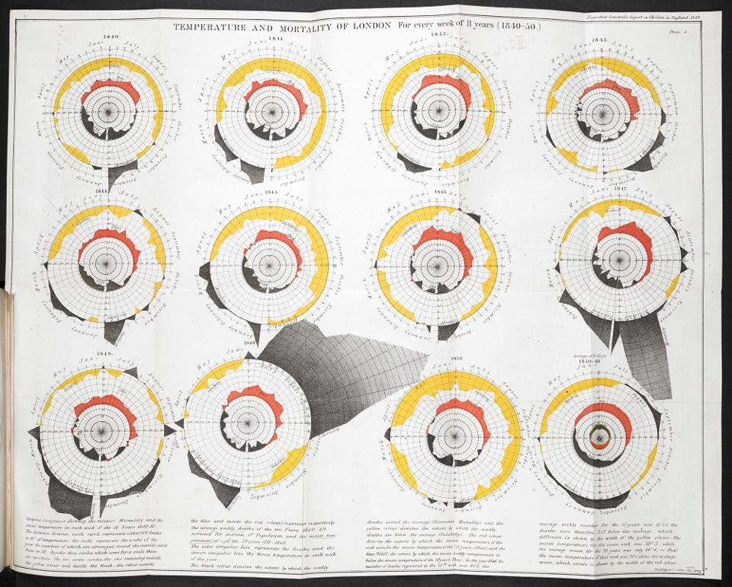
Temperature and Mortality of London. William Farr,
Report on the Mortality of Cholera in England, 1848-1849. London, 1852

Looking at this Infographic without any prior context, it certainly is more complex that J. Snow’s infographic. This Infographic visualises data that spans over 11 years, displaying every week of every month of those 11 years. There is certainly a lot more data being presented, W. Farr’s Infographic visualises data that spans 11 years were as J. Snow’s infographic only displays the number of deaths within a few months. However putting aside the volume of data and analysing exclusively how it is is presented, upon first glance I find it certainly a lot more difficult to understand the presentation of the data without reading the description at the bottom. Comparing that to the first glance of Snow’s map, you only have to read the title and you understand that it is a map of London and the bar tabs correlate to a death in that particular location. Upon deep analysis of the infographic, I realised that the center circle visualises the temperature, and the larger circle around the outside visualises the deaths. The center circle, when the red extends outside of the center circle, this showcases when the temperature was above the average for that time, and when it remains inside the circle it showcases when the temperature was below the average. This is the same for the number of deaths in the case of the outer circle, when the black extends beyond the outer circle, the means there was a higher number of deaths than average in that particular week. When it is inside the outer circle it means that the number of deaths were lower than average. Instantly I can understand how W. Farr believed this Infographic supported his findings, as it displays a pattern that more or less supports the Miasma theory as when the heat is either average or above average, the data shows that there were an average or above number of deaths. W. Farr believed that the bad air was as a result of the heavily polluted Thames evaporating. It is certainly the way in which he chose to visualise this data that led to this false conclusion. Even if W. Farr had not included the temperature as part of his data, the use of the radial clock to visualise the weeks and months of the year would have also led to the wrong conclusion that the summer was as a result of the higher death rate. As I stated before despite W. Farr’s Infographic being incorrect it was not criticized for its visualisation method and that is why there has not been another take on how it could have been presented. Personally I believe that no matter how W. Farr visualised his data, it would have still led to the same false conclusion, as the temperature was a significant factor in his data W. Farr was trying to prove that the temperature did affect the number of deaths therefore it cannot be left out and therefore, every method of visualisation will lead to the same conclusion, that seasonal temperature change was the main factor behind the number of Cholera deaths.

Compared to Farr’s historical example of an Infographic, I have found a contemporary example of significance, that being the 2016 Clinton vs Trump Electoral Map. There are several reasons I have chosen this particular Infographic, one being because it visualises the election data of one of the most influential countries in the world, second because it was arguably one of the most astounding election results in recent history and also because there is a major flaw with the way the visualised.

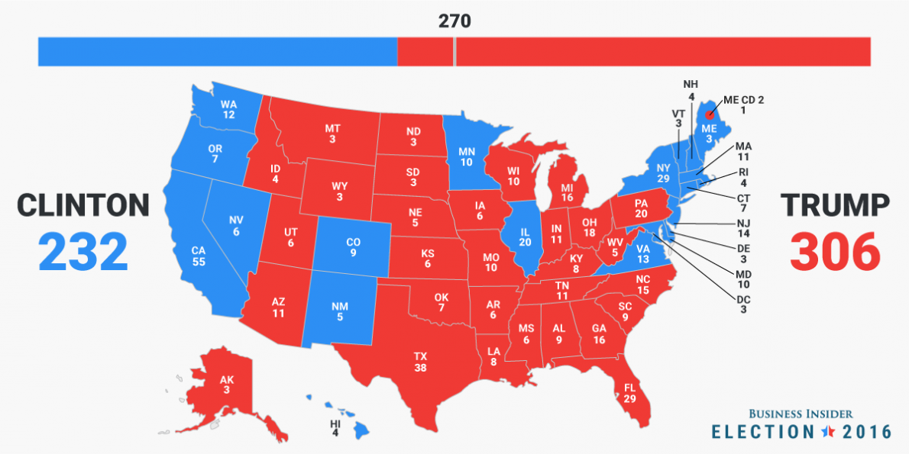
Business Insider - Election 2016

Firstly it is easy to understand that the Infographic is a map of the United States, and the colour of the state, either blue or red, determines the party in which received the highest electoral points. The numbers represent the number of electoral points each state is worth, however at first glance this Infographic doesn’t make sense. The map would suggest that Trump had a larger majority than he actually did, a larger proportion of the map is shaded Red than blue, however Clinton was only 74 electoral points behind Trump despite less than 20% of the map being shaded blue. The viewer instantly sees this large block of red that takes up the majority of the map and instantly assumes that most of the country voted republican. But this isn’t the case, it is the result of the way the data has been visualised using a map of the United States that gives it this distorted view of the data. Liz Scheltens (2016) states in her online article The bad map we see every presidential election states that the problem with the electoral maps is that geographical accuracy are prioritised of electoral value [19]. If the map scaled state's proportionate to the value of their electoral points, the state of California would have been visualised nearly 1 and a half times larger than the state of Texas. The same goes for the state of Montana only being worth 3 electoral points compared to the state of Michigan which is worth 16.
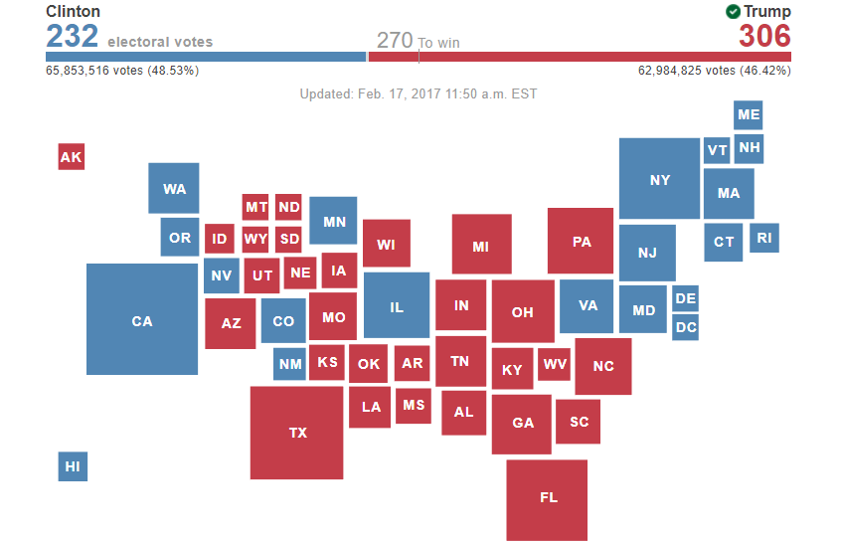
Associated Press, Election 2016

The Associated Press published their own take on the American Electoral map and visualised it in a completely different and a much more effective way. Taking out all geographical accuracy and comparing it to the other map it is clearer to see the results now, California having the highest population and therefore being worth the most electoral points is the largest state. Were as states such as Montana, North Dakota, South Dakota and Wyoming are visualised much smaller than their geographical equivalent because they are worth only 3 electoral points each.
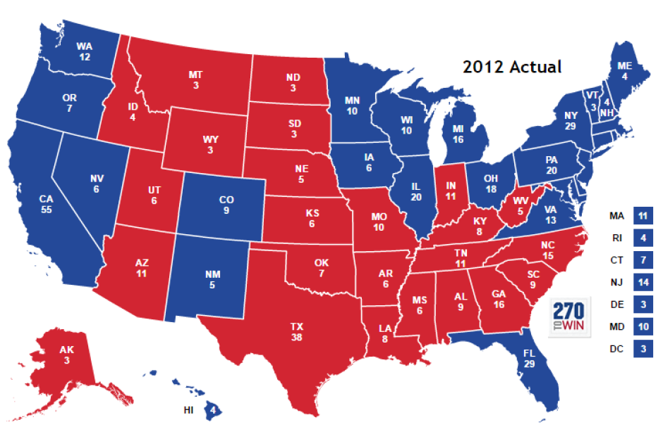
Election 2012 Map

My arguments are supported even further by the 2012 electoral map. This was the year of the Obama / Romney election, and once again the poor design choice of the electoral map suggests that Romney took the lead and won, however this is not the case. Obama won with an over 100 point lead. Knowing that in context helps truly understand how poorly this data has been visualised and how the value is not proportionate to the geographical scale. That is why I believe the Infographic created by the associated press is a much more effective and also simpler method of presenting the electoral data.

Upon analysing these examples of Infographics, it is easy to realise that the way the data is visualised is absolutely key. In the introduction to this dissertation I stated that at its core, Infographics are a way of telling a story to the viewer through images and symbols. Analysing these examples of Infographics have emphasised the importance of proportion, accuracy and also the way in which the data is visualised. If the data is portrayed incorrectly, in the case of William Farr’s Infographic and also the American Electoral Map, it can lead to a completely false conclusion. The electoral map was arguably one of the most significant examples of a poorly designed infographic because it’s so widely used, broadcast to millions of viewers every four years during every presidential election. A map to show individual states were the electoral value of the state is not equal to the states’ geographical size is a poor method of visualising the data and will continue to mislead as long as this method is used. The redesign example of the American Electoral map from the associated press emphasises how Infographics can vary and there are always a different ways to visualise data.

CONCLUSION:

This dissertation started out with the aim to discover the history of Infographics, selecting and
researching examples of the most significant and influential infographics. This dissertation led me to discover the story of Florence Nightingale and how she conveyed her finding through her famous Coxcomb and also the story of Doctor John Snow who portrayed his own findings of the cholera epidemic in his famous Cholera Map. One of the key aims of the dissertation was to find out what actual impact infographics could and have had and for I have certainly achieved that with these two examples, both Nightingale and Dr. Snow had huge impact on social change and change within the medical practice. I expected to find some examples of minimal impact as a result of Infographics however I never anticipated that Infographics had resulted in such huge social change. When analysing the Infographics from the separate time periods I did expect to see some obvious differences and I my analyse helped further my understand of what makes or breaks an Infographic, one point became very clear during the analyse, that if the data is portrayed incorrectly, it can visualise something completely different. This is was I found from the infographics that I chose to analyse. From my dissertation it is clear to see that Infographics are more than just art, they have the potential to be used in every aspect of life, and as the examples showed, the potential to change the world. My research is important because it helps emphasises the importance of Infographics and how they can be used in every aspect of life. It helps point out the key changes to society’s perception regarding health and medicine that are directly a result of Infographics. My own recommendations for any future research conducted on this topic would be to perhaps look into maybe one or two more examples of significant historical infographics, alongside Florence Nightingale and John Snow. Furthermore, another recommendation would to be perhaps dive more into detail regarding the science behind why Infographics are so popular and also so effective, this is where this dissertation lacks in detail. Again more examples of contemporary and historical examples of Infographics to analyse just to further support my findings in this dissertation. I originally chose to research Infographics because I personally liked them as an art form, I was unaware to their wide array of uses and also their historical impact. After completing this dissertation I certainly have a newfound appreciation of Infographics and also now feel when it comes to design, I will have a lot more knowledge to apply to the design process. In conclusion to this dissertation, there is a significant history to the creation and use of infographics and they have had a definite significant effect on the world, as an ending note, it can be argued that as Infographics are a powerful tool for social change for good, they can also be used in a manipulative way in order to affect society in a negative way.

BIBLIOGRAPHY

Sources in alphabetical order

Atlas Obscura. (2017). Happy Birthday Florence Nightingale, Unexpected Queen of Infographics. [online] Available at: https://www.atlasobscura.com/articles/florence-nightingale-infographic
Bostridge, Mark (2008) Florence Nightingale: The Making of an Icon. p. 1172.
Cadbury, Deborah (2003). Seven Wonders of the Industrial World. London and New York: Fourth Estate. pp. 189–192.
Chapelle, Frank (2005) Wellsprings. New Brunswick, New Jersey: Rutgers University Press. ISBN. p. 82
Cheng. K & Drewnowski. A (2015) Infographics And Public Policy: Using Data Visualization To Convey Complex Information [online] Availible at: https://search-proquest-com.ezproxy.uwtsd.ac.uk/docview/1731754928/fulltext/154A4C0E914433DPQ/1?accountid=130472 [Accessed 27 Nov. 2017].
Cohen, I. Bernard (1984)
Confalone. J (2013). The rise of infographics. [online] Available at: http://www.dmnews.com/dataanalytics/the-rise-of-infographics/article/246247/ [Accessed 21 Nov. 2017].
John M. Last, ed. (2007). "A Dictionary of Public Health". Westminster College, Pennsylvania: Oxford University Press
Keats. J (2014). London Exhibit Shows How Data Visualization Quashed Epidemics 150 Years Before Google [online] Available at: https://www.forbes.com/sites/jonathonkeats/2014/02/20/london-exhibit-shows-how-data-visualization-quashed-epidemics-150-years-before-google/#6fa4fbcf2d51 [Accessed 28 Nov. 2017].
Lewi, Paul J. (2006) Speaking Of Graphics. Chapter 5. P. 5.
Lienhard, John H (2000). No. 1712: Nightingale's Graph. [online] Available at: https://www.uh.edu/engines/epi1712.htm [Accessed 11 Nov. 2017].
Nightingale, Florence (August 1999). Florence Nightingale: Measuring Hospital Care Outcomes Retrieved 13 March 2010.
Rehmeyer, J. (2008). Florence Nightingale: The passionate statistician. [online] Science News. Available at: https://www.sciencenews.org/article/florence-nightingale-passionate-statistician [Accessed 9 Nov. 2017].
Rogers, S. (2013). John Snow's data journalism: the cholera map that changed the world. [online] the Guardian. Available at: https://www.theguardian.com/news/datablog/2013/mar/15/john-snow-cholera-map [Accessed 14 Nov. 2017].
Scheltens. L (2016). The bad map we see every presidential election. [online] Availible at : https://www.vox.com/2016/5/17/11686328/bad-election-map [Accessed 3 Dec. 2017].
Small, H (2010). Did Nightingale’s ‘Rose Diagram’ save millions of lives?. [online] A Paper Presented to the Royal Statistical Society Of London, 2010. Available at: http://www.florence-nightingale-avenging-angel.co.uk/?p=462 [Accessed 11 Nov. 2017].
The National Archives. (2017). Florence Nightingale - The National Archives. [online] Available at: http://www.nationalarchives.gov.uk/education/resources/florence-nightingale/ [Accessed 9 Nov. 2017].
Tufte, E. (2013). John Snow's data journalism: the cholera map that changed the world. [online] the Guardian. Available at: https://www.theguardian.com/news/datablog/2013/mar/15/john-snow-cholera-map [Accessed 14 Nov. 2017].
Www1.udel.edu. (2017). Dr. John Snow's map of the 1854 London cholera outbreak. [online] Available at: https://www1.udel.edu/johnmack/frec682/cholera/ [Accessed 14 Nov. 2017].
[Accessed 9 Nov. 2017].

Sources in order of use
The National Archives. (2017). Florence Nightingale - The National Archives. [online] Available at: http://www.nationalarchives.gov.uk/education/resources/florence-nightingale/ [Accessed 9 Nov. 2017].

Nightingale, Florence (August 1999). Florence Nightingale: Measuring Hospital Care Outcomes Retrieved 13 March 2010.

Bostridge, Mark (2008) Florence Nightingale: The Making of an Icon. p. 1172.

Lewi, Paul J. (2006) Speaking Of Graphics. Chapter 5. P. 5.

Rehmeyer, J. (2008). Florence Nightingale: The passionate statistician. [online] Science News. Available at: https://www.sciencenews.org/article/florence-nightingale-passionate-statistician [Accessed 9 Nov. 2017].

Cohen, I. Bernard (1984)

Lienhard, John H (2000). No. 1712: Nightingale's Graph. [online] Available at: https://www.uh.edu/engines/epi1712.htm [Accessed 11 Nov. 2017].

Atlas Obscura. (2017). Happy Birthday Florence Nightingale, Unexpected Queen of Infographics. [online] Available at: https://www.atlasobscura.com/articles/florence-nightingale-infographic
[Accessed 9 Nov. 2017].

Small, H (2010). Did Nightingale’s ‘Rose Diagram’ save millions of lives?. [online] A Paper Presented to the Royal Statistical Society Of London, 2010. Available at: http://www.florence-nightingale-avenging-angel.co.uk/?p=462 [Accessed 11 Nov. 2017].

Rogers, S. (2013). John Snow's data journalism: the cholera map that changed the world. [online] the Guardian. Available at: https://www.theguardian.com/news/datablog/2013/mar/15/john-snow-cholera-map [Accessed 14 Nov. 2017].

John M. Last, ed. (2007). "A Dictionary of Public Health". Westminster College, Pennsylvania: Oxford University Press

Www1.udel.edu. (2017). Dr. John Snow's map of the 1854 London cholera outbreak. [online] Available at: https://www1.udel.edu/johnmack/frec682/cholera/ [Accessed 14 Nov. 2017].

Chapelle, Frank (2005) Wellsprings. New Brunswick, New Jersey: Rutgers University Press. ISBN. p. 82

Cadbury, Deborah (2003). Seven Wonders of the Industrial World. London and New York: Fourth Estate. pp. 189–192.

Tufte, E. (2013). John Snow's data journalism: the cholera map that changed the world. [online] the Guardian. Available at: https://www.theguardian.com/news/datablog/2013/mar/15/john-snow-cholera-map [Accessed 14 Nov. 2017].

Confalone. J (2013). The rise of infographics. [online] Available at: http://www.dmnews.com/dataanalytics/the-rise-of-infographics/article/246247/ [Accessed 21 Nov. 2017].

Cheng. K & Drewnowski. A (2015) Infographics And Public Policy: Using Data Visualization To Convey Complex Information [online] Availible at: https://search-proquest-com.ezproxy.uwtsd.ac.uk/docview/1731754928/fulltext/154A4C0E914433DPQ/1?accountid=130472 [Accessed 27 Nov. 2017].

Keats. J (2014). London Exhibit Shows How Data Visualization Quashed Epidemics 150 Years Before Google [online] Available at: https://www.forbes.com/sites/jonathonkeats/2014/02/20/london-exhibit-shows-how-data-visualization-quashed-epidemics-150-years-before-google/#6fa4fbcf2d51 [Accessed 28 Nov. 2017].

Scheltens. L (2016). The bad map we see every presidential election. [online] Availible at : https://www.vox.com/2016/5/17/11686328/bad-election-map [Accessed 3 Dec. 2017].

