Children, young people, and families.



Student Name: Natalie Tully
Student Number: 2025743
Module: Children, young people, and families
Module Code: BMHP5004_BIRM
Lecturer: Dr Crisford Chogugdza

CONTENT PAGE

Introduction
This paper will be investigating the importance of children safeguarding policies and procedures in the UK and will be analysing and compare two high-profile safeguarding cases which will be outlining the importance of the cases, how the impact of the failures had on multi-disciplinary agencies and examine what should have been put in place to prevent any harm to other children in future. What lessons were learned from the failures? The two cases that will explore and analysed will be peter Connelly and Victoria Climbie in which the same failures were with Haringey social care.

Safeguarding
Safeguarding is an important legal framework under the Children Act 1989 which was amended in 2004, due to failure within the multi-agency to share relevant information. Safeguarding is an action that is taken to promote the welfare of children and protect them from harm. It’s important that all organisations that work or are in contact with children follow the guidelines of the safeguarding policies and procedures to ensure that every child is protected from abuse and maltreatment, preventing harm to children’s health and development, ensuring children grow up with the provision of safe and effective care and taking action to enable all children and young people to have the best outcome (NSPCC, 2022). There are six important principles to safeguarding:
- Empowerment
- Prevention
- Proportionality
- Protection
- Partnership
- Accountability
These six principles outline the importance of protecting and ensuring the local authorise proving quality care and work within guidelines to protect vulnerable people from harm and abuse. (Kettle, 2022)
Even though safeguarding is in place to protect children, there are some disadvantages that could lead to abuse and neglect being missed, which involve professionals not having the right training and understanding of safeguarding, which will impact the staff following the correct procedures to be able to recognise any concerns or issues. The advantages of safeguarding are when all the policies are put in place correctly and the right training is given, it enables the ability to recognise and spot forms of neglect and abuse, the tools to communicate with those that are vulnerable, identify and understand the people that are more likely to be at risk of harm and confidence to report and record issues of safeguarding. I also want to express the importance it’s a duty of care that everyone, not just professionals report any concerns under safeguarding (Martinelli, 2018).
Legislations
Children’s Act 1989
This act was designed to ensure that all local authorities were provided equal provision to support children and young people and their families. This ensures that early intervention will happen if there are any signs of safeguarding. There are ten key parts to the children Act 1989, each focusing on a different aspect of child welfare and the safety of children, Children Act 1989 Legislation is important in safeguarding to protect children from all backgrounds and races.
There are important sections to the children act 1989 which are put in place to protect vulnerable children that support families and the duty of care by local authorities, Sections 1 to 17 support families, and the duty are:
Section 17 Assessments the needs of the children and their families and others, you must get consent, it is voluntary under the Children Act 1989.
Section 20 Provision of accommodation for children in care.
Voluntary accommodation, support by police court order.
Section 31 care and supervision,
31A Care orders: care plans
Section 38 interim care orders
Section 47 Local authority’s duty to investigate child protection issues. Seek issues of negotiation, Evidence basic practice, and cognitive level development. Section 47 links to section 20 C.S.S remove a child, court order, or use of police (Children Act, 1989).
Children Act 2004
The children act 2004 is an expansion of the 1989 Children act, The 2004 Act reaffirms that everyone who works with children has a responsibility to promote child welfare and assist safeguard children. Making Britain a safer place for kids is the major goal of the Children Act of 2004. Lord Laming conduct an inquiry in 2003 into the failures of safeguarding by local authorises to protect and safeguard Victoria Climbing, the report outlined the poor practice within and between social services, police, and the health services. There were 58 recommendations for child protection. “The result was the Keeping children safe report (DfES, 2003) and Every child matters green paper (DfES, 2003), which in turn led to the Children Act 2004” (Evans, 2013). A significant portion of the Children Act 1989 is not repealed or even modified by the Children Act 2004. Instead, it established the procedure for integrating services for kids and established the position of England's Children's Commissioner.

Data protection Act 1998
This act prevents personal information from being exposed, the data protection includes 8 principles that ensure personal information is:
- Fairy and lawfully processed
- Processed for limited purposes
- Adequate, relevant, and no excessive
- Accurate
- Not kept longer than necessary
- Processed by the person’s rights
- Kept secure
- Not transferred abroad without adequate protection

Human Rights Act 1998
This act enables children, young people, and adults to protect their rights both nationally and internationally through the European courts of human rights. This enables every individual to have their needs and wellbeing met and ensures protection from being discriminated against.
Policies
Every child matter 2003
This policy was created from the legislation children’s Act, which considers the wellbeing of children and young people from age 0-19 years. This allows all organisation that works with every child matters policy to work together to protect the children from harm. There are 5 underlying principles of the policy, which state all children should be healthy, stay safe, enjoy, and achieve, make a positive contribution, and experience economic wellbeing.
Confidentiality
This policy states the principles that must be followed by all who have access to personal information of confidentiality information, to ensure that staff and service users are safeguarded. All employees must be aware of their responsibilities for safeguarding the confidentiality and preserving information,

This section of the assignment will explore and examine two high-profile cases of safeguarding Victoria Climbie and Peter Connelly in which they were both let down by agencies in London’s Borough of Haringey. The circumstances are similar patterns around the failures, which draw attention to both cases for change in the new framework, which was incorporated in the Children Act 2014, and agencies’ training and understanding of policies (Mohajerani, Baptista and Nandhakumar, 2015).

Victoria Climbie

Victoria Adjo Climbie was eight years old, who came to England for better education by her great-aunt and her boyfriend but instead they tortured and murdered her. There were 128 separate injuries to Victoria’s body, “Dr. Lesley Alsford, the consultant responsible for
Victoria care on that occasion, said, “I had never seen a case like it before. It is
the worst case of child abuse and neglect that I have ever seen.” (Laming, 2003)
Following Investigation into her death, into the horrific conditions and the abuse of an 8-year-old girl, hot boiling water tipped over her head, toes were struck by a hammer, she was beaten with a bicycle chain, tied up for periods longer than 24 hrs. The amount of suffering Victoria must have counted is unbelievable.
The lack of communication with multi-agencies, to share key information, there were several failures with all organisation malaise, working on the case of Victoria, including policies and procedures out of date, inexperienced social workers working with children and families. There were 12 key missed opportunities to successfully intervene in the life of Victoria. Accountability, none of the organisations took accountability for the failures that took place instead pass it on to other people. The fact that Victoria was given a low priority to the task of protecting children and the needs of the great aunt was put before Victoria’s needs. Kouao and Manning were charged with murder on 12 January 2001 serving life for the murder of Victoria. Following the death of Victoria and the failures of the local authorises to act the government called on Lord Laming to conduct an inquiry which the finding was an action for changes which Laming recommendations for the universal protection of children. Which states:
. “It would be unreasonable to expect that the sudden and
unpredictable outburst by an adult towards a child can be
prevented. But that is entirely different from the failure to protect
a child or young person already identified as being in danger of
deliberate harm. The death of a child in these circumstances is a
reproach to us all.”
“It is essential that action is now taken so that as far as humanly
possible children at risk of harm are properly protected.” (GOV.UK, n.d.)
Summary of key recommendations.
- Training for social workers and understanding of policies
- Communication with a child and use of an interpreter if needed for safeguarding a child.
- Professional agencies need to work together and communicate key information regarding the safety and protection of the child. The changes to prevent this from happening to another child in the future:
- Working Together to safeguarding children 2010, which aimed to support multi-agency working and joined-up approaches to child protection
- Social Work Taskforce, to make improvements to the recruitment, training, and supervision of social workers.
Peter Connelly
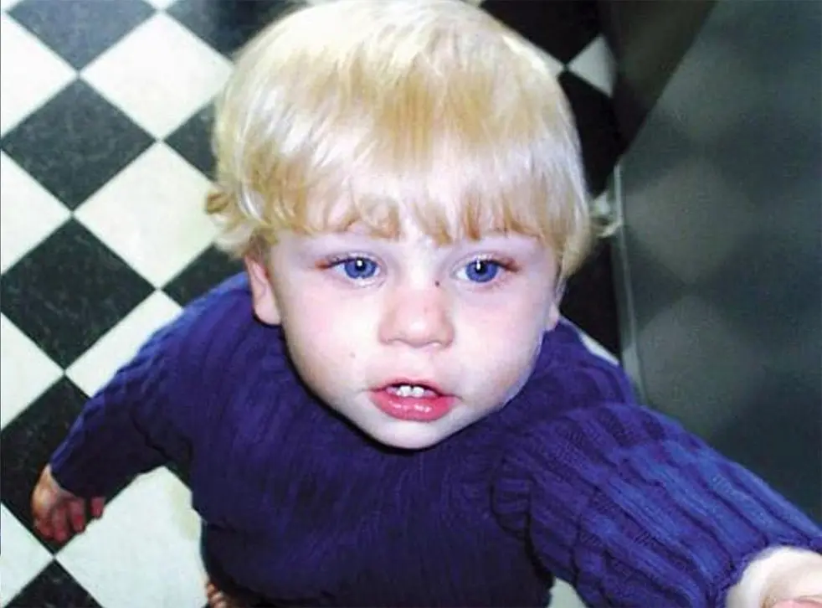
Known as baby p died in August 2007 only 17 months old. He was subjected to months of violence by his mother, her new partner, and a lodger at the family home. In the eight months before his murder, Peter had been visited by the police 60 times and had more than 50 injuries before his death. With Peter or his family, ten organisations were involved. On December 22, 2006, Peter was placed on "child protection/at risk" but was not adequately safeguarded by experts or authorities. (LSCB, 2006)

'Baby P' was subjected to dreadful physical abuse, which left him with a broken back, a shattered shinbone, damage to his skull, blackened fingers and toes from cigarette burns, missing fingernails, neck wounds, and a loss of soft tissue, and cracked ribs.
The lack of multi-agencies not working together in partnership to share key information, the authorities that were meant to protect Peter Connelly, there were several fails and opportunities under section 47, and peter being placed on the child protection plan should have been more awareness for quicker interventions and responses which was needed to protect Peter. The lack of understanding of who was in the household around the children, with social services not challenging the mother on how the injuries occur led to Peter being returned home each time, which sadly led to his death.
Professor Eileen Munro’s review in April 2011 due to the several high-profile abuse cases, including the death of Peter Connelly. There were 15 recommendations. Her report called for a more child-focused system and a reduction in prescriptive timescales and targets from the central government (Munro Review-Summary of Recommendations, n.d.).
- Working together to safeguard children, the framework for assessments
- All local services working effectively to the protection of the children
- Child journey from needing to receiving help,
- Working together to safeguard children, should include monitoring and evaluating local arrangements
- Multi-agency Training in safeguarding and promoting the welfare of children and young people.
These are only some of the 15 recommendations.
Consultation

GOV.UK. (n.d.). The protection of children in England: government response. [online] Available at: https://www.gov.uk/government/publications/the-protection-of-children-in-england-government-response.

‌

Evans, M. (2013). Policy guide: Children Act 1989 Amended 2004. [online] Nursery World. Available at: https://www.nurseryworld.co.uk/features/article/policy-guide-children-act-1989-amended-2004.

‌

Children Act (1989). Children Act 1989. [online] Legislation.gov.uk. Available at: https://www.legislation.gov.uk/ukpga/1989/41/contents.

‌

Martinelli, K. (2018). What is Safeguarding Training & Why is it so... [online] The Hub | High Speed Training. Available at: https://www.highspeedtraining.co.uk/hub/what-is-safeguarding/.

‌
Mohajerani, A., Baptista, J. and Nandhakumar, J. (2015). Exploring the role of social media in importing logics across social contexts: The case of IT SMEs in Iran. Technological Forecasting and Social Change, 95, pp.16–31. doi:10.1016/j.techfore.2014.06.008.

‌

NSPCC (2022). Safeguarding children and child protection. [online] NSPCC Learning. Available at: https://learning.nspcc.org.uk/safeguarding-child-protection. (Accessed 7 Aug. 2002)

‌
Laming, L. (2003). The Inquiry Victoria Climbie. [online] gov.uk. Available at: https://assets.publishing.service.gov.uk/government/uploads/system/uploads/attachment_data/file/273183/5730.pdf.

‌LSCB (2006). SERIOUS CASE REVIEW: BABY PETER Date of Birth: 1 st. [online] Available at: https://www.basw.co.uk/system/files/resources/basw_111257-10_0.pdf.

‌ Munro Review-Summary of Recommendations. (n.d.). [online] Available at: https://councilmeetings.lewisham.gov.uk/documents/s3946/04%20Munro%20Review%20Summary%20of%20Recommendations.pdf.

‌ Kettle, M. (2022). Book Review: Safeguarding across the lifespan by June Keeling and David Goosey. Journal of Social Work, p.146801732110735. doi:10.1177/14680173211073562.

‌

