LABORTAORY REPORT: FT-IR ANALYSIS AND IDENTIFICATION OF ORGANIC MATERIALS
advanced chemistry, acda6020
Luke Malcolm (2030773)
2025
Contents
1. Aim 2
1.1 Topic 2
1.2 Tasks 2
2. Hypothesis 3
3. Experiment Variables 3
4. Theory 3
4.1 ATR-FTIR 3
4.2 Relevance to OME 3
5. Chemicals and Equipment Used 4
5.1 Chemicals 4
5.2 Equipment 4
6. Procedure 4
6.1 Safety and PPE Requirements 4
6.2 Procedure 4
7. Observations 6
8. Results and Discussion 8
8.1 Results 8
8.2 Discussion 10
8.2.1 Compounds 10
8.2.2 Library Comparisons 10
8.3 Use in Energetics 12
9. Conclusions 12
References 13
Appendix A: Troubleshooting 15

Table of Figures
Figure 1 - Anvil Selection (Credit - Author) 4
Figure 2 - Cleaning Areas (Credit - Author) 5
Figure 3 - Sample A Spectrum 6
Figure 4 - Sample B Spectrum 7
Figure 5 - Sample C Spectrum 7
Figure 6 - Sample D Spectrum 7
Figure 7 - Sample A and Library Comparison 8
Figure 8 - Sample B and Library Comparison 9
Figure 9 - Sample C and Library Comparison 9
Figure 10 - Sample D and Library Comparison 10
Figure 11 - Sample C (bottom line) and Ethyl 4-Nitrobenzoate Spectrum 11

1. Aim

1.1 Topic
Following a site inspection at a materials testing facility, inspectors recovered a series of labelled reference powders used in the evaluation of new energetic formulations. Each sample contains a different class of functional group frequently encountered in the design, manufacture, or degradation of energetic materials. These samples must be disposed of. Before the samples can be cleared for disposal, full confirmation of their identity and chemical functionality is required.

1.2 Tasks
The following tasks must be undertaken. Specific instructions are given in section 6.2 Procedure.
- Sample Preparation (note – samples are effectively “pre-prepared” due to being powders, so no grinding or other preparation is required)
- Instrument Preparation & Setup
- Material Scans
- Result Comparison

2. Hypothesis
The four samples will correspond to either Guanidine, Acetaminophen, Ascorbic acid, or Methyl 3-nitrobenzoate. Samples may show evidence of degradation, contamination, or moisture absorption.

3. Experiment Variables
Independent: Sample material
Dependent: ATR-FTIR spectrum output
Control: Instrument settings, cleaning procedure, contact force, type of crystal

4. Theory

4.1 ATR-FTIR
Attenuated Total Reflection - Fourier Transform Infrared Spectrometry (ATR-FTIR) is a qualitative method used to study the molecular structure of compounds. An infrared beam is passed through an interferometer, which splits the beam of light, then recombines it, to form an interference pattern. This beam is then directed at the sample. The beam reflects off the sample onto the detector. The intensity of the reflected light is recorded – this data undergoes a Fast Fourier Transform, the result of which is a spectrum graph, showing either transmittance or absorbance (one is the inverse of the other) against wavelength. Different types of molecular bonds have different vibrational modes, corresponding to different levels of IR absorption. These can be used to easily identify different functional groups [1] [2].
This technique has some notable advantages and limitations. The instant result and portable machine options makes it attractive for field use, especially when the user has access to many library samples. Despite this, analysis of complex samples is often different due to spectral overlap, especially when samples contain similar (but not quite identical) components. Many variables – some of which are impossible to control – can also affect the result. Atmospheric conditions (temperature, humidity), and even differences in sample storage all have an effect [2] [3]. The difference in machine setup can also have a significant impact as various smoothing and apodization functions affect the output graph. Sample preparation is also important, as poor grinding and unequal contact can lead to artefacts or incomplete spectral acquisition [3].

4.2 Relevance to OME
FTIR is a common technique used in the identification of explosives (both in a laboratory and in the field), but it is not without considerable limitations. It works best when relatively high concentrations of a material are present – but as soon as contaminants are present in reasonable quantities, analysis gets considerably more difficult.

5. Chemicals and Equipment Used

5.1 Chemicals
Cleaning Materials: Isopropyl Alcohol and lint-free wipes

5.2 Equipment
ATR-FTIR Spectrometer & Crystal Type: Perkin-Elmer Spectrum Two, UATR Two Unit (Diamond Crystal)
Software: Perkin-Elmer Spectrum IR
Sample Handling: Micro-spatula

6. Procedure

6.1 Safety and PPE Requirements
PPE Required: Lab coat, nitrile gloves, safety glasses
Waste Route: Bin provided

6.2 Procedure
1. Ensure unit is powered on and Perkin-Elmer Spectrum Two software is running
2. Select the correct anvil for the material under test per Figure 1. The anvil is a simple push-fit to the foot. It is retained by a rubber O-ring.
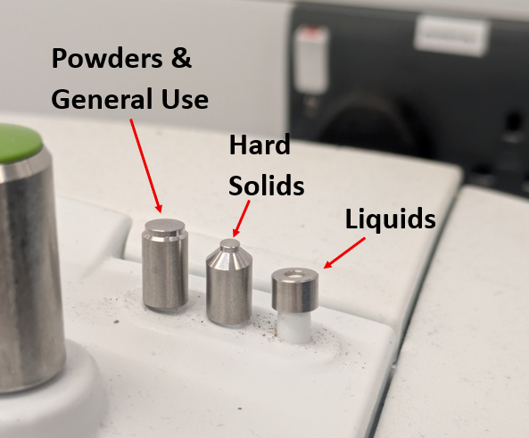
Figure 1 - Anvil Selection (Credit - Author)
3. Using isopropyl alcohol and a lint-free wipe, carefully clean the sample plate, ATR crystal, and anvil (shown in Figure 2). Ensure areas are dry and free of contaminants before proceeding.
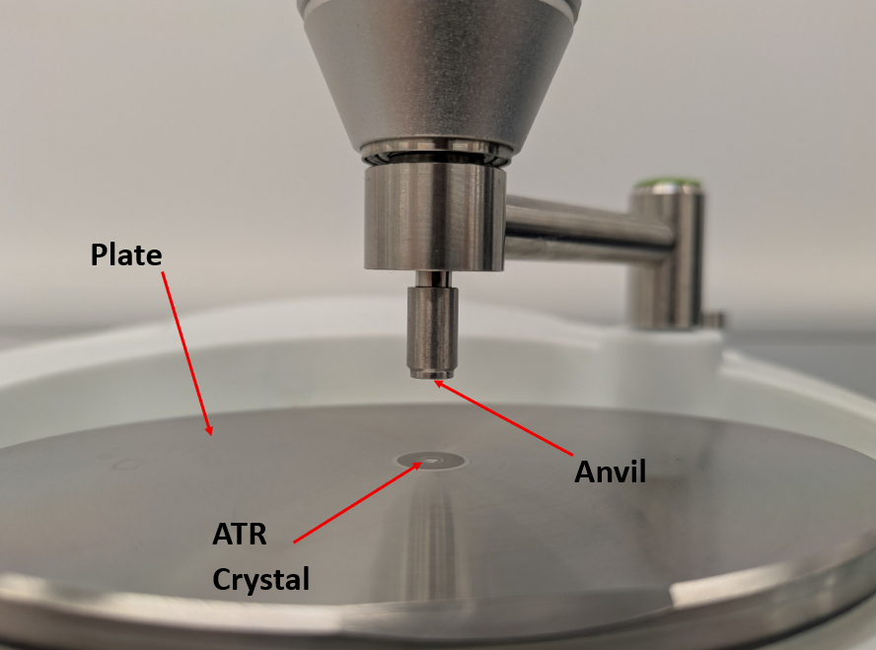
Figure 2 - Cleaning Areas (Credit - Author)
4. Swivel the anvil such that it locks into its detent directly over the ATR crystal.
5. Rotate the green handle clockwise until the anvil tip contacts the ATR crystal. Continue to rotate the green handle until the built in ratchet clicks over.
6. Set up the software with the following parameters:
- Spectral Range: 4000cm⁻¹ to 450cm⁻¹
- Background Scans: 15
- Sample Scans: 15
- Apodization Function: No
- ATR Correction: No
- Baseline Correction: No
- Smoothing: No
7. Using the Spectrum Two software, run a background scan. The unit is pre-set to run 15 scans in one user-defined full scan so this background scan must only be run once.
8. Rotate the green handle anticlockwise until the anvil is well clear of the crystal, then swivel it out the way.
9. Deposit a reasonable quantity of sample material onto the ATR crystal, ensuring that the crystal is completely covered. Ensure you use a clean or new spatula each time.
10. Swivel the anvil back over the ATR crystal and rotate the green handle clockwise until the ratchet clicks over, crushing the sample between the anvil and the ATR crystal
11. Run a preview scan. This is a fast scan which gives an instant indication if the result will be of acceptable quality. If the preview scan gives a poor spectrum, see Appendix A: Troubleshooting.
12. If the preview scan is acceptable, run a full scan. The unit is pre-set to run 15 scans in one user-defined full scan, so the full scan must only be run once.
13. Assuming the full scan gives acceptable results, save the spectrum under a suitable file name. If results are unacceptable, see section 6.3 Troubleshooting.
14. Compare the resulting spectrum to those held in the software library. A percentage match figure will be given to a certain chemical or material. Note this value.
15. Repeat steps 2 through 15 for each sample you wish to test.

7. Observations
Figure 3 through to Figure 6 shows the collected spectrums for each material sample. The full spectrums are available separately in .csv file format but have been reproduced here for simplicity.
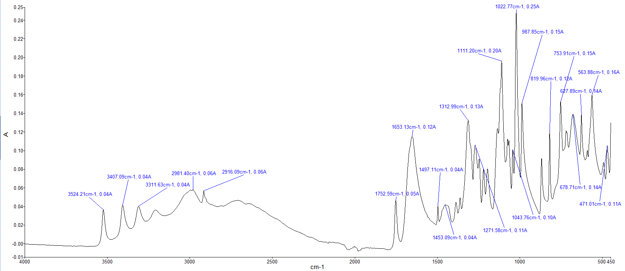
Figure 3 - Sample A Spectrum

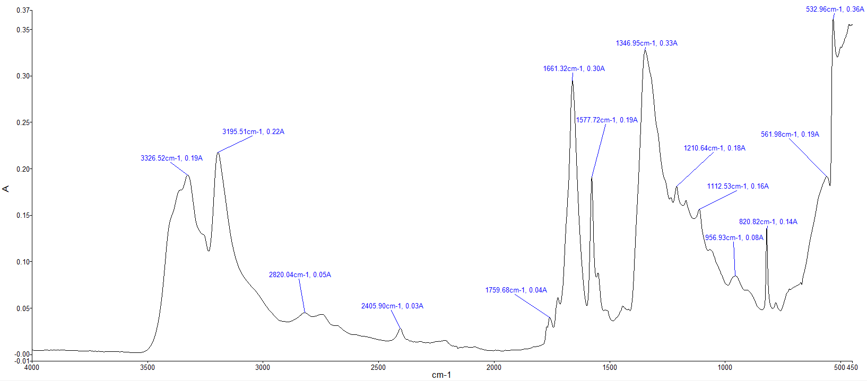
Figure 4 - Sample B Spectrum

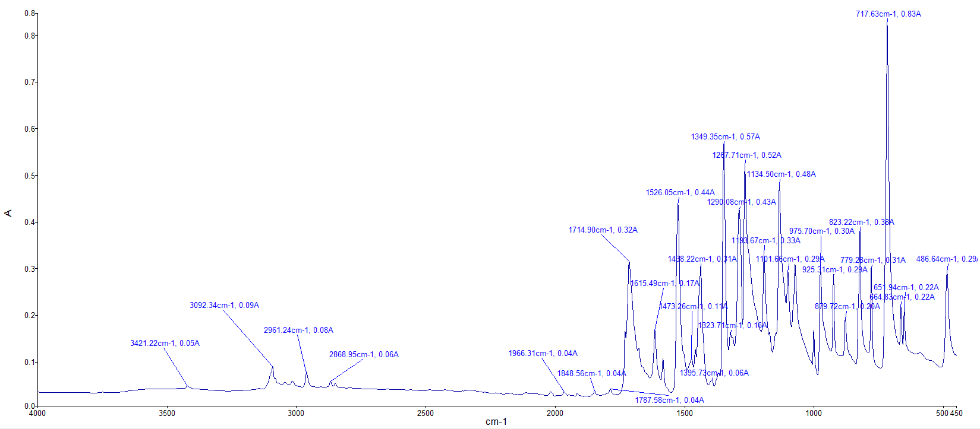
Figure 5 - Sample C Spectrum

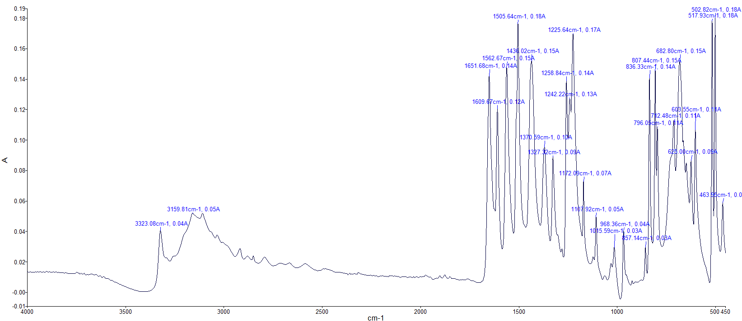
Figure 6 - Sample D Spectrum

8. Results and Discussion

8.1 Results
Shown in Figure 7 through Figure 10 are the collected spectra, overlaid against the spectra for the selected highest match percentage library material. In each case, the “top line” shows the library sample. The “search score” in the top right-hand quadrant shows the exact percentage match.
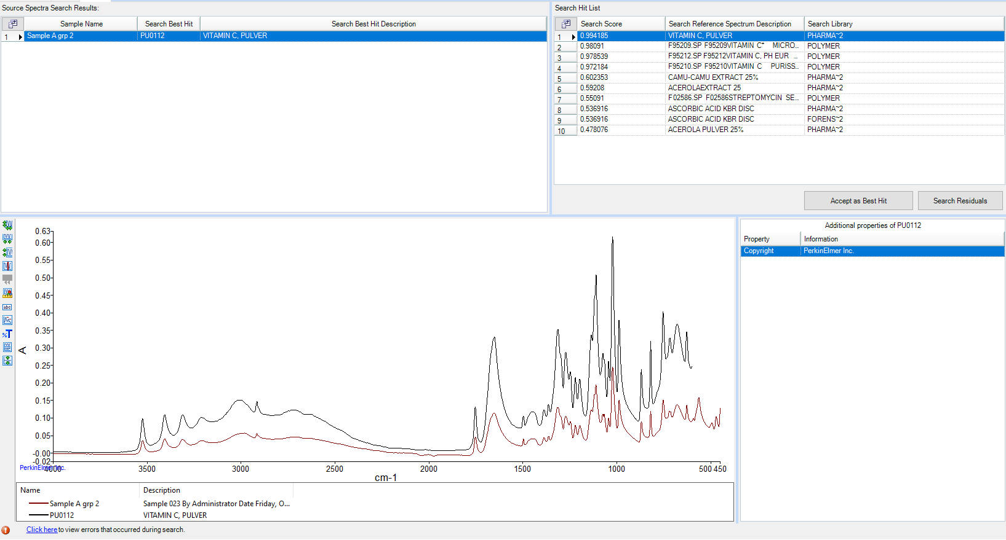
Figure 7 - Sample A and Library Comparison

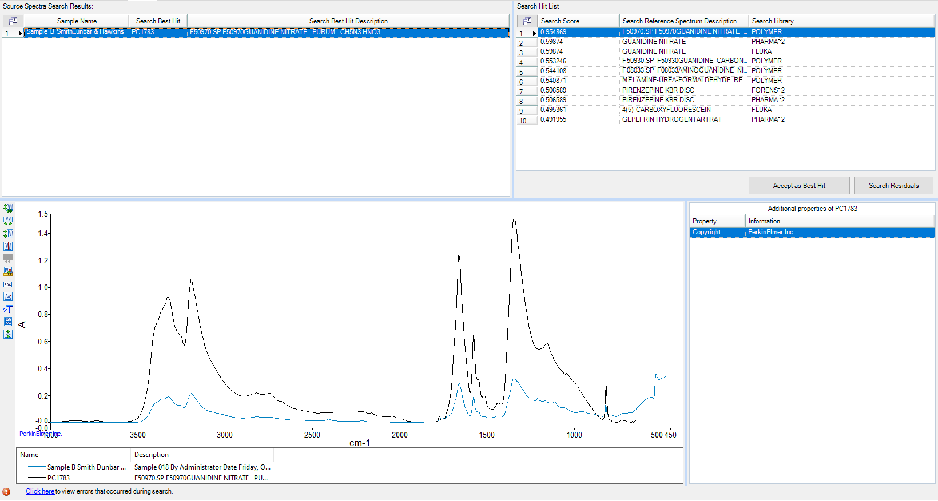
Figure 8 - Sample B and Library Comparison

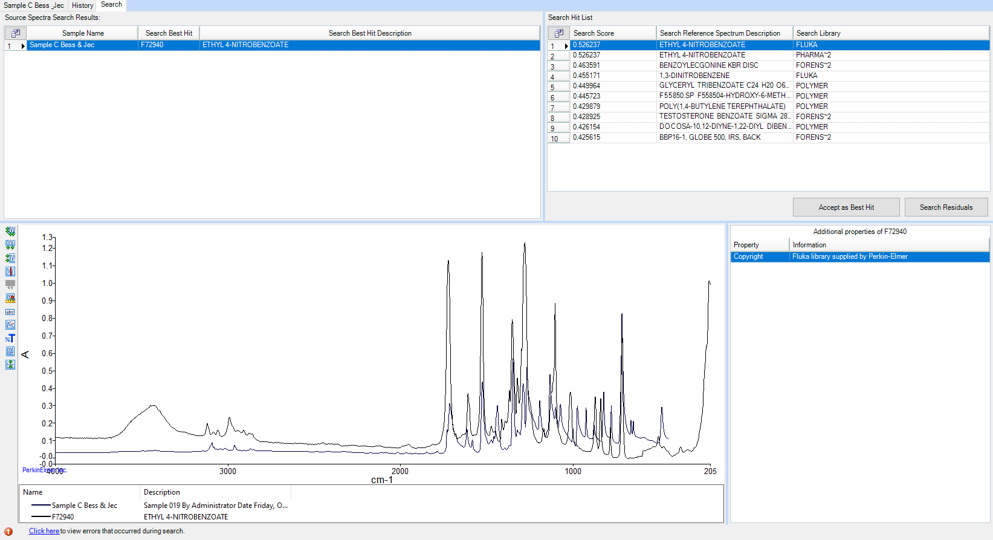
Figure 9 - Sample C and Library Comparison

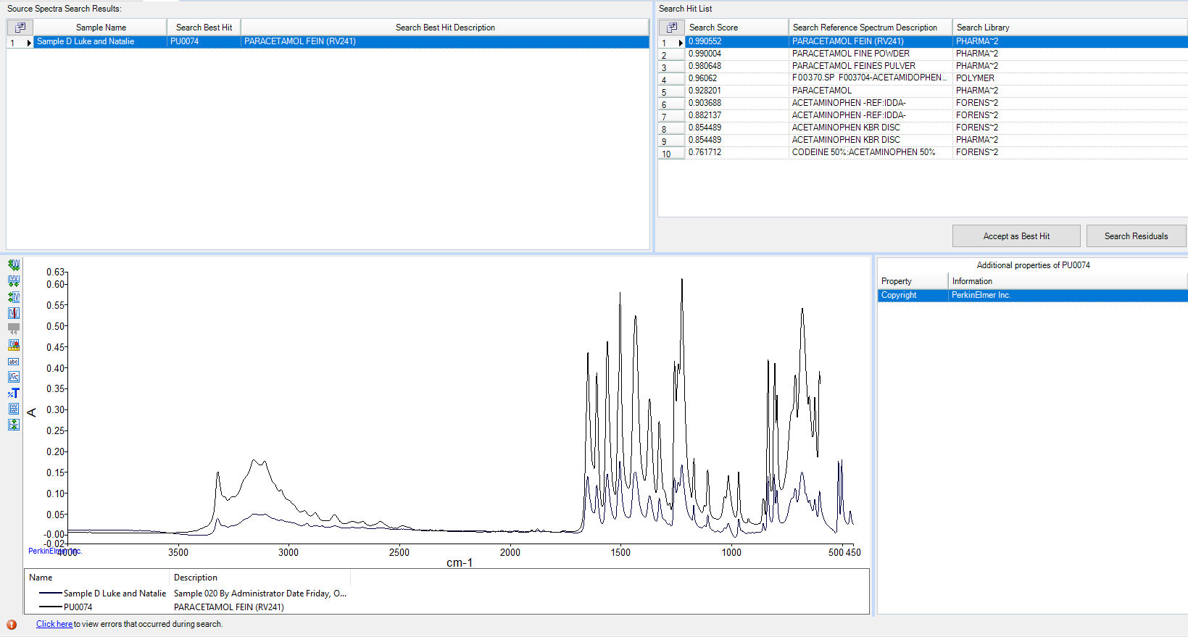
Figure 10 - Sample D and Library Comparison

8.2 Discussion
Absorption regions discussed in subsequent sections have been primarily taken from the Infrared Spectroscopy Absorption Table by LibreTexts Chemistry [4].

8.2.1 Compounds
Each of the compounds under examination has a different functional group, and consequently exhibit considerably different spectra:
Guanidine: The key functional group in guanidine is the amino group (-NH₂), of which there are two [5].
Acetaminophen: The key functional groups in acetaminophen are the phenol group (-OH) bonded to an aromatic hydrocarbon group and the amide group (in the case of acetaminophen, a carbonyl group (C=O) bonded to a nitrogen atom [6]
Ascorbic Acid: Contains a lactone ring and multiple hydroxyl groups [7].
Methyl 3-Nitrobenzoate: Is an aromatic nitro-ester containing both a nitro group (-NO₂) and ester group (-COOCH₃) [8].

8.2.2 Library Comparisons
The library search is considerably more useful to the analyst when examining “known” materials such as in cases like these – it gives an “instant answer” (in the case of a good match), saving a considerable amount of time. It must be noted that libraries do not have examples of every single compound known to man, and on occasion, common sense must be applied. A library search was conducted for each sample scan. The overlaid spectra and percentage matches are shown in Figure 7 through Figure 10. Each sample is discussed in depth below:
Sample A: 99.4% match to ascorbic acid. This is a strong degree of confidence. Examining the individual peaks confirms this is a good match for the key identifying groups.
- O-H stretch present (peaks at 3524cm⁻¹and 3407 cm⁻¹ match hydroxyl groups)
- C=O lactone stretch present at 1752cm⁻¹
- Multiple C-O stretches present between 1312cm⁻¹ and 1022cm⁻¹
Sample B: 95.5% match to guanidine nitrate (a common salt form of guanidine). This is a strong degree of confidence. The sample showed a broad peak at approximately 500cm⁻¹, this can possibly be explained by some atmospheric water vapour contamination [3], and salts absorb water very easily. Examining the spectrum:
- Strong peaks at 3326cm⁻¹ and 3195cm⁻¹, indicative of N-H stretching
- Peaks at 1661cm⁻¹ and 1577cm⁻1, indicating N-H bending or C=N stretching
- Nitro compound N-O stretching at 1346, 1210, and 1112 cm⁻1, a key indicator for nitrates
Sample C: 52.6% match to ethyl 4-nitrobenzoate. This sample is almost certainly methyl 3-nitrobenzoate (by simple process of elimination) but the library does not contain an entry for this compound. Examining the two spectra, there are some commonalities but also some notable differences. Commonalities include a strong ester C=O stretch at ~1715-1730cm⁻¹ and nitro group peaks at ~1520-1550cm⁻¹ and ~1340-1360cm⁻¹. A key difference is that ethyl 4-nitrobenzoate will show additional peaks in the fingerprint region, [9] as methyl 3-nitrobenzoate does not contain a methylene group (CH₂). As can be seen in Figure 11, the sample C line does not show any peaks between 900 and 1100cm⁻¹, whereas there are many peaks in this area in the ethyl 4-nitrobenzoate spectrum.
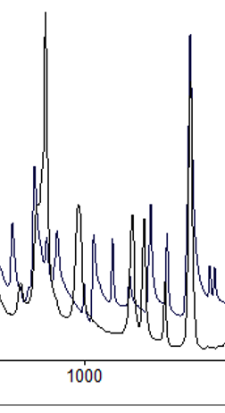
Figure 11 - Sample C (bottom line) and Ethyl 4-Nitrobenzoate Spectrum
Sample D: 99.1% match to acetaminophen. This is a strong degree of confidence. Confirmatory analysis of the spectrum proves this:
- Broad peak(s) at 3524 and 3407cm-1 match O-H stretches
  - Same region also indicates N-H stretch
- C=O amide peak at 1653cm-1
- Multiple peaks between 1259 and 1225cm-1 indicates C-O stretch presence

8.3 Use in Energetics
All of the compounds discussed in in this report have possible applications in the explosives industry, even if some of the chemicals are not a direct explosive or precursor:
Guanidine: Is nitrated into nitroguanidine, a key ingredient in triple-base propellants. This is primarily because nitroguanidine decomposes into nitrogen gas. This keeps energy content high, but also keeps flame front temperatures down- contributing to significantly greater barrel life, which in the case of costly artillery pieces is hugely valuable [10].
Acetaminophen: Sometimes used as a “safe simulant” in explosives research, or to research chemical fundamentals which themselves are key to explosives research (such as kinetics) [11]. One study at Los Alamos National Laboratory used acetaminophen as a simulant for polymer-bonded explosives (PBXs) due to its mechanical and crystal property similarities to RDX and HMX [12].
Ascorbic Acid: Is widely used as a fuel in modern black powder substitutes (which are less toxic and less corrosive than traditional black powder) [13].
Methyl 3-Nitrobenzoate: This stable nitro-aromatic ester is used in studies to further understand explosive mechanisms [14], but research into explosives use is limited.

9. Conclusions
Through ATR-FTIR analysis, the identity of each sample has been confirmed:
Sample A is ascorbic acid
Sample B is guanidine nitrate
Sample C is methyl 3-nitrobenzoate
Sample D is acetaminophen
Prior to disposal, specialist advice should be sought regards the specific waste route to ensure that no pollutant limits are breached.

References

[1] | V. Maniar, K. Kalsara and U. Upadhyay, “A Review of Ftir – An Useful Instrument,” International Journal of Pharmaceutical Research and Applications , vol. 8, no. 1, pp. 2486-2490, 2023.
[2] | R. Iqtadar, N. Ahmed, S. Asghar and M. Azam, “Advances and Applications of FTIR Spectroscopy: Precision, Accuracy, and Validation Challenges,” Journal of Pharma and Biomedics, vol. 3, no. 1, pp. 119-131, 2025.
[3] | J. Chalmers, “ Mid-infrared Spectroscopy: Anomalies, Artifacts and Common Errors,” Wiley, 2006.
[4] | LibreTexts, “Infrared Spectroscopy Absorption Table,” [Online]. Available: https://chem.libretexts.org/Ancillary_Materials/Reference/Reference_Tables/Spectroscopic_Reference_Tables/Infrared_Spectroscopy_Absorption_Table. [Accessed 20 10 2025].
[5] | C. H. Tan and M. Coles, “The Chemistry of Guanidine, Guanidinium, and Guanidinate Compounds.,” CSIRO, 2014.
[6] | V. V. Kouznetsov, “Exploring acetaminophen prodrugs and hybrids: a review,” RSC Advances, vol. 14, pp. 9691-9715, 2024.
[7] | S. J. Devaki and R. L. Raveendran, “Vitamin C: Sources, Functions, Sensing and Analysis,” Intech Open, 2017.
[8] | National Institute of Standards and Technology, “Benzoic acid, 3-nitro-, methyl ester”.
[9] | A. Najjar, “Instrumental Chemical Analysis Infrared Spectroscopy,” 2021. [Online]. Available: https://philadelphia.edu.jo/academics/anajjar/uploads/2020%20Fst%20IR%20Spectroscopy.pdf.
[10] | J. L. Block, “The Thermal Decomposition of Nitroguanidine,” US Navel Ordnance Laboratory, White Oak, 1953.
[11] | J. Freitas, A. Ferreira, G. Galigeri, G. Bannach and E. Cavalherio, “New insights on the thermal behavior of acetaminophen,” Journal of Thermal Analysis and Calorimetry, vol. 150, pp. 4165-4176, 2025.
[12] | D. Jeager, D. Bahr and E. Hooks, “Microstructural Characterization of Plastic-Bonded Explosives,” Los Alamos National Laboratory, 2011.
[13] | M. Bottegal, L. Lang, M. Miller and B. McCord, “ Analysis of ascorbic acid based black powder substitutes by high-performance liquid chromatography/electrospray ionization quadrupole time-of-flight mass spectrometry,” Rapid communications in mass spectrometry, vol. 24, pp. 1377-1386, 2010.
[14] | M. J. Ledo, H. Flores, F. Ramos, V. L. S. Freitas and M. D. M. C. Riberio da Silva, “MatThermochemical study to assess the energetical and structural effects of nitro substituents in methyl benzoate isomers,” Journal of Chemical Thermodynamics, vol. 173, 2022.

Appendix A: Troubleshooting
If the spectral return given is poor, ensure the following conditions are met then repeat the measurement:
1. That the anvil, ATR crystal, and plate are properly clean and no cleaning solvent, fibres, or other contaminants are present on the surfaces.
2. That the sample itself has not been unduly contaminated.
3. There is an adequate amount of sample present, and the ATR crystal is fully covered.
4. That the ratchet on the handle is engaged when tightening (i.e. there is an appropriate amount of contact force).
5. That the instrument is adequately protected from vibration and movement.
If these five conditions are met, but the return is still not suitable, seek further help from instrument SMEs. They may first propose using the apodization or smoothing functions to clean up the spectrum.

