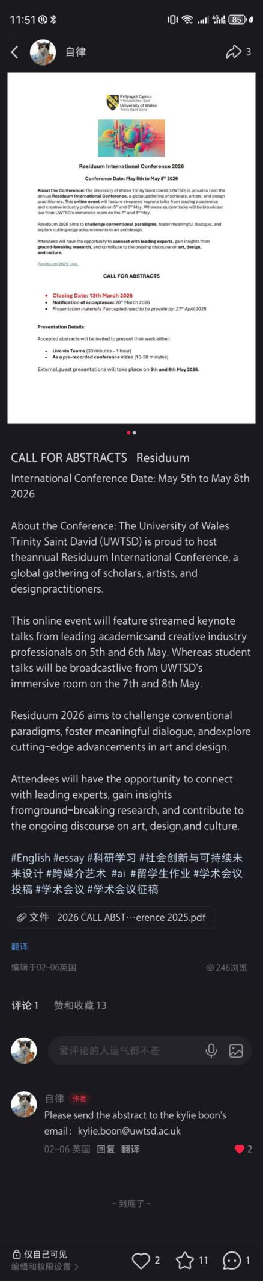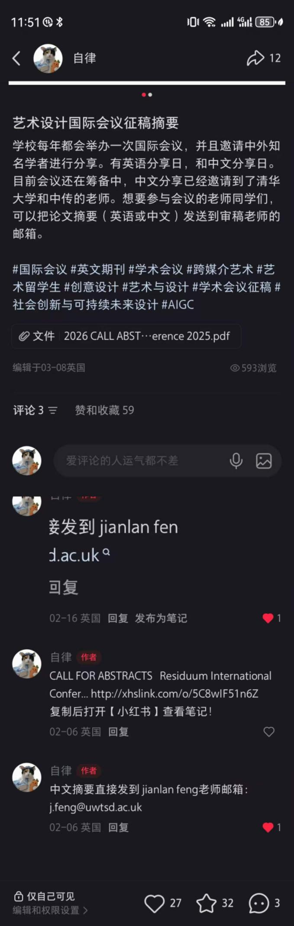
A total of 839 people have viewed it, with 29 likes and 43 collects.

My Contribution to Marketing the Residuum 2026 International Conference
I contributed to marketing the Residuum 2026 International Conference hosted by the University of Wales Trinity Saint David (UWTSD) through targeted digital promotion, clear information delivery, and multilingual outreach to expand global participation.
First, I created and published engaging promotional content on mainstream social platforms, highlighting core details: conference dates (May 5–8, 2026), themes of art, design, cross-media art, social innovation, and sustainable future design, as well as keynote lectures and student presentations. I used concise text, labeled keywords, and attached official call-for-abstracts documents to improve visibility and searchability.
Second, I clarified submission rules and timelines for global scholars, artists, designers, and students. I shared key deadlines (abstract submission: March 13; acceptance notice: March 20; materials due: April 27) and two presentation formats (live Teams or pre-recorded video). I also provided dedicated email contacts for English and Chinese abstracts to lower participation barriers.
Third, I conducted multilingual marketing to attract international and Chinese participants. I emphasized distinguished speakers from Tsinghua University, Communication University of China, and other leading institutions, enhancing the conference’s academic reputation. I actively responded to inquiries, guided submissions, and boosted engagement through likes, collects, and shares.
Through these efforts, I broadened the conference’s reach, attracted diverse contributors, and supported its goal of fostering global dialogue in art and design.

