

Drill Press Re-design and Reflective Report
  - Engineering Design
Josef Ahmed

Executive Summary
A re-design of a drill press main sliding unit was required. The original design characteristics were discussed. Solid works was used to re- design the product to use less material, in turn saving money. A material was then selected to use from three different material which were:
- High-density polyethylene
- Polytetrafluoroethylene
- Polyamide
Once the final material was chosen (Polyamide), the manufacturing processes were discussed. 3D printing was chosen to use for prototyping of the product. Whereas for the main production process chosen was injection molding. This was discussed along with the method used as well as limitations of the process. The report was then concluded.

Contents
Executive Summary 1
Introduction 3
Main Body 4
Research 4
Analysis of original Drill Press Main Sliding Unit 5
Materials 5
Material- Polymers 5
Polymer Selection 6
Manufacturing process 8
Prototype 8
Injection Molding (500 Units P/w) 9
Conclusion 10
References 11
Bibliography 12

Introduction
The following report will discuss and analyze the processes involved in the re-design of a product whilst keeping its natural attributes. The report shall cover the aspects of materials used, design, and the manufacturing side of the product, along with any comparisons made along the way. Finally, the report will discuss the manufacturing processes that can be used to produce 500 units on a weekly timescale, including a chosen process for this number of units.

Main Body

Research
What is the purpose of a drill press?
“Drilling machines, or drill presses, are primarily used to drill or enlarge a cylindrical hole in a workpiece or part. The chief operation performed on the drill press is drilling, but other possible operations include: reaming, countersinking, counterboring, and tapping. The floor type drill press used in the Student Shop is a very common machine, found in both home and industrial workshops. This style drill press is composed of four major groups of assemblies: the head, table, column, and base.”
(UC Davis College of Engineering, 2013)

“Explaining a Drill Press(DP) goes without saying that this instrument has a lot of variables that contribute to the full drill_pressfunction and precision. Generally it can be described as a drill head mounted on a column which can in turn be fixed on some immovable object for example: a work bench. This drill head can be moved on up , around the column as required by handles. Since the drill axis is fixed and do not deviate due to jerks (which happens in a normal handheld drill), it can give a very precise cut or bore in the intended object.”
(Drill Press Guide, 2018)
The two pieces of information tell us that a drill press is commonly used for producing precise cuts for the work piece being used. It does not limit the user to just drilling but allows for a few processes such as reaming, countersinking, counter boring and tapping. This allows for variety in its purpose, and allows for an all-in-one type machine.

Analysis of original Drill Press Main Sliding Unit
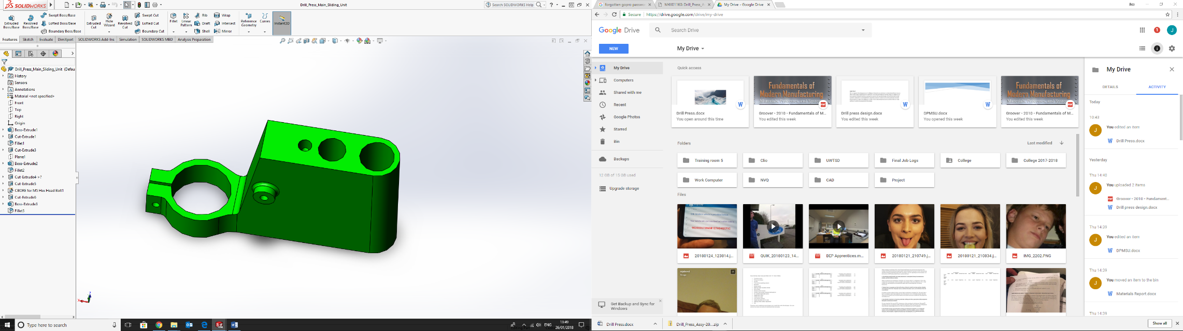
The sliding unit has a very simple task. It needs to slide in both directions on the Y-Axis whilst maintaining a 90 degree angle for the drill against its work surface. The following section will breakdown the purpose of each element of the unit
The hole shown in figure 1 will slide up and down on the ‘column’. This hole would have a clearance fit, to allow it to slide. It is vital the whole is not too large as this will cause the sliding unit to wobble and have a higher limit range of the 90 degrees.
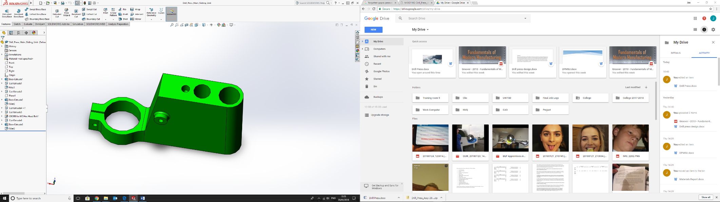

The hole shown in figure 2 in conjunction with another shaft as seen, acts as a guide/support. This keeps the unit parallel with the column reducing the tolerance limit angle.

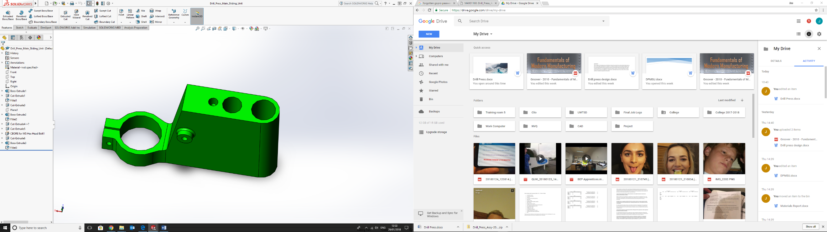
As you can see from the hole shown in figure 3, this attaches to the linkage for lever and handle. The purpose of this is to allow for ease of control when drilling. The lever block travels with the sliding unit up and down the column and guide shaft. Upon release of the lever, the sliding unit and level block will return back up to its original position. This is due to the level block being spring loaded.

Finally the hole shown in figure 4 is the drill mount collar. This will have a reducing bush to allow it to secure the drill. A bolt will pull the mount tighter round the drill when tightened.

Materials
This section will discuss the materialselection. The sliding unit needs to slide along the column and guide whilst carrying the weight of the drill. Due to this, a polymer will be an acceptable material to use. The manufacturing process to be used will be injection molding, as this will meet the requirements of the specification. This section will explain the reason for this in more depth.

Material- Polymers
So, what is a polymer?
“The word "plastic" is frequently used loosely as a synonym for "polymer," but the meaning of "polymer'' is based on molecular size while "plastic" is defined in terms of deformability. Plastics are polymeric materials that are formed into a variety of three-dimensional shapes, often by molding or melt extrusion processes.”
(National Academy Press, 1994)

Polymer Selection
This section will compare and contrast 3 different polymers. After analyzing each polymer, one will be selected for use. The three polymers chosen are:
- High-density polyethylene
- Polytetrafluoroethylene
- Polyamide
High-density polyethylene –
- Flexible and Coil-able
- Heat Fusible
- Strong and Ductile
- Impact Resistant
- Durable
- Abrasion Resistant
- Inert
- Economical
- Corrosion Resistant
- Longevity
- Scratch Tolerant
- Chemically Resistant (Plastic pipe institute, 2018)
Polytetrafluoroethylene –
- Non-Stick
- Low Coefficient of friction
- Heat Resistant (up to 600 degrees F)
- Chemical Resistance
- Abrasion Resistance (The Chemours Company, 2017)
Polyamide -
- High wear resistance
- High thermal stability
- Very good strength and hardness
- High mechanical damping characteristics
- Good sliding properties
- Good chemical resistance (Ensinger Plastics, 2017)

To enable a clear comparison of the three polymers, a matrix table has been used below:
Material Property | High-density polyethylene | Polytetrafluoroethylene | Polyamide
Tensile Strength | 1 | 2 | 3
Elastic Modulus | 2 | 1 | 3
Max Service Temp | 1 | 3 | 2
Impact Strength | 3 | 2 | 1
Processing Methods | 3 | 2 | 1
Dielectric Constant | 2 | 1 | 3
Total | 12 | 11 | 13
(Matmatch, 2017)
The Matrix table shows a comparison of the three polymers using 6 different characteristics. The total of each score was added up to give each polymer a ranking. Polyamide came out on top therefore will be the chosen material for the DPSMU.

Manufacturing process
The following section will now discuss the manufacturing process that will be used to produce a prototype along with the process used to produce 500 units per week. It will look at the benefits and limitations of the two methods.

Prototype
The DPSMU would need to be prototyped to enable checks to be carried out on the product prior to producing volumes of over 500 units per week. Prototyping usually produces a slightly lower quality version of the end product, but a good enough representative of what to expect.
“A prototype is an operating version of a solution. Often a designer makes a prototype with different materials than the final version, and generally it is not as polished.
Prototypes are a key step in the development of a final solution, allowing the designer to test how the solution will work and even show the solution to users for feedback. Occasionally, designers will prototype pieces of the final solution very early in the design process. Sometimes designers will make several prototypes during the development of a solution.
Prototypes can help you to develop the structure, function, and appearance of your solution.”
(Science buddies, 2018)
The benefits of prototyping are that it allows for testing, to check holes are in the correct position etc. Due to advancements in technology, 3D printing is an efficient method of prototyping products such as the DPSMU. A benefit of choosing Polyamide as a production material is that is can be used as a 3D printing material,

“Many different materials can be used for 3D printing, such as ABS plastic, PLA, polyamide (nylon), glass filled polyamide, stereo lithography materials (epoxy resins), silver, titanium, steel, wax, photopolymers and polycarbonate.”
(3Ders, 2018)
Due to 3D printing allowing Polyamide to be used as a material, it will be used as the prototyping manufacturing process. The cycle time take several hours for a product the size of the DPSMU. This will allow for a small batch production of approximately 5-7 units. This will allow for checks to be made to the product and any modifications to be made, and will avoid costs of re-tooling if changes are required. Once the product has been necessarily tested and trialed with success, higher volume production can begin.

Injection Molding (500 Units P/w)
There are many manufacturing processes which can be used for the main production run. The chosen method due to the number of units is injection molding. This also allows for an increase in unites per week if needed.
The injection molding process is a simple process to understand. Polymer pellets are placed into a hopper, from here they are heated and melted in a parallel. A reciprocating screw mixes the pellets and feeds them into a nozzle. The melted polymer, in this case polyamide is fed into a custom mold until the mold is filled. Once the cavity is filled, injection comes to a halt and the polymer is left to cool. Only once the polymer has solidified will the mold be unclamped and the product may now be removed. (Groover, 2010)
With regards to the production of injection molding. If the cycle time is 30 seconds, we could then allow 1 minute for cooling. In an 8 hour working day, this would produce 320 units per day and 1600 for a 5 day working week. This would be more than enough for the required amount and again, leaves room for increments in units per week. (Groover, 2010)
Problems can occur when manufacturing using injection molding. Such as:
- Short shots – Polymer cooling before cavity is filled
- Flashing – Polymer squeezing into parting surface between mold plates
- Sink marks – Indents on final product usually found in thick molded sections
- Weld lines – where two parts of the melt meet and cause a weld line
(Groover, 2010)

Conclusion
The report shows that by tweaking an original design, it is possible to achieve the same outcome but for a smaller cost. Cost is a massive element in manufacturing so reducing it is essential, especially when mass producing. Due to the advancements in technology it has allowed processes such as prototyping a lot easier and a lot cheaper. 3D printing has had a great impact on the manufacturing industry allowing companies to test their products for a fraction of the cost.
In conclusion the DPSMU re- design has allowing for less material to be used for the same outcome. The process used not only will produce the number of units required, but can be increased significantly if it was ever needed in the future. The process is future proofed meaning savings can been made on tooling (no need to replace if more units required).

References
Engineering.ucdavis.edu (2013) ‘Drill Press’ [Online]. Available: http://engineering.ucdavis.edu/wp-content/uploads/2013/08/DRILLPRESS.pdf?69cb4f
Bestdrillguide.com (2018) ‘What is a drill press used for? [Online] Available: https://bestdrillpressguide.com/what-is-a-drill-press-used-for/
National Academy Press( 1994) Polymer Science and Engineering
Matmatch.com (2018) ‘Comparison Results’ [online]. Available:https://matmatch.com/compare/mbas008-general-polyethylene-high-density-pe-hd---vs--mbas034-general-polyamide-610-pa610---vs--mbas023-general-polytetrafluoroethylene-ptfe-?gclid=CjwKCAiAnabTBRA6EiwAemvBdzr_3nGUJVGmcWQLYzgSe9ljkummrolTJHJDe1HSCf2M9ikKHMutFxoCBH0QAvD_BwE&filters[0][type]=text&filters[0][filterValue]=General+Polytetrafluoroethylene+%28PTFE%29&filters[1][name]=thirdLevelCategory&filters[1][filterValue]=Polyamide+%28PA%29&filters[1][type]=materialProperty&filters[1][suggestionCategory]=thirdLevelCategory&filters[2][type]=text&filters[2][filterValue]=General+Polyethylene%2C+high+density+%28PE-HD%29
Sciencebuddies.com (2018) ‘Prototyping’ [Online]. Available: https://www.sciencebuddies.org/science-fair-projects/engineering-design-process/engineering-design-prototypes#prototyping
3ders.org (2018) ‘3D Printing basics’ [Online]. Available: https://www.3ders.org/3d-printing-basics.html
Groover, M. (2010), Fundamentals of Modern Manufacturing, (4th edition), United States.

Bibliography
Alce.vt.edu (DU) ‘Drill Press(metal)’, [Online]. Available: https://www.alce.vt.edu/content/dam/alce_vt_edu/teacher-resources/lab-safety-resources/drillpress.pdf
Doityourself.com(2018) ‘How to use a drill stand’, [Online]. Available: https://www.doityourself.com/stry/how-to-use-a-drill-stand

