Computing (Software Engineering)
MATHS ASSESSMENT
Aled Evans

>> x=2.0
>> y=3.0
(i)
>> 3*x^2 - 2*y^3

ans = -42
(ii)

>> log(x*y)

ans = 1.7918

(iii)

>> sqrt(x/y)

ans = 0.8165

(iv)
>> exp(y)

ans = 20.0855

(v)
>> exp(-x) + log10(y)

ans = 0.6125

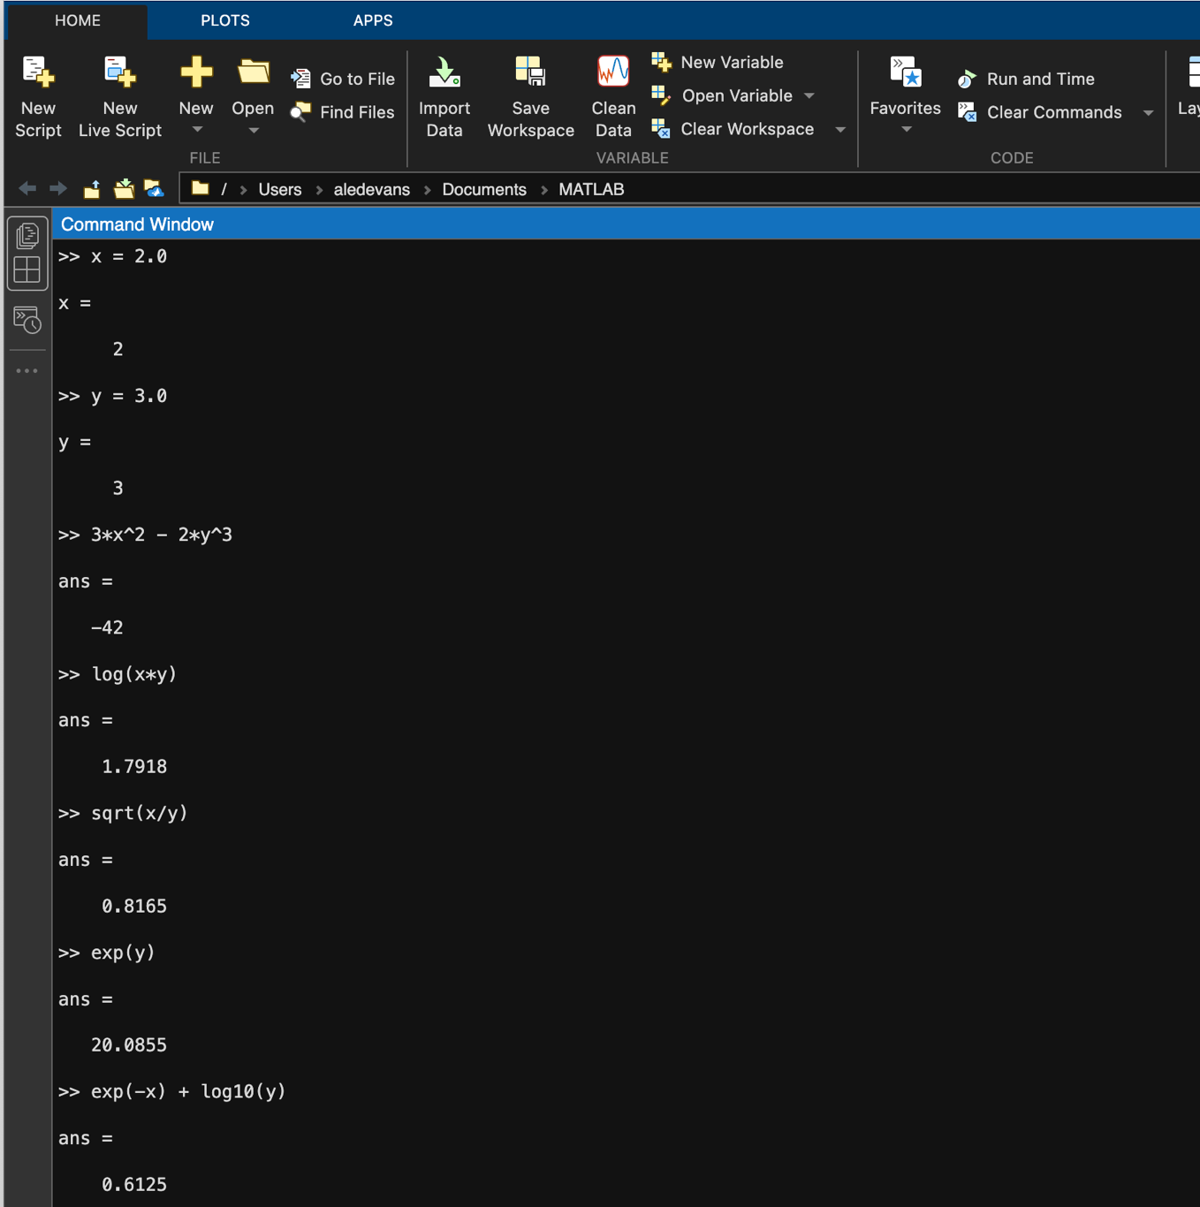

- >> clear all
>> fplot('exp(-x)', [0,4])
>> hold
>> fplot('0.75*x', [0,4])

X 0.677 3 d.p | Y 0.508 3 d.p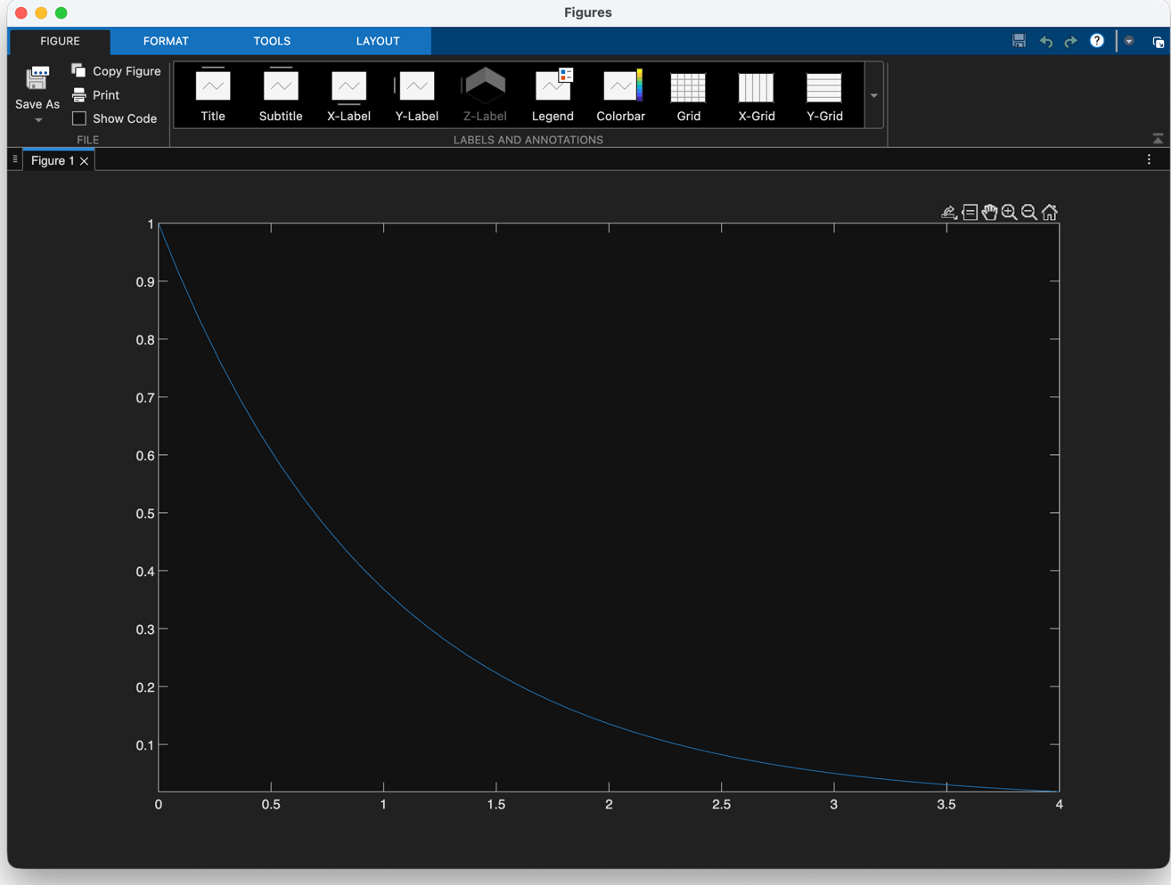
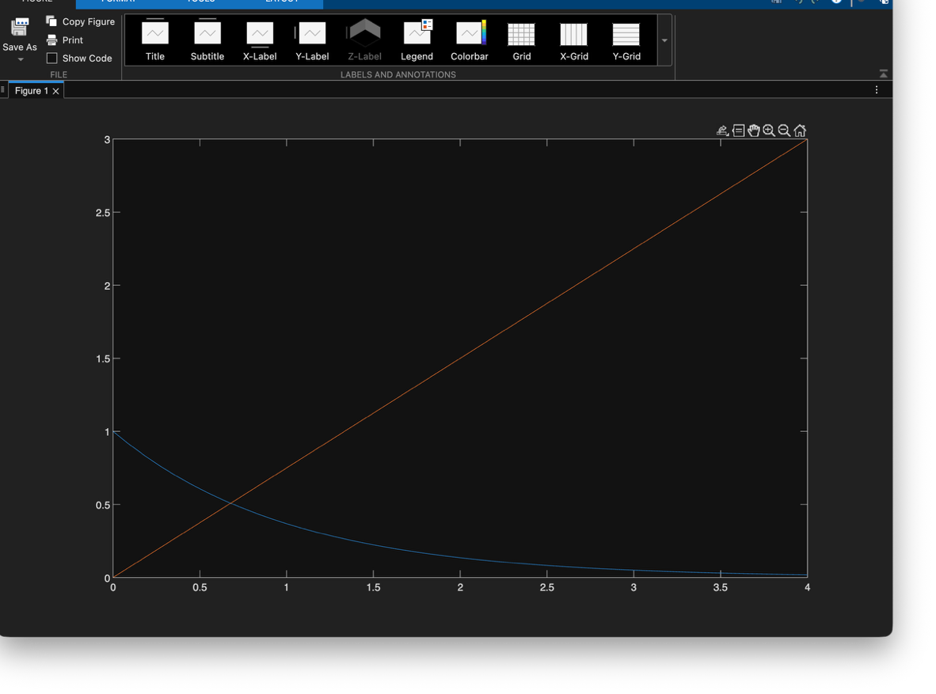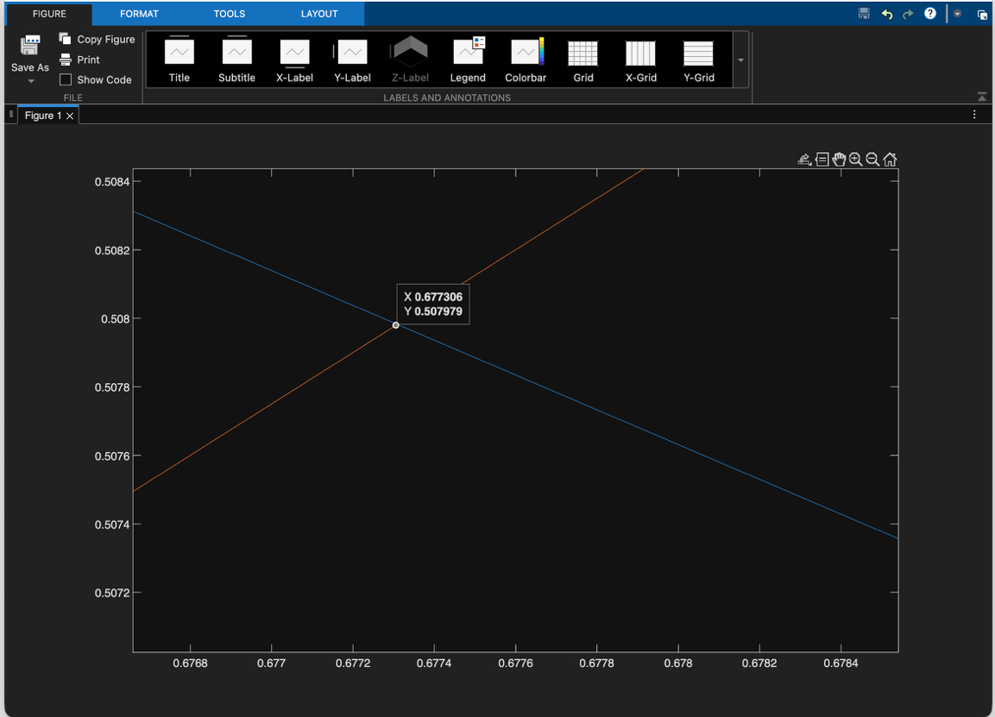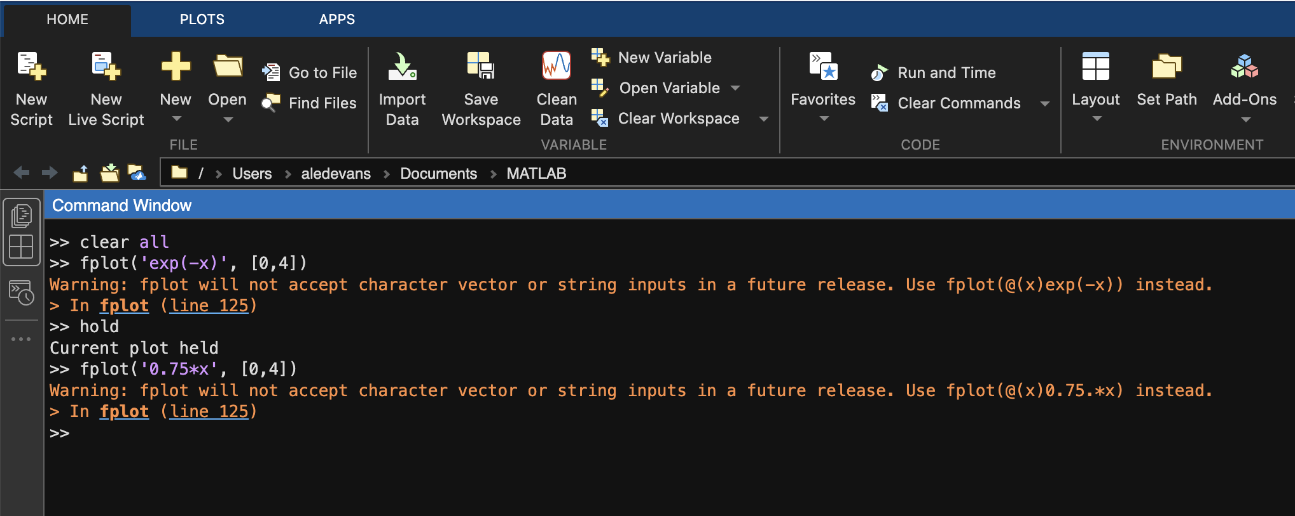
- >> clear all
>>
>> syms x
>> solve(x^3-6*x^2+11*x-6)

ans =
1
2
3
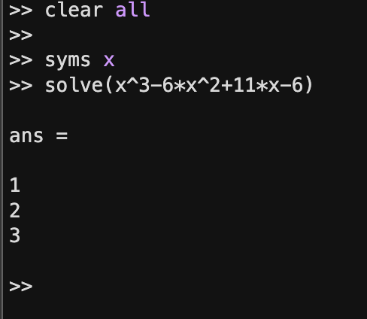

- >> clear all
>>
>> x = [1.0 2.0 3.0 4.0 5.0 6.0]

x =

1 2 3 4 5 6

>> y = [4.1 6.7 9.9 13.3 16.4 19.3]

y =

4.1000 6.7000 9.9000 13.3000 16.4000 19.3000

>> p = polyfit(x,y,1)

p =

3.1000 0.7667

>> y1 = polyval(p, 4.5)

y1 =

14.7167

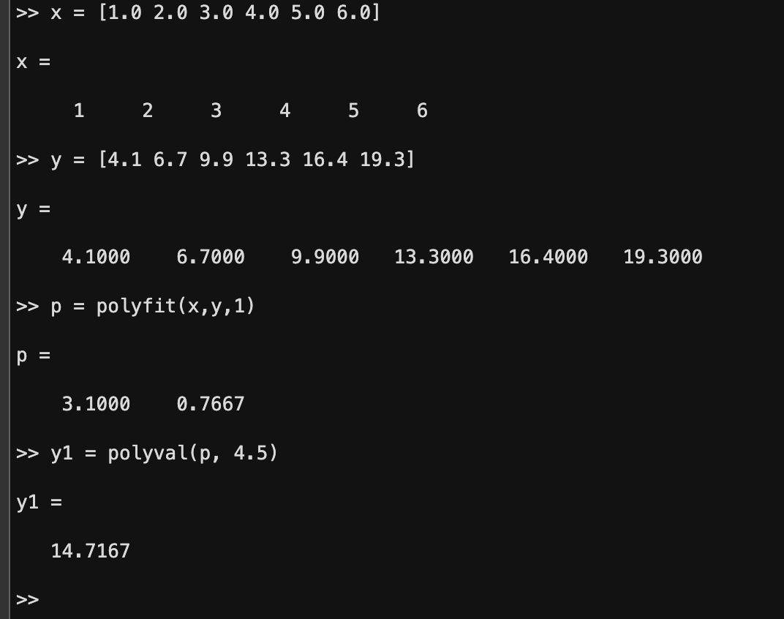

>> clear all
>>
>> syms x
>> y = sin(6*x)

y =

sin(6*x)

>> y2 = diff(y, 2)

y2 =

-36*sin(6*x)

>> y2 + 36*y

ans =

0

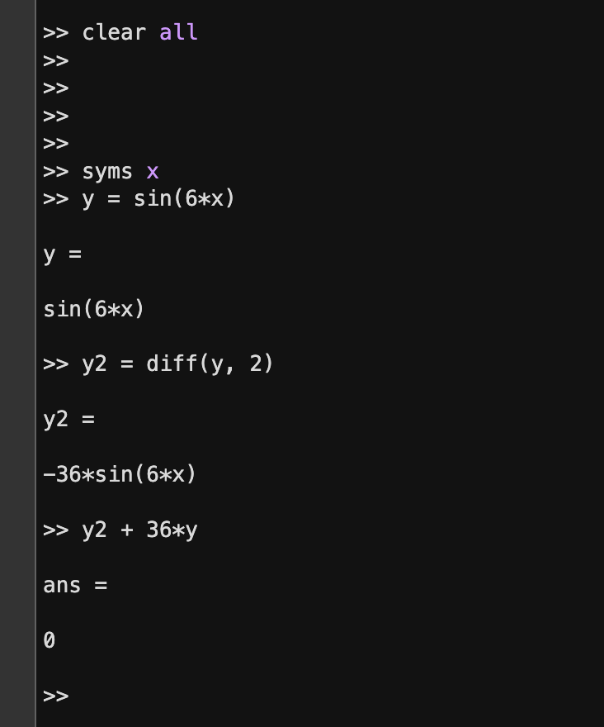

- >> clear all
>>
>> a = [2 -2 3]

a =

2 -2 3

>> b = [2 -3 2]

b =

2 -3 2

>> dot(a,b)

ans =

16

>> cross(a,b)

ans =

5 2 -2

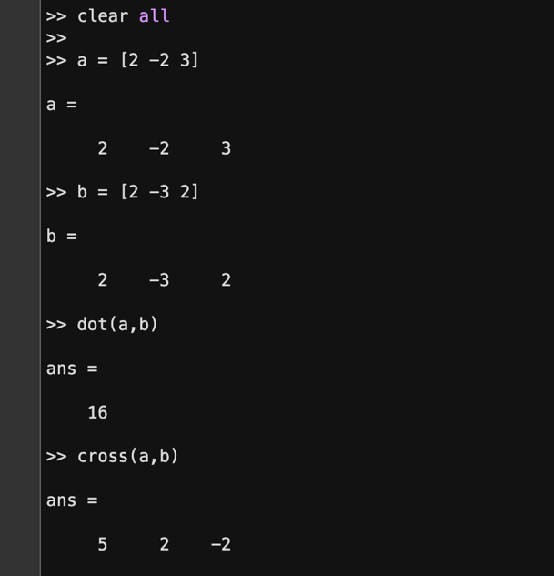
- >> clear all
>>
>> a = [ 1 1 2; 1 2 1; 3 -1 -1]
a =
1 1 2
1 2 1
3 -1 -1

>> det(a)
ans =
-11.0000

>> inv(a)
ans =
0.0909 0.0909 0.2727
-0.3636 0.6364 -0.0909
0.6364 -0.3636 -0.0909
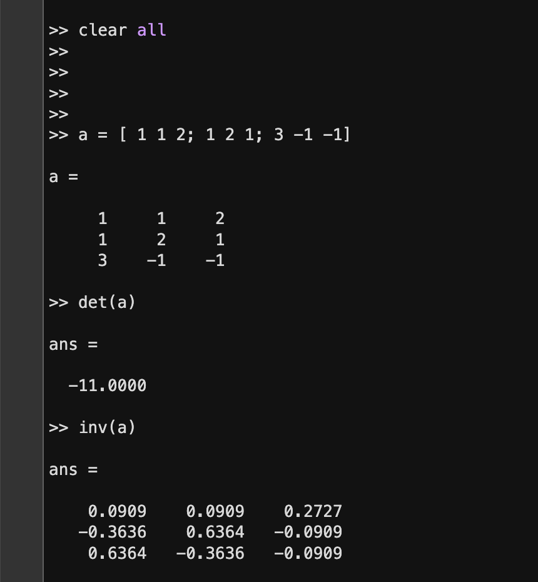
- >> b = [4;4;1]
b =
4
4
1

>> Result = inv(a)*b
Result =
1.0000
1.0000
1.0000


