LEVEL 4 ASSESSMENT SPECIFICATION

Student name: | Julian Milligan | Student ID number: | 1904804
Programme: | BSc (Hons) Computing Portfolio
Module: | Internet Technology and Security
Module code: | ACCA4018 | Contribution to Overall Module Assessment (%): | 50%
Lecturer: | Dr Carlene Campbell- | Internal Verifier: | Nitheesh Kaliyamurthy.

Contents
Introduction 2
Related work 3
Comparing types of platforms. 4
Meraki 4
In-Tune 4
Design overview 5
Network design 5
Implementation 7
Extra Work 8
Conclusion 9
Bibliography 10
Appendix 11
1.Switch Commands used to secure them. 11
2 . Meraki Dash board. 11
Extra Reading 13

Introduction
With Bring Your Own Device (BYOD) becoming more popular with staff and companies, CoffeeCapulus have requested the author of the report to investigate the benefits to them and their staff. This report will focus on the company’s current network infrastructure and what changes would be needed to implement BYOD. It will also investigate several Mobile Device Management platforms and finally a security policy for staff and visitors to follow. Utilising BYOD would help CoffeeCapulus money in the future however there will be capital costs and ongoing revenue costs. Security is one of the driving principles within this report. The report will contain an over view of the current network, discussing 2 different platforms for BYOD, the implementation of the system and any recommend future work.

Related work

With the number of smartphones in circulation as of 2021 there are an estimated 3.8 smartphones in use worldwide.
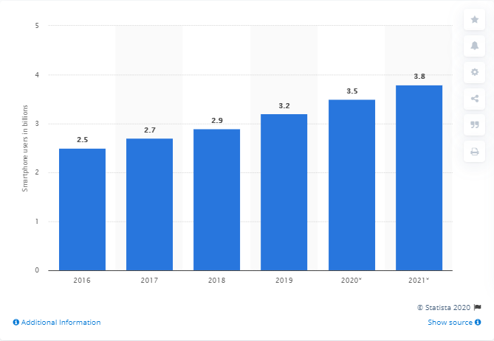 [1]
CoffeeCapulus have requested the requested the report author to look into the feasibility of using Bring Your Own Device within the workplace for staff, guest access for business visitors and customers within the store. This type system will need to be setup in a way where visitors and customers can not access the internal network and view private data and vice versa that staff cannot capture or see personal information on visitors or customers devices.
To archive this BYOD will be introduced into the existing companies’ network. BYOD is the process of allowing a member of staff to use their personal smart phone, laptop or tablet to access resources on the internal network without the device being fully controlled by the company. “BYOD obtain an annual savings of $350 per year per employee” [2], so there are finical benefits too in the long run because there is a cost to implement BYOD and to make sure it`s as secure as it can be. Currently CoffeeCapulus are running a basic network infrastructure that allows staff to login, access internal websites, transfer files via FTP and access emails. BYOD will at looking at giving the staff access to their emails and internal files.
BYOD works by enclosing certain programs like Microsoft`s Outlook within a secure bubble on the personal device. The idea being that data in the bubble stays in the bubble and can not be accessed by personal programs on the device. This however is down to the security policy. The diagram below shows a very basic BYOD onboarding.
User authenticates
User connects to Access point
Details match
Access to internal data

Incorrect details / request rejected

There are other ways of providing the BYOD experience depending on the software or environment used these will be discussed next.

Comparing types of platforms.

The report will look at 2 different packages that provide support for BYOD.

Meraki
This package is provided by Cisco [3], The dashboard ( Appendix 2 ) would allow staff and visitors to sign in and access different parts of the network depending on the access point they choose. For staff it would allow them to access internal resources such as email and visitors would have access to the internet and would allow them to use the app`s on their phones. Meraki can also be used a Mobile Device Management platform. This could be installed on the staff members device and control features such as location, remote wiping and remove Pin codes. This can be quite intrusive and would normally be used on a device owned by CoffeeCapulus. There are also capital cost and revenue cost associated with this platform. The company would need to replace all their current Wireless Access points and purchase a new switch to control them. The ongoing revenue cost would then cover licences for the Access points and users.
Some of the benefits of the package include a Dashboard to show current staff and guests logged in See Appendix 2. Heat maps to show where the wifi is being used the most and if there connections issues it would show another AP is needed and meshed.

In-Tune
This package is provided Microsoft [4] and was part of the Azure platform but is now is a separate entity. This platform does not require the current network infrastructure to be changed so there would be no Capital cost unless the company decided to add a new server for the Azure platform. In-Tune would allow the IT Admin`s to invite users and automatically assign them to an Active Directory group that would allow them to access internal systems such as Email, FTP and Websites. There are many more benefits that could help CoffeeCapulus in the future
- Application Proxy – this could be used to server up internal applications to any 3rd parties that need access.
- Multi factor authentication – this will add extra level of security and is recommended by National Cyber Security Centre [5]
- Active Directory – can be used to control user login, group access and up to date details of employees.

There are on going revenue costs with this platform, CoffeeCapulus would need to tender for current pricing.

Design overview

Network design

The core of the network is located within the Server / Network Room via a Secure door. The room also contains a small UPS ( uninterruptible power supply ) to allow the servers to be shut down safely in the event of a power failure and an air conditioning system to keep the servers cool in their racks.
The 3 servers are

Groot – handles email and DNS entries
Deadpool – handles DCHP
Cylon – HTTP and FTP

There is also one appliance called Viper which the internal Firewall.

Device | Private IP | Public IP | Subnet Mask
Email / DNS Server | 10.44.1.253 |  | 255.255.255.0
DHCP | 10.44.1.252 |  | 255.255.255.0
HTTP / FTP | 10.44.1.250 |  | 255.255.255.0
Firewall | 10.44.1.249 |  | 255.255.255.0

Each room or extra building has it`s on switch, see Appendix 1 for a list of the commands used to secure the switches. Each switch was set up with a secret password ‘QWERTY123!’ and as extra security SSH is enabled on each one with a 1024 bit RSA Key.

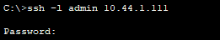

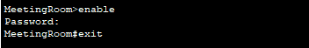

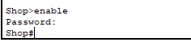

ServerSwitch | 10.44.1.110
MeetingRoom | 10.44.1.111
Office | 10.44.1.112
WareHouse | 10.44.1.113
Shop | 10.44.1.114

SSH was enabled as currently this was the best encryption method available on the switches. With no encryption enabled then anyone inside the internal network would be able to access the switches. Telnet is another option available but as written in an article on Study CCNA “One of the greatest disadvantages of this protocol is that all data , including username and password , is sent in clear text” [6] . SSH uses encrypted data to send all commands, usernames and password. This is done using a public key which is generated as part of the setup on each router. The default on the router is 512 bits but 1024 was used to be more secure.

DHCP is being used via Deadpool. DHCP or Domain Host Configuration Protocol. This server assigns an IP Address to each device on the network bar the servers, switches and appliances which all have static IP Address so they can be accessed either by the IP or Hostname. The benefit of using a DHCP server is that if a new machine comes on an is connect to the domain then it will have the correct IP range and default gateway (Viper).

The HTTP / FTP services are sitting on the same server Cylon. The HTTP contains a basic website for internal use and cannot be accessed from the outside world. The company’s website would be hosted on an external server provided by a 3rd party. Data sent to the FTP Server is sent in plain text so if a hacker were to gain access into the internal network, they would be able to see any username and password. The ideal situation would be to use SFTP or secure file transfer protocol. *** find info ***

Email is configured with the network and secured. The email server is setup on the server called Groot. A DNS A record has also been created for the server.
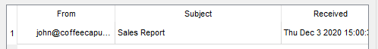

A DNS record was also created for www.coffeecapulus.corp to allow staff to view the Internal Corporate Website. A basic Intranet Website has been created for the company however an external company will be needed to revamp the site and include sections on the new BYOD policy and have a section where the all polices can be down. We have added a simple link for this so the policy will be available.

The Wifi is setup with two Service Set Identifier (SSID).

- SSID = BYOD , Password using WPA2-PSK = GrootHoliday
- SSID = Guest . Password uising WPA2-PSK = GuestAccess

The Meeting Room AP is using the SSID BYOD however the meeting room also has another Access Point in there that is broadcasting the Guest SSID. The Shop AP is broadcasting the Guest SSID too. As part of the implementation a number of access points will add ideally ones that can support multiple SSID`s and routing.
WPA2-PSK was chosen as it is considered the strongest encryption for Wi-Fi to date as quoted by E Wahyudi
“… Wireless technology has enough advantages over existing cable technologies (Stallings, 2011) …
Many people are still questioning about wireless security, and many others believe that wireless
security systems that use WPA2-PSK are more secure than other wireless security …” [7]

In the Appendix 3 you can see SmartPhone2 is connect to the BYOD SSID and SmartPhone3 is connected to Guest Access AP in the meeting room.

In Appendix 4 SmartPhone0 is a staff phone connected to BYPO in the meeting room and SmartPhone1 is connected to the ShopAP which is broadcasting SSID Guest

As the shop is less than 100 meters from the main building then a standard cat5 cable can be used to connect from the server room switch to the switch in the shop. If it was over 100 meters, then an extra switch or a VPN solution would be needed. [8]

Appendix 5 shows the over all network infrastructure in the main building,

Implementation

The works will be carried out over several weeks with the consultant working along side the IT staff at CoffeeCapulus. The first part will be to install the new Azure In-Tune environment on an existing server or new server if required. Once this is done all current members of staff will need to on boarded and assigned to groups for BYOD. The new BYOD Security policy (see Appendix *) will need to be sent to all members of staff and requesting them to agree to it. MFA can then enabled and guidance given to the staff on how to download the application to their personal device.
Alongside this a splash screen will be created for the guest / visitors wifi access and new rules will be created on DHCP Server and Firewall. These rules will ensure that guests will only have access to the Internet and not any resources on the Internal network.
In order to help secure the existing network and all devices currently on it windows update will be run on every device the main reason for this is so any exploits in the operating system detected by Microsoft are patched however ZeroDay exploits may still exist. “Zero-day vulnerability has been considered one of the most serious threats to network security at present.” [9]. Also to support the security antivirus will be installed all device and kept to date centrally by IT. This will help prevent the company be targeted by Malware. At the time of writing this report there have been 267 million records breached in September 2020 [10].

Extra Work

Moving forward it would be a benefit for CoffeeCapulus to move to Office 365, This would then allow the IT Admins to push Applications to devices which are enrolled with in the BYOD policy. The applications themselves would be controlled by IT and would sit in a secure bubble on the phone. Different policies could be written to allow data to copied from the bubble to the personal device and vice versa. Once a user is enrolled then these apps could be installed automatically and pre setup saving on IT support. Other benefits of Office 365 could include access to share point if the company did not want to upgrade to SFTP. SharePoint would be the better option as it would allow user to collaborate on documents in real time.

As the current shop is near the main office then a simple cable connection is ok however if more shops were to open, they would need access to internal files and email. It would be recommended by the report’s author that the company look down the route of a virtual private network. This would allow devices not connected to the internal to connect securely via a VPN and then become part of the internal network.

As Azure will be a new system on the network then it would be recommended to build a new server to support it. This will great help with support if it`s running the latest version of Windows Server.

Conclusion

As BYOD is becoming more popular and some companies need to make saving then this would be a route to go down. As 2020 has seen one the worse pandemics in living memory, many businesses needed to move to a home working solution overnight.
“Bring Your Own Device (BYOD) may not be a new topic – but it has renewed significance in light of the wholesale changes to working practices instigated by the COVID-19 pandemic.” [11]
If the process is introduced with good security include Windows updates, up to date Anti-Virus and forcing users to use good security measures on their personal device such as a strong PIN or password on the lock screen. Then the benefits will out way the costs of implementing BYOD.
Appendix 6 shows a copy of the BYOD policy that will be available to all staff on the company’s intranet at http://www.coffeecapulus.corp/byod.html

Bibliography

[1] | S.O`Dea, “Statista,” 20 8 2020. [Online]. Available: https://www.statista.com/statistics/330695/number-of-smartphone-users-worldwide/. [Accessed 03 12 2020].
[2] | A. J. P. B. Yves Barlette, “Bring Your Own Device (BYOD) as reversed IT adoption: Insights into managers’ coping strategies,,” International Journal of Information Management,, 2020.
[3] | “Meraki,” Cisco, [Online]. Available: https://meraki.cisco.com/solutions/?ref=2JGkLPt&utm_source=google&utm_medium=cpc&utm_campaign=uki_brand&utm_content=brand&utm_term=meraki&gclid=Cj0KCQiAtqL-BRC0ARIsAF4K3WGABEKSz9Md653v4wmBSOc5thiMHdmnzzoRqUuAdeKrd8b_HP_afUoaAlVfEALw_wcB.
[4] | [Online]. Available: https://www.microsoft.com/en-gb/microsoft-365/enterprise-mobility-security/microsoft-intune.
[5] | K. R, “Stepping up to multi-factor authentication,” National Cyber Security Centre , 14 6 2018. [Online]. Available: https://www.ncsc.gov.uk/blog-post/stepping-multi-factor-authentication. [Accessed 04 12 2020].
[6] | C. CCNA. [Online]. Available: https://study-ccna.com/telnet-ssh/. [Accessed 29 11 2020].
[7] | M. M. E. Erfan Wahyudi, “Wireless Penetration Testing Method To Analyze WPA2-PSK System Security And Captive Portal,” 2019. [Online]. Available: https://www.semanticscholar.org/paper/Wireless-Penetration-Testing-Method-To-Analyze-And-Wahyudi-Efendi/e9023b8db564b7ec5d24322e3aad9e7ee92cafcf?p2df. [Accessed 06 12 2020].
[8] | “What is the Cat5e / Cat6 Ethernet cable maximum distance ?,” Schneider Electric, 10 06 2020. [Online]. Available: https://www.se.com/ww/en/faqs/FA269550/. [Accessed 04 12 2020].
[9] | Z. Ye, “Zero-Day Vulnerability Risk Assessment and Attack Path Analysis Using Security Metric,” Springer Link, 11 7 2019. [Online]. Available: https://link.springer.com/chapter/10.1007/978-3-030-24268-8_25. [Accessed 04 12 2020].
[10] | L. Irwin, “it governance,” 2020 10 01. [Online]. Available: https://www.itgovernance.co.uk/blog/list-of-data-breaches-and-cyber-attacks-in-september-2020. [Accessed 04 12 2020].
[11] | G. E, “Bring Your Own Device - the new normal,” National Cyber Security Centre, 24 08 2020. [Online]. Available: https://www.ncsc.gov.uk/blog-post/bring-your-own-device-the-new-normal. [Accessed 04 12 2020].

Appendix

1.Switch Commands used to secure them.

Enable
Configure terminal
interface vlan 1
ip address 10.44.1.110 255.255.255.0 (ip address changes for each router)
no shut
Banner motd #
Unauthorized access is forbidden#
Enable secret QWERTY123!
ip domain-name coffeecapulus.corp
crypto key generate rsa
line vty 0 4
transport input ssh
login local
password 7
exit
username admin password T8pJc?jn
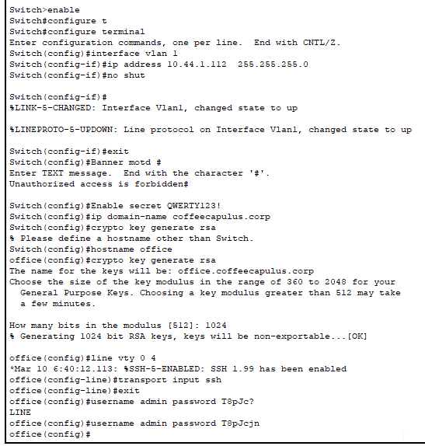

2 . Meraki Dash board.

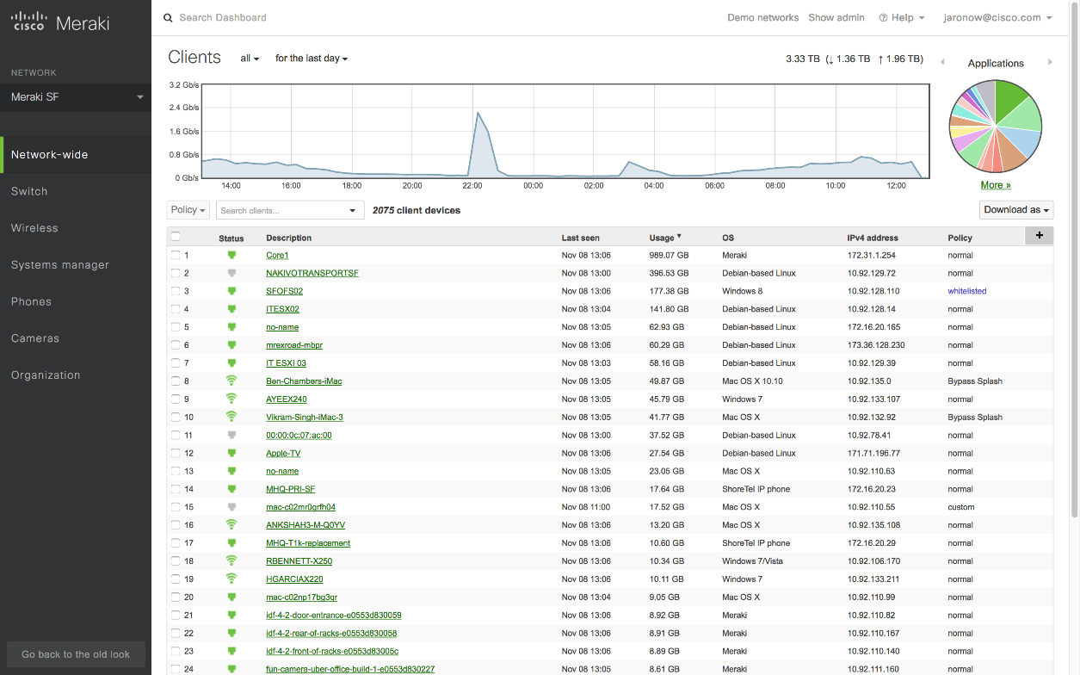

3.Meeting Room Diagram
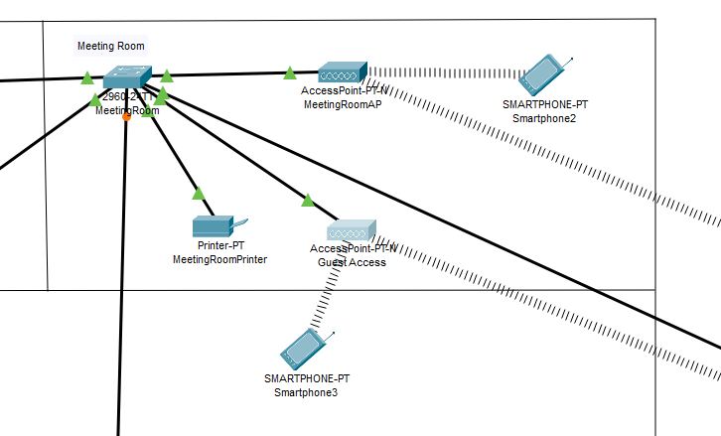

4.Shop Diagram
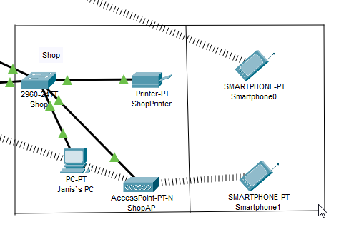

5.Main Network Diagram
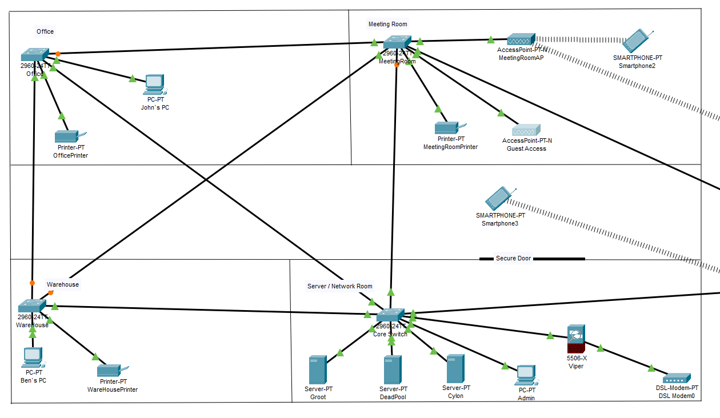

6.BYOD Policy

Coffee Capulus | 

Portable Device Policy / Bring your own device

Purpose

A portable device is defined as a device that is able to access data and store it and can be any of the following:
- Laptops
- Tablets included Android , iPads or touch screen laptops
- Smartphones e.g iPhone , Samsung S20 etc
- Any device able to take a picture
- Anyother device that can store data , such as USB sticks.

Any device connected to the internal network without the permission of the IT Admin will pose a risk and will be subject to disciplinary action. It would also fall under the
Non-compliance with relevant laws and regulations such as the Data Protection
Act (1998), Freedom of Information Act (2000) and the Human Rights Act
(1998).

Requirements & Responsibilities for BYOD

- The user will be responsible for
  - Having a secure pin or password on their device
  - If the device is lost inform IT Admin straight away so your account can be locked
  - Must have update antivirus software installed and running
  - Device must be kept up to date as far as security patches
  - Any suspicious actions must be reported
- IT Admin will be responsible for
  - Keeping the servers up to date
  - Updating this policy when needed
  - Advise the user of any suspicious activity on their account
Access to the BYOD must be authorized by your line manager and the request emailed to itadmin@ coffeecapulus.corp.

Extra Reading

https://www.packettracernetwork.com/

Refresh my knowledge on setting up Cisco switches.

https://www.ncsc.gov.uk/collection/mobile-device-guidance/bring-your-own-device

UK`s guidance on BYOD

marking criteria and Student FEEDBACK

This section details the assessment criteria. The extent to which these are demonstrated by you determines your mark. The marks available for each criterion are shown. Lecturers will use the space provided to comment on the achievement of the task(s), including those areas in which you have performed well and areas that would benefit from development/improvement.

Common Assessment Criteria Applied (Assignment 1) | Marks available | Marks  awarded
1. Engagement with Literature Skills
Extent of research and/or own reading, selection of credible sources, application of appropriate referencing conventions.
Your research aspect can be improved. The research literature can be benefitted from peer reviewed articles/journal papers. Try to utilise the university online resources and journals. A number of key concept considered. (Grade mark: 60.00%) | 15 | 9
2. Knowledge and Understanding Skills
Extent of knowledge and understanding of concepts and underlying principles associated with the discipline.
As mentioned above, your related work could incorporated more research aspects. You did not use the IEEE report format. (Grade mark: 60.00%) | 15 | 9
3. Cognitive and Intellectual Skills
Analysis, evaluation and synthesis; logic, argument and judgement; analytical reflection; organisation of ideas and evidence
Your introduction can be improved, see comment in the report. Your report incorporate the case study which is good but your research aspect could link more to the case study. Good use of diagram in your report. Good way of linking your discussion to your appendix content. It would be good to breakdown your report into the three main headings given in the assignment. Your conclusion need improvement; see comment in report. (Grade mark: 67.50%) | 40 | 27
4. Practical Application Skills
Deployment of methods, materials, tools and techniques; application of concepts; formulation of innovative and creative solutions to solve problems.
A working design, appropriately ladled and security countermeasures implemented. You also considered redundancy in your design; very good. You have explained your design. (Grade mark: 85.00%) | 20 | 17
5. Transferable Skills for Life and Professional Practice
Attributes in professional practice: individual and collaborative working; deployment of appropriate media; presentation and organisation.
There are minor typo errors. Your work could be formatted to make it look more professional. (Grade mark: 65.00%) | 10 | 6.5

Assignment Mark (Assessment marks are subject to ratification at the Exam Board. These comments and marks are to give feedback on module work and are for guidance only until they are confirmed. ) | Late Submission Penalties (tick if appropriate) |  | 69%
 | Up to four weeks late |  | 69%
 | First Attempt? |  | 69%

