
Student Name: | Neet Bajariya | Student ID: | 2520872
Programme: | Master of Business Administration
Module: | Marketing Management
Module Code: | LCMB7024
Assignment Title: | Assessment Component 1: Marketing Environment Analysis
Lecturer Name: | Laila Maazouz Dian Mayasari
Word Count: | 2477(Excluding Refernces, Tables) | Submission Date: | 27th March, 2026

Table of Contents
1. Introduction 1
2. Overview of the Global Smartphones Industry 3
3. Macro Marketing Environment Analysis 3
3.1 Technological Factors 3
3.2 Economic Factors 4
4. Strategic Analysis of Response 5
4.1 Porter’s Generic Strategies 5
4.2 Ansoff Growth Matrix 6
5. Comparative Discussion 7
6. Conclusion 8
References 9

Marketing Environment Analysis: Apple vs Samsung

1. Introduction
The smartphone market is one of the most active and competitive industries in the contemporary technology market. Smartphones have redefined how people interact with one another, obtain knowledge, conduct business, and engage with digital platforms (Jamalova, 2024). The last 10 years have seen technological innovation, better internet connectivity and increased significance of mobile technology in daily life, among other things, contribute greatly to smartphone adoption across the globe (Statista, 2025). It follows that organisations within this sector need to keep up with the external environmental changes in order to sustain a competitive edge and stay in the long run (Chaffey and Ellis-Chadwick, 2022).
The marketing environment analysis is important in making sense of the effects of the external forces on organisational strategy and performance (Grant, 2021). The strategic decisions of firms in the smartphone industry are influenced by macro-environmental factors that include technological changes, economic factors, consumer buying behaviour and international rivalry (Whittington et al., 2020). These forces provide an opportunity to innovate and grow, and offer challenges that organisations have to deal with in a strategic manner (Chaffey and Ellis-Chadwick, 2022).
Apple and Samsung are two of the most powerful organisations in the smartphone market in the world.
Apple is generally considered an innovative organisation due to the launch of the iPhone in 2007, which transformed the design of smartphones by embedding hardware, software and digital services as a single ecosystem (Kornelakis and Petrakaki, 2025). The innovation made Apple one of the market leaders in the luxury smartphone market (Koetsier, 2024).
Samsung, however, may be regarded as a follower organisation that has been able to cope with the changes in technology and gain a larger market share (Counterpoint Research, 2026). The company also has a diversity of smartphones within various price segments, but remains in the investment of innovation. This approach will enable Samsung to cover the various consumer groups within the developed and emerging markets (IDC, 2025).
This report is a critical analysis of the macro marketing environment of Apple and Samsung, and it dwells on both technological and economic aspects. It also compares the strategic responses of the two organisations through Porter's Generic Strategies and the Ansoff Growth Matrix.

2. Overview of the Global Smartphones Industry
The smartphone industry in the world has been registering positive growth in the last ten years, which has been mainly due to the advancement of technology and rising digitalisation (Grand View Research, 2024). Smartphones are no longer restricted to communication but can be used as multifunctional devices with social networking, electronic payments, entertainment, education and business support (Kenney and Pon, 2011). This has led to them being an indispensable resource for billions of users all over the world (Statista, 2025).
Competition in the market is very stiff, and the multinationals dominate the market. Among the mentioned, Apple and Samsung are the usual leaders in terms of their strong technological background, worldwide distribution networks and brand awareness (Mordor Intelligence, 2026). Although the rivals like Xiaomi, Oppo and Huawei have been making inroads into the market, Apple and Samsung still control major parts of the market (StatCounter, 2026).
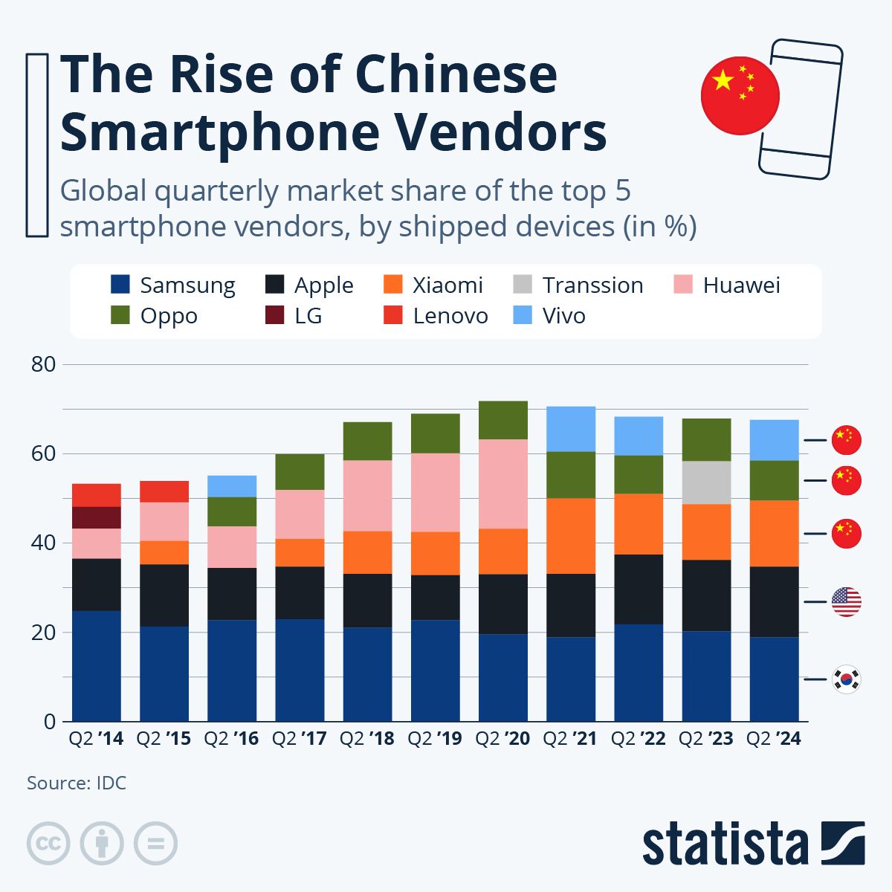
The positioning of Apple is based on the high-end and integration of its ecosystem. The company manufactures high-end smartphones with its own operating system, which is iOS. Its ecosystem integrates gadgets like iPhone, MacBook iPad and Apple Watch using services like iCloud and App Store to provide customers with an uninterrupted user experience, which makes them remain loyal (Apple, 2025).
Samsung follows a more comprehensive approach by selling smartphones in a wide range of prices, including entry-level and flagship phones like the Galaxy S and the Galaxy Z (Samsung, 2025). The Android operating system offers flexibility in product development and pricing that will enable Samsung to serve a large population of consumers (Cecere, Corrocher and Battaglia, 2015).
Characteristics of the industry include:
- Constant technological advancement.
- High levels of competition
- Rapid product life cycles
- Growing consumer demands.
Based on these factors, companies have to innovate and change every day so as to be competitive.
Table 1: Competitive Positioning of Apple and Samsung in the Smartphones Industry
Company | Market Position | Key Competitive Strength | Target Market
Apple | Premium smartphones leader | Strong ecosystem integration, brand loyalty, proprietary iOS platform | High-income consumers and premium smartphone users
Samsung | Global smartphones manufacturer | Product diversity, technological innovation, flexible Android platform | Multiple market segments, including budget, mid-range and premium users

3. Macro Marketing Environment Analysis
Macro-environmental factors significantly influence the smartphone industry and can be analysed using frameworks such as PESTLE (Chaffey and Ellis-Chadwick, 2022). This report focuses on technological and economic factors, as they are the most influential drivers of change (Grant, 2021).

3.1 Technological Factors
Among the most significant forces that influence the smartphone industry, there is technological advancement. Unceasing advancement in artificial intelligence, processing power, screen technology and mobile applications have raised consumer demands and stiff competition (Cecere, Corrocher and Battaglia, 2015).
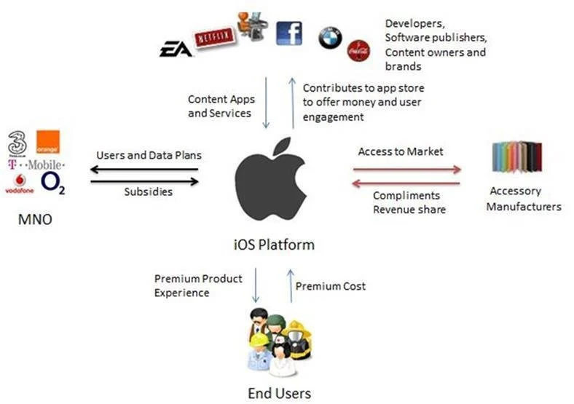
Technological differentiation has been one of the ways Apple has created a competitive advantage. The company has a heavy investment in research and development especially on proprietary technology like its A-series processors (Apple, 2025). These processors provide high performance, energy efficiency and security and enable Apple to have control in both hardware and software integration (Kornelakis and Petrakaki, 2025).
The ecosystem is one of the strengths of Apple as it integrates various devices and services. This integration will raise switching costs and provide a seamless user experience to ensure long-term customer loyalty (Choi, 2014).
Samsung is another company that concentrates on technological innovation and takes another strategy. The company focuses on the development of hardware and making of components, specifically in the display technology (Samsung, 2025). AMOLED displays and foldable smartphones are some of the innovations that show that Samsung leads in the hardware design (Kornelakis and Petrakaki, 2025).

Such opportunities that technological innovation opens include:
- Creation of AI capabilities.
- Enhanced camera and display technology.
- Digital eco-system growth.
- Expanding of new device models like foldable mobile phones.
It has difficulties, however, also. The high cost of research and development, the quick obsolescence of products and higher competition by new manufacturers are exerting pressure on a firm to constantly innovate (Corrocher and Paganuzzi, 2025).

3.2 Economic Factors
Economic factors are very vital in determining the market of smartphones. Demand and profitability depend on factors like the level of income, inflation, consumer purchasing power and cost of the supply chain (PwC, 2024).
The diversification of products does favour Samsung as the emerging markets are experiencing economic growth (IDC, 2025).
The company offers:
- Affordable mobile phones for low-end consumers.
- Mid-end gadgets in mass markets.
- Premium Smartphones: High-end customer smartphones.
This will enable Samsung to enjoy a large market share in various regions.
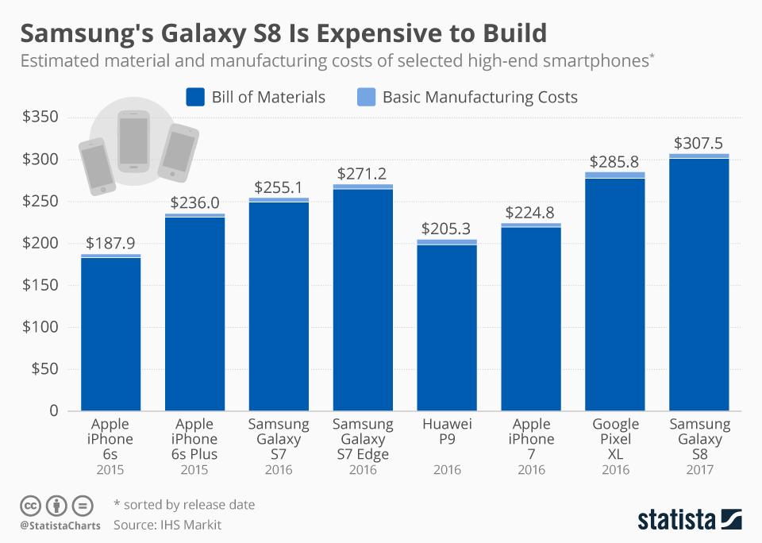
Apple, on the other hand, targets the high-end market. Its high prices and profitability are supported by its good brand image and ecosystem (Deloitte, 2024). The customers of Apple are usually brand-loyal and can afford to pay high prices (Backhaus, 2023).
Both companies however may be affected by economic downturns. When inflation or low spending amongst consumers occur, premium devices might not be required (PwC, 2024). This is more threatening to Apple and the diversified strategy of Samsung is more flexible (Grant, 2021).

4. Strategic Analysis of Response

4.1 Porter’s Generic Strategies
The framework of Generic Strategies by Porter reveals how organisations gain competitive advantage based on cost leadership strategy, differentiation or focus strategy (Porter, 2008). In the smartphones market in the world, Apple and Samsung have differentiation strategies but the way these are put into practice varies considerably.
The major strategy that Apple implements is differentiation strategy whereby it provides high quality smart phones that are focused on design, innovation, security, and smooth integration of hardware and software (Porter, 2008). The fact that it is in control of its operating system (iOS) and hardware enables the company to provide a high level of consistency and optimisation of its user experience (Apple, 2025). Moreover, the ecosystem, linking the devices, including iPhone, MacBook, iPad and Apple Watch, via the services, including iCloud and the App Store, helps Apple to enhance its differentiation by establishing a cohesive digital sphere. Such an ecosystem makes customers more loyal and costly to switch to since users are now more reliant on interconnected Apple products (Barney, 1991).
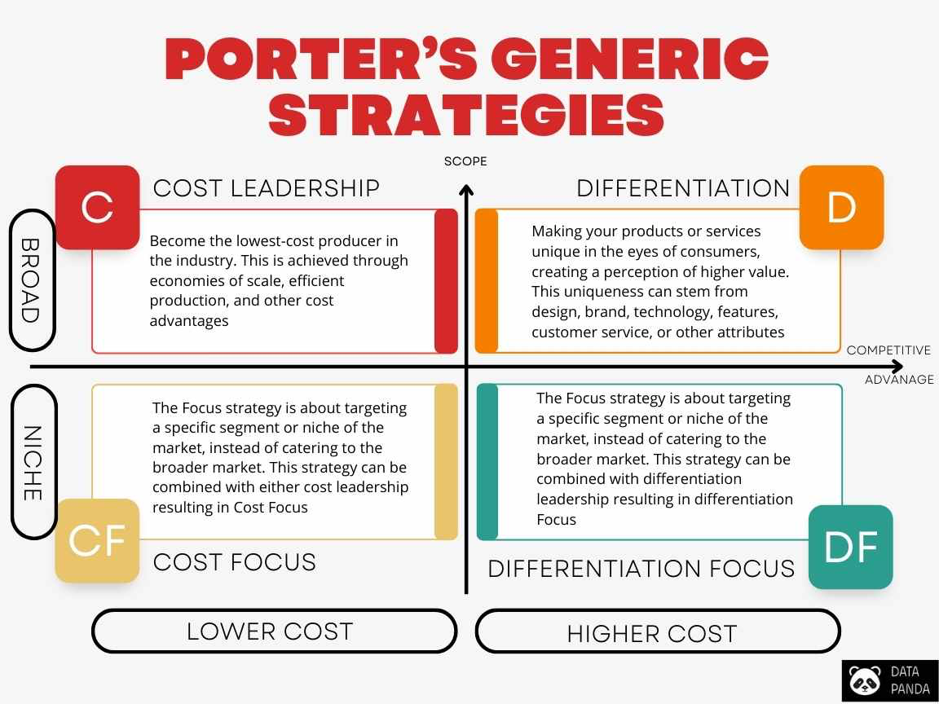
Consequently, Apple can sustain a high value pricing policy and realise high profitability (Hamel and Prahalad, 1990). It does not only relies on the features of its products when differentiating but also on brand image and perceived value (Kay, 2006). This strategy, however, restricts its availability in the price-sensitive markets because its products are segmented in high-income consumers (Backhaus, 2023).
Contrarily, Samsung uses a more wide-ranging strategic strategy combining differentiation with the aspects of cost leadership (Porter, 2008). The firm sets itself apart by the constant technological innovation especially in hardware capabilities like display technology, camera systems, foldable smartphones (Samsung, 2025). Meanwhile, Samsung has products in a range of price categories such as low-end, low-end and high-end smartphones (Counterpoint Research, 2026).
This is a two-fold strategy, and with it, Samsung is able to serve more customers and compete in the developed and emerging markets (Whittington et al., 2020). Through the provision of a variety of products in varying prices, Samsung can attain economies of scale and remain competitive in varying market segments (Grant, 2021). This general approach though could diminish brand exclusivity in comparison to the premium positioning of Apple (Albasoos and Al Musallami, 2020).
In sum, both companies use the strategy of differentiation, but Apple is oriented to premium exclusivity and integration into the ecosystem, and Samsung to product diversification and technological versatility (Porter, 2008).
Table 2: Porter’s Generic Strategies Comparison
Strategy | Apple | Samsung
Differentiation | Premium design, ecosystem integration | Hardware innovation, foldable phones
Cost Leadership | Limited focus | Budget and mid-range phones
Market Coverage | Premium market | Multiple price segments

4.2 Ansoff Growth Matrix
The Ansoff Growth Matrix offers a framework on the company growth strategies based on the four main approaches, namely, market penetration, product development, market development and diversification (Ansoff, 1988). A number of strategies in this framework are applied by both Apple and Samsung to foster their development and expansion in the international smartphone market.
The growth strategy of Apple is mainly directed at the penetration and product development in the market (Ansoff, 1988). The company also urges its current customers to upgrade their devices by launching new models of iPhone with more functionality and better performance regularly (Apple, 2025). The approach can be used to keep the customers engaged, and will secure a stable demand in its current market. Besides that, Apple also grows its ecosystem by introducing complementary products like Apple Watch, AirPods and digital services that also enhance its position in the market and make customers even more dependent on its ecosystem (Choi, 2014).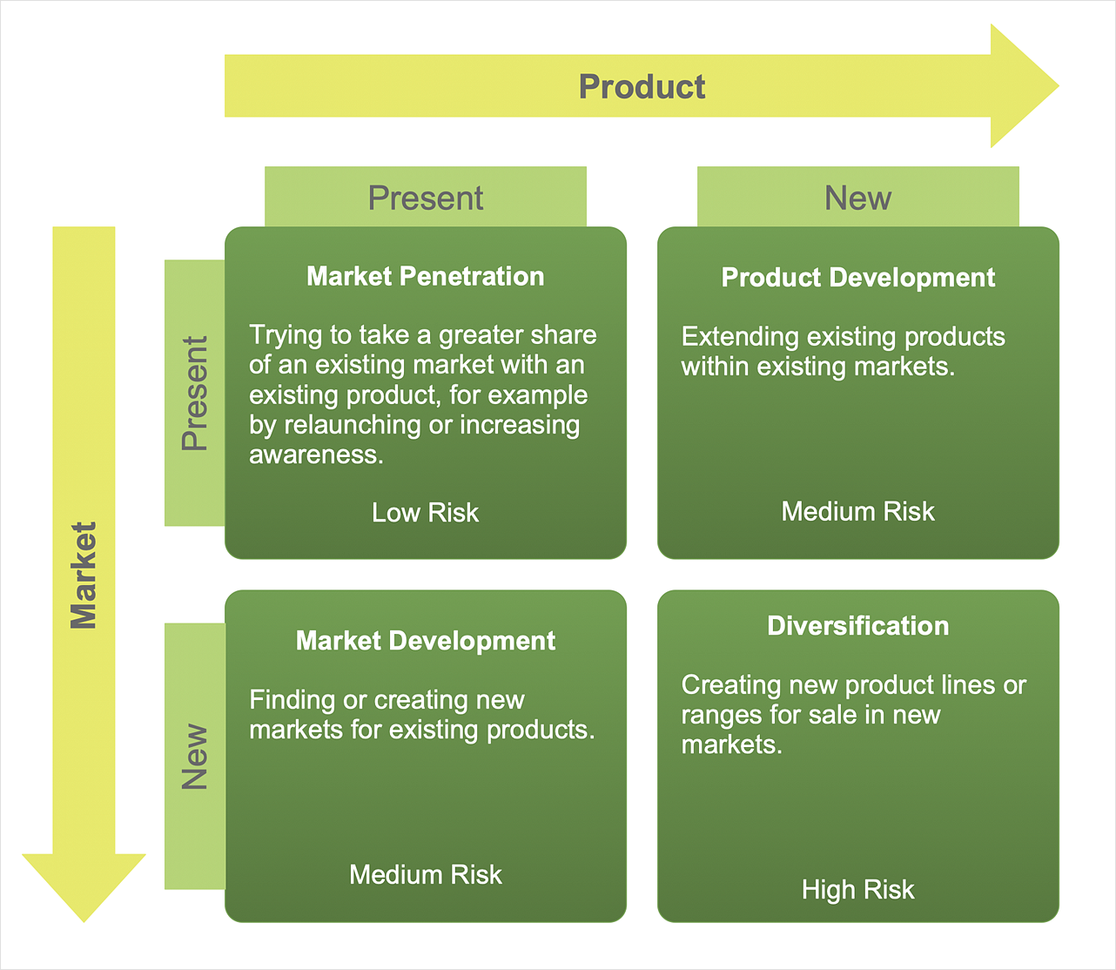
Samsung, however, is more diversified in its growth strategy. Besides, penetrating the market and product development, Samsung also engages in market development by venturing into emerging markets where the adoption of smartphones is growing (IDC, 2025). Another form of diversification that the company engages in is through operating in several segments, one of which is the semiconductor and the other being consumer electronics and home appliances (Samsung, 2025). This will make it less dependent on smartphone sales as well as diversify its business portfolio (Ansoff, 1988). Having the capability to deal in different industries has given Samsung more flexibility and toughness especially in the face of fluctuation in the economy. Nevertheless, this diversity of activities can lead to the problems of sustaining the focus and coherent brand image (Grant, 2021).
Overall, the growth strategy of Apple is more narrow and ecosystem-driven, whereas the strategy of Samsung is more wide and is focused on diversification and focus on the global market (Whittington et al., 2020).

5. Comparative Discussion
Despite the two companies being in the same industry of smartphones worldwide, their strategies vary greatly in the way they position themselves in the market, the strategy of their product and the competitive focus (Cecere, Corrocher and Battaglia, 2015). It is these differences that indicate how organisations can attain a competitive advantage by following different strategic directions (Porter, 2008).
The differentiation and integration of the ecosystem is the core of the strategy at Apple (Hamel and Prahalad, 1990). Apple provides a coherent user experience by providing high-quality products which are interconnected with its ecosystem (Choi, 2014). Such integration enhances loyalty among customers and the cost of switching because a user becomes dependent on various Apple products and services (Barney, 1991). As a result, Apple can continue with the high-end pricing strategy and record high profit margins (Koetsier, 2024).
Samsung on the contrary, is more diversified and free. The company has many brands of Smartphones with various price ranges which enable it to serve a larger number of customers (Counterpoint Research, 2026). This strategy will help Samsung compete on both developed and emerging markets and adjust to different preferences and economies of consumers (IDC, 2025). Its competitive advantage is further reinforced by its emphasis on technological innovation, which is especially in hardware design (Kornelakis and Petrakaki, 2025).
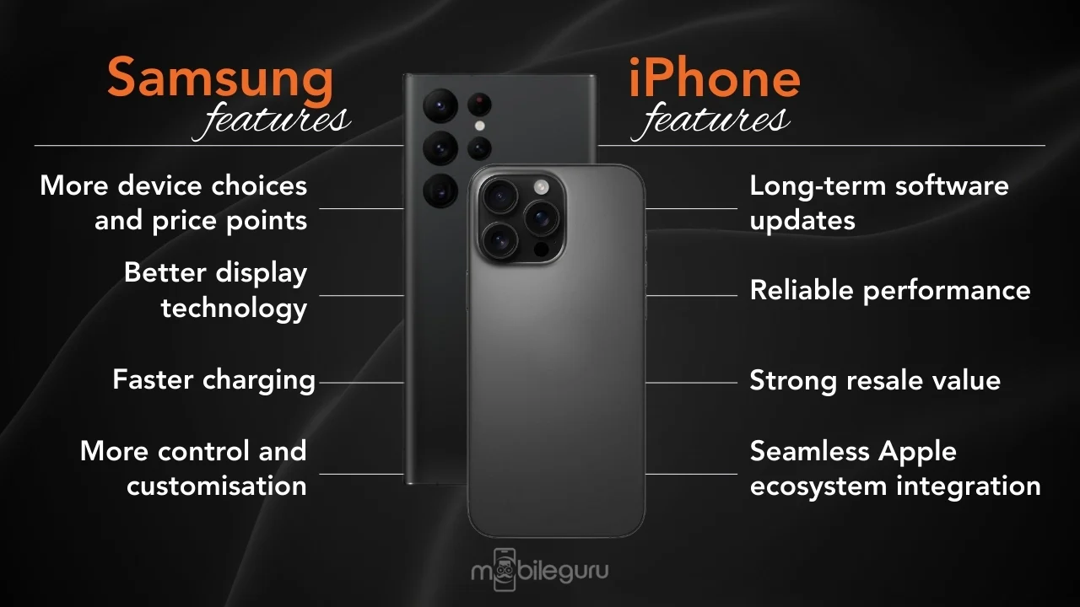Although this strategy has resulted in a high level of brand loyalty and profitability at Apple, it could be a constraint to its market penetration into price-sensitive markets (Albasoos and Al Musallami, 2020). The diversified strategy of Samsung, in its turn, offers higher accessibility and flexibility at the expense of the exclusivity of its brand (Grant, 2021).
Altogether, the comparison reveals that the strategy of Apple is more depth-oriented, using customer loyalty and high positioning, but Samsung's strategy is more breadth-oriented, with market coverage and product diversity (Whittington et al., 2020). The two strategies have been successful, yet they represent varying priorities in having a long-term competitive advantage (Barney, 1991).

6. Conclusion
The external marketing environment is highly relevant to the success of an organisation due to the high level of technological improvement and competition in the global smartphone industry (Chaffey and Ellis-Chadwick, 2022). In this report, the macroenvironmental forces driving Apple and Samsung have been analysed, specifically, the technological and economic forces that contribute to the making of strategic decisions (Grant, 2021).
Technological innovation has been a major competition factor in the industry (Deloitte, 2024). The Apple Company derives competitive advantage through the integration of its ecosystem, proprietary technologies and a powerful differentiation strategy that underpins premium pricing and customer loyalty (Hamel and Prahalad, 1990). It allows it to provide a highly optimised user experience as it can control both hardware and software (Apple, 2025).
Category | Apple | Samsung
Strengths | Strong brand, ecosystem | Product diversity, innovation
Weaknesses | High prices | Less brand exclusivity
Opportunities | Ecosystem expansion | Emerging markets
Threats | Economic downturns | Intense competition
Samsung, on its part, is technologically innovative in terms of hardware and product diversification, and as such, can compete in numerous market segments (Kornelakis and Petrakaki, 2025). Its wide range of products enables it to react better to the shift in consumer demand and economic conditions, offering it increased flexibility in a volatile market environment (Grand View Research, 2024).
Another important factor that determines consumer purchasing behaviour is economic factors (Backhaus, 2023). Premium pricing strategy by Apple enables it to have high profit margins, but it can be unreachable when economic patterns are unpredictable (PwC, 2024). However, Samsung can be competitive on the different income levels as well as on the market conditions due to the diversified pricing strategy chosen by the company (IDC, 2025).
To sum up, Apple and Samsung have worked out successful strategies that help them to take leading positions in the smartphone market on the planet (Counterpoint Research, 2026). The ecosystem-based strategy at Apple has produced high customer loyalty and brand value, whereas the diversification strategy of Samsung offers high flexibility and market coverage (Whittington et al., 2020). The future of the two organisations will be based on the capacity to maintain the innovation, meet the changing consumer expectations and adjust to current technological and economic trends (Deloitte, 2024).

References
Kay, J., 2006. STRATEGY AND SOME THOUGHTS ABOUT. The Oxford Handbook of Strategy: A Strategy Overview and Competitive Strategy, p.27.Chaffey, D. and Ellis-Chadwick, F. (2022) Digital Marketing. 8th edn. Harlow: Pearson.
Grant, R.M., 2021. Contemporary strategy analysis. John Wiley & Sons.
Whittington, R., Angwin, D., Regnér, P., Johnson, G. and Scholes, K., Welcome to Exploring Strategy.
Backhaus, J.F., 2023. Which decision-making process step is perceived as being the most challenging when purchasing a smartphone? A study on Gen Z consumers at the example of the decision-making process model by Kotler & Keller (Master's thesis, Universidade NOVA de Lisboa (Portugal)).Pariser, E. (2011). The Filter Bubble. London: Penguin.
Porter, M.E., 2008. On competition. Harvard Business Press.
Chusnah, F.N., Barney, JB, 1991, “Firm Resources and Sustained Competitive Advantage”, Journal of Management, Vol. 17, pp. 99-120. Management, 17, pp.99-120.
Cecere, G., Corrocher, N. and Battaglia, R.D., 2015. Innovation and competition in the smartphone industry: Is there a dominant design?. Telecommunications Policy, 39(3-4), pp.162-175.
Hamel’s, G., CK Prahalad & Gary Hamel’s The Core Competence of the Corporation.
Kornelakis, A. and Petrakaki, D., 2025. Technological innovation, industry platforms or financialization? A comparative institutional perspective on Nokia, Apple, and Samsung. Business History, 67(8), pp.1983-2008.
Albasoos, H. and Al Musallami, N., 2020. The conflict between Apple and Samsung over Patents and Copyrights. Bussecon Review of Social Sciences (2687-2285), 2(3), pp.1-17.
Corrocher, N. and Paganuzzi, S., 2025. Planned obsolescence and smartphone replacement: Empirical evidence on the Italian market. Telecommunications Policy, p.103022.
Jamalova, M. (2024) ‘Modelling user behaviour towards smartphones’, arXiv.
Kenney, M. and Pon, B. (2011). Structuring the smartphone industry.
Choi, J. (2014) ‘UX and strategic management in smartphone companies’, Springer.
Counterpoint Research (2026) Global Smartphone Market Share Report. Available at: https://counterpointresearch.com
Deloitte (2024) Global Technology, Media and Telecommunications Predictions. London: Deloitte Insights.
Grand View Research (2024) Smartphone Market Size Report. Available at: https://www.grandviewresearch.com
International Data Corporation (IDC) (2025) Worldwide Smartphone Market Share Report. Available at: https://www.idc.com
PwC (2024) Global Technology Industry Outlook. London: PricewaterhouseCoopers.
StatCounter (2026) Global Mobile Vendor Market Share. Available at: https://gs.statcounter.com
Statista (2025) Global Smartphone Market Statistics. Available at: https://www.statista.com
Mordor Intelligence (2026) Smartphone Market Growth and Forecast. Available at: https://www.mordorintelligence.com
Apple (2025) Annual Report. Available at: https://www.apple.com
Samsung (2025) Annual Report. Available at: https://www.samsung.com
Koetsier, J. (2024) ‘Apple becomes the number one global smartphone brand’, Forbes.

