Curtis Stephens
1903184 University of Wales Trinity Saint David
ACCA5023 – Network operating systems and services – Worksheet four

Contents
No table of contents entries found.

Introduction
For this final worksheet, it is required that the File Transfer Protocol (FTP) service be enabled, and that FTP is utilised across the network.
As well as the FTP service, the Routing and Remote Access Service (RRAS) will also be enabled. This will enable the first network (Server 1 and Client 1) to communicate with the second network (Server 2 and Client 2) despite them being disconnected, via the PublicNet interface.
Finally, packet filtering will be enabled. This can stop data packets being sent and received from certain IP addresses – For example, Client 2 can be set up to receive all packets except those sent by Server 1, and so on.
There are two different types of filters, inbound and outbound. Inbound filters deal with data packets coming into the network, and outbound filters deal with packets that are leaving the network.

Practical Tasks
Firstly, an ARP table was created. This maps logical IP addresses to physical addresses of interfaces. This is how a packet is sent or received over a network.
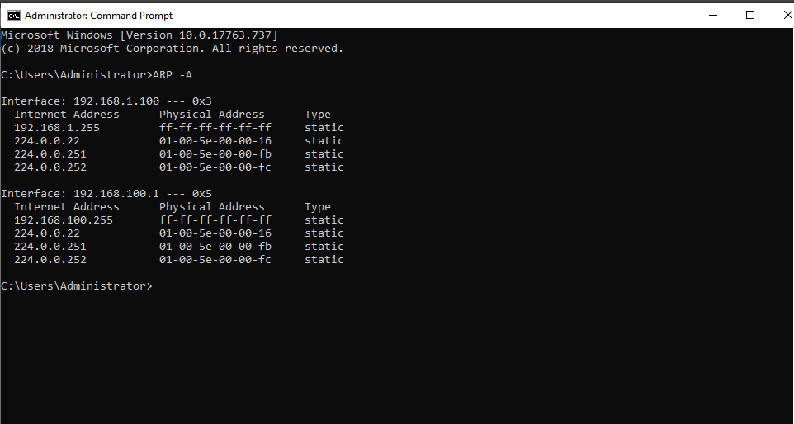
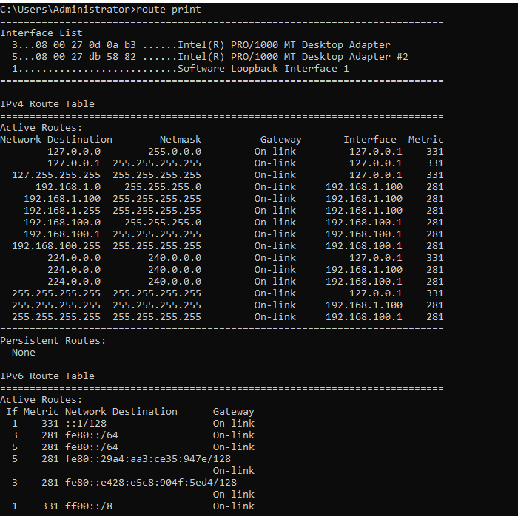
The above table shows which networks a host is connected to. As this is the Server 1 machine, it is showing as connected to PublicNet and PrivateNet1 and being connected to Client 1.

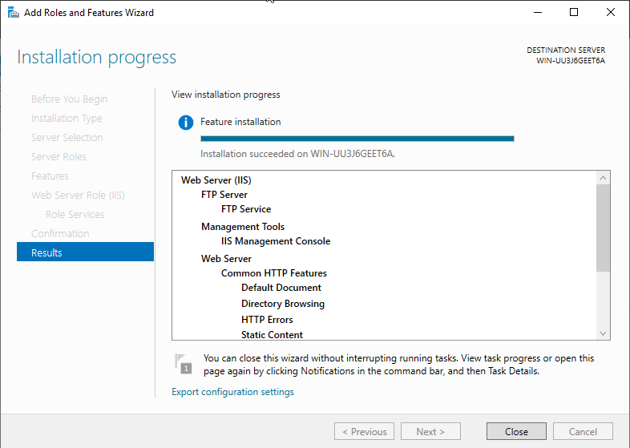
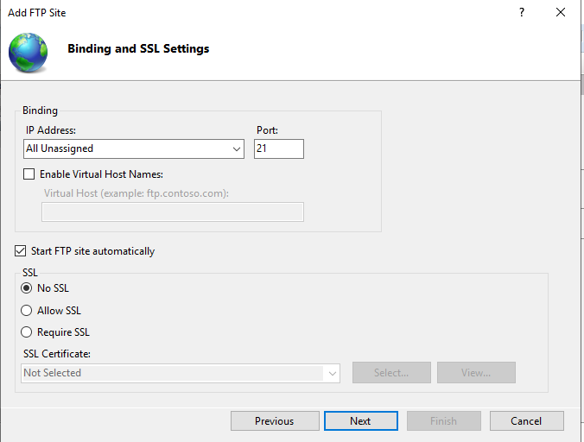
The FTP Server role has been installed, meaning that Server 2 is able to be used as a file transfer server. The below screenshots verify the settings for the FTP site.
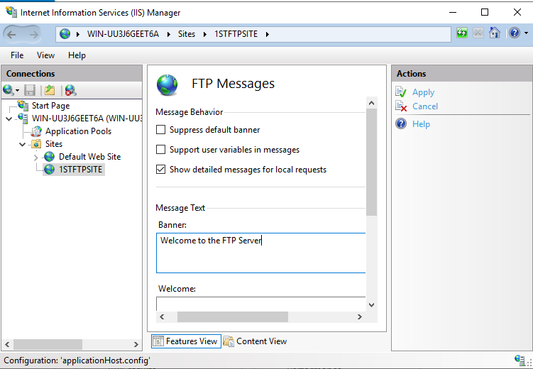
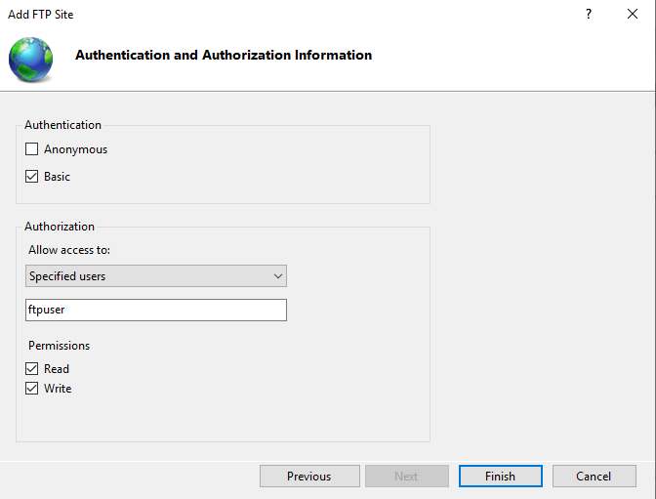
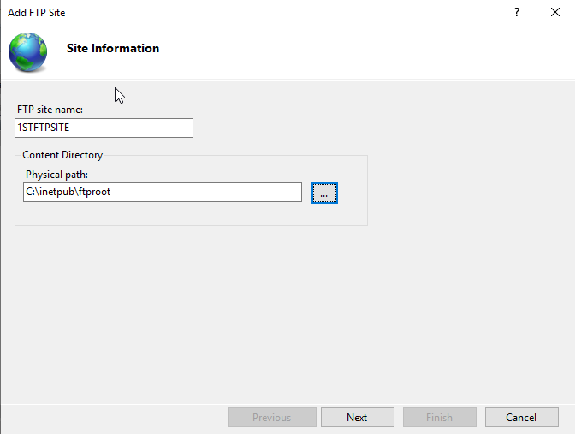
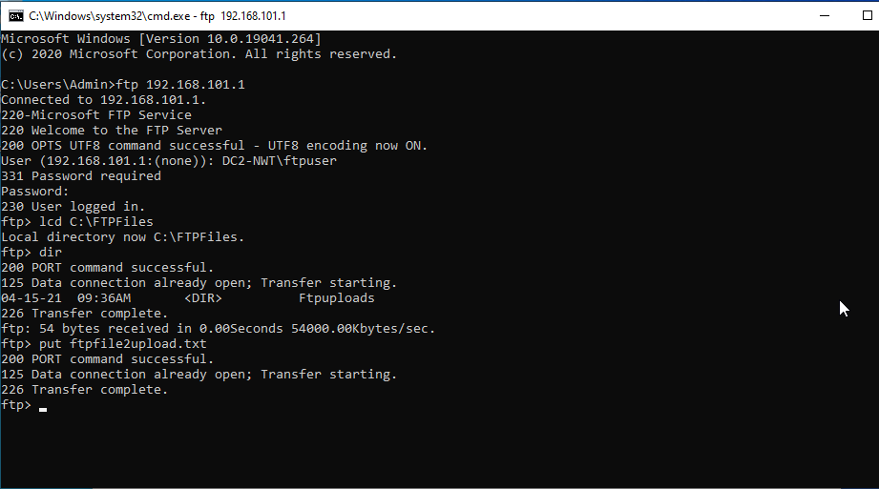
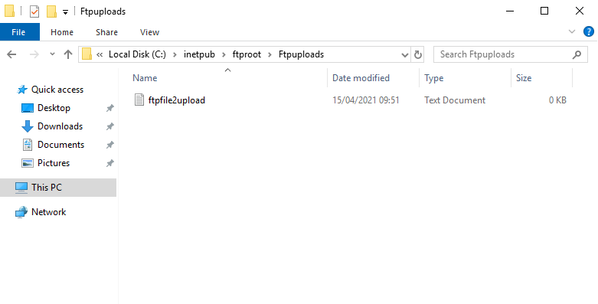
As can be seen above, a successful FTP connection has been established between Client 2 and Server 2, and a file has been uploaded onto Server 2.
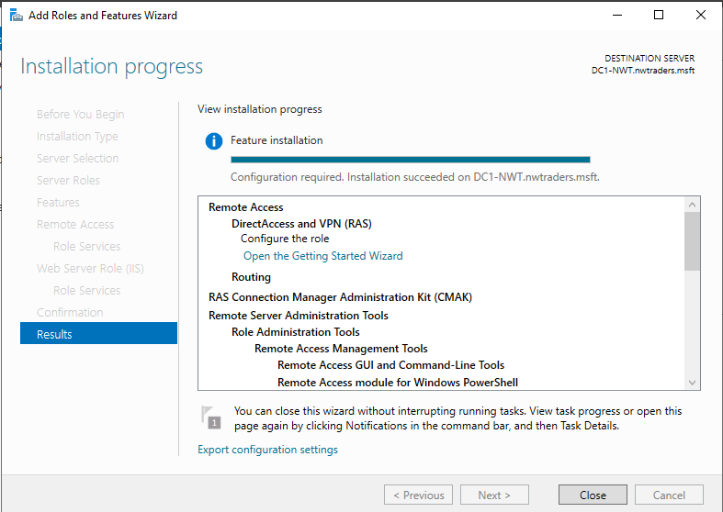
The above screenshot verifies that the Routing and Remote Access role has been installed successfully on Server 1.
This screenshot below shows a filter being set up. This filter will stop anybody from PrivateNet1 pinging the Router Firewall Service.
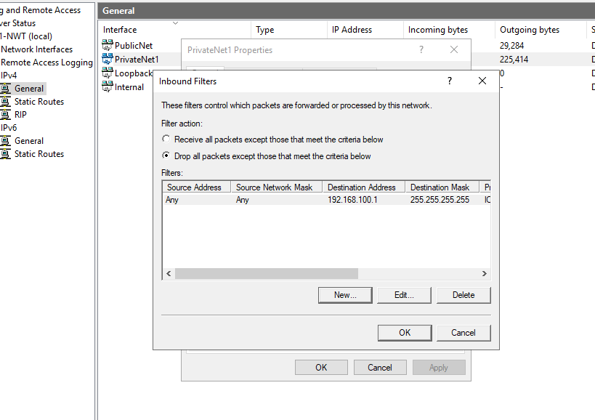

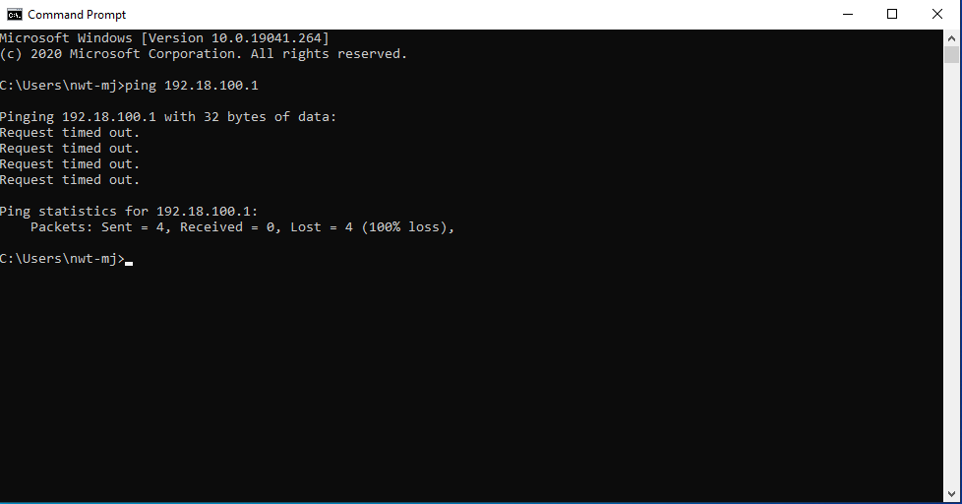
As can be seen above, the filter has worked as the request is timing out and packets are being lost.
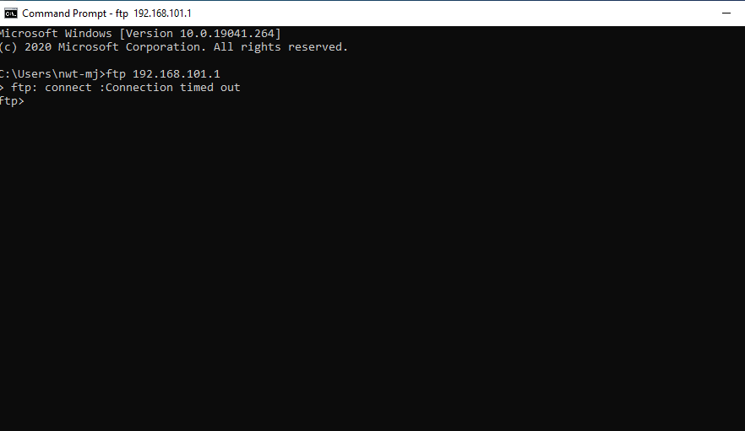
A second filter has been set up. This second filter stops hosts in PrivateNet1 accessing the FTP service running on Server2. The connection has timed out when running from a PrivateNet1 host meaning that the filter has worked.

Observational Tasks
  - Failover Clusters
When using a failover cluster, there are multiple factors that need to be considered. In this task, these factors will be explained.
Firstly, traffic that uses this type of communication uses port 3343. It is vital that the firewall on the workstation or network is set up in such a way that it allows the port to be used for both TCP and UDP traffic.
Secondly, communication through this method is vulnerable to latency and packet loss, meaning that performance is affected when using this method, and there is also a risk of losing data. Latency delays could also result in the removal of nodes from membership.
In this situation, bandwidth is not as important as quality of service. This means that packets are prioritised in a way that they can be sent as quickly as possible.
It is also important that the NetFT adapter is enabled. This means that intra-cluster traffic will automatically be switched to another cluster should the network being used go down or not respond. (1)
To enable failover clustering, the feature needs to be enabled. This is done through Server Manager and completing a role or feature based installation, then checking Failover Clustering on the ‘Select Features’ page. This process must be completed on every server.
In terms of hardware considerations, it is recommended that computers with similar components are used. (2)

Network Policy
For this observational task, a network policy will be created which outlines the architecture of the network, network access, security policies, security risks, the monitoring of security and mitigations if there are any violations.
Network Architecture
The company will be using a wide area network for their nationwide operations. This will allow multiple locations to communicate with each other, as well as being able to share files with each other.
Within the locations, star topologies will be used within the networks. This topology has been chosen as it allows for easier upgrading of the network, and if one of the nodes on the network fails to operate, the rest of the network can continue to work as normal. It is much more likely for a node to break than the server hub to break down, meaning that the network will be more reliable with this topology in place.
Network access
Every employee will have access to the network, whether that is through their workstations or through company provided devices, for example, if an employee is working from home.
The extent of network access will be granted depending on a ‘need-to-access- basis, meaning that the user will only be granted access to files and folders that they require – They are however able to request access to the folder by contacting the network administrator with the reasons for access.
In terms of Internet access, employees will be granted access only to websites which they require. The use of social media whilst at work is prohibited unless work related, such as for marketing purposes. The viewing of any content that may be considered explicit, inappropriate, and content related to drugs and illegal acts is prohibited whilst on the premises.

Security team
A security team has been created for the purpose of keeping the company network safe from any threats, vulnerabilities and data loss or theft. This team comprises of the following:
- The site manager at each location
- The Chief Information Officers of the company
- Staff in the company who have created a ‘Network Security Board’, with network administrators being the head of each location’s respective board.
If there are any threats or vulnerabilities that can be seen in the network, it is imperative that you contact any of the above members of the committee as soon as it is possible.
Enforcement of Security Policies
Measures have been put in place on the company network which are there to make the network as secure as it can possibly be. These measures are in place for the protection of staff as well as for the company.
These measures are as follows (This is not an exhaustive list):
- URL filtering to avoid access to websites unrelated to work.
- Measures are in place to stop users using USB drives and CD drives on workstations. These are two of the most common mediums for the transmission of viruses and malware. If you need to use one of these devices, please contact a network administrator as they will need to perform a scan on the drive before use.
- Online downloads are prohibited, again as they are a common media type for the transmission of viruses. If an online download is required, an administrator should be contacted who can check the download.
- Access to the control panel and command prompt is prohibited to most users. This is because administrative settings can be viewed and changed which may pose a vulnerability on the network.
- As mentioned earlier, access to files and folders has been granted on a ‘need to access’ basis. This means that users will only be able to access files and folders that they are required to use. Permission to access may be granted on various basis. Users will wither be able to only view the file, write to the file, or modify and delete the file, depending on what they are required to do.
- Emails must not be opened, replied to, or forwarded if they appear suspicious, and must be reported to a network administrator.
If security policies are found to be circumvented, or users are found to be using software such as VPNs or brute-forcing passwords to gain access to unauthorised material, the company disciplinary guidelines will be followed, up to and including summary dismissal from the company.
Analysis of Security Risks
The biggest threat to the network has been found to be viruses and malware. These can be spread via downloads, removable storage, and email. To mitigate these risks, a security policy as mentioned above has been put in place which restricts user access to articles that may spread them.
Secondly, network intrusion by external threats has been outlines as another threat. To mitigate this, a security panel has been set up, which users can report to if they see any vulnerabilities in the network. As well as this, the network also has firewall enabled, which further mitigates the risk of an external threat becoming real.
In addition, internal threats are also very real, therefore if we suspect that any members of staff are attempting to break rules or create vulnerabilities in the system, their accounts will be disabled, and they will face disciplinary action.
Phishing scams are a risk to the security of the network as well as our staff. Phishing emails convince the user to give up their personal data which may result in them being hacked or their card information being stolen. Therefore, clicking links in emails from outside sources is prohibited.
Monitoring operations
The company reserves the right to monitor staff network usage, including their website and search history, if they have reasonable suspicion to believe that there is wrongdoing by a member of staff.
The network will be monitored 24/7 by trained network professionals in an aim to achieve minimal downtime. There may be dome periods of downtime late at night (typically between 2-4am), however, as this is the least disruptive time to install updates on the network.
RAID backups are in operation on the network, meaning that if the network does go down and data is lost, there will be another copy available (However, due to the nature of the backup some data may still be lost).
Disciplinary Procedures
If it is found that an employee of the company is breaking the rules outlined in this policy, they may have their privileges to use the network revoked for minor breaches.
If an employee is found to be repeatedly attempting to or successfully breaching the network policy outlined, the company disciplinary procedures will apply, up to and including summary dismissal.

Router network referencing
A user can use Command Prompt and use the ‘route print’ table to show which networks and routers a computer is connected to. The route print command shows all computers that the workstation is connected to, as well as the networks that it is connected to.
The ping command can be used, as a router will be able to reference its ability to connect to a network depending on whether the command is successful or not.

