Roxana-Oana Imbrea

2124855

LCBB4005 – Global Business Environment

Assessment 1

6th of May

Nadeem Mirza

Content

Introduction – BMW……………………………………………………………………3
Challenges faced by the company…………………………………………………..3
- Internal………………………………………………………………………….3
- Employee well-being………………………………………………….3
- Sustainability…………………………………………………………..4
- External – PESTEL analysis…………………………………………………4
- Political…………………………………………………………………4
- Economic……………………………………………………………...4
- Social………………………………………………………………….5
- Technological………………………………………………………...5
- Environmental………………………………………………………...5
- Legal……………………………………………………….................6
- SWOT Analysis………………………………………………………...........6
        - Strengths……………………………………………………….....6
        - Increased profits……………………………………………..…..6
        - Investing in research and development……………………….7
- Weaknesses………………………………………………………....7
        - Debt history………………………………………………………7
- Court involved previously…………………………………………...8
- Opportunities………………………………………………………...8
        - Chance of collaboration……………………………….………..8
        - Positive expectation of profit level………………….………….8
- Threats………………………………………………………….……8
        - Large number of competitors……………………….…………8
        - Porter’s Five Forces…………………………………………....9
References…………………………………………………………………………10

This report is going to look at the automobile industry and critically evaluate the challenges faced by a specific brand, overviewing both internal and external aspects of the business as well as the popularity and trading not only in the UK, but across the entire globe.

I have chosen to look at Bayerische Motoren Werke, as well known as BMW Group, because this is a well-know company, considered to produce luxurious cars as well as motorcycles and has even produced aircrafts until 1945. It is a German company established in 1913, initially with the intention to focus on aircrafts motors rather than car motors.
The company is continuously evolving by producing new car and motorcycle models almost each year. BMW Group is taking the pride for the entire process when presenting a new model, from developing the idea, manufacturing, and assembling the pieces as well as selling the final product.

Challenges faced by the company
As one of the leading companies in the industries, BMW is facing different challenges on a day-to-day basis.

- Internal

- Employee well-being
BMW has experienced negative feedback about employee well-being previously since they did not offer a pension scheme. However, the company is offering a lot more to their employees in order to create a comfortable environment to work on and to motivate them. Some of the benefits offered by BMW Group are medical coverage, paid holidays, life insurance, pension scheme and BMW associates assistance program.

- Sustainability
The automobile company is aware of all the CO2 emissions that their products are causing, therefore they are focusing on reducing. One way of reducing the emission is by ensuring that each vehicle must have Co2 emission lowered to at least 30% over the entire lifecycle of the car.
Another way that is becoming more popular amongst the automobile industry is to introduce electric cars which have 0% emissions.

- External

- Political
There are two major political factors that affected the company recently.
Firstly, the tensions between Russia and Ukraine have increased cost prices such as, imports and exports to and from both countries and petrol prices. This not only discourages consumers to make further purchases but is also affecting their budget, which means that the brand, which is considered luxurious, may experience a decrease in buyer consumption.
Secondly, the Covid-19 pandemic has left an impact on the business as well since people have also experienced budget limitations.
- Economical
Two of the main challenges that BMW is facing in terms of economy are currency exchange and consumer demand.
Currency exchange is deeply important for the company as they need to evaluate the budget used for one automobile, the budget a customer has available to buy their product and the final price for it.
Consumer demand is referred to the preferences of the customers and it is important for the automobile company to sell their products. For example, electric cars have become very desirable lately and BMW introduced two new models, one electric and one half-electric.
- Social.
As BMW is a company operating all around the globe, they need to take into consideration different cultures in order to meet each country’s expectations and this is because not everyone will be interested in the same model of a car. A wide variety of products and services is what got the business globally recognized. BMW is constantly checking the market to ensure that they know exactly what they customers require, and they are using big countries for manufacturing such as China or South Africa

- Technological
BMW is a company that produces premium cars and motorcycles therefore their technology must be very advanced. Due to the environmental reasons such as pollution and limited natural resources, most companies in the automobile industry are introducing electric cars, amongst which BMW is included.
Moreover, the company’s reputation not only requires sustainability but also comfort which is brough into their products through technology. This needs or wants of the customers to meet comfort are brought by BMW through services such as: heated seats, air conditioning, parking sensors or cameras incorporated into their cars.

- Legal
Although BMW Group is a premium brand, it has had legal problems over the years all around the globe regarding engine failures and mysterious fires. Some BMW consumers who have experienced these problems have taken the matter to the court accusing the company of hiding these problems.
Statistics have shown that more than 3 million cars manufactured between 2007 and 2011 have had problems related to total engine failures or fires.

- Environmental
BMW was the first company in the automobile sector to show interest in sustainability and has been donating to UN Environmental Program since 2001. The company uses their technology towards developing models with reduced CO2 emissions and electric cars with a percentage of pollution of 0%.

SWOT Analysis of BMW Group
- Strengths
Popular amongst premium international automobile sector BMW is one of the most desired car brands and is holding a strong position in the industry due to the wide range of products and services provided. The company owns not only the BMW brand, but also MINI and Rolls-Royce. This aspect of the business serves as a big advantage due to being able to sell their products and services to a larger amount of customer. Having a wider range of products available means that it is easier to meet different needs and wants of different types of customers.
Increased profits
BMW Group has reported a massive increase in profits in the financial year 2021 with a total of 111.2 million euros compared to financial year 2020 which had a total of 98,9 million euros. The difference in profits has as a main factor the pandemic of Covid-19, which started towards the end of 2019, but had visible effects on the industry on the following year.
However, since the establishment of BMW, the company has rarely retrograded from a year to another in terms of profits.
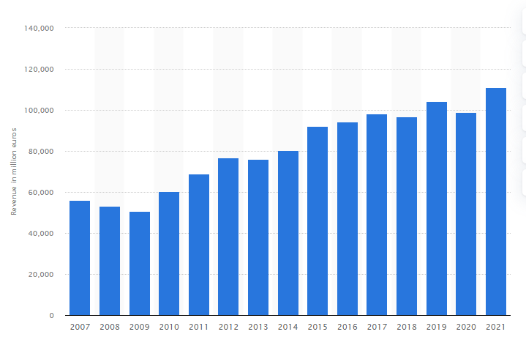
BMW Group profit from financial year 2007 to financial year 2021
(Image 1)

Investing in research and development
The automobile company is highly focused on research and development in order to be able to understand and exceed customer wants and needs. Therefore, every year BMW invests millions of euros towards researching new technology and developing products.
In 2021, 6,229 million euros were attributed to the research and development department whilst in 2020, only 5,689 euros were spent for the same purposes. With an increase of 10% from previous year the company shows credibility and encourages opportunities of partnership by creating a trustable reputation.

- Weaknesses
Debt history
As previously mentioned, BMW is classified as a luxurious brand, therefore in case of an economic crisis, the company would be one of the first in the sector to feel the downturn. The company felt this kind of consequences before, although the most recent outbreak was due to Corona virus. In 2020, the company has suffered a loss of 739 million euros which is adding to the threat of financial instability.
Court involved previously
Over the time BMW has had claims regarding manufacturing processes that do not follow health and safety processes resulting in faulty car parts. Being involved in such legal battles has had impacts not only on the profit figures but also on the reputation of the company. Following a bad reputation comes loss of other opportunities such as partnerships, stakeholders, or shareholders.
- Opportunities
Chance of collaboration
Due to the company’s reputation and popularity in the automobile industry, collaborations arise quite easily and are very beneficial for BMW’s profits and image. One example is the agreement between Daimler AG and BMW in which they agreed to combine their business units. The document states that both companies are able to use products and services for their own expansion and also to build a distinctive mobility system as well as strategically enlarge their individual systems.
Positive expectations of profit level
BMW has a positive progress regarding their profit from a year to the other. As shown in Image 1, almost every year marks an increase in the profit levels, which encourages the company to visualize an increase in the following years as well.
However, statistics are not the only factor to hearten this outcome but the effort into creating new technology and the investing into research plays a major role into this aspect too.
- Threats
Large number of competitors
The automobile industry has many brands that actively operate within the sector, posing as a thread to BMW. Below is presented Porter’s Five Forces analysis to understand the key factors that create the competitive pressure for the company.
1.Competitive rivalry level
BMW has got competitive advantage over most brand competing with the company due to its luxurious products and services offered. The company is constantly adapting to changes and develops new car and motorcycle models so customers would be attracted to what they have to offer. BMW also invests in customer satisfaction by ensuring their customer and service department is effective and all customer queries and complains are dealt with as soon as possible.
However, even after all the efforts to minimise or even eliminate competition there is still tight rivalry in the industry. This aspect is caused by the privileged products and services offered by BMW, which might not be affordable to all market’s customers.
Moreover, BMW is not the only luxurious considered brand in the industry, but brands like AUDI, Mercedes-Benz, Tesla, or Jaguar are also investing towards research and development and are some of the brands to closely compete with BMW.

2.Supplier power level
The company has a good reputation and poses popularity in more than 200 countries; therefore, it demands suppliers which can adhere to the high-quality raw materials production and distribution. BMW has more than 12000 suppliers to work with all around the globe, most of the business being auto firms. What it means is that products are not very differentiated and switching costs are not high either.

3.Potential new market entrants
Considering BMW’s position in the automobile sector, the threat of possible new entrants is low to nil. The process of entering this sector is requiring a large amount of funds to set up the company, technology as well as a research team, different departments, suppliers, and the ability to keep up with the existing brands. Moreover, a business will need to set up strategies and come with new ideas and internal protocols; by the time they will be able to set up all this requirements, existing brands will be one step ahead making it almost impossible for new companies to join the market.
In addition, even though a company will be able to enter the sector, it will find it difficult to compete with BMW, as their position in the market is very high.

4.Threat of substitute products
BMW is a brand that provides products and services to customers who aim to maintain a social status or improve their life quality; therefore, substitute products are not a massive threat to the company. Although services such as public transport or electric scooters are an option, this is not a service that a BMW consumer will choose due to the level at which this are position in the society’s view.
In conclusion, the thread of substitute products is mostly considered within other premium brands such as AUDI, Mercedes-Benz, or Jaguar, but customer loyalty is quite high when it comes to BMW, so chances of customer loss is moderate to low.

5.Consumer Power
Customer satisfaction is a very important factor for a brand as reputable as BMW because consumers are the ones that make the business function. As people are becoming more aware of their range of choice, they are not only looking for the product itself but the entire experience with the company. A regular consumer will make sure that apart from the product they want to purchase, they will also have to possibility to use other services such as customer services.
The competition is tight even with the differentiate products, however the competitive advantage that BMW has amongst the industry is the customer loyalty. As the business has creates a positive image, customer have become loyal to the brand and the company is ensuring that every customer has a positive experience with them in order to gain their loyalty.

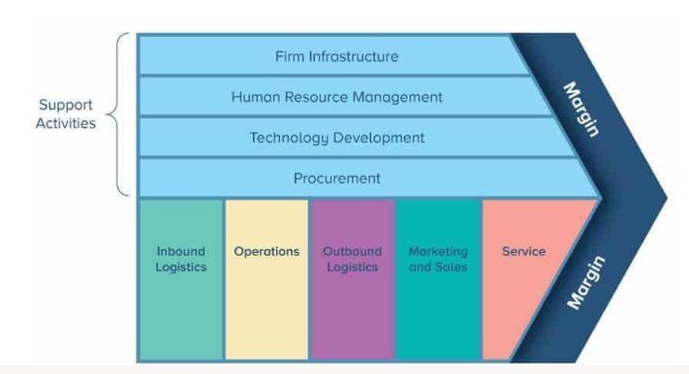

References

https://www.mbaskool.com/five-forces-analysis/companies/18293-bmw.html - Published by MBA Skool Team, Last Updated: February 16, 2022

BMW SWOT Analysis Matrix: Opportunities and Weaknesses- https://brandongaille.com/bmw-swot-analysis/
Apr 12, 2021 by Brandon Gaille
https://statstic.com/bmw-research-and-development-costs/
https://www.press.bmwgroup.com/global/article/detail/T0372853EN/bmw-group-significantly-increases-group-earnings-and-net-profit -10.03.2022

https://www.statista.com/statistics/264340/global-revenue-of-bmw-group/ - Global revenue of BMW Group 2007-2021
Published by Mathilde Carlie rMar 22, 2022

https://www.academia.edu/35441469/BMW_Corporate_Social_Responsibility_Introduction_of_the_BMW_Group - by Prof. George Reiff

6A41C0F5-51FC-4B71-AF83-0B9F412CB891 PUBLICATION DATE: 26 Apr 2018 - https://cdn.uconnectlabs.com/wp-content/uploads/sites/82/2020/01/BMW.pdf

https://www.bmwgroup.com/content/dam/grpw/websites/bmwgroup_com/company/downloads/en/2021/BMW_Group_Corporate_Governance_Key_Aspects.pdf

