Study Skills for Psychology
Modular code: ECPS4018
E-portfolio

Context:
AI acknowledgement ......................................................................3
Article summary...............................................................................4
Infographic ......................................................................................5
Essay plan ......................................................................................6
Research evidence .........................................................................8
Reference list ................................................................................10

AI acknowledgement
I confirm that I have not used any AI in the research and creation of this assignmen. I confirm that I have not presented any AI generated material as my own work. I confirm I have copies of my drafts, notes, and other resources I used, which I may be asked to provide in evidence.

Article summary
How does music make you feel?
Music plays a big part in our society and can play a big part in how we feel.
Music can make you feel many things, it is commonly taught that major music is happy and minor notes are sad. (Zoe Nendick, 2022)
Though everyone can have very different reactions to music as people associate people, places, and memories to songs (Belfi et al, 2016, in Nendick, 2022)
Blood and Zaorre found that listing o music can activate the reward are of the brain resulting in musical ‘chills’ (2001)
Further research is still being carried out into the relationship between music and our emotions, though there are many other factors to consider such as if the songs are randomly picked or if the person chooses the songs. These factors can effect how someone feels about the music.
This research is important as is it has already lead to musical therapy.

Infographic
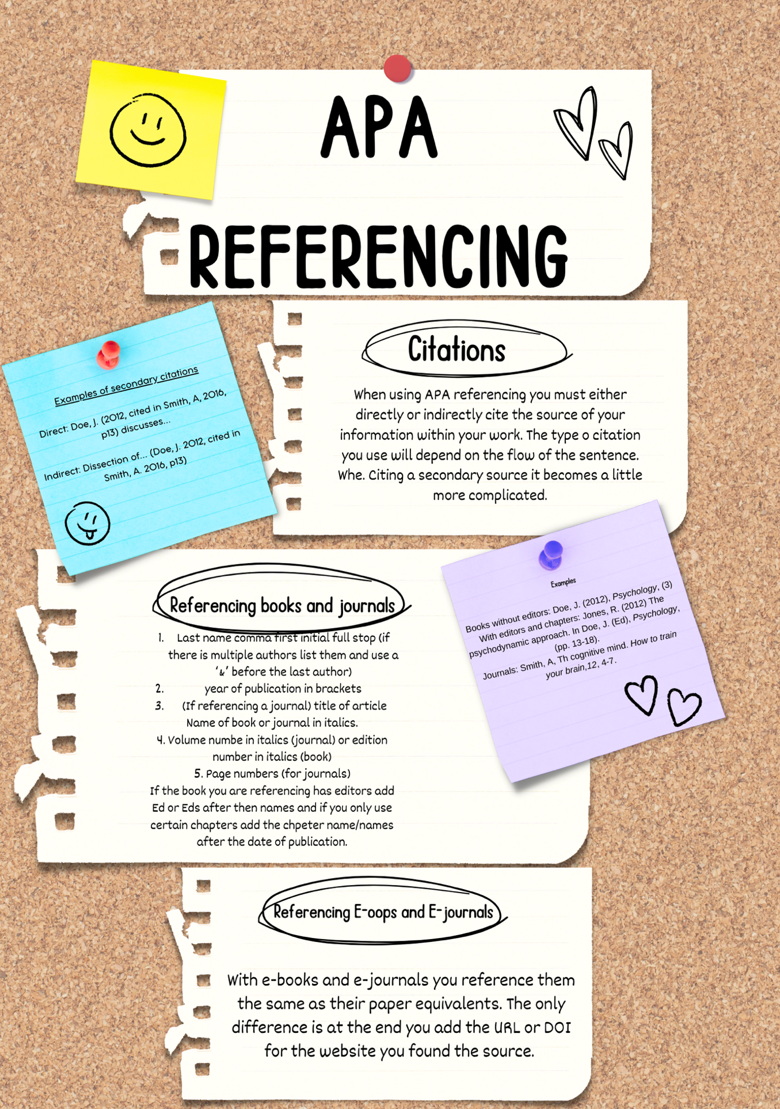

Essay plan
(a) Describe and discuss the psychological, social and physical benefits of owning a pet.

Intro-
There are many many things online that will tell you owning a pet is beneficial to you this essay will look more deeply into if there is any actual evidence to that.
Para 1- psychological benefits
McDonough, I. M., Erwin, H. B., Sin, N. L., & Allen, R. S. (2022)
- Larger brain size.
- More cognitive activity needed therefore better cognition.
- Best results with dogs.
- Processing speed improved.
- Better attention.
- But results for owning multiple pets not significant.

Para 2- possible links to cancer
Chan M.M, Gonzalo T.R (2019)
- Owning birds linked to increased likelihood to get lung cancer
- Other research has fund opposite
- Possibly due to different research methods, different breeding of the birds or recall bias
Para3- service animals
Hall, S. S., MacMichael, J., Turner, A., & Mills, D. S. (2017).
- Help both generally oe specifically
- Promote learning and independence for people with disabilities
- People with report higher quality of life than those waiting
- The effect more evident in physical disabilities
- Does not affect personal relationships

Para4- fanatical burden
Hicks, M (20114)
- In US $14.2 billion on veterinary bills in 2013
- MRI= $1,500
- Routine check ups dog= $225 cats= $203
- Insurance
- Other countries
- May cause mental health issues

Conclusion-
While owning a pet comes with its downsides there is also a lot of benefits for certain people.

Research evidence
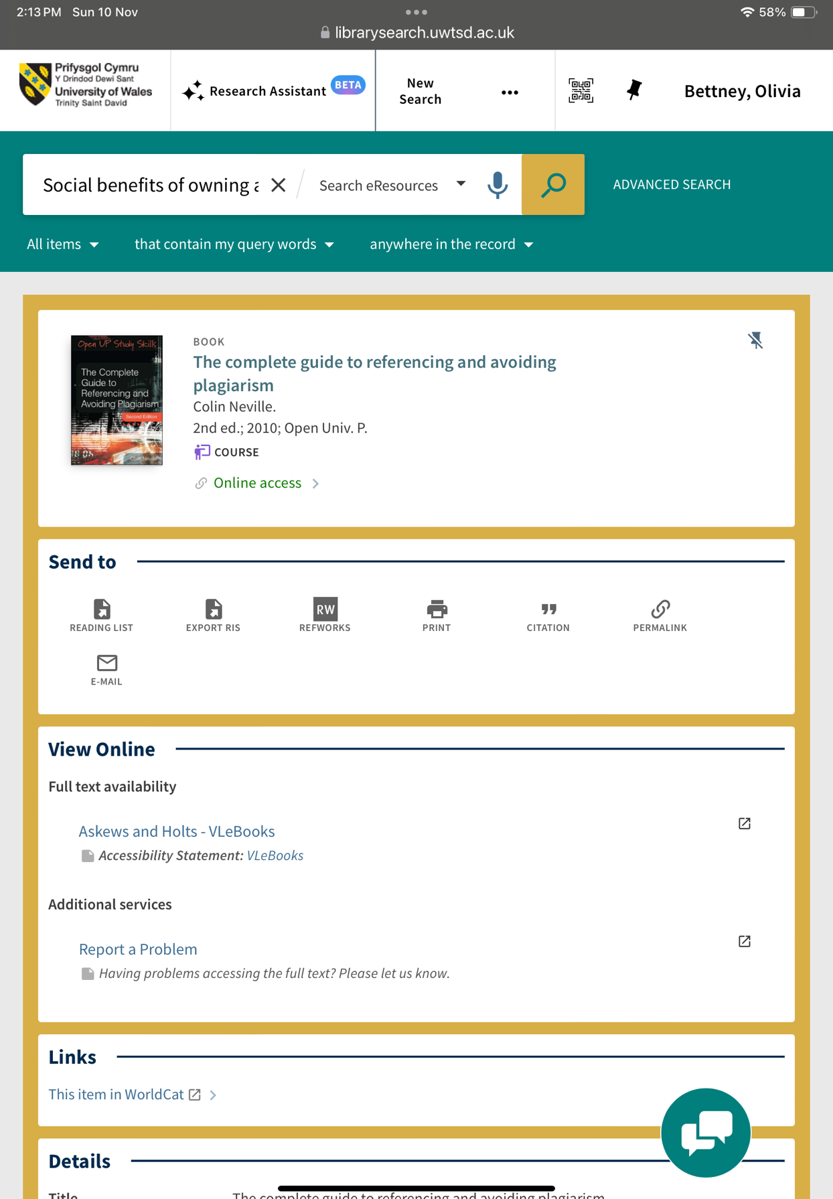
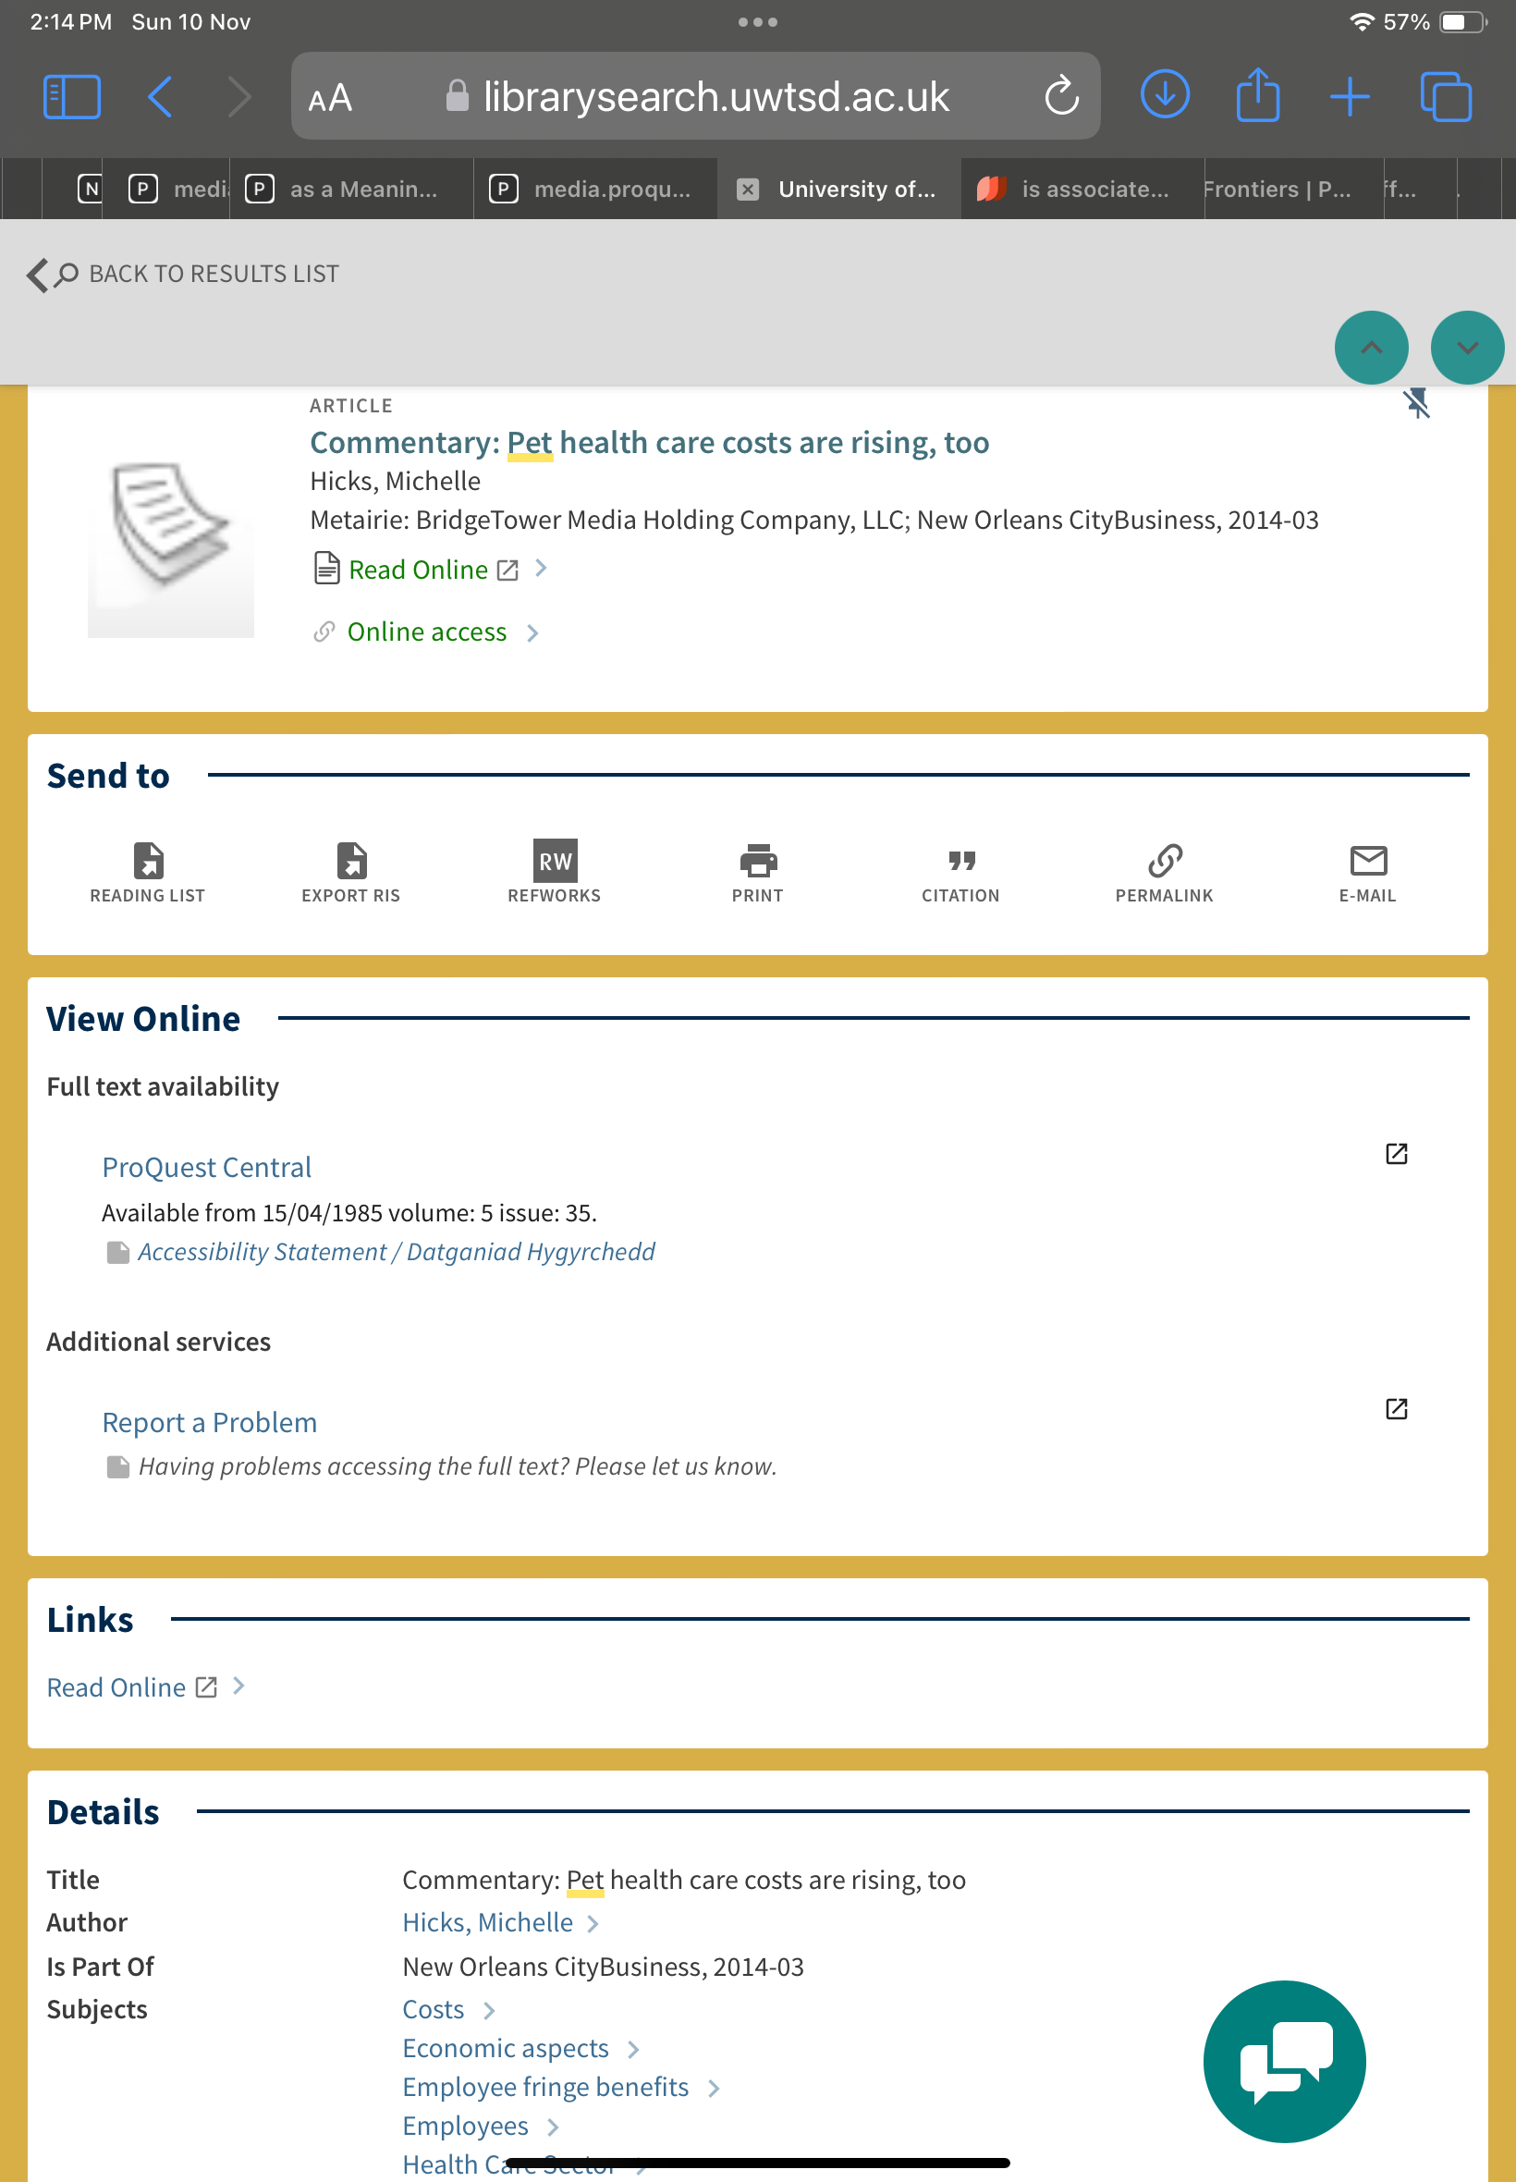

I chose the first source as it covered the entire topic of my infographic therefore I could use this one source to ensure all the information I used was correct. The second source I used for the essay plan as it portrayed a good argument as to why pet ownership can have its downsides.

Reference list

Nendick, Z. (2022). How does music make you feel?. PSYCHOLOGIST, 35, (pp.38-40). https://www.bps.org.uk/psychologist/how-does-music-make-you-feel

Neville, C. (2010). The complete guide to referencing and avoiding plagiarism (2nd ed.). Open Univ. P (pp. 48-49) https://www-vlebooks-com.ezproxy.uwtsd.ac.uk/Product/Index/155511?page=0&startBookmarkId=-1

Chan, M. M., & Tapia Rico, G. (2019). The “pet effect” in cancer patients: Risks and benefits of human-pet interaction. Critical Reviews in Oncology/Hematology, 143, 56–61. https://doi.org/10.1016/j.critrevonc.2019.08.004

Hicks, M. (2014). Commentary: Pet health care costs are rising, too. New Orleans CityBusiness.

Hall, S. S., MacMichael, J., Turner, A., & Mills, D. S. (2017). A survey of the impact of owning a service dog on quality of life for individuals with physical and hearing disability: a pilot study. Health and Quality of Life Outcomes, 15(1), 59–59. https://doi.org/10.1186/s12955-017-0640-x

