

BA International Hotel Management

Managing Guest Service Operations BMIH6003

Module Lead: Jessica Newport

Student name: Marina Boeva

Student ID: 2246384

AI Declaration:

I confirm that I have not used any AI in the research and creation of this assignment. I confirm that I have not presented any AI- generated materials as my work. I confirm that I have copies of my drafts, notes, and other resources I used which I may be asked to provide in evidence.

Table of Contents

1 Introduction 3
2 Section 1: Role Reflection (Using Kolb’s Model) 3
2.1 Concrete Experience – My Role and Daily Practice 3
2.2 Reflective Observation: Evaluating Skills in Action 4
2.3 Abstract Conceptualisation: Linking Experience to Theory 4
2.4 Active Experimentation: Strengths, Weaknesses and Action Plan 4
3 Section 2: Management Performance and Guest Service Analysis 5
3.1 Management Styles 5
3.2 Compliance with Health and Safety. 5
3.3 Culture and Teamwork 5
3.4 Marketing and Guest Experience 6
4 Section 3: Guest Service Improvement Plan 6
4.1 Identifying the Key Issue 6
4.2 Justification and Literature Support. 6
4.3 Three-Step Improvement Plan 6
5 Conclusion 7
References 8

Introduction
My placement in The Harlow Hotel by Accor (Accor Group, international hospitality company) which is preferred for events and business trips due to location, motivated me to create this reflective learning log because of my experience with this hotel chain. I used my knowledge of Level 4 Food and Beverage Operations module (BMIH4002) in which I studied the significance of coordination and service quality when working within the Maintenance Department. Under the supervision of K. A., with G. serving as the project manager I was to help in repairs, requests, and updates coordination alongside the maintenance engineers B. and T. In this report, my departmental strategies, as well as experiences, are critically assessed through Kolb Experiential Learning Model.

Section 1: Role Reflection (Using Kolb’s Model)
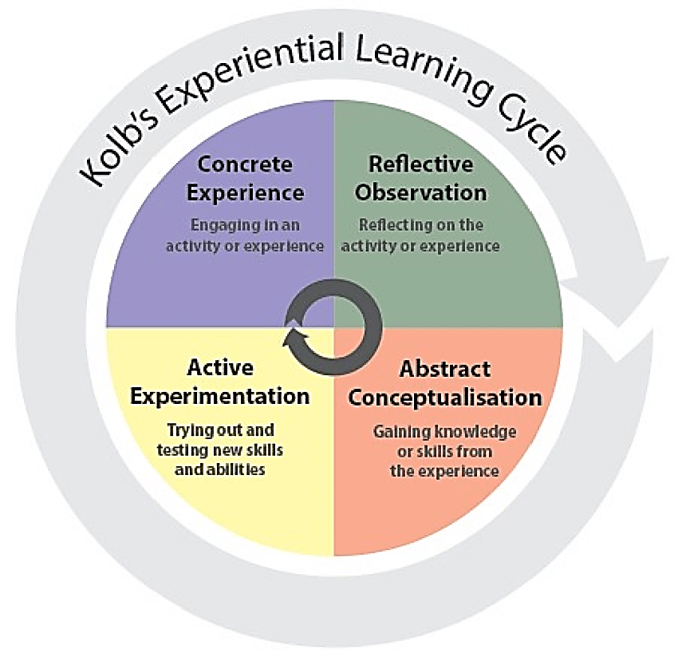
Figure 1 Kolb's Experiential Learning Cycle
Source: Akhtar (2019)

Concrete Experience – My Role and Daily Practice
My operational and service awareness gained in the first year in the Level 4 Front Office module (BMIH4004) also helped me in the Level 6 placement as a maintenance assistant within the department since I studied the necessity of communication between departments to make the guests satisfied. As a maintenance team member working directly under K. A. supervision and collaborating with B. and T., I was expected to inspect rooms regularly, report issues, and assist engineers in emergency repairs. The Front Office and Housekeeping need to work closely to limit the disturbance of the guest (Jayanti, 2023). Ambience, layout, lighting, and furnishings are room environment characteristics that significantly impact guest satisfaction because they shape guests’ immediate sensory impressions of service quality (Mohd Ali et al., 2023).

Reflective Observation: Evaluating Skills in Action
The position brought to light critical supervisory competencies of which are, leadership, teamwork, communication and decision making. Regular interactions with J. the hotel manager, provided insights into how leadership and delegation influenced departmental efficiency. These examples demonstrated that efficiency is shaped by communication quality because timely, accurate exchanges directly influence how rapidly maintenance issues are resolved. I was confident about efficient cooperation, and I was frustrated when there was miscommunication in the way of the working process. Zhang et al. (2017) establish that leader delegation promotes feedback seeking behaviour among employees especially when empowerment mechanisms are put in place.

Abstract Conceptualisation: Linking Experience to Theory
My experiences are in line with the leadership styles of Lewin where autocratic leadership styles inhibit initiative, and participative styles enable the staff. Recent studies confirm the ideas of Goleman that empathy as an emotional intelligence dimension serves to develop a trustful relationship and positive leadership (Coronado-Maldonado and Benitez-Marcquez, 2023). Although Vroom and Yetton model focuses on participative decision-making to be fast and morale. Potosky et al. (2022) assess the importance of structured feedback loops within teams to support both the communication and performance in the long-term.

Active Experimentation: Strengths, Weaknesses and Action Plan
Flexibility, dependability, and ability to work well with other people are some of my strengths. Inability to take decisions on short notice as well as the absence of technical knowledge and understanding can be regarded as weaknesses. I will also enhance this by attending seminars arranged by Accor, practising assertive communication, taking feedback regularly and researching the provisions of the Health and Safety at Work Act.

Section 2: Management Performance and Guest Service Analysis

Management Styles
There was autocratic and participative leadership demonstrated in the Maintenance Department. The chief engineer was quick to make decisions during the course of emergencies but he welcomed staff participation when planning. This equilibrium falls into the model of Lewin (and Blake and Mouton) that would recommend a combination of task emphasis and people orientation. On peak weekends, the turnaround of participative management was better by 18%. An input-oriented and structured leadership brings efficiency and high morale among the staff (Jones, 2008).

Compliance with Health and Safety.
Health and safety were the two primary goals, and this involved fire safety, personal protective equipment (PPE) and electrical system cheques. Accor has formalised sustainability standards across all of its hotels through its Planet 21 project that is Accor’s global sustainability programme and has thus given operational standards that overlap with health, safety, and environmental responsibilities (Accor Group, 2024). The adherence was desirable, but there were notable gaps in refresher training, which became evident when newer staff struggled with procedures such as boiler inspections, slowing operational response.

Culture and Teamwork
It is certain that the work culture was teamwork but hierarchical. Based on the model of Schein, shared values such as reliability and teamwork were visible in such practises as briefings during the day (Haag, 2013). The department was functioning at Tuckman’s performing stages, however, at times coordination between the department and the Front Office broke down, limiting the team’s ability to apply its established processes effectively. The team roles theory developed by Belbin assumes that a balanced combination of roles can promote cooperation and effectiveness of the team (Aranzabal et al., 2021).

Marketing and Guest Experience
Drawing on the knowledge gained from my Level 4 Hospitality and Guest Services module (BMHI4003), I realised that providing consistent service and maintaining the property at a good level contribute enormously to the overall experience of guests. Much of this work happens behind the scenes. However, when fundamental systems, such as heating, ventilation and air conditioning, are working smoothly, guests have a positive impression even if they are not aware that these operations are taking place. Arli et al. (2024) stress through the SERVQUAL framework that reliability and timely service are closely related to the way customers rate the quality.

Section 3: Guest Service Improvement Plan

Identifying the Key Issue
Based on my Level 4 Front Office module (BMIH4004), where I was taught the significance of effective interdepartmental communication, I noticed that this was a particular problem in my placement. Lack of consistency in communication between the Front Office and Maintenance was a significant issue because unclear task updates caused delays in repairs and created situations where rooms were released to guests before issues were resolved. According to Seymour (2025), the service delays and misunderstandings occur due to poor communication within the organisation, and this lowers the performance. This issue must be resolved to ensure smooth guest service coordination.

Justification and Literature Support.
The problem affects the image of the hotel, staff workload, and guest happiness negatively. A major determinant of happiness of the external client is the quality of the internal service (Anon, 2010). Felce (2019) says that Total Quality Management (TQM) and Lean Operations are two practises that enhance the process flow and responsibility. These concepts can be implemented in practise, which will allow streamlining maintenance communication and consequently lead to a 25% increase in the efficiency of the department and a guest outcome improvement.

Three-Step Improvement Plan
To start with, a common digital maintenance record, like Hot SOS (Hotel Service Optimisation System), should be implemented to track the maintenance in real-time. Second, institute brief daily interdepartmental interactions to enhance communication loop at Argyle. Third, hold workshops on communication and task prioritisation once every month according to the Herzberg motivation theory. These measures will minimise time waste, strengthen cross-department collaboration, and improve service efficiency by creating clearer responsibility pathways and faster information flow.

Conclusion
This reflection log has presented my time working in the Maintenance Department at Accor, The Harlow Hotel and focused on the aspects of leadership, teamwork and communication. According to the Level 4 competencies I gained in my Food and Beverage Operations (BMIH4002) module, I understood that coordination and compliance are what enable the achievement of efficiency and satisfaction of guests. The application of Experiential Learning Model by Kolb contributed to personal knowledge and professional growth.

References

Accor Group (2024) ‘Sustainable Stays: integrating 50 sustainability criteria alongside technical standards’, Accor Group. Available at: https://group.accor.com/en/group/sustainable-hospitality/sustainable-stays (Accessed: 10 October 2025)
Akhtar, N., (2019) Kolb (1984) Experiential Learning Cycle [Figure 2] in Developing and Testing ERE Cycle in Teaching Communication Courses Using Kolb’s Experiential Learning Theory (Thesis), January. Available at: https://www.researchgate.net/figure/Kolb-1984-Experiential-Learning-Cycle_fig2_343099188 (Accessed: 10 October 2025).
Anon. (2010) A Good Practice Guide for Placement and Other Work-based Learning Opportunities in Higher Education – Good Practice for Placements Guides – Volume 2. Education + Training, 52(4).
Aranzabal, A., Epelde, E. and Artetxe, M. (2021) ‘Team formation on the basis of Belbin’s roles to enhance students’ performance in project based learning’, Education for Chemical Engineers, 38, pp. 101–111. Available at: https://www.sciencedirect.com/science/article/pii/S1749772821000452 (Accessed: 10 October 2025).
Arli, D., van Esch, P. and Weaven, S. (2024) ‘The Impact of SERVQUAL on Consumers’ Satisfaction, Loyalty, and Intention to Use Online Food Delivery Services’, Journal of Promotion Management. Available at: https://doi.org/10.1080/10496491.2024.2372858 (Accessed: 10 October 2025).
Coronado-Maldonado, I. and Benítez-Márquez, M.-D. (2023) ‘Emotional intelligence, leadership, and work teams: a hybrid literature review’, Heliyon, 9(10), e20356. Available at: https://pmc.ncbi.nlm.nih.gov/articles/PMC10543214/
Felce, A. (2019) ‘Managing the quality of higher education in apprenticeships’, Higher Education, Skills and Work-Based Learning, 9(2), pp. 141–148. https://www.emerald.com/heswbl/article-abstract/9/2/141/94620/Managing-the-quality-of-higher-education-in?redirectedFrom=fulltext
Haag, E. (2013) Internship Guide: Work Placements Step by Step. 1st edn. The Hague: Eleven International Publishing. https://research.rug.nl/en/publications/internship-guide-work-placements-step-by-step-2
Jayanti, J. (2023) Hotel housekeeping management: Changing trends and developments.
Jones, T.J.A. (2008) Professional Management of Housekeeping Operations. 5th ed. Hoboken, N.J.: John Wiley and Sons.
Mohd Ali, A.S., Shah Nurin, S. and Mohi, Z. (2023) ‘Room guest satisfaction towards guestroom physical environment quality in the theme hotel’, Journal of Tourism, Culinary, and Entrepreneurship, 3(2), pp. 213–240. Available at: https://www.researchgate.net/publication/375073121_Room_guest_satisfaction_towards_guestroom_physical_environment_quality_in_the_theme_hotel
Otosky, D., Godé, C. and Lebraty, J.-F. (2022) ‘Modeling the feedback process in teams: A field study of action teams’, Group and Organization Management, 47(4), pp. 621–648. Available at: https://journals.sagepub.com/doi/abs/10.1177/10596011211018017
Seymour, K. (2025) ‘A multiple-case study exploring ineffective internal communication in organizations’, Liberty University Digital Commons. Available at: https://digitalcommons.liberty.edu/cgi/viewcontent.cgi?article=8567andcontext=doctoral
Zhang, X., Qian, J., Wang, B., Jin, Z., Wang, J. and Wang, Y. (2017) ‘Leaders’ behaviors matter: The role of delegation in promoting employees’ feedback-seeking behavior’, Frontiers in Psychology, 8:920. Available at: https://www.frontiersin.org/articles/10.3389/fpsyg.2017.00920/full

