Assessment Component 2
Quantitative Data Analysis
Contents
Introduction
Analysis
Conclusion
Recommendations

Student Name: Mia Evans
Student No.: 2129370
Qualification: Master of Arts, Professional Practice Level 7
Module: BMPF7006
Work-Based Research
Word Count: 2518

Introduction
Gwalia Stores is a grocery store and newsagent in a small village in Wales. This report represents findings from a customer dataset who regularly shop at the store. The data shared has been gathered using a Quantitative methodology. It appears to have been collected using a questionnaire or survey with the customer along with probable store records for spend or order details. This suggests that a quantitative research approach was used to collect the information with a Primary data set as it has been recently generated by Gwalia Stores. The methodology approach seems to align to positivist research paradigms due to the numerical and statistical data gathered.
Owing to the different types of measurement contained in the data set there are examples of nominal, ordinal and scale information present. The gender and newspaper preference of the customers is an example of nominal data as they are a label and can be categorised but have no inherent order. Ordinal data is evident from the gathering of customers opinion of the local borough council using a Likert scale to ascertain their contentment or discontentment with the council. There is also scale data present showing numerical data for the average weekly customer spend and the distance the customer lives from the store. This can be categorised as a Ratio measurement of scale due to the data having a true zero starting point of measurement.
It is likely that a structured questionnaire may have been used to gather the information as individuals gender and opinion of their local borough council would need to have been gathered directly from the customer. The newspaper purchased, distance from the customers home and the average weekly spend could have also been gathered from utilising a questionnaire. However, this quantitative data could also have been gathered from customer records if this was held within the store.
The dataset offers insights into customer demographics, spending behaviours, newspaper preferences, and opinions on the local borough council. The customer base shows a near-even gender split, with 55% male and 45% female representation. Notably, male customers tend to spend more on average (£16.30) than female customers (£14.00), with a higher mode spend, suggesting a group of high-value male shoppers. Proximity to the store also appears to influence spending, as customers living within 200 metres spend significantly more, up to four times as much, than those living 1000 metres away. The Guardian and Daily Express emerged as the most frequently purchased newspapers, together accounting for 65% of total sales, with a distinct gender divide in readership. Additionally, customers who expressed dissatisfaction with the local council were found to spend more on average than those who were content, hinting at a potential link between local concerns and consumer behaviour. These findings provide a foundation for exploring targeted strategies for Gwalia Stores to enhance customer engagement and store performance.

Analysis
The following section will look at the analysis of the data gathered from Gwalia Stores.
Customer Demographics
The sample data shows information gathered from 20 of Gwalia Stores’ customers. The below bar chart illustrates the breakdown of customers by gender. The chart was created within Excel, however, to make a more visually appealing chart, the default series option fill has been replaced with male and female images. In total there are slightly more male customers in the sample data with 11 men and 9 women. Therefore, it is a fairly even gender split amongst the customers with 55% males and 45% females, as noted in the table overleaf.
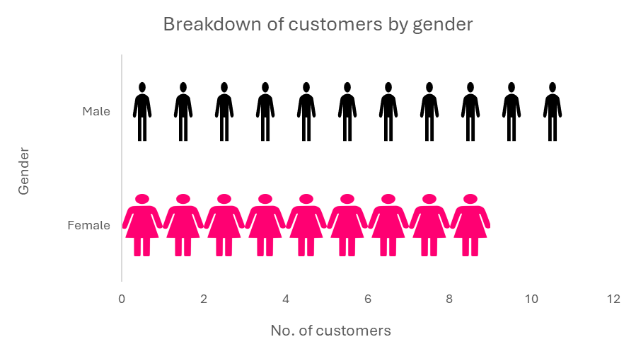

When looking at the difference in customer trends by gender, we are able to look at a breakdown of the average spend. The column graph below displays the average pound spent by females in comparison to males. As is illustrated, females on average spend £14 weekly at the store whilst males spend a higher proportion at £16.30 a week. Further analysis on this can be found in the next section, customer spending patterns.
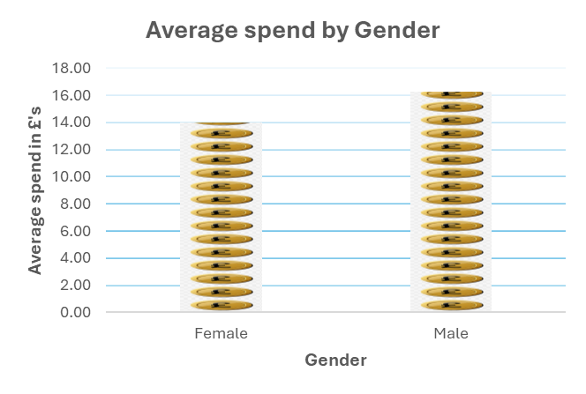

We are also able to interrogate the data to look at newspaper choice by gender. The column graph overleaf denotes the number of newspapers purchased by type (Daily Express, Guardian, Telegraph & Western Mail) and by gender. The newspapers purchased by females are denoted in green, whilst male purchases are illustrated in navy. As can be seen the Telegraph and Western Mail were bought by both men and women, although the later was predominantly bought by men (4 males in comparison to 1 female). However there is a distinct gender split for the Daily Express buyers and those that purchased the Guardian newspaper. Only males (6) bought the Daily Express, with only females (7) buying the Guardian.

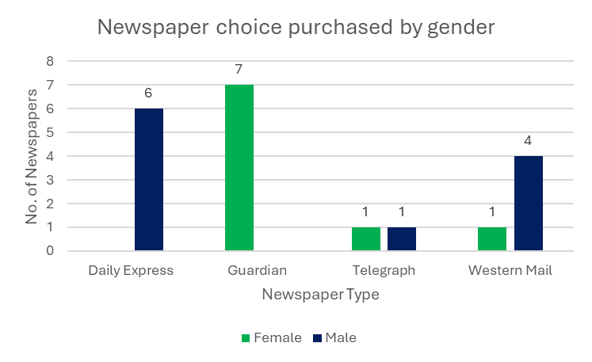

Within this data set there is a slight majority of males, if this is true of the wider population of the area there may be a case for the store to consider ordering more Daily Express newspapers if this seems to be the preferred newspaper of choice. Similarly if the Guardian readers of the area are predominantly female, marketing and sales of these newspapers could be targetted to specific genders. As newspapers also tend to have a political leaning, local views could be researched to aid in these decisions. Further analysis on newspaper choice will be explored in the Newspaper Purchase trends section.

Customer Spending Patterns
Across the 20 customers, a total of £305 was spent on their weekly spend in store. This reveals a mean average of £15.30 across the 20 customers with a similar median of £15. The mode for the total data was £11 which may suggest that a significant number of customers spend less than the average, therefore there may be a few higher spenders raising the average. This data was calculated within excel using the formula functionality to determine the mean (average), mode and median.
As can be seen in the table below, further analysis of the customer spend was looked at based on their noted gender.
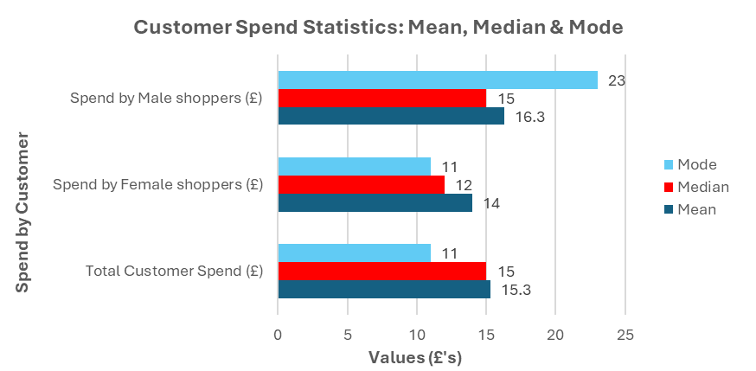
The table overleaf has been converted into the below bar chart where the difference between the Mode, Median and Mean can be seen clearly when focusing on spend by gender.

Male shoppers have a higher mean average spend of £16.30, compared to the Female average of £14 and the total average of £15.30. The median for female shoppers is £12, whilst the mode is £11 suggesting that they tend to spend less than the overall average, with fewer high spenders amongst their group. For Male shoppers we can see an opposing trend with a median of £15, the same as the total customer spend however the mode for Male shoppers is £23. With the mode being significantly higher than the mean or median for this group it indicates that a larger proportion of men are spending more at the store. Further insight on what specific items males and females are buying may aid in increasing general spend by providing targeted items for the different genders.

The scatter plot graph overleaf shows the relationship between customer spend and the distance to which they live to Gwalia stores. This data may have been gathered through a questionnaire or address data for customers could be held within the store’s administrative system. As can be seen there is a larger cluster of higher spending customers who live within 200 metres of the store with the largest spenders living within 50 metres. This suggests that the proximity of the store to these customers corresponds to them spending a higher average amount (over £20) or making more frequent purchases at Gwalia stores.
The further away from the store that customers live, the average spend decreases to under £10. This indicates that those that live further away from the store either spend less or frequent Gwalia less than those who live closer. It may be interesting to interrogate the purchases of those that live further away to understand what items they are buying to inform future marketing campaigns or store orders to increase custom from this population. This data was calculated by using the pivot functionality within Excel to enable trends across different elements of the data set to be explored.
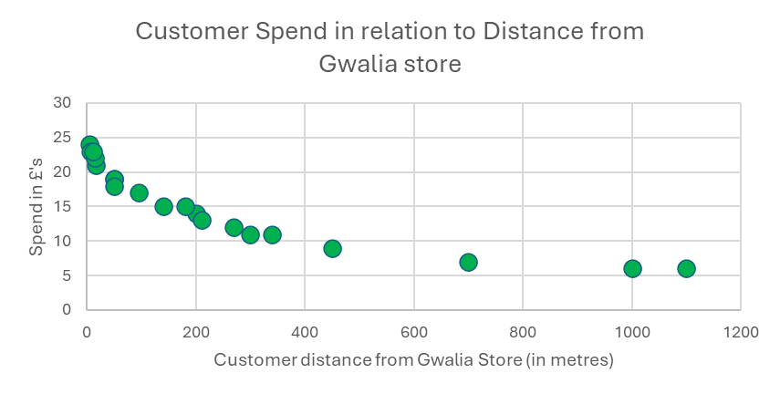

Newspaper Purchase trends
There are 4 main newspapers purchased regularly by customers within the data set provided. Overleaf is a Tree map chart of the number of newspapers purchased by title. The larger the rectangle, the higher the number of newspapers purchased.
The Guardian and Daily Express are the most frequently purchased with 65% of the total sold (7 & 6 respectively). This is followed closely by the Western Mail with 5 purchases (25%), however only 2 copies of the Telegraph are purchased regularly equating to only 10% of overall sales. This suggests that the 2 main newspapers of choice for Gwalia Stores customers are the Guardian and the Daily Express. Low numbers of Telegraph papers sold may indicate that it is not a popular local choice or if only limited numbers are ordered, individuals may be curtailed in their ability to purchase their newspaper of choice. Further insights could be gathered from local customers to help improve future stock decisions.

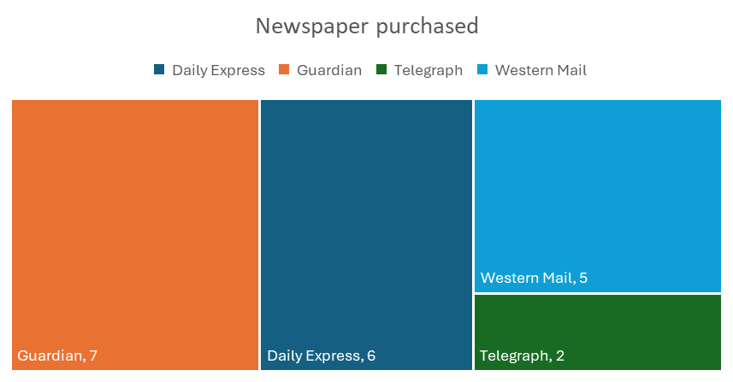
As newspapers can have political leanings, as part of the data analysis, we looked at newspapers purchased in relation to individual opinion of the local borough council to see if there were any insights that could be gleaned. In the bar chart below, you will note the opinion of the customer on the left vertical axis, with a stacked bar chart of the differing newspapers purchased on the horizontal axis.

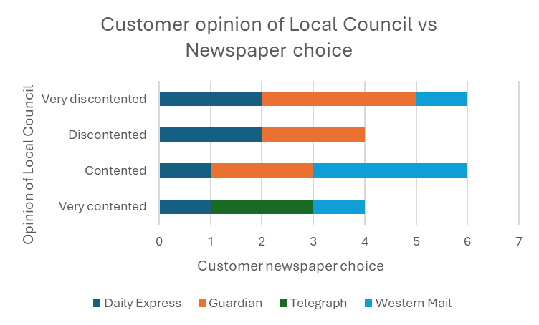

From the chart we can see that there are mixed views of the local council, with an even split amongst those that are content or very contented (10) and those that are discontent or very discontented (10). In looking at the detail, Daily Express readers show a more consistent trend of discontentment than contentment (4, 2 respectively), similarly with Guardian readers (5, 2). As these newspapers are generally seen as having opposed political views there seems to be no direct correlation with the political stance of the local council, however further analysis would need to be sought. Western Mail readers are generally more positive in their views of the local council, 4 contented and very contented whilst only 1 is very discontented. Whilst both Telegraph readers are very contented with the local council.
As this data set is limited in its numbers, we cannot read any direct inference to customers opinions in relation to their political stance however if there are changes in the local community, opinions may sway or increase readership of certain publications. Therefore, it is suggested the local political climate is considered when the store is looking at wider marketing or communications in relation to local activity.
Further analysis of the opinions of the local council can be seen in the next section.

Opinions on the Local Borough Council

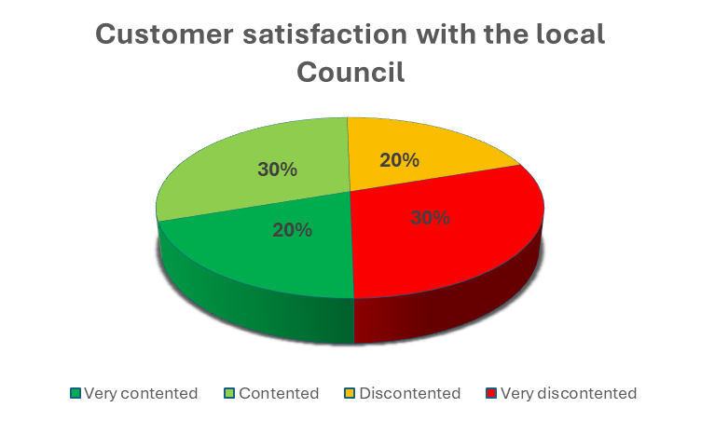
The pie chart above notes the customer opinion of the local borough council. As can be seen there is an even split in customer opinion. In green on the left, 50% noted that they are Very Contented (4) or contented (6), and in red and amber on the right, 50% stated that they are discontented (4) or very discontented (6) with the local council. There is a slightly higher proportion who are very discontented (30%, 6) compared to those who are very contented (20%, 4).
We have previously explored if there is any correlation to the opinion on local council and the newspaper purchased by customers. Below we look at customer opinion in comparison to average spend at Gwalia Stores.
In the funnel chart below, we have looked at the amount customers spent in relation to their opinion and have calculated an average using Excel formulas for each category. We can see that the average spend in comparison to opinion of the council varies from £11 to £17.25 a week. Interestingly it is those that are more discontented with the local council that also spend more within Gwalia stores, spending on average £17.25. Those that are very discontented spend £16 on average giving an average across those with a negative opinion towards the council of £16.50 in comparison with £14 on average for those that are contented or very contented.

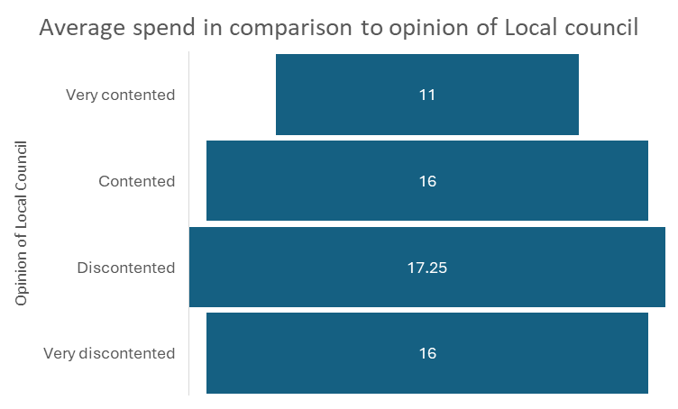

This suggests that those with more critical views of the local borough council are linked to spending a higher amount on average. When we look back at the general average spend from our first analysis (overleaf), the mean average customer spend was £15.30 therefore the above correlates that generally those with a more negative view, do seem to be spending a higher average amount at Gwalia stores than the mean.

As noted earlier, it may be pertinent to keep abreast of any local council changes as this may affect general customer spend in the future.

Conclusion
From the data set provided of the 20 Gwalia stores customers who took part in the research, the findings are as follows:
- The demography of Gwalia stores customers is a near even split, with 55% male and 45% female customers.
- On average men tend to spend more (£16.30) in comparison to women (£14.00).
- The average spend across all customers is £15.30, with a median of £15 and a mode of £11.
- Male shoppers have a higher mode, indicating that there are higher spenders within this group.
- Customers living within 200 metres of Gwalia stores tend to spend more, over double, and up to 4 times as much as those living 1000 metres away.
- The Guardian and Daily Express are the most purchased newspapers, accounting for 65% of total sales.
- Newspaper preferences show a gender divide: only males purchased the Daily Express, while only females purchased the Guardian.
- Customer opinions are evenly split between positive and negative views of the local council.
- Those who are discontented or very discontented with the council tend to spend more (£16.50 average) than those who are contented or very contented (£14.00 average).

Recommendations
To aid in increased footfall and spend within Gwalia Stores, based on the data analysed the following is recommended.
- Conduct further research of the customer base to widen the pool of data available. This could include further data on spending patterns by gender, age profile, political leanings and occupations.
Gathering this additional data could aid in exploring targeted marketing strategies for gender or location specific preferences.
- Consider increasing stock of Guardian and Daily Express newspapers to meet local demand.
- Develop localised promotions for the higher spend customers living within 200 metres of the store to promote and encourage loyalty.
- Monitor local council developments as this may influence customer engagement and spend.
- Create a feedback scheme to understand further customer requirements.
- And finally, it’s suggested that Gwalia Stores invest in its data analytics capability to monitor spend and customer interactions. Excel has been used to analyse this data however utilising Power BI, or a similar tool could enable more real time analytics to aid in adapting orders to customer need.

Robinson, J., 2014. Likert Scale. In: A.C. Michalos, ed., Encyclopedia of Quality of Life and Well-Being Research. Dordrecht: Springer. [online] Available at: https://link.springer.com/rwe/10.1007/978-94-007-0753-5_1654 [Accessed 13 Jun. 2025].

