Managing Digital Identities

BMSP5004

Assignment 1 – Essay


Hannah Kilburn

1805552

Tutor – Anthony Burns

Introduction
This assignment will include topics on two famous influential people, one that uses social media well in a professional polished way and one that uses social media poorly. Each famous person will have reasons for how they portray themselves on social media or for the one that uses it poorly, the reasons that they are unable to use social media to branch out to their audience. The person that has been chosen to use as someone that uses social media in a professional way is Dwayne Johnson. This person has been chosen as from browsing through different social media platforms and as a google search, he appears to be one of the most influential actors that use social media and appears to know exactly who his audience is and what his target is when posting online. The celebrity that has been chosen as someone that is poor at using social media is Emma Stone as she doesn’t have certain social media accounts and doesn’t use the right platforms and doesn’t have a specific target audience that she promotes to. These two celebrities are different in ways that they use social media but similar when it comes to familiarity in the public eye as they are both very well known people that have very important and famous careers.

What is a digital identity?
The definition given for a digital identity is “A digital identity is an online or networked identity adopted or claimed in cyberspace by an individual, organization or electronic device.” (Techopedia, 2019) A digital identity can also be in the form of a digital footprint which shows how much a person uses social media. The definition of a digital footprint that is given by Techterms is “A digital footprint is a trail of data you create while using the Internet. It includes the websites you visit, emails you send, and information you submit to online services.” (TechTerms, 2014) A digital identity is based around how you use social media and what you choose to share and post on the different social media platforms such as Instagram, Facebook and Twitter. On these websites people will set up an account with usernames that make them recognisable to other people, these accounts will also have passwords which is another system which leads to a growing digital identity online.
A lot of people will add on their date of birth and other factors such as location of where they come from or locations that they have previously been which adds to a person’s digital identity. There can be privacy issues with sharing so much information, but it doesn’t stop many people from posting personal stuff on social media where information could so easily be found and used inappropriately. (Rouse, 2019)
There are ways to make sure that your digital identity is kept as safe as possible, some of these factors consist of; making sure that passwords are unique and not the same for every website, making sure that setting on your social media sites are set to private and only adding and accepting people that you know. Making sure that the system you are on has an antivirus programme set up and that it is always updated to ensure the highest level of protection. (Rubenking, 2018)

Famous person that uses social media in a professional way
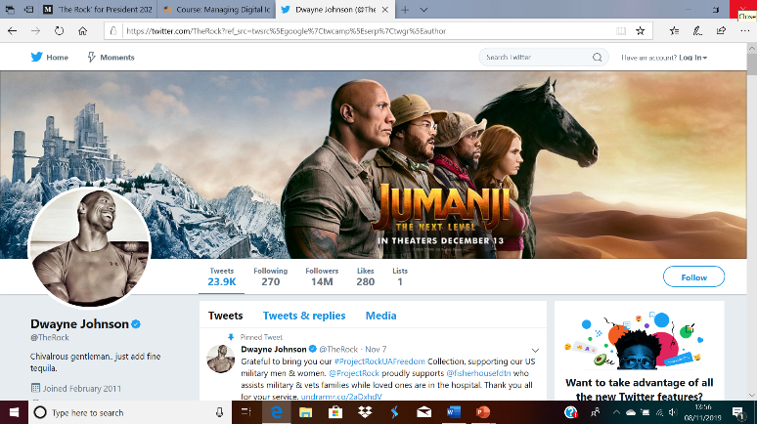
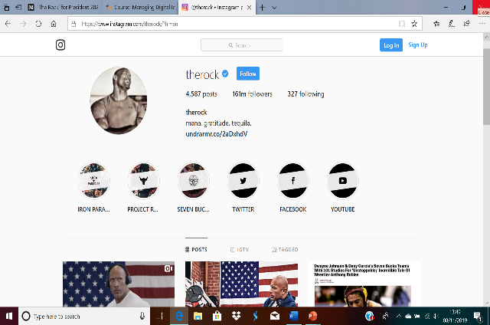
The person that has been chosen as someone that uses social media in a good and polished way is Dwayne Johnson, also known as “The Rock” in the public eye which shows that he is a popular icon in the world and has a specific nickname which many people are aware of. He is a world famous Canadian-American actor that has been in the celebrity star light for a long time and has also won awards and been nominated for many awards for the work that he has produced.
(Instagram, 2019) (Twitter, 2019)

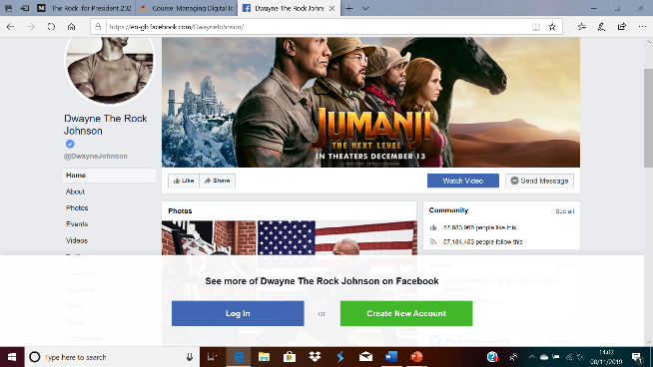
(Facebook, 2019)

As shown in the images above, Dwayne Johnson is a very public figure on social media and is followed by millions of people which shows that people want to keep up to date on his lifestyle and what he decides to share. Lots of these posts will get thousands of likes each which shows people enjoy what he wants to share and there may also be other celebrities that will like and comment on his posts which shows that he has a close network of people that he can show off his life to. This is a very professional profile as his name is the same on all accounts and his profile pictures are the same on all three accounts which makes it clear as to who he is. He knows exactly what he wants to allow people to see and what he wants to promote, as an example his new film that he is staring in, and is coming out soon, is shown in two of his profiles as one of the first pictures that you see when going onto his page. As the images show he has 141 million followers on Instagram, 14 million on Twitter and around 57 million people following him or liking his profile on Facebook, these figures show a massive range of population that are interested in his pages. (Facebook, 2019) (Instagram, 2019) (Twitter, 2019)
Dwayne Johnson will have his own personal brand identity as a celebrity. He would have previously outlined who his target audience is, and how he stands out from other celebrities that make him more popular and more recognisable than others. Dwayne Johnson is one of the highest paid actors in 2019 where his earnings were a shocking $89.4 million. This figure was from June 2018 to June 2019. He is up against actors like Chris Hemsworth, Robert Downey Jr and Bradley Cooper, these celebrities are all very popular actors, but Dwayne Johnson comes out top against some of the best actors in the world and he is very successful and well-known for his work that he has produced over many years. (Berg, 2019)
He is naturally good in the public eye and is interested in topics such as politics, social work and teaching his good intentions to his fans and people that follow him for his speciality in working with all sorts of people, famous or not. Dwayne Johnson is very good at inspiring other people to follow his views, creative ideas and positivity in the world which leads to him attracting the right kind of people to follow him and be a part of his life journey. Every celebrity will have to face consequences of having such power, so that is a disadvantage that comes with being such a highly well known figure in the public eye, being able to deal with these situations is a very tricky task and must be taken with care or he could end up upsetting fans and potentially risking his high end and high powered job as such a famous person. (Celebrities-Galore, 2019)
Social media plays a huge role in the positive and negative aspects of a celebrity. Being able to reach out and share all aspects of everyday life with your follows can lead to many positives but there will always be some negatives when it comes to sharing nearly every aspect of your life with millions of people. There is hardly any privacy when it comes to be a celebrity, especially now since almost everything is done online and through social media. There may also be an issue with trust as some relationships and friendships may only be based on the fact that you are famous and could potentially have large sums of money and expensive possessions. (Maclin, 2018)
The four main topics that Dwayne Johnson portrays on social media is value, identity, community and emotion. He has strong values which he wants to promote and share with his followers to feel as though he is doing good in the world and being a positive influence that people will look up to. Identity is being yourself and showing off who your really are, only you are in control of your identity, Johnson is fully understanding of who he wants to be. Johnson has a massive community and is always making sure that he provides posts on social media which makes up most of his large community of a variety of people. Posts that are filled with different emotion are striking to the people that are reading and commenting on them. Making posts full of emotion will entice more people to read, comment and like a post and therefore more people will be talking about him. Dwayne wants to be able to inspire people as his role of being in the public eye and he does that very well through using all platforms of social media. (Dean, 2019)

Famous person that doesn’t use social media well
The person that has been chosen as a famous person that uses social media poorly is Emma Stone. She is someone that has decided to not use social media so her platforms would be very poor, and this shows that her digital identity would have to been portrayed in a different way. Emma is an award winning actress but fails to use social media in the same way that Dwayne Johnson does to keep up with his fans ands also keep them updated on his life. Emma Stone will lose out of a variety of fans from social media websites that could promote her even more. Emma said in an interview with People Magazine that social media “I think it wouldn’t be a positive thing for me,” which shows she thinks very differently to other celebrities and feels that it wouldn’t promote her or her work. (PeopleMagazine, 2018)
Emma is missing out on certain aspects of not using social media because it is a very easy way to branch out to individuals and share opinions and potential upcoming work that may interest the public that may want to see what she is working towards. Making a direct connection with your target audience is so much easier when working on social media as people can reach out to you and show a real understanding of what you promote as a good celebrity. Even though celebrities earn a lot through the work they already do, advertising promotion could be available which would make them even more well known for promoting possibly smaller businesses that need a kick start. Although by not having social media she is able to avoid having negative feedback which could affect people in a bad way and lead to different complications in someone’s life. By being a celebrity there also comes a great demand with being in the public eye so posting lots of pictures, videos and statuses must be uploaded on all the platforms at all times and this would be time consuming. (Webfx, 2018)
From looking through internet sites it is clear that Emma Stone is not interested in sharing her life on social media so therefore there is very little of her life that has been shared on these platforms. Emma Stone has been in many very popular films but fails to see the point in using social media and she is one of the top 21 celebrities that doesn’t use social media through a choice of their own and reasons that are appropriate to their lifestyle, they feel as though they do not need to share their lives to be popular. (Bahou, 2016)
Conclusion
As shown in the essay, Dwayne Johnson is the actor that uses social media in a professional way by having all social media platforms and is constantly sharing different posts of his life online. Emma Stone on the other hand is someone that uses it poorly as she doesn’t have any of the social media platforms and is not interested in sharing her life online and is unable to understand the concept of promoting herself online to strangers online. Having good social media profiles means that these celebrities could promote different work and work with other people to creative inspirational work that the public will enjoy. As the two celebrities chosen are both actors, they are both very successful through this line of work and are both award winning people that want to provide entertaining and a sense of community through their career. Dwayne Johnson will have a set up as he likes to connect and communicate with his fans, hence why he is one of the highest earners and most followed actor at this time.

References
Bahou, O. (2016, April). Retrieved from Instyle.com: https://www.instyle.com/celebrity/celebrities-who-dont-use-social-media
Berg, M. (2019, August). Retrieved from Forbes: https://www.forbes.com/sites/maddieberg/2019/08/21/the-highest-paid-actors-2019-dwayne-johnson-bradley-cooper-and-chris-hemsworth/#5705c8ef2b96
Celebrities-Galore. (2019). Retrieved from https://www.celebrities-galore.com/celebrities/dwayne-johnson/home/
Dean, H. (2019, August). Retrieved from Backstage.com: https://www.backstage.com/magazine/article/dwayne-the-rock-johnson-social-media-actors-should-do-68870/
Facebook. (2019, November). Retrieved from https://en-gb.facebook.com/DwayneJohnson/
Instagram. (2019). Retrieved from https://www.instagram.com/therock/?hl=en
Maclin, E. (2018, June). Retrieved from Thriveglobal: https://thriveglobal.com/stories/the-life-and-death-of-celebrities-is-it-always-good-to-be-famous/
PeopleMagazine. (2018, August). Retrieved from https://www.peoplemagazine.co.za/celebrity-news/international-celebrities/emma-stone-explains-why-she-shuns-social-media/
Rouse, M. (2019). Retrieved from Techtarget: https://whatis.techtarget.com/definition/digital-identity
Rubenking, N. (2018, November). Retrieved from Pcmag: https://uk.pcmag.com/features/94680/12-simple-things-you-can-do-to-be-more-secure-online
Techopedia. (2019, September). Retrieved from Techopedia.com: https://www.techopedia.com/definition/23915/digital-identity
TechTerms. (2014, May). Retrieved from TechTerms: https://techterms.com/definition/digital_footprint
Twitter. (2019, November). Retrieved from https://twitter.com/TheRock?ref_src=twsrc%5Egoogle%7Ctwcamp%5Eserp%7Ctwgr%5Eauthor
Webfx. (2018, January). Retrieved from https://www.webfx.com/internet-marketing/social-media-marketing-advantages-and-disadvantages.html

