Task 1: Medi Link Pharmacy Relational Database Development
Student Name: Ryan Watson
Student ID: 2517865
Module: ACCA4023_LON
Date: 23 March 2026

Table of contents:
Page 2 – Introduction
Page 2 - Conceptual Design (Entity Relationship Diagram)
Page 3 - Normalisation & Data Structure (3NF)
Page 4 - Relational Integrity & Database Connections
Page 4 - Query Development & Implementation
Page 6 - User Interface & Usability Design
Page 7 - Data Dictionary (System Architecture)
Page 8 - Testing & Quality Assurance
Page 8 - System Evaluation & Conclusion
Page 9 – Bibliography/References

Introduction
The purpose of this task was to create a fully functioning and relational database for a fictional company, MediLink Pharmacy. I developed the database using Microsoft Access, as I have had previous exposure to Access in the past, meaning that I have familiarity with some of its core functions. I created the database with the intention to make the pharmacy's day to day operations of business far more streamlined, which in turn, removed any flat files that could have caused some inaccuracies that could have otherwise presented themselves naturally. This will have been due to performing these tasks more manually. The result of implementing this database in their pharmacy is that they are now able to provide a more improved service delivery and customer care to their patients. This has been achieved through less user error since the system now has a robust integrity structure. This now contrasts significantly from the manual process. The database can store entities related to the day-to-day operations of running their pharmacy such as pharmaceutical vendors, medicines, customer information, prescriptions being filled and daily retail sales transactions - all in a compartmentalised manner. I also explain the different queries I designed and can run within the system, as well as how and why I designed a General User Interface.
2. Conceptual Design (Entity Relationship Diagram)
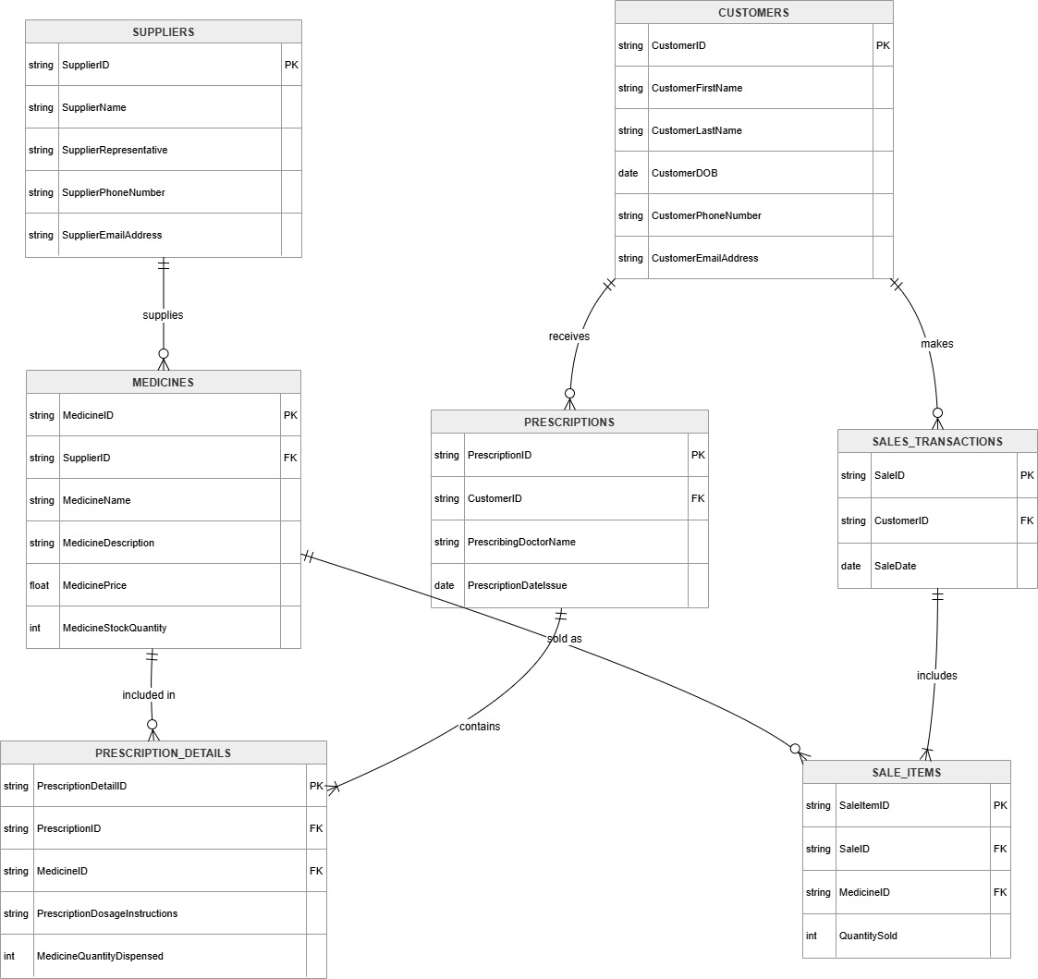
Before I physically designed the database using Microsoft Access, I had to create this Entity Relationship Diagram (ERD.) This followed the Entity Relationship Data Model approach described by Watt [3].
The purpose of this was to illustrate the database’s conceptual design. This diagram I created with draw.io shows entities that are central to business operations at Medi Link Pharmacy. It identifies relationships that exist among these entities; providing a robust foundation for database design.

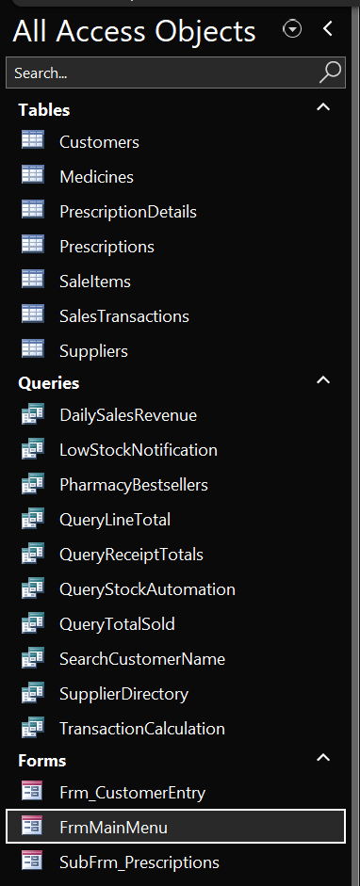
3. Normalisation & Data Structure (3NF)
To achieve data integrity and prevent data redundancy, I made sure that this database is normalised to Third Normal Form, as was carried out by the methodology presented by Watt and Eng [1] and detailed in Watt [4]. This demonstrates that, instead of using a single spreadsheet to hold all this data, seven separate tables have been created to store this data. I made sure that this data was categorised into seven distinct tables.
- Customers
- Medicines
- PrescriptionDetails
- Prescriptions
- SaleItems
- SalesTransactions
- Suppliers

To further expand on the reasons why I normalised the database to Third Normal Form; was to ensure that all non-key data is mutually independent and totally dependent on the primary key. This means that I only ever enter customer’s details once in the database, under Customers. The result is that a customer’s details are not entered repeatedly whenever they make a new prescription or a sale.
Additionally, to design this database to Third Normal Form, I had to be sure that all calculated fields are not included as part of this database. Calculated fields include data like receipt line totals and live stock levels, things that change based on another part of data. These are not included as part of the database because they would be included as part of a relational database, which would compromise database structure. Calculated fields have a transitive dependency on other tables. This means that if raw numbers change, database integrity would be compromised. Calculated fields are not stored as part of this database.

4. Relational Integrity & Database Connections
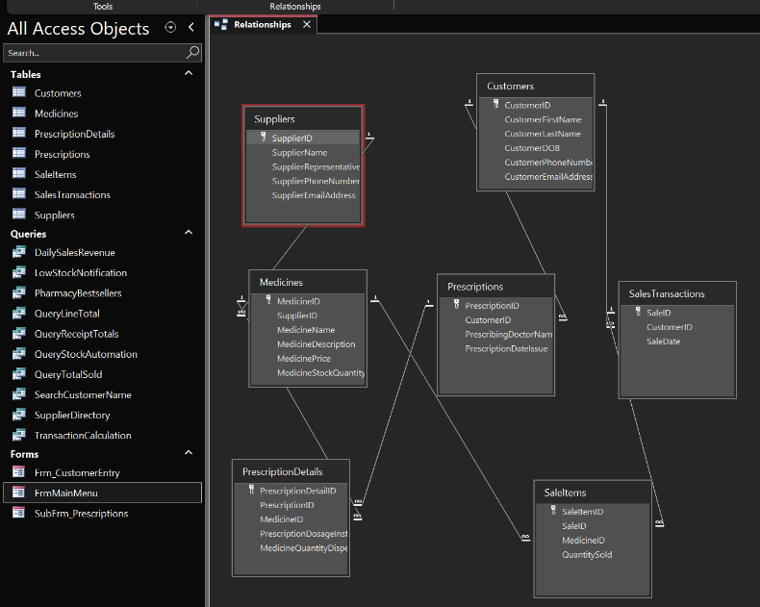
The individual data tables are interconnected by Primary Keys (identifiers for individual data records) and Foreign Keys (identifiers that connect related data records in different data tables). To prevent potential user error and data corruption, I ensured that the “Enforce Referential Integrity” constraint was applied to all relationships when Creating the Relationship tree. The enforcement of referential integrity aligned well with the relational design principles that were outlined by Watt and Eng [1]. This constraint will typically prevent a user from accidentally assigning a prescription to a non existent customer, as well as prevent a supplier from being removed if they are assigned to active medicine inventory.

5. Query Development & Implementation
To illustrate the functionality of my database, I created a series of queries that directly correlate with the daily needs of the pharmacy manager and employees.

5.1 Low Stock Alert Query (LowStockNotification - Query)
I created this query to proactively manage the levels of the pharmacy’s inventory through the use of the dynamic stock engine. By querying the real-time data of the LiveStock field, which is generated through the QueryStockAutomation system, it will display only those items with an amount of less than 50 units. This will provide the pharmacy manager with an automated, mathematically accurate list of items that need replenishing each day. By joining the Medicines table with the Suppliers table, this query will also provide the name and phone number of the relevant supplier of the low-stockitem, thus assisting with supply chain management.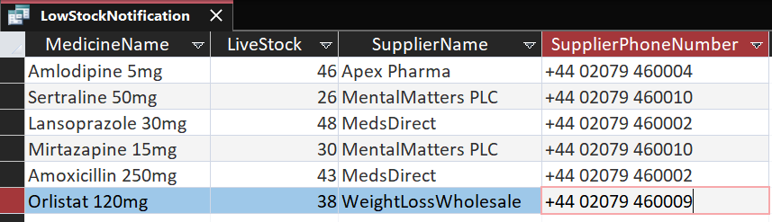

5.2 Customer Prescription Lookup (SearchCustomerName - Query)
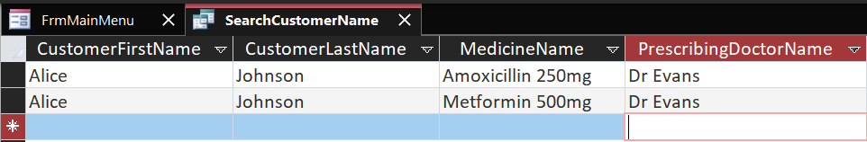
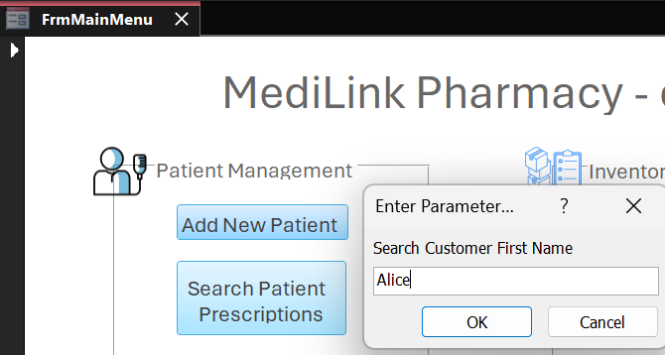
To further enhance the efficiency of the pharmacy’s front-desk personnel, I included a parameter query that will prompt the user to enter the first name of a customer. By utilising the relational links between the Customers, Prescriptions, PrescriptionsDetails, and Medicines tables, this query will immediately display a customer’s active prescriptions as well as their prescribing doctor’s name.

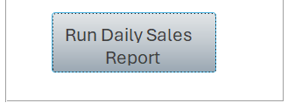
5.3 Daily Sales Revenue (DailySalesRevenue - Query)
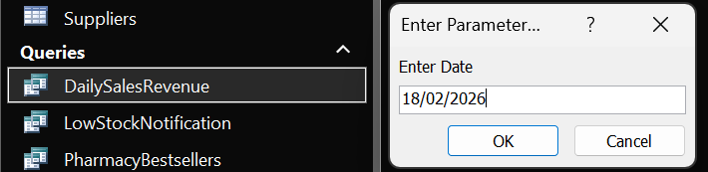
To further assist the management of the pharmacy, I incorporated another aggregate query, this time focusing on the SalesTransactions table. By grouping the data by the SaleDate field and utilizing the 'Sum' mathematics function on the TotalSaleAmount field, this query will automatically calculate the gross revenues made on a particular day as input by the user.
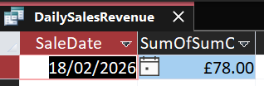

5.4 Pharmacy Bestsellers (PharmacyBestsellers - Query)
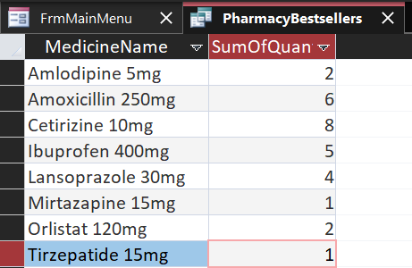
To assist in marketing and inventory purchasing decisions, I added an aggregate query using the Medicines and SaleItems tables. By using the 'Sum' function to the QuantitySold field, pharmacy management can quickly determine the most popular items for their store. This is dynamic, and ever-changing as sales continue to occur. This allows the pharmacy to adjust pricing, to increase their profit margins if they wish to.
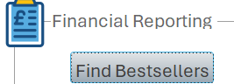

5.5 Supplier Directory (Qry_SupplierDirectory)
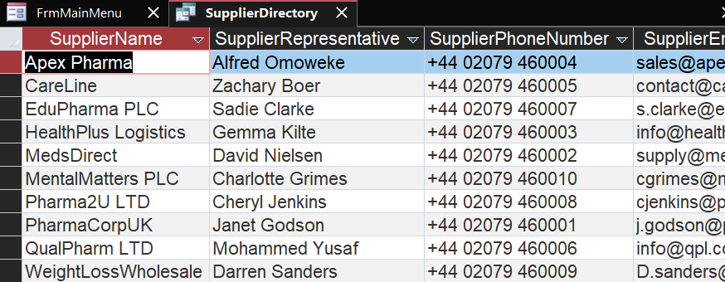
To provide a concise query for referencing supplier information, this query is designed to extract only supplier information from the Suppliers table. By using the Ascending sort function for the SupplierName field, management can instantly generate an ABC directory for emergency situations.
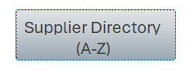
5.6 Live Inventory Automation (QueryStockAutomation & Query_TotalSold)
In compliance with the project’s requirement to automate pharmacy related processes, I sought to craft a dynamic and real-time calculation engine which would calculate the Live Inventory. While relational data tables usually contain static data such as the quantity of medicines initially delivered to the pharmacy, relying on this data to obtain real-time data on stock levels would be inefficient. To overcome this limitation in relational data modelling, I decided on a dual query system. First, an aggregate query named (Qry_TotalSold) was created to aggregate the total quantity of a specific medicine ever recorded in the SaleItems table. This aggregate data was then used in the second query named (QueryStockAutomation) to dynamically subtract the total units sold from the initial quantity in the Medicines table. This method produces mathematically accurate Live Inventory data without altering any data in the SaleItems table.

6. User Interface & Usability Design
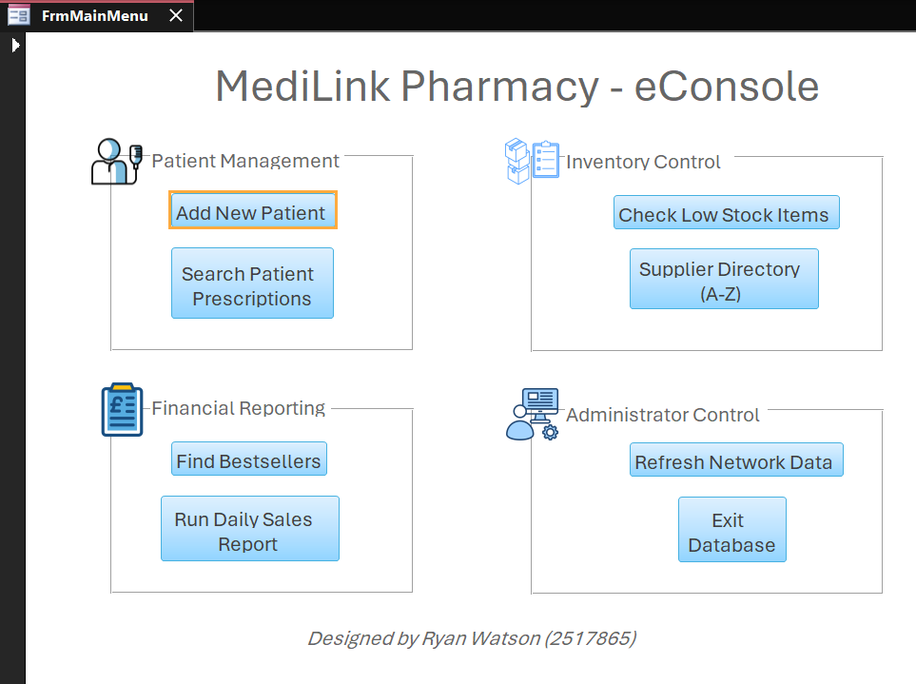
In transforming the database into a working software application rather than a simple data storage system, a customised Graphical User Interface (GUI) was created to facilitate secure data entry for pharmacy staff.
Cognitive Load Reduction: The primary GUI was created in compliance with mainstream ergonomic design standards through the use of categorised grouping boxes and visual icons in the Main dashboard named FrmMainMenu, guided by practical techniques presented in McFadyen [2].
This design segregated data entries in Patient Management, Inventory Control, Financial Reporting and Administrative tasks. Overall, this drastically reduces cognitive load for the end-user.

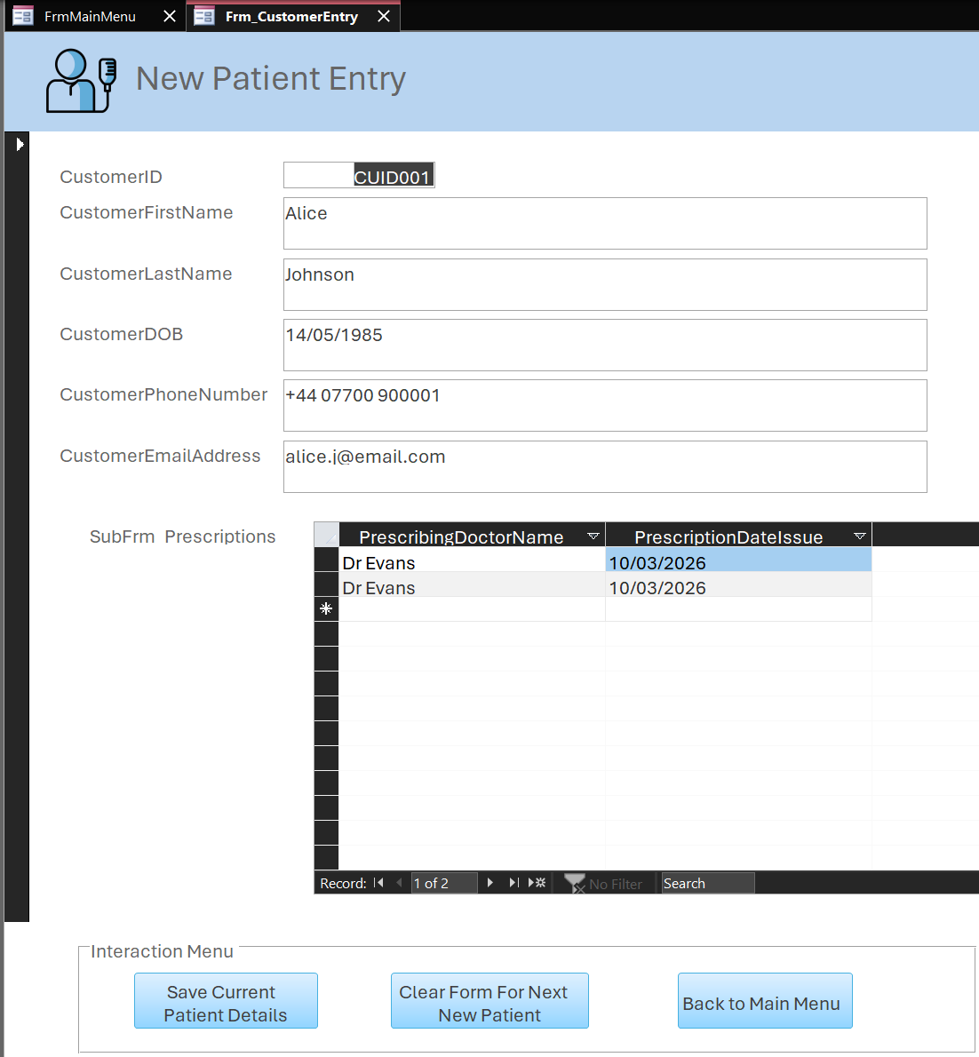
- Explicit Interface Controls: Instead of relying on hidden system commands in Access, I included explicit macro-driven buttons in the design of the ‘New Patient Entry’ form. These include ‘Save Current Patient Details’. This creates clear pathways for navigation and reduces the risk of data loss in high-volume pharmacy environments.

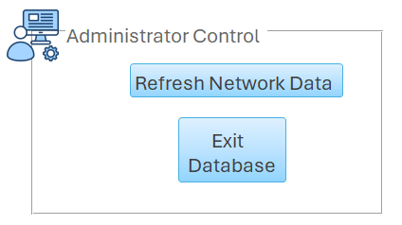
- System Administration Controls: The 'Refresh Network Data' command has been included in the main dashboard. This allows the system administrator to manually poll the backend tables and synchronize the dashboard with real-time data input entered by users on other networked terminals.

7. Data Dictionary (System Architecture)
To ensure that the data entry consistency and system stability of my database was mainted, I needed to ensure that any data types and constraints were strictly defined. This prevented any Integrity based violations. Below is an extract of the core architectural rules that were applied to the database modelling:
- CustomerID: AutoNumber (Primary Key) - Automatically generates a unique ID for each patient.
- CustomerFirstName / CustomerLastName: Short Text - Restricted to 50 characters to save memory.
- CustomerDOB: Date/Time - Enforces valid date formats to prevent text entry errors.
- CustomerPhoneNumber: Short Text - Used instead of 'Number' to preserve leading zeros.
- MedicinePrice: Currency - Enforces exact monetary formatting and prevents rounding errors.
- MedicineStockQuantity: Number - Restricted to integer values for accurate inventory counts.

- Testing & Quality Assurance
To ensure the database operates reliably, validation tests were conducted on the system's structural integrity.
Test ID | Feature Tested | Action Performed | Expected Outcome | Actual Result
T-01 | Referential Integrity | Attempted assigning a prescription to a non-existent CustomerID. | System blocked the entry and displayed a relational constraint error. | Pass
T-02 | Delete Cascade Restriction | Attempted to delete a Supplier that currently supplies active Medicines. | System blocked the deletion to prevent potential orphaned inventory records. | Pass
T-03 | Data Type Validation | Attempted to type letters into the MedicineStockQuantity field. | System rejects the keystroke and prompts for a valid numeric integer instead. | Pass
T-04 | Parameter Query Logic | Ran the DailySalesRevenue Query and inputted a specific date (18/02/2026). | Query accurately filters and sums only the transactions from that exact date. | Pass
T-05 | Dynamic Inventory Calculation | Processed a new transaction in the SaleItems table for 5 units of a specific medicine | The LiveStock figure in the QueryStockAutomation engine instantly and automatically decreases by exactly 5 units. | Pass

- System Evaluation & Conclusion
My MediLink Pharmacy database meets all of the requirements of the project. My database going above and beyond just meeting the requirements by utilizing rules of normalization and enforcing data integrity at every level. This gives them a reliable database to work with when managing medical data. The UI that I designed shows that this database I created is quite useful. It uses macro driven forms and a sorted dashboard to allow inventory alerts to be automated, improve services to patients, and allow generation of financial information safely. While the current iteration of the MediLink Pharmacy database successfully fulfils the CEO's brief, future development could focus on enterprise-level security and scalability. Implementing Role-Based Access Control (RBAC) would be the logical next step. In a real-world clinical setting, not all employees should have universal access to the system. By defining specific user roles, the database could automatically restrict front-of-house dispensing staff from viewing sensitive financial reports or modifying supplier contracts, while reserving full administrative rights, such as executing the Daily Sales Revenue query, exclusively for the pharmacy manager.
Furthermore, the Graphical User Interface (GUI) could be expanded to include dedicated administrative forms for inventory management. Developing a dedicated 'New Medicine Intake' form or a 'Supplier Management' portal would further isolate end-users from the raw backend tables. Design of this, would look similar to the New Patient Entry Form, except it would have suppliers in the sub-form rather than prescriptions. This would reduce the risk of accidental data deletion and enforce stricter data validation rules during the stock intake process. Ultimately, the current architecture provides a highly normalized, automated, and secure foundation that is fully capable of scaling alongside MediLink Pharmacy’s growing business operations.

References:
[1] A. Watt and N. Eng, Database Design – 2nd Edition. Victoria, BC, Canada: BCcampus, 2014. [Online]. Available: https://opentextbc.ca/dbdesign01/
[2] R. McFadyen, Relational Databases and Microsoft Access 365, Version 4.0. Winnipeg, MB, Canada: University of Winnipeg, 2023. [Online]. Available: https://open.umn.edu/opentextbooks/textbooks/442
[3] A. Watt, “Chapter 8 The Entity Relationship Data Model,” in Database Design – 2nd Edition, BCcampus, 2014. [Online]. Available: https://opentextbc.ca/dbdesign01/chapter/chapter-8-entity-relationship-model/
[4] A. Watt, “Chapter 12 Normalization,” in Database Design – 2nd Edition, BCcampus, 2014. [Online]. Available: https://opentextbc.ca/dbdesign01/chapter/chapter-12-normalization/

