Jurys Inn

ANALYSIS OF THE FINANCIAL STATEMENT

Susana Raquel Da Cunha Balinha (2016797)
2016797@student.uwtsd.ac.uk

DALE CLARKE
February 16, 2022
University of Wales Trinity Saint David

FINANCIAL MANAGEMENT

(BMIH5007)
Executive Summary

In this report will be analysed a financial statement for the years of 2019 and 20120 for Jury Inn. It will be calculated the ratios for those two years and analyse the financial information, this will include the formulas and ratios for profitability, liquidity, and gearing for the hotel chain where it can be understanding the ratio fluctuations necessaries for the hotel management. It also discuss and demonstrate the benefits and limitations of the ratio analyses.

Table of Contents

Executive Summary 1
Introduction 3
Financial Analysis 4
Figure1 4
Financial Analysis Trends and Knowledge from Ratio Analysis 5
Graph 5
Profitability 6-7
Figure 2 6
Liquidity 7-8
Figure 3 7
Gearing 8
Figure 4 8
Benefits and Limitations of Ratio Analysis 9
Conclusion 10
Bibliography 11

Introduction

Jurys Inn hotels are conveniently located in city centres around the UK and Ireland, allowing visitors to explore local landmarks from comfortable accommodation, (Jurys Inns, 2022).
This report aims to outline to the Chief Executive of Jury inn's the financial strengths and limitations presented by a financial analysis statement for the period of 2019 and 2020 mainly to help monitor the wealth of the company but also to exceed the customers' point of view. This will provide an understanding of the profitability, liquidity, and gearing of the hotel and by examining the hotel's financial accounts, will be able to demonstrate a better understanding of the current situation.
Managing a hotel is challenging in numerous sectors but the financial department is the head of the business, as without the financial support the success of it would just not be liable. In this context of developments and collaboration for financial sustainability, there are used some tools to help manage, make decisions, and archive the success of any business and will help the Jurys Inn.
By using the balance sheet from 2019 and 2020 provided analysed the differences between both, furthermore demonstrating the data from the profitability liquidity and gearing ratios, and for last the benefits and limitations of ratio analyses. This concept is basic, and it provides the company with continuous data and results targeted at their competitive brands. Moreover is a very important reason for the formula used to be universal it is to others to be able to recognise any mistakes. Is important that the correct formula is used, because in the accounting world they would be able to spot any mistakes committed.

Financial Analysis

Financial analysis is a procedure of generating information into a company's performance by examining the links between its financial statement figures. - There is a past, a present, and a future, (Stice and Stice, 2019). The analyse of a financial statement is made to evaluate the performance of the company.

Figure 1

The image figure above represents a financial statement (provided by the lecture) that demonstrate the figures archived by 2012 and 2012 in a balance sheet and a profit and loss account at 31st of august of each year. A balance sheet is a detailed statement of an organization's financial statements, ownership, and liabilities. Any organization, whether it's a corporation or a sole trader, has a set guidelines for it and demonstrates the business's performance stability and a profit loss, also known as P&L is also known as a breakdown of revenue and costs or a financial statements. The account displays the financial output of the company at a certain particular period of time, (BYJU’S. 2022).

Financial Analysis Trends and Knowledge from Ratio Analysis

The calculation of financial ratios are determined by using numerical data extracted from financial statements in order to gather useful information about an organization. The data on a financial statement - the balance sheet, income statement, and cash flow statement – are often applied to undertake statistical approach and measure a financial condition, leverage, growth, margins, profitability, returns on capital, and valuation, among other things, (Financial Ratios, 2015-2022). It will also help to evaluate if Jurys Inn was success or unsuccess I this financial years as it helps on the understanding the profitability or losses and obtain figure to be able to compare with other companies and help.
Every company should be using a financial statement.
Furthermore it will be present four of the most used ratio calculations to analyse the fluctuation in those 2 years , 2019 and 2020 of jury Inn hotel.
It must have in consideration the correct way to performance the calculation on the formulas in the ratios.
graph
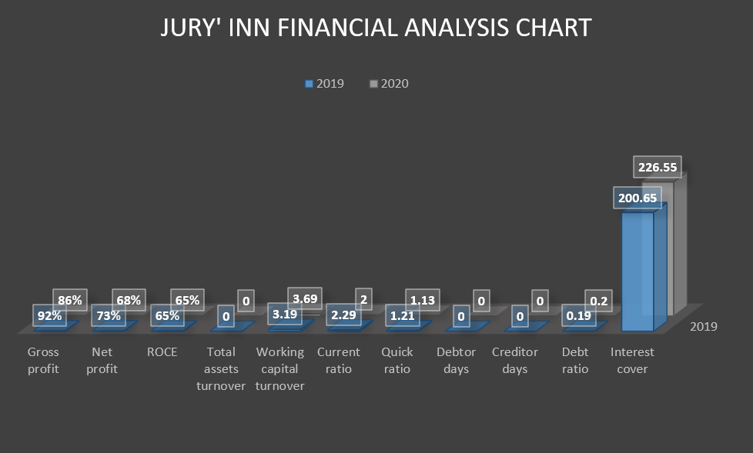

Profitability
Figure 2
-Profitability ratios are financial indicators used by entrepreneurs and others to analyse a company's financial performance by cut costs while increasing earnings. Moreover, profitability ratios can be used to track corporate performance and compare to other companies, (Boyd, 2020).
As show in the figure 2 above, the profitability ratio is divided by 5 ratios:
- Gross profit margin, (cost of goods sold / sales) x100 with 92% in 2019 and 86% in 2020 showing a decrease of 6% even presented an increase in sales, from 5500 to 6000 can be notice in the figure 1 that rent expenses, advertising, light and heat, depreciation, and bad debts, ring this result to a negative figure. but gross profit for the company a reference point of 40%
- Net profit margin (net profit / total sales) x100 with 73% in 2019 and 68% in 2020 again show that was a decrease of 5% also due to the increase of the expenses mentioned above.
- ROCE, it stands for Return On Capital Employed (operating profit / capital employed) x100 or simplified (Profit before interest / total assets less current liabilities) x100 with 65% in 2019 and 65% in 2020 a similar figure for both years, 20% is already an accepted result, and this ratio is a good indicator of how efficiently a company utilises its assets, (What are the three main profitability ratios and how do you calculate them?, 2020).
- Total assets turnover, ( sales turnover / fixed assets) or (Sales/total assets less current liability) with 0.88 times in 2019 to 0.96 times in 2020, as a difference between both years 2020 show as result, a greater asset turnover ratio indicates that the organisation is effectively employing its assets.
- Working capital turnover ( Sales turnover / net current assets) with 3.19 times in 2019 to 3.69 times in 2020 an increase of 0.5 times that demonstrate the net currents assets are lower n 2020 related with 2019 so the turnover was grater.
This demonstrate that the profitability of the hotel had a slightly decrease due to the costs been higher than the year before. It would be worthy to rethink in an increase of the price of rooms to cover that.

Liquidity
Figure 3
-Liquidity ratios are an indicator of a business's capacity to pay down short-term debts and is a crucial aspect of every firm, is also an indicator of a business's capacity to pay down short-term debts.
Figure 3 is able to demonstrate liquidity is divided in 4 ratios:
- Current ratio (Current assets total/current liabilities total) in 2019 is 2.29 and 2.0 in 2020 a decrease of 0.29 but a result above 1.5 is already acceptable.
- Quick ratio (Current assets total – stock / current liabilities total) in 2019 1.21 and 1.13 in 2020, with in the acceptable range as 1.1 is a acceptable number.
- Debtor days (Debtors x 365 days of the year / credit sales) with a range of 106 days in 2019 and 109.5 days in 2020 took 3.5 days more in 2020 for the debtors to pay , way more than the acceptable 30 to 36 days that should be paid on. This is a point of reference for jury’s Inn take in consideration to review
- Creditor days (Trade creditors x 365 days / credit purchases ) shows a total of 584 days in 2019 to a 373.5 days in 2020, even considering the days in 2020 reduce by 208.5. Again Jury’s Inn need to work out the numbers of day to pay to the creditors as it can be said that the time taken to pay to the creditors was way above than the desired 30 days.
According with the number of days gather from the table is recognise a delayed in the payments from the debtors and to the creditors and furthermore the management team should get some focus on this specific point to reduce the days.

Gearing
Figure 4
The amount of debt a company uses to support its operations as a percentage of its equity capital is referred to as gearing. A company with a high gearing ratio also has a high debt-to-equity ratio, which increases the risk of financial ruin. The best gearing level depends on the industry in which a company operates. (Gearing, 2022).
- Debt ratio ( total debts / total assets) or, step by step (Total current liabilities + bank loan )( total current assets + fixed assets ) answers divided by one another give us the value of 0.20 in 2019 and 0.22 in 2020
- Interest cover ( profit before interest and tax / periodic interest charges) or simplify by (Net profit of the year + cash in hand / loan interest) show an increase in 2022 of 25.9 compared with 2019
A higher gearing ratio indicates that a company has a higher degree of financial leverage. This is due to the fact that organisations with higher leverage have more debt compared to their shareholders' equity. Companies with a high gearing ratio have more debt to service, whilst those with a lower gearing ratio have more equity to rely on for funding. This means they are more vulnerable to economic and business cycle downturns than enterprises with greater debt to pay for services. (Kenton and Kindness, 2021).

Benefits and Limitations of Ratio Analysis

- Benefits:
Ratio analysis is a useful tool for analysing financial statements that is extensively used. It determines the numerical or quantitative relationship between two figures on a financial statement in order to evaluate the strengths and weaknesses of a firm, as well as its current financial situation and prior performance. It allows a wide range of stakeholders to evaluate a specific aspect of a company's performance. Moreover, ratio-based trend analysis could be helpful in forecasting and planning potential business, budgeting is the estimation of future actions based on previous experience. (Pant, 2022)
Fernandes, Vieira, Neiva and Peguinho, (2013) argue that the ratios are practical and easy to build, since the elements necessary for its calculation are relatively easy to obtain, and its simple-to-apply calculation formulas. It also adds that they allow summarize a large amount of information contained in the financial statements, thus gathering information on management elements.

- Limitations
Ratio analysis can be a powerful tool However, it has significant limitations that must be considered before doing such a study such as Limitations of Financial Statements, Historical Information they do not reflect current condition , Different accounting policies, a lack of a comparable standard, quantitative analysis window dressing, price fluctuations, causal relationships must be advertised, ratios account for one variable, and seasonal variations affect financial data are all aspects that affect financial data. (Pant, 2022)
Furthermore in the ratio limitations will not be able to be compared to competitors, and the brand strength will not be able to be compared, a few ratios will only reflect the past, so future prospects will not be able to be shown.
And further understanding show that the miss calculation, or miss use of the financial analyses it will mislead in information where it can lead to more serious matters.

Conclusion

In conclusion to the financial analyses of Juris Inn year 2019 and 2020 It is noteworthy that cost analysis appears not as the only solution, but as the best solution for the success of a company, there are numerous strategies for the growth and profitability of a company, but financial analysis is considered essential because it is the most outstanding today. Knowing how to analyse means being able to spend less and profit more, a company that spends more and profits less is not having a good cost analysis, it is worth highlighting the need to know the best strategy of your own business. The understanding of manage and use costs strategically reveals the compression of many factors within an organization. From a good management the Jury Inn comes to have greater control of its expenses and where it can invest, eliminate waste, among other actions.

Bibliography

- Boyd, K., (2020). Profitability ratios: What they are and how to use them - Article. [online] Quickbooks.intuit.com. Available at: <https://quickbooks.intuit.com/r/midsize-business/profitability-ratios/> [Accessed 13 February 2022].
- BYJU’S., (2022). Difference Between Balance Sheet and Profit & Loss Account. [online] Available at: <https://byjus.com/commerce/balance-sheet-vs-profit-loss-account/> [Accessed 13 February 2022].
- CFI Education Inc. (2022). Gearing. [online] Available at: <https://corporatefinanceinstitute.com/resources/knowledge/finance/gearing/> [Accessed 14 February 2022].
- Corporate Finance Institute, (2015-2022). Financial Ratios. [online] Available at: <https://corporatefinanceinstitute.com/resources/knowledge/finance/financial-ratios/> [Accessed 13 February 2022].
- Fernandes, C., Vieira, E., Neiva, J. and Peguinho, C., 2013. Análise financeira. 5th ed. Lisboa: Edições Sílabo.
- Jurysinns.com. (2022). Jurys Inn | Jurys Inn & Leonardo Hotels UK and Ireland. [online] Available at: <https://www.jurysinns.com/brands/jurysinns> [Accessed 21 January 2022].
- KENTON, W. and KINDNESS, D., (2021). How the Gearing Ratio Works. [online] Investopedia. Available at: <https://www.investopedia.com/terms/g/gearingratio.asp#ixzz4O5jIbW9Q> [Accessed 14 February 2022].
- Pant, S., (2022). Ratio Analysis: Meaning, Advantages and Limitations | Accounting. [online] Your Article Library. Available at: <https://www.yourarticlelibrary.com/accounting/ratio-analysis/ratio-analysis-meaning-advantages-and-limitations-accounting/65204> [Accessed 14 February 2022].
- Revolut. (2020). What are the three main profitability ratios and how do you calculate them?. [online] Available at: <https://blog.revolut.com/main-profitability-ratios/> [Accessed 14 February 2022].
- Stice, J. and Stice, K., (2019). Common methods of analysis - NASBA Continuing Professional Education (CPE) Video Tutorial | LinkedIn Learning, formerly Lynda.com. [online] LinkedIn. Available at: <https://www.linkedin.com/learning/corporate-financial-statement-analysis/common-methods-of-nalysis?autoAdvance=true&autoSkip=true&autoplay=true&resume=false&u=77966930> [Accessed 13 February 2022].

