Name | Student Number | Date | Lecturer’s Name | Your score
Salaha begum | 2433612 | 30/06/25 | Ellie Ristic | To be filled by the marker  ___/40
You will have 90 minutes to complete this assessment. It is divided into three sections: note-taking, paraphrasing and writing a paragraph.
---------------------------------------------------------------------------------------------------------------------
1. Take diagrammatic notes from the passage below using the space provided:

The university experience is not just about subject knowledge, but also about developing skills that will equip you for your future life. For starters, it's impossible to graduate without a range of people skills under your belt. You'll meet new people from different backgrounds. You'll also interact with lecturers, tutors and university staff almost daily. Another life lesson that university teaches you is taking responsibility for yourself, your own schedule and learning. A lot of university study is self-directed - it's up to you to plan and organise your work, juggle multiple projects and manage deadlines – you will need to develop self-motivation if you want to succeed. Let’s not forget learning how to overcome obstacles; whether academic, work-related or personal, you'll face your fair share of hurdles as a student, but you will develop resourcefulness and resilience in the process. If you were a bit unorganised before you went to university, you won't be by the time you leave. To successfully navigate student life you'll need to handle a variety of study, work, social and personal commitments and the only way to do this is with organisation and time management. Finally, university provides plenty of opportunities to work on and boost your confidence: you'll work in groups, deliver presentations, complete assessments and maybe even become a class representative.
Adapted from: https://www.prospects.ac.uk/applying-for-university/university-life/7-life-skills-youll-learn-at-university

Space for your notes (max 12 marks):

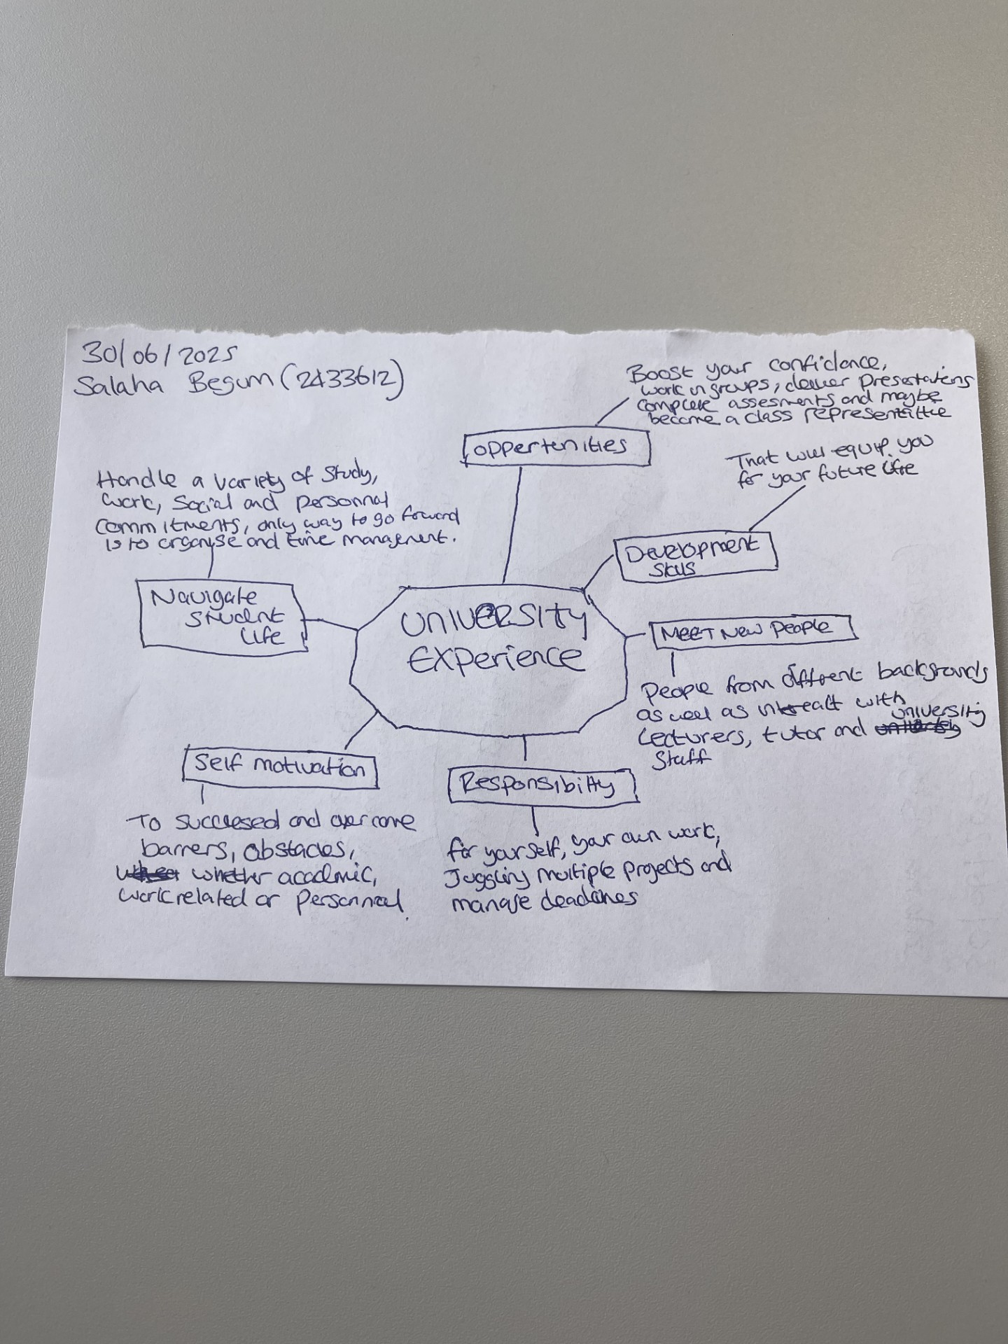

2. Paraphrase the following sentences (max 3 marks for each, max 12 marks in total):

- To successfully navigate student life you will need to handle a variety commitments.

To productively navigate student life you'll need to handle a variety of study, work, social and personal commitments and the only way to do this is with organisation and time management.
- You will need to develop self-motivation if you want to succeed at university.

A lot of university study is self-directed - it's up to you to plan and organise your work, juggle multiple projects and manage deadlines – you will need to develop self-motivation if you want to succeed.
- Many students find it challenging to manage stress during assessment periods.

You will need to develop self-motivation if you want to accomplish a successful life, let’s not forget learning how to overcome obstacles; whether academic, work-related or personal, you'll face your fair share of obstacles as a student, but you will develop resourcefulness and resilience in the process.

d) Frequent reading can help you become a more effective communicator.

The university offers an online library for easy access to a lot of reading materials for free also the university provides plenty of opportunities to work on and boost your confidence: you'll work in groups, deliver presentations, complete assessments and maybe even become a class representative.

3. Write a well-structured paragraph (8 sentences) on the following topic:

Effective time management techniques for university students

Your paragraph must be written in full sentences (no bullet points) and in an academic style.

(max 16 marks in total)

It has been known that students who manage their time accordingly do better academically.
To successfully navigate student life, you'll need to handle a variety of study, work, social and personal commitments and the only way to do this is with organisation and time management.
By simply applying self-management, students can set clear goals by creating a daily study structure, prioritizing tasks on a to do list based on deadlines and importance.
These strategies can help students manage their time more effectivity and reduce stress as well as develop resourcefulness and resilience in the process.
It is important to set goals that are SMART (specific, measurable, achievable, and time-bound).
Setting clear and achievable goals will help you stay on track and motivated.
The university provides plenty support if you are struggling to meet your deadline or need motivation, speak to a member of staff for assistance.
Do not procrastinate and have fun while you learn.

