University of Wales Trinity Saint David
Group Project
Thomas Rosser
2214462
Apprenticeship in Mechanical and Manufacturing Engineering (BEng)
26th May 2023
Reflective Project Report ACMA5009



Contents
1. Abstract 2
2. Introduction 3
2.1 Project background 3
2.2 The Process 3
2.3 The Project 5
2.4 Project Gauge R&R 7
3. Preliminary research/literature review 8
3.1 Change management 8
3.2 Process improvement 8
3.3 L.J. Mullins 8
4. Analysis Methodology 9
5. Analysis 10
5.1 Project Planning – Gantt Chart 10
5.2 Success Score – Lewin’s FFA 12
5.3 Process monitoring management - Kanban 13
5.4 Project Risks – Risk Register 14
5.5 Project Specifications – Six Sigma 15
5.6 Management style 16
6. Improvements 17
6.1 Lack of Communication - Scrum 17
6.3 Understanding the Gantt chart - Critical path analysis 18
6.4 Chances for Feedback – Paternalistic Style 18
7. Conclusion 19
8. References 20

1. Abstract

This report will look into a project that was implemented within an engineering firm Renishaw that is based in Miskin South Wales. The project itself is a process improvement, making an already existing process faster and more cost efficient.
The report will initially go into detail about the project, explaining how the initial issue was discovered, the cost benefit and the proving out of the new process giving in-depth knowledge of the subject matter. The report will then focus on project management techniques used throughout the process, analysing the techniques such as their strengths and weaknesses.
The report shows that despite the success of the project and the use of well-known project management techniques there is also room for improvement such as the communication between employees and the monitoring of the project.
2. Introduction

2.1 Project background
Change has a significant impact on manufacturing companies. With the constant need for innovation, engineers are required to implement change to stay relevant to modern day. Change is implemented through projects – projects consist of a set of tasks that need to be completed to successfully achieve a particular outcome or goal (Yarbrough, 2021).
This report will focus on a project within Renishaw and how it has been managed throughout its implementation. Renishaw is a worldwide precision metrology and medical technology group. Renishaw designs, develops and delivers solutions and systems that provide unmatched precision, control and reliability. Renishaw’s worldwide reputation employs over 5,000 employees around the globe with more than seventy-seven offices in thirty-six countries, 3,000 of these employees are within the United Kingdom (Renishaw plc, 2020). The main manufacturing facility (figure 1) is located in Miskin South Wales where over 700 employees manufacture and assemble a range of product lines.
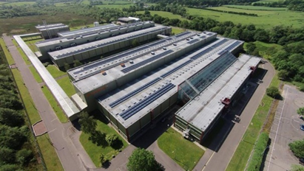
Fig. 1 – Renishaw manufacturing sight (Allcock, 2020)

2.2 The Process
Renishaw’s biggest manufacturing process within the Miskin site is a product grouping under ‘Precision motion control’ (Renishaw plc, 2020). If customers require an accurate measurement readout from a CMM or CNC machine, this product provides this service. The product grouping requires two separate manufactured products:
Scale – This is high accuracy (±5 μm/m), stainless steel track of ablated lines with pitches ranging from 20µm to 40 µm. There are two types of ablation. Incremental which is as displayed like a ruler; one, two, three etc and requires reference marks for locating (figure 2). Absolute which takes a form of a barcode and the code along the scale is given a numerical value, not needing reference marks (figure 3).

Fig. 2 – Incremental scale (Renishaw plc, 2020)

Fig. 3 – Absolute scale (Renishaw plc, 2020)

An Open optical encoder – An Encoder (figure 4) reads and interprets the scale by using a light source to optically sense the spacing of the lines. Giving a numerical value to the user through a visual display.
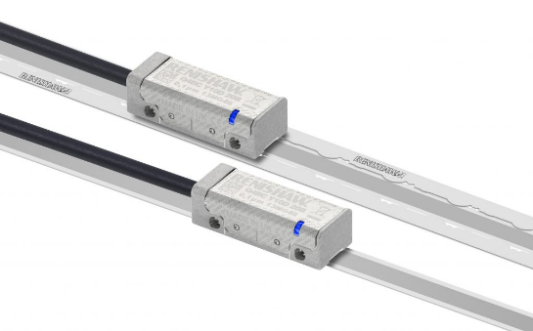
Fig. 4 – Readheads (Renishaw plc, 2020)
The project is based within the scale manufacturing process. Scale is ablated in 200m lots which can take up to 4hours and cannot be interrupted. Before committing to ablating a lot, a coupon check is done. A coupon is a sample part which is a replica of the scale being produced but only 100mm long, they are checked for properties such a Mark-Pitch-Ratio which is related to the function of the part and the margins of the scale which is the position of the ablated scale within the blank stainless steel, this is solely cosmetic.
The margins of the scale are checked using a single manual “Hawk measurement system” (Systems, 2023) (figure 5) which is a single piece of equipment where, under magnification, operators make points on the scale between required parameters using the X and Y movements, which the Hawk then calculates to give a dimension which is either labelled G (go) or NG (no go). However, with a coupon needing four parameters checked and one of them parameters needing to be repeated three times, this is a lengthy process.
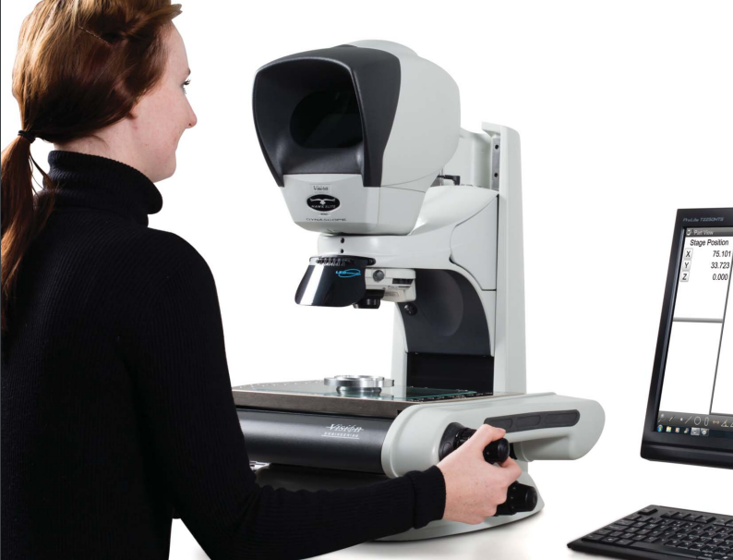
Fig. 5 – Hawk vision system (Vision , 2013)

2.3 The Project
The issue that was being faced was the length of time that operators were taking to check the parameters of the coupon using the manual system. This amount of time was also causing a queue for the measure system as there are multiple operators needing to use the one piece of equipment around the same time. This delay of production time created an opportunity into cost saving and made the aim of the project to increase efficiency reducing the cost of running.
To achieve this cost saving a fast method would need to be implemented. After research and several commercial tests, an investment was made into a Keyence product. This product is a “Keyence dimension system” (Keyence, 2023) (figure 6). As described by Keyence “An automated, instant measurement system that provides highly accurate and repeatable measurement data in seconds; simply place a part on the stage and push one button (Keyence, 2023).” Eliminating the need for the operators to move the bed to make points to calculate the parametres.

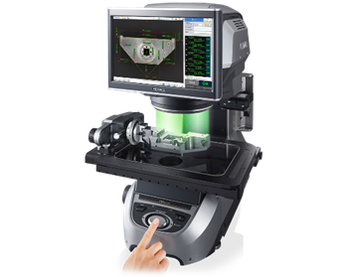
Fig. 6 – Keyence vision system (Keyence, 2023)

Figure 7 shows the Keyence system within the overall process imporovement roadmap and its cost saving. The intital time to check the coupons paramets took 0.74hrs, with the new Keyence system in place it takes 0.5hrs which is a time saving of 0.15hrs per coupon checked. With the process ablating 1050 lots in 2022 it was calculted that the annual cost saving due to time reduction is £12,093.48.
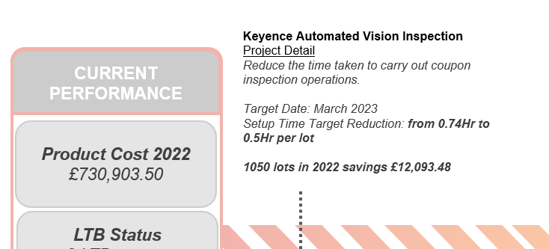
Fig. 7 – Roadmap of cost reduction

However, this Keyence system is not plug and play. In order for the system to measure parameters, individual programs must be made for each product. This was done in the edit function of the machine system where you could take an image of the parts, add parameters as if on a CAD drawing and then the system will measure the part (figure 8). The programs then needed to be vetted through a commissioning process to ensure they all work accurately and are passing/failing parts as it should.
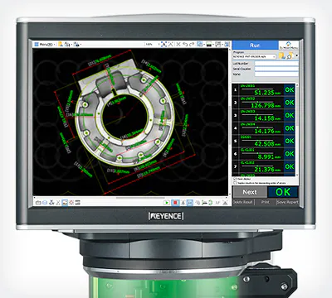
Fig. 8 – Keyence software (Keyence, 2023)

2.4 Project Gauge R&R
To ensure the new system is preforming as it should before placing it within the process it was important to analyse the data. This was done using a technique name Gauge R&R. Gauge Repeatability and Reproducibility is a method used to determine the variation of the measurement data due to the measurement system being used emphasising the capability of the measurement system. The gauge R&R for the valuation of the new system is shown in figure 8.
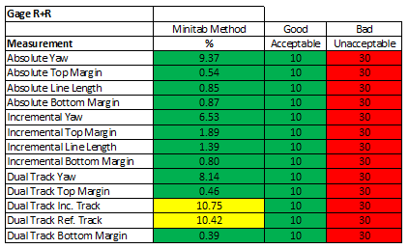
Fig. 8 – Gage R&R Results

As shown in figure 8 this table shows the results of the gauge R&R tests and calculations. Along the left of the table show the parameters that have been tested such as the Top Margin and line Yaw (Angle). Each parameter is then given a percentage that has been produced by Minitab where you input numbers from the testing done on the new system, into a formula and a percentage is given. The results for Gage R&R are usually as shown:
< 10% = Acceptable
10-30% = Acceptable dependent upon method of measurement, application, etc.
30% = Unacceptable and requires improvement
However due to the accuracy of the parts and the importance of the parameters being within spec it was decided to aim for all of the parameters to be < 10%. This was achieved for all the parameters bar two, the two exceptions being the dual track incremental and reference track, this is because these are not physical parameters they are estimated on the back of other parameters, hence the variability being a slightly higher percentage.

3. Preliminary research/literature review
This research and literature review consists of the main topics of this report and an explanation of them in order to give sufficient background to the points regarding them.

3.1 Change management
Change management refers to any changes to a company's operations, which can be as little as staff promotions or as significant as a merger. Change management can occur spontaneously or be planned and implemented gradually. The objective is to make the changeover as easy and efficient as possible. It is preferable if modifications can be planned in advance to prevent interruptions and employee opposition. A change management plan's principal goal is to assist employees in understanding and adapting to a new style of working (Coursera, 2023).
According to research, most changes fail to achieve their intended goals, restrict organisation's potential and its employees as a result of unsuitable change management. Due to the consequences of ineffective change management possibly being serious and long-lasting, it is critical that individuals grasp the concerns and equip themselves with the correct tools to assist change (CIPD, 2021).

3.2 Process improvement
Process improvement, often known as business process improvement, is the practise of improving current processes to make them faster, more accurate, more efficient, and more dependable. This should be viewed as a continuing activity rather than a one-time event. (Corona, 2020)
The advantage of incorporating a process improvement technique into the overall management systems is that it identifies and improves difficulties in the processes. These difficulties may be affecting the client experience, internal production, or other company objectives. Poor or inefficient procedures can waste time and money for a company. By using a process improvement technique, you can ensure that you are continually looking for and fixing these issues (Sitar, 2022).

3.3 L.J. Mullins
Laurie Mullins formerly held the position of Principle Lecturer at the University of Portsmouth Business School. Laurie focused in managerial and organisational behaviour, as well as human resource management, and was the topic leader for the behavioural and human resource management group. (Mullins, 2009)
Laurie has written the book “Management and Organisational Behaviour” which is currently on its 11th edition. In this book he covers relevant topics such as:
Management styles
Lewins Force field analysis
Organisational behaviour

4. Analysis Methodology
The aim of this analysis is to highlight the strengths and weaknesses of the management of the project and how they affected the overall outcome of the project. Although this is a past project it is important to highlight these characteristics of the management in order to learn from the project and assist future projects.
Throughout this report the strengths will be presented and described with their related management techniques which will be researched to a degree of understanding. The weaknesses will be stated and how they affected the project. However, with the weaknesses a recommended project management strategies/ideologies and relevant research will be suggested to help overcome/avoid the weakness for possible future projects.

5. Analysis

5.1 Project Planning – Gantt Chart
A Gantt chart represents the completion of each job in a project by using timelines. These timelines demonstrate how the tasks are related to one another. Gantt charts are important because they show the activities and progress of a project.
Gantt charts show how work on an activity can begin only when a related task has been completed. Such data assists managers in understanding project obstacles and making key decisions regarding the best approach to bring a project ahead. (Ramos, 2021)
Advantages of a Gantt Chart include:
- Clear Layout of Dependencies
- Increased Schedule Accuracy
- High Visibility for Stakeholders
- Flexible Format (Donato, 2018)
Before work was carried out on the implementation of the new vision system within Renishaw a Gantt chart tailored to the project was created. Firstly, the tasks were put into a table their start dates and the time allocated for the task to be completed (figure 9).
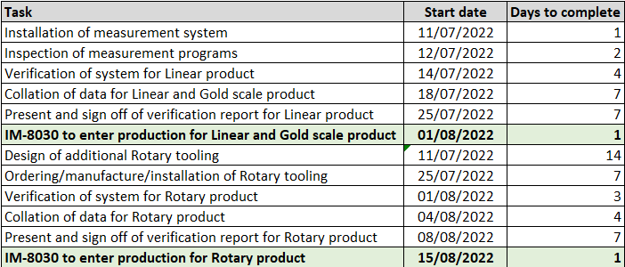
Fig. 9 – Gantt Chart Tasks

The Gantt chart was then created using Microsoft Excel, using the task description for the X axis, the date for the Y axis and the duration for the horizontal bars (figure 10). This chart was then shown to the team involved with the project during an initial task introduction presentation, which was conducted by the project manager and senior engineer whom are the managing bodies within the area. The Gantt chart was broken down and explained to the team:

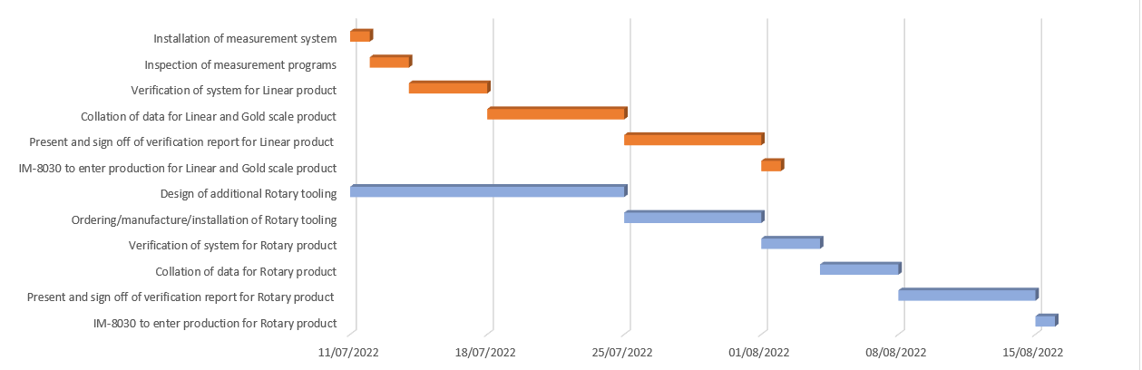
Fig. 10 - Project Gantt Chart

The Gantt chart showed that the aim for the project was to start on the 11th July and finish on the 15th August, giving the team only two months to complete the project. The longest tasks being the design of tooling and collation of data. Despite the tight timeline the project, it was still finished within the timeframe.

5.2 Success Score – Lewin’s FFA
The implementation of the Keyence vision system is the first step towards automation of the process. Process automation will be standard practice in future of engineering. This is because more and more businesses will see the benefits of automation. When activities and processes are automated, the organisation saves money on materials and labour, boosts efficiency and production, and significantly lowers errors (ESSS, 2022).
However, from the view of operators working on the process, automation is a serious threat within the industry due to fear of being made redundant as their roles have been replaced by systems and programmes. This resistance of change by the operators was highlighted when completing the preliminary Lewins Force-field analysis (figure 11). A Force-field analysis (Lewin, 1951) highlights the forces driving change and resisting change. It is widely used in change management and can be used to help understand most change processes in organisations, highlight the forces driving change and resisting change.
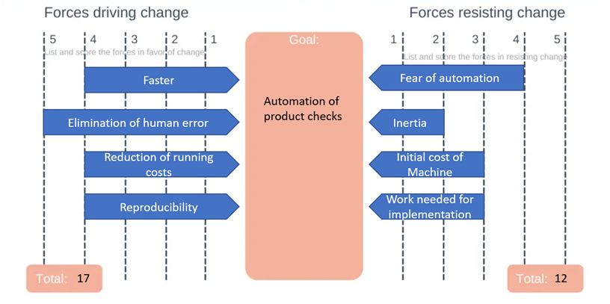
Fig. 11 – Lewins force-field analysis(Expertprogrammanagement.com, 2021)

With the Lewins diagram highlighting the ‘fear of automation’ as the strongest resisting change, it posed the biggest threat to the project not being successful. In order to reduce the change it needed to be acted upon. The operators who currently run the process and are tasked with the manual measurements checks were gathered together for a presentation and a display of the new system, this presentation assured the operators that this new system was to assist them in their work and not to replace them. From this presentation the operators were more at ease with the new implementation and their force of resisting change was reduced, creating a larger chance of success.

5.3 Process monitoring management - Kanban
Kanban is an Agile project management strategy that helps visualise workflow in order to enhance efficiency. The approach originated in the Japanese manufacturing business before expanding to other industries. A Kanban board — a physical or digital instrument that splits workflow into columns organised by development stage, such as to-do, in-progress, and finished tasks — is at the heart of the Kanban technique. This reduces multitasking by encouraging teams to concentrate on only a few tasks at a time. It also allows both the team and stakeholders to know where the team is in the development process at a glance (Coursera, 2023a).
Shown in figure 12 is an example of a Kanban board used within this project. The board shows the subject area which is then split into tasks. The tasks are assigned to individuals with their initials. There is then the detail of the task and the percentage of completion as well as the date for completion.
As this is from a previous project the percentage of completion is all 100%, however through the working of the project the percentage of completion for the individuals’ tasks would vary, their progress being indicated using the colours red – not started, yellow – doing, green – complete.
This Kanban board was proven to be successful within the project as it helped break down the large project into smaller tasks where the individuals allocated with the tasks can isolate their tasks and solely work on completing them. The task allocation also gave individuals ownership of their work, so when completed to a high standard they were noticed, however if not completed it allowed the managers of the change to monitor the individuals process and prompt the work if needed.
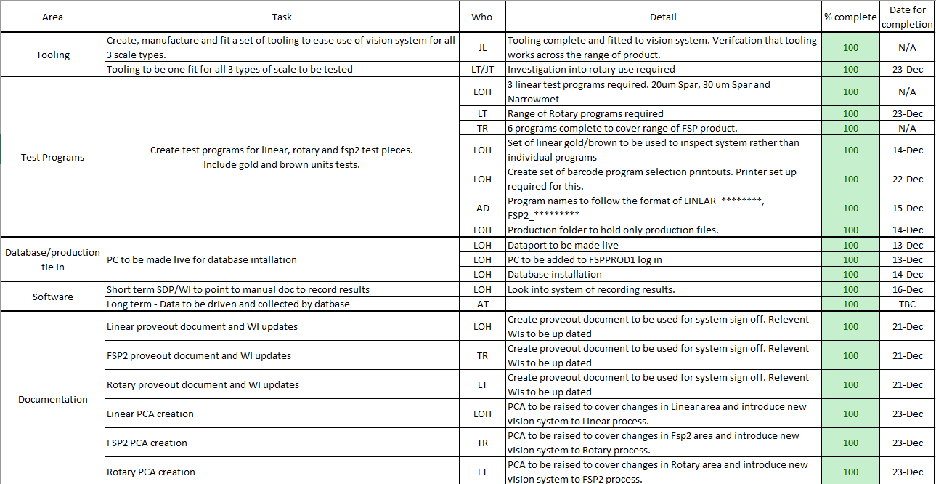
Fig. 12 – Kanban Board

5.4 Project Risks – Risk Register
A risk register which is found within the project management method PRINCE2. A risk register can be displayed as a table or a scatter plot which identifies any risks to the project and additional information relating to them such as, the nature of the risk, the impact if it occurred and the overall risk factor (Hillson, 2007).
A risk register is used to identify issues early in the project. Something that might seem unlikely to occur at the beginning of the project could become a real possibility as time passes. Maintaining the risk register helps spot threats that could throw your project off track, as the register is monitored trends begin appearing which helps adjust approaches towards the project. A risk register also allows a proactive stance as the risks are already known, instead of a reactive approach with ad-hoc solutions (Kemper, 2023). The risk register used for this project is shown in figure 13.
From this risk register, 10 risks were identified. Ranging from 3 types of issue such as purchasing, technical and project. From there, the risks were identified with their impact and outcomes. The risks were then given a score, combining the impact (severity) and their occurrence (how often) to give them an overall factor. From this factor a decision was made to either accept, mitigate or avoid, with actions to be taken.
From this risk register it is apparent that the two biggest risks are that the project not being finished on time, the action taken for this risk was to ensure a period of training to cover this issue within the requirements specification. The main risk illuminated by the register was the system not being able to carry out the scale measures correctly, this was actioned by implementing a robust validation process covering all aspects of the system.
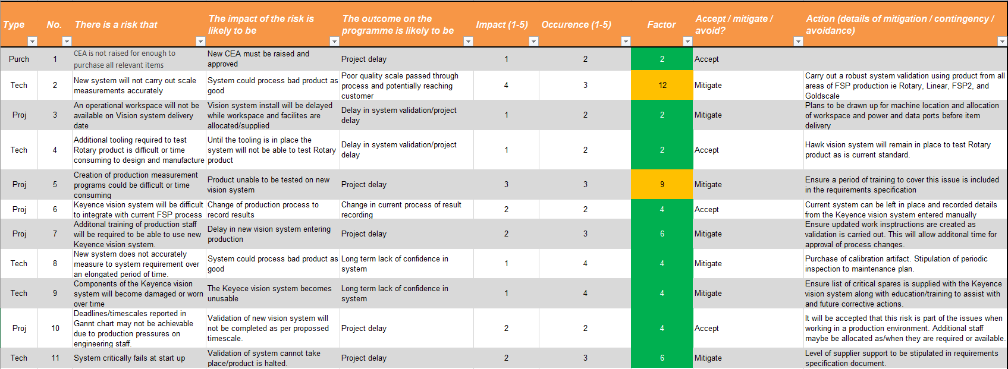
Fig.13 – Risk Register

5.5 Project Specifications – Six Sigma
Six Sigma, a quality management method established by Motorola in the 1980s, is a collection of tools and procedures for reducing development errors. This could help to decrease expenditures and consumer complaints caused by mistakes (Coursera, 2023a). In general, the strategy improves present methods in five stages:
Define - Analyse a company problem from the customer's point of view.
Measure - Data-driven issue measurement and performance metric development.
Analyse - Determine the efficiency and effectiveness of your process by quantifying your goals.
Improve - Look for methods to enhance the process's implementation.
Control - Implement and uphold the solution.
Six Sigma was applied to this project when writing the CEA (Cost-effective analysis). The CEA is a report which is presented to the approvers such as “Head of manufacturing” and “Divisional Finance Manager” in order for the funds to be released to go ahead with the implementation of the new system. The 5 stages of Six Sigma were applied to the report as followed:
Define – Due to the competitive industry of which the product belongs to, it is imperative that demand can be met. In order to meet influxes in demand it is vital that the process is made as efficient and cost efficient as possible.
Measure – This issue was highlighted in a recent CBR (cost benefit report) where a cell walk was conducted, highlighting the cost of the current production methods and where the most amount of cost was being incurred due to an excessive amount of time. After calculations the process was 0.75hrs long and costing £6.97 per check.
Analyse – Due to the CBR, the method of checking the parameters of the coupons was brought to light due to the checks taking too long and causing a back log of operators waiting for the use of the machine.
Improve – In order to improve the current process of checking the parameters of coupons, multiple avenues were researched. The research concluded with the choice of the Keyence vision system which, when implemented would save an annual amount of £13,000
Control – The product was implemented using a structure of change management tools such as a Gantt chart and task allocation. The engineering team was then educated on the maintenance of the product.
This Six Sigma approach was proven to be successful as the Money for the CEA report was approved due to the relevant approvers understanding and accepting the ideology. Not only was Six Sigma successful for the CEA report but it was also used to refer back to during the project as during a project it is easy to lose sight of the overall goal and why it is being done.

5.6 Management style
The management style used for this project is an autocratic style. Autocratic leaders centralise decision-making authority. The manager often makes the bulk of choices on these teams, including what the team should focus on, what short- and long-term goals they should strive for, and which activities and projects are related with these efforts. An authoritarian manager would then distribute tasks to the team member they believe is most fit for the job. This is the most top-down management style (Asana, 2022).
The Gantt chart was created by the manager overseeing the change as well as the task allocation. But due to the project involving three different areas this was greatly received as there was always one person to turn to and not ‘too many chefs in the kitchen’ making it confusing for the individuals working on the project. This style also prevented and cross area tension as each area had their allocated time on the system making it fair (Cherry, 2023).
This management style was also approved by the stakeholder of the project. Due to the significant cost of the project, it was important that it stayed on scheduled and delivered the results as promised within the time frame. If a Laissez-faire management style was used which is a more relaxed style where managers monitor employees’ behaviour, but don’t get involved with the projects or day-to-day tasks (Asana, 2022), the progress of the project may have slipped causing possible concern higher up.

6. Improvements

6.1 Lack of Communication - Scrum
An issue that was brought to light was a lack of communication within the team working on the project. An issue that came from this was not keeping the Kanban board up to date which was causing confusion between individuals. The confusion and lack of communication could have been eradicated by conducting regular meetings. A management technique that encourages this is Scrum.
Scrum is a lightweight Agile framework that aids self-organizing teams in the development of increasingly complex projects. The framework consists of roles and meetings based on the qualities of commitment, courage, focus, openness, and respect.
Within the Scrum (group of individuals working on the project) there are allocated positions. A position that would prove to be successful would be the Scrum master. The Scrum master is a team leader that is responsible for organising events and meeting called Scrums. A daily Scrum could have been held which is a 15-minute stand-up meeting held each day where the team plans the work for the working day ahead (figure 14).
Despite the work already being allocated and the dates through the Gantt chart. Individuals working on the project still found it challenging to keep track of the progress of the project for reasons such as being busy or not technically minded to be able to open the documents. A quick 15-minute meeting each day would help bring the workers together and remind them of the work that is required to be completed within the working day. With this meeting the progress could also be monitored more closely from a management perspective, assessing whether the progress of the project is on target for its set completion date.
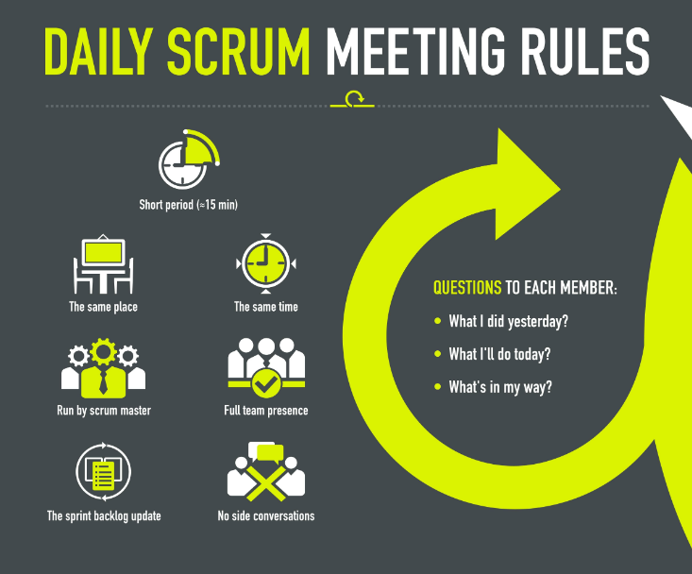
Fig. 14 – Scrum meetings (Choudhary , 2017)

6.3 Understanding the Gantt chart - Critical path analysis
The Gantt chart proved to be successful due to the project finishing on time, although, Ramos (2021) shows that despite a Gantt chart being a great tool, it does have its downfalls such as, the setup can be time consuming with a large project as well as them having multiple tasks which can cause the chart to look crowded. In order to create a Gantt chart that cannot look to crowded and to avoid confusion when working towards the Gantt charts completion date, a critical path analysis could be used.
Critical paths define the sequence of project activities that determine the duration of a project and highlight essential deadlines that must be met in order to complete a project on time. In brief, the critical path is the largest distance or time span between the start and end of a project (Ramos, 2020).
When you utilise a Gantt chart in conjunction with the critical path approach, you can follow the tasks on the path throughout a set time period, allowing you to keep your project on track and avoid difficulties. While your critical path analysis assists you in making better scheduling estimates and decisions, your Gantt chart follows this schedule and closely monitors the time and progress of your project (Ramos, 2020).

6.4 Chances for Feedback – Paternalistic Style
During the project an autocratic style was used. Despite this style to be proven as successful for this project and it was accepted by the stakeholders, the team working on the project found that it had a flaw which as also been made apparent after research. This flaw is that the team members felt less encouraged to offer suggestions towards the project due to the autocratic managers (Asana, 2022). If these possible suggestions were heard it could have made the project better and created a more positive environment within the workplace.
A management style that would have allowed this form of feedback is a paternalistic style. This style allows the teams suggestions and needs to be heard which gains trust within the employees, however there is still no collaboration between the manager and the team about the decision itself which would still please the stakeholders of the project.

7. Conclusion
The project of implementing the new Keyence measurement system within Renishaw was proven to be successful due to the gauge R&R results, this report then shows how the project was managed successfully and how it positively affected the projects results. However, after an analysis of the project it was highlighted that there were still some weaknesses of the project and using additional management techniques they could be reduced.
The strengths of this project were the planning which was done through a Gantt chart, the production of a success score using Lewins force-field analysis, the monitoring of the process which was assisted using a Kanban technique called a Kanban board, the identification of the project’s risks using a risk register, the highlighting of the project’s specifications using the Six-Sigma approach and the autocratic management style. These strengths all contributed towards the success of the project and how efficiently it was undertaken.
The weaknesses which were brought to light from the team of individuals working on the project on completion were then analysed, why the weakness occurred and a management technique was suggested. The weaknesses were the communication within the project, the Scrum management technique was suggested for this. The confusion regarding the depth of the Gantt chart was also highlighted and the suggested management tool was a critical path analysis.
The analysis has proven to be a learning experience, covering different types of management and how they can be applied to real life situations that happen in work. From this analysis the strengths and weaknesses will be considered in the future when conducting more project work and managing projects.

8. References
Allcock (2020). Renishaw reveals its part in the UK’s ventilator manufacturing effort. [online] Machinery. Available at: https://www.machinery.co.uk/content/news/renishaw-reveals-its-part-in-the-uk-s-ventilator-manufacturing-effort [Accessed 5 2023].
Animitevabg (2020). 3 Great SWOT Analysis Examples with Real Companies - mktoolboxsuite.com. [online] MkToolBoxSuite. Available at: https://mktoolboxsuite.com/swot-analysis-examples/ [Accessed 5 2023].
Asana (2022). The Best Management Style to Support Your Team • Asana. [online] Asana. Available at: https://asana.com/resources/management-styles [Accessed 24 May 2023].
Cherry, K. (2023). Autocratic Leadership. [online] Verywell Mind. Available at: https://www.verywellmind.com/what-is-autocratic-leadership-2795314 [Accessed 25 May 2023].
Choudhary , N. (2017). 10 Common Scrum Mistakes and How to Avoid. [online] TO THE NEW BLOG. Available at: https://www.tothenew.com/blog/10-common-scrum-mistakes-and-how-to-avoid/ [Accessed 25 May 2023].
CIPD (2021). CIPD | Change Management. [online] CIPD. Available at: https://www.cipd.org/uk/knowledge/factsheets/change-management-factsheet/ [Accessed 22 May 2023].
Corona, K. (2020). What Is Process Improvement? Definition, Steps, & Basics | Pipefy. Pipefy. [online] 12 Mar. Available at: https://www.pipefy.com/blog/process-improvement-definition/#:~:text=Process%20improvement%2C%20also%20known%20as%20business%20process%20improvement%2C [Accessed 22 May 2023].
Coursera. (2023a). 12 Project Management Methodologies: Your Guide. [online] Available at: https://www.coursera.org/articles/project-management-methodologies-your-guide [Accessed 24 May 2023].
Coursera. (2023b). What Is Change Management and How to Use It Effectively. [online] Available at: https://www.coursera.org/articles/change-management [Accessed 22 May 2023].
Donato, H. (2018). Advantages and Disadvantages of Gantt Charts. [online] Project-Management.com. Available at: https://project-management.com/advantages-and-disadvantages-of-gantt-charts/ [Accessed 14 May 2023].
ESSS (2022). Engineering of the Future: How to prepare for the changes in the market. [online] ESSS. Available at: https://www.esss.co/en/blog/engineering-of-the-future/#:~:text=In%20the%20engineering%20of%20the%20future%2C%20process%20automation [Accessed 23 May 2023].
Expertprogrammanagement.com. (2021). Force Field Analysis - Decision Making Training from EPM. [online] Available at: https://expertprogrammanagement.com/2021/09/force-field-analysis/?utm_content=cmp-true [Accessed 21 Apr. 2023].
Hillson, D. (2007). PRACTICAL PROJECT RISK MANAGEMENT : the atom methodology. S.L.: Berrett-Koehler.
Kemper, A. (2023). Risk Register: Examples, Benefits, and Best Practices | HyperComply Blog. [online] www.hypercomply.com. Available at: https://www.hypercomply.com/blog/risk-register-examples.
Keyence.co.uk. (2023). Measurement Systems | KEYENCE UK & Ireland. [online] Available at: https://www.keyence.co.uk/products/measure-sys/ [Accessed 22 Apr. 2023].
Lewin, K. (1951). Field theory in social science. New York: Harper And Row.
Mullins, L.J. (2009). Management and organisational behavior. New York: Prentice Hall / Financial Times.
PBA Systems - The Future of Precision Robotics. (2021). Renishaw Encoder. [online] Available at: https://www.pbasystems.com.sg/product/rh200-linear-encoder-system/ [Accessed 17 May 2023]. Figure 4.
Puyt, R., Lie, F.B., De Graaf, F.J. and Wilderom, C.P.M. (2020). Origins of SWOT Analysis. Academy of Management Proceedings, [online] 2020(1). doi:https://doi.org/10.5465/ambpp.2020.132.
Ramos, D. (2020). Gantt Charts & the Critical Path Method | Smartsheet. [online] www.smartsheet.com. Available at: https://www.smartsheet.com/content/gantt-chart-critical-path [Accessed 23 May 2023].
Ramos, D. (2021). The Pros and Cons of Gantt Charts | Smartsheet. [online] www.smartsheet.com. Available at: https://www.smartsheet.com/content/gantt-chart-pros-cons#:~:text=Gantt%20charts%20are%20useful%20because%20they%20provide%20an [Accessed May 14AD].
Renishaw plc (2020). Renishaw: About Renishaw. [online] Renishaw. Available at: https://www.renishaw.com/en/about-renishaw--6432 [Accessed 5 Apr. 2023]. Inc Figure 2, 3.
Sitar, D. (2022). What Is Process Improvement? Forbes Advisor. [online] 17 Jan. Available at: https://www.forbes.com/advisor/business/what-is-process-improvement/ [Accessed 22 May 2023].
Status Net (2019). 10 Benefits and Limitations of SWOT Analysis You Should Know About - Status Articles. [online] Status Articles. Available at: https://status.net/articles/swot-analysis-process-benefits-limitations/ [Accessed 20 May 2023].
Systems, H.M. (2023). Level Measurement Technologies - Flow Instrumentation Solutions | Hawk Measurement Systems. [online] www.hawkmeasurement.com. Available at: https://www.hawkmeasurement.com/ [Accessed 17 May 2023].
Vision (2013). Premier Provider of Precision Measurement Solutions | Measurement Supply. [online] measurementsupply.com. Available at: https://measurementsupply.com [Accessed 26 May 2023].
Yarbrough, Q. (2021). Project Definition: The Meaning of a Project. [online] ProjectManager.com. Available at: https://www.projectmanager.com/blog/project-definition [Accessed 17 May 2023].

