BUSINESS PLAN
FOR
PIZZERIA FANTASISCO
Name: Selda Nergiz
ID number: 1919894
Lecturer name: Isaiah Oino

Cover Letter
Mr Watson
London SW10 5EJ
XXX.XXX@uwtsd.ac.uk
Dear Mr. Watson,
We are writing this letter to express our interest in the food industry and we have over five years’ experience in the same. As our current role at Pizzeria Fantasico we aim to prepare variety of pizza and pasta dishes to sell to our customers.
We are highly skilled in preparing varied kinds of pizza, pasta and many other items which include savory as well as desserts. We enjoy creating new and innovative dishes matched to customer taste-buds, hence we will love to take this opportunity to introduce our skills in the market.
We are confident that we will be able to bring a complete transformation in the pizza business with our talents and with focus on customer orientation. Please contact us at your convenience to set-up an interview to view our plan for the business. We are eagerly looking forward to hearing from you.
Sincerely
Pizzeria Fantasico Team

Business Plan for Pizzeria Fantasico

EXECUTIVE SUMMARY
Pizzeria Fantasisco will be one of the new fine-dine businesses in the food and beverages industry and is aiming to grow its organization in the next few years. This fine-dining experience will offer one of the most popular, cosy and comfortable vibrant places in the city delivering perfectly fine dine services to the customers. The city has numerous vibrant places for fine dining but this will act as another addition for the customers as it will provide one of the pizza and pasta food services to the customers. The Pizzeria Fantasisco will be a comparatively new and young family which will be tremendously evolving in the present times. The main objective of this vibrant and happening place will be to become enlisted as the most favourite place of all the customers in the city belonging to various age groups. This report therefore broadly presents the business plan and the background of the new start-up and the business plan of Pizzeria Fantasisco. Along with pizza and pasta, the restaurant will offer tremendous potential for growth with its varied types of dishes and regular new introduction of savory items.

SKILLS AND EXPERIENCE
The background of all the owners provides an additional advantage for this business venture as it helps them in possessing the skills and training required for the business venture. Moreover, we the owners have worked with a popular dine out restaurant and therefore has gained skills and training in handling a dine out outlet.

BUSINESS DESCRIPTION
Pizzeria Fantasisco will be one of the new ventures in the city which is a very vibrant fine dining place for the customers. This business will be owned by two university graduates who desire to provide quality services to the customers in the city. The business idea is comparatively new and will be growing at a fast pace (McKenzie, 2017). This business will mainly try to focus on its major goals and objectives. Some of the goals and objectives are discussed hereinbelow:
- Short-term objectives: One of the major objectives of this business will be to develop a profitable market and expand its business by marking its presence in the market by providing the best quality pizza products to the customers.
- Short-term objectives: Another objective of this business will be to maximize sales and generate more profits for the organization.
- Short-term objectives: To equip better financial sources for the organization
- Medium-term objectives: To create and maintain well developed and healthy relationships with both internal as well as external stakeholders.
- Long-term objectives: To expand the business and develop new tie-ups with the most popular food delivery apps and distributors to gain a better reaching capacity with the customers.

Apart from the above-mentioned objectives, various goals are to be maintained by the organization and its team. Some of the major goals are mentioned below:
- To provide the best pizza as well as food and beverages services to the customers.
- To offer an instant bundle of joy with their pizza’s to the customers.
- To maintain and develop teamwork among the organization.

2. BUSINESS STRUCTURE
This venture particularly focuses on the customers and their satisfaction. Different roles within the organization will be as follows;

Figure 1: Business Structure
Source: Author
The CEO will overview the entire operation within the organization will the CFO will manage the finances. The HR team will look after hiring, and training of employees. The finance department will tackle the finance and accounts of the business. The production department will be responsible producing innovative dishes and menu for its customers (Ghezzi et al., 2015). While the marketing department will be responsible for marketing the name of the restaurant. The services department will take care for customer services in the fine dining restaurants as well as for deliveries.

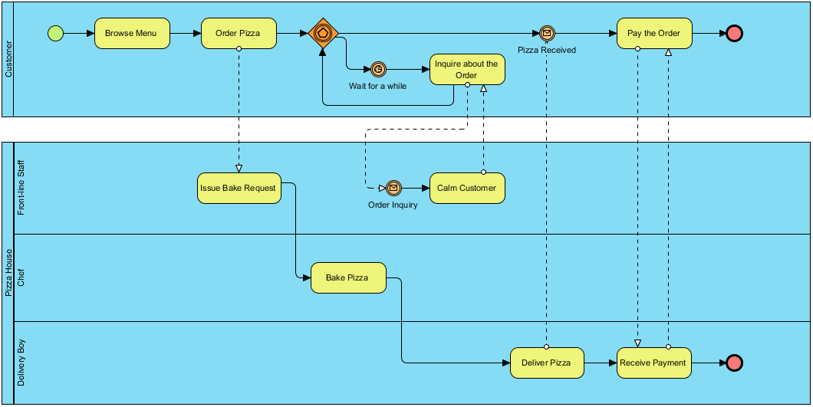
Fig: 1: The above diagram is the business diagram of the business venture.
The above diagram is the business structure of the present startup venture that aims at providing delicious customized pizza at the doorstep as well as at their current dining place.

3. PRODUCT AND SERVICES
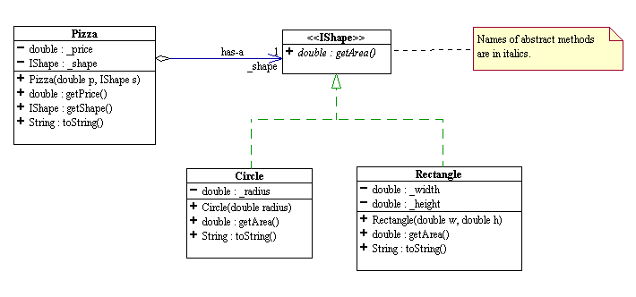
Fig: 2: The above diagram is the product list of the business venture
The above model is the depiction of the different kinds of products that are widely available in this dining place. This same menu of the products will be available for the online deliveries and fine dining orders as well. There are various types of crusts and toppings will be made available for the customers to experience an unusual service and taste the products (de Faria et al., 2021). The products are also available in different shapes and sizes for the convenience of the customers. Primary food available will be pizzas, pastas, desserts of different kinds and sides.
SERVICES
Pizzeria Fantasisco will be one of the growing ventures of the present time that will be growing as it will be preferred by most of the customers presently and will be widely made available over the most popular food delivery applications as well as the physical dining outlet situated at the heart of the city. For the initial days as a startup, this business will be mainly open in the evening from around 4:00 PM 2 12:00 AM from Monday to Saturday. However, on Sundays, the startup will have a special breakfast menu and will offer it to a limited number of customers in the morning therefore it will be open at around 8:00 AM and serve the breakfast till 11 AM. On the later part of the Sunday, it is open from 3:00 PM to 12:00 AM entirely. However, the startup business may consider its options for opening earlier on the weekdays considering the demands and the potential for growing the sales in the market. However, analysing the cost and finances of opening earlier on the weekdays is an important part of the venture and therefore after considering this widely it will be considered (Saura et al., 2019). Moreover, the venture will also consider increasing its production services to a great extent after analyzing the demands and capturing insights on the potential of the venture.

4. MARKET ANALYSIS AND NEEDS
The main market segment for this business venture can be classified into two subparts
a. the primary target group is the group of people who like to dine out and visit comfortable environments for availing of different kinds of food services.
b. The secondary target group is a group of people who like to have food or special pizza at the comfort of their home or wherever they are.
The location where this particular venture will be situated is in the middle of the city and therefore it will allow the outlet to attract several customers. The majority of the customers will be attracted when they pass by a get attracted by the vibrant culture and decoration patterns. Most of the customers, therefore, discovered this happening place is expected to desire to dine out in their leisure time with their families’ friends’ acquaintances and others. Thereafter, another group of customers who will also get attracted to the products and services to the delivery applications where this particular venture has been listed as one of the top places to order pizza. Customer age group will be 10 years till 55 years of age, middle and upper income class, both male and female consumers.
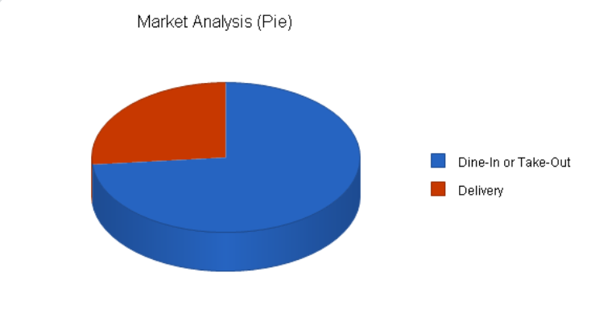
Fig :3: The above pie chart depicts the market analysis of the business venture.
Targeted Customers | Estimated Growth | CAGR | CAGR | CAGR | CAGR
Outlet | 5% | 13,860 | 14,830 | 15,868 | 16,979
Delivery | 8% | 5000 | 5,350 | 5,725 | 6,126
Total | 13% | 18,860 | 20,180 | 21,593 | 23,105

Moreover, with the expected growth of the online ventures of this business is expected to grow at 10% per annum. However, it is not only the advantage of the location that helps in capturing the market for this business model but also the different types of products which will offer a variety in the items and provide the best products to the customers with no compromise on the tasting skills. The product will aim at delivering any order from its restaurant in 30 minutes with exclusive taste (Watson et al., 2018). The product pricing strategy will be skimming pricing methods, by which the firm will charge highest initial price and then eventually lower it over time.
As mentioned above, the targeted customers are the two categories of people therefore the ones at the physical outlet of the venture and the other at the delivery application services. These are the two main target groups of customers for the business venture. This particular target group of customers includes groups of people of all ages.

5. COMPETITIVE ANALYSIS
There is very limited competition for this particular pizza venture in the location that it is situated just in the middle of the city as previously mentioned. Competition analysis has been undertaken by desk research using online mechanism. However, there are several business services available online which serves as the major competitors (Türko, 2016). Various other organizations that are located in the close vicinity of the area and are good competitors. Some of the common competitors of this business venture are Pizza Delights, Kentil Pizza Place and others. The strength and weakness analysis for this business venture and its competitors are following:
COMPETITOR 1: PIZZA DELIGHTS
Strengths: One of the major strengths of this business juncture is that it offers the best toppings and a variety of customization to the customers.  Moreover, the oldest junctures and, therefore, possess one of the best and oldest teams in the business. | Weaknesses: A major weakness of this particular venture is that it does not provide delivery options for the customers.
Opportunities: There are various opportunities available for the juncture to expand itself in the market and increase its sale. | Threats: The major threat for this business venture is the financial threat for the business.

COMPETITOR 2: KENTIL PIZZA PLACE
Strengths: The major strength of this business juncture is that it offers products at a very affordable rate.  Further, it is one of the businesses that focus on satisfying the customers. | Weaknesses: The major weakness of this particular venture is that it does not provide a large number of products for the customers in one particular box.
Opportunities: There are various opportunities available for the juncture to expand itself in the market and increase its sale. | Threats: The major threat for this business venture is the reducing market share threat for the business.

MY BUSINESS VENTURE
Strengths: The major strength is that it provides standard quality products at an affordable rate.  It provides a variety of products and services. It provides delivery at the doorstep. | Weaknesses: It is closed on weekdays in the morning hours.
Opportunities: It may expand the business into more sub-divisions and help the business to grow. | Threats: The major threat for this business venture is the financial threat for the business.

Marketing and sales
Marketing and sales of the business will start by online promotion using website and social media promotion. Promotional activities that will enable meeting the business objectives includes;
- Website promotion using SEO
- Social media promotion using SMO
- Leaflet distribution

6. OPERATIONS
The two important key suppliers or service providers for this particular business venture is the community of people who supply the raw materials for the products and the food delivery application services. There are numerous people involved in the process of collecting and delivering raw materials to the dining outlet and this helps the venture to grow even more (Ferreras-Garcia et al., 2019). Moreover, there is another key major supplier which is the food delivery applications services. These are the community of people who ensure the best services are delivered to the targeted customers at the comfort of their doorsteps.
There are also some important legislations which are followed by this business venture to ensure safety and security to the customers. Some of the important legislations with regard are the Food and Beverages Act of 1988, Food Contamination and Regulation Act of 2004 and the UN Food and Regulations Guidelines (Ivanisevic et al., 2016). These major rules and regulations are followed so that to ensure zero contamination of food and ensure the best quality of products provided to the customers both at the physical outlets as well as at the online delivery applications.
SUPPLIER/ RELATIONSHIP 1
Organization: FRUITS AND FOODS PVT. LTD. | Relationship Status: PROVIDES RAW MATERIALS
Service provider: Mr Anil Tiwari (owner) | Key terms of relationship: Supplier of raw materials

SUPPLIER/RELATIONSHIP 2
Organization: FAST FOOD APP | Relationship Status: PROVIDES DELIVERY SERVICES
Service provider: Mr Kunal Mehta (owner) | Key terms of relationship: Supplier of delivery vehicles and employees.

This is a proposed business plan and currently does not employ any staffs. However, in future, there will be a minimum of 12 people employed for starting of the business.
The business will start from the designated location at center of London city.
Certain insurances need to be undertaken for the business and includes fire safety insurance, workman’s insurance and so on.

Section 4

7. TECHNOLOGY PLAN
Technology such as innovation plays one of the most imminent roles in the development of this particular business venture. Technology is very much required for this particular business venture. Technology will ensure that the delivery applications operate effectively and help in providing quality services to the customers at their doorstep (Euchner, and Ganguly, 2014). The customers will be able to order food from their location and the delivery applications will collect the product and deliver it within the given period to help reach the customers. Therefore, technology is one of the most efficient factors in this entire business model. Moreover, technology will also be used in this business venture to provide customers with mobile banking and net banking services to help them make online transactions.

8. MANAGEMENT AND ORGANIZATION
This is a very new and small venture which will be owned and operated by two graduates from UK in London. Therefore the management and organisation pattern is based on the way the owners take part in the venture and looks forward to carrying the business. As this venture will respects the community of coworkers and aims at building oh healthy relationship with each of them (Ghezzi, and Cavallo, 2020). This organisation mainly focus on the traditional style of management and organisation and therefore treat the coworkers and the team as the topmost priority after the customers.

9. SOCIAL RESPONSIBILITY AND SUSTAINABILITY
Social responsibility and sustainability are one of the major important parts of business organisation in the present times. The social responsibility and sustainability criteria of this particular venture are that this venture has a separate human resource department that looks after the development of the workers and emphasizes their learning and training skills (Dalmarco et al., 2017). This venture believes in innovation and developing social responsibility within the organisation and believes in a more sustainable pattern of service for a longer period. This venture thus focuses on the employees and tries and promotes corporate social responsibility and sustainability (Gabler et al., 2017).

10. FINANCIAL PLAN
Sources of Finance
The financial plan for a particular business venture is one of the most important aspects of analysis in the startup. It is imperative to balance the debts and depend more on the earning cash flows. Sources of finance for the business will mainly be owned funds along with loan funds gained from the bank. However, the increase in several sales will generate more revenue for the organisation therefore for the initial days it is a little difficult to balance between the loans and the investments (Gonzalez, 2017). There are two main types of sources for the business venture therefore loans and assets taken for investments and personal financial assets available for use. Below is a detailed financial plan for the venture. The personal budget, cash flow statement and balance sheet are all annexed herein.
Cash Flow Statement
Cash Flow Statement
Fiscal year begins: |  | (Pre) Start-up | JUL | AUG | SEP | OCT | NOV | DEC | JAN | FEB | MAR | APR | MAY | JUN |  | Total
01-07-2021 |  | EST | 01 | 01 | 01 | 01 | 01 | 01 | 01 | 01 | 01 | 01 | 01 | 01 |  | Item EST
Cash on Hand (beginning of month) |  | 100 | 100 | -30 | 180 | 249 | 474 | 719 | 909 | 1,109 | 1,429 | 1,689 | 1,919 | 2,169 |  | 2,169
Cash Receipts |  | 125
Cash Sales |  |  | 150 | 100 | 170 | 100 | 200 | 130 | 100 | 120 | 140 | 130 | 150 | 100 |  | 1,590
Collections from CR accounts |  |  | 120 | 60 | 75 | 75 | 45 | 60 | 100 | 200 | 120 | 100 | 100 | 90 |  | 1,145
Loan/other cash injections |  |  |  | 50 | 50 | 50 |  |  |  |  |  |  |  |  |  | 150
Total |  | 0 | 270 | 210 | 295 | 225 | 245 | 190 | 200 | 320 | 260 | 230 | 250 | 190 |  | 2,885
Total Cash Available (before cash out) |  | 100 | 370 | 180 | 475 | 474 | 719 | 909 | 1,109 | 1,429 | 1,689 | 1,919 | 2,169 | 2,359 |  | 5,054
Cash Position (end of month) |  | 100 | -30 | 180 | 249 | 474 | 719 | 909 | 1,109 | 1,429 | 1,689 | 1,919 | 2,169 | 2,359 |  | 4,428

Balance Sheet
Balance Sheet
 | FY-2020 | FY-2021
Asset Type | Previous Year | Current Year
Current Assets | 100 | 8,000
Fixed Assets | 200 | 5,100
Other Assets | 100 | 0
Current Liabilities | 400 | 15,000
Long-term Liabilities | 200 | 200
Owner Equity | 100 | 2,000
Total Assets | -100 | 24,715
Total Liabilities & Stockholder Equity | 500 | 24,715
Balance | -600 | 0

Break-even Analysis
BREAKEVEN ANALYSIS
VARIABLE COSTS | COST PERCENTAGE
Cost of Goods Sold | 20.0%
Inventory | 10.0%
Raw Materials | 3.0%
Direct Labour (Includes Payroll Taxes) | 40.0%
Total | 73.0%

CONCLUSION
As regards the above-mentioned business plan reveals the various aspects of the business, it is evident that the business venture is likely to grow at a fast pace and expect best results to establish itself in the food and beverages industry.

REFERENCES
Dalmarco, G., Maehler, A.E., Trevisan, M. and Schiavini, J.M., 2017. The use of knowledge management practices by Brazilian startup companies. RAI Revista de Administração e Inovação, 14(3), pp.226-234.
de Faria, V.F., Santos, V.P. and Zaidan, F.H., 2021. The Business Model Innovation and Lean Startup Process Supporting Startup Sustainability. Procedia Computer Science, 181, pp.93-101.
Euchner, J. and Ganguly, A., 2014. Business model innovation in practice. Research-Technology Management, 57(6), pp.33-39.
Ferreras-Garcia, R., Hernández-Lara, A.B. and Serradell-López, E., 2019. Entrepreneurial competences in a higher education business plan course. Education+ Training.
Gabler, C.B., Panagopoulos, N., Vlachos, P.A. and Rapp, A., 2017. Developing an environmentally sustainable business plan: An international B2B case study. Corporate Social Responsibility and Environmental Management, 24(4), pp.261-272.
Ghezzi, A. and Cavallo, A., 2020. Agile business model innovation in digital entrepreneurship: Lean startup approaches. Journal of business research, 110, pp.519-537.
Ghezzi, A., Cavallaro, A., Rangone, A. and Balocco, R., 2015, April. A Comparative Study on the Impact of Business Model Design & Lean Startup Approach versus Traditional Business Plan on Mobile Startups Performance. In ICEIS (3) (pp. 196-203).
Gonzalez, G., 2017. Startup Business Plans: Do Academic Researchers and Expert Practi-tioners Still Disagree. Muma Business Review, 1(15), pp.189-196.
Ivanisevic, A., Katic, I., Buchmeister, B. and Leber, M., 2016. Business plan feedback for cost effective business processes. Advances in Production Engineering & Management, 11(3), pp.173-182.
McKenzie, D., 2017. Identifying and spurring high-growth entrepreneurship: Experimental evidence from a business plan competition. American Economic Review, 107(8), pp.2278-2307.
Saura, J.R., Palos-Sanchez, P. and Grilo, A., 2019. Detecting indicators for startup business success: Sentiment analysis using text data mining. Sustainability, 11.
Türko, E.S., 2016. Business plan vs business model canvas in entrepreneurship trainings, a comparison of students' perceptions. Asian Social Science, 12(10), pp.55-62.
Watson, K., McGowan, P. and Cunningham, J.A., 2018. An exploration of the Business Plan Competition as a methodology for effective nascent entrepreneurial learning. International Journal of Entrepreneurial Behavior & Research.

