

Certificate of Higher Education in Skills for the Workplace

Task 2
Problem Solving and Decision-Making Report

Student name: Atanas Radev
Student ID: 2119680

Module name: Problem Solving and Decision Making
Module code: (BMSW4004_LON)
Lecturer name: Laila Maazouz

Table of Contents
Executive Summary 3
Introduction 3
Main Body 4
Define a complex problem in the workplace including its scope and impact 4
Analyse information on the identified problem, to help inform the decision-making process 4
Use a decision-making technique to evaluate a range of solutions to identify the most appropriate option. 7
Develop a plan for implementing the solution, an action plan 8
Communicate the plan to stakeholders 9
Assess appropriate monitoring and review techniques to ensure successful implementation of the solution. 9
Conclusion 11
References 12
Appendix 1. Presentation fort Task 1 14
Appendix 1.2 Roleplay between manager and team member 19

Executive Summary
The report below has involved defining the complex problem of the workplace and the probable outcomes of the same. The work-based issue is relevant to the role of a security guard has been discussed. Cause-and-effect analysis has been done and this has been followed by proving multiple alternative solutions for dealing with the issue. In the next section, potentiality and feasibility of the solutions have been recognised for each of the recommended options and the best among them have been selected. An action plan for the implementation of the plan has been suggested and the KPIs for measuring the efficiency of the plan have been documented.

Introduction
The effective orientation of the employees towards their job roles and responsibilities determines their job satisfaction levels, which is important for sustaining the employees in an organisation (Abdirahman, 2018, p.14). This report will involve identifying a work-based complex issue and its impacts. The identified problem will be suggested solutions through this report and the method of communicating with the stakeholder will be stated. An action plan will be made so that the suggested solution can be appropriately implemented for problem resolution.

Main Body

Define a complex problem in the workplace including its scope and impact
Working as a security guard is related to challenges like low pay and extended working hours. Long hours of work with having to provide service on night shifts as per varying working schedules is one of the potential problems for security guards. Additionally, this work role cannot expect a high pay check and, in the UK, the same is an extremely low-paid job unless one is working for a massive and reputed corporation (Abmsecuritymonitoring, 2022). As an outcome of the same, the employee in this role is likely to remain discouraged and demotivated with their role and most likely to leave their jobs.
As the impact of the same security would be leaving their jobs creating a vacancy or affecting the employee retention capabilities of the organisation. It is demotivation and job dissatisfaction that forces workers to give up their current job roles and seek new ones (Chiat and Panatik, 2019, p.7). This can affect the service of firms towards their customers by reducing the productivity of the corporation.

Analyse information on the identified problem, to help inform the decision-making process
A cause-and-effect analysis will be made for understanding the complex issues and the factors that have caused their emergence.
Employee demotivation and dissatisfaction
Low Wages
Willingness to Perform new job role
Long working hours
Reduced satisfaction
Increasing inflation in the UK
No flexible working chances
Effect
Causes
Literate but no additional benefits
Additional night shift working
Ethnic Inequality
Figure 1: Cause-and-effect analysis model
(Source: Created by the learner)
The major cause of employee demotivation among security guards in the UK is inflation is rising and the ability to meet the needs of the employees with low wages is being compromised. Reduced dissatisfaction occurs due to ethnic inequality and lack of adequate benefits even after possessing basic education training. The majority of the employees working as security guards in the UK are employees that are not from a country with 40% from Pakistan and black men from the Caribbean (Platt and Warwick, 2020, P. 274). Long Working hours, night shifts and poor flexibility opportunities and being tempted for new job roles are major reasons behind the issues. The impact of the same has been the major issues that are employee demotivation and dissatisfaction.
One of the efficient tools for the analysis of external factors that are likely to affect a job or a sector is the PESTEL analysis. PESTEL analysis will enable the major factors that are affecting the working of the employees as security guards:
Political: The political corruption index of 78 points implies that the UK is a politically clean nation (Tradingeconomics, 2022). The work of the employees as security guards might not be impacted due to any political activity in the country.
Economic: The inflation rate in the UK increased in 2022 to 10.1% and this implies that more amount of money has to be expended for purchasing goods and services in the country (BBC, 2022). Thus, in the absence of high pay and benefits employees in the role of security guard would lead to employees leaving their job on being unable to meet their needs. This is because they will have limited financial resources in meeting their daily necessities.
Social: 99% of the residents in the UK are educated and it is evident that such employees would not prefer low wages for their efforts (Una, 2021). Low wages or pay to security guards will discourage them and increase their levels of dissatisfaction.
Technological: in the context of investment in technology in the UK stands third in the world after the United States and China. Its investment has been 15 billion pounds in 2020 (Techuk, 2022). This implies that the use of technology can ease the working capabilities of the security guards thus increasing their engagement and retention in the workplace.
Environmental: Climate change is an issue in the UK and making the practices of working more sustainable is the trend (Gov, 2022). The security guards if not motivated by pay and rewards for upholding suitable values might be discouraged.
Legal: As per the Equality Act UK, it has been identified that organisations cannot discriminate among employees based on their backgrounds, gender, disability, or culture. It is necessary to pay equal wages for equal work to the workers (Gov, 2015). Thus, the legal aspects in the country can secure the positions and wages received by the security guards.
Propose a range of alternative solutions to the problem
Workplace motivation is the key determinant in directing the employees in a firm towards the attainment of the goals (Pinder, 2014). Companies would be in a difficult position in the absence of a motivated workforce. The probable solution that can be suggested for dealing with the demotivation aspects of the security guard in the country are as follows:
Greater work-life balance: Improved providence for employee work-life balance is important in motivating employees (Rahman, 2020, p. 85). Thus, it should be the goal of the corporations to grant required flexibility to the security guards so that their motivation to serve the organisation is maintained and intentions for leaving an organisation can be prevented.
Increase in wage: Wage and welfare facilities that an organisation provides its employees serve as the major motivators for them. According to Alam et al. (2020, p.41), the rise in wages is related to improved productivity of the workforce and it increases the tendency of the employees to work devotedly for an organisation. Thus, if timely the wages and benefits received by the security guards are increased then they might remain motivated, and firms will be capable of motivating and retaining them.
Increasing Diversity and Equality: Diversity and Equality is the practice of giving equal chances without discriminating based on racial background, gender, age or disability-related grounds and other grounds. It might also involve no discrimination in the process of hiring based on the ground (Villesèche, Muhr and Holck, 2018, p.13). Poor ethnic equality is an issue and security guards of different ethnic orientations can be recruited as employees. This can lead to improving the motivation of employees. Equal pay for the work to people from different nationalities and cultures can serve to be equally beneficial in staff retention.

Use a decision-making technique to evaluate a range of solutions to identify the most appropriate option.
Decision-matrix is the use of a table in the form of rows and columns that help find the decision outcomes. It involves selecting the best decision among alternatives using the decision matrix (Alinezhad and Khalili, 2019, p. xv). The decision matrix is being used in this section for understanding the feasibility and suitability of the options so that the best among them can be selected.
Criteria | Weight | Greater work-life balance |  | Increase in wage |  | Increasing Diversity and Equality
 |  | Rating | Weighted Score | Rating | Weighted Score | Rating | Weighted Score
Cost | 2 | 3 | 6 | 3 | 6 | 2 | 4
Ease of Use | 3 | 1 | 3 | 3 | 9 | 2 | 6
Availability of resources | 2 | 2 | 4 | 3 | 6 | 3 | 6
Total |  |  | 13 |  | 21 |  | 16
Table 1: Decision Matrix
(Source: Created by the learner)
The decision matrix leads to the understanding that among the identified solutions or alternatives to resolve the problem of work-based demotivation of the security guards in the UK a wage rise might serve as the best solution. The score for the same has been identified as 21, which is the maximum among the other alternatives that communicated the feasibility of the option in leading to motivating the employees working in the role of a security guard.

Develop a plan for implementing the solution, an action plan
The SMART action plan helps the achievement of goals on time and the ways the objectives are to be attained can be identified with the plan (Corporatefinanceinstitute, 2022). It further helps understand the relevance of action or the advantages of the same. The salutation as suggested above will be implemented with the help of a SMART Action plan below.
Objective | Specific | Measurable | Achievable | Relevance | Timely
To increase employee wage | To increment the wages of the employees annually | Reduced employee turnover in the security guard sector or industry. | Based on the annual contribution of the employees and effective performance increasing their wages by at least 15% shall be ensured. | The implementation of the plan will enable the meeting of the need of workers and they will remain satisfied and motivated. | 3 months for implementation of this objective might be necessary
To increase employee wage | Bonus at intervals of 6 months for security guard jobs | Staff retention with respective security guards and reduced absenteeism | A bonus of 2000 pounds to security guards at intervals of 6 months for long working hours.  Giving them medical facilities in the form of a bonus can be equally potential | The rate of absenteeism among security guards will fall and they will remain more productive and efficient. It can be expected that they will work more with greater dedication. | 2 months can be taken in the implementation of this option.
Table 2: Action Plan
(Source: Created by the learner)

Communicate the plan to stakeholders
A Communication matrix or plan will help communicate it to the various stakeholders to deal with any gap in communication.
Information to be shared | Stakeholder | Medium | Relevance
To increase the wage of the employees of the organisation time and provide them with necessary benefits and bonuses. | HR | Meetings | Increasing the wage of the employees working in the role of security guards will enable increase their work motivation and ensure their retention.
To provide employees with the opportunity to work for flexible hours, supervise them properly and enhance flexibility for employees working for long hours. | Management | Board Meeting | Working flexible hours will enable reduce employee dissatisfaction and motivate them to work dedicatedly for the organisation in long run.
Table 3: Communication Matrix
(Source: Created by the learner)

Assess appropriate monitoring and review techniques to ensure successful implementation of the solution.
KPIs also referred to as key performance indicators are important indicators that help understand the progress towards some intended goal. Strategic and functional improvement is the focus of KPIs (Kpi, 2022). In order to ensure that the security guards are motivated in their job role the following indicators will be considered:
- Employee retention: Employee retention would be the not prominent indicator of job satisfaction and motivation. Increased retention as an outcome of increased wages will denote that they are motivated and happy with their job roles and responsibilities.
- Client satisfaction and retention rate: The satisfaction rate of the clients will allow estimating that they are engaged with their work and are effectively serving the customers. If the customers are happy with their service and are retained it will denote the efficiency of the wage and bonus increment in motivating employees.
- Employee absenteeism rate: A reduction in the rate of absenteeism and unnecessary sudden leaves on the parts of the employees would indicate that they are motivated to work for the organisation.
- Self-report of job satisfaction: Administering a survey to estimate their level of satisfaction with the job will help denote whether they are satisfied with their wages and motivated to work under the organisation.

Conclusion
This report has led to the findings that security guards in the UK are paid low wages, there is ethnic inequality in the sector and working for long hours are the causes of the complex issue of employee demotivation and dissatisfaction. The potential solutions for the same in the form of alternatives have been documented in the report. However, it has been found that the best solution would be wage increments and providing them with bonuses. Next, an action plan for the implementation of the solution has been added in the form of SMART Objectives. A communication plan for communicating with the stakeholders has been formulated and lastly, the KPIs for evaluating the effectiveness of the plan have been recognised. The indicators would be employee retention and absenteeism rate, self-reported satisfaction and customer retention.

References
Abdirahman, H.I.H. (2018) ‘The relationship between job satisfaction, work-life balance and organizational commitment on employee performance.’ In The relationship between job satisfaction, work-life balance, and organizational commitment on employee performance: Abdirahman, Hussein Isse Hassan.
Abmsecuritymonitoring (2022) ‘COMMON PROBLEMS FOR SECURITY GUARDS.’ Available at: https://www.abmsecuritymonitoring.co.uk/common-problems-for-security-guards/(Accessed: 26 November 2022).
Alam, M.N., Hassan, M.M., Bowyer, D. and Reaz, M.(2020) ‘The effects of wages and welfare facilities on employee productivity: Mediating role of employee work motivation’ Australasian Accounting, Business and Finance Journal, 14(4), pp.38-60.
Alinezhad, A. and Khalili, J. (2019) ‘New methods and applications in multiple attribute decision making (MADM)’ (Vol. 277). Cham: Springer.
BBC, (2022) ‘What is the UK inflation rate and why is the cost of living rising?’ Available at: https://www.bbc.com/news/business-12196322 (Accessed: 26 November 2022)
Chiat, L.C. and Panatik, S.A. (2019). ‘Perceptions of employee turnover intention by Herzberg’s motivation-hygiene theory: A systematic literature review.’ Journal of Research in Psychology, 1(2), pp.10-15.
Corporate finance institute (2022) SMART Goals Available at: https://corporatefinanceinstitute.com/resources/management/smart-goal/ (Accessed: 26 November 2022).
Gov (2015) ‘Equality Act 2010: guidance.’ Available at: https://www.gov.uk/guidance/equality-act-2010-guidance (Accessed: 26 November 2022).
Gov (2022) ‘Effects of climate change.’ Available at: https://www.metoffice.gov.uk/weather/climate-change/effects-of-climate-change#:~:text=How%20will%20climate%20change%20impact,affected%20by%20climate%20change%2C%20too. (Accessed: 26 November 2022).
Kpi (2022) What is a Key Performance Indicator (KPI)? Available at: https://www.kpi.org/kpi-basics/(Accessed: 26 November 2022).
Pinder, C.C. (2014) ‘Work motivation in organizational behavior.’ psychology press.
Platt, L. and Warwick, R. (2020) ‘COVID‐19 and ethnic inequalities in England and Wales’. Fiscal Studies, 41(2), pp.259-289.
Rahman, M. (2020) Employee Motivation: ‘The Need for Organizational Support to Foster Work-Life Balance.’ International Journal of Management Sciences and Business Research, 9(5), pp.85-94.
Techuk (2022) ‘Tech Nation’s 2021 report shows a resilient UK tech sector despite Brexit and the pandemic (2022).’ Available at: https://www.techuk.org/resource/tech-nation-s-2021-report-shows-a-resilient-uk-tech-sector-despite-brexit-and-the-pandemic.html (Accessed: 26 November 2022).
Tradingeconomics (2022) United Kingdom Corruption Index - 2022 Data - 2023 Forecast - 1995-2021 Historical. Available at: https://tradingeconomics.com/united-kingdom/corruption-index (Accessed: 26 November 2022).
Una (2021) International Literacy Day - Factsheet. Available at: https://una.org.uk/international-literacy-day-factsheet (Accessed: 26 November 2022).
Villesèche, F., Muhr, S.L. and Holck, L. (2018) ‘Diversity and identity in the workplace: Connections and perspectives.’ Springer.

Appendix 1. Presentation fort Task 1

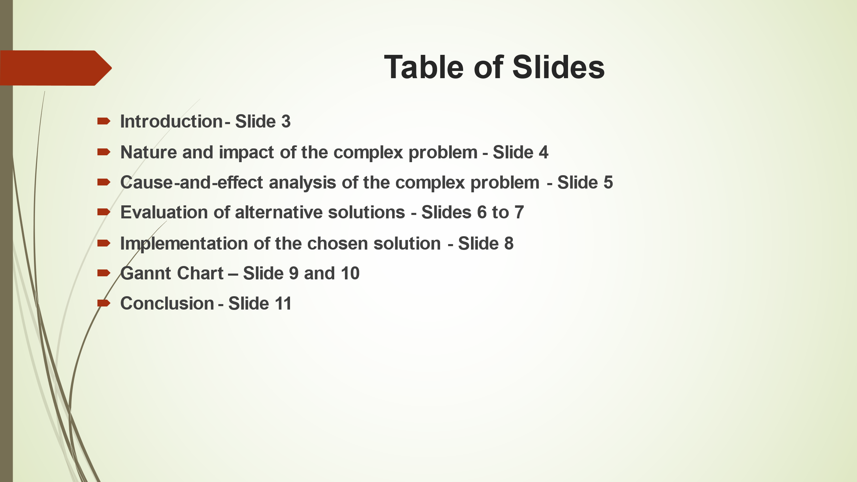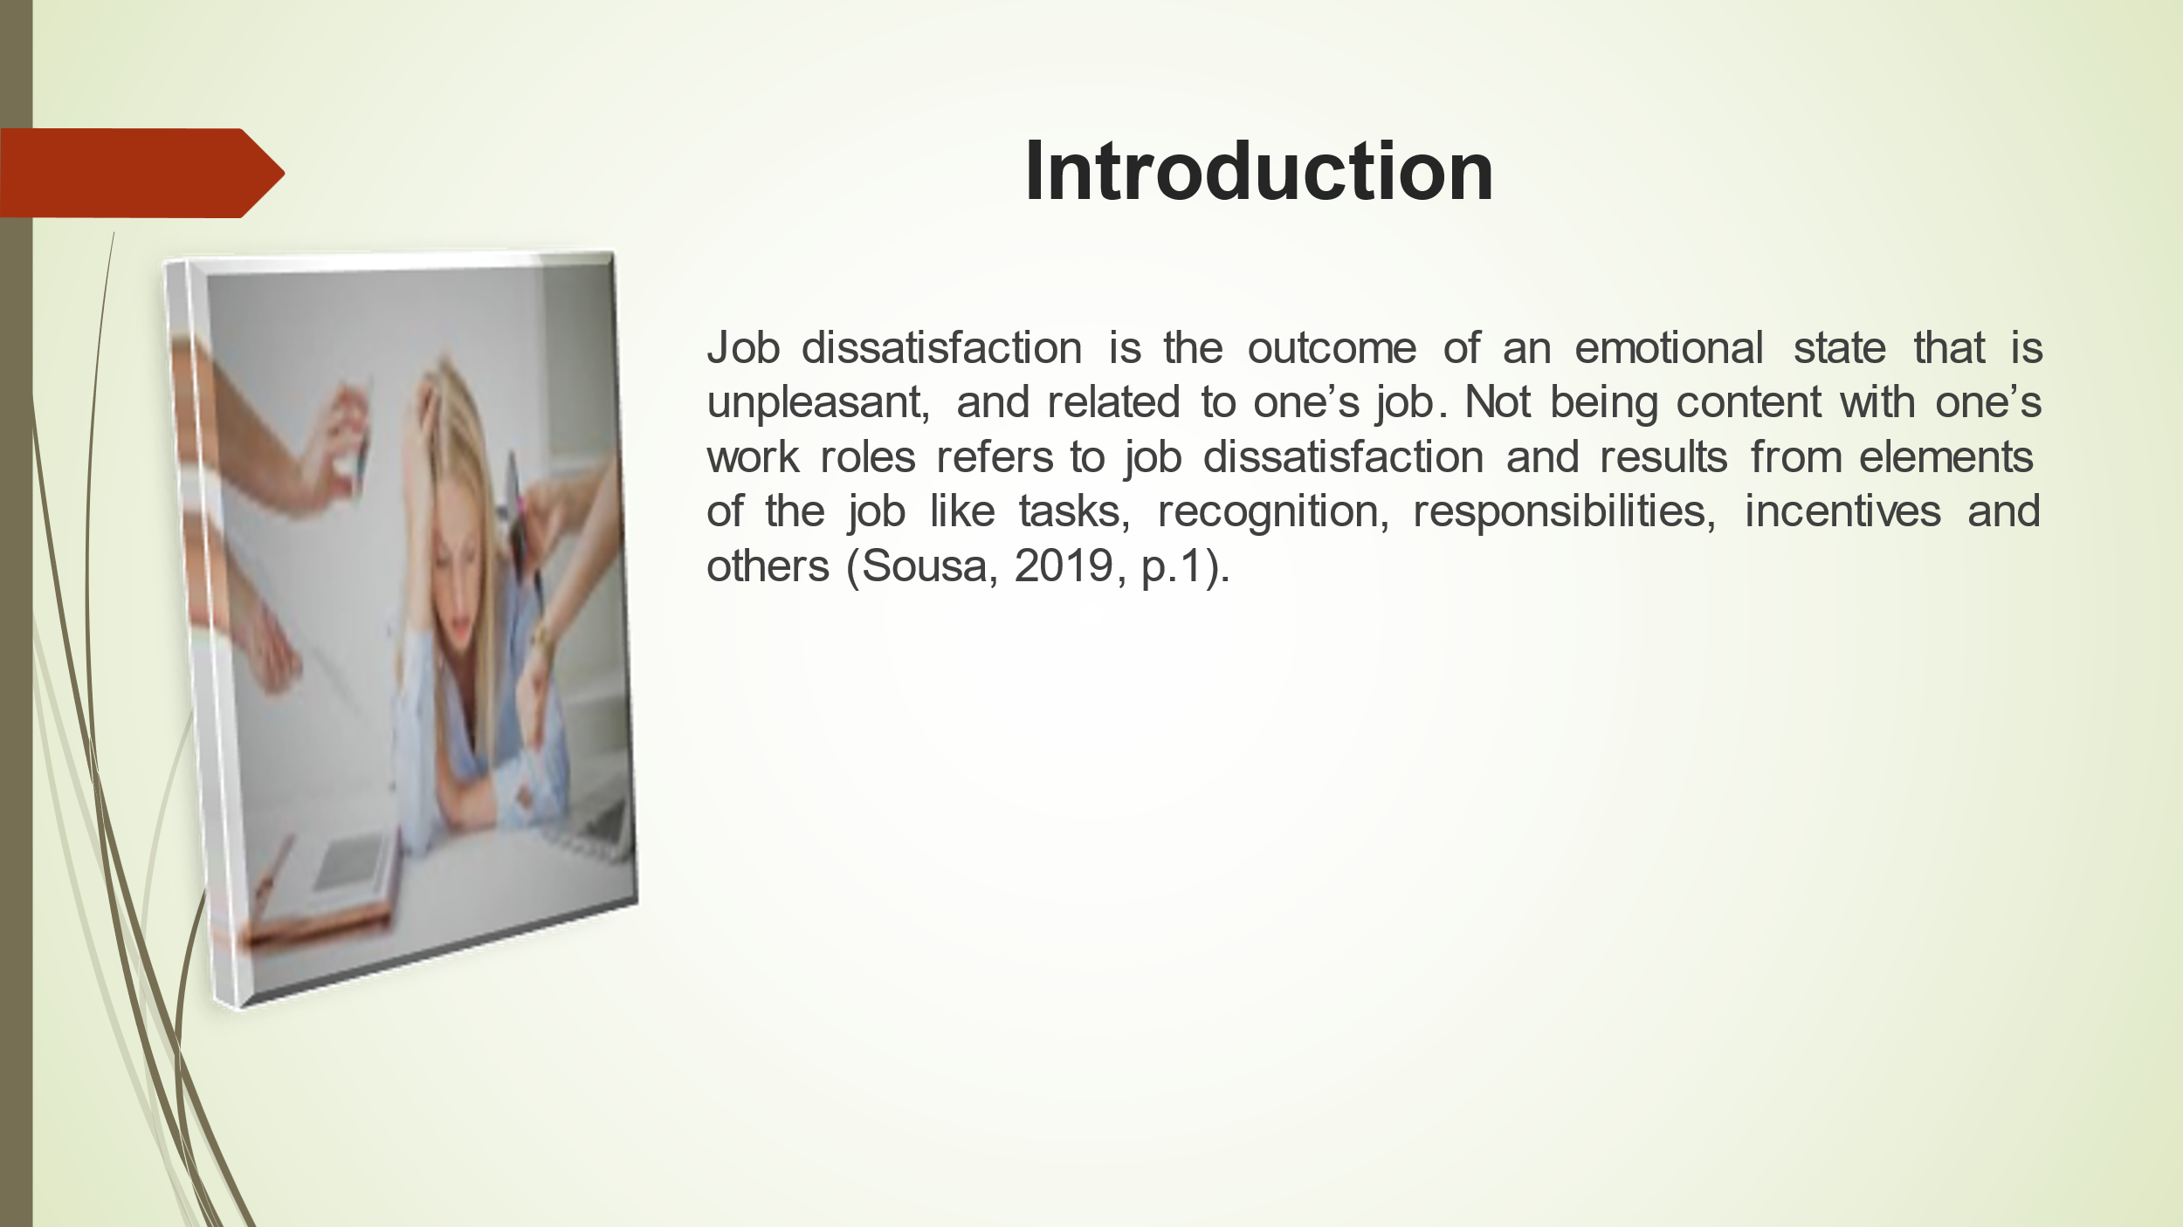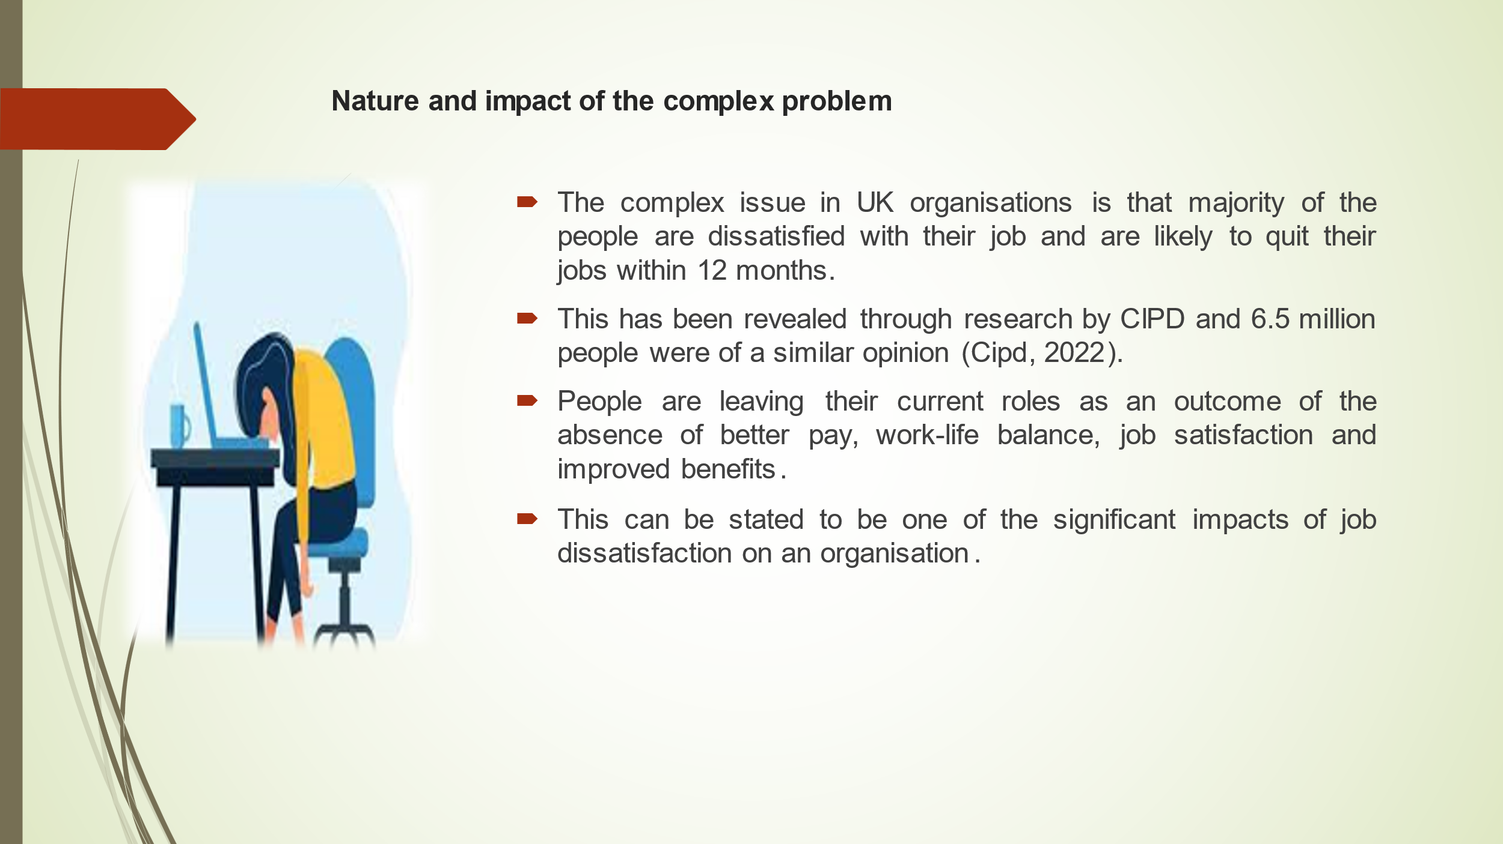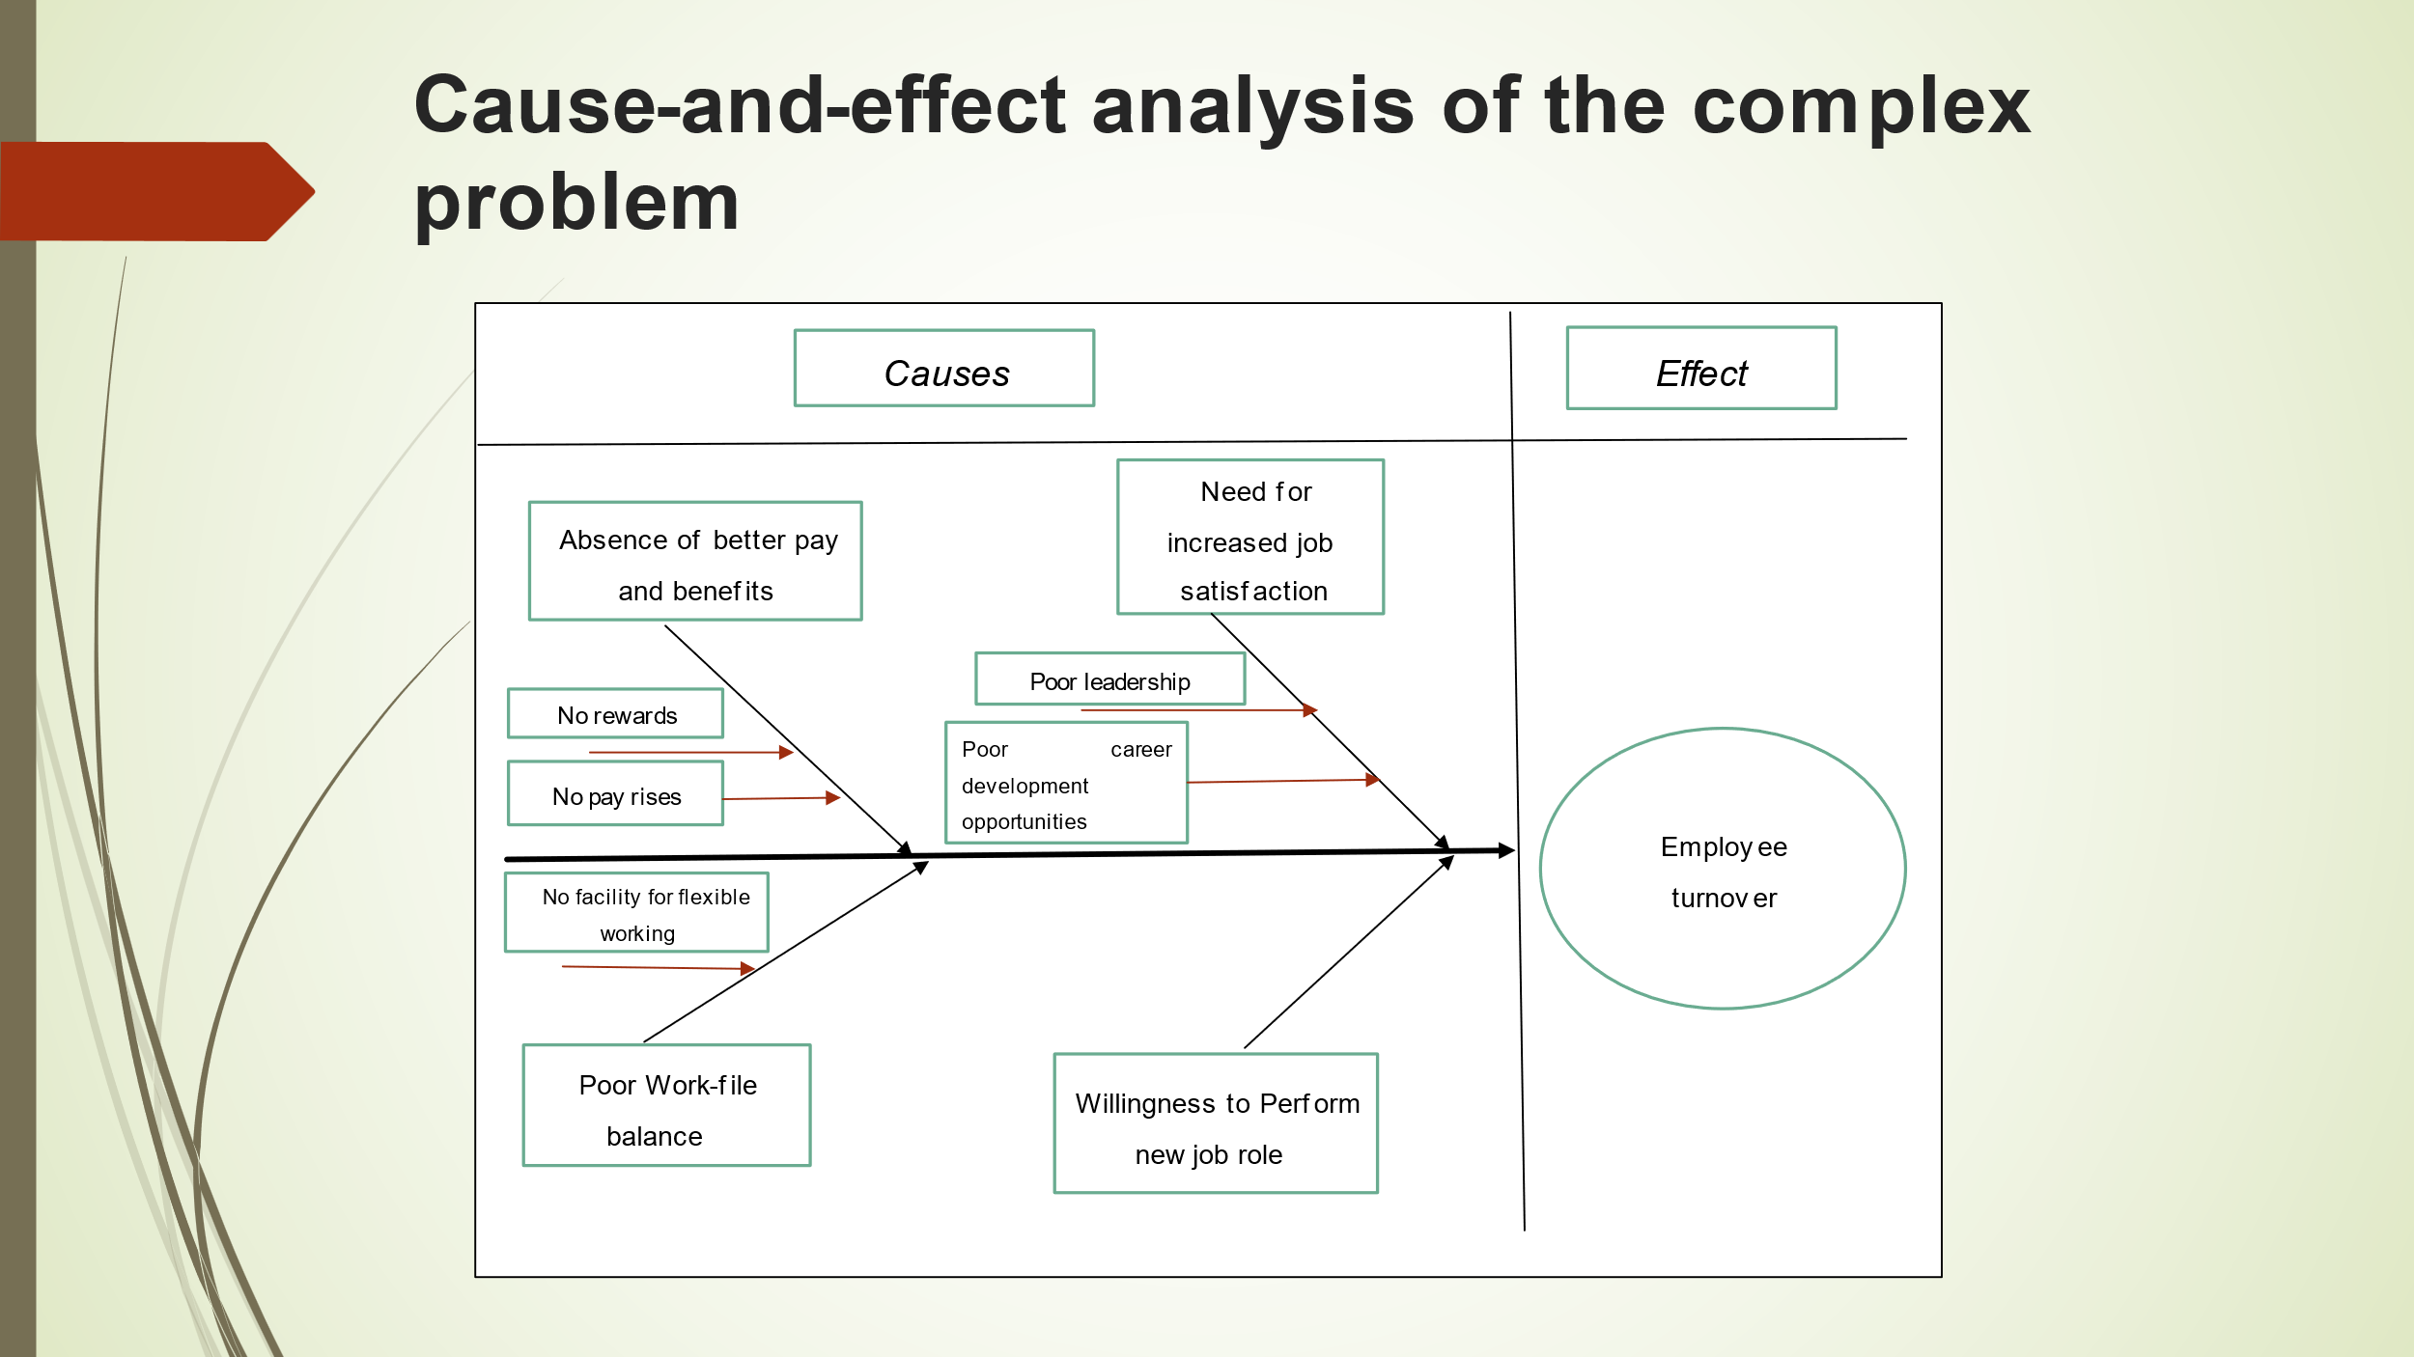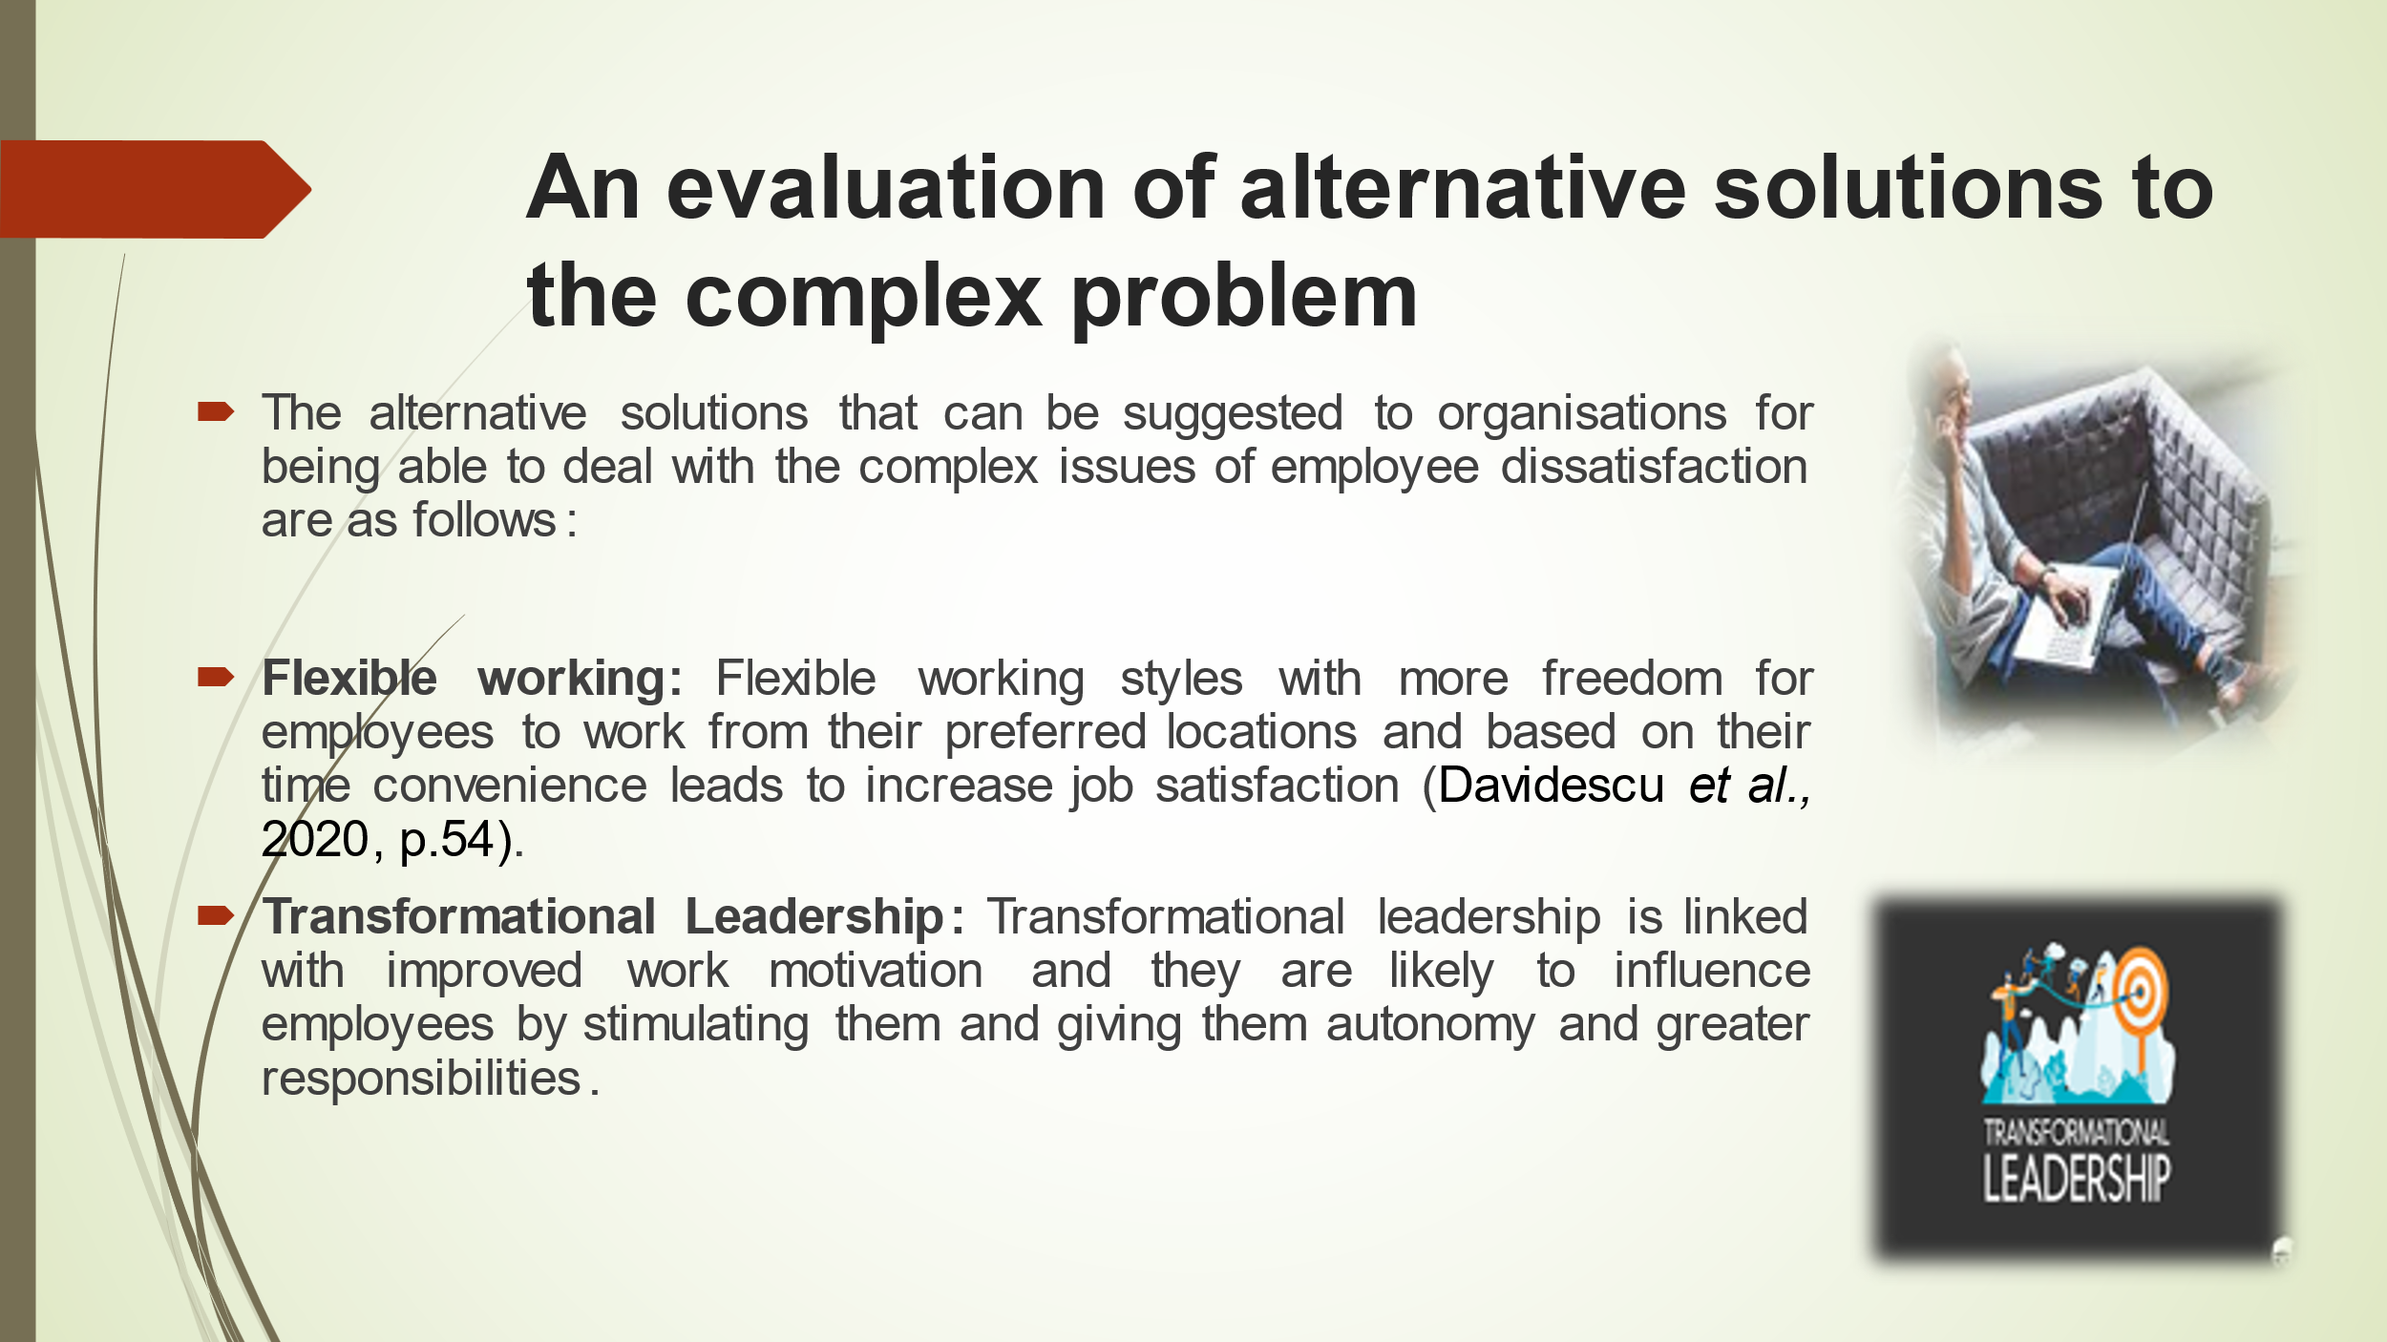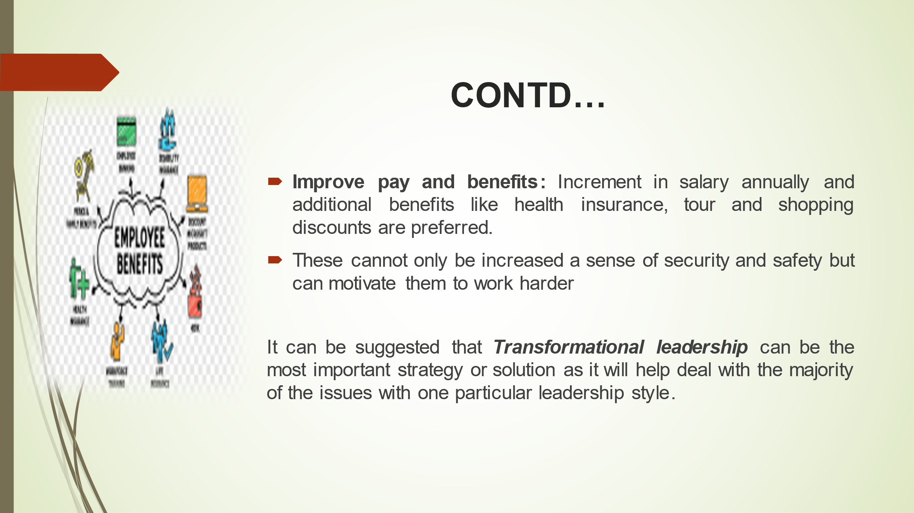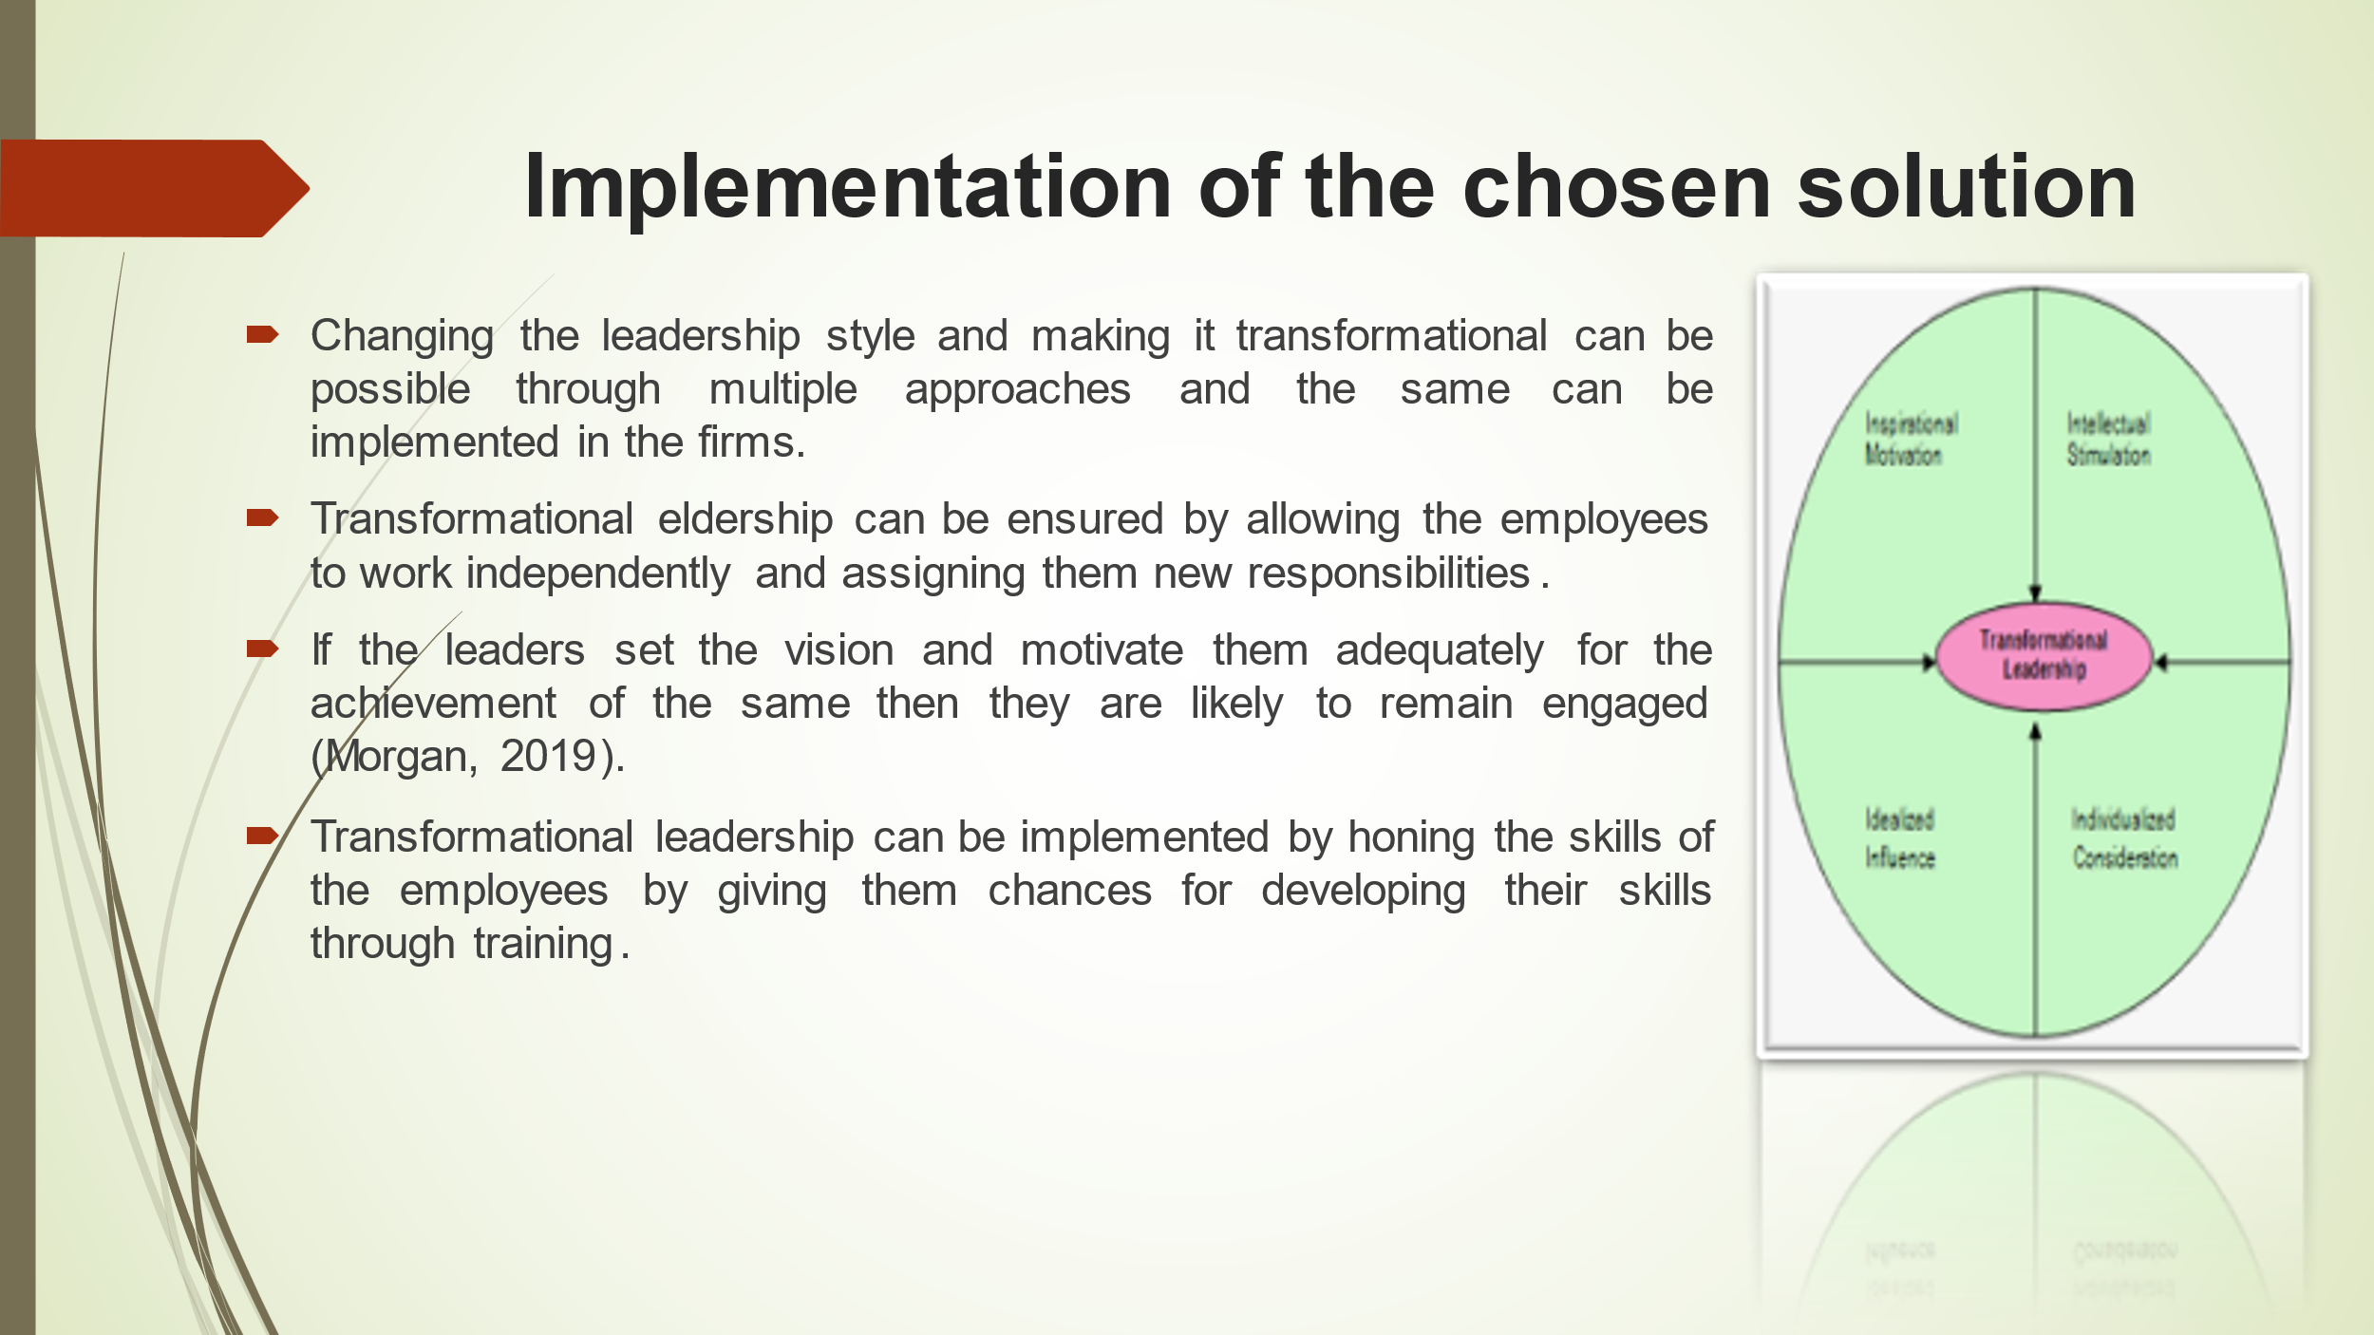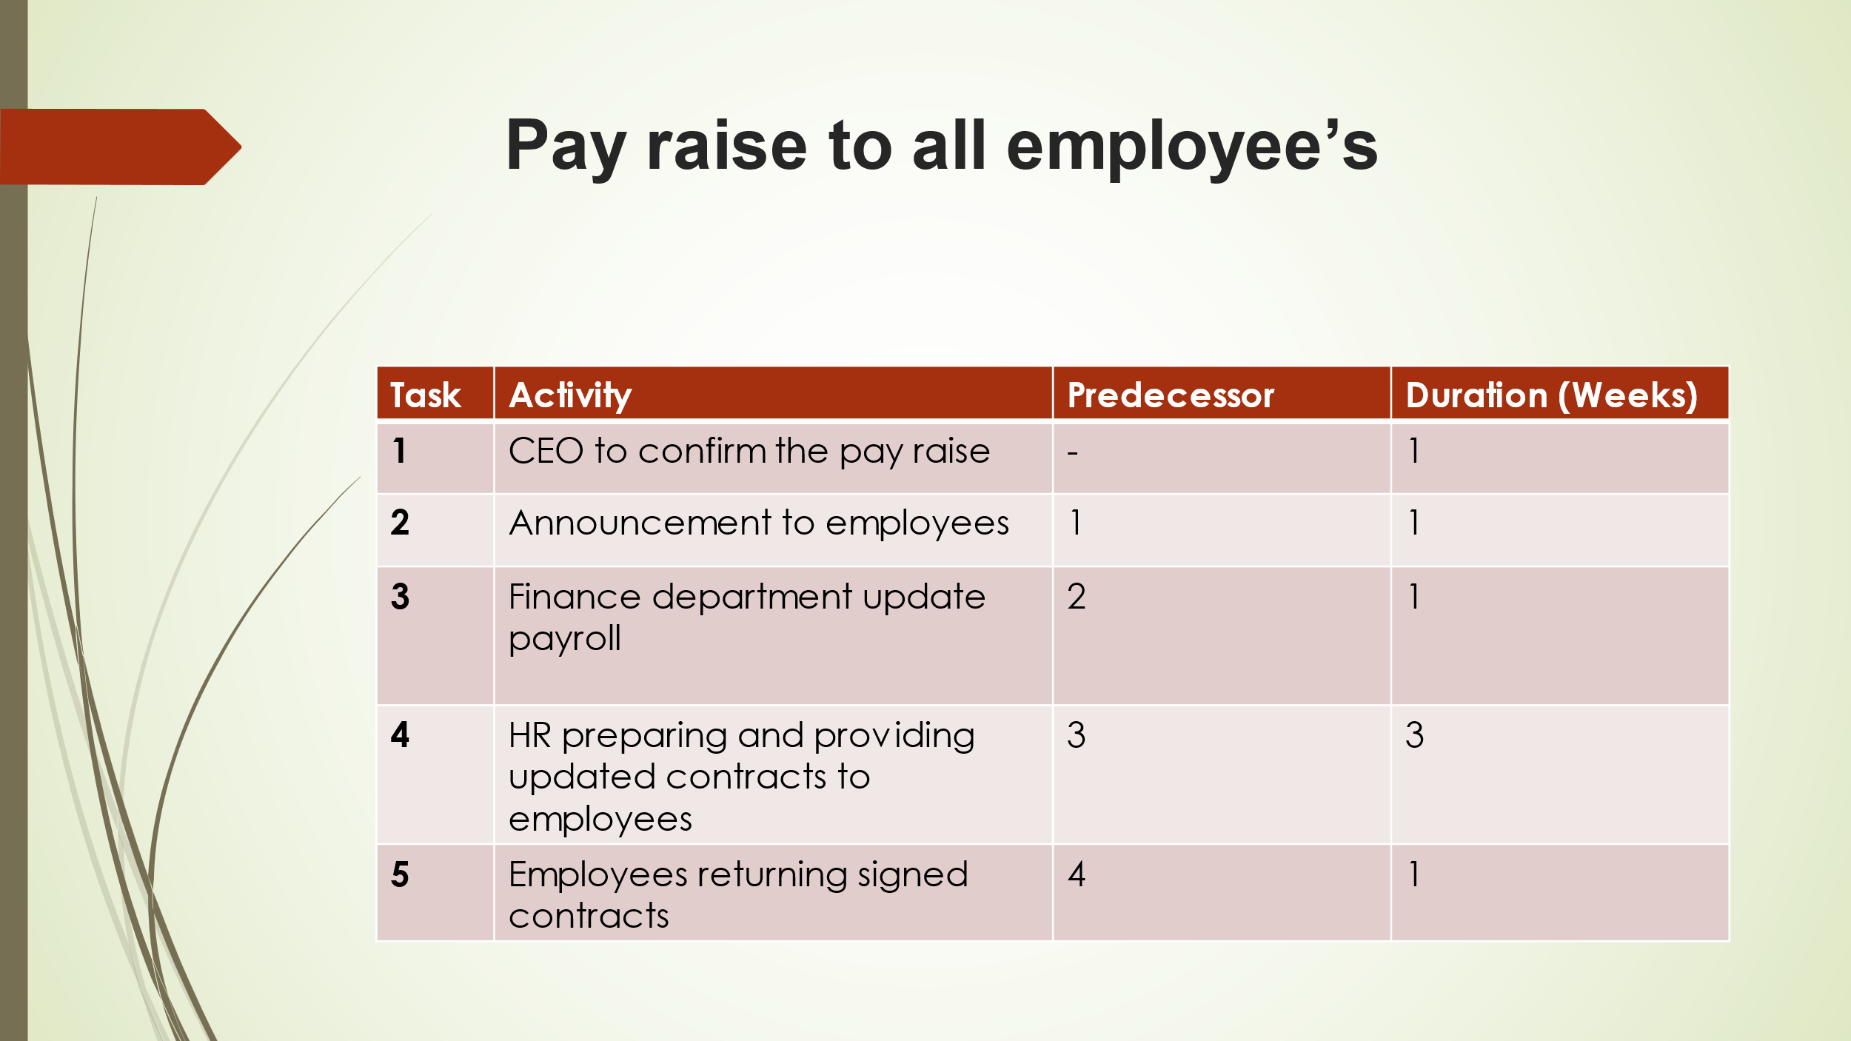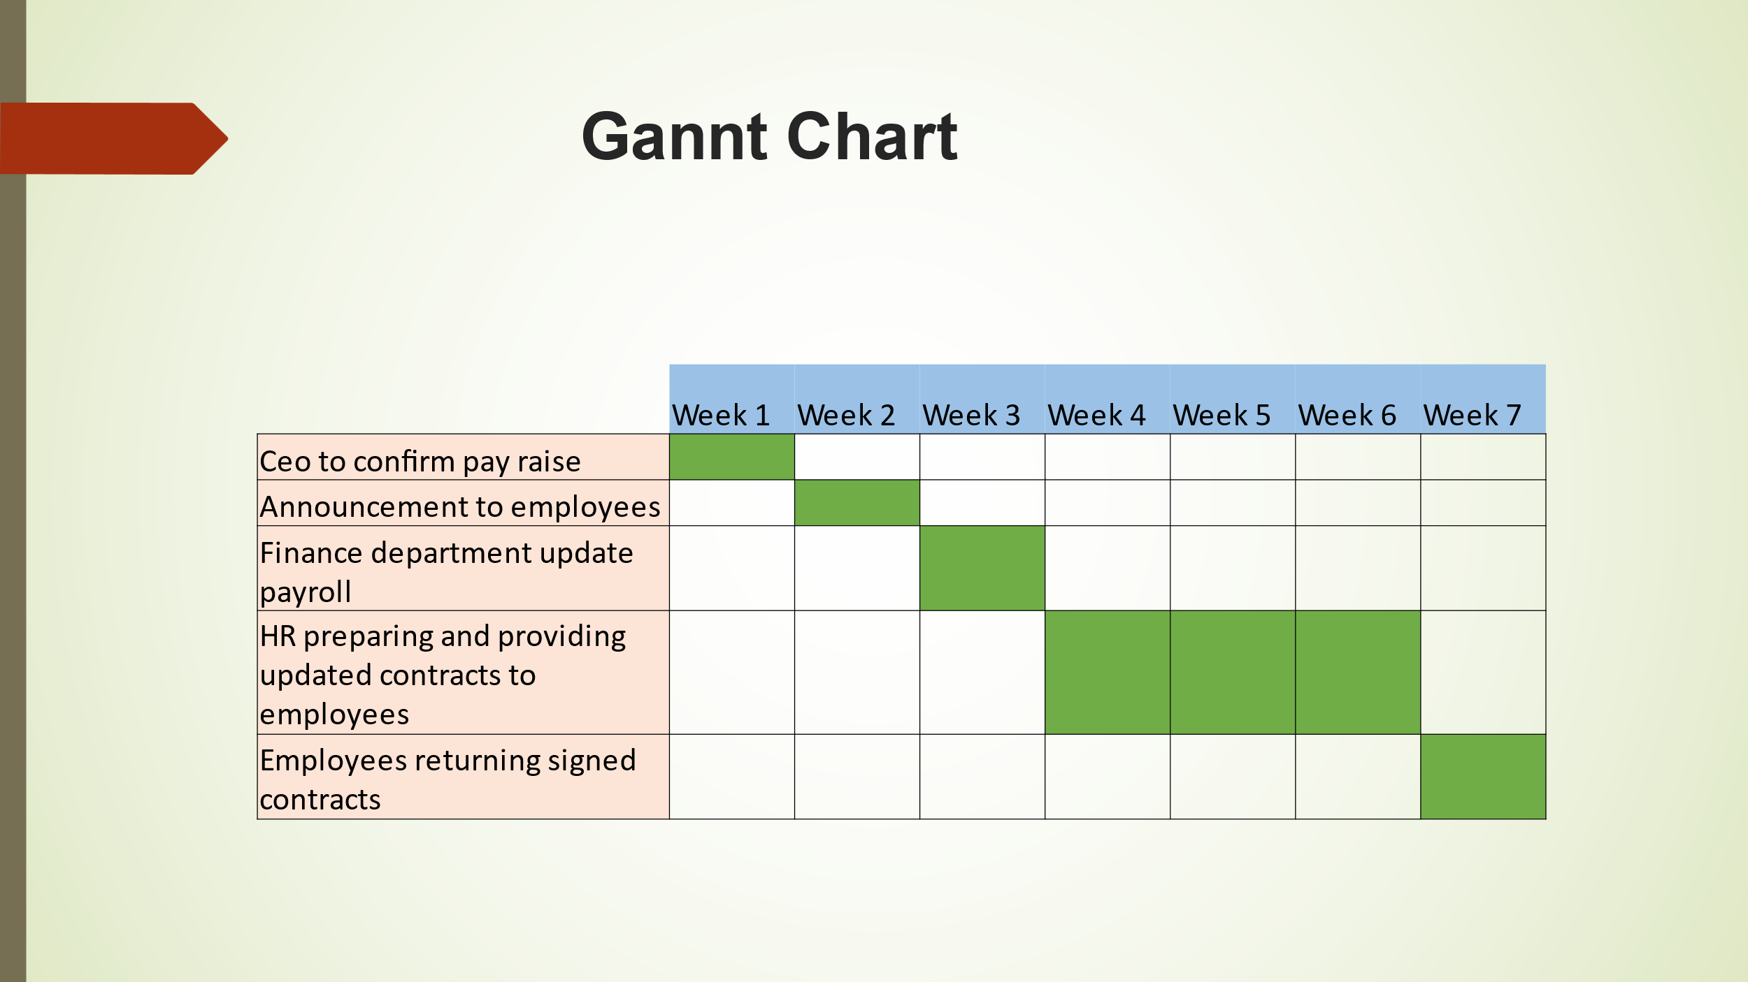
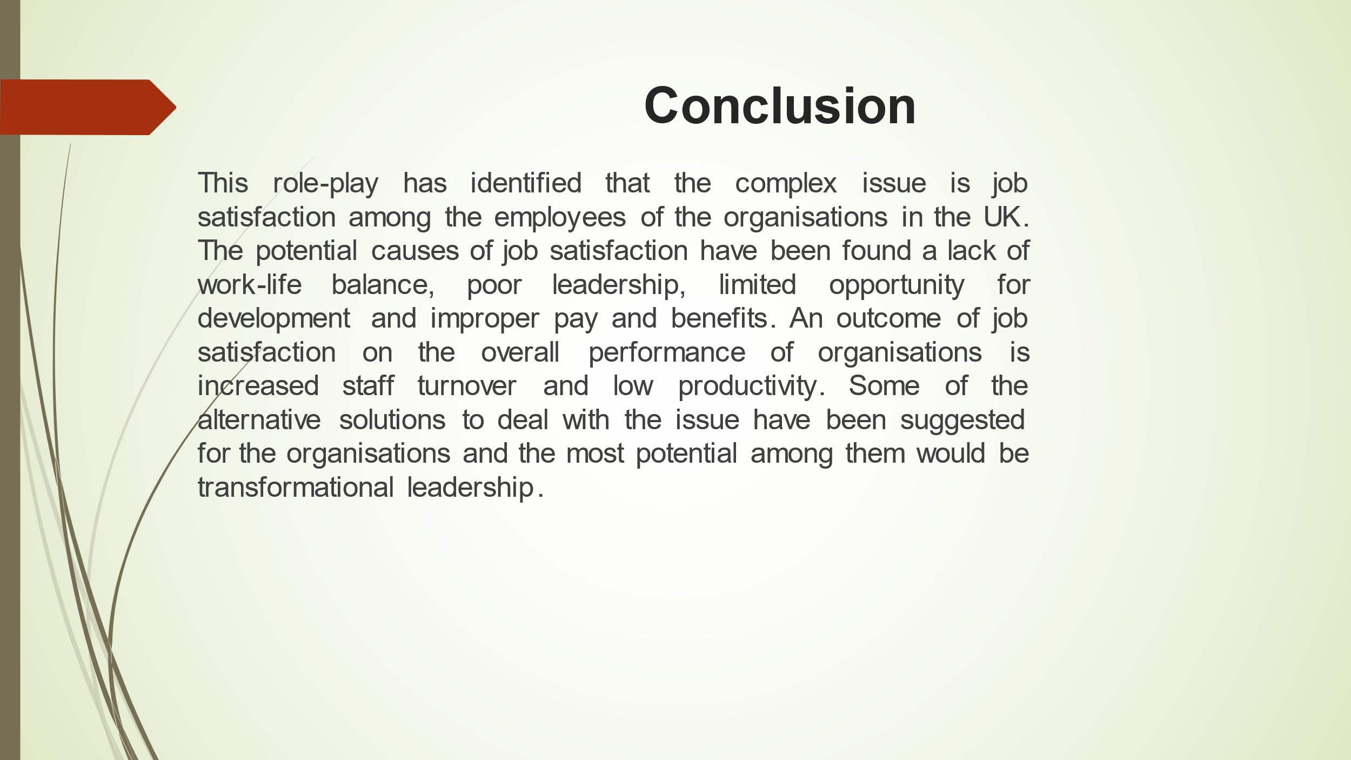

Appendix 1.2 Roleplay between manager and team member

Manager: Hello and good to see you, Atanas. I received your email requesting a chat; can you take a seat and let me know how I can support?
Atanas: Hello, I appreciate your prompt reply and setting up this meeting. As you are aware, I have been employed here for almost six years, and I always do my best to support our department. However, as the amount of work and responsibility has increased over the past few months, we have been doing things that are entirely outside the scope of our job. The fact that there is so much to do and there is only one person working each shift started to worry me because I couldn't complete my duties in time. In addition, every manager in that building is disrespectful toward us if we refuse to assist their departments as there isn't enough time to do our work; however, when we do, there is no recognition or gratitude for any work done in the past year. The price of everything in supermarkets, even gas and electricity, increased last year, but our salary did not.

Manager: Atanas, I appreciate you sharing everything you've gone through. I'm really sorry you feel this way; at our organisation, we try to make work enjoyable for everyone. At our upcoming meeting with all managers, I will share your thoughts and recommend that the benefits and pay be increased, transformational leadership be implemented, and flexible working be improved.
Atanas: I appreciate you listening to me and understanding the problem. I am looking forward to enjoying the changes and am hoping they will improve my feeling of satisfaction at work so I can stay and not consider leaving.
Manager: We hope the same too Atanas, have a nice day.

