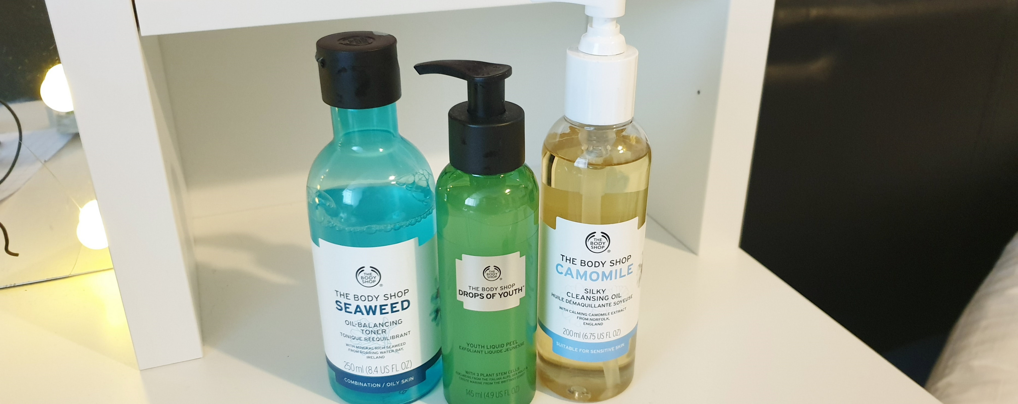
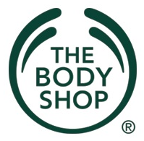
This Photo by Unknown Author is licensed under CC BY-SA

Moving Forward
  - Sustainably

Lisa Lewis 180921

April 2019

This Photo by Unknown Author is licensed under CC BY-SA

Moving Forward Sustainably?
“Our mission is to to dedicate our business to the pursuit of social and environmental change. To creatively balance the financial and human needs of our stakeholders’ employees, franchisees, customers, suppliers and shareholders”.
The Body Shop (2018)

01 Background

02 What has The Body Shop done so far?

03 What does The Body Shop plan to achieve going forward?

04 What else could The Body Shop consider?

01 Background
The Body Shop was first established in 1976 by Dame Anita Roddick in Brighton, England. Her aim was to create and sell products which were made using natural products by methods she had picked up during time she spent living and travelling abroad and to provide an income to help support her family. With the success of her first store The Body Shop began to grow and with it so did their key environmental messages. The Body Shop worked and promoted campaigns such as Save the Whale, Community Trade and one of their most famous campaigns to ban animal testing, which also made The Body Shop the first company to be awarded the Leaping Bunny Logo in 1997. In November 1998 a UK wide ban on animal testing was announced which followed by an EU ban a while later in 2013.
Today the Body Shop has over 3,000 stores located across 68 countries of the world. It sells over 1,000 products and employs 22,000 staff. In 2009 The Body Shop published its first report which outlined what the company had achieved and the obstacles that they had come up against. Over the years the Body Shop has faced a decline in its sales as other brands/companies with similar values have begun to flourish. In 2006 the company was controversially sold to L’Oréal who had different set of values and core beliefs which also further damaged its reputation. In 2007 its founder Dame Anita Roddick passed away and the company remained with under L’Oréal until it was sold to a Brazilian company Natura & Co in 2017 who have better aligned core values.
In 2018 the body shop launched their latest campaign called ‘Enrich not Exploit (It’s in your hands)’ which also highlights their key targets to achieve by 2020.



02 What has The Body Shop done so far?

The Body Shop have said that they want to become the ‘world’s most ethical sustainable business’ Their 2020 campaign groups their current targets into three main categories – 1) enrich our people, 2) enrich our products and 3) enrich our planet which also fit into the four root causes of unsustainability.

The Body Shop have pledged that they will by 2020 power their stores with renewable or carbon balanced energy. According to their latest sustainability report they have put in changes to look at reducing the amount of lighting and heating used in their stores across the world and they produced an energy saving booklet which was rolled out to all stores. They have also removed 55% of fossil fuels from their packaging and 100% of their delivery packaging is recyclable. They have also introduced biodegradable wipes and face masks into their range.

Within the ingredients that they use the Body Shop have chosen to rank them in order to see which ingredients have the least amount of impact on the environment, requiring minimal processing. With this information they have looked to source alternative raw ingredients that have the largest negative impact where possible, which is something that they openly admit is one of their biggest challenges. With each of their products the Body Shop has also assigned them all an environmental score which is made up of how the ingredients are sourced and how the product biodegrades. This helps the Body Shop to identify key products to target and improve.

The Body Shop also want to make sure that all of their products are fully traceable. Consumers are used to hearing about traceability of the food that we consume so why not apply this thinking and questioning to the products that we use on our bodies. By 2016, 62% of products used by the Body Shop had information of the country in which the ingredients had been harvested and cultivated and by 2017 this had increased to 70%. In their 2017 report they also stated that they had reduced their environmental footprint by 3% and had also managed to identify an additional 44 ingredients from ‘biodiversity hotspots’.
The Body Shop have also worked with the people in their supply chain to help ensure that they have working conditions and are paid a living wage so that they can support themselves, their families, communities and achieve a good standard of living. The Body Shop want to ensure that they work with communities to provide sustainable incomes and help build the supply chains.

03 What does The Body Shop plan to achieve going forward?
Going forward The Body Shop does have a clear plan which takes them through to 2020. They have 14 targets and a clear annual report which tracks progress against each of the targets. With the change of ownership to Natura & Co, the Body Shop can now start to rebuild its customer base and focus back onto its own core values. Most recently they have also launched the bio-bridge initiative where they are working with local communities to help rebuild natural habitats for the local wildlife, they aim to build 10 bio-bridges by 2020. They also want to hit a 100% on using ingredients in their products that are sustainable and traceable as well as powering all stores with renewable energy and reach 70% of fossil fuel free packaging.

04 What else could The Body Shop consider?
Going forward there is a lot more work that The Body Shop needs to do. The Body Shop is already onboard with bringing sustainability into their working practices and want to lead the way. Firstly, they need to ensure that they build back trust with the public. There have been occasions where their products have been available to purchase China where products can be chosen at random as part of their testing programme. These tests are then sometimes done on animals which was one of the key principles that the Body Shop is against. Since the Body Shop opened there are now plenty of other retailers competing for the same customer base who have moved forward at a much quicker pace than the Body Shop has done especially since they were part of the L’Oréal group e.g. brands and stores such as Lush, Weleda and Burt’s Bees etc. If we go back to look at the four stages of unsustainability, we can look to see where further opportunities or areas of progress lie.
- When we keep taking large amounts of raw materials from within the earth, we are causing harm. To help reduce the amount that we need to keep taking the Body Shop could implement a refill and reuse policy within their stores. This could be customers bringing back their Body Shop containers and having the products that they want re-filled in the same plastic bottle that they were sold the original product in. To take this a step further the Body Shop could roll out a bring any suitable container back to refill, as long as the container could hold the amount of allocated product safely. The Body Shop could also look at the way that its current items are packaged and look to see where this can be reduced or completely eliminated an example of this would be the plastic film that is added onto their range of soaps. Other companies who are competing in the same market have already chosen to eliminate this type of packaging on the same products. The body shop has also committed to reduce the amount of fossil fuels that they are using in their packaging and to reach a goal of 70% free of fossil fuels used, however the plan that they have does not in any way detail how they are looking at achieving this. In their last video report on their website they mention ‘new light’ an air carbon which is an oil free plastic which removes green house gases from the atmosphere in production which they were hoping to bring into use, however as they are no longer part of the L’Oréal group that do not have access to this and don’t seem to have a clear forward plan as yet.
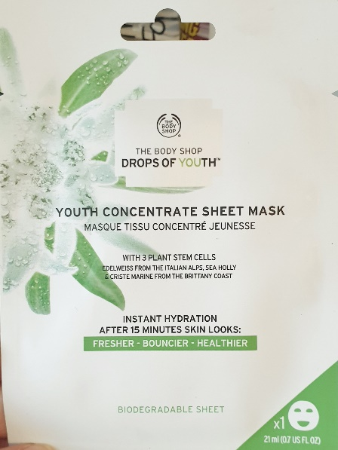
- Increase of substances created by our society. The Body Shop also have brought in the biodegradable face masks (known as sheets). These on the outside seem environmentally friendly as they are marketed as a ‘biodegradable sheet’ however there is no information at all on the packaging to tell you how to dispose of the sheet or how long it would take to break down. The sheet itself is also packaged in a plastic/aluminum packaging which is thrown away along with the product itself. Even though the sheet mask is said to be biodegradable it is a single product which by its own design is meant to be thrown away after one single use. The Body Shop could look into how many of their products would be classed as ‘Single-Use’ items and would there be an alternative e.g. reusable cotton sheets that can be soaked in the same fluids to achieve the same or similar customer experience and results? The Body shop could also make the move away from plastic carrier bags in store. Recently Morrisons supermarket have made the move to paper carrier bags with a higher charge rate but have also committed to plant three trees for every one tree that is used to make the bags. I am sure that once this becomes more normal for people to have many other stores with follow suit. As well as rewarding customers for bring back used containers e.g. by using the current loyalty points system, they could also look into customer only purchasing what they need rather than a set amount dictated by the store itself. This way the customers can feel more empowered by making the right choice. This could help to reduce the volume of products that customers throw away and may also increase customers trying different products in a more friendly way by choosing to purchase smaller amounts as trials or if they are staying away from home etc. In their last video report the Body Shop also mentioned scoring their products on the impact that the ingredients have the environment and also the amount of water it takes to completely dilute the product. They also used this information to help them to identify and prioritize what needs to be changed. Environmental scores could be shared with the public via the Body Shop website. The Body Shop could also do more to move with technology. Under its time with L’Oréal many of The Body Shops main competitors have made themselves more available to the public via Facebook, Instagram, YouTube and Apps etc. this would help to build the brand and keep them current.
- Preventing natures natural cycle. One of The Body Shops latest project is called ‘bio-bridge communities’ where the Body Shop are working with communities to help re-build area that have been over harvested or where forests have been wiped out. Although this is a great step forward it is unknow the history behind what has happened at these sites, why these areas have been specifically chosen by the Body Shop and did they have any part in what had already happened already? The Body Shop talk about traceability of ingredients in their products but they also need to think about the transparency of their decision and actions to fully get their customers onboard. They would also need to look at how this work is achieved e.g. would local people be employed; how would this be maintained in the future and would there be something in place to stop these areas being targeted and deforested in the future? The Body Shop also state that they have reduced their own environmental impact by 3% but what does this actually mean? The figures that they give does not go into any details of what the impact was to begin with and where they are at now. It does not clearly say enough about the progress that they made and how they achieved it.
- Preventing people from meeting their needs. The Body Shop talk about giving back to the communities that they work in by volunteering. As well as giving their own staff the time to volunteer in the community they could also have people coming to the Body Shop. This could help to build the reputation, share information of what the Body Shop is doing to become more sustainable e.g. share their booklet on how to reduce energy usage with other businesses, community run centers or schools etc., share knowledge and best practice. The Body Shop could do more to share their success stories and how they ensure that they invest in communities where their ingredients are directly harvested and how they buy directly from fair trade communities. The Body Shop also need to look at why some of these ingredients which are labelled as being harvested directly from different parts of the world then end up being ‘Made in Thailand’. This is something that could also be improved on to help reduce carbon footprint and ensure that work is kept in the places that the ingredients are made.

There is still plenty of areas that the Body Shop can continue to make further progress but it is also evident that they have also come a long way as they have also been shortlisted for the 2019 Champions of Sustainability Awards and the best natural brand by The Times.

(2017) The Body Shop Sustainability Report available at: https://www.thebodyshop.com/medias/Enrich-Not-Exploit-Report- 2017.pdf?context=pdf/h17/h04/27818345005086.pdf (accessed 05/04/2019)
The Boy Shop available at: www.thebodyshopcareers.com (accessed 05/04/2019)
The Body Shop available at: www.thebodyshop.com (accesses on 05/04/2019)

