

Module: Introducing the Modern Workplace
Module Code: LCBB4003

Program: BA Business Management

Assessment Title: Assessment 2 – Organisational Behaviour in the Airline Sector

Module Lecturer: Dr. Hoang Dang Nguyen

Students name:

Rumyana Popova ID: 1909673
Mariya Ilieva ID: 2123768
Elena Goranova ID: 2122365
Sebastian Patrascu ID: 2122706
Mihael Velikov ID: 2123841
Valentina Stefanovska ID: 2123930

Table of Contents

Reflective Report on the Background of EasyJet 2
Reflective Report on Organisational Structure and Performance 6
Reflective Report of Different Tasks and Skills 10
Reflective Report of Leadership, Motivation and Performance (1) 14
Reflective Report of Leadership, Motivation and Performance (2) 19
Reflective Report of Factors influencing Group behaviours 24
Presentation Slides 28

Reflective Report on the Background of EasyJet
Rumyana Popova ID: 1909673

The requirements of the assessment are to provide an overview of an airline company. Our team chose the company EasyJet after proper discussion by the members. The assessment, additionally, required details on the company’s organizational structure and performance, different tasks and skills a manager can apply to ensure operational effectiveness, leadership to motivate staff and improve performance and factors influencing team behavior. Each member of the team was allotted five key topics and I got to give an analysis of the background of the company.
In the run-up to fulfilling the requirements, I have done extensive research on the selected topics of the background of EasyJet including its history, business model, financial position, marketing and CSR activities of the company and also its fleet size. While being very active in researching topics, I also had to demonstrate the topics with figures and references from appropriate and recent sources. These demonstrations helped me to fulfil all categories of the assessment and write my topic effectively, providing examples to further circulate on the topics properly (Cottrell, 2020).
Firstly, I researched on the respective topics one by one and found considerable data sources from numerous journals and sites. “Google Scholar” the go-to site for journals and research papers was there to guide me in searching all topics and even provide references. I also looked up the topics on the website of the company, EasyJet which further strengthened my ideas on the given topics. From credible information at websites to books and journals, I also had to ensure the data was recent and had examples. This took a while but taking proper time, I researched every topic properly until I found the appropriate information. I also took help from my textbook and looked up some basic information on the topics and how to arrange them in my writing (Cottrell, 2001).
The class has greatly enhanced my learnings and knowledge on the topics which enabled me to extensively perform my research and analyse on the background of the company. I had the capability to arrange my information with the incredible help that I got from attending the classes. The class lectures, materials and the professor were great in helping to understand each topic properly and analyse them. For example- in writing about the CSR activities the materials helped in understand the proper information I had to include while eliminating many due to words restraint. I understood that I had to include the important activities that changed the company and made it an important part of the betterment of society. My classmates also helped by sharing many thoughtful ideas in class on how they would represent the topics. Moreover, my team members provided a greater helping hand in each of them sharing their own perspectives and respective ideas on how everyone should represent the topics. Whenever anyone had any queries in the group chat created for this assignment, all the team members would respond on time and assist each other while pushing for submitting each member's allotted topics in the doc file within the given deadline.
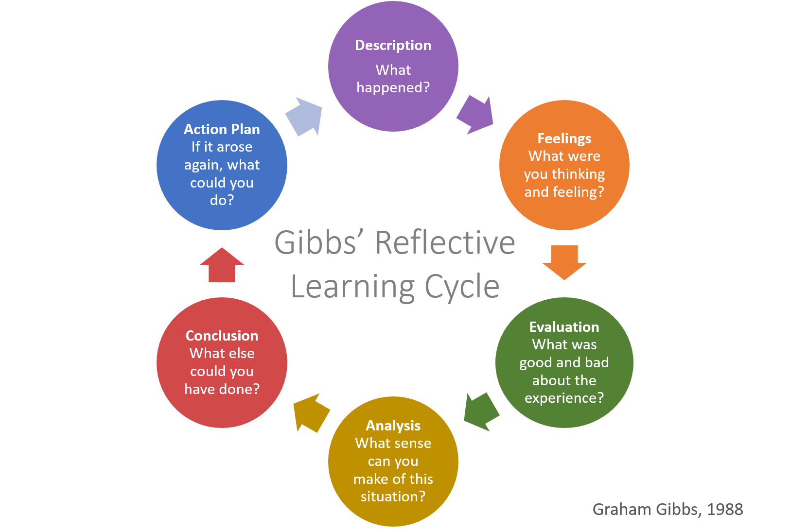
I also affected my classmates in raising questions on the assessment requirements in class and inquired on the topics I was unsure of. This helped all students to be clear on all the given topics and how to start researching on them. Some of them even came to me and made inquiries on some information that they were unsure of, and I was able to answer them appropriately. Not only that, but I also helped my team members in providing them answers to specific queries they had. Due to my depth of researching I even helped a couple of my team members in finding out information that they were struggling to provide. Moreover, I arranged all the topics from each team members on the doc file and providing the headings, subheadings and table of contents later on. In times like this, I vote to act as team leader which motivates me to do further group works and score on them.
My experience in preparing and performing the requirements had both positive and negative aspects. I now have a better understanding on the background of the company, EasyJet and how the company is outgrowing on its financial performance. The company is also doing and outstanding job in performing CSR activities by incorporating Big Data information and artificial intelligence for enhancing customer experience and cutting down costs (Yoon et al., 2006). Furthermore, the research has helped me to do further work on research activities and even become a research analyst to curve my future goals. Thirdly, the group activity was also a great guide in being cooperative and helping each other to achieve the perfect score. This was a future reference to always being helpful and strive for achievement. The negative aspect of the assessment was however, was putting up an all-nighter in preparing the information and finishing the requirements on time. I also had to wait for my team members to finish their parts as a couple of them were running behind the deadline, to compile their works and finalise the report.
The challenges revealed to me previously unknown strengths about myself. Although I had never thought of myself as a leader, I realised I was one after the class used group thinking on multiple occasions. I shared my opinions with the group while seeking to balance those of others in order for us to reach an agreement (Groff and Mouza, 2006). Obviously, this leadership role can help me outperform in any industry I choose because the ability to manage a crisis while maintaining diplomatic connections with coworkers is a necessary talent. I also had the ability to rethink what job I want to get as being a research analyst, although difficult is a very demanding career. I am empowered to be someone who had the unnerving attitude in being successful. The truth is that, I am satisfied with who I am and have a hard time envisioning any skills that I do not already have.

References

Cottrell, S., 2020. Teaching study skills and supporting learning. Bloomsbury Publishing.
Cottrell, S., 2001. Integrating study skills into teaching. In Teaching Study Skills and Supporting Learning (pp. 97-119). Red Globe Press, London.
Groff, J. and Mouza, C., 2008. A framework for addressing challenges to classroom technology use. AACE Review (Formerly AACE Journal), 16(1), pp.21-46.
Yoon, Y., Gürhan-Canli, Z. and Schwarz, N., 2006. The effect of corporate social responsibility (CSR) activities on companies with bad reputations. Journal of consumer psychology, 16(4), pp.377-390.

Organisational Structure and Performance
Mariya Ilieva ID: 2123768

To assess the organizational structure and performance of EasyJet, one would need to analyze the company's current business model and compare it to its competitors. Additionally, a review of EasyJet's financial statements would be required in order to get an understanding of the company's overall profitability and efficiency. (Dean, 2014). Furthermore, an evaluation of the company's customer satisfaction levels would provide insights into whether or not EasyJet is providing a good experience for its passengers. Finally, a review of the airline's safety record would be essential in order to ensure that EasyJet is operating in a safe and reliable manner. By considering all of these factors, one would be able to get a comprehensive picture of EasyJet's organizational structure and performance.
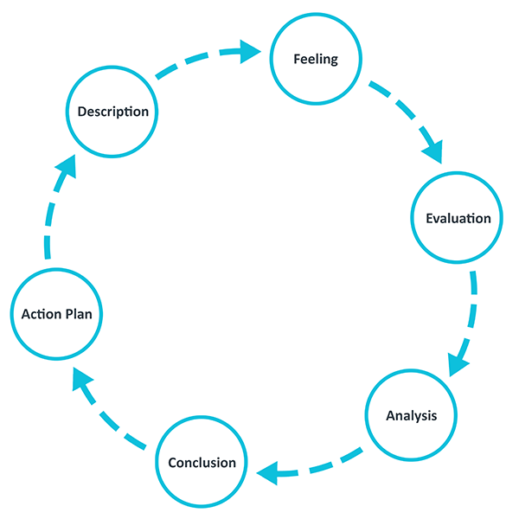
Figure 1: Gibbs Reflective Cycle
Description: In this assessment I have written about the organisational structure and performance of EasyJet. I have looked at how EasyJet's bureaucratic organisational structure has contributed to the company's success, and how it has helped easyJet to overcome some challenges. I have also looked at how EasyJet's low-cost business model has helped to drive its performance, and how the company has used technology to support its operations. (Potter, 2015). Finally, I have considered how easyJet could improve its performance in the future by adopting a more customer-centric approach.
Organisational structure and performance are two of the most important aspects of any business. EasyJet is no different. In order to meet the requirements of the assessment, I had to learn about both easyJet's organisational structure and how it impacts performance. The easyJet website was a great resource for this. I was able to find out about the company's hierarchical structure, as well as how different departments are organised and what they do. This information helped me to understand how easyJet operates and how it is able to achieve such high levels of performance. Additionally, I was also able to find out about EasyJet's key performance indicators, which gave me further insight into the company's success.

Evaluation: In order to research the topic of "Organisational Structure and Performance of EasyJet", I used a variety of resources. I started by looking for books and articles on the topic in the library, and I also searched online for relevant scholarly papers. I also looked for news articles and other sources that could provide insights into how EasyJet is structured and how it has performed in recent years. In addition, I spoke to several people who have direct experience working for or with the company. This allowed me to get a more comprehensive understanding of the topic. Overall, this research has provided me with a great deal of information about EasyJet's organizational structure and performance.

Analysis: I was affected by the class, the classmate, and team members in different ways. First, the class was very informative and though it challenged me, I enjoyed it. I learned a lot about organisational structures and how they can affect performance. This was especially true for easyJet, which has a very flat structure. I also found my classmates to be very helpful. We worked well together and I felt that we all contributed to the learning process. Finally, the team members were also great. We worked together closely on the project and I felt that we all supported each other. In sum, I had a great experience in this class and am grateful for the learning opportunity.
In a group project, each person's role is important to the success of the project. I may have been the one who came up with the initial idea, but it was the team's hard work that made it a reality. Each member contributed their own skills and knowledge to the project, and I was able to learn from them as well. As we worked together, I began to understand how my actions affected not just the outcome of the project, but also the team dynamics. If I became too focused on my own work, it would throw off the balance of the team. (Adeani et al., 2020). On the other hand, if I helped out too much, it would take away from other team members' contributions. It was a delicate balance, but in the end, we were all able to work together harmoniously and produce a great final product.

Conclusion: It is now two weeks since I handed in my final assignment for this module and I have had time to reflect on the experience. Overall, I found the process of preparing and performing the assessment to be challenging but rewarding. I was required to research a topic that was new to me, and I found the process of synthesising the information to be both difficult and time-consuming. However, I was pleased with the final product and felt that my presentation was well-received by the audience. In terms of future learning, I would like to continue to develop my skills in research and data analysis.

Action plan: One of the most important things that I have learned from the experience of doing an assessment in a team is the importance of communication. In order to complete an assessment effectively, it is essential that all team members are able to communicate openly and candidly with each other. This means that team members need to be able to share their ideas and opinions freely, without fear of judgement or reprisal. (Child, 2012). Additionally, team members need to be able to actively listen to each other in order to fully understand the various perspectives that are being brought to the table. Without effective communication, it would be very difficult for a team to come to a consensus on how to proceed with an assessment. Another thing that I have learned from this experience is the importance of taking responsibility for one's own actions. In any team setting, it is important that each team member feels ownership over the work that they are doing. (Koberg and Ungson, 2017). This sense of ownership ensures that team members are more likely to take pride in their work and be willing to put in the extra effort required to get the job done right. Finally, I have also learned the importance of flexibility when working in a team. Assessment tasks often require team members to change their plans or take unexpected detours in order to achieve the desired results. As such, it is important for team members to be flexible and adaptable in order to make sure that the assessment is completed successfully. (Markkanen et al., 2020). In conclusion, working on an assessment in a team has taught me a lot about the importance of communication, responsibility, and flexibility.

REFERENCES

Adeani, I.S., Febriani, R.B. and Syafryadin, S., 2020. USING GIBBS’REFLECTIVE CYCLE IN MAKING REFLECTIONS OF LITERARY ANALYSIS. Indonesian EFL Journal, 6(2), pp.139-148.
Child, J., 2012. Organizational structure, environment and performance: The role of strategic choice. sociology, 6(1), pp.1-22.
Dean, E., 2014. Reflective practice.
Husebø, S.E., O'Regan, S. and Nestel, D., 2015. Reflective practice and its role in simulation. Clinical Simulation in Nursing, 11(8), pp.368-375.
Koberg, C.S. and Ungson, G.R., 2017. The effects of environmental uncertainty and dependence on organizational structure and performance: A comparative study. Journal of Management, 13(4), pp.725-737.
Markkanen, P., Välimäki, M., Anttila, M. and Kuuskorpi, M., 2020. A reflective cycle: Understanding challenging situations in a school setting. Educational Research, 62(1), pp.46-62.
Potter, C., 2015. Leadership development: an applied comparison of Gibbs’ Reflective Cycle and Scharmer’s Theory U. Industrial and Commercial Training.

The reflective report of Different Tasks and Skills
Elena Goranova ID: 2122365

The requirements
The assessment was prepared for an organisation named EasyJet. Public limited company of United Kingdom and very popular among the consumers as a low-cost airline business (EasyJet., 2022). The assignment required identifying of the necessary task activities and skills for operational effectiveness. Gibbs's reflective cycle is one of the most famous cyclical models that help reflect the experience of performing a task with the help of 6 different stages (Potter, 2015). I am using this model for preparing this reflective report

Gibbs's reflective cycle

Description of the situation
As it was a group assignment, I and my team decided to divide the whole work into different sections like researching the organisation's historical background, people-orientation skills, interpersonal skills, communication skills, quality maintenance skills and so on. Then we started working on our part individually when I merged the whole file, I read the document properly to maintain the sequence of the topic. For finishing the work on time dividing the assignment was crucial and as everyone chose their path according to their preference so all of them work enthusiastically and finished on time. The task breakdown procedure helps to finish all the things and fulfil all the requirements within the time frame (Thompson, 2016).
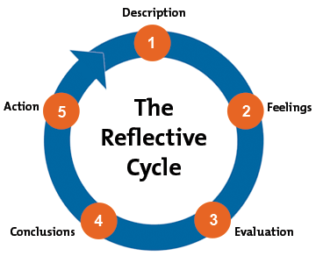
Figure 1: Gibbs Model of Reflection

Feelings
How the class, classmates, and my team affected me: I always learn a lot and get motivated a lot by the way the class teaches me. My classmates are very supportive and friendly. At first, I was very interested in the task but when we started working as a group, we had some clashes regarding our insides and opinions. So, I was a bit upset when they were not accepting my opinion then I tried to give them more logic and information supporting my opinion and finally they accepted and started working together. Each member of the group met the deadline with high-quality work they had all committed to doing. In addition, the fact that two members of the group had to cancel their activities pushed us to put in extra time that night. That made a constructive contribution to the group's overall work ethic. In retrospect, it was evident that the group's unsuccessful time plan was due to the members' false assumptions that they wrote in the same way as everyone else.

Evaluation
How I affected the team: I have always loved to lead teams so when I propose to my team members about, I want to late this task I understood that they were not happy at the start but later on they accepted me wholeheartedly. So, I proposed a plan on how we are going to perform the work and started working on the plan. Even though we still had a lot to do, I was feeling quite good about how we had divided the workload amongst ourselves. I felt a lot of frustration when we realised, we couldn't turn in the assignment as it was. As a result of my confidence in its success, I felt no impetus to complete the reworking. But we have to start working on it again and I felt terrible when I found out two of our team members had to cancel their evening program with their families, I felt very guilty. And that guilt drove me to work through the night and get things done more quickly. Later on, I apologized to the group and they also promise that they will be more careful during the task. As I reflect on our efforts, I am pleased with our choice to put in the time and effort.

Analysis
How I researched: As I was working on identifying different tasks and skills, I had to perform research for exploring the topic and complete the report. EasyJet was chosen as a model organisation for this assignment so I searched on the company's website to find out the required level of skills and task activities from the organisational management. Also, I have to go through some blog posts to understand their people-orientation skills, interpersonal skills, communication skills, and quality maintenance skills. I have read several books that contain topics related to leadership, motivation, and team and group behaviour. I also need to go through some research papers and articles to find relevant information about the modern workplace as well as information about EasyJet (Lasarte et al., 2016). Though I have to face some difficulties as all the articles are not accessible to students so I have used the sites that are mostly free of cost.

Conclusion
How my experience helped: I have experience performing these types of assessments in my academic life so from the start I knew how to perform research to find out the most accurate information regarding a particular topic. So, it helps me a lot to find data faster as well as I could help my team members to use some tricks to find data faster. I am also good at negotiating and convincing people so it helped me a lot to convince my team members and make them work effectively.

Action Plan
Learning: The next time I'm in charge of a group undertaking, I'm going to make it a point to praise everyone in the team for the great contributions they've made. This might serve as a discussion starter for our first encounter since it is easy to remember and simple, which is particularly useful in the event that neither of us is previously acquainted with the other. Second, before we begin, I would want to propose that we create an overview of our objectives for any work-sharing agreements (Shehzad, 2011). Before we get started on our individual contributions, it could be a good idea to write the introduction or the first portion of the paper together so that there is coherence throughout. I am certain that this present experience will serve as a reminder to suggest that we do so in the future whenever the subject of how to split up the labour is brought up. This is something that I am confident will happen. Then, to prevent us from falling victim to groupthink, I will inquire as to whether or not our first selections may be contested. This will give us confidence that the decisions we make are sound. If I am concerned about something, I will make sure that the group is aware of it. I feel that I will be able to disagree with others, even when it is tough to do so, as long as I keep in mind that I want the greatest possible conclusion

References

EasyJet. (2022) What we do, Easyjet.com. Available at: https://corporate.easyjet.com/about/what-we-do (Accessed: August 26, 2022).
Lasarte, M. P. et al. (2016) “Low cost airlines and tourism: analysis of the case of Easyjet from the perspective of complex networks and its management implications.” Available at: https://www.researchgate.net/publication/305135510_Low_cost_airlines_and_tourism_analysis_of_the_case_of_Easyjet_from_the_perspective_of_complex_networks_and_its_management_implications (Accessed: August 26, 2022).
Potter, C. (2015) “Leadership development: an applied comparison of Gibbs’ Reflective Cycle and Scharmer’s Theory U,” Industrial and commercial training, 47(6), pp. 336–342. doi: 10.1108/ict-03-2015-0024.
Shehzad, W. (2011) “Outlining purposes, stating the nature of the present research, and listing research questions or hypotheses in academic papers,” Journal of technical writing and communication, 41(2), pp. 139–160. doi: 10.2190/tw.41.2. c.
Thompson, N. (2016) Effective Teamwork: How to develop a successful team. Wrexham, Wales: Avenue Media Solutions.

The reflective report of Leadership, Motivation and Performance

Sebastian Patrascu ID: 2122706

Introduction
In this report I have represented my learning experience with the group on EasyJet Plc which is a public airline in UK. I have discussed the requirements, how I have met those requirements, how I was affected by the team members and how I affected the team members as well.

Description
EasyJet Plc is a public airline that operates out of the United Kingdom and serves passengers located all over the world. I have made up my mind to take this airline, and it is important to note that EasyJet Plc is a British company. The first obstacle I had was determining how to classify each of the various topics into the appropriate category (Bourner, 2003). As part of the assignment, I was required to provide a comprehensive analysis of five significant general statements. In the end, I gave in and agreed to talk about a significant amount of information with each of the other members of the group. I wanted to make sure that each of the members was given a topic in a way that was completely arbitrary, so I offered them all distinct themes to discuss in order to accomplish this goal. On the other hand, it was abundantly clear that not all of us possess the same level of command over our writing abilities and our comprehension of business.
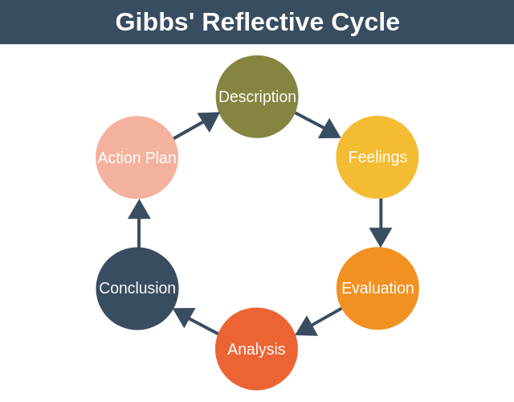
Figure 1: Gibbs Reflective Model
Because of this, I gave two of our members' complete freedom to choose whatever topic they wanted to discuss during our meeting. I told them they could talk about anything they wanted. As a result of this group task division, I have arrived at the conclusion that the first topic, which is a brief background to the company that I have selected, and the third topic, which is the identification of the necessary task activities and skills for operational effectiveness, are more straightforward than the other topics (Boyd and Fales, 2013).
In order to tackle the assignment that was given to me, I used Belbin's nine distinct team responsibilities as a conceptual framework. This allowed me to approach the problem in an organised manner. My first step was to do an analysis of both the areas in which I excel and those in which I struggle before I could begin.
For example, one of the members of the team possesses a great deal of talent when it comes to the production of work that is significantly impacted by research. On the other hand, there were two individuals in the group who possessed an excellent level of familiarity with the conceptual understanding that is important for managing a corporation. Both of these individuals were a part of the group. This conceptual framework outlines nine distinct roles that each member of the team is expected to fulfil, which takes us briefly around to the structure of the team rules that were just covered in the previous paragraph (Schaffer, 2008). A resource investigator, a plant, a shaper, a monitor, a completer, a finisher, a collaborator, a team worker, and a problem solver are some of the roles that this person does. In addition to that, they are a team member. I used the template that was offered by the idea of teambuilding, and I assigned a distinct function for each individual member to fulfil, in addition to a list of responsibilities that they were responsible for meeting.
Working on this assignment has given me a wealth of experience that is abundant in logical thinking as well as intuitive insights. This has been a great benefit to me. In general, I feel like I have come out rather well from going through this experience. My first important takeaway is that the airline industry in the UK is now noticeably simpler to comprehend than it was in the past. This was the first key thing I discovered (Adair, 2006). I was able to obtain a deeper grasp of the impact that COVID-19 has on the financial health of a dynamic airline organisation such as EasyJet by performing more research as well as conducting an analysis of financial figures. In addition, I was conscious of the significance of the role that organisational structure had in the development of performance over the course of time inside an organisation, and I was aware of the relevance that organisational structure played in this development. The process of going through this procedure allowed me to become familiar with three unique sorts of organisational structures, namely functional, divisional, and metrical structures. In addition to this, the managerial level of the organisation certainly needs to have a thorough awareness of the activities that are linked with the work as well as the level of expertise that is required for the role. This is an absolute must. For example, I have learned that in order to be a manager at EasyJet, one needs to have specific skills, such as an orientation toward people, the ability to interact with others, the ability to communicate, the ability to maintain quality, and so on and so forth. These are just some of the skills that are required. As I continued our inquiry into the leadership and motivating components at easyJet, I came to the realisation that the organisation had successfully mixed both positive motivators and sanitary considerations into its operations (Andersen et al., 2018). As I carried on with our inquiry, this realisation came to me like a flash of lightning. While I was doing more research on the topic, I came across this piece of information, which sparked my interest in the topic. One of the aspects of this investigation that I found to be particularly interesting was the attempt to establish a connection between the possibility that characteristics related to cleanliness can serve as job dissatisfies and the possibility that characteristics related to motivation can serve as job satisfiers. This was one of the aspects that I found to be particularly interesting. This is the conclusion that I arrived at based on my personal observations.

Conclusion:

This paper is a representation of my group's and my learning about EasyJet Plc, a public airline in the United Kingdom. I went over the requirements, how met them, the impact my teammates had on me, and how made an impact on them. I was able to acquire a knowledge of the factors that play an important role in moulding the behaviour of teams and groups at EasyJet thanks to the opportunities that were presented to me, and I was able to do so because I was given those chances. Because of this, the many subcultures and social groupings that can be found inside EasyJet are impacted by the fact that they interact with one another, have identical value systems, and are striving toward the same goal.

References

Adair, J.E., 2006. Leadership and motivation: The fifty-fifty rule and the eight key principles of motivating others. Kogan Page Publishers.
Andersen, L.B., Bjørnholt, B., Bro, L.L. and Holm-Petersen, C., 2018. Leadership and motivation: A qualitative study of transformational leadership and public service motivation. International Review of Administrative Sciences, 84(4), pp.675-691.
Bourner, T., 2003. Assessing reflective learning. Education+ training.
Boyd, E.M. and Fales, A.W., 1983. Reflective learning: Key to learning from experience. Journal of humanistic psychology, 23(2), pp.99-117.
Schaffer, B., 2008. Leadership and motivation. Supervision, 69(2), p.6.

The reflective report of Leadership, Motivation and Performance

Mihael Velikov ID: 2123841

- Requirements of the Assessment
This assessment is done on EasyJet Airlines. The factors to be investigated in making this assessment include the history of EasyJet Airlines Company, the airline's business model, marketing and CSR, the organizational structure of EasyJet Airlines Company, the way leadership is used in EasyJet Airlines, the way the airline motivates its employees, and EasyJet airlines company uses team and group behavior among their employees. We dividend our work among our team members to fulfill these requirements. In this case, some of us worked on the history, business model of EasyJet Airlines Company, some worked on their organizational structure and performance, some worked on their team and group behavior, but in this case my work was on their leadership and motivation factors. We collectively fill the assessment requirements of the EasyJet airline company by researching these issues.
The early part of the assessment discusses the EasyJet airline's history. Which includes their business model, financial position, marketing and CSR and fleet size along with its history. The next part discusses the organizational structure and performance of EasyJet airlines. This section includes their Accountability and Transparency, Competition and Culture and Autonomy. The next part discusses the types of work and skills that EasyJet airline managers use to manage their operations. Next is a discussion on leadership in airlines and how leaders increase organizational performance by motivating their staff members. These include Leadership in EasyJet Airlines, Motivation, Motivators, Hygiene Factors, and finally a discussion of how to manage motivational activities using Maslow's Theory of Motivation. Later, the factors that influence their team and group behavior are discussed. These include interdependence, social interaction, perception of the group, shared culture, role specification. Finally, a reflection on group work is given. In this way all the requirements of the assessment have been fully discussed.
- Things I have done and how I was helped by those things to meet the requirements
Leadership is the topic that I worked on and that helped me to fulfill the requirements of this assessment. I have already mentioned that I have completed the tasks of the leadership part. But before doing this we first divide the entire assignment into five parts. Which we shared with our five team members. Everyone completes their respective parts and sends it to our team leader. And the team leader compiles the tasks by verifying the importance of the tasks. In doing my part of leadership work I have come across several theories (Nader, 2019). I get full knowledge of those theories in the beginning. Among which Herzberg 2 Factors motivational theory, Hygiene Factors, Maslow's Theory of Motivation are included (McLoed, 2007). Then I learned about how leadership is used in EasyJet airline company. My main responsibility was to analyze how leadership motivates employees in an airline company and how to improve employee performance. I used both primary and secondary data to do this, but most of the time I had to use secondary data. Through my work, my other team members also get to know the EasyJet airlines company better. And they also get an opportunity to include these topics in their discussions. I also had the required information from them. And complete my part of research by combining all these data.
- The way I have done the research
As I mentioned earlier, my part in the research work was leadership. In order to complete this part of the work, I first learned about various important leadership theories. That's why I read their various books and articles which include secondary data. These include Herzberg's Two Factor Theory, Hygiene Factors, Maslow's Theory of Motivation etc (Gambriel and Cianci, 2003). Next, I collect aggregate information about the EasyJet airline's organization from its website. Which includes how they hire employees in their airlines, how employees are assigned to different jobs, how their training is done, who are appointed as managers of employees, the various requirements and safety benefits provided to employees, etc. Later I analyzed all these data together in my part I presented an overall discussion about leadership and motivation factors in EasyJet airlines. My discussion highlighted the importance of leadership and how to improve employee performance in EasyJet airlines through leadership.
- The way I was affected by the class, the classmate, and the team members
In completing the research, I received various types of assistance from my classmates and team members. At the beginning we started a discussion among our classmates about the overall idea about the research and the opinions of others about it. Later we can understand from there how we can share the work of this research among ourselves. Accordingly, we later divide the work among my team members. In this case, needless to say, if I did not get the help of my classmates and team members, then the work of recharge would not have been done so easily. So, my classmates and my team members played a very important role in completing this research work.
- The way I affected my classmates and the team members
I gave all types of support to my teammates and classmates to complete the task of recharge smoothly. Along with my share of work, I also helped other classmates of my class by imparting proper knowledge about various aspects of recharge. As we are all students, we all have some deficiency in some topic, and some have more knowledge in some topic. As I have a fairly good idea about research, my classmates ask me about it, and I give them a thorough understanding of research. Later, when my team members complete their part of the work and submit it to me, I review their work to see if it was done correctly (Brockbank et al., 2017). Later I also do the work of compiling the research paper myself. In this way I helped my team members.
- My experience in preparing and performing these requirements
I have had a variety of experiences in fulfilling the research requirements. In the beginning a nervousness was working through me, whether I would be able to do my job properly. Later, after starting the research work, my confidence increased when we were able to analyze the various topics using the correct data. This motivated me to do this work in a better way. In this regard, my team members have given me a lot of support and have helped me a lot in various areas. Besides research work we all had a great time. We were all very happy to accomplish the task together. I think our friendship has increased (Cottrell, 2019). Overall, the research has enhanced our own skills and knowledge as well as instilled a positive vibe in all of us.
- Things those I have learn from the experience.
Following is what I have learned after completing the research:
- This research taught me how to perform a teamwork with group members.
- Teamwork makes any task much easier.
- In doing research, it is very important to acquire the knowledge of the subject at the beginning of the research.
- Recharge work must always be done by ensuring truthfulness and correct information.
- Before doing any research a framework of the whole work should be developed. For example, what will be included in the research, how long will the work be completed, etc.
- Maintaining respectful behavior towards other team members is very important.
- The entire research is a result of joint efforts of all, so no one's work should be underestimated here.
This kind of work always helps to increase the friendly relationship between team members or classmates.

Reference

Brockbank, A., McGill, I. and Beech, N., 2017. Reflective learning in practice. In Reflective learning in practice (pp. 18-28). Routledge.
Cottrell, S., 2019. The study skills handbook. Bloomsbury Publishing.
Gambrel, P.A. and Cianci, R., 2003. Maslow's hierarchy of needs: Does it apply in a collectivist culture. Journal of Applied Management and Entrepreneurship, 8(2), p.143.
McLeod, S., 2007. Maslow's hierarchy of needs. Simply psychology, 1(1-18).
Nader, R., 2019. Leadership and motivation (Doctoral dissertation).
Schaffer, B., 2008. Leadership and motivation. Supervision, 69(2), p.6.

The reflective report of Factors influencing Group and Team behaviours
Valentina Stefanovska ID: 2123930

Introduction
The evaluation has settled on the airline EasyJet to carry out the mission, so I'll be writing a report on the elements affecting team and group behavior at EasyJet. As a bridge between my report and the company, I will provide a brief overview. British low-cost airline EasyJet is a publicly traded company with its headquarters in London and primary operations based out of Luton Airport. Across its subsidiary airlines, such as EasyJet UK, EasyJet Europe, and EasyJet Switzerland, the corporation runs thousands of scheduled passenger flights on over 800 routes serving 30 different countries (EasyJet, 2022) .

My task in the assessment
The evaluation my team and I completed is exclusively focused on the business EasyJet. For my part in this assessment, I have done research on the subject of "Factors influencing team and group behavior" in the company EasyJet. Since this evaluation concerned the organization and management of the company as a whole, I feel that my contribution is significant (Savelsbergh,et al., 2010). I know that effective teams rely on effective coordination and interaction and that in order to improve these qualities, it is necessary to gain insight into the variables that shape team dynamics. During the course of this assignment, I've learned that there are many determinants of group behavior in the workplace, especially in a fast-paced setting like that of EasyJet plc. Based on my reading of scholarly articles and journals, I've concluded that interdependence, perception of the group, commonality of purpose, social contact, and favoritism are the five most significant impacts on team and group behavior (Rubin and Beckhard, 1972) . After conducting thorough research of the business, I have learned that EasyJet's organizational structure is quite dynamic, to the point where it can offer varied opportunities to team members who possess their own unique set of autonomous authority. Aside from the ease of communication, the community's social dynamics are also harmonious. Not only that, but as I've already indicated, every team and group operates as its own autonomous sub-organization, so everyone's perspective is different in EasyJet.

How did I conduct the research?
I have relied extensively on secondary sources like the internet and scholarly papers for this investigation. To accomplish this, I devised my own strategy. Early on, I concentrated on the section under "Factors influencing team and group behavior" as the focus of my efforts. This prompted me to begin learning as much as possible about the subject, with a particular eye toward identifying relevant data that could be most useful in completing my assignment (Abrams and Kleiner, 2003). I had conducted a thorough examination at the time I received the material, according to the business EasyJet. My research has shown, for instance, that favoritism and a shared sense of purpose are two crucial variables to think about when it comes to keeping groups and teams at EasyJet working together in a positive manner (Ghauri, 2004). It is vital that the crew is on the same page as to what the EasyJet upper management expects from them.

How was I affected by the class, classmates, and teammates?
The research I did had a beneficial effect. Before anything else, I have to say that the lectures given in my class have helped me much in mastering the material. This information has given me a solid foundation upon which to build my research, both theoretically and methodologically. My professors guided me in choosing a suitable topic for my contribution and provided me with guidance on how to conduct the required research. When it came to my fellow students, I never felt pressured when I couldn't figure out a solution to a problem because the assessment and the company were different. When I got stuck on a particular aspect of the assignment, my classmates would often step forward to help me understand it. Being a team effort, I must acknowledge the significant contributions of my fellow team members. I was unable to find a study paper that adequately reflected my efforts on this topic. However, a few of my collaborators assisted in the identification of suitable research topics. In addition, we held frequent team meetings, during which I frequently shared my ideas and sought their feedback on whether or not I should pursue a given course of action. All things considered, I'd say the effect was quite beneficial to me. Now, if I discuss the ways in which I had an effect on them, I may say that, from my vantage point, I was having an advantageous effect on them. I provided several of my classmates with assistance in determining their topics and the finest sources of information. I also provided my teammates with advice that made it easier for them to do their part.

My experience
Regarding my preparation and performance of the criteria, it was challenging, but I underwent a thorough investigation of this industry and learned how to acquire information, work in a team, and complete a research paper. As a result, I feel like I gained a lot of valuable experience that will assist me in my future career. As an illustration, I had never heard of EasyJet or the industry it operates in before beginning this investigation. As for my understanding of team and group dynamics, while I had a good theoretical grounding, I knew that putting that knowledge into practice would yield the most fruitful results. As a result of working on this project, however, I got an insight into concepts like independence, group identity, shared goals, interpersonal relationships, and favoritism as they pertain to EasyJet's organizational culture. This greatly enhanced the value of my experience and inspired me to pursue related areas of study.

My learnings during the assessment
It was due to this really productive experience that I realized how effective teamwork can be (Hoegl and Gemuenden, 2001). As an added bonus, I have picked up knowledge of several study methods. As I worked on this project, I realized the significance of making sound judgments when conducting this kind of investigation. Because of this, I was able to acquire a skill that will serve me well in the years to come (Nutt and Wilson, 2010). The ability to think critically and solve problems was also crucial to success. As a result, I incorporated this into my learning. I have acquired a great deal from this experience, but just those things that I consider to be crucial have been included here.

Conclusion
In a nutshell, I can state that the results of this evaluation were beneficial to me in a unique way. As a result of this evaluation, I have a much better grasp of business research, and because to the teamwork I participated in, I consider this project to be my greatest to date.

References

Abrams, R.M. and Kleiner, E., 2003. The successful business plan: secrets & strategies. The Planning Shop.
EasyJet, 2022. About. [online] EasyJet.com. Available at: <https://www.easyjet.com/en/holidays?awc=6296_1661539970_5a29c9e391a36a9fb2a1fe9b19c63ab8&utm_source=aw&utm_campaign=http%3A%2F%2Fwww.yahoo.com&utm_medium=aff&utm_content=Direct+Traffic> [Accessed 26 August 2022].
Ghauri, P., 2004. Designing and conducting case studies in international business research. Handbook of qualitative research methods for international business, 1(1), pp.109-124.
Hoegl, M. and Gemuenden, H.G., 2001. Teamwork quality and the success of innovative projects: A theoretical concept and empirical evidence. Organization science, 12(4), pp.435-449.
Nutt, P.C. and Wilson, D.C. eds., 2010. Handbook of decision making (Vol. 4). John Wiley & Sons.
Rubin, I.M. and Beckhard, R., 1972. Factors influencing the effectiveness of health teams. The Milbank Memorial Fund Quarterly, 50(3), pp.317-335.
Savelsbergh, C.M., van der Heijden, B.I. and Poell, R.F., 2010. Attitudes towards factors influencing team performance: A multi‐rater approach aimed at establishing the relative importance of team learning behaviors in comparison with other predictors of team performance. Team Performance Management: An International Journal.

Presentation slides:







