

Postgraduate/Distance Learning
Assignment coversheet & feedback form

THIS SHEET MUST BE THE FIRST PAGE OF THE ASSIGNMENT YOU ARE SUBMITTING (DO NOT SEND AS A SEPARATE FILE)

For completion by the student:
Student Name: Maurane Gisiger
Student University Email: 2219166@student.uwtsd.ac.uk
Module code: HPCA7028  Module title: Sacred Skies | Student ID number:  2219166 |  |  | Educational support needs:  No
Assignment title: Explore the Cultural Significance of a Lunar Myth
Assignment due date: 30 March 2023
This assignment is for the 1st 2nd 3rd 4th 5th 6th module of the degree
I confirm that this is my original work and that I have adhered to the University policy on plagiarism.
Signed ………………GISIGER……………………………………………
Email submission: if you are submitting this form via email, please tick this box
(as a substitute for your signature) to confirm that you agree to the above declaration.
Assignment Mark
1st Marker’s Provisional mark
2nd Marker’s/Moderator’s provisional mark
External Examiner’s mark (if relevant)
Final Mark

NB. All marks are provisional until confirmed by the Final Examination Board.

For completion by Marker 1 :
Comments:

Marker’s signature: |  |  | Date:
For completion by Marker 2/Moderator:

Comments:

Marker’s Signature: |  | Date:
External Examiner’s comments (if relevant)

External Examiner’s Signature: |  | Date:

Explore the cultural significance of a lunar myth

Word Count: 3264 words

Introduction

Originally published under the title “Great Astronomical Discoveries Lately Made by Sir John Herschel” as a 6-part series in the New York Times, what became known as the Great Moon Hoax of 1835 (GMH) was a 17 000-word newspaper story claiming that the famous astronomer Herschel had discovered life on the Moon using a powerful new telescope . While the author Richard Adams Locke ultimately revealed the narrative to be a fabrication, the debate about the categorisation of the GMH is ongoing: some scholars like Julien Gorbach claim that the GMH was “a straightforward bid for newsstand sales” , others like George Mavridis label it “nothing more than a hoax” . By exploring the GMH through the lens of myth, this essay aims to exemplify the enduring power of myths, particularly celestial myths, as tools to shape a culture's perception of its place in the cosmos.

The definition of myth is a highly contested one, as shown, e.g., through John Gentile’s record of numerous academics’ definitions and conclusion in agreement with Sophia Heller that "Modern myth resists precise definition” . Despite the diversity of sometimes contradictory opinions, mythology scholar Robert Seagal finds that “All theorists deem myth useful” and “The falsity or truth of myth is secondary. What is primary is the need that the story originates and functions to serve”. This essay will therefore be split in two parts: firstly, considering the cultural context in which the GMH originated and the needs it might have fulfilled for the author and the audience, before turning to the functions, that is, the broader cultural movements that the GMH stimulated.

Gentile still points at William Doty as an author whose attempt to provide a comprehensive definition of myth he qualifies as “helpful”. Following “a long survey of the methodological approaches to myths” Doty recognises 17 features for a mythological corpus, where through points 2-10 he pins myths down to “(2) culturally important (3) imaginal (4) stories, conveying by means of (5) metaphoric and symbolic diction, (6) graphic imagery, and (7) emotional conviction and participation, (8) the primal, foundational accounts (9) of the real, experienced world, and (10) humankind's roles and relative statuses within it […] Myths may be enacted or reflected in (16) rituals, ceremonies, and dramas, and (17) they may provide materials for secondary elaborations, the constituent mythemes having become merely images or reference points for a subsequent story, such as a folktale, historical legend, novella, or prophecy” . The main focus in the first part of the essay be on (2), for which Doty notably specifies that myths are “stories that uniquely represent particular societies”. In the latter part of the essay, Doty’s 16th feature stating that “myths may be enacted or reflected in rituals, ceremonies, and dramas” will be extended to signify responses relevant for a 19th century audience, that reveal the foundational character of the GMH. Overall, this essay seeks to illuminate the GMH’s power to captivate and inspire its audience, of the 19th century and beyond.

The Great Moon Hoax as a Folk Myth

To understand the widespread appeal and credibility of the GMH for its initial receivers, it is necessary to give some more substance to Doty’s point (2) for which he only details that myths are “stories that uniquely represent particular societies” . American folklorist Alan Dundes, heralded as “the most renowned folklorist of his time” , defines folk as “any group of people whatsoever who share at least one common factor” - which in the case of the GMH’s initial target group, is at least that they are readers of the New York Sun. In a subsequent publication, he coins the term “folk ideas” to give folklorists “the task of identifying the various underlying assumptions held by members of a given culture, […] folk ideas which are the building blocks of worldview” . In his chapter of the “Readings in the Theory of Myths” collection edited by Dundes, another folklorist, Lauri Honko, construes the “Myth as a result of historical situation” approach where “stress is laid on the reconstruction of those events which were most decisive in the formation of the myths” . This section will analyse both historical events and broader folk ideas which contributed to the formation of the view of the Moon being inhabited, as depicted in the GMH.

For one, by drawing on well-established motifs of lunar myths, the GMH taps into a long-standing fascination with our celestial neighbour. In fact, this is acknowledged in a 1859 re-edition of the story, where publisher William Gowan’s advertisement states that “It appears to be as natural for the human mind to be craving after the wonderful, the mysterious, the marvellous, and the new discoveries” . In the original newspaper article, the lunar landscape is indeed described as “a scene of life and motion”, and the author goes on to depict a variety of fantastical creatures, including the winged humanoids “Vepertilio-homo” or man-bats, and bipedal beavers . Moreover, the narrative came with illustrations, manifesting Doty’s point (6), see Figures 1 and 2. The descriptions and images are strongly reminiscent of traditional lunar myths, for example, Bernd Brunner references one of the earliest known narratives describing lunar beings: “the philosopher Philolaus (ca. 470—ca. 385 B.C.) […] believed that the moon had mountains, valleys, humans, animals, and plants that were much taller and more beautiful than those on Earth” and Antje Steinhoefel exemplifies “associations between the moon’s surface and animals, like the ‘rabbit in the moon’ in oriental and Middle American cultures” . Beyond representing creatures, another motif of lunar myths adopted in the GMH is that of the Moon’s utopian nature. Again, this is acknowledged by Gowan, who places the GMH on par with “such productions as the Arabian Nights, Sir Thomas More's Utopia, Bishop Berkeley's Adventures of Signior Gaudentio Di Lucca, Swift's Gulliver's Travels, De Foe's Robinson Crusoe, Bunyan's Pilgrim's Progress, and Lord Erskine's Armata, besides numerous others of a similar character but of a less celebrated reputation”. Brunner goes further when he identifies multiple fictional works where “the fictional moon became utopia” , such as Godwin’s 1638 Man in the Moone, Fontenelle’s 1686 Discourses on the Plurality of the Worlds, or Vasilii Levshin’s 1784 The Latest Journey. Through its connection to these longstanding myths, the GMH contributes to a larger narrative surrounding the Moon and perpetuates the themes of the Moon’s enigmatic and possibly inhabited nature.

However, the GMH is not a re-iteration of traditional lunar myths and thus should not only be seen as situated within this larger cultural narrative about the Moon’s otherworldly nature. It also reflects specific cultural and scientific attitudes held by many early 19th century Americans, making it significantly rooted in its time and place. In 1852, William Griggs released the information the GMH’s author actually intended “to satirize the unwarranted and extravagant anticipations upon this subject, that had been first excited by a prurient coterie of German astronomers, and thence aggravated almost to the point of lunacy itself, both in this country and in England, by the religo-scientific rhapsodies of Dr. Dick”. Thomas Dick was a natural theologian, which István Vida describes as a discipline according to which “the observation of nature provides evidence of the existence of God as well as insight into his divine plan”, and had calculated that the Moon could have as many as 4’200’000’000 inhabitants. Vida further notes that “Dick's astronomical and philosophical works were widely read in the United States” and presents additional characters “Carl Friedrich Gauss (1777-1855) and Franz von Gruithuisen (1774-1852) - both German astronomers and firm believers of the existence of life on the Moon” . Copeland confirms that this scientific attitude was established and underlaid in the general public’s assumptions in his statement that “for decades, people had waited anxiously for undisputed scientific description of lunar life. The intellectual community of the western world had repeatedly guaranteed everyone that intelligent life could be found throughout the Universe” . Locke’s narrative fulfils this need in the introduction: “we have the happiness of making known to the British publick, and thence to the whole civilized world, recent discoveries in Astronomy which will build an imperishable monument to the age in which we live” . Mario Castagnaro notes a number of other factors that would have given credibility to the narrative, including the publication of a “teaser” article a week prior to the first day and the narrative being “riddled with scientific jargon and references to figures in the field of astronomy like Dick, Schroeter, and Dolland” . All this corroborates Doty’s point (7) about conviction of the audience, and to exemplify this further, one can for instance consider how on the first day of the series, Locke devotes an entire section to describing “the Younger Herschel's Telescope” using scientific-sounding concepts and even measurements like the size and weight of this new telescope. He also appeals to authority by claiming exclusivity over the news through, on one hand, “the devoted friendship of Dr. Andrew Grant, the pupil of the elder” (a fictional persona) and on the other, having obtained a copy of the “Supplement” to the Edinburgh Journal of Science (a journal that had stopped publishing in 1832).

While some like Tibor Herczeg contend that the readers trusted that GMH “without caring about verification” , this section rather situates the GMH in an epoch where belief in extraterrestrial creatures was commonplace and trust in scientific authority was firm, although Vida points at the lack of science education and discernment among the general public when holding that “The Sun […] sought to satisfy the thriving immigrant communities' thirst for news, using simple language” . In this context, the GMH fulfils a timeless desire to wonder at the Moon and satisfies the American folk’s expectations of scientific news.

The Great Moon Hoax as a Foundational Myth

After establishing that the GMH was rooted in its time, the consequences that the story had are presented next. The GMH’s foundational nature will emerge from it functioning as a basis for new cultural practices or as a reinforcement of cultural norms, substantiating the argument that the GMH fulfils the latter part of Doty’s definition of myth. Honko also writes of “the ritual acting out of myth” , and Dundes claims that one of the functions of myths is setting a “sacred precedent for present action” . However, here, the enactment of myth will be understood more broadly, notably without a religious connotation, much like in Baklanov et al.’s article where myths are seen as “Means of Ordering and Organizing Social Reality” , opening up the possibility for myths to steer changes within their culture by “solving particular […] tasks” . Hence this section will demonstrate how the cultural impact of the GMH contributed to its cultural significance.

Journalist Curtis MacDougall articulates the accepted view that the GMH “established the New York Sun and with it the penny press” . Supporting this, Fred Fedler remarks that the New York Sun’s circulation increased to 19 360 copies, overtaking the leading newspaper the London Times , to which Mario Castagnaro adds “the confluence of a large number of newspapers” republishing the story, which can be understood as secondary elaborations of the myth under Doty’s point (17). Notably, many republications and later public articles on the GMH were also accompanied by illustrations, see Figures 3-5. Denise Agosto reflects on the fact that the GMH was characterised as a sensation at the time, and that “within a few decades, “sensationalism” became known as a style of journalism that selects subject matter and employs a style of writing meant to excite and entice the public” . In a similar way, David and Judith Spencer recount that “the rise of the penny press produced other significant changes in American journalism that would also find their ways to the Yellow journals of the late 1890s” , yellow journalism being “a style of newspaper reporting that emphasized sensationalism over facts” according to the US Office of the Historian. Therefore, by paving the way for the institution of the penny press and later yellow journalism, the GMH functioned as a foundational narrative.

Echoing this, James Black proposes that the GMH “may have actually started the discussion on journalism ethics” . Relatedly, Brian Thornton quotes historian David Henkin to argue that readers were aware of the questionable reliability of the penny press and cites the hoaxer Phineas Barnum to suggest that the readers of such press sought entertainment. He surveys 92 editorials and 73 letters to conclude that while the GMH allowed the penny press to thrive, “editors and readers alike pledged their commitment to truth in journalism” . Ulf Bjork also collects early skeptical responses to the GMH, and additionally discussed Edgar Allan Poe’s story The Unparalleled Adventures of One Hans Pfaall. He criticises Schiller’s defence of the GMH as an early sign of objectivity in journalism and instead touches upon the idea of the GMH as literature, once more reporting comments that compare the narrative to other stories like Gulliver’s Travels . This is further explored by Carlo Martinez, who jointly discusses Poe’s Hans Pfaall and Locke’s GMH and recognises “an emerging differentiation between the popular and the artistic” . An even stronger position about the GMH’s impact on literature can be found in English student Laura Torp’s thesis, in which she provides an extensive study of rhetorical and linguistic elements of lunar travel narratives and posits the GMH “as a tipping point in the genre; in this text, scientific discourse’s associations combine with a newspaper context so that instead of fiction critiquing scientific discourse, that discourse legitimates fiction” . She also discusses Poe’s 1840 version of the Hans Pfaall tale as marking “a movement […] toward the genre’s quarantine within modern science fiction”. Roger Luckhurst considers multiple aspects of the definition of science-fiction (SF), notably referencing Gernsback on SF as “stories that have their basis in scientific laws as we know them” . Vida applies a similar interpretation of science fiction to recount the influence of the GMH on subsequent stories, including Poe’s Balloon-Hoax of 1844, which he claims is likely to have inspired further science fiction narratives such as Jules Verne’s Five Weeks in a Balloon . Thus the GMH played an essential part in discussions about the ethics of journalism, especially the need for a demarcation between scientific reporting and fiction.

Furthermore, the GMH played a part in the evolution of the scientific mindset regarding extraterrestrial life. Michael Crowe argues that Locke’s intended satire “misfired because of the gullibility of his readership” , where by gullibility he notably refers to the prevalent acceptance of the existence of extraterrestrial life (ETL) analysed in the first section of this essay. Crucially, this is a relevant consideration for both the general public and scientists, since in his responses to the GMH Herschel qualify it as “ridiculous” and “nonsense” , in another publication where he considers published and unpublished writing of both Sir John Herschel and his father Sir William Herschel, Crowe documents the “intense interest they shared in the question of the existence of extraterrestrial intelligent life” . At the same time, he suggests that, although the inexistence of a lunar atmosphere was a proven fact at the time, skepticism regarding ETL on the Moon and in the solar system more generally partially arose following the reveal of the GMH as a fabrication, but also required “the development of biological science, from which astronomers learned the delicacy of the conditions necessary for life” that occurred in the second half of the 19th century. Still, Steinhoefel finds that “until the definite confirmation in the 1960s, speculations about mythical life on the Moon were not entirely given up” ; however, this belief continues to be excusable in relation to the development of science, as Steven Dick and James Strick highlight that “only in the 1950s and 1960s did the cognitive elements -- planetary science, planetary systems science, origin of life studies, and SETI ---combine to form a robust theory of cosmic evolution as well as provide an increasing amount of evidence for it. Only then, and increasingly thereafter, were there serious claims for disciplinary status for a field known alternatively as exobiology, astrobiology, and bioastronomy, the biological universe component of cosmic evolution” . When studying Herschel’s wife Margaret’s response to the GMH, Paul Maliszewski determines that trust in science and “Optimism […] [were] necessary ingredients for the success of Locke's hoax” . The success of the GMH in terms of its reach, though not in Locke’s view, is likely to have sustained this optimism up to the present day: with the development of sciences, especially astrobiology, dreams and expectations about ETL, from both the scientific community and the public albeit on a different timescale, merely shifted from the now accessible lunar neighbour to more distant destinations. Moreover, Dick and Strick accentuate the importance of the question of ETL for the worldview of a culture: “exobiology will place humanity in a cosmic context. That context - a universe full of microbial life, full of intelligent life, or devoid of life except for us - may to a large extent determine both humanity's present worldview and its far future” ; by suggesting an answer (though it is beyond the scope of this essay to discuss why detecting the presence of ETL might be perceived as an optimistic scenario), the GMH is thus a tool that shapes its culture’s worldview.

Since Locke aimed at satirising proponents of natural theology, the repercussions of the GMH on religious communities should also be considered. Some initial thoughts were given on the matter by Douglas Vakoch, who suggests that adopting a “psychohistorical approach [through diaries and journals of individuals] would allow an examination of such questions as: Were more religious individuals more skeptical about the news report?” . On the contrary, in 1838 writer Harriett Martineau recorded that Herschel had received requests from Baptist clergymen “beseeching him to inform his correspondents whether science affords any prospects of a method of conveying the Gospel to residents in the moon” . In a comparably zealous way, Thomas Dick himself replied in 1837 that “all such attempts to deceive were violations of the laws of the Creator who is the God of Truth […] they, who willfully and deliberately contrive such impositions ought to be ranked in the class of liars and deceivers” . Furthermore, much like astrobiology eventually developed out of a greater understanding of the prerequisites for life, the discipline of Astrotheology unfolded with a worldview-building purpose, in Theology professor Ted Peters’ words as a “branch of theology […] for the purpose of constructing a comprehensive and meaningful understanding of our human situation within an astonishingly immense cosmos” .

In summary, the GMH, often alongside similar stories of the time, has left a legacy in the practices of journalism, literature, science and the public reception thereof, as well as, potentially, religion.

Conclusion

In conclusion, the acceptance of the GMH was a phenomenon that transcended the author’s intention, arguably propelling the narrative to the status of a myth. Being anchored in a tradition while bearing relevance to its contemporary audience are two key aspects to justify its ability to capture the 19th century American public's imagination in a folk-myth-like fashion. As such a captivating story, the story was passed down, becoming a foundational myth that had a transformative effect on journalistic, literary, scientific and even religious communities in the United States and beyond. While the GMH is often seen in a negative light as a precursor to modern fake news , this essay intends to show that Locke’s “Great Astronomical Discoveries Lately Made by Sir John Herschel” reveals more of its rich cultural significance when addressed as a myth.

Bibliography

A

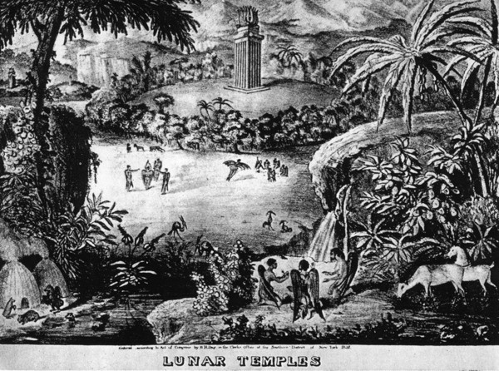
Appendix: Figures
Figure 1 : “1835 print sold by the Sun showing the Sapphire Temple”
In “The Great Moon Hoax” by Alex Boese for hoaxes.org

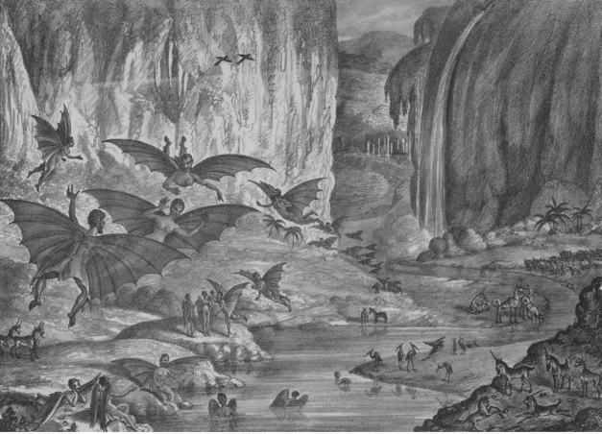
Figure 2 : “Lunar animals and other objects. Lithograph issued by the Sun 1835”.
Courtesy of the Library of Congress

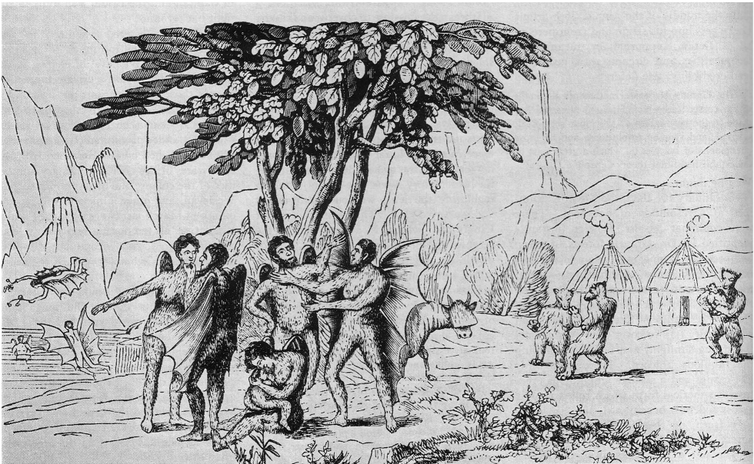
Figure 3 : “A remarkably detailed portrayal of the inhabitants of the Moon” from an English pamphlet published in 1836.
In “The Great Moon Hoax” by David Evans for Sky and Telescope magazine, 1981

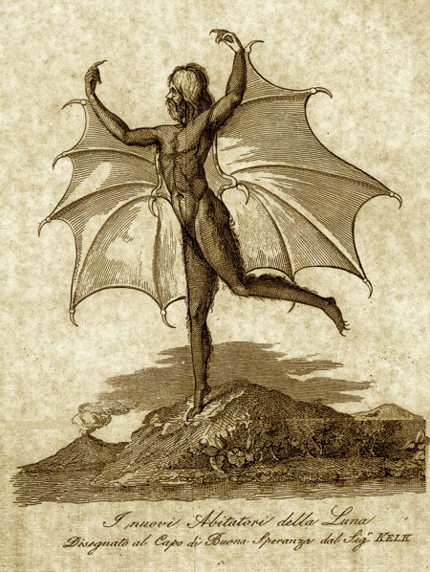
Figure 4 : “Vespertilio-Homo, from an Italian edition of the moon hoax”
In “The Great Moon Hoax” by Alex Boese for hoaxes.org
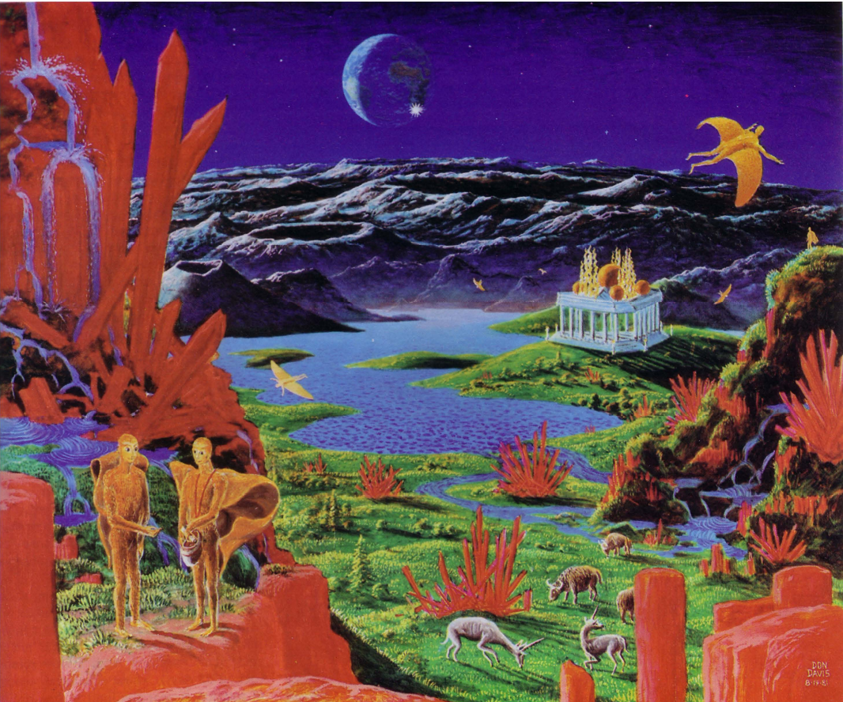
Figure 5 : “Don Davis has provided a modern-day reconstruction of the sights visible through Sir John Herschel’s imaginary telescope” for a Sky and Telescope article on the GMH
In “The Great Moon Hoax” by David Evans for Sky and Telescope magazine, 1981

