Community Engagement Assignment 2 – Reflective Report
Module code: LCBB4002
Lecturer: Dale Clarke
Student: Silviu Mujea 2019254

- Introduction
In this report I will talk about the importance of reflection and reflective practice giving an example of analysis using Gibbs Theory.
Reflective Practice is a modern term for an ancient approach of self-improvement, as well as a growing framework. Reflective Practice is a means of evaluating our own ideas and activities for the sake of personal growth and learning.
Reflective Practice can be utilized for personal growth as well as to help others grow. Reflective Practice is a method that can be applied in a variety of situations. It's a set of principles that can be used in a range of situations, including training, learning, personal growth, and self-improvement.
Reflective Practice, for example, is extremely important and beneficial to ongoing professional development (CPD). It is also very helpful in teaching and developing young people and children.

- Main body

Graham Gibbs, an American psychologist and sociologist, authored a book called "Learning by Doing." This was essentially a reflecting cycle model that was created in 1988.
Reflective Practice is primarily concerned with self-improvement. It encourages future personal growth by addressing how we think and feel about ourselves and situations now, as well as how we think and feel about ourselves and past events.
As a result, Reflective Practice is a useful tool for assessing where we are now and improving our present and future using insights and learning from the past. This has a wide range of Benefits that go beyond professional development and learning include, but are not limited to:
Workplace, romance, parenthood, and other human interactions
Rehabilitation
Reconciliation
Mediation
Stress management and reduction
Various types of teaching, training, coaching, and counseling
Parenting
Managing Change and Trauma
Reflective Practice is a term that can be used to describe an idea that is both old and flexible. This alternate terminology, which incorporates certain well-known concepts, can assist us in comprehending and explaining the principles and scope of the project. Reflective Practice, for example, is also known as, and is synonymous with, or comparable to:
Personal reflection, Self-review, Self-awareness, Self-criticism or self-critique, Self-appraisal Self-assessment, Intra-personal awareness, Personal cognisance/cognizance, Reflective dialogue, Critical evaluation, Self-analysis of our thoughts, feelings, actions, performance, etc.
The phrase "Reflective Practice" and its accompanying framework of language and application are increasingly being used to describe and express these concepts, terminology, and underpinning philosophy
As a result, 'Reflective Practice' is a theory through which current and classic self-improvement concepts may be better defined, developed, enlarged, modified, taught, accepted, and implemented for personal growth, teaching and coaching, and organizational improvement.
Reflective practice, according to Gibbs (1988), is concerned with practitioners reflecting on their regular ways of thinking and behaving within a particular circumstance in order to acquire insights about self and practice. Reflection alone is not sufficient but taking action is the solution, therefore, one needs to put their learning, knowledge and new understanding into practice; allowing the reflective process to inform the practice .
Gibbs' (1988) work enables the reflective practitioner to analyze and assess their practice, as well as make required adjustments. offers a six-part experimental reflective cycle that includes a detailed ‘DESCRIPTION' of the scenario, analysis of the ‘FEELINGS,' ‘EVALUATION' of the experience, ‘ANALYSIS' to make sense of the event, and ‘CONCLUSION' and reflection upon experience to examine what you would do if the situation occurred again ‘ACTION PLAN’.
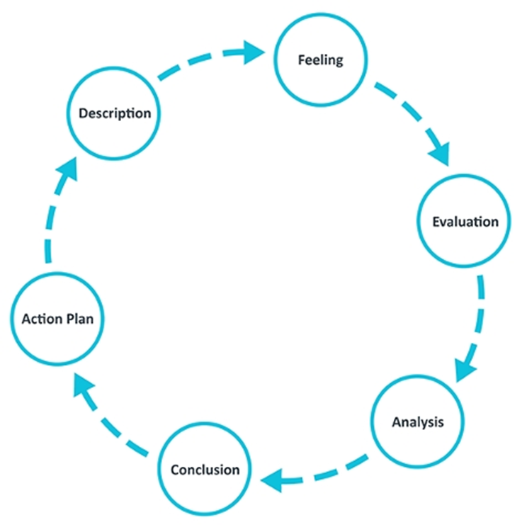
Source: University of Edinburgh (2019:1)

Gibbs (1988) stated:
“It is not sufficient simply to have an experience in order to learn. Without reflecting upon this experience, it may quickly be forgotten, or its learning potential lost. It is from the feelings and thoughts emerging from this reflection that generalisations or concepts can be generated, and it is generalisations that allow new situations to be tackled effectively”.

Gibbs model of appearance in nursing practice

There are various circumstances inside nursing where Gibbs becomes helpful. Consider dull undertakings, for example, patient registration or discussions or more specific, and less continuous occasions like managing a patient affected by liquor or enduring with psychological sickness. Gibb's will permit the attendant to ponder how they took care of the circumstance and feature the positives and negatives.
This may be beneficial if Gibbs was used to examine how the situation was handled in terms of usefulness, desk work, and measurements. On the other hand, it might be associated with particular characteristics and behaviors , such as how the medical attendant dealt with a pressing problem or sympathy, among other things.
According to Howatson-Jones (2016), Gibbs is important to nursing because he focuses on sentiments (or feelings) and acknowledges their importance in the reflective interaction, as opposed to other intelligent cycles that focus solely on the cycles and frameworks in place and how they may be improved.
At the point when appearance in the nursing rehearsed is talked about, recognize the two kinds, being reflection-on-activity and appearance in real life On the one hand, the exercise revolves around the client recalling a past meeting, but in real life, the focus is more intuitively on perceptions. Reflection allows clinical specialists to test and improve their present knowledge, increasing their chances of learning and aiding them in avoiding mistakes they may have made in the past. (Royal College of Nursing, 2012).
Because there is an emphasis on a reasonable reflection, zeroing in on both the fantastic and the horrible, Bulman and Schutz (2013) choose Gibbs Reflective Cycle as the ideal model to use. This is unusual, considering that most intelligent models focus solely on disappointments or the negative aspects of the situation, focusing on hostility as a result.
Why use the Gibbs reflective model?
Because Gibbs is a repeating model, the assumption is that the individual will offer suggestions that can be written down in an activity plan and implemented later. As indicated in the picture, there are numerous phases, each of which poses a unique set of questions. The first stage, for example, is portrayal, in which the customer is given the chance to represent the situation. Gibbs mentions a few questions that will assist focus on the portrayal alone, such as

1. What happened?

2. When did it happen, and where did it happen?

3. Who was available at the time?

Gibbs is a tried-and-true method of self-reflection that is simple to understand and apply for those who aren't specialists in the field. Following representation, the focus shifts to sentiments, with the client focusing on who they were throughout the event and what these feelings meant in the context. Given that each stage is only a few minutes long, the model is manageable.
Roffey-Barentsen and Malthouse (2013) states that the model is parted into two fundamental areas with the main requesting that the client group their experience, while the second segment assists the client with understanding the alternatives accessible for development.

Gibbs model of reflection model - Dementia

1. Description
Gibbs is a tried-and-true method that even non-experts in self-reflection may understand and apply. Following representation, the focus shifts to sentiments, with the client focusing on who they were throughout the event and what these feelings meant in the context. Gibbs is a interaction that is simple to understand and implement.
The woman become exasperated during the evaluation and vocal with me – not all that much however unmistakably the woman would not like to be here, however it was fundamental that we surveyed her.

2. Feeling

Sure, at first glance, given that I was familiar with the patient and their medical history. However, what I was not prepared for was the behavior of the patient, who grew agitated during the examination and was occasionally described as violent. Unfortunately, this might happen to someone suffering from dementia, as the patient here was becoming confused.
My perspective shifted. Compelled to keep the patient quiet, my focus on the assessment waned, and I sensed the urgent issue catching up with me, sabotaging my understanding. I was uncomfortable with the situation, and I recognized that this was reflected in my nonverbal communication, which may have seen as me not being fully focused on the patient or as me being 'weary' of treating this patient.

3. Evaluation

Excellent – I was well-educated and confident in my ability to devise a patient-care strategy.

Terrible - I allowed my emotions to obscure my judgment and so influence the type of care I could provide at the moment. While I was prepared to handle the patient's medical requirements, I was not prepared to handle their behavior during the evaluation, especially because I was taken off guard by their mental illness.

4. Analysis

Sympathy is an important quality in nursing that helps to build the patient-nurture connection. The patient must be reassured that the medical team is putting their health first in any evaluation and treatment plan, and that they are aware of their own problems. It's a balance between acting in a way that reflects your position and standing as a medical professional and acting in a way that doesn't.

5. Conclusion

From this experience I am more aware of how my own conduct and non-verbal communication during an appraisal or other association with a patient can straightforwardly impact their conduct.
I'm more aware of how easy it is for anyone but a patient to discern my feelings, from my nonverbal communication to how I speak. I should be more empathetic in these instances and have more mental fortitude so that I am not influenced by the patient's behaviour. In these situations, I need to resist panicking and maintain a professional demeanour.

6. Action Plan

In the future, I should be more proactive in discussing prior experiences with my partners and friends so that I may have a better knowledge of dementia patients' behavior. Two dementia patients' behavior may change in unexpected ways, with one becoming more controlled and the other growing more aggressive. This is something I need to recognize and feel more confident in.
I comprehend that I will turn out to be surer over the long run with this as I am presented to more circumstances, and as I get more counsel from my companions on how they manage it.
To summarize, the preceding presentation has presented a brief overview of Gibbs Reflective Model, demonstrating why the model is widely used throughout the medical care field. Following Gibbs' depiction of the interaction to self-reflect, a model focusing on dementia has been presented, which concludes with a practical activity plan that may be implemented.

III. Conclusion
This individual reflective report demonstrates that reflective practice is a cycle of analysing a particular scenario, and it tends to be accomplished via dynamic, in light of the strengths and flaws identified in the evaluation.
Reflective practice not only relieves us of the need to worry about the aspects of expert accountability, but it also demonstrates concern about how an expert can be transformed, inside a structure of responsibility.

Reference list

- Gibbs, G. (1988). Learning by Doing: A guide to teaching and learning methods. Further Education Unit. Oxford Polytechnic, Oxford.
- Millard, F. (2008). GP management of dementia: a consumer perspective. Australian family physician, 37(1-2), 89.
- Dinç, L., & Gastmans, C. (2013). Trust in nurse–patient relationships: A literature review. Nursing ethics, 20(5), 501-516.
- Roffey-Barentsen, J., & Malthouse, R. (2013). Reflective practice in education and training, London, Learning Matters.
- Bulman, C., & Schutz, S. (Eds.). (2013). Reflective practice in nursing, London, John Wiley & Sons.
- Royal College of Nursing (2012). An exploration of the challenges of maintaining basic human rights in practice. London, Royal College of Nursing
- Howatson-Jones, L. (2016). Reflective practice in nursing, London, Learning Matters.
- Jasper, M. (2013). Beginning Reflective Practice. 2nd edition. Andover, Cengage.
- Johns, C. (Ed.). (2017). Becoming a reflective practitioner, London, John Wiley & Sons.

