Smart and Connected Devices 2
Nick Alexander
Networking & Cyber Security
UWTSD
nalexander.147734@student.uwtsd.ac.uk

BENEFITS OF DIGITIZATION TO RELIEVE THE STRESS ON OVERSTRETCHED SERVICES & RESOURCES.

TABLE OF CONTENTS
Smart and Connected Devices 2 1
BENEFITS OF DIGITIZATION TO RELIEVE THE STRESS ON OVERSTRETCHED SERVICES & RESOURCES. 1
TABLE OF CONTENTS 1
LIST OF FIGURES 1
Abstract 1
1.0 INTRODUCTION 1
1.1 INTERNET OF THINGS 1
1.2 THE CURRENT IoT SITUATION 2
1.3 CURRENT RENEWABLE ENERGY 2
2.1 SECURITY 3
2.2 NETWORKING 4
2.3 SAFETY 4
2.4 POWER SAVING 4
2.5 POWER SOURCES 4
2.6 RESOURCE CONSERVING 5
2.7 MONITORING 5
2.8 LIMITATIONS OF THE SIMULATION 5
3.0 CONCLUSION 6
LIST OF ACRONYMS 6
4.0 REFERENCES 6

LIST OF FIGURES
Figure 1 – Design of the smart home 3
Figure 2 - The Setup of the Home Router 3
Figure 3 – IoT Server Rules for the Home 4
Figure 4 - IoT Server Rules for Office 4
Figure 5 - Green Power on Homes & Offices 5

Abstract- Because the world’s population has tripled in the past 60 years[1], the need for heat and power has surged, putting a high demand on the world’s fossil fuels. Scientists are increasingly turning their attention to alternative means of power, as well as ways to use less of the earth’s resources by using renewable energy in our homes and offices.

1.0 INTRODUCTION
This is an overview of what systems are available and what is currently being used around the world, a background of the Internet of Things (IoT), the benefits and risks of using these systems in a smart city environment and how houses and office buildings can incorporate smart devices to use less resources.
Essentially, by using smart devices and not just ‘dumb’ timers – electronics are only running when needed, not all the time. If every house used less gas and electricity, collectively the saving would be huge. This will show how solar panels, wind turbines and IoT devices can be used in conjunction with battery powered cars, to create smart homes of the future, putting far less pressure on fossil fuel demand.

1.1 INTERNET OF THINGS
The development of IoT devices is relatively new, and is already being “regarded as the third wave of information technology after Internet and Mobile networks”[2]. The attraction for the public is the immediate effect that the IoT device can bring – such as being able to turn on their heating or their lights with a mobile phone (or voice); but the interest for the companies and governments is the data that this activity provides[3]. Analysing the ‘big data’ from millions of IoT devices can be used to build up a pattern of people’s habits, therefore helping to predict future behaviour. This can assist power companies with the expected demand for homes; but also make predictions on behaviour patterns by using the big data from their servers.
One problem arising from this big data analysis, is that most of the processing is being done on cloud computers, so data security is becoming a major concern[4].

1.2 THE CURRENT IoT SITUATION
Siemens have written about the benefits of a smart, connected city, saying that it can “improve a city’s productivity and drive economic growth”[5]; they have even created a cloud based IoT operating system that can connect devices, then analyse the wealth of data that all of these devices generate[6]. This will likely be commonplace in a few years, but there are many devices available for homes and offices right now.
The main competitors in the smart heating market currently are:
- Hive[7] - which sell smart heating and lighting products as well as window and door sensors
- Nest[8] - A subsidiary of Google selling smart heating, smart fire alarms and doorbell-cameras.
Both offer similar functionalities such as control over the boiler using a mobile app & GPS presence detection, but nest has the advantage of being able to learn your routine and build up a schedule automatically. Also being part of google should give them many resources to ensure their products are secure from outside attacks.
The current leading brands in smart lighting are:
- Philips Hue[9]
- Samsung SmartThings[10]
SmartThings have taken an ‘open source’ approach so that they are compatible with many different manufacturer’s products. Philips Hue only work with their own light bulbs, yet they can be connected to a SmartThings hub so they can work together as part of a larger system. Philips seem to have the edge when it comes to security because of their closed system and secure hub.
As well as being able to control gadgets from a computer or mobile phone, it is becoming increasingly normalised for people to control their gadgets with their voice. The most popular of these devices are:
- Amazon Alexa[11]
- Google Assistant[12]
Because both are relatively new to the market, there are still some concerns over the ethics of these devices[13]. Amazon claims that their devices aren’t listening and recording everything, but only activate when hearing the wake-up word, (typically “Alexa”). Yet Amazon have been asked several times to hand over background recordings to the police for evidence in criminal cases[14].

1.3 CURRENT RENEWABLE ENERGY
Wind turbines, solar panels and ground source heat pumps[15] have all been around for many years now, but the main problem has been that the home’s devices such as the washing machine, TV etc had to be used while the electricity was been generated. This isn’t always viable (for example generating solar energy at night isn’t possible – which is when most people are at home). Wind turbines of course rely on windy weather for any power to be generated.
One of the most exciting revolutions in renewable energy of recent years is Elon Musk’s electric cars. The research for these cars has rapidly accelerated battery development[16][17]. This in turn has led to an alternative use for the batteries – they can now be used inside homes. Branded as Tesla’s ‘Powerwall’, with the ability to store power received from solar panels in the day time, and can be used to power devices in the home throughout the day and night, whatever the weather[18].
Another area of research being carried out in into renewable energy is Hydrogen fuel. There are some cutting edge developments at the moment using Hydrogen as an alternative to natural gas for cooking and heating. The benefits are that the only by-product is water, it is highly efficient and freely available; the challenges are capturing, storing and transporting it[19]. Research into using Hydrogen to power cars[20] has resulted in Hyundai releasing a car that is powered purely by hydrogen[21].
It seems ‘early days’ for the Hydrogen fuel cells yet, for the general public to make use of the technology it would require many petrol stations to supply Hydrogen, and homes to adapt their boilers. Whereas smart homes can be introduced fairly seamlessly, even adding renewable energy such as solar panels can be done without too much disruption to the existing infrastructure. This is the reason this scenario has been focused on in the simulation.
Some building developers are already starting to think in terms of sustainability and reducing their carbon footprint such as ‘Breeam buildings’[22]; but our existing homes and offices can be made to be much smarter and energy efficient. If many people each make a small change, the overall effect can be huge.

2.0 DESIGN & IMPLEMENTATION
It was decided that the implementation would focus on adapting existing homes and offices to avoid wasting energy on heating and lighting when nobody is around by using IoT devices, as well as using green power sources. The devices should be able to be controlled remotely and their power usage monitored.

A simulation of a smart home and a smart office was created using a program called ‘Packet Tracer’[23]. This was able to recreate how a street of houses connects to internet servers and how each individual home would be able to remotely monitor and control sensors and devices - see Figure 1.

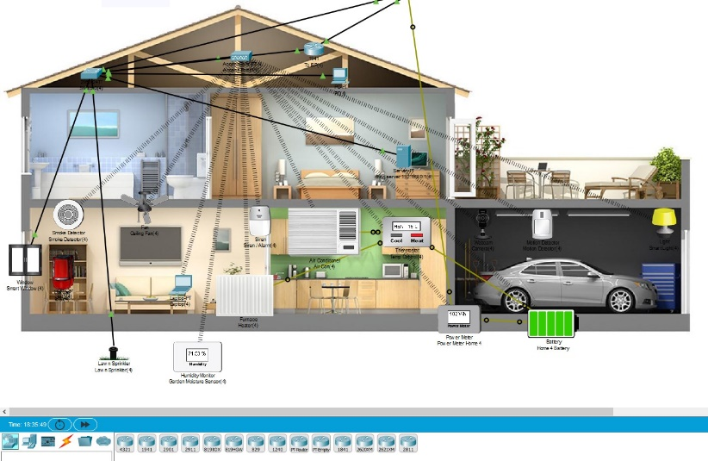
Figure 1 – an image taken from the design of the smart home
The home owner could then create a series of rules to control their devices however they wanted. An example of which can be seen in Figure 3. This shows how devices can be programmed by anyone – no knowledge of programming is required. Similar rules were setup in the smart office, designed so that devices would only work when somebody is present – see Figure 4.

2.1 SECURITY
One concern with adding many IoT devices to the home is whether each one is creating a weak spot in the security that hackers could exploit. To minimize the risk, NAT and Access Control Lists were setup in the routers (restricting access to the networks).
NAT is configured on the inside and outside of both edge routers –see Figure 2. (This is usually part of the wireless router in most homes, but are separated for this demonstration). This is essential nowadays because there a limited number of IP addresses, so by using NAT, all of the addresses in the home don’t have to be globally unique, in fact each house in the street uses the same addresses but the public IP address on the outside edge is different (and automatically assigned by DHCP on the ISP router).
Wifi is secured with AES encryption so only the house occupants can connect to the network.

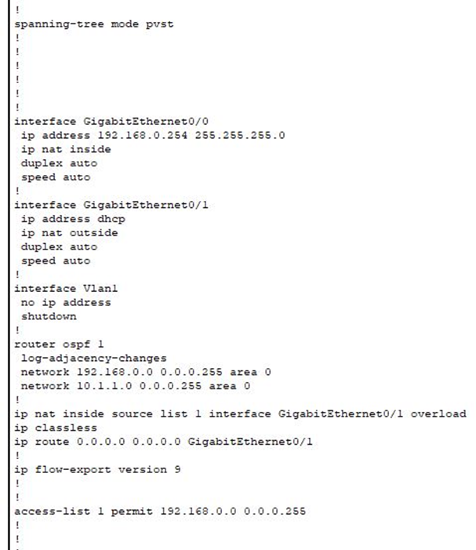
Figure 2 - The Setup of the Home Router

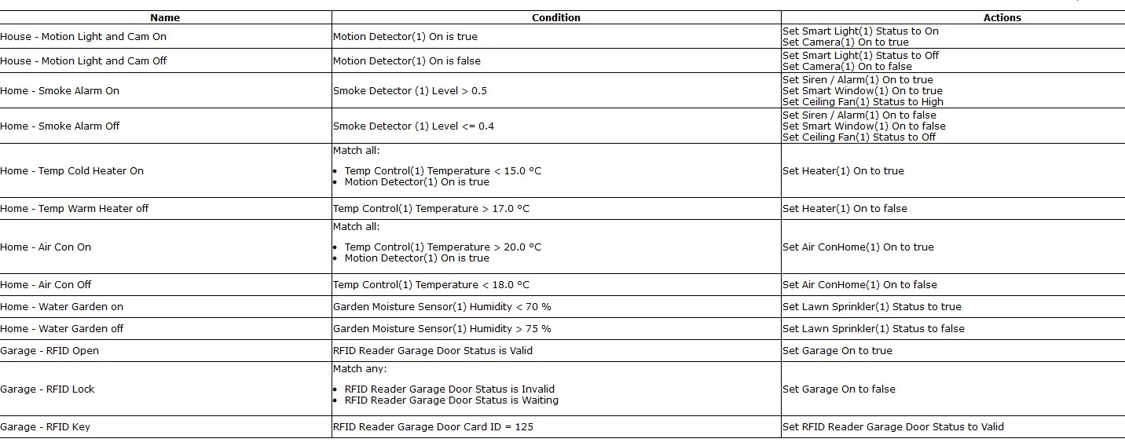
Figure 3 – IoT Server Rules Setup for Home Iot Devices

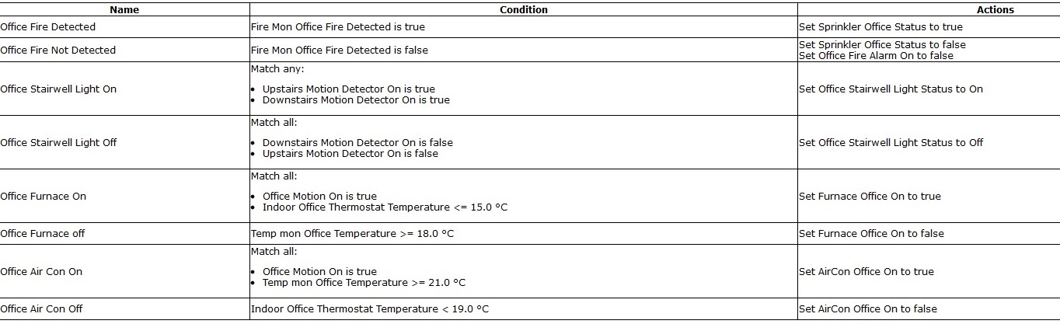

Figure 4 - IoT Server Rules Setup for office Iot Devices

2.2 NETWORKING
In order for the devices to work, they all connect to a remote server, but for this to work effectively several aspects had to be established, such as:
- DHCP - All devices whether connected wirelessly or by a wire to the home router, and are automatically given an IP address by the DHCP server. Also, each house is given a unique public IP address when it connects to the internet.
- A DNS SERVER – This is where the devices go to in order to translate a website address, for example www.bbc.co.uk, into its numerical address: 151.101.128.81. The devices know how to reach the DNS server because the DHCP server gave them its address when they first connected to the network.
- A Webserver – All servers are connected through the internet (setup with static IP addresses). The webserver is where the websites are hosted.
- IoT servers – This is where the IoT devices connect, which enables remote access to them and is where ‘rules’ can be created which dictate their functionality.

2.3 SAFETY
If smoke is detected in the kitchen the fire alarm sounds, the fan is turned on and the window opens. This happens whether somebody is home or not.
Fire detectors in the office, when activated tell the server to turn on the water sprinkler.
The garage door is automatically locked shut and can only be opened by using the correct RFID card. This protects the battery powered car from theft.

2.4 POWER SAVING
When the motion sensor in the office stairwell is activated – the light turns on, but when no motion is detected the light turns off again. This saves electricity by not having lights on when nobody is around. The same technology has been used to turn on a light and a security camera when motion is detected in the home, rather than constantly recording an empty house.
Smart windows can now be used as part of an energy efficient office, to heat up or cool down the interior (depending on the outdoor temperature). Even though the window / vent uses a little electricity to open and close – it is far less than that used in a heater or air conditioning unit. This has been setup in the office, by using a set of rules that only regulate the temperature when somebody is present.

2.5 POWER SOURCES
Smart Integrated power in the form of solar panels on the roof of each house, which charges a battery so the household can use the battery power instead of the national grid. On the roof of the office is a wind turbine which also generates electricity which can be used to power the office devices and the car batteries – see Figure 5:

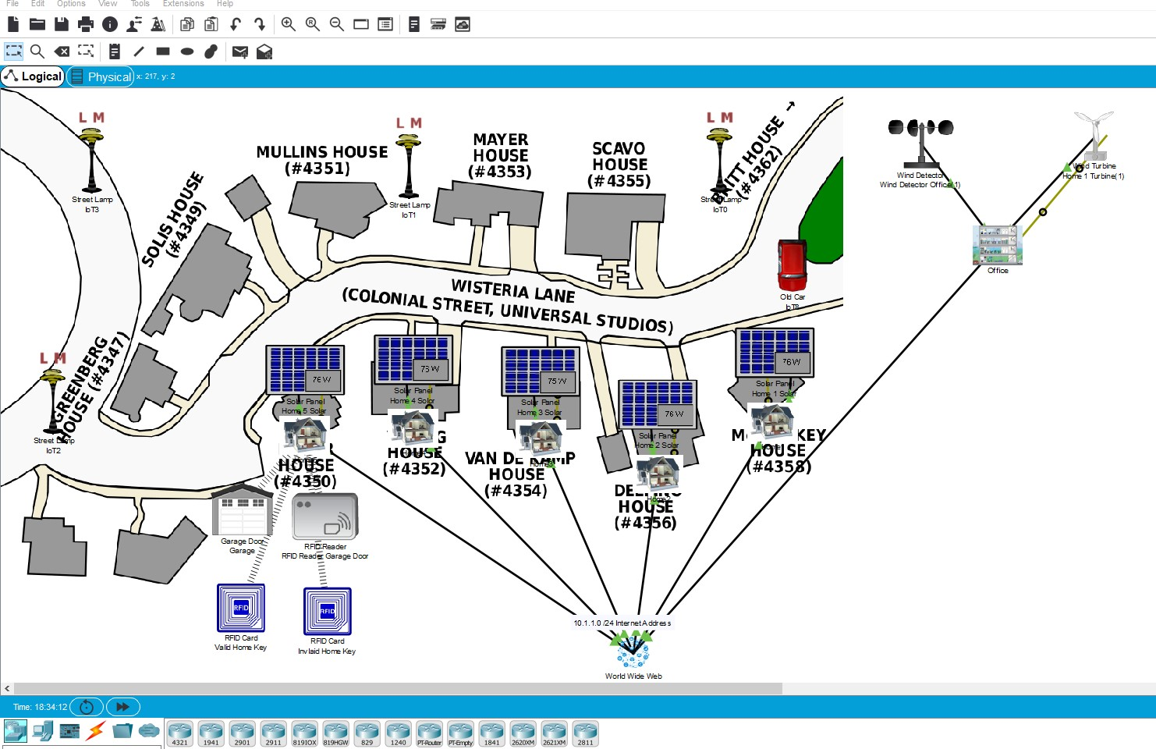
Figure 5 – Each house has a solar panel, and the office has a wind turbine for green energy

2.6 RESOURCE CONSERVING
Many people have their gardens watered by irrigation systems – which use a simple timer to turn the water on each day. The smart watering system used in the simulation monitors the moisture levels in the garden, and only turns the tap on if the grass is dry, saving water.

2.7 MONITORING
Monitoring is done by a power meter connected between the battery and the solar panel. Also a temperature monitor is connected to the thermostat, and a sensor in the garden to see if the internet enabled garden tap needs turning on. The RFID reader and the garage door are both IP enabled; meaning all of these sensors are linked to the remote server so the data can be recorded and viewed remotely.
Smart street lighting which only turn on when needed helps save power and also builds a pattern of traffic usage in that area.

2.8 LIMITATIONS OF THE SIMULATION
Packet tracer was primarily designed for networking tasks and can’t always perfectly recreate scenarios for IoT. For example – the indoor and outdoor thermostats always showed the same reading making it impossible to demonstrate the conditions setup for the office smart window. Not many devices could be connected to the battery, so a coffee machine was used to demonstrate, but this would normally be computer equipment, lighting, heating or a car-battery charger.

The internet network of connected routers would be much more complex in real life but was simplified for the demonstration, partly because the program would crash if too many devices were being used at the same time.
There was no sensor to test the wetness of grass, so a humidity sensor was used for the purpose, but this was impossible to control / demonstrate.
One of the biggest problems was the list of conditions wouldn’t scroll down beyond one page; the only way to fix this seemed to be to setup a second server (one for home, one for office).

3.0 CONCLUSION
This report has given an overview of what smart devices are currently available for sale and a simulation of a smart city was created. If it were to be created using the devices reviewed, the Philips lights would have been chosen, along with Google voice and Google’s Nest thermostat because of their experience and excellent track record of security.

The simulation showed how devices can be enabled only when someone is present, how sensors can save resources by only turning on when required. It was unable to demonstrate the use of a smart window because the thermostats couldn’t be isolated to interior and exterior zones. To allow this a more specialised simulator would be needed.

It shows that much more can be done to use green energy to power our homes and office buildings. One of the shortcomings of a simulator like this is the power monitor – evaluating how much green energy could be generated in a real-life situation. To overcome this, some sunlight or wind-speed readings would need to be recorded outdoors.

Overall the design of the network shows that it is quite possible to reduce power consumption by using smart devices, and by having them connected to remote servers. They can then be controlled remotely and monitored remotely also. There is some security to setup on the network to reduce the risk of hackers, but this is usually configured by the ISP. Using green energy to power and heat the home and even the car should be a reality within a decade.

LIST OF ACRONYMS
- IoT – Internet of Things
- DHCP - Dynamic Host Configuration Protocol
- SSID - Service Set Identifier
- DNS – Domain Name Servers
- NAT – Network Address Translation
- GPS – Global Positioning Satalite

4.0 REFERENCES

[1] G. W. Leeson, “The Growth, Ageing and Urbanisation of our World,” J. Popul. Ageing, vol. 11, no. 2, pp. 107–115, 2018.
[2] Q. Zhu, R. Wang, Q. Chen, Y. Liu, and W. Qin, “IOT Gateway: BridgingWireless Sensor Networks into Internet of Things,” in 2010 IEEE/IFIP International Conference on Embedded and Ubiquitous Computing, 2010, pp. 347–352.
[3] I. A. T. Hashem et al., “The role of big data in smart city,” Int. J. Inf. Manage., vol. 36, no. 5, pp. 748–758, Oct. 2016.
[4] C. Liu, C. Yang, X. Zhang, and J. Chen, “External integrity verification for outsourced big data in cloud and IoT: A big picture,” Futur. Gener. Comput. Syst., vol. 49, Aug. 2014.
[5] J. Schönig, “Welcome to the City 4.0,” 2019. [Online]. Available: https://new.siemens.com/global/en/company/stories/infrastructure/welcome-to-the-city-4-0.html. [Accessed: 07-Dec-2019].
[6] Siemens, “This is MindSphere!,” 2019. [Online]. Available: https://new.siemens.com/global/en/products/software/mindsphere.html. [Accessed: 08-Dec-2019].
[7] Google, “Hive,” 2019. [Online]. Available: https://www.hivehome.com/. [Accessed: 30-Nov-2019].
[8] Nest, “Nest,” 2019. [Online]. Available: https://nest.com/uk/. [Accessed: 30-Nov-2019].
[9] Philips, “Philips Hue,” 2019. [Online]. Available: https://www2.meethue.com/en-gb. [Accessed: 30-Nov-2019].
[10] Samsung, “Smart Things,” 2019. [Online]. Available: https://www.smartthings.com/gb/. [Accessed: 01-Dec-2019].
[11] Amazon, “Alexa,” 2019. [Online]. Available: https://www.amazon.co.uk/b?ie=UTF8&node=12728352031. [Accessed: 01-Dec-2019].
[12] Google, “Google Assistant,” 2019. [Online]. Available: https://assistant.google.com/. [Accessed: 01-Dec-2019].
[13] A. AboBakr and M. A. Azer, “IoT ethics challenges and legal issues,” in 2017 12th International Conference on Computer Engineering and Systems (ICCES), 2017, pp. 233–237.
[14] The independant, “AMAZON ORDERED TO GIVE ALEXA EVIDENCE,” 2018. [Online]. Available: https://www.independent.co.uk/life-style/gadgets-and-tech/news/amazon-echo-alexa-evidence-murder-case-a8633551.html. [Accessed: 01-Dec-2019].
[15] E. S. Trust, “Ground source heat pumps,” Website, 2019. [Online]. Available: https://www.energysavingtrust.org.uk/renewable-energy/heat/ground-source-heat-pumps. [Accessed: 24-Nov-2019].
[16] E. M. Jeff Dahn, “Battery ground-breaking research,” ioppublishing.org, 2019. [Online]. Available: https://ioppublishing.org/news/million-mile-battery-unveiled-by-ground-breaking-research/. [Accessed: 24-Nov-2019].
[17] J. Keil, N. Paul, V. Baran, P. Keil, R. Gilles, and A. Jossen, “Linear and Nonlinear Aging of Lithium-Ion Cells Investigated by Electrochemical Analysis and In-Situ Neutron Diffraction,” J. Electrochem. Soc. , vol. 166, no. 16, pp. A3908–A3917, Jan. 2019.
[18] Tesla, “Tesla Powerwall,” 2019. [Online]. Available: https://www.tesla.com/en_GB/powerwall. [Accessed: 24-Nov-2019].
[19] R. Mulla and C. W. Dunnill, “Powering the Hydrogen Economy from Waste Heat: A Review of Heat-to-Hydrogen Concepts,” ChemSusChem, vol. 12, no. 17, pp. 3882–3895, Sep. 2019.
[20] R. A. Najdi, T. G. Shaban, M. J. Mourad, and S. H. Karaki, “Hydrogen production and filling of fuel cell cars,” 2016 3rd Int. Conf. Adv. Comput. Tools Eng. Appl. ACTEA 2016, pp. 43–48, 2016.
[21] Hyundai, “Introducing the next generation of fuel cell vehicles,” 2019. [Online]. Available: https://www.hyundai.co.uk/new-cars/nexo. [Accessed: 25-Nov-2019].
[22] “BREEAM Worldwide,” 2019. [Online]. Available: https://www.breeam.com/. [Accessed: 25-Nov-2019].
[23] Netacad, “Packet tracer,” 2019. [Online]. Available: https://www.netacad.com/courses/packet-tracer.

