Student Name: Silviya Lambeva Petkova
Student ID: 2131589
Assignment: Reflective Report using Gibbs’ Reflective Cycle
Module and Code: LCBB4003 Introducing the Modern Workplace

Submitted on: 26/03/2023

Introduction
The Gibbs Cycle is a theoretical framework for engaging in self-reflection. The Reflective Cycle (or the Gibbs Reflective Cycle) is another name for this phenomenon. Using the Gibbs Cycle for Introspection When introspection is valued as highly as it is in fields such as education, social work, and healthcare, this tool is frequently used. The Gibbs Cycle entails the following steps: describing the situation, considering one's emotions, performing an evaluation, conducting an analysis, drawing conclusions, and developing a plan of action. Introspective practice, which could be thought of as the means by which one learns from one's own experience, was one of the main motivations behind the creation of the Gibbs Cycle. By acting in reflective practice, professionals can receive insight into what they did well, where they can improve, and how they can approach similar situations differently in the future. By applying the Gibbs Cycle to one's own thought processes, one can increase their self-awareness, critical reasoning, and problem-solving abilities. It may also help with things like teamwork and personal development. I was tasked to explore the relationship between the organization structure and its performance of British Airways.
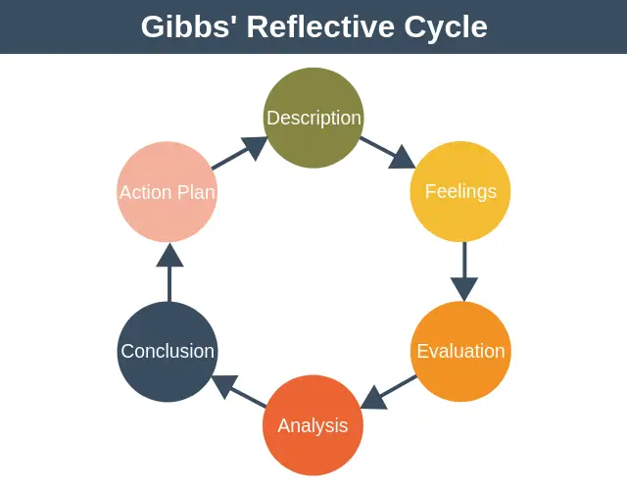
(Fig. 1 – Gibbs’ Reflective Cycle)

Description
I was part of a 5-member team. After a thorough discussion every one of us picked a topic to work on it. After doing my research I found that British Airways is a global airline that employs a hierarchical system with separate divisions for different services. The Board of Directors sits atop the company's structure, and it is their job to make big-picture choices that will affect the company's overall success.
We all were to submit our task individually according to our selected topic then go through them and organize accordingly. We were able to put together our whole tasks thanks to our excellent teamwork in my opinion. Although there were few hiccups on the way I believe we did pretty good.

Feelings
Understanding the importance of British Airways' organizational framework to the company's success is not beyond my capabilities. Alignment between the organizational structure and the company's aims and purposes is crucial to the success and efficacy of its operations. I think one can examine the variables that have an effect on the airline industry to gain a better understanding of where the layout of British Airways contributes to the company's performance. In my opinion, internally, the management, leadership style, but also attitude of British Airways can have a significant influence on the company's operational efficiency, the motivation of its workforce, and the level of satisfaction it provides to its customers. If I were to relate this finding with our group’s situation, to have someone we can be accountable to makes the task more reliable. This way we can voice our opinion and justify our actions. We appointed one person from our team who was in charge of selecting the organization and worked on topic one. We all submit our share of the task to that person and propose our findings. This made our task very organized. Cause we were able to critically evaluate the findings from our work and justify them.

Evaluation
From my work the organization is designed to make sure that day-to-day business activities support the company's long-term goals. While working as a team our main objective was to finish the work on time and generate a decent result.
Despite having our differences, we were able to come to common ground while giving our best. We were able to communicate, negotiate and convince each other.
We also found our shortcomings. As for me, I found out that I am less enthusiastic. I just provide the amount of effort which is needed without minding the whole situation. But this attitude is not healthy for teamwork. Since we almost had a conflict not sharing our thoughts.

Analysis

My group members were pretty good at maintaining the whole situation. When one of our members voiced their opinion, I came to realize it is very important to a team dynamic to properly convey your thoughts. We were able to reflect on our own work and give proper review on each other’s work to push ourselves to our limits. The overall experience taught working on a team can be overwhelming but also rewarding when we are able to put together our task.

Conclusion

In my opinion, considering the nature of mine I think I did a very decent job. But I think I could offer more to the team’s overall success. Like trying to be more considerate of others. I could properly follow up with my teammates and be supportive. I find the importance of encouraging the group to be able to meet the expectations. Overall, in my opinion I did a good job while doing my share of work but I could have done better in terms of doing the team work and being more engaging team member.

Action plan
I plan on working on my team management skills. Be mindful about other members’ thoughts and opinions. I also plan on improving my team building and communication skills. I think we have enough to prepare ourselves for future employment. I plan on challenging myself to go on further and participate in more group work as much as possible.
Conclusion
By the end of this self-reflective report, I have a better grasp of organization structure and its impact on employee performances for British Airways. Using Gibbs' Reflective Model, I have taken stock of my own leadership development and considered how I might use the theories I've studied. I am dedicated to developing as a leader and applying this knowledge to increase morale, enthusiasm, and output in the workplace.
References
Adeani, I.S., Febriani, R.B. and Syafryadin, S., 2020. USING GIBBS’REFLECTIVE CYCLE IN MAKING REFLECTIONS OF LITERARY ANALYSIS. Indonesian EFL Journal, 6(2), pp.139-148.
Gibbs’ Reflective Cycle (https://expertprogrammanagement.com/2019/05/gibbs-reflective-cycle/), Accessed on 24th March 2023
Husebø, S.E., O'Regan, S. and Nestel, D., 2015. Reflective practice and its role in simulation. Clinical Simulation in Nursing, 11(8), pp.368-375.

