(AC 1.1)
The CIPD explains (CIPD, 2017, 4:56) that evidence-based practice is the ability to utilise critically appraised evidence, from multiple sources to make high quality decisions. This supports us to ensure that all decisions that we make, are factual, none biased and not based on our personal thoughts or opinions. The CIPD outline, (CIPD, 2025) there are six key concepts to achieving this:
- Translating the practical issues into answerable questions,
- Searching for and receiving the evidence,
- Critically judging the trustworthiness and relevance of the evidence,
- Pulling the evidence together,
- Incorporating the evidence into the decision-making process and
- Evaluating the outcome once the decision has been made.
When using the bounded rationality model to evaluate the concept of evidence-based practice, I have concluded that following these guidelines regimentally is unrealistic. Especially when dealing with very complex HR scenarios.
For example; We only have a limited amount of mental capacity, and therefore complex scenarios which include a lot of evidence, may become difficult to effectively interpret.
Mental shortcuts, can also affect our decision-making process, making consistency in decision making very difficult to manage.
The CIPD (CIPD, 2023) However, argues that utilising evidence-based practice ensures professionals are able to make the best decisions, based on the best information available at any given time. It also encourages professionals to research the trustworthiness of the information they receive, therefore creating a professional perception, that any decision that HR make is based on other research, published by credible sources.
In my opinion, Technivara should use evidence-based practice to deal with flexible working requests. We already know that Bill struggles with change, and therefore Sue and her team, could utilise these six concepts to ensure they adopt a structured approach to dealing with individual requests. This may ease Bill ‘s anxiety, by knowing that Sue and her team have followed a regimented set of guidelines, utilised previously, within other organisations, in order to make their decisions effectively. This also ensures an open line of communication is enforced, between employee and employer, creating a better working environment for all.
Similarly, Sue and her team could also use these concepts to draw effective conclusions within disciplinary meetings. The concepts will ensure that all information they have considered, is based on its own merit, and any decision they reach, will be enforceable and consistent across the rest of the business.
(AC 1.2)
The CIPD explain (CIPD, 2025) that the PESTLE analysis is a management framework and diagnostic tool which supports various organisations diagnose problems, understand their challenges and evaluate their opportunities.
Each business will react differently, depending on the varying degree of change within each category below;
- Political – Changes within government and their policies
- Economic – Changes in exchange rates, economic growth or decline, globalisation, inflation, interest rates and the cost of living
- Social – Changes in lifestyle factors, cultural norms and expectations, career attitudes and work-life balance.
- Technological changes - Innovations in technology, production and the distribution of products and/or services
- Legal changes – Employment tribunal decisions which are made, affecting the stability of exiting company policies
- Environmental changes – The companies’ environmental impact, carbon emissions and how the company engages with sustainable resource
The benefit of using a PESTLE analysis tool, is that Technivara can identify risks to the business quickly. For example, Sue has already admitted to failing to store confidential information digitally, and therefore the company may now be in breach of GDPR guidelines. By failing to embrace this change, Sue has now put the company at risk of receiving legislative fines and reputational damage.
The disadvantage of using this type of tool however, is that some changes happen rapidly and therefore it becomes increasingly hard for businesses to keep up. Bill is struggling with change as it is, so if Sue completes and in-depth PESTLE analysis, this may identify an array of issues, which make Bill further resistant to change. Although I think PESTLE is great analysis tool to identify potential issues quickly, it needs to be used in moderation.
In addition, Richard explains that exit interviews are also another great way for companies to gain invaluable employee feedback. (Newsome, 2024) He explains, gaining this feedback helps businesses to understand why their employees leave, in addition to gaining insight as to their experiences with the company thus far. Reflecting on this feedback can help businesses identify all sorts of problems, and by rectifying these issues, it puts the business in a good position to improve experiences for all their future employees too.
Alice Agues, however, (Burks, 2025) that exit interviews are outdated, and ‘stay’ interviews should be conducted instead. Speaking to employees before they leave, can influence their decision to stay. Having these types of conversations taps into individuals’ levels of engagement, loyalty and understanding. It’s also been argued that businesses who continue to demonstrate these high levels of engagement with their staff have far better chance of retaining them.
In my opinion, Technivara should utilise both analysis tools in order to gain the most insight. It sounds as though Bill and Sue run a large-scale organisation, and therefore it would be reasonable to believe that their workforce is varied. Utilising this lucrative candidate pool will be a great opportunity for the business to better understand their staff and make small scale changes to improve their chances of retention.
(AC 1.3)
Critical thinking involves objectively analysing information and situations to make sound decisions and problem solve. It’s about asking the right questions, gathering evidence and evaluating different perspectives.
Chris suggests there are four key principles to achieving this (Cebello,2018).
I have utilised them below, and demonstrated how Technivara may use them to deal with a grievance scenario.
Problem Identifying;
During this stage, Sue and Bill could work together to have a healthy debate as to why they feel a grievance has been raised. They can also hold each other to account, if they feel their bias is coming into play, ensuring consistency.
Information Gathering;
During this stage, Sue could discuss her findings with her HR team allowing for counter arguments to be made against people’s thoughts and opinions. Sue should also ensure Technivara company policies and procedures are up to date at this point, she can do this by reaching out to her wider HR network to ensure reliability.
Evaluating the Options;
This is a reflective task and therefore Sue and Bill should use past examples here, to understand how previous decisions have affected their workforce. It’s also important for them both to recognise, that although the company has been running for sixteen years, the landscape would have changed over that time, so what worked before, might not work now.
Implementation and Monitoring
This will be the most challenging part for Technivara. As Bill is reluctant to change. It might be a good idea, therefore for Bill and Sue to reach out to other companies, and ask how they have dealt with these types of situations. This may influence Bill to be more open minded about the options they have. At this stage it will also be important for Sue to document the effectiveness or ineffectiveness of the outcome they have chosen, as this will provide them with data driven evidence, they can utilise when dealing with future related grievances.
Tim Coburn outlines that critical thinking gives us the tools needed to ask open questions and be persuasive. (CIPD,2019, 14:58). These skills are needed in order to ensure implementation of critical thinking it is done so effectively.
Ron (Young, 2023) outlines, the benefits of using critical thinking are as follows;
- It provides fair and equitable outcomes for all.
- It prevents future disputes and improves workplace relationships.
- It improves critical thinking skills, allowing HR and Mangers to be more effective in dealing with other workplace conflicts.
- It allows employees to feel more heard, fostering trust and more positive working relationships.
(AC 1.4)
De Bono explain that, ‘lateral thinking is for creating ideas, and the six thinking hats are used to explore, develop and implement them.’ (The De Bono Group, 2019).
By wearing and switching the hats, an individual can focus on/or redirect their thoughts, to ensure they have completed an in-depth evaluation process of all outcomes.
Technivara can benefit from this, by utilising this process within the hypothetical grievance example mentioned above.
The ‘White Hat’ can be used to ensure Bill and Sue have looked at all the information objectively. Taking into account everyone’s thoughts, opinions and feelings. The ‘Red Hat’ can then be used to evaluate how they feel about the options they have. For example, I’m worried about that outcome because... or I don’t like that one because... The ‘Black Hat’ will then highlight areas of risk. For example, legal implications that could arise as a result of ignoring legislation, e.g., Equality Act 2010. The ‘Yellow Hat’, will then provide opportunity to discuss positive outcomes, and how this could benefit both parties. The ‘Green Hat’ will then be used to explore further ideas, and provide modification opportunities. Finally, the ‘Blue Hat’ will ensure Sue and Bill can reflect on the decisions they have made, ensuring these have achieved their original agreed objectives.
The benefits of doing this, says Daniel (Halis,2023) is that it improves decision making by encouraging participants to systematically consider the problem from multiple perspectives. Helping to reduce bias, enhance creativity, balance emotions, and identify risks and benefits.
Another process Technivara could use is; problem outcome framing. David says this is a structured framework used to help employers focus more on desired outcomes, rather than the problems themselves. (Young, 2023)
The key elements to outcome framing are;
- Clearly defining the outcome, you want
- Understanding the positive impacts these could make
- Determining how this will be achieved
- Focusing on the resources available to facilitate this
This framework is suitable to achieve positive outcomes within a flexible working request, for example.
Technivara should use this to focus on what healthy relationships look like, rather than who’s at fault. It also helps both parties to look at the bigger picture, says Alvin, working more collaboratively to achieve an agreed outcome. (Hermanto, 2021).
(AC 1.5)
Utilitarianism can help you evaluate the consequences of your actions. Promoting a culture of collaboration, transparency, and accountability says, David. (Vogel,2023).
In order to achieve this, you firstly need to understand the problem, identify your stakeholders and generate solutions based on what is suitable for the majority. Once a solution is implemented, its then important to evaluate and monitor its effects.
(Zinsili, 2023) Steven suggests that utilitarianism can be used to encourage rational and consistent decision making, basing all conclusions on facts and evidence.
An example, utilitarianism was used during the pandemic. The government decided to implement a widespread vaccination programme in order to achieve a herd immunity, protecting the entire population, reducing overall illness and deaths instead of focusing on the minority.
The benefit of Utilitarianism is that it provides clear and objective decision making. Focussing on benefiting the majority of people. It also encourages impartiality and focuses on the interests of everyone.
Technivara should use this to deal with redundancies, as an example. As it will allow them to think of alternative options, outside what may seem the most obvious. Looking at implementing shorter working weeks, or temporary bonus reductions, for example, as this is spreading the over financial cost across the business, rather than taking away from the minority’s livelihoods.
The difficulty arises however, when trying to measure and compare different levels of success. To improve Technivara’ s chances of getting decisions right the first time, they should involve their stakeholders in all of their decision-making processes. They should also evaluate the short- and long-term effects on people, by utilising relevant data, published by similar organisations, in these scenarios. This ensures the wellbeing of staff is prioritised.
Kantianism, however, emphasises on treating employees with inherit dignity and respect regardless of the desired outcomes. (Mwasalwiba, 2022) Modester explains Kantianism expects practitioners to act without regard for personal desires, incentives or biases.
Nwozichi et all. (2018) Explains that Kantianism is often used by health professionals to treat cancer patients. Oncology nurses use this to deal with the patients and their families. Making ensure all decisions made are seen as ethical and not seen as impulsive or driven by emotion.
This allows decisions to be made based on human dignity. Preventing people from mealy putting a means to an end. The challenge with this however, it’s that it’s a ridged approach. Potentially not fit for scenarios whereby emotional discretion needs to be used.
I therefore feel Kantianism could be in applicant interviews, for example. As this will ensure the process is fair and consistent. This will also avoid any form of discrimination and/or exploitation being used.
(AC 3.1)
Technivara could use key performance indictors to measure their non-financial performance. These are measurable values that show how effectively an organisation is achieving its strategic and operational goals. An example of this can be seem within my organisations broader measure scores. This is a satisfaction score that is generated by averaging our customers survey feedback, monthly. The customers are asked a number of questions to establish their levels of customer service. The closer to an average of ten we receive the better. If we do receive any scores of four and below however, these investigated, and dealt with accordingly. Similarly, Bill could use this type of measure to evaluate his own employee engagement levels. Creating a survey assessing how his employees may feel after a change, or a business decision is made for example. This can be done either monthly or quarterly. Sue could also use this information to take learnings back to her HR team to implement these changes. According to Frith (2025) 87% of businesses are now using KPI’s to track their time to hire. A recruitment metric, which assesses the employee recruitment cycle from advert to offer.
Becky, suggest that KP tracking is invaluable, as it provides objective data, which can be used to make informed decisions about hire options that may benefit the business. It also tracks performance over time, showing clear progress or decline. Furthermore, it provides the businesses with clear objectives that everyone can work towards collaboratively, encouraging a shared vision. Snowden (2025) counterargues, that incorrect data however, could make KPI tracking inconsistent. In addition, it may also narrow the company’s focus to outcome-based objectives, inhibiting them from seeing the bigger picture.
Technivara could measure their financial performance by tracking their gross and net profits. Gross profit is the revenue from sales, minus the costs of producing or acquiring the goods. Whereas net profit, is what is left after all expenses are paid. (HSBC, 2025) Advise that this is a beneficial way to measure performance, as it helps identify areas of cost control and pricing strategies. This optimises decision making and sustains business growth. Grundy (2024). Supports this claim by adding, businesses are able to use profitability ratios to calculate how effectively their business converts sales into profit. Tracking trends over time, allows you to see a comprehensive picture of the companies overall financial health. Companies like Apple are known for effectively tracking and managing their gross and net profit, demonstrating a strong and consistent profitability over the years, with 2024 showing a net income of 93.7 billion Migiani (2023).
(AC 3.2)
Woodhams and Perkins (2022, P.135) Explain – The primary objective of the people management function within an organisation is to add value to the organisation, plus its stakeholders including its shareholders, employees and surrounding community. Value created for each may be measured differently though, such as higher earnings or improved engagement levels.
Sue could use cost-benefit analysis, to demonstrate how recruitment decisions could benefit company. This will involve comparing financial and non-financial costs against predicted benefits to determine overall value and financial viability. Employment Hero (2022) outlines there are six steps to this process; These are:
- Identifying objectives – This could be, increasing the company revenue by 10%.
- Auditing the workload – Understanding how much work there is to be done, the time spent doing this, and where the bottlenecks are.
- Defining the requirements – Identifying areas where current workload challenges can be redistributed, in order to identify challenges.
- Weighing up the costs – Quantifying the indirect and direct costs of the hiring process. For example, the initial costs of recruitment, such as, time spent training the new employee for example, versus the benefit of hiring such as easement of team workload and reduction to workplace stress.
- The consideration of alternatives – Deciding whether the initial objective can be achieved via a different method. For example, seconding an existing employee into the department
- Using the results to build a business case – After considering all options, the cost benefit analysis will demonstrate whether recruiting will be beneficial to the business or not.
Another Impact measure is, return on investment (ROI). This could be used to measure Technivara’ s impact on employee engagement levels, as an example. To apply this, you would need to compare the money spent on imposing an employee engagement indicative versus the benefits the company would see in increased employee satisfaction survey scores.
To measure return on investment, you apply this simple formula, says, (Quantum Workplace, 2025).
- Subtracting the total costs incurred from the benefits realised. Providing you with a net gain or a return generated by engagement initiative.
- Then divide the net gain, by the total costs incurred. Providing you with a decimal value, which you can then multiply by 100 to express you’re (ROI) as a percentage.
As an example; The cost to implementing an engagement initiative will cost the business £10,000. The benefit of this however, will be: increased productivity, saving the company £20,000. Reduced turnover, £10,000. Improved customer satisfaction, leading to more sales £5,000. Therefore, (£35,000 - £10,000)/£10,000 x 100 = £250% ROI. This means, for every £1.00 invested, the company will generate a £2.50 return.
(AC 2.1)

(AC 2.2)
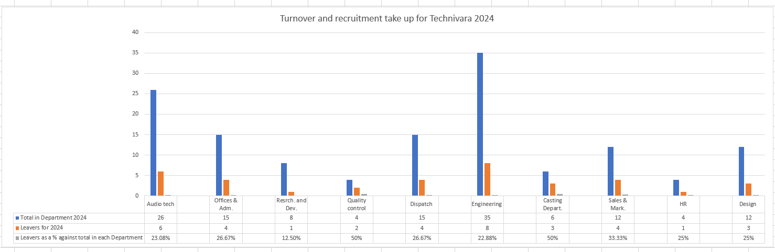

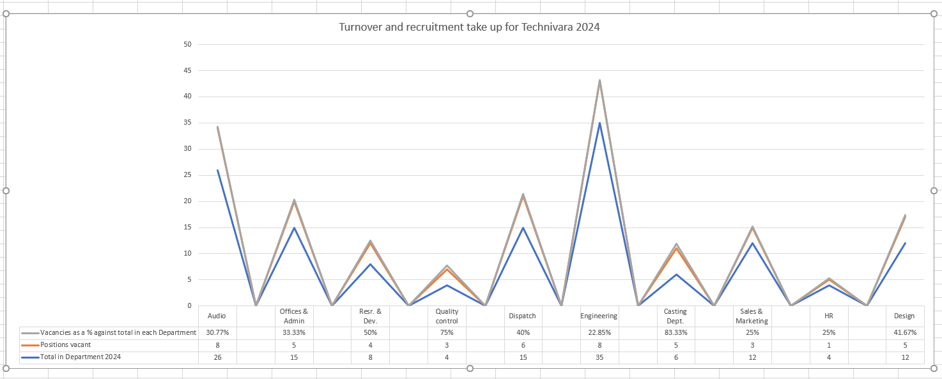

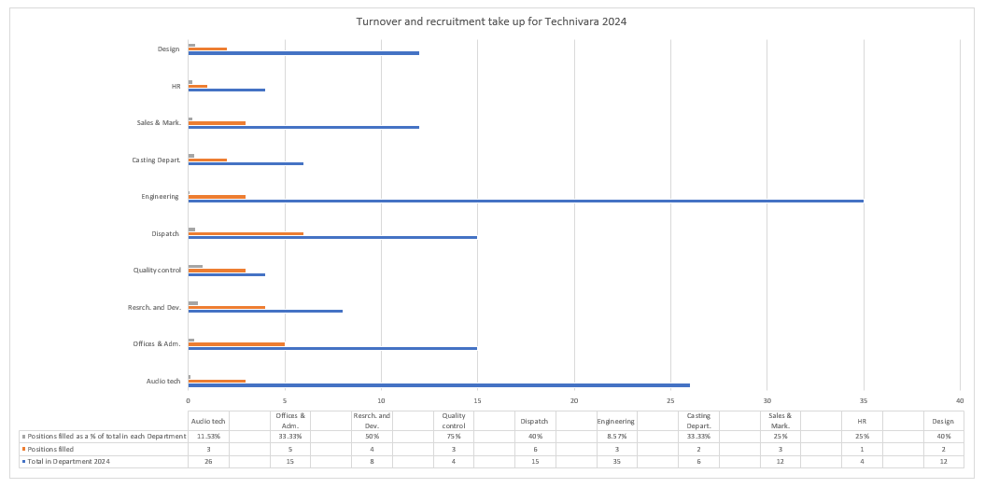

(AC 2.3)
From analysing the data, it is evident that 36% of employee’s felt agreed objectives were not met by the end of the session. However, 81% of employees felt objectives were clearly communicated from the outset. This demonstrates to me, either a lack of clear communication/understanding by the employees or a lack of potential support from the facilitator, when trying to support the learner in achieving their goals.
This outcome may replicate itself in other scenarios for Technivara, for example within performance management conversations, one to one’s scenarios or appraisals.
The CIPD outline, (CIPD, 2025) Helping employees to perform well is a central role of line managers and people professionals. Employees need to understand what is expected of them, and must be managed so that they are motivated, have the skills, resources and support they need to succeed.
I therefore recommend that Technivara invest is some form of Management training, such as the Level 5 Certificate and Diploma in Effective Coaching and Mentoring, offered by the Institute of Leadership and Management. To, as the course content suggests (ILM, 2025) allow Managers to unlock employee potential, increase engagement and enable change. This improves team performance by giving Managers the toolkit needed to build rapport, set powerful goals, and inspire resilience and self-belief.
This would improve the likelihood of employees achieving their objectives the first time around. Enhance employee engagement and empower Managers to ask the right questions. The risk of not looking at these types of options, may mean employees are forced on performance improvement plans, unnecessarily. Costs could also be incurred by sourcing further training for these individuals, when failure to meet objectives, could purely be down to a lack of understanding. I appreciate there may be an initial outlay for the business to facilitate this type of training, however the return on investment could be great.
From reviewing the data, I also note that 57% of employees felt the training may not have aligned with their current performance targets, in addition to 52% of employees also feeling unsure how they could implement this training within their day-to-day roles. This to me, is a clear indication of Managers thinking they know what’s best for their employees.
Engagement research (Itzchakov, Weinstein and Cheshin, 2022) shows that ‘effective listening can lead to improved performance at work, more job satisfaction, enhanced creativity, and increased employee engagement’
Therefore, my suggestion would be that Technivara establish a working group, consisting of a verity of sources, in order to discuss training needs in depth, regularly. Technivara could also source an experienced trainer, to facilitate this. The benefit of this would be improved workforce culture. A workforce where employees feel listened to, and feedback taken onboard. The risk of not doing this, could be that employees feel they are never going to meet workplace objectives, potentially having a negative effect on future sickness targets. Although, I appreciate there will be a considerable financial implication to achieving this, such as the trainer’s salary and the time spent facilitating the working group, the employee and employer relationship development could be substantial.

Bibliography
- Burks, A. (2025). 'Stay interviews are an excellent tool, but they remain underused', Hr Magazine. (June). Available at: https://www.hrmagazine.co.uk/content/features/stay-interviews-are-an-excellent-tool-but-they-remain-underused (Accessed: 12 August 2025).
- Cabello, C. (2018). 'The Seven Key Steps of Critical Thinking'. Forbes. (April). Available at: https://www.forbes.com/sites/forbescoachescouncil/2018/04/20/the-seven-key-steps-of-critical-thinking/ (Accessed: 15 August 2025)
- CIPD . (2025). Evidence-based HR: Make better decisions and step up your influence. Available at: https://www.cipd.org/uk/knowledge/guides/evidence-based-profession/ (Accessed: 30 July 2025).
- CIPD. (2017, July 4). Evidence-based practice: an introduction [Video]. YouTube. https://www.youtube.com/watch?v=ikJ687g2tPo (Accessed: 30 July 2025).
- CIPD. (2019) Critical Thinking [Podcast]. 5 November. Available at: https://www.cipd.org/en/knowledge/podcasts/critical-thinking/ (Accessed: 15 August 2025).
- CIPD. (2023). Building an evidence-based people profession. Available at: https://www.cipd.org/en/views-and-insights/thought-leadership/insight/evidence-based-profession/#:~:text=The%20benefits%20of%20evidenced%2Dbased,are%20more%20trusted%20by%20employees. (Accessed: 04 August 2025).
- CIPD. (2025). Performance Management: an introduction. Available at: https://www.cipd.org/uk/knowledge/factsheets/perfromance-factsheet(Accessed: 15 September 2025).
- CIPD. (2025). PESTLE analysis. Available at: https://www.cipd.org/uk/knowledge/factsheets/pestle-analysis-factsheet/ (Accessed: 04 August 2025).
- Dunhill, J. (2024) 'Happy Employees, Thriving Business: The ROI of Employee Engagement ', Moralbox, 16 January. Available at: https://www.moralbox.com/happy-employees-thriving-business-the-roi-of-employee-engagement/#:~:text=Real%2Dworld%20examples%20paint%20a,be%20part%20of%20the%20team(Accessed: 15 September 2025)
- Employment Hero. (2022) 'How to perform a cost-benefit analysis pf hiring', Employment Hero, 10 September. Available at: https://employmenthero.com/uk/blog/cost-benefit-analysis-of-hiring/#hiring-costs (Accessed: 15 September 2025).
- Frith, B. (2025). ‘Metrics enable better decisions around talent’. HR Magazine. 27, July, Available at: https://www.hrmagazine.co.uk/content/features/metrics-enable-better-decisions-around-talent (Accessed: 08 September 2025)
- Grundy, R. (2024) ‘What is net income and why is it important?’ Sage. 18 January. Available at: https://www.sage.com/en-gb/blog/what-is-net-income-why-its-important (Accessed: 08 September 2025)
- Halis, D. (2023). ‘Unveiling Edward De Bono’s Six Thinking Hats: A Strategic Approach to Thinking.’ The People Development Magazine. (November). Available at: https://peopledevelopmentmagazine.com/2023/11/08/six-thinking-hats/(Accessed: 19 August 2025)
- Hermanto. A. (2021). ‘Problem Framing: What it is and How to Write a Problem Statement’. Medium. (April). Available at: https://alvinhermanto.medium.com/problem-framing-what-it-is-and-how-to-write-a-problem-statement-401720cd5a41 (Accessed: 19 August 2025)
- HSBC (2025) Gross profit vs net profit. Available at https://www.business.hsbc.uk/en-gb/insights/starting-a-business/gross-profit-vs-net-profit (Accessed: 08 September 2025)
- ILM (2025). Qualifications explained. Available at: https://www.i-l-m.com/learning-and-development (Accessed: 15 September 2025)
- Itzchakov, G. Weinstein, N. Cheshin, A. (2022) 'Learning to listen: downstream effects of listening training on employees' relatedness, burnout, and turnover intentions', CIPD. Available at: https://www.cipd.org/uk/knowledge/bitesize-research/listen-improve-employee-engagement/(Accessed: 16 September 2025).
- Migiani, J. (2023) ‘Apple Sales and Profits Analysis For FY 2023’. FForester. 21 November. Available at: https://www.forrester.com/blogs/apple-sales-and-profits-analysis-for-fy-2023-top-10-insights (Accessed:08 September 2025)
- Mwasalwiba, M. (2022). ‘Resolving ethical dilemmas in the HR profession by Kantian perspective’. [LinkedIn] 20 December. Available at: https://www.linkedin.com/pulse/resolving-ethical-dilemmas-hr-profession-kantian-modester-mwasalwiba/(Accessed: 27 August 2025)
- Newsome, R. (2024). ‘Exit Interviews: Their Purpose & Best Practices’. Access People HR. (July). Available at: https://www.peoplehr.com/en-gb/resources/blog/exit-interviews (Accessed: 12 August 2025).
- Nwozichi, CU., Guino-O, TA., Madu. AM. (2018). Kant in Presenting Oncology Nursing Realities. Asia-Pacific Journal of Oncology Nursing. Available at: 10.4103/apjon.apjon_2_18(Accessed: 27 August 2025)
- Snowden, R. (2024) ‘Think HR Has No Metrics? Here's How to Prove Them Wrong with HR Metrics for 2025!’ [LinkedIn] 23 November. Available at: https://www.linkedin.com/pulse/think-hr-has-metrics-heres-how-prove-them-wrong-for2025-snowden-erohc (Accessed: 08 September 2025)
- The De Bono Group. (2019). Six Thinking Hats. Available at: https://www.debonogroup.com/services/core-programs/six-thinking-hats/ (Accessed: 19 August 2025)
- Vogel, D. (2023). ‘How to foster a culture of utilitarianism in your organisation or team?’ [LinkedIn] 16 April. Available at: https://www.linkedin.com/advice/0/how-do-you-foster-culture-utilitarianism-your#:~:text=David%20Vogel-,Solar%20Energy%20Mentor%20I%20Streamlining%20Federal%20Grant%20Approvals%20&%20Material%20Distribution,divineintervention%20%23gabenfreude%20%23MentalHealthAwarenessMonth(Accessed: 27 August 2025)
- Woodhams, C. and Perkins, G. (2022) Research and evidence-based practice. Kogan Page Limited.
- Young, D. (2023). ‘A guide to problem framing: best practices & templates. Mural. (June). Available at: https://www.mural.co/blog/problem-framing(Accessed: 19 August 2025)
- Young, R. (2023). ‘The Power Of Critical Thinking: Enhancing Decision-Making And Problem-Solving’ Forbes. (July). Available at: https://www-citethemrightonline-com.ezproxy.uwtsd.ac.uk/sourcetype?docid=b-9781350927964&tocid=b-9781350927964-28&st=magazine (Accessed: 19 August 2025)
- Zinsili, S. (2023). ‘How to foster a culture of utilitarianism in your organisation or team?’ [LinkedIn] 16 April. Available at: https://www.linkedin.com/advice/0/how-do-you-foster-culture-utilitarianism-your#:~:text=David%20Vogel-,Solar%20Energy%20Mentor%20I%20Streamlining%20Federal%20Grant%20Approvals%20&%20Material%20Distribution,divineintervention%20%23gabenfreude%20%23MentalHealthAwarenessMonth(Accessed: 27 August 2025)

