Student: Ileana Gabriela Juganaru

Student ID: 2106753

University Name: University of Wales Trinity Saint David

Lecturer: Nazmul Hasan

Digital Skills and Research Methods


Table of Content

Introduction 3
Script on DIKW Research 4
CRAAP Test 7
Primary Data Analysis 9
DIKW Analysis 10
Secondary Research 12
DIKW Analysis 13
Comparison 15
Conclusion 16
References 17

Introduction
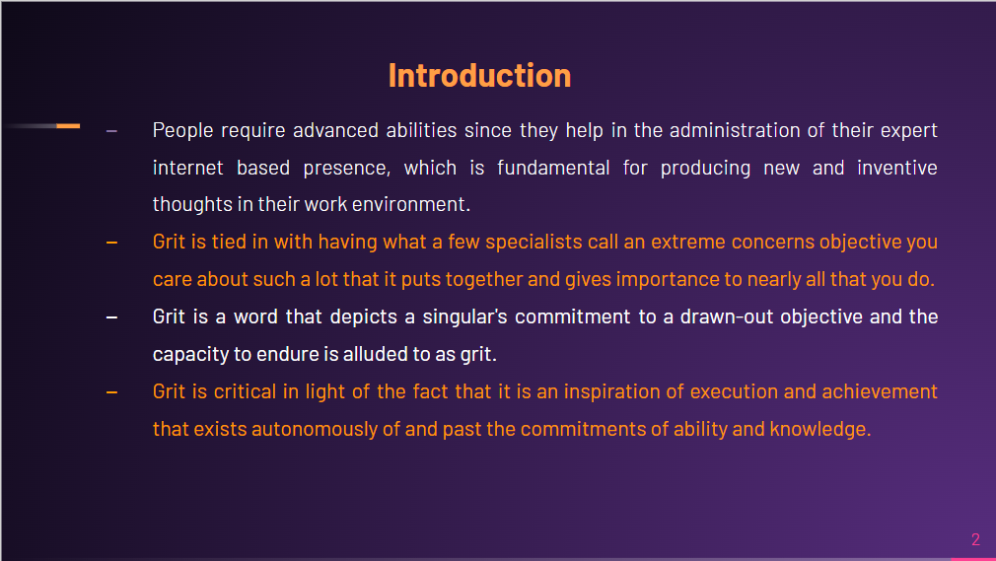

In recent times we have become increasingly reliant on technology, and it aids in bridging the gap between rising technologies and digitalisation by making things easier and smarter. Each person needs to master some digital skills as they help with the maintenance of their professional internet presence, which is required for developing new and inventive ideas at work. These features include social networking, cloud technologies, and web conferencing, to name a few. These kinds of duties are critical in the work, where technology facilitates successful management practices. Grit is a word that denotes an individual's commitment to a long-term goal and the capacity to persevere. Grit is the ability to stay to one objective every day, not just every week or month, but for years, and to work extremely hard to make it a reality. Grit is important in light of the fact that it is an exhibition and achievement inspiration that exists autonomously of and past the commitments of capacity and knowledge. Grit is energy and steadiness for long haul objectives. One method for contemplating grit is to think about what grit isn't. Grit isn't ability or talent. It isn't any luck either. grit isn’t how strongly, for the occasion, you need something. All things being equal, grit is tied in with having what a few specialists call an extreme concerns objective you care about such a lot that it puts together and gives importance to nearly all that you do. What's more, grit is holding ardent to that objective. In any event, when you tumble down. In any event, when you screw up. In any event, when progress toward that objective is stopping or slow. This review examines the utility of present-day innovation in the work environment, just as the utilisation of web-based media as an advertising device. At last, it will decide if it is important to foster an expert web presence.

Script on DIKW Research
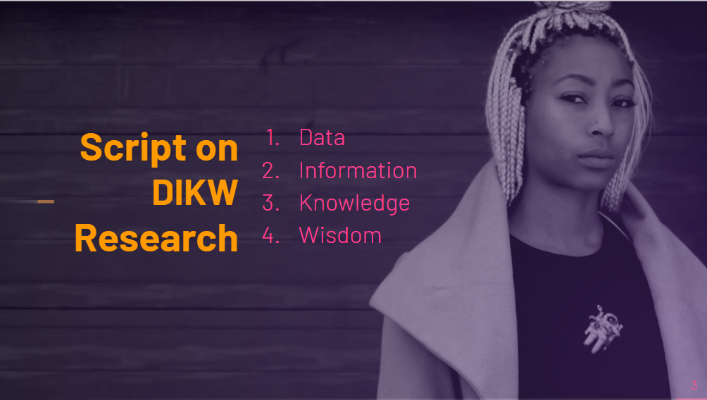
The following is the DIKW research on Duckworth's Grit.
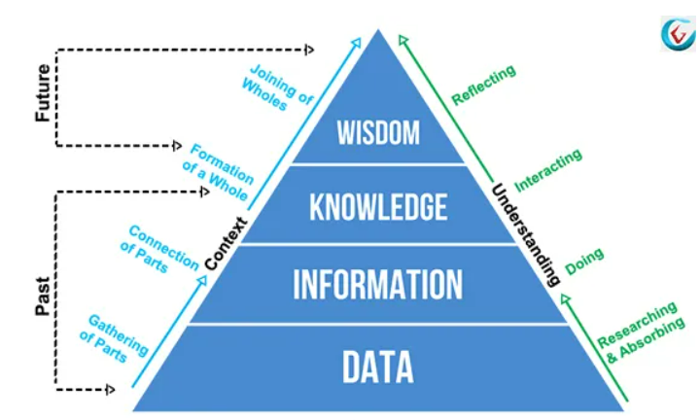
Figure 1: DIKW Theory
Source: (i-SCOOP, 2021)

Data, which are symbols, represent the properties of things and occurrences. Data that has been processed to make it more useful is what information is built of (Blokdyk, 2019). The study's data sources include Angel, 27 years old, grit, teaching, psychologist, research team, national spelling bee, Stanford University rookie instructors questionnaires, schools, graduate schools, and pupils.

Depictions, or reactions to requests that start with terms like who, what, when, where, and the number of, including data. Heavenly messenger quit their administration counselling position following 27 years and started educating at New York City Public School, as indicated by the data and information segment of the review (Oh, 2019). She found that IQ doesn't recognize the best and the most noticeably awful, that inspirational point of view permits one to rapidly get a handle on or address anything with the help of a troublesome term, and that for a review she continued to graduate school as a therapist for the two kids and grown-ups. She takes a review and holds up a year to see who will graduate and who will not. By this, she needs to reach a resolution on the most proficient method to forestall the danger of the drop. She went to military scholastics to see who pass and who drops, she notice the best deals and the motivation to be awesome.

Directions and replies to how-to questions are utilized to convey information (Duckworth, 2016). Subsequent to thinking about all of the prior, she arrives at the resolution that social insight, great looks, actual wellbeing, and even IQ are lacking for progress. Everything unquestionably revolves around coarseness, which suggests determination and want. Stanford University concocted the thought that the learning limit isn't fixed, however can be improved with exertion. To evaluate the inquiry close to graduate school, different classes are picked, including family pay, normalized accomplishment test results, and kids' wellbeing sentiments in schools (Oh, 2019). Subsequently, the development attitude is the best strategy to ingrain coarseness to youngsters.

Values are critical to intelligence and it requests the utilization of good judgment. All effectiveness evaluations depend on the thinking that could speculatively be modified into a PC just as computerized. These assessment standards are unbiased. The appropriate response for Angel's situation is to utilize constancy and an improvement mentality. Development might ingrain relentlessness in kids' cerebrums, showing that disappointment isn't the end-all reply. To accomplish a definitive evenhanded, one should endeavour over and over.

CRAAP Test
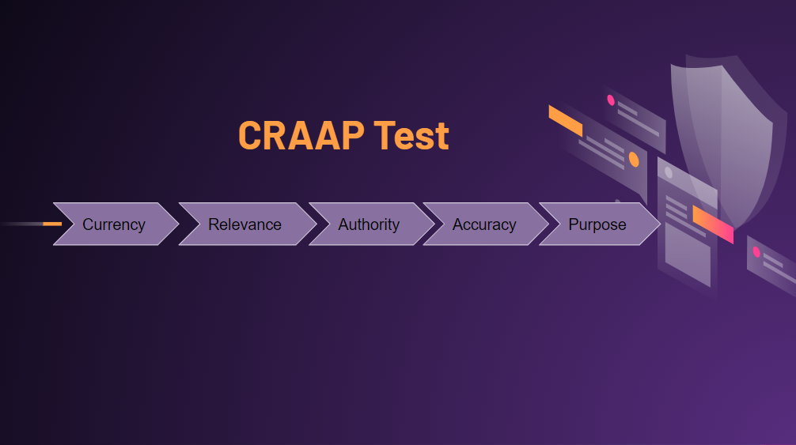

Here it is assessed that how Angel's coarseness hypothesis was breezed through in the CRAAP assessment and The CRAAP test is intended to help teachers and understudies assess whether or not their sources can be trusted (Duckworth, 2016). A specialist can diminish the shot at using wrong data by applying the test when assessing sources. The assessment is given below. Certain inquiries might be utilized to complete the assessment; on the off chance that the inquiries are impeccably addressed, any hypothesis or viewpoint can breeze through the test (Yang et al., 2020). The responses to the inquiries might be found underneath.
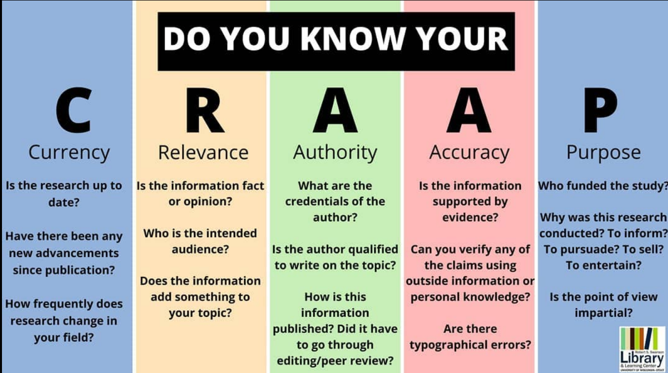
Figure 2: CRAAP Test
Source: (LibGuides, 2021)

Currency
- When did the data become public?
- Is the material cutting-edge or outdated?
- May without doubt money assumes a part in this conversation??
Relevance
- Is the data given adequate to fulfil the data necessities?
- Is it essential or through inclusion?
- What is the name of the creator?
Authority
- What is the name of the creator?
- Is it true that he is or she qualified to talk or compose regarding that matter?
- Is the creator an individual from a notable college or association all through this field?
Accuracy
- Is the data dependable?
- Is the information liberated from blunders?
- Is the data upheld by proof? (Yang et al., 2020)
- Is it conceivable to twofold actually take a look at current realities with other dependable sources?
Purpose
- What precisely is the data is the accessible planned use?
- Is the information genuine or abstract?
- Is there any reason for the data?

The coarseness hypothesis meets every one of the inquiries above and has all the logical proof with regards to coarseness so that is the reason Angel's coarseness hypothesis breezed through the CRAAP assessment.

Primary Data Analysis

The following is a summary of the major data analysis.
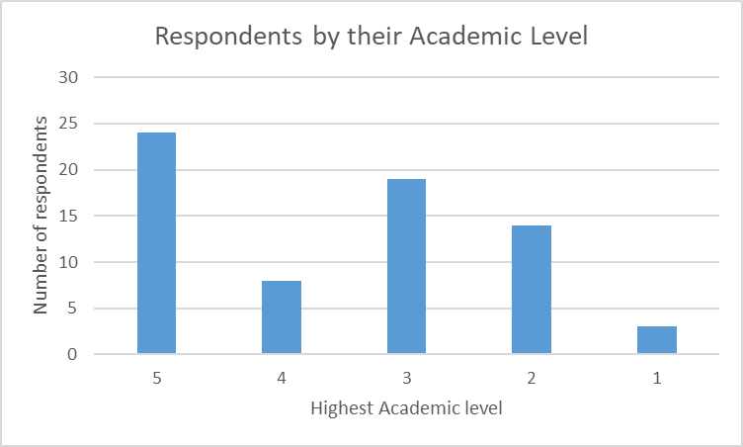

Chart 1: Academic level
Source: Self-Made

DIKW Analysis
The characteristics of things and occasions are addressed by information, which is images. Data is comprised of information that has been handled to make it more important. A few inquiries are utilized to play out the essential, and there is a sum of 70 reactions. In the supplement, the inquiries are given.
Portrayals, or reactions to requests that start with terms like who, what, when, where, and the number of, including data (I-SCOOP, 2021). Directions and replies to how-to questions are utilized to impart information. Clarifications and reactions to why questions are utilized to communicate understanding. The most extreme coarseness score in this essential review is 4, which is amazing. Barely any individuals get a 2 or a 3, while some get a 5 or higher.
Data, information, and understanding permit us to further develop productivity rather than viability (Yang et al., 2020). The proficiency of conduct or a demonstration corresponding to a point is dictated by ascertaining either the number of assets important to accomplish that objective with a specific likelihood or the probability of accomplishing that objective with a given amount of assets (Jumat, 2020).

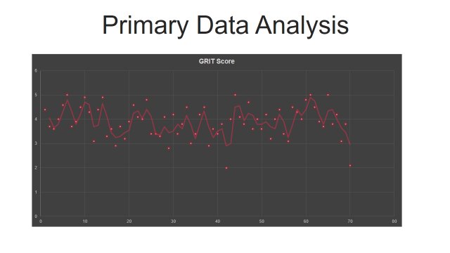
The significance of the goal(s) sought after doesn't matter to productivity, yet it affects viability. Productivity is utilized to survey adequacy. Effectiveness for an esteemed result is productivity increased by the worth. While a score of 5 is astounding, a score of under 3 isn't negative since it very well might be improved.
Abilities incorporate the capacity to support productivity, while intelligence is the ability to further develop viability. The difference between improvement and development addresses the split among straightforwardness and responsibility, which isolates insight from information, data, and realities. Advancement, not development, requires an ascent in esteem (Mikos et al., 2017). Accordingly, development requires again insight, just as appreciation, information, and data.
Shrewdness is worried about standards, and assuming one has the coarseness and accepts that everything is feasible through difficult work, then, at that point, nothing can keep one from succeeding. All proficiency appraisals depend on the thinking that could theoretically be modified into a PC and robotized (Yang et al., 2020). These are objective assessment measures. For Angel's situation, determination and a development outlook are the keys to progress. Kids' minds might foster diligence because of development, showing that disappointment isn't the end-all arrangement. To accomplish a definitive objective, one should attempt over and over.

Secondary Research

Highest academic level | Number of respondents
5 | 24
4 | 8
3 | 19
2 | 14
1 | 3

DIKW Analysis
Information, which is images, address the properties of items and events. Information that has been handled to make it more important is the thing that data is comprised of. The fundamental is performed utilizing a few inquiries, and there is a sum of 174 answers. The inquiries can be found in the informative supplement.
In the optional examination is it shown the understudies merits level and their situation, by this data their future presentation can be assessed. Since it is feasible to be effective with appropriate information about thinks and difficult work for long haul clear point or vision (Mikos et al., 2017). In this principle research, the most noteworthy coarseness score was 4, which is extraordinary. A couple of individuals get a 2 or a 3, while others get a 5. An understudy's coarseness score was 3.20 on a size of 0.0 to 5.0. This shows the understudy beat around 30% of all grown-ups in the United States. A solid coarseness score was characterized as one somewhere in the range of 46 and 60, while a customary coarseness score was characterized as one somewhere in the range of 36 and 45.
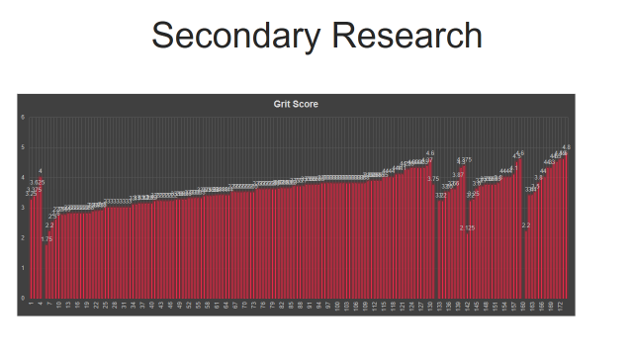
An understudy can answer any issue in the wake of getting data, and the shot at coming up short is more modest. Explicit estimations are characterized, and the information assembled in the previous stage is used to address inquiries regarding them. To address this inquiry, the data assembled in the Information stage can be diverted through specific techniques. Understudies' idea of insight is altogether less created, and they express insight through a progression of similitudes. Insight as-a-Valuable-Item is the most widely recognized (Oh, 2019). Understudies utilize this illustration to underscore the significance of astuteness being ''developed," ''collected," and ''put away" inside people. As Jessica calls attention to, after a specific measure of insight has been collected, it is kept in the body. Astuteness a-benefited secret is the second most normal allegory utilized by understudies to characterize insight (van Oers et al., 2018). In this view, a few encounters help astuteness searchers to improve comprehension of shrewdness' real substance. At the point when we concentrate on thoughts and writing in intergenerational gatherings, intelligence turns out to be more noticeable. It has been demonstrated that concentrating on ideas among a fluctuated gathering of people effectively discussing them enlightens information more than pondering similar thoughts alone.

Comparison
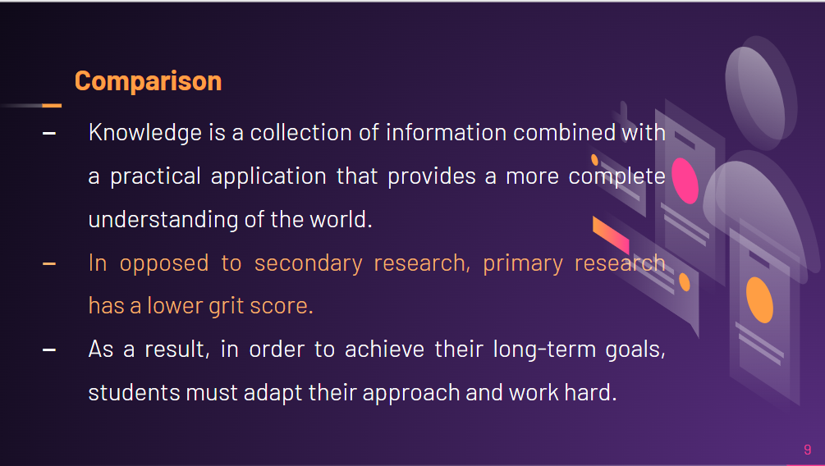
DIKW (Data, Information, Knowledge, and Wisdom) is an information pyramid in which each degree of pecking order contributes qualities and henceforth worth to the one preceding it. Information is an arrangement of realities with a down to earth application that gives a superior image of the world. Astuteness settles on choices dependent on information it is a round model for understanding information stream inside an organization. It capacities as a straight model to exhibit the numerous strategies for getting bits of knowledge and worth from different information sorts (Oh, 2019). A chain, a system, a progression of charts, a continuum, an order, and a pyramid have all been utilized to characterize the DIKW worldview (van Oers et al., 2018).

The Grit Scale catches two parts of coarseness: perseverance of exertion and steadiness of interest. The objective of this methodical audit was to take a gander at the connection between coarseness and amazing instructive accomplishments by investigating both the causes and outcomes of coarseness. The measure of understudy scores in essential and auxiliary is 70 and 174, and this review is assessing coarseness in an instructive climate. The normal mean worth of essential score is 3.89 which is great and in future, this can be expanded with the assistance of understudy endeavours. The normal mean worth of auxiliary score is 3.48 which is below the essential normal score. At last, positive elements like expectation, great effect, and familial ties can assist individuals with creating coarseness. To isolate the coarseness develop from elements of the uprightness aspect of the character, nonetheless, a piece of more profound information on the build is required. The need of empowering coarseness all through the instructive populace to develop character in children and increment their latent capacity is featured, including the utilization of the discoveries for policymakers just as schooling experts.

Conclusion
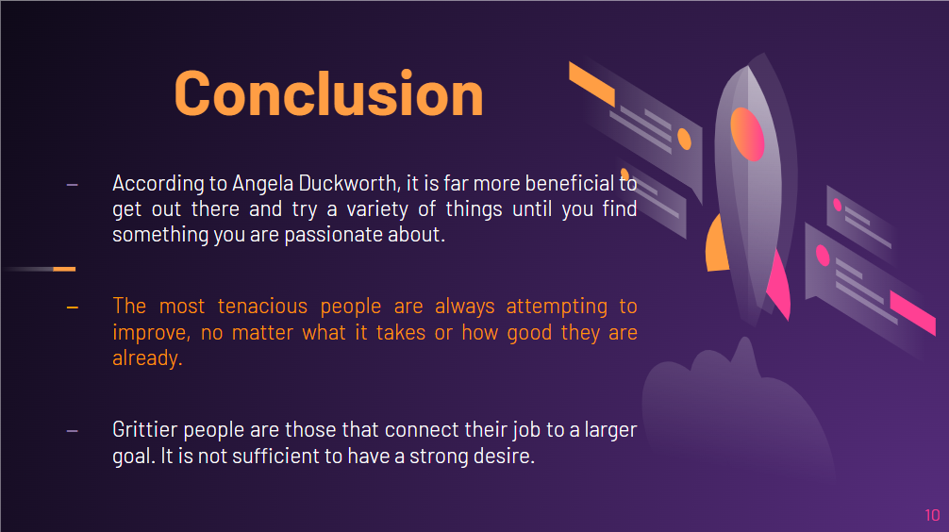
Observing something intriguing to do is the initial move toward expanding your coarseness. Be that as it may, it doesn't suggest you ought to lounge around contemplating your enthusiasm. It is considerably more powerful, as indicated by Angela Duckworth, to get out there and attempt a few things until you observe something you're energetic about. From that point forward, you should search for a good example, guide, or mentor to help you to improve. Individuals have undeniably more leaned to persevere with things they are astounding at assuming they put in the energy. The most determined people are persistently endeavouring to better, regardless it takes or how great they are now. Along these lines, after one has found your enthusiasm, set forth the work to work on consistently. Contend with the individual you were the other day. Increment the power of your exercise. Keep a little longer. Regardless of whether one needs to, stay with a drawn-out movement. Consider the accompanying snags to mental obstruction preparing. Grittier individuals are those that interface their work to a more prominent reason. It isn't sufficient to have a powerful urge. One should likewise make a stride back and consider what one's activities mean for the prosperity of others. This isn't just useful for supporting one's coarseness. It likewise makes the work more charming. In this way, consider how one activity helps everyone around one.

References
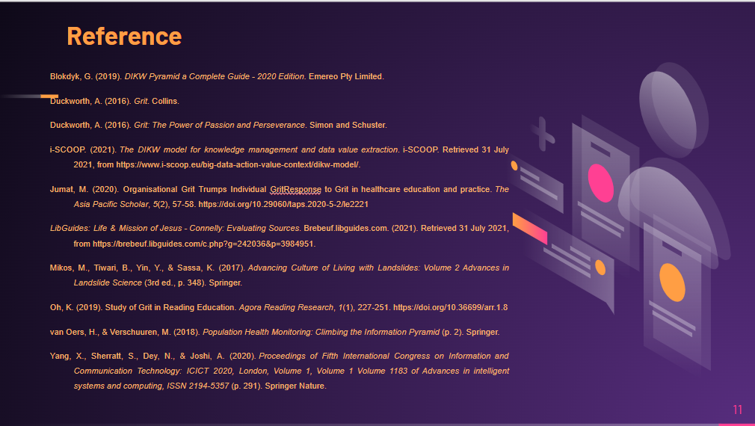
Blokdyk, G. (2019). DIKW Pyramid a Complete Guide - 2020 Edition. Emereo Pty Limited.
Duckworth, A. (2016). Grit. Collins.
Duckworth, A. (2016). Grit: The Power of Passion and Perseverance. Simon and Schuster.
i-SCOOP. (2021). The DIKW model for knowledge management and data value extraction. i-SCOOP. Retrieved 31 July 2021, from https://www.i-scoop.eu/big-data-action-value-context/dikw-model/.
Jumat, M. (2020). Organisational Grit Trumps Individual GritResponse to Grit in healthcare education and practice. The Asia Pacific Scholar, 5(2), 57-58. https://doi.org/10.29060/taps.2020-5-2/le2221
LibGuides: Life & Mission of Jesus - Connelly: Evaluating Sources. Brebeuf.libguides.com. (2021). Retrieved 31 July 2021, from https://brebeuf.libguides.com/c.php?g=242036&p=3984951.
Mikos, M., Tiwari, B., Yin, Y., & Sassa, K. (2017). Advancing Culture of Living with Landslides: Volume 2 Advances in Landslide Science (3rd ed., p. 348). Springer.
Oh, K. (2019). Study of Grit in Reading Education. Agora Reading Research, 1(1), 227-251. https://doi.org/10.36699/arr.1.8
van Oers, H., & Verschuuren, M. (2018). Population Health Monitoring: Climbing the Information Pyramid (p. 2). Springer.
Yang, X., Sherratt, S., Dey, N., & Joshi, A. (2020). Proceedings of Fifth International Congress on Information and Communication Technology: ICICT 2020, London, Volume 1, Volume 1 Volume 1183 of Advances in intelligent systems and computing, ISSN 2194-5357 (p. 291). Springer Nature.



