
Module: Management Economics
Module code: LCBB5003

Student Name: Yordan Gospodinov Gospodinov
Student ID: 2020080
Table of content

Introduction 3
Background of the company 3
Product Line and market operations 4
Aim of Report 4
Analysis and Discussion 4
Demand and Supply for Zara products 4
Market Equilibrium for Zara Plc 5
The factors that influence the demand, supply and profit of Zara Plc 7
Factors influencing demand 7
Factors influencing supply 7
Factors influencing the profit and service of Zara Plc 8
Price Elasticity of Demand 8
Consider the following when determining whether demand is more elastic or inelastic 9
Substitution Effects 9
Income effects 10
Indications that the demand for the company's goods is rising or falling 10
Price of substitutes 10
Price of complements 10
Consumer Income 11
Consumer tastes & preferences 11
Consumer expectations of price 11
Demographics 12
Recommendation 12
Justification 12
Conclusion 13
References 14

Introduction

Background of the company
The Inditex Group owns Zara Plc, a well-known high fashion store with its headquarters in Spain. When the first store for Zara Plc opened in 1975, it was in a Spanish beach town called Galicia. Presently, Zara Plc operates in over 92 countries with a multi-brand portfolio of 11 businesses broken down into distinct men's, women's, and children's apparel divisions. For managing its dynamic business model, Zara is well known for using quick response strategies (Sitaro, 2020). It is efficient in reducing production time and shipping costs by quickly responding to customer requests. As a result, they may provide fresh options with minimum production waste and quick turnaround times. Additionally, Zara uses just a little marketing and promotion, which reduces costs. One of the highest retail firm turnovers ever was reported by Zara in the Inditex 2021 Annual Report, with sales of 8190 million euros (Zara Plc, 2022).
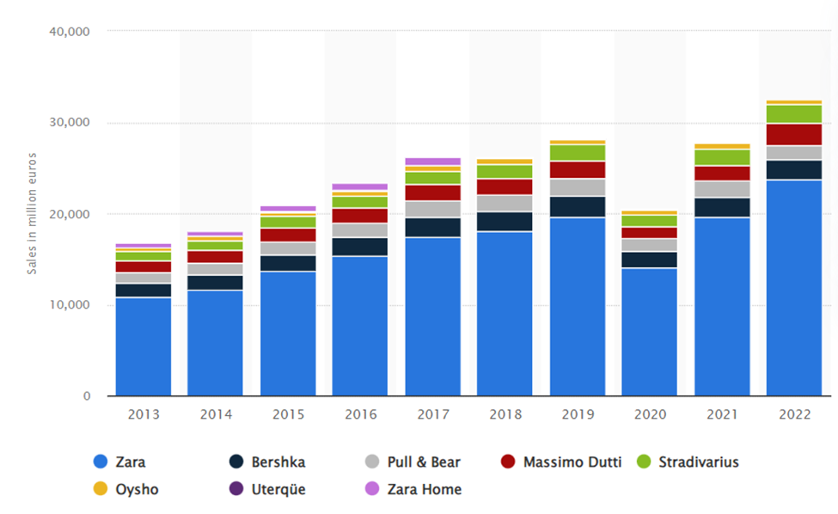
Figure 1:The Inditex Group's global net sales
Source: (Statista, 2022)
Zara Plc primarily engages in the retail business with an emphasis on selling clothing, accessories, and footwear. Customers may construct a traditional wardrobe using a choice of products that are normally of excellent quality from the product line. According to Akhilendra and Aravendan (2023), the economic, legal, social, and technical variables are constantly influencing the business environment in which Zara Plc works. To be competitive and continue to be a leader in the retail industry, the firm must constantly adapt. Zara Plc primarily does business in North America, Europe, Asia, and Latin America.

Aim of Report
This report's objective is to assess economic information as a tool for policymaking in the global, national, and organisational contexts of Zara Plc. Analyse the influence of government policy on the markets and its impact on management choices. Recognise and apply a variety of distinct economic ideas about managerial decision-making.

Analysis and Discussion

Demand and Supply for Zara products
The global fashion retail market is one in which Zara Plc competes. The market for the company's goods, however, may fluctuate due to shifting customer tastes and escalating competition from other fashion firms. One of the important contributors to the business's lucrative operation is its capacity to effectively maintain and provide items to suit the constantly shifting needs. As a result, the macroeconomic environment in which Zara works affects both the supply and demand for its goods.

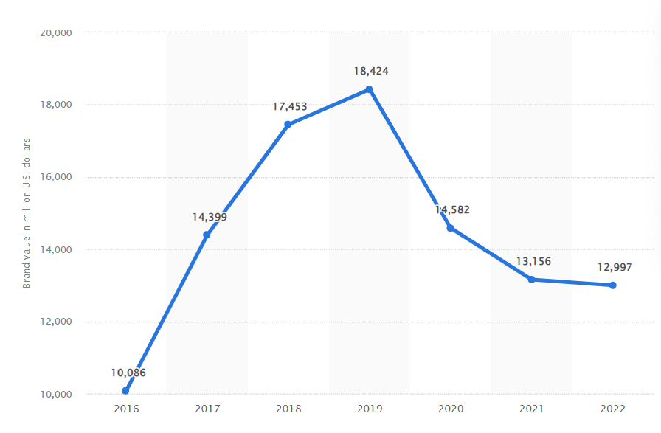
Figure 2: The global brand value of Zara
Source: (Statista, 2023)

Market Equilibrium for Zara Plc
Analysis of the law of demand and supply, macroeconomics, and knowledge of how different external variables, such as government policy, might affect the equilibrium, are used to reach the market equilibrium for Zara Plc. Dewi, Suryaputra and Sondakh (2022), observed that when the quantities provided and requested are equal, the equilibrium is determined using the supply and demand diagram. This might be discovered by comparing Zara Plc's annual report data with the costs of other companies that sell comparable goods. The elasticity of demand may then be calculated using this information, which will assist determine the price at which the market will be in equilibrium. Macroeconomic terms like GDP, inflation, and economic growth may be used to assess how external variables may impact the equilibrium of the market.
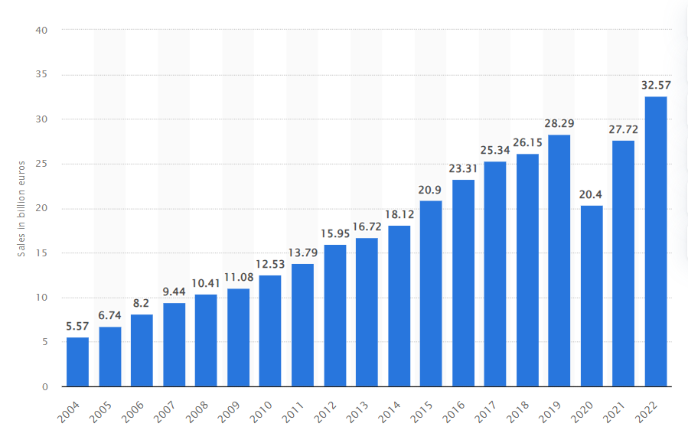
Figure 3: International sales for Inditex Group
Source: (Statista, 2022)
Sales and earnings for Zara plc have a significant role in determining the market equilibrium. Zara's average annual revenue for the 2019–2020 fiscal year was 6822 million euros, an 8.2% rise over the previous year. As a consequence, the net profit increased by 6.3% to 736 million euros over the prior year (Statista, 2022). A larger demand for the firm's goods is also shown by the stock price of the corporation, which increased 8.6% from the prior year to 16.37 euros per share. These figures show that the market is in balance and that Zara plc's finances are sound. Understanding these ideas will enable Zara Plc to better balance the market by altering pricing. The most recent annual report of the firm may be used to assess the market equilibrium for Zara Plc. Zara Plc reported total sales of £140.76 billion in 2020, up from £127.48 billion in the prior year, a 10% rise (Inditex, 2023). The quantity of money made shows that there is a significant market need for Zara's goods and services. Furthermore, Erhun, Kraft and Wijnsma (2021), stated that despite the market shock caused by the pandemic, demand for the company's goods and services has remained rather inelastic in terms of pricing. The effective use of resources, which assisted Zara Plc in maintaining cost management throughout 2020, emphasises the market equilibrium even more.

The factors that influence the demand, supply and profit of Zara Plc

Factors influencing demand
- Pricing: Zara's pricing is very competitive and excellent value for the money, which increases customer appeal for its items.
- Product Quality: Due to their creative designs and high-quality materials, Zara's items are of exceptional quality, which entices customers to buy them.
- Advertising & Promotion: By showing new styles and collections, advertisements and promotions for Zara's items have a beneficial impact on customer demand.
- Competition: Due to the increased variety and understanding of fashion trends, people are more likely to explore Zara's items now that there are rivals in the market.
- Brand Image: Because of its reputation as a high-quality clothes store, Zara has a strong brand image that was developed via clever marketing campaigns.

Factors influencing supply
- Price: Any changes to the cost of Zara's goods will have an immediate effect on their availability. Suppliers can be less willing to provide if the price increases since it will make manufacturing less lucrative.
- Production costs: Changes in production costs, such as those associated with labour and materials, will also affect the availability of goods to Zara. Suppliers may choose to use other, less expensive options if manufacturing prices rise.
- Market demand: Suppliers must consider markets when deciding how much to provide. According to Fiandra et al. (2023), to manufacture what customers want to purchase, suppliers are influenced by changes in market demand in terms of how much they are ready to provide to Zara.
- Competitors and Substitutes: As Zara's rivals provide comparable goods, suppliers can decide to stop working with Zara in preference of working with other businesses. Additionally, the possibility of competing goods might affect the supply level.

Factors influencing the profit and service of Zara Plc
- Competitive factors: Zara has a competitive edge in the market owing to its concentration on rapid fashion (Xuejie, Chang and GuangHao, 2019).
- National economic conditions: GDP, inflation, and interest rates are only a few national economic elements that have an impact on Zara's earnings.
- Seasonality: Seasonal fashion trends have an impact on Zara's revenue.
- Exchange rates: Because Zara's company is international, changes in exchange rates may affect both service and revenue.
- Marketing and advertising: Sales and earnings at Zara may be impacted by the company's marketing plan and advertising efforts.

Price Elasticity of Demand
Demand responsiveness to price changes for an item or service is measured by the price elasticity of demand. It gauges the ratio of the percentage change in an item or service's quantity required to the percentage change in its price. Analysing Zara Plc's annual report will reveal the price elasticity of demand for its items. According to the estimate, the corporation would have net sales of 19,470 million Euros in 2020, an 8% increase over 2019 (Zara Plc, 2022).
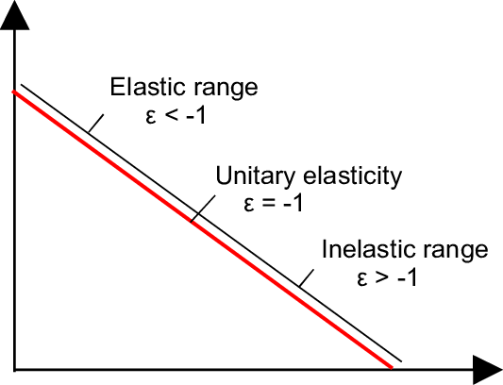
Figure 4: Price Elasticity of Demand
Source: (Research Gate, 2022)
The average selling price of its goods fell by 1.1% throughout this time. Given that the price cut resulted in a very small rise in sales volume, this shows that the price elasticity of demand for Zara Plc's items is rather inelastic. López, Köhnen and Fütterer (2022), opined that this could be brought on by customer devotion to the brand as well as a dearth of suitable alternatives in their market. Customers continue to choose the company's goods over those of other brands despite the minor drop in selling price, suggesting a relatively low price elasticity.

Consider the following when determining whether demand is more elastic or inelastic

Substitution Effects
Depending on the extent of replacement effects, the demand for Zara PLC's goods may be either elastic or inelastic. According to Rego, Srivastava and Srivastava (2022), the demand for Zara will be more elastic if there are several close competitors to its goods, such as Primark, H&M, ASOS, and Topshop. The elasticity of the market for Zara PLC's goods is larger the closer the alternatives are, and the amount requested is smaller. On the other hand, the demand for Zara will be less elastic when the replacement effects of other items are minimal.

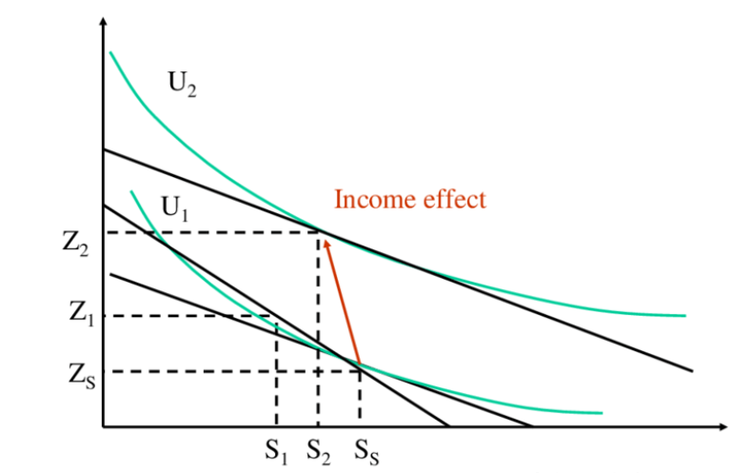
Figure 5: Income and Substitution Effect
Source: (Research Gate, 2022)

Income effects
Demand's sensitivity to changes in income is gauged by its income elasticity. Due to comparable styles on the market, rivals like H&M, for instance, may replace Zara Plc's needs. If earnings increase, consumers may start purchasing H&M items instead of Zara Plc goods. Ruan, Sang and Zeng (2022), advocated that this implies that as more customers explore less expensive alternatives, demand for Zara Plc items will grow more elastic. The elasticity of H&M's demand, which may be influenced by their own manufacturing and price costs, will also have an impact on this effect on Zara Plc's demand.

Indications that the demand for the company's goods is rising or falling

Price of substitutes
A crucial economic indicator, the price of substitutes may tell firms how much demand there is for their goods. According to a review of Zara Plc's annual report, the cost of alternatives dropped by 3.7% from the time in 2019 (Zara Plc, 2022). The demand for the products of Zara Plc is projected to increase as a result of this percentage drop-in replacement product pricing. In the words of Sabanoglu (2022), customers are more likely to buy Zara Plc's items since they will be less expensive than the alternatives, which might enhance demand for their products.

Price of complements
A crucial metric of consumer demand for the products of Zara Plc is the Price of Complements. In the period between 2015 and 2019, the Price of Complements dropped by an average of 3.5% every year, according to the company's annual report (Zara Plc, 2022). This shows that the demand for Zara's goods and services is on the decline. An efficient economic indicator for Zara Plc is the indication of the price of accessories. It may be utilised to comprehend how a shift in the cost of accessories like clothing influences the demand for Zara Plc's products.

Consumer Income
Data on UK consumer income may be used to predict the demand for Zara Plc's items. Consumer spending will grow in response to rising income levels, which will raise demand for the company's goods. Further supporting the claim that customer demand would increase for Zara Plc's items is data gathered from the Office for National Statistics (ONS) suggesting apparel sales over the same time were 3.2% higher than anticipated. Owing to the cost of accessories rises, buyers would be able to purchase fewer items at a Zara Plc shop, which will likely result in a decline in demand for Zara Plc's goods. Declining consumer earnings translate into customers spending less, which lowers the demand for the company's goods. To effectively forecast the demand for its goods in the UK, Zara Plc must regularly analyse consumer income indicators.

Consumer tastes & preferences
Examining client preferences and inclinations is vital to comprehend the demand for the goods made by Zara Plc. Understanding client preferences can help Zara Corporation develop appealing new items as demand rises as fashion, trends, and styles change. Additionally, financial circumstances and earnings might have an impact on consumer behaviour since people tend to spend less when they have less free cash flow. The question of whether people prefer to purchase locally or online should also be investigated by Zara Plc. Strong indications of interest in an organization's goods are consumer preferences and trends.

Consumer expectations of price
According to Zara Plc's annual report for 2019, the company's sales in the UK market were up 5% over the previous year. The inflation rate did, however, decrease by 2% throughout that time. This suggests that UK consumers' expectations of pricing have stayed consistent or even grown, which has raised demand for Zara Plc's products as a whole (Zara Plc, 2022). In addition, a 2019 poll found that 61% of UK customers were prepared to spend more for high-quality goods from Zara Plc, indicating that customers' expectations of pricing are probably going to rise in the near future.

Demographics
The worldwide consumer market for Zara Plc grew by 3.8% of the entire consumer market, according to Forbes' 2019 FTSE 100 study. This expansion was mostly fueled by the Asia Pacific area, where consumers increased by 7.4% (Forbes, 2022). In addition, compared to the prior year, there were 43% more active users on the site. As more individuals interact with the brand and purchase its items, this may indicate that there is a growing demand for Zara Plc's goods. A 59% growth rate was seen in the number of clients making purchases online from the previous year. Overall, these figures indicate that there is rising demand for Zara Plc's products as more customers interact with the company both online and offline.

Recommendation
In the UK market, Zara Plc should use a penetration pricing strategy. By this pricing strategy, a company's goods or services are offered at prices that are cheaper than those of its rivals. Customers gravitate towards the goods or services with the lowest prices, hence this pricing approach increases consumer demand. With penetration pricing, Thơ (2022), observed that the business may build a strong client base in addition to establishing its product in the UK market. Furthermore, Zara could be able to compete with renowned brands because of the reduced costs. As a result, penetration pricing will eventually help Zara Plc establish itself in the UK market and grow its brand.
- Penetration pricing is a pricing strategy that includes lowering costs to get consumers to try a new item or service.
- Salim, Santona and Zara (2023), claimed that Zara Plc will be able to establish a strong client base and brand loyalty inside a country by fast gaining market share via cheap pricing, which will allow it to take an unchallengeable lead in the UK's rising markets. It will attract clients and broaden consumer awareness of the brand.
- Due to the high costs imposed by rivals, penetration pricing will prevent fans from switching brands.
- Furthermore, making a product that is accessible and inexpensive, would assist Zara Plc in lowering their client acquisition expenses, boosting long-term corporate profitability (Sitaro, 2020).
- Additionally, it would enable the business to get important information regarding modifications to product design and price in the cutthroat market.
- Penetration pricing will enable the business to target various demographic groups with varied prices and so obtain a more comprehensive knowledge of its target market.

Conclusion
To inform policy decisions in the global, national, and organisational settings of Zara Plc. this report assessed economic data critically. Analysis was done on how government policy affected markets and how it affected management choices. The application of several economic ideas to management decision-making includes demand and supply, price elasticity, and cost analysis. Additionally, elements affecting customer interests, preferences, and expectations as well as those affecting supply, demand, and profit were covered. The report provided a thorough review of Zara Plc's economic statistics, supported by data and case studies, and ultimately suggested using penetration pricing as a strategy in the UK market.

References
Akhilendra, S.P. and Aravendan, M., 2023. A Review on Apparel Fashion Trends, Visual Merchandising and Fashion Branding. Intelligent Information Management, 15(3), pp.120-159.Available at: https://doi.org/10.4236/iim.2023.153007 (Accessed: 21 June 2023).
Dewi, N.N.N.S., Suryaputra, R. and Sondakh, O., 2022. Analysis of the Effect of Product Quality Factors, Product Style, Product Price, Brand Image, Service Quality and Store Environment against Brand Loyalty of Zara Customers in Surabaya. Available at: https://doi.org/10.47191/jefms/v5-i3-14 (Accessed: 21 June 2023).
Erhun, F., Kraft, T. and Wijnsma, S., 2021. Sustainable triple‐A supply chains. Production and Operations Management, 30(3), pp.644-655. Available at: https://doi.org/10.1111/poms.13306 (Accessed: 21 June 2023).
Fiandra, C., Cattani, F., Leonardi, M.C., Comi, S., Zara, S., Rossi, L., Jereczek-Fossa, B.A., Fariselli, P., Ricardi, U. and Heijmen, B., 2023. Machine learning for predicting clinician approval of treatment plans for left-sided whole breast radiotherapy. Advances in Radiation Oncology, 8(5).Available at: https://doi.org/10.1016/j.adro.2023.101228 (Accessed: 21 June 2023).
Forbes (2022) Zara | Company Overview & News, Forbes. Available at: https://www.forbes.com/companies/zara/?sh=23dee0748773 (Accessed: 21 June 2023).
Inditex (2023) Sustainability. Available at: https://www.inditex.com/itxcomweb/en/sustainability#reporting (Accessed: 21 June 2023).
López, T., Riedler, T., Köhnen, H. and Fütterer, M., 2022. Digital value chain restructuring and labour process transformations in the fast‐fashion sector: Evidence from the value chains of Zara & H&M. Global Networks, 22(4), pp.684-700. Available at: https://doi.org/10.1111/glob.12353 (Accessed: 21 June 2023).
Rego, L., Brady, M., Leone, R., Roberts, J., Srivastava, C. and Srivastava, R., 2022. Brand response to environmental turbulence: A framework and propositions for resistance, recovery and reinvention. International Journal of Research in Marketing, 39(2), pp.583-602.Available at: https://doi.org/10.1016/j.ijresmar.2021.10.006 (Accessed: 21 June 2023).
Research Gate (2022) 5 income effect when useful work is an inferior good, Research Gate. Available at: https://www.researchgate.net/figure/Income-effect-when-useful-work-is-an-inferior-good_fig5_237426465 (Accessed: 21 June 2023).
Research Gate (2022) Elasticities along the demand curve. | Download the scientific diagram, Research Gate. Available at: https://www.researchgate.net/figure/Elasticities-along-demand-curve_fig2_242587130 (Accessed: 21 June 2023).
Ruan, T., Sang, D. and Zeng, Q., 2022, July. Research on ZARA’s Business Environment and Marketing Strategies in China. In 2022 2nd International Conference on Enterprise Management and Economic Development (ICEMED 2022) (pp. 659-672). Atlantis Press. Available at: https://doi.org/10.2991/aebmr.k.220603.106 (Accessed: 21 June 2023).
Sabanoglu, T. (2022) Zara: Brand value worldwide 2022, Statista. Available at: https://www.statista.com/statistics/980126/brand-value-of-zara-worldwide/ (Accessed: 21 June 2023).
Salim, A., Deiana, P., Fancello, F., Molinu, M.G., Santona, M. and Zara, S., 2023. Antimicrobial and Antibiofilm Activities of Pomegranate Peel Phenolic Compounds: Varietal Screening Through a Multivariate Approach. Journal of Bioresources and Bioproducts.Available at: https://doi.org/10.1016/j.jobab.2023.01.006 (Accessed: 21 June 2023).
Sitaro, T.D., 2020. Fast Fashion and Sustainability-The Case of Inditex-Zara. Available at: https://www.doi.org/international_senior/46/ (Accessed: 21 June 2023).
Statista (2022) Zara: Brand value worldwide 2022, Statista. Available at: https://www.statista.com/statistics/980126/brand-value-of-zara-worldwide/ (Accessed: 21 June 2023).
Statista (2023) Inditex group: Global sales 2022, Statista. Available at: https://www.statista.com/statistics/268817/sales-of-the-inditex-group-worldwide/ (Accessed: 21 June 2023).
Statista (2023) Inditex: Net Sales Worldwide by brand 2022, Statista. Available at: https://www.statista.com/statistics/456505/sales-inditex-group-worldwide-by-format/ (Accessed: 21 June 2023).
Thơ, T.T.A., 2022. Assessing customer satisfaction with the retail service quality of Zara Vietnam stores. Tạp chí Nghiên cứu Tài chính-Marketing, pp.13-23. Available at: https://doi.org/10.52932/jfm.vi72.351 (Accessed: 21 June 2023).
Xuejie, C., Chang, Q. and GuangHao, Z., 2019, August. Research on Innovation supply chain Management in Fast Fashion Industry——A comparative analysis of ZARA and H&M. In 2019 3rd International Conference on Education, Culture and Social Development (ICECSD 2019) (pp. 7-16). Atlantis Press. Available at: https://doi.org/10.2991/icecsd-19.2019.2 (Accessed: 21 June 2023).
Zara Plc (2022) Zara, Zara Plc. Available at: https://static.zara.net/static/joinlife/2020_Inditex_Annual_Report.pdf (Accessed: 21 June 2023).

