

Risk Assessment & ALARP Justification Report

Author: Joshua Luke Evans (2011912)
Course: BEng Ordnance, Munitions, and Explosives – Level 5 Safety & Hazard Assessment (ACDB 5013)
Faculty of Architecture, Computing and Engineering
Date of Submission: 18th July 2023
Word Count: 1639 (excluding references and annexe)

Introduction
Generating and managing a safety case is vital for ensuring that existing hazards can be removed or controlled to minimise the risk and severity of the hazard to employees, contractors, and the general public. Within the defence sector, the processes and systems that safety cases are developed for are generally complex and can potentially cause serious harm. The Health and Safety at Work (HASAW) Act 1974 [1] requires employers to ensure the health and safety of their employees and anyone else that could be harmed due to the employer’s work.
Sadly, there have been several safety incidents within the Ministry of Defence (MOD) in recent years, with the RAF Nimrod aircraft incident in 2006 and the Snatch Land Rover case being some of the more well-known incidents from the Iraq War. The subsequent reviews [2] [3] found significant failings from DE&S, BAE Systems, and QinetiQ and recommended an overhaul of their safety culture. The MOD has since changed its safety processes, which now require platforms to operate within their safety case. The safety case approves which areas of the world they can operate and what missions they can conduct.
The UK workplace health and safety regulatory body is the Health and Safety Executive (HSE). They release guidance to employers and employees about their rights and responsibilities regarding safety in the workplace. In the event of a health and safety incident, the HSE investigate the cause. When the HSE investigate an incident, they look for whether the process in which the incident occurred has been made safe to a certain level. This level is known as “As Low As Reasonably Practicable” (ALARP). This statement originates from the HASAW Act [1]. ALARP or SFAIRP means that risk must be proportional to the time and cost spent implementing the control measures. “Reasonably practicable” provides balance for employers so that they will not be expected to remove all risk from their processes, but they must ensure that where time and cost allow, that mitigation is put in place to reduce the risk.
In this report, the control measures implemented to reduce the risk of noise from an L118 towed Howitzer gun are set out and investigated to ensure that the hazard has been controlled to an ALARP level. The entire risk assessment, which covers other additional hazards associated with the L118 system, can be found in Annex A.

Background of Hazard
The L118 towed howitzer is used by the British Army for providing fire support. Noise hazards are common with OME systems due to the nature of these systems. Howitzers produce noise levels up to around 180 decibels [4]. Any sounds above 85 decibels can harm humans if exposed for long durations. The average human pain threshold occurs around 105 decibels, and eardrum rupture can occur above 140 decibels. Therefore, the consequences of this hazard occurring without controls are ‘severe’ as an explosion can potentially cause significant injury (temporary or even permanent hearing loss) to the entire L118 crew.
The likelihood of this hazard occurring without any controls would be ‘frequent’, meaning that an accident of this kind could occur at least ten times per system year. This seemingly high frequency is because the noise hazard would occur with every firing of the L118 system. The Frequency Index (FI) and Severity Index (SI) have been combined in Annex A to provide an overall Risk Index (RI) that indicates the overall risk rating of the hazard. In the case of an unintentional detonation hazard, it has an FI of 7, and an SI of 3, giving it a total RI of 10.

Controls and Mitigation
The Hierarchy of Control was applied to prioritise more effective control measures. The Hierarchy of Control is as follows: [5]
- Eliminate;
- Substitute;
- Isolate;
- Engineering control;
- Procedural control;
- Personal Protective Equipment (PPE).
Installing a silencer on the howitzer barrel was one possible control method for eliminating noise. Howitzer silencers are available [6] but are not practical in theatre. They are incredibly bulky and would hinder the portability of the L118 system, which would have a knock-on effect on operational capability. The example silencer in Figure 1 is only used on trials sites to reduce the noise for the general public. Furthermore, a design change of this type would have to undergo rigorous trials to be approved for use and could result in other design changes being required to other parts of the system for it to work effectively.
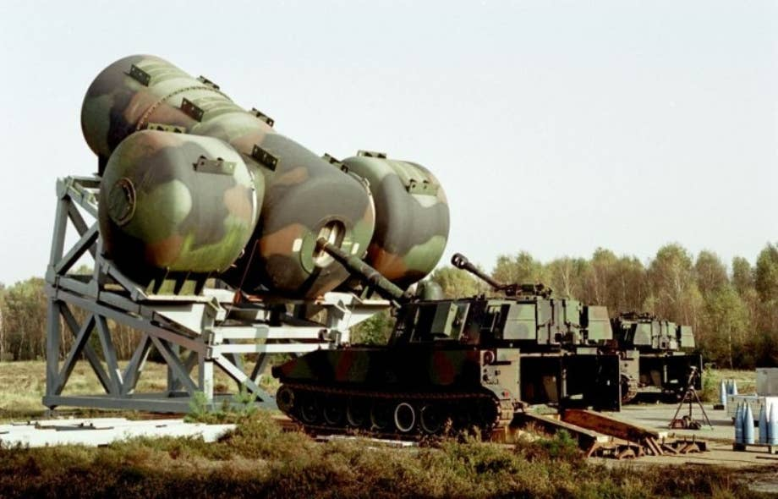
Figure 1 - Howitzer silencer on a German artillery range [6]
Substitution is not currently an option, as many current-generation light artillery platforms have the same noise issue. However, the development of the replacement system for L118 is underway, with one pre-concept design being an uncrewed and self-propelled system [7]. By substituting the L118 platform with this type of concept in the future, the noise hazard would no longer be an issue for the crew. With the L118 system due to be replaced in 2030, other control methods are still required to reduce the noise hazard.
Isolation is impossible with the L118 system as it requires a crew of up to six people to operate the weapon effectively.
Several engineering and procedural controls have been put in place. Training is vital as engineering and procedural controls require personnel to use them appropriately and safely. Misuse or misapplication can give rise to new hazards. Specific and regular training for firing the L118 could minimise unnecessary exposure to noise by being taught more efficient and controlled firing methods. Effective training programmes would help the howitzer crews develop better communication during operations, reducing the number of firings and ensuring that the crew are fully prepared for the next shot.
Another procedural control measure is to select firing positions with natural features that could reduce noise levels. Features like hills or vegetation can act as noise barriers and have been found to effectively reduce sound levels experienced by the human ear [8]. Similarly, avoiding firing locations with suboptimal acoustics that could amplify the noise generated by the L118 would reduce the noise hazard. Acoustic barriers are an alternative engineering control that could be applied. By placing sound-absorbing materials near the firing position (as seen in Figure 2), some noise generated could be absorbed or reflected away from the crew.
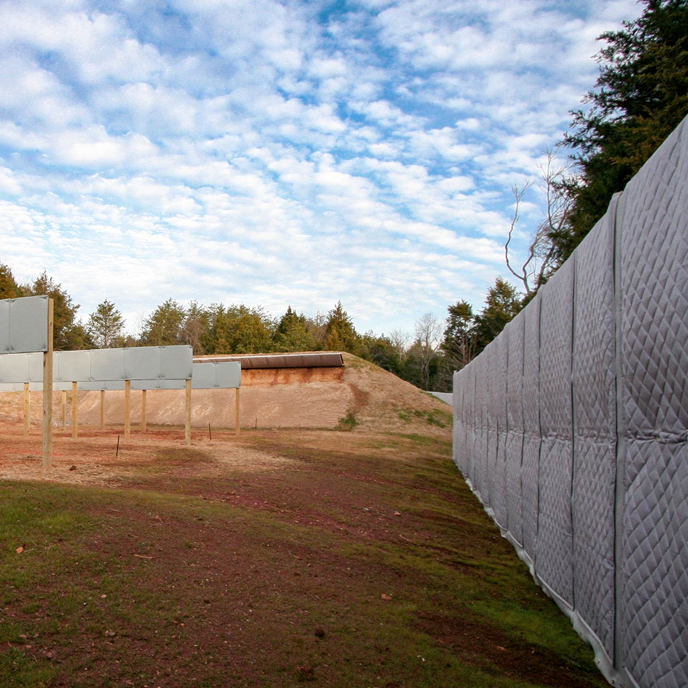
Figure 2 - Example of soundproofing panels used on a firing range [9]
PPE was the last type of control method that was looked at in line with the Hierarchy of Controls. Ear plugs and ear defenders are widely available to reduce noise hazards effectively, but they are non-discriminatory in blocking out all noise. Therefore, standard ear protection becomes a hazard as the L118 crew would find communicating more challenging, which could lead to a different accident with more severe consequences. The PPE specified for use on the L118 in this risk assessment is Active Noise-Cancelling (ANC) headphones, such as the example shown in Figure 3, that counteract the low-frequency noise of the L118 when firing by sending opposite sound waves. Crewmembers can still hear one another as the ear defenders amplify quieter sounds.
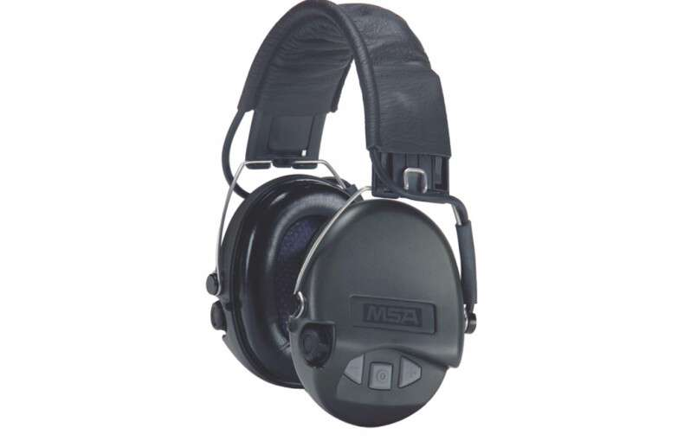
Figure 3 - MSA Sordin Supreme Pro IV active noise cancelling headphones [10]
Although the noise hazard for the L118 system could not be removed, substituted, or isolated within reasonably practicable bounds, practical engineering and procedural controls have been implemented to try and reduce the noise levels experienced by the crew. The final mitigation for this hazard was using ear defenders for crewmembers, which reduced the noise from around 180 dB to 82 dB while not hindering communication between other crewmembers. PPE is seen as the least effective method of control in the hierarchy, as it relies on the user to wear the PPE appropriately, and if they do not, they are still exposed to the hazard. The combination of the control methods has reduced the likelihood of occurrence to 5 and the severity of the hazard to 2, giving a total RI of 7.

Future Risk Management
Although suitable risk mitigation has been implemented for the L118 system, the risk assessment shall be regularly reviewed to monitor for new or evolving hazards. The Acquisition Safety & Environmental Management System (ASEMS) provides brief guidance on the timing of periodic safety case reviews [11]. For the L118, The risk assessment shall be reviewed every two years, but it shall be immediately reassessed whenever there is an increase in accident rates or if there has been a change to the system, either in its design or its use. Design changes to the gun or the ammunition can create new hazards. When a design change is requested in DE&S, it goes to all the teams across DE&S and SDA to assess if it will have any knock-on effect on the systems or components within their area of responsibility.

Conclusion
In this ALARP Justification document, the noise hazard on the L118 towed howitzer has been covered. All six hierarchical control methods have been considered to reduce the likelihood and severity of an accident involving noise. The combination of engineering and procedural controls and PPE have reduced the RI for the noise hazard from 10 to 7. Any further risk reduction would not have been reasonably practicable, as it would have involved expensive design changes. Given that the L118 system will be decommissioned within the next seven years, the design changes would take time and may not be used before the system goes out of service. For this reason, the current decision is that the noise hazard is reduced to an ALARP status. The risk assessment will be continuously monitored going forwards to capture any changes to the hazards associated with the L118 system.

References

[1] | HM Government, “Health and Safety at Work Act 1974,” HM Government, London, 1974.
[2] | C. Haddon-Cave QC, “The Nimrod Review,” House of Commons, London, 2006.
[3] | B. Smith, J. Chilcot, L. Freedman, M. Gilbert, R. Lyne and U. Prashar, “Chilcot Inquiry,” House of Commons Library, London, 2016.
[4] | USACHPPM, “Noise Levels of Common Army Equipment,” United States Nuclear Regulatory Commission, Washington, 2006.
[5] | SSO, “Hazard and Risk Assessments - Risk Reduction,” SSO, 2023.
[6] | B. Stilwell, “This is what a silencer for howitzers looks like,” We Are The Mighty, 12 October 2022. [Online]. Available: https://www.wearethemighty.com/mighty-tactical/howitzers-silencer/. [Accessed 11 July 2023].
[7] | Think Defence, “The L118 105mm Light Gun Replacement,” Thnk Defence, 11 February 2022. [Online]. Available: https://www.thinkdefence.co.uk/2022/02/the-l118-105mm-light-gun-replacement/. [Accessed 11 July 2023].
[8] | Conserve Energy Future, “Can trees reduce noise pollution in urban areas,” Conserve Energy Future, [Online]. Available: https://www.conserve-energy-future.com/can-trees-reduce-noise-pollution.php. [Accessed 13 July 2023].
[9] | Acoustical Solutions, “PrivacyShield Outdoor Absorptive Soundproofing Blanket,” Acoustical Solutions, 2023. [Online]. Available: https://acousticalsolutions.com/product/outdoor-absorptive-soundproofing-blanket/. [Accessed 16 July 2023].
[10] | Scott Country, “MSA Sordin Supreme Pro IV Green Cups Black Headband,” Scott Country, 13 July 2023. [Online]. Available: https://www.scottcountry.co.uk/products/msa-sordin-supreme-pro-iv-green-cups-black-headban. [Accessed 13 July 2023].
[11] | ASEMS, “SMP12. Safety Case and Safety Case Report,” ASEMS, 15 June 2023. [Online]. Available: https://www.asems.mod.uk/guidance/posms/smp12. [Accessed 11 07 2023].
[12] | Wikipedia, “L118 Light Gun,” 5 June 2023. [Online]. Available: https://en.wikipedia.org/wiki/L118_light_gun.
[13] | International Maritime Organization, “Revised guidelines for Formal Safety Assessment (FSA) for use in the IMO rule-making process,” IMO, London, 2018.
[14] | HSE, “Manual handling at work - a brief guide,” HSE, London, 2020.
[15] | Safeguard Armour, “NIJ and CAST Body Armour Levels and Standards,” Safeguard Armour, [Online]. Available: https://www.uk.safeguardarmor.com/pages/body-armour-protection-levels. [Accessed 13 July 2023].
[16] | Arco, “Safety Footwear Standards,” Arco, 2022. [Online]. Available: https://www.arco.co.uk/expert-advice/safety-footwear/standards. [Accessed 13 July 2023].
[17] | BSI, “Hearing protectors. Safety requirements - Active noise reduction earmuffs,” BSI, 30 November 2020. [Online]. Available: https://knowledge.bsigroup.com/products/hearing-protectors-safety-requirements-active-noise-reduction-earmuffs/standard. [Accessed 11 July 2023].
[18] | Safety Services Organisation, “Hazard and Risk Assessments - Risk Reduction,” Safety Services Organisation, 2023.

Annexe A – Risk Assessment of L118 (105mm) Towed Howitzer

A-1. Task/System Description
The L118 towed howitzer is used by the British Army for providing direct and indirect fire support. As well as High Explosive rounds, the L118 can fire illuminating and smoke rounds to provide non-lethal support to infantry and armoured units. The L118 is typically crewed by a team of six personnel and requires a minimum of three [12]. In theatre operations, the field artillery crew would have to provide fast and accurate firing at a given location to aid other units on the battlefield. This risk assessment covers using the L118 (105mm) Towed Howitzer whilst on operations. Storage is covered in the context that appropriate and safe storage is required on operations to ensure that munitions are not exposed to temperatures and humidity levels outside of their safe operating limits. However, storage-specific hazards and controls are not covered.

A-2. Hazard Descriptions
The hazard descriptions used in this risk assessment are adapted from the International Maritime Organisation’s (IMO) Formal Safety Assessment (FSA) guidance [13]. The IMO use a Frequency Index (FI) and Severity Index (SI), which captures the hazard data on a logarithmic scale, where:
Risk = Frequency X Severity
Log (Risk) = log (Frequency) + log (Severity)
Tables A.1 and A.2 below outline the Frequency and Severity Index descriptors.
Table A.1 – Frequency Index (FI) definitions [13]
Frequency Index
FI | Frequency | Definition | F (per system year)
7 | Frequent | Likely to occur at least once a month | => 10
6 | Probable |  | 1
5 | Fairly Probable | Likely to occur once during the life of the system | 0.1
4 | Unlikely |  | 10⁻²
3 | Remote | Likely to occur in the total life of several similar systems | 10⁻³
2 | Very Remote |  | 10⁻⁴
1 | Extremely Remote | Not likely to occur during the life of several similar systems | 10⁻⁵

Table A.2 – Severity Index (SI) definitions
Severity Index
SI | Severity | Effects on Human Safety | Effects on Equipment/Facilities | S (Equivalent fatalities)
1 | Minor | Single or minor injuries requiring on-site first aid | Damage to local equipment. < £10,000 in value | 0.01
2 | Major | Multiple or severe injuries requiring hospital treatment | Damage to surrounding equipment. < £100,000 in value. | 0.1
3 | Severe | Single fatality or multiple severe injuries requiring hospital treatment | Damage to surrounding equipment and structures. < £500,000 in value. | 1
4 | Critical | Multiple fatalities | Total loss of surrounding equipment and structures. > £500,000 in value. | 10

Table A.3 (below) shows the risk matrix. The SI and FI combine to give a Risk Index (RI).
Table A.3 – Risk Matrix
Frequency Index | Frequency | Severity (Severity Index)
Frequency Index | Frequency | 1 | 2 | 3 | 4
Frequency Index | Frequency | Minor | Major | Severe | Critical
7 | Frequent | 8 | 9 | 10 | 11
6 | Probable | 7 | 8 | 9 | 10
5 | Fairly Probable | 6 | 7 | 8 | 9
4 | Unlikely | 5 | 6 | 7 | 8
3 | Remote | 4 | 5 | 6 | 7
2 | Very Remote | 3 | 4 | 5 | 6
1 | Extremely Remote | 2 | 3 | 4 | 5

Table A.4 - Initial risk assessment of uncontrolled hazards
ID | Hazard Description | Consequence | Who/What could be harmed | Initial Risk Rating
 |  |  |  | Frequency  (1-7) | Severity  (1-4) | Risk Index
1 | Unintentional detonation caused by, but not limited to, the following:  - Gun misfire (either by human error or mechanical fault)  - Dropped munition  - Cook-off from hot barrel/breech  - Incorrect storage conditions  - Mishandled munitions | Death or injury may occur to several people due to blast, fragmentation, ground and air shock, debris, noise, heat and fire. Total loss of platform and nearby equipment may also occur. | - 6 x L118 crew members  - L118 platform  - L118 ammunition  - Other nearby personnel/equipment | 5 | 4 | 9
2 | Noise | Injury may occur to several people due to high noise levels generated by the gun when firing. | - 6 x L118 crew members | 7 | 3 | 10
3 | Heavy loads | Injury may occur due to incorrect manual handling processes or dropping heavy loads when lifting. | - 1 x L118 crew member  - L118 components  - L118 ammunition | 6 | 2 | 8
4 | Slips, trips, and falls | Injury may occur from obstacles incorrectly stored around the L118 platform | - 1 x L118 crew member  - L118 components  - L118 ammunition | 4 | 1 | 5
5 | Vibration | Exposure to intense or prolonged vibration can cause Hand-Arm Vibration Syndrome (HAVS) | - 1 x L118 crew member | 7 | 1 | 8
6 | Noise | Injury may occur to several people due to high noise levels generated by the gun when firing. | - 6 x L118 crew members | 7 | 3 | 10
7 | Hot surfaces | Injury may occur from touching hot surfaces (e.g. breech or barrel after firing) | - 1 x L118 crew member | 7 | 1 | 8
8 | Rotating or moving parts | Injury may occur from rotating or moving parts on the L118 system (e.g. breech, wheels, recoil system, elevation and traverse mechanisms). | - 1 x L118 crew member | 7 | 2 | 9
9 | Intentional detonation caused by, but not limited to, the following:  - Sabotage by an insider or enemy operative  - Intentional mishandling of ammunition  - Using damaged or modified ammunition  - Overcharging the gun with too much propellant | Death or injury may occur to several people due to blast, fragmentation, ground and air shock, debris, noise, threat and fire. Total loss of platform and nearby equipment may also occur. | - 6 x L118 crew members  - L118 platform  - L118 ammunition  - Other nearby personnel/equipment | 4 | 4 | 8

Table A.5 - Risk Assessment with implemented controls and residual risk scores
ID | Hazard Description | Control Measures | Residual Risk
ID | Hazard Description | Control Measures | Frequency | Severity | Risk Index
1 | Unintentional detonation | General  - Rapid fire can only be conducted when using “insensitive” munitions. For munitions containing more sensitive explosives such as TNT or RDX, the L118 loader must wait at least 30 seconds before loading the next round into the L118 breech. This reduces the risk of unintentional detonation due to barrel cook-off.  - Ammunition shall be inspected for damage prior to loading. Typical damage to look for includes dents, cracks, and waxy or sticky residues leaking from joints.  Storage (when on operations)  - Artillery shells should be kept from direct sunlight for prolonged periods (> 1 hour).  - Hazard classifications should be noted for different munitions and their compatibility checked. Fuzes shall not be kept next to artillery shells or other munitions containing secondary explosives.  - The storage handling form should be inspected upon receiving L118 ammunition to check that humidity and temperature controls have not been exceeded for that type of munition. Suppose the temperature and humidity limit of ammunition has been exceeded several times or for prolonged periods. In that case, the munitions should be returned for a different batch and marked as “unsafe for use”.  Contraband  - Any unauthorised or uncontrolled radiofrequency emitting devices and Personal Electronic Devices (PEDs) must remain at least 500m away from munitions and the L118 artillery system.  - Personnel cannot smoke near the L118 gun or its associated munitions.  - Lighters or other naked flames are prohibited near the L118 gun or its associated munitions.  Handling  - Manual handling aids (e.g. ammunition trolley, palletiser, vehicle) shall be used for transporting equipment over longer distances.  - The HSE manual handling guide [14] is to be observed to determine what type of lift warrants a two-person carry.  - Manual lifting of ammunition without a manual handling aid must be carried out over as short a distance as possible.  - The route over which the item shall be carried shall be inspected prior to manual handling activity to check for any slip, trip or fall hazards.  PPE  - Personnel shall wear a helmet (to NIJ IIIA standards [15])  - Personnel shall wear appropriate footwear (BS EN ISO 20345 [16])  Weather  - During or following wet weather, gloves with grip shall be used to reduce the chance of dropping wet munitions. | 2 | 4 | 6
2 | Noise | - Personnel shall wear hearing protection that complies with BS EN 352 Part 5: Active noise reduction ear-muffs [17].  - Crews shall undertake L118 training every two years or before deployment, whichever comes first.  - The L118 commander must shout a ready-to-fire call so that other crew members can don their hearing protection correctly and brace for firing.  - When selecting a battery site, a setting with hills, vegetation, and trees should be sought if appropriate.  - Sound absorbent and reflective plates shall be installed around the L118 to attenuate the sound waves away from crew members. | 5 | 2 | 7
3 | Heavy loads | - Personnel shall undertake a mandatory manual handling course, with a refresher every two years.  - Personnel shall wear protective footwear (BS EN ISO 20345).  - Manual handling aids (e.g. ammunition trolley, palletiser, vehicle) shall be used for transporting equipment over longer distances.  - The HSE manual handling guide is to be observed to determine what type of lift warrants a two-person carry.  - Manual lifting of ammunition without a manual handling aid must be carried out over as short a distance as possible.  - The route over which the item shall be carried shall be inspected prior to manual handling activity to check for any slip, trip or fall hazards. | 4 | 1 | 5
4 | Slips, trips, and falls | - Personnel shall wear protective footwear (BS EN ISO 20345) with appropriate grip.  - Personnel must take extra caution during wet weather as the ground can become slippery.  - A walkway approximately 2m around the proximity of the L118 shall always be clear of obstacles.  - When slippery substances have been spilt, a spill kit shall be used to soak up the liquid.  - Personnel shall not run whilst in the vicinity of the L118 | 3 | 1 | 4
Page limit reached

HASAW act 1974 used the term “so far as is reasonably practicable” (SFAIRP), but the two terms essentially mean the same thing.

