

ADAA7000 Coexistent Perspectives Module

Name: Shannon Shaw

Student number: 1802991

Word Count: 3803

- Please keep all drafts of your essay. You may be asked to produce these as evidence of your writing process.

- Please ensure you follow the AI guidance on the assessment brief and note when and how you are able to use AI.

- Please also note the guidance regarding plagiarism on your assessment brief also refers to referencing the source of your material and that includes the use of AI.

For this assessment,
I confirm that I have not used Generative AI to support me in structuring my submission, including creating a draft argument structure, identifying parts and headings.
I confirm that I have not used Generative AI to create text for my submission.
I confirm that I have not used Generative AI for creative materials, such as images.

Student Signature: S Shaw

Q. How do Francesca Woodman and Edward Honaker use photographic self-portraiture to explore the complex nature of mental health, and what do their works reveal about the relationship between time, memory, and instability of ones identity?
Abstract
This essay will be delving into the topic of mental health and how two photographers have used their bodies to portray complex and internal struggles. The two photographers that will be focused on are Edward Honaker and Francesca Woodman, both of whom suffered with depression, with Woodman’s battle ending in suicide. Their photography displays concepts of time and temporality, identity and fragmentation of self, and how depression changes and warps perspectives and reality. These concepts draw on the theories of Martin Heidegger’s phenomenology, Roland Barthes’ posthumanism, and Jaques Derrida’s hauntology. Their use of self-portraiture conveys their vulnerability and the fragility of the human. The photographs they staged act as an archive of their struggle and existence and using photography as the chosen method gives their work a more haunting feel, especially when techniques such as blurring, distortions and spacing are utilised. It shows the past continuing in the present despite the images being frozen in time. Woodman and Honaker’s images are analysed and critiqued, displaying how their imagery is created with similar visuals and set up, yet presented with contrasting interpretations and messages being conveyed on the subject matter, and why their photography is important in the world of mental health.
Introduction
Mental health has always been a difficult topic to discuss; some may be open to having a conversation about it, while others may shy away or bottle up their struggles. It can be a fine and delicate line between saying too much or not saying enough. It is a growing crisis in today’s society, with services under pressure and underfunded. With the state of the world as it is currently, many people are suffering in silence, afraid that their problems are not as bad as others. The truth is that mental health is a global issue that needs to be spoken about more, otherwise, many more lives will be taken too soon as suicide remains one of the highest causes of death among young people (WHO, 2025).
The issue is that there is still stigma around mental health, how it is treated, and how people perceive it. Media reporting and known stereotypes lead to discrimination against people with mental health issues, and this can make people feel isolates, more vulnerable and frightened to speak up about their difficulties. In more recent years, mental health has been a growing talking point, with more people talking about their experiences to help reduce the stigma, misconceptions and misinformation that is out there on any given mental health disorder (Mental Health Foundation, 2021). Artists and photographers alike have been coming out with their own experiences by using their disciplines to portray mental health disorders in a creative way, so others may understand them. This includes Edward Honaker and Francesca Woodman, who’s works have inspired and opened people’s eyes to how mental health can affect people in different ways.
Both photographers, Honaker and Woodman, have demonstrated in their works the manifestation of mental illness and how it can affect someone’s day to day life. Their works are similar, using black and white imagery with alike set ups. Despite both showing mental health, their photography conveys slightly different aspects of mental health. Their photography and this writing will discuss memory, trauma, depression, identity, dissociation and fragmentation of oneself.
Theories
When looking at mental health art and photography, theorists and philosophers such as Martin Heidegger, Jacques Derrida and Roland Barthes come up; each of them having their own way of interpreting different aspects that relate to mental health such as phenomenology, posthumanism, hauntology and temporality.
Martin Heidegger explored the concept of phenomenology and in his book ‘Being in Time’ he delves into being in the world and the basic concept of Dasein, which is Heidegger’s word for the human and can be roughly translated to ‘being-there’; “The being of Dasein is existence, understood as average everyday existence or our life in the world” (Critchley, 2009). With an altered mental state due to depression or another mental illness, being present can be a difficulty as time can be irrelevant or perceived in an altered way such as slowed down or non-linear. Depression can make people question their entire life and existence, wandering what their purpose in the world is and why their everyday existence is plagued by thoughts of hopelessness, worthlessness and not feeling like they belong in this world. According to Heidegger, the human being is not just thrown into the world, “It is also one who can throw off that thrown condition in a movement where it seizes hold of its possibilities” (Critchley, 2009). Heidegger also mentions about anxiety and that it ties into Dasein, noting that it can occur at any moment in time, in any place, and without much warning. Anxiety is often paired with depression, the two common mental illnesses, that can happen to anyone at any time, that can throw your life into disarray. Heidegger’s works can be seen as an attempt to understand mental illness but in an indirect way, analysing Dasein’s connection to the world, which links it to the phenomenology of depression (Heidegger, 2001). Heidegger’s work links into Edward Honaker’s photography, looking at the phenomenology of depression in his works.
The book ‘Camera Lucida’ by Roland Barthes gives an insight into posthumous thinking, giving pause for thought on photography and how images capture a moment in time and freezing it in that moment forever, which ties into Francesca Woodman’s works as many of her photographs became well known after her death. Photography is not only about taking photographs, but also about documenting life and reality, giving back moments that otherwise would have been lost to time and decaying memory. Looking at old photographs can evoke feelings and emotions such as nostalgia, melancholy, happiness and sadness, knowing that period in time is gone but that you were also there in that moment. These photographs may depict loved ones who are no longer with us, but their memory and life live on in the stills of an image. It can show that time is linear, it moves on but a photograph is the link to the past. Barthes also discusses what he calls ‘flat death,’ “the idea that photographs can create a sense of mortality and impermanence” (Aesthetics of Photography, 2025). Barthes’ works can also be linked to hauntology seeing as photographs can be seen as what once was, a reminder of people passed and years gone by (Barthes, 1987).
Hauntology was first coined in Jaques Derrida’s book ‘Specters of Marx’ in 1993. Since then, hauntology has been analysed and criticised, but has continued to be influential in art, photography, music, literature and even politics. Derrida argues that time is not really linear and that the past is never really gone, “hauntology is, above all, the product of a time which is seriously "out of joint" (Gallix, 2011). Hauntology also leads into temporality since it deals with time and memory.
Edward Honaker
Honaker is a photographer whose previous work depicts his battle with depression and anxiety, bringing his confusing and conflicting emotions to life in a photograph to make his feelings more understandable to himself and to others. Most of his work around his mental health features him in self-portraiture utilising different poses, props, locations and editing styles to convey his emotions to the viewer of the images, making them stop and think about how depression could affect a person and their self image. He described having depression and anxiety as “being at war with his brain” (Holmes, 2015). He went on to explain that depression took away his ability to do things that he had been able to do before, and that it was hard to feel his emotions when you are depressed. Depression can take away so much from you that you lose yourself and some images from Honaker showcase this well. Honaker began creating images to document his depression and in hopes that his work would break the taboo, get others talking about mental health and to hopefully make people more empathetic towards those who struggle with mental illnesses (Holmes, 2015).
Many of Honaker’s portraits involve distortions or blurriness, particularly of his face, to make himself unidentifiable, showing how depression can change you and your outlook of yourself, the world around you and of life itself. All images in the series are in black and white. This is most likely to show how depression can dull or even take away colours in your own world, leaving you feeling lost, numb and hopeless. In an interview Honaker says, "You never really know what others may be going through so all you can really do is be kind and nonjudgemental" (Holmes, 2015), and this statement is still very true now, especially in a world where there is still so much stigma, hatred and misunderstanding. No one should go through life struggling alone and this is one of the main reasons why Honaker created his inspirational photography series, to make people feel less alone and as a “reminder that while each individual's experience with depression is personal, the feelings can be universal” (Holmes, 2015).
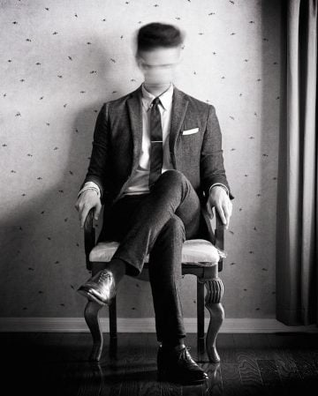

Figure 1. Book II – Edward Honaker
All of Honaker’s depression and anxiety images are under the series Book II, which consists of sixteen photographs, all of which include himself, with some images linking to one another to create a different portrayal entirely.
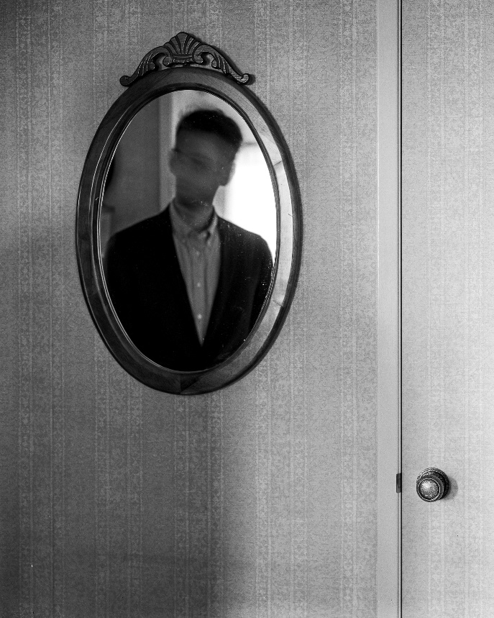
The image of Honaker sat in a chair, legs crossed and in a suit gives off the impression that he is someone who cares about his appearance and stance, but his face and expression, or lack thereof, tell a different story and depiction of him. Face and features blurred by shaking his head distorts the image and the presentation of a normal person. Viewing this image does not give a clear picture of what Honaker looks like as his facial features are indistinguishable due to the blurry nature of the head. This could give off the sense of uneasiness, not knowing who you are looking at; all that is seen is a distorted face of a well dressed man, a distortion that does not fit in with the feel and place of the image. In quite a few of his portrayals, Honaker is seen in decent clothing, most frequently dressed in a suit or a smart shirt and trousers. It is a contrast to the stereotypes that are heard about people with depression, usually thinking of them as messy, bad hygiene, struggling to get dressed properly or get out of bed, baggy clothes and hoodies, and not caring about their appearance (Tides, 2025). Honaker’s imagery breaks these stereotypes by showing that people can and will still struggle with their mental health regardless of how they look, even if they have good hygiene, are well dressed or do not struggle with simple tasks. The blurriness can also indicate an unstable sense of self, identity confusion and identity stripped away as a result of struggling with depression.

Figure 2. Book II – Edward Honaker
Edward Honaker’s blurred facial expression appears once again with him standing in front of a mirror, looking at himself. The mirror and himself are seemingly the only things in the room, with the wallpaper looking rather plain and the mirror itself has nothing too special about it. Honaker is dresses smartly in a shirt and jacket, again reinforcing the notion of having it all together and breaking stereotypes. Even though it looks like Honaker is looking at his reflection, the distortions of his face give the impression that he cannot face himself or the reality of his situation, the depression changing how he views himself or how he cannot view himself. It is a simple yet effective image to convey how depression can disrupt your mind and how you think and feel about yourself. It also shows how you can be physically present in a place but not actually there mentally which ties into the notion of dissociation (Fung et al 2025).
There have been links between depression and dissociation, both can co-occur, and distort a person's reality further. With Honaker’s imagery, there are depictions and feelings of dissociation but also possible confusion. Dissociation and dissociative disorders can have symptoms such as “amnesia, depersonalisation, derealisation, identity confusion, and identity alteration” (Şar, 2014). The photography done by Honaker, whether intentional or not, does depict dissociation, specifically depersonalisation and derealisation. The blurry faces, disconnection from backgrounds, and unsettling poses creates a story of struggle, desperation and loss, all of Honaker himself as an archive of his own depression.
Honaker’s photography of blurriness and emptiness can be seen as haunting in a sense as depression has haunted him for years. It is a lived reality by him that is unseen by outsiders, and he has used his imagery to open up a conversation on mental health and the distortions in his images cause lingering feelings in the viewer which make a lasting impression, showing that a photograph can haunt like a ghost and that time may well be an illusion (Wittman, 2009).
Francesca Woodman
Francesca Woodman was a photographer and like Honaker, used black and white photography that featured self-portraits or sometimes other women, alongside using different poses, backgrounds, and photographic techniques such as long exposure; “Many of her photographs show women, naked or clothed, blurred, merging with their surroundings, or whose faces are obscured” (Tate, 2025). Her self-portraits are unique, cleverly using the environment and props to hide herself or part of her body, particularly if no clothing was being worn. She would often use long exposure to get the blurred effect in her photographs to conceal parts of her naked body and to give the impression of a more ghostlike appearance. Also “these beautiful and yet unsettling images seem fleeting but also suggest a sense of timelessness” (Tate, 2022).
The themes she would look at were self-image, (personal) identity, sexuality, the (naked) body, isolation and confusion. The use of location, lighting and props were important parts of her work, creating the perfect environment to properly convey her thoughts, feelings and her own reality. The reality Woodman played with was often distorted, placing herself in poses most would find awkward or unsettling, but this would play into the aspects of isolation, vulnerability and alienation as she would hide among the props and furniture, almost becoming one with them in the positions she would put herself in. Location was a big factor in her photographs; the environment was always carefully staged. Woodman’s photographs were small-scale, inviting the viewer to look closer at all the details, making them notice everything that was shown to them. Most locations were sparce of anything loud or dramatic, putting emphasis on Woodman herself and the props she was using. Some rooms looked frozen in time, like they had not been lived in or trodden into in a while. This was on purpose, to create an atmosphere and evoke certain feelings. If Woodman wore any clothing in her photographs, they typically were old fashioned or vintage, to fit in with the feel and mood of the image as they were in black and white, giving more of a timely feel and taking you back to times gone by. This would give the images a sense of timelessness and “adds to the ambiguity of when the pictures date from, leaving Francesca forever trapped in a timeless world” (Tate, 2022).
Many of the images containing Woodman herself give off the sense of vulnerability, making the viewer thinks about the fragility of the human and of human existence. Especially now since Woodman took her own life, her photographic legacy she left behind can be seen as a haunting reminder of how momentary someone’s existence can be. She is forever captured in time in her own images, disturbing yet intimate, a reminder that life can be cruel and cut short for many battling with mental illness and suicidal ideation (Tate, 2022).
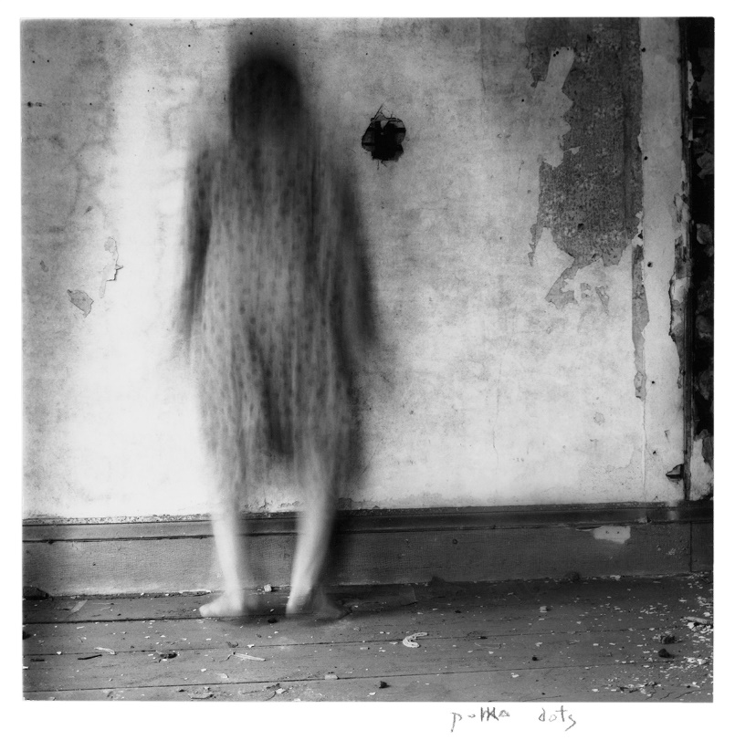

Figure 3. Polka Dots – Francesca Woodman
The photograph ‘Polka Dots’ is part of the Polka Dots series that Woodman created. This image in particular portrays the blurriness that is seen in many of her works. At first glance, it confuses the eyes, unable to distinguish features or determine if she is facing the wall or facing outward. It does appear that she is facing the wall, but the blurriness makes it hard to fully understand her posture. The long shutter speed creates this image of Woodman, a ghost stuck in a dilapidated room with crumbling walls, peeling paint and debris on the floor, a person in ruin. The environment is not pleasant and there is a feeling of instability, as if Woodman is trapped between worlds; the living world and the dead, her identity unstable and unable to find herself (Gumport, 2011). Depression can cause a person to feel empty and almost ghost like, unable to comprehend who you are or should be. Woodman’s imagery portrays that unknowing, not knowing if you are coming or going in life.
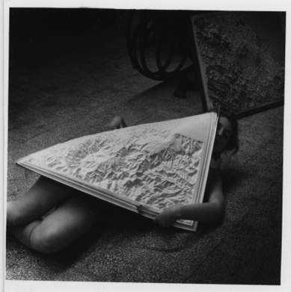

Figure 4. Untitled – Francesca Woodman
Several of Woodman’s works were untitled, like this one. “She experimented with glass panels, pressing them against her body to squeeze, reshape and flatten her flesh to make her physical features appear grotesque and exaggerated” (Tate, 2022). This image shows Woodman under a slab of what looks to be white concrete, hiding her naked body beneath it. As the concrete is the only lighter object in the image, your eyes are drawn to it, and then to Woodman herself and her facial expression that is hard to discern, possibly a look of distress or discomfort. The weight of the object could be seen as metaphorical to the weight of the world or of depression, weighing you down and unable to move it, move yourself, or get up off the ground. Many of Woodman’s works could be used as a metaphor for mental health, depression and identity, especially since she suffered with her own mental health that, in the end, took her way from this world.

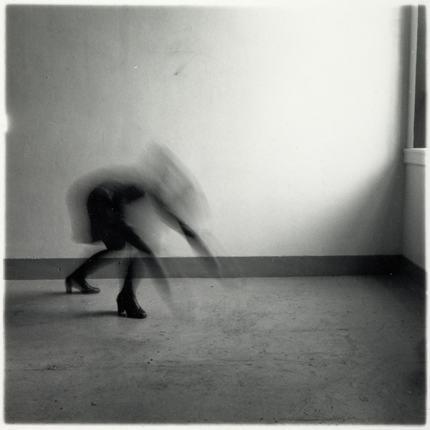

Figure 5. Space² – Francesca Woodman
In the series Space² and in particular the image above, Woodman utilises spaces in different ways; some tight and confined, others open but empty. Her classic blurring and long exposure is seen here again and it almost depicts her as animalistic, looking like she is about to get down on all fours like an animal. The movement of her head does also create a spectral like appearance, and the visuals of two heads. Her head and arms look unnatural, going back to the animal-like visuals that look like motion (Tate, 2022). Taking the animal approach, it would strip Woodman of her human identity, showing her as just an animal, creating instability in who she is or is not. It could be seen as self-fragmentation, torn between being and feeling human, and being and feeling like an animal, disconnected from the world and the human race. Mental illness can make a person feel less than human, not deserving of human comforts like a bed, food or love. The room is empty, void of anything apart from Woodman herself. It is just her and the barren room.
Posthumanism is frequently linked to Woodman as the majority of her works became more known after her death. She left behind a legacy that still inspires artists and photographers to this day. Having her in her photographs is the only way many people can remember her, she is frozen in time in the images, and you have to remind yourself that the person you are looking at is no longer alive which makes you more aware of your own mortality. Woodman became an example of how life is short and unpredictable, how your own mind can betray you. Her works are her life in an archive, what remains of her. She continues on in life through her photographs, influencing the present even though she herself is not (Fiore, 2018).
Woodman’s works are also connected to hauntology through her ghost-like movements and use of old, derelict places. It is almost like she fades into the spaces, fits into the dilapidated looks of rooms. Her body is existing and not existing at the same time, like she is in between worlds or realities, such as life and death. Her images are haunted by her own presence and there she remains, stuck and frozen in haunted imagery for the viewer to see.
Conclusion
The works of Edward Honaker and Francesca Woodman are reminders on what depression can do to a person. Using their own bodies as subjects, they have conveyed the feelings and emotions of what it is like living with a mental illness. The distortions, blurriness, poses and environments all tell a story of their own battles and struggles that sadly took Woodman from this world too soon. Both photographers have displayed hauntology, temporality, phenomenology and Woodman specifically with posthumanism.
Mental health has always had some sort of stigma attached to it, it is considered a taboo subject to talk about, but Woodman and Honaker break the boundaries by putting themselves out there in order to lessen the stigma surrounding depression in particular. Their work is an archive of their thoughts, feelings and emotions; images stuck in a time where they were both finding life difficult. Time and memory have played a role in critiquing their work as these aspects are more beneath the surface. It shows that reality can be different for people with depression; time is slower as seen by the use of long exposure, and memory and identity can be affected as seen by the blurring of faces. Their identity and being is broken down and they are seen as other beings that may be less than human; shells of their former selves or as animals that are below humans. This interpretation of their imagery backs up what depression can make a person feel - non-human, worthless, guilty and detached from oneself (Şar, 2014).
Capturing the complexities of mental health in an image or series of images is not easy but both have used unique techniques and props to bring to life what it may feel like having depression and anxiety. Photography is a suited medium to showcase hauntology and temporality as it captures the past and present for the future, showing what has been and preserving it for generations to come and showing non-linear time through the images. It ties in with Derrida and Barthes’ theories, with photography materialising their concepts in a compelling way. Photography gives the subjects a sense of realism that other mediums and disciplines cannot and captures moments that may have been otherwise lost to time.

References
Aesthetics of Photography (2025) ‘Camera Lucida’ by Roland Barthes. Available at: https://aestheticsofphotography.com/camera-lucida-roland-barthes/ (Accessed: 3rd January 2026).
Barthes, R. (1987). Camera Lucida. Translated by Howard, R. New York: Hill and Wang.
Critchley, S. (2009) Being and Time, part 1: Why Heidegger matters. Available at: https://www.theguardian.com/commentisfree/belief/2009/jun/05/heidegger-philosophy (Accessed: 3rd January 2026).
Critchley, S. (2009) Being and Time, part 2: On mineness. Available at: https://www.theguardian.com/commentisfree/belief/2009/jun/15/heidegger-being-time-philosophy (Accessed: 3rd January 2026).
Critchley, S. (2009) Being and Time, part 3: Being-in-the-world. Available at: https://www.theguardian.com/commentisfree/belief/2009/jun/22/heidegger-religion-philosophy (Accessed: 3rd January 2026).
Critchley, S. (2009) Being and Time, part 4: Thrown into this world. Available at: https://www.theguardian.com/commentisfree/belief/2009/jun/29/religion-philosophy (Accessed: 3rd January 2026).
Critchley, S. (2009) Being and Time, part 5: Anxiety. Available at: https://www.theguardian.com/commentisfree/belief/2009/jul/06/heidegger-philosophy-being (Accessed: 3rd January 2026).
Critchley, S. (2009) Being and Time, part 7: Conscience. Available at: https://www.theguardian.com/commentisfree/belief/2009/jul/20/heidegger-being-time-critchley (Accessed: 3rd January 2026).
Critchley, S. (2009) Heidegger’s Being and Time, part 8: Temporality. Available at: https://www.theguardian.com/commentisfree/belief/2009/jul/27/heidegger-being-time-philosophy (Accessed: 3rd January 2026).
Fiore, J. (2018) Reevaluating Francesca Woodman, Whose Early Death Haunts Her Groundbreaking Images. Available at: https://www.artsy.net/article/artsy-editorial-reevaluating-francesca-woodman-early-death-haunts-groundbreaking-images (Accessed: 29th December 2025).
Fung, H.W et al. (2025) The co-occurrence of depression and dissociation. Available at: https://www.sciencedirect.com/science/article/pii/S0022395625001049 (Accessed: 27th December 2025).
Gallix, A. (2011) Hauntology: A not-so-new critical manifestation. Available at: https://www.theguardian.com/books/booksblog/2011/jun/17/hauntology-critical (Accessed: 3rd January 2026).
Gumport, E (2011) The Long Exposure of Francesca Woodman. Available at: https://www.mariangoodman.com/usr/documents/press/download_url/142/the-new-york-review-of-books-january-24-2011-.pdf (Accessed: 29th December 2025).
Heidegger, M. (2001). Being and Time. Translated by Macquarrie, J and Robinson E. Oxford: Blackwell Publishers.
Holmes, L. (2015) https://www.huffingtonpost.co.uk/entry/edward-honaker-photography-mental-illness_n_55f0759ce4b03784e2777fbb
Honaker, E. (2014) Book Two. Available at: https://www.edwardhonaker.com/booktwo (Accessed: 27th December 2025).
Mental health foundation (2021) Stigma and Discrimination. Available at: https://www.mentalhealth.org.uk/explore-mental-health/a-z-topics/stigma-and-discrimination (Accessed: 27th December 2025).
Şar, V. (2014) The Many Faces of Dissociation: Opportunities for Innovative Research in Psychiatry. Available at: https://pmc.ncbi.nlm.nih.gov/articles/PMC4293161/ (Accessed: 27th December 2025).
Tate. (2022) Finding Francesca. Available at: https://www.tate.org.uk/art/artists/francesca-woodman-10512/finding-francesca (Accessed: 29th December 2025).
Tate. (2022) Five things to know: Francesca Woodman. Available at: https://www.tate.org.uk/art/lists/five-things-know-francesca-woodman (Accessed: 29th December 2025).
Tate. (2025) Francesca Woodman. Available at: https://www.tate.org.uk/art/artists/francesca-woodman-10512 (Accessed: 29th December 2025).
Tides (2025) Depression-Related Clothing Habits Like Hoodies: Understanding Comfort and Coping Mechanisms. Available at: https://tidesmentalhealth.com/depression-related-clothing-habits-like-hoodies/ (Accessed: 27th December 2025).
Whittmann, M. (2009) Time, extended: Hiroshi Sugimoto with Gilles Deleuze. Available at: https://www.imageandnarrative.be/inarchive/Images_de_linvisible/Wittmann.htm (Accessed: 3rd January 2026).
WHO (2025) Over a billion people living with mental health conditions – services require urgent scale-up. Available at: https://www.who.int/news/item/02-09-2025-over-a-billion-people-living-with-mental-health-conditions-services-require-urgent-scale-up (Accessed: 27th December 2025).
Woodman Foundation ([no date]) Francesca Woodman – Work. Available at: https://woodmanfoundation.org/francesca/works (Accessed: 29th December 2025).

List of Figures
Figure 1. Honaker, E. (2014) Book II. Available at: https://www.edwardhonaker.com/booktwo (Accessed: 27th December 2025).
Figure 2. Honaker, E. (2014) Book II. Available at: https://www.edwardhonaker.com/booktwo (Accessed: 27th December 2025).
Figure 3. Woodman, F. (1976) Polka Dots. Available at: https://woodmanfoundation.org/francesca/works (Accessed: 29th December 2025).
Figure 4. Woodman, F. (1977-78) Untitled. Available at: https://woodmanfoundation.org/francesca/works (Accessed: 29th December 2025).
Figure 5. Woodman, F. ([no date]) Space². Available at: https://woodmanfoundation.org/francesca/works (Accessed: 29th December 2025).

