Effective team work and communication

Student name: Anton Shapshalov Student ID: 1907361
Module name: BMSW4002_LON
Lecture’s name: Timothy Hopkins
Date: 02.01.2019

Table of contents
- Introduction
  - What is communication?
  - Why is communication important?
  - For what is my report about?
  - Types of communication.
- My own situation
  - How communication can be effective in the business environment. Relevant Theories (Shanon and Weaver, Shcram and Berlo)
  - Noise.
- The importance of Communication
  - Models of Communication.
- Conclusion.
- References.
- Appendices.

1.
1.1 Communication is the act of exchange information with another person or group. Every communication cycle include at least one sender, receiver and message. Many people think that the communication it’s an easy thing, but actually it’s complicated. While the message goes from the sender to the receiver can be affected from many things. This includes our emotions, situation and even the place that we are at the moment that we exchange the information. All the employers consider the good communication skills for very important, because they are the one who really understand what good communication means. And how communication happens? The sender encodes the message send it to the receiver, then the receiver decodes the message, encodes his answer and send it back to the sender.

  - There are many things that make the communication important. Without communication everything it will be pointless. For example you are bored and you want to go out and spend some time with your friends and to make this happen you need to use communication. Or you are in your house and you and your housemates need to cook something, again you need to use communication to understand each other. Many things requires communication, but one of the things that we really need to communicate is our work places. There is not a job that you will not need communication. If you don’t use communication you can’t exchange information with the people around you. And if you don’t exchange information, it’s like you are alone in this world. (Page, 2019)

  - In my report I will talk about the communication: what does it mean, why it is important, how it happens, what types of communication there is, what methods of communication there is, what can affect the communication, what can make it more useful etc. Also what if effective team work and how it happens.

  - There are four types of communication: Verbal, Non-verbal, Written and Visualizations. The verbal communication is the one using words to exchange information. It can be spoken or written communication. The verbal communication factor it’s connected with the words you choose and how they are understood. It’s good to know that the verbal communication doesn’t exclude the non-verbal one fully. When you apply the verbal communication you use some factors from the non-verbal one like body language, your voice tone or face expressions. Many things can affect the verbal communication. For example if you hear other people on a side, this can change what you wanted already to say. Or if you hear somebody talking with accent you might change your mind and talk more simply with him/her. The non-verbal communication has almost the same importance as the verbal one and it affect many things while you communicate with somebody. Most important factors of this type of communication are: body language, face expressions, gestures, eye-contact and other. All of this matters and it can affect the way how the receiver decodes the information you send. For example if you’re saying to somebody how happy you are and you’re crying in the same time it will not work. That’s why both types are important to know them. Apart of those two types the written communication it’s easier. Writ ten communication it’s the information that you get from reading like reading books, newspapers, e-mails, letters, social media etc. People are different but most of them will decode the information that they read in the same way like the others. And the last ones are the visualizations. That’s all the information that we get from things like graphs, logos or when we watch a movie, presentation.

- As I said before communication is really important, especially in the work place. And also depends from the work place, some jobs require to communicate more than others. In my situation I work in a restaurant as a waiter. My main responsibility is to communicate with the customers. To make my job good I need to have good communication to understand the clients well, make them feel comfortable and provide them good-service. On the other side I need to communicate well with my colleagues, my managers. Some people have special requirements or food allergies, so the food needs to prepared in special way and I’m the one who need to talk with the chef. If I don’t encode the information right or he doesn’t decode it right can cause a big problem. It’s really busy restaurant in good area, so the main thing is the communication. Sometimes one of my colleagues go to smoke without saying to nobody to look after his/her section and then his/her customers complain or manager gets pissed off. Sometimes manager send the our work schedule, after make changes and send it again, so some people confuse and come late or don’t come at all. All of those problems are because of misunderstanding, which is the biggest problem in the communication in my opinion.

  - In my work place 2 models of communication describes it. One of them is the Shannon-Weaver model. This is a simple model of communication but there is one side thing that affects the process like in my situation and this is the noise. As I said it’s a busy place and there are a lot of people working there, a lot of customers and of course music. Most of the time it’s very noisy and sometimes this cause us problems, because we can’t understand each other very good. The other model that describes the situation in my work place is Berlo’s communication model. In this model there are some factors that influence when the sender send the information like: communication skills, attitude, knowledge. Every time before shift we have a shift brief in which manager talks to us. He needs to have good communication skills to make us first feel comfortable and then make us understand good what he/she wants to say. Also the attitude, they need to be positive if they want to motivate us. The other things are the factors of the message. It’s important what they say and how they structure the message. This model is similar to my situation, but Shannon-Weaver more.

  - A lot of things can affect the communication process and one of them is the noise. There are different types of noise regarding communication. The noise can be noise from the environment around us that affect what a person hears and how people talk between each other. For example when I work and I stand near the speaker, even the person next to me talk I can’t understand properly what he is trying to say. The noise can be emotional as well. If you stay near group of people and you want to say something, what you hear from them can affect you and change your thoughts, because the emotional noise influence to your personal experience. Sometimes you can get into conversation already prepared what to say and this can affect what you hear, because you already focus only on your thoughts. That’s the sematic noise when every person understands everything differently. There are many types of noises and any of them is useful to us. (Sears, 2018)

- Communication has always been important. It just improved with the time and now there are much more ways to communicate than before. Nowadays we have phones, computers, television, newspapers, magazines, etc. But even with this technologies or without them communication has the same importance. If there is no communication there is no way how you can share your information and thoughts with the other people. Doesn’t matter if you work or do sport, or play video game, you need to communicate to make thing effective.

  - As well there is communication and there is effective communication. Different methods (models) of communication have different purposes for different situations. The first model we will get more familiar with is “Berlo’s mode”. This model mainly has 4 components of the communication process: Sender, message, channel and receiver. In 1960 David Berlo postulate “Berlo’s Sender-message-channel-receiver (SMCS)” communication model from Shanon and Weaver model. He described the different factors, which affect the components of the communication and makes it more effective. Sender is the source or the person which sends the information. This model explains the factors that can affect the process. For the sender and the receiver the factors are the same and they are: communication skills, attitude, knowledge, social systems and culture. If the sender has good communication skills he can formulate the message good, but If the sender doesn’t have he will not get the message good. The attitude has effect of the message and depends on it can change the meaning of the message as well. Also message can be affected from different factors like: content, elements, treatment, structure, code. It is important to follow all of those factors if you want the message be effective and understood good. Content is what you will say, elements what you will include in your message, treatment the way you will say it, structure is how you will formulate it and code it is the meaning. That’s why those factors are so important. And what affects the channel is: hearing, seeing, touching, smelling and tasting. (Businesstopia, 2018)



The second model is “Shannon and Weaver” communication model. The model was created in 1948 when Claude Shannon wrote an article with Warren Weaver. Shannon was mathematic and Weaver was scientist. Later on the mathematic theory became known as a communication model. This model is not so complicated and there are not many factors to affect it. The components of the model are: sender, encoder, channel, decoder, receiver and noise. The model is working pretty simple. It starts with the sender (the person who sends the message), after the encoder (the sender who uses the machine), channel (the medium used to send the message), decoder (the receiver who translates the message from the signals), receiver (the person who gets the message) and last one is the noise, which can affects the message during the process. For example brain can be the sender, mouth can be the encoder, the channel can be the air, the ear of the other person can be the receiver and his/her brain can be the decoder. In the beginning the model contained only five components and the noise was added later. (Businesstopia, 2018)


From the three models the simplest one is the “SCHRAM” model of communication. It’s a cycle with only three components. They are the decoder, encoder and interpreter. One person can be the sender or the receiver. The whole process can happen in the same time like decoding, encoding and interpretation and because of that sometimes it happens misunderstanding. (Anon., 2017)
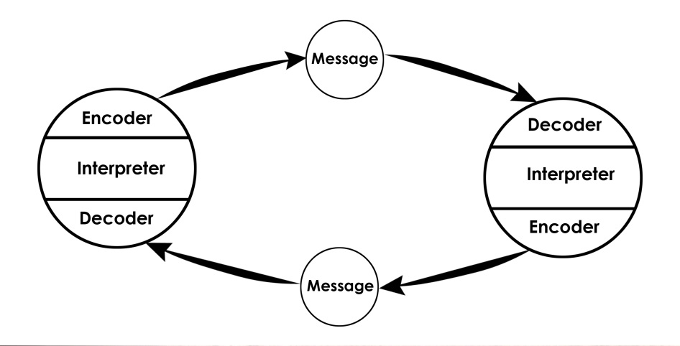

- Communication is the common thing to exchange information, emotions, knowledge with the other people. Communication can happen only with words, only with body language (like gestures, face expressions etc.) or with both. There are different model of communication that if they will be learnt can be really helpful to communicate better with other people.

- References.

Works Cited
Anon., 2017. Communication Theory. [Online]
Available at: https://www.communicationtheory.org/osgood-schramm-model-of-communication/
[Accessed 02 01 2020].
Businesstopia, 2018. Businesstopia. [Online]
Available at: https://www.businesstopia.net/communication/berlo-model-communication
[Accessed 02 01 2020].
Businesstopia, 2018. Businesstopia. [Online]
Available at: https://www.businesstopia.net/communication/shannon-and-weaver-model-communication
[Accessed 02 01 2020].
Page, M., 2019. Michael Page. [Online]
Available at: https://www.michaelpage.co.uk/advice/management-advice/development-and-retention/importance-good-communication
[Accessed 02 01 2020].
Sears, B., 2018. Quora. [Online]
Available at: https://www.quora.com/How-can-noise-affect-communication
[Accessed 02 01 2020].

- Appendices

