



TESCO PLC

BMMB7012 – Marketing Management

Evaluating Tesco’s Marketing Activity

Author: Andrew Morgan 0351590

Executive Summary
Tesco is a multinational retail corporation with its headquarters based in the United Kingdom. It is one of the largest supermarket chains globally, operating as one of the UK ‘Big Four’ supermarkets. Tesco operates stores in various formats and size under different brand names, including Tesco Extra, Tesco Superstore, Tesco Metro, and Tesco Express.
Over the years, Tesco has grown both organically and through acquisitions. It offers a diverse range of products, including groceries, clothing, electronics, household goods, and financial services. Tesco also has a competitive online position through its grocery platform offering customers home delivery and click and collect services.
Tesco has a significant presence in the United Kingdom, it is the largest supermarket chain with a circa 27% market share, whilst also boasting global operations.
The company has been at the forefront of innovation in the retail industry and has introduced initiatives such as loyalty programs, self-checkout systems, and mobile applications to enhance the shopping experience for its customers.
Tesco's focus is on its customer’s needs, by providing quality products at competitive prices. The company has faced various challenges and undergone significant changes over the years, but it remains a prominent player in the global retail industry.
This strategic report will critically evaluate Tesco’s Marketing strategy of its UK operations, scoping out the micro and macro environment using a range of marketing management tools.
A conclusion will sum up findings of this report, with recommendations moving forward.

Contents Page

Introduction…………………………………………………….…………………………….….…………………………….4
What is Marketing.............................................................................................................5
What is Marketing Management?......................................................................................5
Main Findings……………………………………..……..…………..………….………….………………………………..6
SWOT Analysis………………………………………….…………………………….……………………………………….8
STEEPLED Analysis………………………………………………………………………………………………………….12
Marketing Mix…………………………………………………….……….……….……………………………………....15
Measuring Success...........................................................................................................16
Conclusion………………………………………………………………………………………………………………………23
Recommendations………………………………………………………………………………………………………….24
Bibliography……………………………………………………………………..……………………………………………25

Introduction
In 1919, Jack Cohen began trading with a small market stall in the east end of London, the name wasn’t established until 1924, the first brand product was released as Tesco tea, this name was derived from the tea supplier TE Stockwell and CO from Cohen (Tesco, 2023)
Tesco PLC has 337,000 employees across 4,100 stores throughout the UK and ROI, with an annual turnover of £57.7bn and a operating profit of £2,630m for 2022 (Tesco Key Facts, 2023). It also operates in Slovakia, Czech republic and Hungary both online and instore (Globaldata, 2023). Aside from groceries and fuel, Tesco has diversified into clothing, toys, finance services, electronics, telecoms and internet services (Bedford, 2023) Tesco is classed as one of the top four supermarkets in the UK and is a leading grocery retailer holding circa 27 percent of the market (Bedford, 2023)
In 1995, Tesco launched the Clubcard as part of its marketing strategy, a revelation that provided Tesco with the data on what people were buying across the stores, which in turn became profitable. It was able to determine spending habits offering personalised offers whilst boosting itself to the UK’s top supermarket a year later (Winterman, 2013)
In 2022, the Tesco Clubcard loyalty programme was deemed the best reward scheme offered by any supermarket, with the highest customer satisfaction score, beating the likes of Sainsburys, Morrisons, waitrose and Marks and Spencer’s (Houlton, 2023).
Tesco has recently made significant changes to its marketing strategy through the Tesco Clubcard, making all in store discounts accessible to Clubcard members only, altering the way points are collected on fuel spend and reducing the value of vouchers on partner rewards (Sayce, 2023)
Marketing Strategy
Tesco bases it marketing plan on three key core purposes; Customers, Communities and the Planet. The marketing plan starts and end with the customers so that Tesco can focus on their needs and expectations (Tesco plc, 2023). Neil Borden said “Marketing is still an art, and the marketing manager, as head chef, must creatively marshal all his marketing activities to advance the short and long term interests of his firm” (Borden, 1964)

Main Findings
Micro and Macro Environment
Marketing strategy is devised through scoping the internal and external environments, this can identify forces that impact the immediate and/or wider environments, these in business terms are defined as micro and macro environment (Jobber, Ellis-Chadwick, 2019)
STEEPLED Analysis
The STEEPLED analysis assesses eight crucial variables that the business has little to no influence over when evaluating the macro-environment. With a few additions, it is very similar to the PESTEL analysis (Frue, 2022). It will aid Tesco in preventing rival businesses from obtaining a market advantage. The analysis that follows will assist the business in locating important change-related factors that could influence the success or failure of the organization's strategy (Johnson et al., 2008, pp. 55–56).
Social
There are growing trends in what consumers are buying, there are more people switching to alternative diets such as vegan, gluten free, vegetarian, keto and dairy free. Currently the UK has approximately 7.2 million people following a meat free diet with this expected to hit 15.8 million by the end of 2023 (Edwards, 2023).
Technological
The growing number of electric vehicles (EV’s) has grown exponentially in recent years, the first quarter of 2023 has seen sales of more than 2.3m cars. Tesco must ensure they have the infrastructure to allow greater charging facilities for customers while they shop (IEA, 2023). Significant increases reported in the use of self-service checkouts and scan as you shop in supermarkets. Tesco will increase its self-service checkouts based on a decline of use at manned checkouts throughout its stores (Wright, 2022), however some customers have aired frustrations due to a prison like experience in trying to exit the self-serve area due to increased shoplifting (Hill, 2023)
Economic
The cost-of-living crisis is having an impact as people look to save money by switching to cheaper brands or using more supermarkets to obtain the best value for money. Tesco have extended its price lock campaign to strengthen its customer position as the brand reported a seven percent jump in annual sales (wright, 2023)
Tesco supports £53bn in Gross Value Added (GVA) to the UK economy, providing £82 million on average to local economies, whilst being the fourth largest taxpayer in the UK at circa £1.7bn (Tesco impact report, 2023). Eighty percent of all 4,000 suppliers are UK based with an annual spend of approximately £40bn across its procurement and product supply chains. (Tesco impact report, 2023).
Environmental
The Climate Change Act 2008 was introduced to cut emissions and lower carbon footprint by 80% by 2050 (gov.uk). This included powers to charge for single use carrier bags, which tesco has implemented across its stores. Tesco has aimed to become carbon neutral across the group by 2035 and net carbon zero by 2050 across its full operations (Tesco, 2023)
Political
Since its existence, there have been many political challenges that Tesco has had to overcome and it has shown that it able to adapt and respond to such changes. The most significant being the Russian Ukraine war, impacts on rising costs have impacted suppliers ultimately being passed on to the customer. Tesco have challenged suppliers for taking advantage and trying to ‘Cash In’ threatening to remove products from their shelves (Roswell, 2023).
Legal
Recent changes to the Tesco Clubcard have been highlighted by some consumer groups as product unit prices are not clear and consumers are unable to determine which product is the cheapest, Tesco argues that advice from trading standards ensures that there is compliance against all current regulations and no laws have been broken (Sri-Pathma, 2023)
Ethical
Tesco must ensure it has good Corporate Social Responsibility, Tesco must ensure the way in which it operates is sustainable against the society, environment and economy (CIPD, 2023). As of 2020 changes to the grocery promotions are only accessible to Clubcard members only, which allows Tesco to obtain more data on shopping habits, whilst offering more personalised offers to the over eighty percent of people using the Clubcard at major stores (McGleenon, 2023).
Demographics
An ageing population, a growing population and a more diverse population brings changes in shopping habits and desires for consumers. The changes to the Clubcard promotion strategy have forced more people to join, enabling Tesco to collate more data on purchases and from what group.
Porters Five Forces
Threat of new entrants: The threat of new entrants to Tesco would be seen as low, they are well established, financially stable and start-up costs would be significant. There were over 310,000 retail businesses in the UK as of 2022 (retail economics, 2023)
Customer Bargaining power: If customers are satisfied with the rewards/offers they receive from Tesco they would be less likely to change, the cost of living crisis may see customers use more than one supermarket, in turn potentially losing some market share.
Supplier bargaining power: suppliers may be lured by the supermarket to offer exclusive discounts to Clubcard members, this allows the supermarket to negotiate a better buying rate whilst enhancing its bargaining power, whilst Increasing sales for both supermarket and supplier.
Competitors: Competition between the supermarkets has always existed, as of December 2022 Tesco is still holding the majority with a 27.5% market share The cost of living crisis is seeing people shop at multiple supermarkets to obtain offers to simply save money.
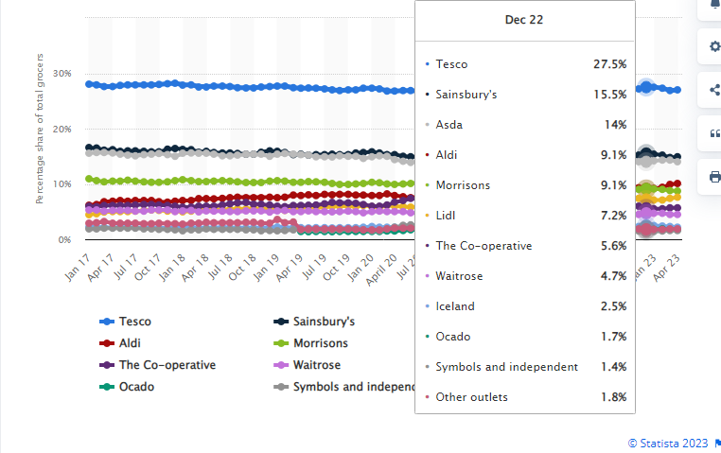
(Source: Bedford, 2023)
Threat of substitutes: Tesco must ensure it offers unrivaled discounts/ rewards for customers, they have the Clubcard to access discounted products, whilst collecting points from groceries and fuel. These can be converted into vouchers to be spent in store or utilise them at partner rewards. It needs to monitor the likes of the Nectar card to ensure unrivalled competition.

Target Market
Segmentation, targeting, and positioning are the foundations of marketing strategy. A company identifies various consumer needs and groups in the market, focuses on those it can satisfy in a superior way, and then positions its offerings so that the target market recognizes it for its distinctive offerings and images (Kotler, Keller, 2017).
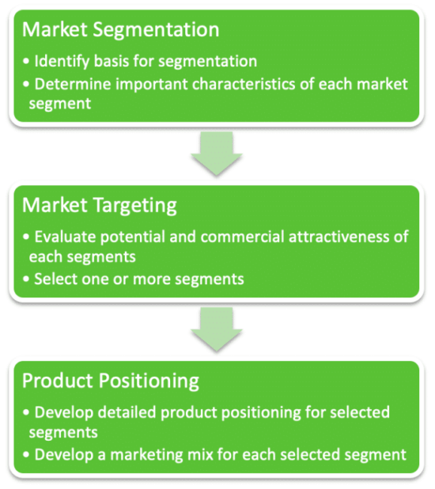
(Hanlon, 2022)
Segmentation
There are four key areas of market segmentation, these are geographic, demographic, behavioural and psychographic. This report focuses on three of there four as the Clubcard data would provide the Psychographic data based on the consumer data it holds..
Geographic
Tesco has strategically placed stores throughout the UK, covering both rural and urban locations. They range from large superstores to smaller express convenient stores. It can analyse data from the Clubcard to determine store locations and size based on footfall (Poulter, 2011).
Demographic
Tesco’s products cater for all, they are able to offer goods to all people of all ages and cater for almost every dietary requirement with an ever expanding range. In recent years they have also looked at people who eat or live alone (Wood, 2018).
Behavioural
Tesco has always aimed for cost and quality, where customers feel satisfied with a good quality product at low cost. This in turn can make them brand loyal and likely to continue as Tesco customers.
By segmenting what has it provided to tesco……..
Market Targeting
Target markets are evaluated in segments, based on the evaluation the potential is determined and prioritised, this evaluation includes the following:
- Criteria size
- Difference
- Money
- Accessible
- Focus on different benefits (Hanlon, 2022)
Tesco main focus is on its customers, to bring quality products based on customers needs and demands, the withdrawal of Jack’s in 2022 seen Tesco launch the Aldi price match, with a primary focus to deliver best value for its customers across the core elements of the business (Tesco Plc, 2022)
Positioning
The image below outlines Tesco’s position in the market, they position themselves midway of high price and high quality, although this may seem high, this is still lower than the likes of Waitrose and M&S, but this is across the whole brand and continues to offer great value for money to its customers. (literature to support)
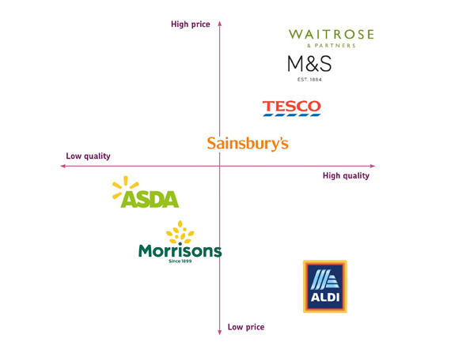
(Alderandalder, 2020)

Marketing Mix
The Marketing Mix was established in by Jerome McCarthy in the 1960’s, he derived the four P’s by taking multiple marketing activities and splitting them into four kinds: Product, Place, Price and promotion (Kotler, 2017). In the 1990’s this grew to become the seven P’s with the inclusion of Process, Physical evidence and people.
Product
Tesco is renowned for it large selection of groceries, whilst it has also diversified into homeware, stationary, electronics, financial services, opticians and clothing. Products are offered as Tesco Redmere farm (low cost value brand), standard own brand, Finest range, F&F clothing, go cook and fox and ivy. They also host a range of other branded products throughout its store network.
Stores are stocked on information collected from automated software that determines buying habits, weather and historical trends, which allows products to be stocked accordingly (Brice, 2013).
Place
Tesco has over 4,100 stores situated throughout the UK with many more worldwide, the bricks and mortar stores range from superstore, extra, metro and express (Bedford, 2023). These stores are large to small offering a vast range of products to smaller convenience style shopping.
There is also the online facility to enable customers to conveniently shop from their own home and request either home delivery or collection from store.
Price
Tesco is focused on cost leadership, by doing so can offer low prices for high quality products, it can do this through economies of scale to reduce costs and subsequently pass these onto its customers. In October 2022, tesco released it low everyday pricing strategy to lock in prices until July 2023 on over 1,000 products in order to combat the cost of living crisis (Houlton, 2023). There was some recent criticism that 100’s of budget products had been cut which Tesco was quick to respond to (Highfield, 2022)
Promotion
To lure customers, Tesco has generally relied upon is print and media to communicate with its target audience. In recent years Tesco has focused more on digital media with the changes to the Clubcard pricing strategy, where discounts are exclusively available to Clubcard members only. Recently Tesco has removed the Clubcard app and replaced it with a new Grocery and Clubcard app, providing more frequent personalised offers which will only be available via the app (McHardy, 2023). Tesco Clubcard
Tesco changed the Clubcard pricing strategy in 2020 making all offers available to Clubcard members only, this was seen as a risk and caused some internal debate, however this worked in their favour as Clubcard members increased from 14m to 21m, giving them unrivalled customer data (Carroll, 2023). Although loyalty schemes exist elsewhere, its about how Tesco engage with its customers, Tesco’s Chief customer officer Alessandra Bellini said that “The mechanics may be the same but what you deliver, the value you deliver, and how you do it can be very different” (Bellini, 2023). Geoffrey Mogre stated “Without big data analytics, companies are blind and deaf, wandering out onto the web like deer on a freeway” (Mogre, 2021)
People
Tesco employs 337,000 people across the UK and ROI, it has invested a significant amount in creating a development academy, to support the development of its staff whilst also offering a leadership programme to allow individuals to grow, whilst enhancing their people management skills (Tesco, 2023). Tesco has recently offered its staff access to virtual doctors appointments privately as the struggles within the NHS continue (Goldfingle, 2023)
Process
Tesco has a process of online orders either delivered to the customers door or via the click and collect option. Traditionally they still have the in store shopping method where customers pick their shopping and either go to a cashier or to the self service checkouts, of which will increase due to growing demands whilst lowering costs (Wright, 2022)
Physical Evidence
Tesco has a vey easy to navigate stores, they are vibrant, modern, colourful and welcoming to customers. The Tesco logo is big and can often be seen from the roadway, marking its presence in the area. The website and app are very easy to navigate and operate whilst also looking great.

Media Selection
Tesco utilises a number of different media options to support the marketing strategy, Clubcard data is key to send personalised offers and vouchers based on the customers shopping habits, as loyalty reward for shopping at Tesco. The key components include:
Advertising – various campaigns are run through print, television, radio and digitally including grocery app, to support promotions which aids sales and attracts customers.
Digital Marketing – This has become the main source of marketing for Tesco, it has reduced costs to conventional marketing by utilising emails, social media and Search Engine Optimisation. Over 47% of searches are organic with just 3% paid searches (Statista, 2023). Tesco.com is the leading supermarket for traffic, it currently sits ahead of Asda, Sainsbury’s, Morrisons with an average of 31M visits per month, has an average visit of 05.49, a 40.31% bounce rate and 7.73 average page visit (Similarweb.com, 2023).
Social Media – Tesco has many active accounts across Facebook, Twitter, YouTube, Instagram and Whatsapp Webapp to showcase promotions and content, either by Tesco or through paid partnerships. Tesco.com receives 35.86% of traffic from YouTube, whilst Whatsapp Webapp sends a mere 3.6% (Similarweb, 2023).
Tesco Magazine – Tesco produces a magazine that showcases new and existing products across the range, it features trends in the market such as healthy meal preparations, seasonal produce and general health and wellbeing

Measuring Success
Tesco will utilise many different metrics in order to measure success, these will be financial and non-financial, including:
Market Share – Tesco currently holds 27.5% of the market share, the leader out of the ‘Big Four’ with Sainsbury’s at 17%. Constant monitoring will allow Tesco to evaluate its position and see increase or decrease and act accordingly.
Financial – Finances will be measured each year on gross and net profits, ROI, share values, sales growth and operating costs. As of 2022, Tesco had turnover of £57.7m with a group operating profit of £2,630m (Tesco plc, 2023) dividend shares have seen an increase from 2021 to 9.15p to 10.90p in 2023 (forbes, 2023)
Digitisation – it will monitor the growth across its digital platforms, this will include the Tesco.com website and Grocery App, for bot home delivery and click and collect. Sales growth can be measured and the footfall as people transition into a more digital way of shopping.
Innovation – The changes to the Clubcard pricing strategy, seen an increase in 7M members, this leads to more dta which Tesco can use to their advantage. As of 2023, 80% of shoppers at bricks and mortar outlets use a Clubcard. The introduction of the grocery app has meant that all coupons will now move digital, this could impact the elder generation.
CSR and Sustainability - Tesco have set sustainability as a core purpose, they will achieve through strategic objectives and business plans. They aim to become net carbon zero by 2035 and will continue to operate in a more responsible and sustainable way,

Conclusion
Tesco is dedicated to providing value to its customers in order to win and maintain continued loyalty. Additionally, it strives to be a cutting-edge business by adding greater value to all of its many goods. Tesco has built many brands to meet the needs of its customers regardless of their economic and financial condition in order to achieve its goal. Tesco has categorised its market in accordance with these market segments.
In order to increase foot traffic to its stores and increase its market share, the corporation has also implemented a marketing mix plan. Tesco wants to use these tactics to increase the value of its products and please customers.
The Clubcard has given Tesco a cutting edge against its competitors due to the 21M members that it has, which provides the pivotal data in order for Tesco to be more competitive and efficient.

Recommendations
Marketing Mix
Tesco needs to constantly review the marketing mix, this will allow better planning and anticipation to any changes, the Ukraine Russian war would have had an impact on suppliers which Tesco was able to respond to. Particular attention should be paid to product expansion on meat free products, as statistics point to a potential 7m increase by the end of 2023 (Edwards, 2023)
Sustainability
Tesco should look at more new initiatives to bring more environmentally friendly and sustainable packaging and products to its customers. Utilising less packaging, locally sourcing, waste reduction and promoting recycling.
Technology
As the number of EV’s increases significantly in the UK, the infrastructure should be prioritised to support vehicle charging across its bricks and mortar locations. This will reassure customers that they can conveniently charge whilst they shop, and or utilise the café area whilst charging increasing sales.
Customer loyalty
Whilst the changes to the loyalty scheme have taken place to a digitised format, the usage should be monitored to ensure the elderly who are less savvy with technology don’t miss out on rewards to which they are entitled to.
Social media
New opportunities may be revealed Utilising WhatsApp Webapp by engaging with its customers. This is the weakest social media platform for engagement at less than 3.5%.
Bibliography
Alderandalder (2020) Knowing your market position is important: Alder and alder: Exeter, Alder and Alder. Available at: https://www.alderandalder.co.uk/knowing-your-market-position-is-important/
(Accessed: 06 July 2023).
BBC (2020) Tesco: Brexit impact on food prices ‘very modest’, BBC News. Available at: https://www.bbc.co.uk/news/uk-55460948
(Accessed: 04 July 2023).
Bedford, E. (2023) Topic: Tesco plc, Statista. Available at: https://www.statista.com/topics/3807/tesco-plc/#topicOverview
(Accessed: 21 June 2023).
Bedford, E. (2023) Great Britain: Grocery market share 2023, Statista. Available at: https://www.statista.com/statistics/280208/grocery-market-share-in-the-united-kingdom-uk/#:~:text=The%20market%20share%20of%20of%20the%20leading%20supermarkets,of%20the%20market%20together%20as%20of%20April%202023
(Accessed: 06 July 2023).
Bellini, A. (2023) Tesco’s CMO on making Clubcard stand out in a sea of Loyalty Schemes, Marketing Week. Available at: https://www.marketingweek.com/tesco-clubcard-stand-out/
(Accessed: 07 July 2023).
Borden, N. H. (1964) The Concept of the Marketing Mix. Journal of Advertising Research. Cambridge, UK: Cambridge University Press. Available from https://motamem.org/wp-content/uploads/2019/07/Borden-1984_The-concept-of-marketing-mix.pdf
[accessed 30 August 2021].
Carroll, N. (2023) Tesco’s CMO on making Clubcard stand out in a sea of Loyalty Schemes, Marketing Week. Available at: https://www.marketingweek.com/tesco-clubcard-stand-out/ (Accessed: 07 July 2023). CIPD (2022) Corporate responsibility: Factsheets, CIPD. Available at: https://www.cipd.co.uk/knowledge/strategy/corporate-responsibility/factsheet
(Accessed: April 21, 2023).
Edwards, L. (2023) How many vegetarians and vegans are in the UK?, Finder UK. Available at: https://www.finder.com/uk/uk-diet-trends#:~:text=Currently%2C%2014%25%20of%20adults%20in%20the%20UK%20%287.2,beginning%20of%202023%20%2830%25%20of%20the%20adult%20population%29.
(Accessed: 04 July 2023).
Frue, K. (2022) Steepled analysis: What is it with examples, PESTLE Analysis. Available at: https://pestleanalysis.com/steepled-analysis/
(Accessed: April 11, 2023).
Globaldata (2023) Number of Tesco stores globally (FY2016 – FY2022), GlobalData. Available at: https://www.globaldata.com/data-insights/retail-amp-wholesale/number-of-tesco-stores-globally/
(Accessed: 04 July 2023).
Goldfingle, G. (2023) Tesco offers Staff Private Virtual doctor appointments, Retail Gazette. Available at: https://www.retailgazette.co.uk/blog/2023/07/tesco-private-doctors/
(Accessed: 06 July 2023).
Highfield, A. (2022) Tesco slammed for cutting 100 budget products, available at: https://www.mylondon.news/whats-on/shopping/tesco-slammed-cutting-100-budget-24752951
(accessed 31 January 2023
Hanlon, A. (2022) STP Marketing: The segmentation, targeting, positioning model, Smart Insights. Available at: https://www.smartinsights.com/digital-marketing-strategy/customer-segmentation-targeting/segmentation-targeting-and-positioning/
(Accessed: 07 July 2023).
Hill, E. (2023) As shoplifting soars, will self-checkout barriers become the norm?, Retail Gazette. Available at: https://www.retailgazette.co.uk/blog/2023/07/self-checkout-barriers/
(Accessed: 10 July 2023).
Houlton, C. (2022) Tesco Clubcard named Best Supermarket Rewards Scheme, Grocery Gazette - Latest Grocery Industry News. Available at: https://www.grocerygazette.co.uk/2022/11/10/tesco-clubcard-rewards-scheme/
(Accessed: 11 June 2023).
Houlton, C. (2023) Tesco extends price lock on over 1,000 products as it drops milk prices, Grocery Gazette - Latest Grocery Industry News. Available at: https://www.grocerygazette.co.uk/2023/04/12/tesco-price-lock-milk/
(Accessed: 05 July 2023).
Hutton, G. (2021) Retail sector in the UK - researchbriefings.files.parliament.uk. Available at: https://researchbriefings.files.parliament.uk/documents/SN06186/SN06186.pdf
(Accessed: 07 July 2023).
IEA (2023) Executive summary – global EV outlook 2023 – analysis, IEA. Available at: https://www.iea.org/reports/global-ev-outlook-2023/executive-summary
(Accessed: 10 July 2023).
Isaac, A. and Partridge, J. (2023) Tesco Chair to stand down after allegations of inappropriate behaviour, The Guardian. Available at: https://www.theguardian.com/business/2023/may/19/tesco-chair-john-allan-steps-down
(Accessed: 07 July 2023).
Jobber, D and Ellis-Chadwick, F (2019) Principles and practice of marketing. Ninth edition. Maidenhead: McGraw-Hill Higher Education.
Johnson, G., Scholes, K. and Whittington, R. (2008) Exploring corporate strategy. Pearson Education UK. P.55-56
McGleenon, B. (2023) Urgent price warning to Tesco customers without a Clubcard, Yahoo! News. Available at: https://uk.news.yahoo.com/tesco-clubcard-prices-phone-contracts
(Accessed: 21 June 2023).
McHardy, M. (2023) Tesco issues fresh warning to anyone with a Clubcard, The Independent. Available at: https://www.independent.co.uk/news/uk/home-news/tesco-clubcard-points-deadline-app-b2302171.html
(Accessed: 05 July 2023).
Mogre, G. (2021) 5 ways Tesco uses Big Data Analytics, Analytics Steps. Available at: https://www.analyticssteps.com/blogs/5-ways-tesco-uses-big-data-analytics
(Accessed: 07 July 2023).
Poulter, sean (2011) Tesco sells Clubcard data for £53m, Insight DIY. Available at: https://www.insightdiy.co.uk/news/tesco-sells-clubcard-data-for-53m/635.htm#:~:text=Not%20only%20does%20this%20let%20Tesco%20chiefs%20know,run%20junk%20mail%20advertising%20campaigns%20for%20particular%20products.
(Accessed: 06 July 2023).
Retail Economics (2023) UK retail stats and facts, Retail Economics. Available at: https://www.retaileconomics.co.uk/library-retail-stats-and-facts
(Accessed: 07 July 2023).
Roswell, J. (2023) Tesco ‘falls out with suppliers’ over whether price hikes are justified, Supply Management. Available at: https://www.cips.org/supply-management/news/2023/january/tesco-falls-out-with-suppliers-over-whether-price-hikes-are-justified/
(Accessed: 10 July 2023).
Sayce, R. (2023) Major changes to Tesco Clubcard from today - all you need to know, Metro. Available at: https://metro.co.uk/2023/06/12/two-major-changes-coming-to-tesco-clubcard-this-week-what-you-need-to-know-18934494/
(Accessed: 21 June 2023).
Similarweb (2023) Tesco.com market share, revenue and Traffic Analytics | Similarweb. Available at: https://www.similarweb.com/website/tesco.com/
(Accessed: 10 July 2023).
Sri-Pathma, V. (2023) Tesco could be breaking law on Clubcard Pricing, says Which?, BBC News. Available at: https://www.bbc.co.uk/news/business-65854124
(Accessed: 15 June 2023).
Tesco (2023) Our history, Home. Available at: https://www.tescoplc.com/about/our-history/
(Accessed: 04 July 2023).
Tesco (2023b) Opportunities to get on | tesco careers. Available at: https://www.tesco-careers.com/explore-our-world/opportunities-to-get-on/
(Accessed: 06 July 2023).
Tesco PLC (2022) Making our business fit for the future, Home. Available at: https://www.tescoplc.com/news/2022/making-our-business-fit-for-the-future/
(Accessed: 06 July 2023).
Winterman, D. (2013) Tesco: How One supermarket came to dominate, BBC News. Available at: https://www.bbc.co.uk/news/magazine-23988795
(Accessed: 04 July 2023).
Wood, Z. (2018) Tesco targets growing number of Britons who eat or live alone, The Guardian. Available at: https://www.theguardian.com/business/2018/jul/06/tesco-targets-growing-number-of-britons-who-eat-or-live-alone
(Accessed: 06 July 2023).
Wright, G. (2022) Tesco says goodbye to staffed checkouts as it prioritises self-service in store revamp, Retail Gazette. Available at: https://www.retailgazette.co.uk/blog/2022/08/tesco-checkouts/
(Accessed: 04 July 2023).
Wright, G. (2023) 4 ways Tesco is winning shoppers during the cost-of-living crisis, Retail Gazette. Available at: https://www.retailgazette.co.uk/blog/2023/04/tesco-maintaining-customers/
(Accessed: 21 June 2023).

