

Constructing a biometric deterrent to reduce drink driving

By
Anthony Smith 1704559

Supervisor: Gaynor Thomas
Second Marker: Sue Maw

Project submitted as part of the requirements for the award of BSc (Hons) Software Engineering

April 2021

DECLARATION

I, .Anthony Richard Smith declare that I am the sole author of this Project; that all references cited have been consulted; that I have conducted all work of which this is a record, and that the finished work lies within the prescribed word limits.

This work has not previously been accepted as part of any other degree submission.

Date : 22nd April 2021

FORM OF CONSENT

I Anthony Richard Smith hereby consent that my Project, submitted in candidature for the B.Sc.(Hons) Computing (stream) degree, if successful, may be made available for inter-library loan or photocopying (subject to the law of copyright), and that the title and abstract may be made available to outside organisations.

Date : 22nd April 2021

Abstract
The aim of this report was to envision an effective way of reducing the volume of drink driving offences that saturate public highways all across the world. By using biometric technology as a deterrent, it was expected that the safety of pedestrians and drivers would increase, and long-term financial expenses fall.
With regard to the topic of this report, the authors proposal was to create a biometric key that would evaluate the user’s ability to drive by reading intoxication levels. As there are many aspects to biometric recognition it was intended to compare findings that has resulted from research. In doing so, it would unearth competitors that are employing similar technology or are progressing towards a similar goal.
A prototype was constructed using Arduino circuitry and aftermarket components that had been investigated to discover their compatibility and suitability. Furthermore, the need to gain Public opinion on the product was essential to assess the need for such a preventative measure as the target audience would be in the public domain. This information was obtained by the use of a questionnaire and was responsible for the collection of the following data:
- Young adults who have been raised with ever increasing advances in technology think that this concept of a deterrent would be a good idea.
- There was a consensus amongst the responders that more needs to be done to tackle drink driving. It was also evident that if this deterrent were available on the market, they would have no reservations in purchasing the product.
- Just by possessing the deterrent would decrease drink driving , as the participants of the questionnaire felt it would be senseless to risk failing the alcohol test. Therefore, they would not drink at all.
The culmination of all the research and the resulting data ensured set objectives were met and the authors concept for a biometric deterrent came into existence.

Acknowledgement

I would like to acknowledge everyone who has helped me achieve my academic goals. Firstly to my wife, who has supported me throughout with patience and understanding. Without you, I would not have achieved this current level of success.
Secondly, all my lecturers through the years, who have had a positive impact on my time in further education of whom have provided me with guidance and advice.
Lastly to Gaynor Thomas, who has been my mentor through this difficult and unprecedented final year. Her patience and knowledge have no limitation, and someone Whom I admire.

Thank you for all your support.

Anthony Smith April 2021

Contents
Abstract 2
Acknowledgement 3
1.Introduction 7
1.1 Proposal Stimulus 7
1.2 Aims and Objectives 7
1.3 Background of study 7
1.3.1 Analysing past deterrents 8
1.3.1.1 Current deterrents and legislation in operation 9
2. Literature Review and Research 10
2.1 Introduction 10
2.2 What are Biometrics? 10
2.2.1 Physiological class 10
2.2.2 Behavioural Class 11
2.3 Research into Alcohol Detection Systems 12
2.3.1 NIR Spectroscopy 13
2.3.1.1 Challenges using NIR spectroscopy 13
2.3.2 Breath Alcohol Detection 13
2.3.2.1 Fuel Cell Technology 14
2.3.2.2 Semiconductor Breathalysers 14
2.3.2.3 Interfering Substances 15
2.4 Utilising Breathalyser Technology Within Vehicles 16
2.4.1 Technological Approaches 16
2.4.1.1 Electrochemical Systems 16
2.4.1.2 Tissue Spectrometry systems 16
2.4.1.3 Distant / Offset spectrometry systems 16
2.4.1.4 Behavioural Systems 16
2.4.1.5 Transdermal System 17
2.4.1.5 Outcome / Findings 17
2.4.2 In-car Breathalyser Using Distant spectrometry 17
2.4.3 In-car breathalyser using touch-based approach 18
2.5 Organisations currently researching in-car alcohol sensor Technology 20
2.6 Algorithms used for alcohol level testing 22
2.6.1 The Biometric algorithm 22
2.6.1.1 Minutiae based fingerprint recognition algorithm 23
2.6.2 The NIR Spectroscopy algorithm 24
2.6.2.1 Baseline evaluation method 24
2.6.2.2 Standard Error Measurements in Spectroscopy 25
2.6.3 The Breath test algorithm 26
2.7 Alternate objectives for fingerprint technology 26
2.8 Conclusion 27
3. Methodology and Development 28
3.1 Development methodology 28
3.2 Questionnaire research methodology 29
3.2.1 Pilot survey 29
3.2.2 Questionnaire results 35
3.3 Implements required for development 35
3.3.1. Hardware 36
3.3.2. Software 36
4. Design and implementation 37
4.1 Design Concept for biometric deterrent 37
4.1.2 Design Decisions 38
4.2 Implementation of the product 40
4.2.1 Electronic components – Creating the Car key 40
4.2.1.1 Coding the key 43
4.2.2 Database and Website implementation 44
5. Evaluation of findings 46
5.1 Functional testing of the prototype 46
5.2 Test case – Car key website and database 47
5.3 Cark-E User feedback 48
5.3.1 Choosing the test questions 49
5.3.2 Test results 50
5.4 Overall evaluation 57
6.Conclusion 58
6.1 Recommendations and Future work 59
7.Reflection 60
8.References 62
9. Appendices 72
Appendix A – Definitions 73
Appendix B – Arduino Code 74
Car key functionality code 74
Arduino enrolment code 81
Appendix C – Website Code 88
Login.php code 88
Logout.php code 88
Connection.php code 89
Cark-E style sheet.css code 89
Submit.php code 99
SignUp.php code 100
Main.php code 105
Appendix D – Webpage and Database Sequence diagram 111
Appendix E – GDPR (General Data Protection Regulation) 112
Appendix F – Flowchart Operation (Key Interface) 113
Appendix G – Questionnaire Results 114
Appendix H – Pilot Survey 121
Appendix I – Website screenshot examples 123

1.Introduction

1.1 Proposal Stimulus
According to Drink Driving.org, figures between 2005 to 2015 show that 595,093 members of the public have been convicted for drink driving [1]. The punishments that offenders receive from the judicial courts are considered a sufficient deterrent, although evidence shows that 10% of those offenders convicted actually reoffend [2] [3]. It has statistically been indicated that incidents relating to alcohol crime increase every year, and records from 2018 show that 5,890 accidents have occurred in the UK alone. The resulting repercussions of this are 8,680 casualties and 240 futile deaths [4]. On conclusion of this data, it is possible to suggest that the punishments given to these types of crime are simply not working efficiently enough to deter potential offenders from taking unnecessary risks with their lives and the lives of others.
This report intends to demonstrate that the current measures of deterrent are not adequate enough to stop such crimes from taking place, and that an alternative solution in the way of biometric technology should be considered. Preventing the public from instigating such offenses would be a constructive approach instead of relying on the courts to penalise the offender after injury or death has been caused.

1.2 Aims and Objectives
The aim of the independent project is to create a potential replacement for the previous ineffective approach taken to shrink the ever growing issue of drink driving .
Objectives:
- To investigate the literature related to historical and current attempts to prevent drink driving using psychosocial and physical means;
- To build and test a tangible prototype device;
- To evaluate the potential user acceptance and effectiveness of such a device.

1.3 Background of study
Alcohol related incidents have been occurring continually since the first recorded arrest in 1897. However, it was not until 1953 when the first deterrent against drink driving was invented in the hope to stem any further cases. This invention assumed the form of the breathalyser. Identified as a scientific breakthrough, this method of gauging the amount of ethanol vapours in a subject’s breath that can reflect the alcohol level in the blood stream would eventually be employed by law enforcement agencies all over the world [5].
By 1965, the UK government acknowledged the increase of drink driving violations and concluded that the 1966 Road Safety Bill would include legislation to limit alcohol consumption to 80mg in 100cc of blood. The implementation of the breathalyser arrived in Great Britain the following year [5].

1.3.1 Analysing past deterrents
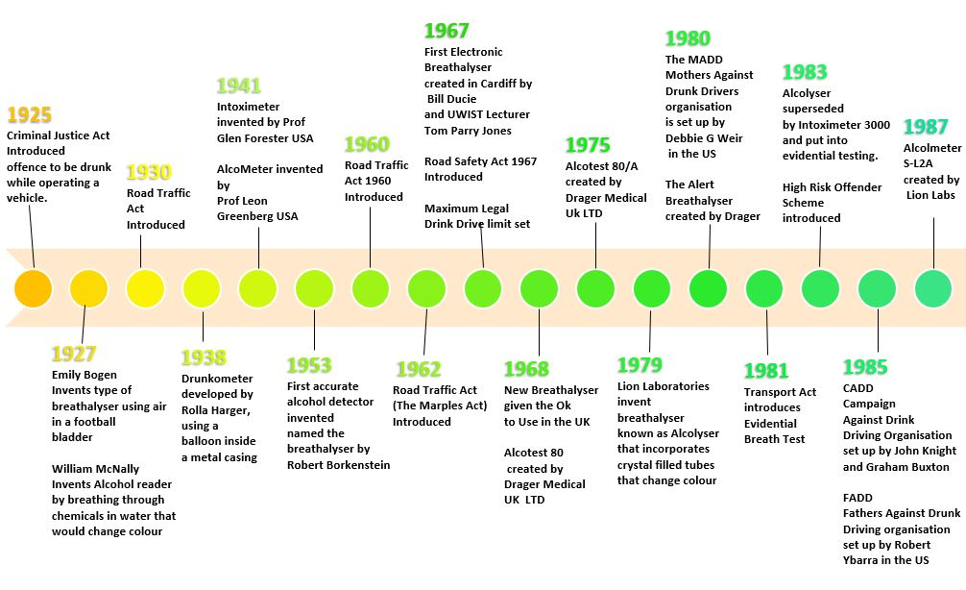

[Fig 1.1] (Above) [Fig 1.2] (Below) Timeline of deterrents to reduce drink driving. [6] [7] [8] [9]
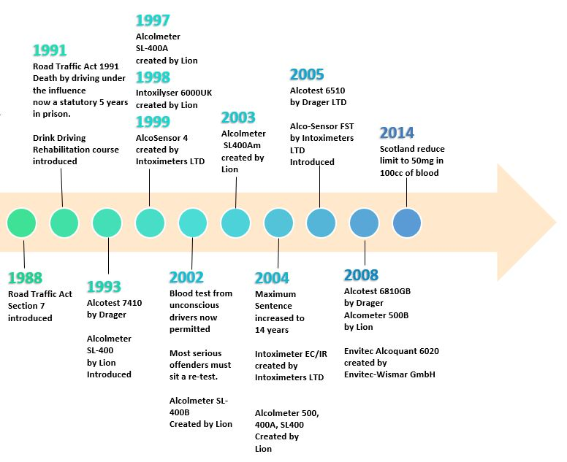

Driving while intoxicated has been an issue ever since the advent of the motor vehicle [5]. The need to reduce this ongoing dilemma has been circulating since 1925, and the majority of research since then, has surrounded breath test data. To coincide with the advances in technology, government legislation had also evolved to prevent people from driving while intoxicated [Fig 1.1, Fig 1.2]. Due to slight changes and updates to the Traffic Act over the last 7 years, the timeline concludes in 2014. This was the last pivotal year that any detrimental change had taken place, even though new technology is currently being tested and developed.

1.3.1.1 Current deterrents and legislation in operation
Currently, breathalysers that measure alcohol content in human breath and blood are the only implemented technologies available to police forces and to the public consumer. But principal modifications to curb alcohol consumption while driving, relate to the Traffic Act and Road Safety Act. Constant Changes and updates to legislation are an attempt to deter driver’s involvement with alcohol, inspiring a logic of inconvenience [10]. An investigation to reduce the alcohol to blood content from 80mg to 50mg of alcohol to 100cc of blood in England and Wales, emerged as irrelevant, due to research analysis stating that this change would make little or no difference to the current situation [11] [12]. Comparing data results with Scotland, who had already reduced the alcohol limit to 50mg, showed a slight increase in alcohol related incidents [13]. The limit in England and Wales has remained unchanged since 1967 [14].

2. Literature Review and Research

2.1 Introduction
Many forms of drink driving deterrents are employed around the world, with each government assessing the severity of the punishment handed out. But with ground-breaking advances in technology, the need to punish could potentially be a thing of the past. This review will focus on three major technological developments that have been recognised as possible advancements to assist in tackling the global dilemma. These developments are: biometrics, near infrared spectroscopy and distant spectroscopy (breath based sensors). Although this review may cover a variety of information regarding a broader scope of the topic, this paper will primarily focus on the aforementioned technologies.

2.2 What are Biometrics?
The term biometrics originates from the Greek term meaning Bios “life” and Merton “measure”. Biometrics refers to the entire class of technologies and techniques to uniquely identify human traits. Although biometrics can have various uses, its primary purpose is to provide a secure alternative to traditional access-controlled systems. Many of the problems that biometrics help to solve are the weaknesses applied to keeping private information away from unauthorised access.
Biometrics can solve these problems by acquiring additional credentials which are associated with the human body. To secure access to confidential and classified data, systems that control access must utilise electronic devices that measure some aspect of a person’s body or behaviour that will help positively identify that individual.
As a means of protecting assets, the first case of digital biometrics was utilised in 1994 and then become commercially available in the following year. Since this time, military intelligence and law enforcement have been using biometrics, but it has only grown in popularity in the past several years. Many technology-based companies are employing biometrics into everyday products such as laptops, USB drives and home safes. Due to the advances of the mobile phone and other technology that will store financial data like online banking ,credit card details and Apple Pay, the introduction of biometric security was an important addition.
Since biometric identifiers are unique to individuals, they are more reliable in verifying identity than other forms of commonly used identification methods.
There are several effective ways to identify an individual, but they all fall within two class sets, Physiological and behavioural. [15] [16] [17]

2.2.1 Physiological class
Physiological biometrics measure a specific part or portion of the human body, that requires the participant to have the pre-defined identifier scanned.
- Fingerprints
Discovered as a means of uniquely identifying people since the early 1900’s. The skin of the distal phalanx [18] contain ridges and minutia points that have incomparable characteristics . Fingerprints are easily measured and have a 99% recognition accuracy rate.

- Hand / veins scan
Hands also have a unique way of identifying an individual and can take three specifics into consideration. The geometry of the hand does not alter after a certain age is reached and the techniques applied for measuring will include length, width, thickness, and the surface area of the hand. The angles of the fingers along with the 27 bones, muscles and ligaments can also be used to identify a human being.
Palm prints leave a similar impression to that of a fingerprint, despite the scale size being very different.
Vein pattern recognition relies on the differences between the deoxidised and oxygenated blood that runs from human lungs to the tissue that has been selected to scan. Deoxidised blood absorbs light, which makes the pattern visible when an infrared scanner is operational [19].
- Iris scan
Using the coloured area that surrounds the pupil, the iris has a complex collection of muscles that are unique to each person. When these muscles are scanned the identity of an individual can be found.
- Retina scan
This is based on the pattern of blood vessels that can be found on the surface of the rear of the eye. These blood vessels create unique patterns that are different from person to person.
- Facial scan
Relies on the dimensions of the human face, such as eye position and the distances between the nose and mouth. When a person is viewed by another, this system is what the human brain uses to distinguish identifying features. [17] [20] [21]

2.2.2 Behavioural Class
Behavioural biometrics targets how a certain individual demonstrates a measure and does not rely on static dimensions of a body part. The behavioural class comprises of:
- Handwriting
Signatures and defined ways of styling single letters add individuality to handwriting and can be an ideal approach to find the writers identity. The discovery of recognition can be successful through comparable writing, using a stored image to locate similarities. The pressure and motion of the pen when the writing is taking place can add authentication of the individual.
- Keystroke dynamics
The rhythm of typing on a keyboard can also be used as an identifier. The specific timing of keystrokes is a result of the geometry of the human hand as well as the brain’s ability to send signals at the precise time. Software can take measurements continually of keystrokes until a plateau occurs, after which, it can sense when a user has walked away and been replaced by someone else.
- Voice recognition
The sound of the human voice is constructed using a combination of the larynx, passageways, and the brain ( which controls the linguistics of the voice). Biometric voice recognition can identify a subject by presenting unique phrases to declare and recording any indiscretions that can used to identify that individual.

- Gait
The way a person walks can compose a pattern that is also unique and can be utilised for biometric purposes. This style of walking can be compared to facial recognition in the fact that it sometimes can be easier to identify an individual from a distance than when they are up close. [17] [15]

2.3 Research into Alcohol Detection Systems
Even though identification through digital means has been accessible for many years in terms of security and keeping information confidential, very little has been ventured in the interest of Human safety. Since 2009 the Driver Alcohol Detection System for Safety Program (DADSS) which is a culmination of the National Highway Traffic Safety Administration and the Automotive Coalition for Traffic Safety performed numerous tests to discover the variant alcohol concentration within human breath, blood, and skin tissue. The aim of the clinical trial was to create a non-invasive method of acquiring alcohol measurements that reside in samples given by a suspected perpetrator. Methods that are already in operation such as blood and urine tests can be hindered by unexpected circumstances that can manifest case by case. For example, the time that elapsed between giving a sample of blood and receiving the results can delay a prognosis and any decisions that are dependent on that result. Breath tests can deliver instant results without the need for medical examination but can be hampered by the individual who is breathing into the device. Measurements may be inconclusive due to the offender having limited lung capacity [22].
An alternative means of gathering results for alcohol concentration and in keeping with the non-invasive concept, would be to implement the spectroscopic technique. Comparisons between the measuring methods were made by taking subjects of various ethnic backgrounds, age groups and differing amounts of consumed alcohol and recording the findings under strict conditions.
The outcome suggests that the alcohol to blood saturation from breath and spectroscopy has a similar high rise from the beginning and maintaining a steady decline as time elapses. However, results emerging from blood trials show a delayed rise and at a slower rate. This suggests that a more instant and positive results will be achieved by using spectroscopy or a breath-based system [Fig 1.3].
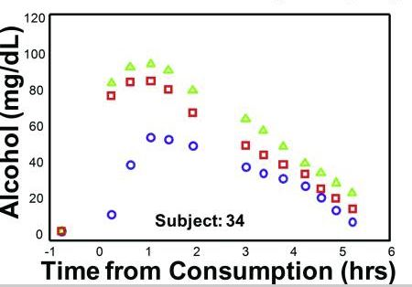
Key - Spectroscopy =
Breath =
Blood =

[Fig 1.3] Alcohol to blood saturation using blood, breath, and NIR spectrometry methods taken from a trial subject. [22]

2.3.1 NIR Spectroscopy
Near Infrared spectroscopy technology allows the alcohol content that resides in human skin to be detected. This is achieved by sending a beam of light through the skin and obtaining a measurement from the reflection received by the spectrometer. Each molecule contained in the human tissue reflects a unique light that the NIR can determine the differences such as water, alcohol, and other liquids within the skin. The alcohol molecules can then be isolated from the others and then measured to find required results. This technique can provide accurate results and deliver the outcome in minutes. For spectroscopic measurements, the results are typically abstracted from the subject’s forearm due to the conveniently large surface area and consistent oxygenation and blood volume changes can be attained [22] [23] [24].
Clinical studies by members of TruTouch Technologies and VeraLight Inc in 2011, were implemented to determine a one-to-one comparison of the forearm and an improved adaptation by using finger tissue. The Spectrometer penetrates the dermal skin layer of the finger and measures the alcohol that is present in the interstitial fluid [25]. The skin of the finger and forearm exhibit the same layered structure and composition. However, dramatic error change was documented within the forearm measure compared to its counterpart, which resulted in the forearm tissue containing lower alcohol concentration [24].

2.3.1.1 Challenges using NIR spectroscopy
Spectroscopy has been developed over many years to provide a diagnosis for skin conditions and other ailments that inhabit skin tissue. Since the introduction of computers as well as lasers and photonics, it has become increasingly accurate to identify such conditions [26]. Upon investigation of several papers based on skin conditions and implementing electromagnetic radiation, the outcome is positive. Although skin pigmentation can have an affect with accurate measurements at a given wavelength, a slight alteration to the sensitivity and power of the wavelength can produce the results that are required. Therefore, NIR spectroscopy will not generate any harmful side effects to the subject or generate a negative impact on the alcohol measurements. Through research, the wavelength will already be selected prior to testing. [27] [26] [28] [29]

2.3.2 Breath Alcohol Detection
The most adopted form of alcoholic detection in the human body, is implemented by the breathalyser. Given as apparatus to law enforcements across the world, it has been complimented due to the nature of its size, portability, and accurate readings. Alcohol breath tests calculate the amount of consumed alcohol by sampling the subjects exhaled breath. The result that is recorded is known as the BAC level. Once the ethanol has entered the subject, it is quickly absorbed into the blood and within minutes the subjects BAC can be measured. Most of the Alcohol consumed is absorbed by the liver but 10% is passed through urine and breath. The speed in which alcohol levels increase depends on factors that are characteristic to the subject. A person’s weight, gender, the amount of consumed alcohol, and even when they last ate all have a bearing on the final measurement [30].
Currently, Breathalyser tests incorporate two types of technology to produce instant on-site results required for evidential purposes.

2.3.2.1 Fuel Cell Technology
Considered as the more accurate form of breath testing, fuel cell testers are highly sensitive and extremely reliable when mobile. The breathalyser consists of two platinum electrodes that are separated by a (PEM) proton-exchange membrane. A chemical reaction takes place once ethanol vapour is introduced into the anode partition of the breathalyser. The alcohol is oxidized and contains protons and electrons and sent to the cathode compartment, where they react to oxygen taken from fresh air to form water [Fig 1.4]. This results in identifying the ethanol ratio in the breath example, and the BAC in the subject under test [31]. Cannot detect if a breath sample is deep lung air, and as a result may produce a false high reading, although this is highly unlikely as mouth alcohol evaporates quickly [1].

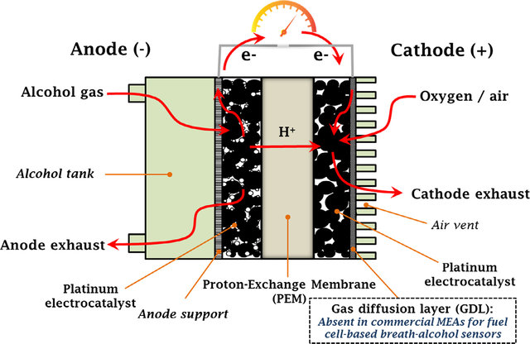

[Fig 1.4] Schematic of the Fuel Cell and its operation [31].

2.3.2.2 Semiconductor Breathalysers
Semiconductor breathalysers achieve reliable results and measure the alcohol content within the breath of a test subject. This is attained by recording the change of resistance upon the semiconductor which then produces a small electrical current. The ethanol in the breath becomes absorbed into the surface of the semiconductor which changes the resistivity and therefore changes the electrical current. This process gives the amount of alcohol present in the breath of the subject [1] [32].
Although both types of breathalyser can secure dependable results, the semiconductor can be comprised, due to certain disadvantages:
- The sensor can be unstable
- Highly sensitive to atmosphere
- Sensitive to changes in temperature, humidity, and breath flow patterns

2.3.2.3 Interfering Substances
Both the semiconductor and the fuel cell breathalyser can fall victim to “interfering substances” or “false positives”. If this occurs, the test is aborted, and a blood sample will then be required.
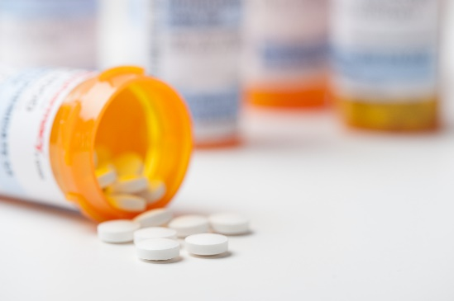
Medication
The most common treatments that can cause false readings and cause high BAC measurements include cold/flu powders, mouthwash, asthma inhalers and allergy pills.

[33]
Mouth Alcohol Presence
In some cases, when alcohol is consumed, it can get embedded in the lining of the mouth. This can inflate the BAC measurement, making the reading higher than the actual blood alcohol content.
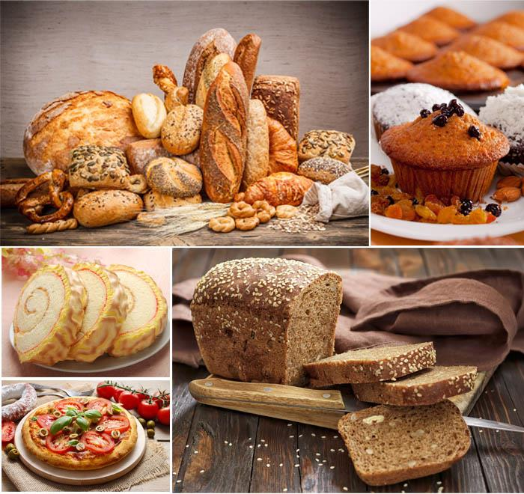
Types of Food
Certain foods can contain traces of alcohol or have alcohol added to them. Spirits are sometimes added to desserts such as trifle and becomes a key ingredient. In this case the ingestion of alcohol likens to drinking it.
Products that contain yeast can also cause error readings, as yeast that is present in dough can produce small amounts of alcohol. Pizza, bread, and other food products that require fermentation.
[34]
Acetone
Levels of acetone can be found in diabetic breath due to the breakdown of fats rather than glucose and can be much higher than that of a non-diabetic subject. It must be observed that this has little influence on fuel cell based breathalysers, but the semiconductor would produce a significant measure.
Environmental Substances
Contact with volatile substances can occur on a regular basis and interaction with such chemicals can have an impact on BAC readings. Typical examples include cleaning products, paint, spray paints, glue, and lacquers.

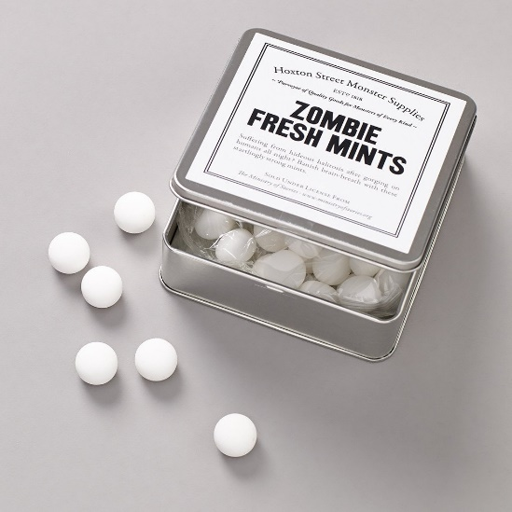
Confectionery
Sweets that contain menthol can also become an interfering substance and give incorrect readings. This is also the case for mints, chewing gum, energy drinks, protein bars and liqueur chocolates.

[35]

Cigarettes
Smoking can have an effect on the breath test outcome as cigarette smoke contains 1% hydrogen, even when the detector is dedicated to ethanol. Hydrogen can be oxidized to generate an electro current. The current maybe small but can still interfere with BAC measurement.
The above substances identified by Alcolizer technology will have more of an effect on semiconductor tests, as fuel cell breathalysers have been optimized to be responsive to ethanol only. [36]

2.4 Utilising Breathalyser Technology Within Vehicles
Over more than decade, The DADSS has taken imperative steps to invest time and knowledge in to creating in-car prototypes gathered through the science of pharmacokinetics and human clinical trials. Comprehensive analyses of emerging and existing technology for alcohol detection were undertaken and through patent reviews, five categories were identified as potential technologies [37].

2.4.1 Technological Approaches

2.4.1.1 Electrochemical Systems
Chemical reaction from breath - This system has been previously explored in this report.

2.4.1.2 Tissue Spectrometry systems
The Measure of alcohol concentration in tissue - This system has been previously explored in this report.

2.4.1.3 Distant / Offset spectrometry systems
Similar to the approach taken by tissue spectrometry but excludes the use of skin contact. An Infrared beam is transmitted towards the user from the integrated component which also contains a sensor to receive and analyse the breath. From this procedure the alcohol concentration can be assessed [37].

2.4.1.4 Behavioural Systems
Implementing cameras and other sensors to detect inebriated subjects through objective behavioural measures. Recording eye movement as well as other signs of impairment to measure the driver’s performance [37].

2.4.1.5 Transdermal System
Excreted water contains unaltered alcohol concentration and can produce extremely accurate measurements. Transdermal sensors obtain results from insensible perspiration that escapes from the skin when sweating occurs. However, alcohol migrates last through the skin which can result in slower readings [38].

2.4.1.5 Outcome / Findings
Various technology companies were selected to invest expertise based on the proposals given by the DADSS, and an evaluation of those suggestions resulted on approaches that best fit the criteria.
In conclusion, the scope of the findings lead to two forms of technology that has been previously outlined by the author of this report, tissue NIR spectroscopy and distant spectroscopy. Transdermal and behavioural measures were deemed not suitable, due to their limitations for the non-invasive application. Systems that utilised fuel cell technology experienced temperature accuracy as the cells must be warmed up to breath temperature before operations can proceed. This can have a considerable effect on the start-up time in colder climates. Furthermore, measurements from fuel cells can become unreliable over time and require recalibration within a year. Due to this issue, fuel cell technology is unsuitable for every-day use. Fuel cell devices that utilise transdermal technology can suffer with the same disadvantages; however the time taken to reach peak alcohol concentration in sweat has caused concerns, and that it can take two or more hours to acquire an accurate sample.
Behavioural systems measure alcohol concentration by impairment, and a large number of behaviours have been recognised that can be affected by alcohol. Such examples can include reaction time and eye movement, but several impairments can be linked to vehicle based measures namely, changes in speed, braking times, steering control, and lane position. Yet these factors may occur without the presence of alcohol and may be related to fatigue, illness, medication, or other issues, all of which can change the measure result. In order to measure impairments there also has to be a “normal behaviour” measure which acts as the base line for comparison [37].

2.4.2 In-car Breathalyser Using Distant spectrometry
The breath based system that utilizes distant spectrometry, measures the concentration of alcohol and carbon dioxide simultaneously. The measure of carbon dioxide in a subject’s breath is an indication of how diluted the alcohol concentration is within the exhaled air.
Kea Technologies working in conjunction with the DADSS designed a sensor that draws in the driver’s breath via a built in fan. Infrared beams are then directed towards the breath and an analyse of the wavelengths of both the alcohol and CO2 are carried out. The concentration is then quickly measured, producing accurate results. To make the sensor more versatile and improve capabilities, several re-designs to the overall size and temperature range of -40c to +85c had to be implemented to DADSS specifications [Fig 1.3]. Research into aerodynamics of breath within the vehicle to identify effective locations for the sensor were carried out to provide successful measurements. After comprehensive research, Ideal locations were identified that would improve the analysis of direct readings of the driver and the surrounding ambient air.

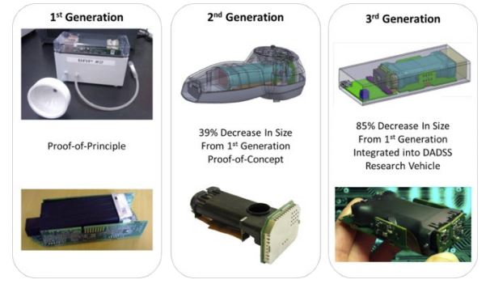

[Fig 1.3] evolution of the breath-based sensor [39].

Positioning above the steering column directly aimed at the driver’s head and a second sensor mounted on the driver’s side door [Fig 1.5] [Fig 1.6]. The position of the prototype sensors improved the overall analysis of air flow within the vehicle and performance of accurate measurements from the driving seat. For testing purposes a handheld breath sensor was used to create a reference measurement to provide control data for comparison. On receiving results from test subjects, the feasibility of introducing unobtrusive breath alcohol detection was advantageous. It was also acknowledged that this technology could be combined with other technologies such as autonomous driving in the future [40] [39] [41] [42].

2.4.3 In-car breathalyser using touch-based approach
To measure alcohol content within the fingertip tissue, an infrared light propagates the tissue and detects the blood alcohol concentration that resides in the capillaries. A portion of the light is then reflected back to the skin surface for result analysis. Due to pigment variances of the skin in different ethnicities, a certain wavelength had to be chosen to give the highest sensitivity and a stronger measurement of alcohol. 1.25 – 2.5 micrometre provided the best all round wavelength that was unaffected by skin pigment and hundreds of times stronger than the 0.7-2.5μm that was first believed [43].
Nanoplus© and TruTouch© developed laser and sensor technology that contributed to the initial development of the touch based sensor that was implemented at the research and testing phase for the DADSS. [39] [44] [45]. From the first generation of touch based sensor, which was only for non-automotive application, significant strides had been taken to reduce the size and accuracy that would benefit the subsequent generations. The DADSS sensor achieved a 93% decrease in size from the original sensor and contained multiple laser packages that improve the accuracy. However, further advances will increase the performance of the laser diodes, but reduce the number needed as they have a significant impact on power consumption, size, and cost.

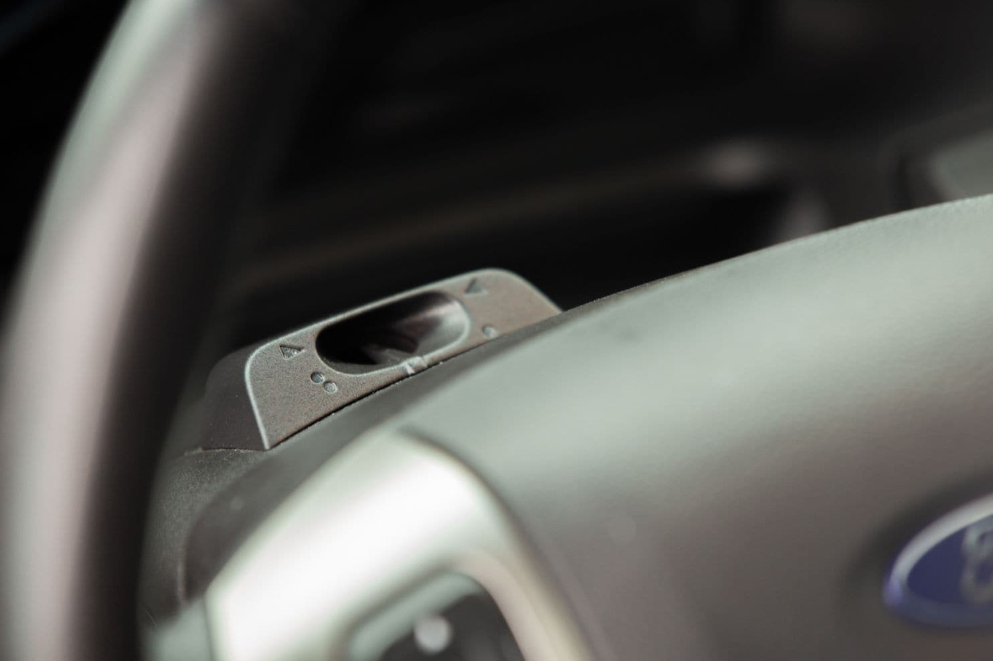

[Fig 1.5] Breath Sensor positioned at the top of the steering column.
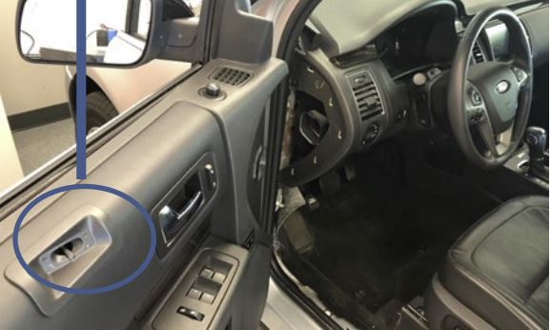

[Fig 1.6] Second sensor within the driver’s door.

The multiple laser formation allows for a very compact optical module and has plenty of positional options that can discreet and non-invasive. A proficient Placement opportunity is the integration of the alcohol sensor and the START/STOP ignition switch [Fig 1.6], although other locations exist, the touchpad should be mounted where it will feel more natural to the driver.
As with any technology that will supress user ability, safeguards need to be put in place to stop the opportunity of override. The potential for an alcohol-free passenger to start the vehicle for a
driver who is over the limit has been identified as a cause for concern. To mitigate this situation, the implementation of an OCS system (Occupant Classification System) within the driver seat can be a successful solution. This system is utilised in the passenger seats to highlight whether the seats are either empty, occupied by a child or an adult. The information given can also supress airbag deployment if the situation is one of the fore mentioned.

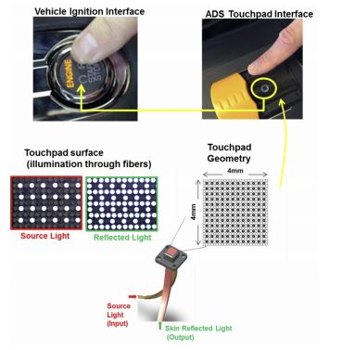

[Fig 1.7] Touch based sensor combined with START/STOP ignition

The OCS uses an electric field that emits a signal towards the seated occupant. This signal is then influenced by the seated occupant and is transferred through anything that the occupant touches. As the driver will need to touch the START/STOP ignition, the OCS will be able to identify where they will be seated. [46] [47]

2.5 Organisations currently researching in-car alcohol sensor Technology
In terms of mass appeal, most vehicle manufactures believe it is premature to include biometrics or sensors within the cars, as the technology is not up to specification [48]. Even though this opinion may be the mainstream consensus, there are companies willing to invest resources to either prototype their own technology or as part of a collective that will input ideas, research, and components.

SEAT
In 2017, Carmaker SEAT introduced the Leon Cristobal to an audience at the Smart City Expo in Spain. Described as the safest car in the history of SEAT, one of the key elements to this vehicle was the inclusion of the drive lock. The vehicle had a built-in hand-held breathalyser [Fig1.8] that if identified as over the limit would block the car from starting. The results of the test are displayed on the dashboard console [Fig 1.9] after several seconds, if a driver is successful in the test, they are given clearance to carry on. SEAT claim that this in-car technology could potentially reduce accidents by up to 40%. [49]

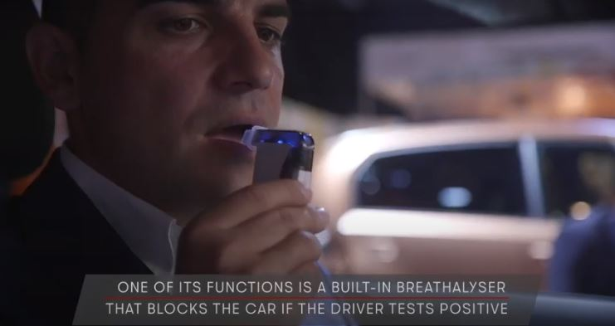

[Fig 1.8] The handheld breathalyser is connected to the ECU of the vehicle. [49]
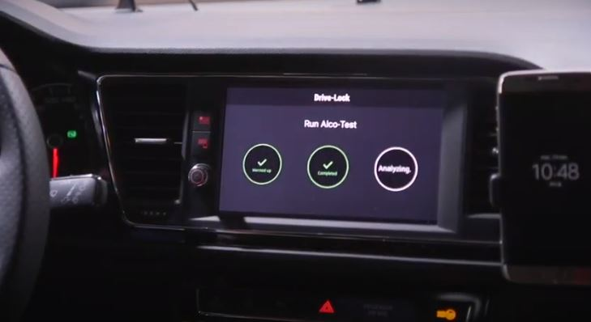

[Fig 1.9] Results of the test are displayed on the dash console. [49]

TruTouch
Developers of non-invasive optical technology that measures alcohol content in people. The focus of research is primarily touch-based systems that adapts NIR spectroscopy. The TT2500 [Fig 2.0] was the first approach to fully incorporate the finger scan biometric that could not only read the alcohol levels in the skin, but to also identify the individual who was using the system. This innovative machine has since been supplied to businesses all of the world.
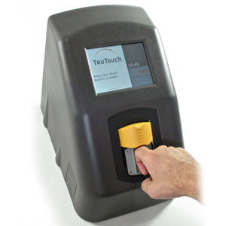
Since joining the DADSS, the aim has now shifted slightly into sensors that can be adapted into vehicles. Improvements to the TT2500 are currently in motion to reduce the size and increase durability, so that the system can be shaped to ergonomically fit within a vehicle. The location of the optical
reader will be the dashboard, where it will be infused with the START/STOP button. [45]

[Fig 2.0] The TT2500 alcohol sensor, designed for
Organisations to test for alcohol impaired workers [45].
KEA Technologies
Established in 2015, KEA provide engineering research and development services in the transportation industry. While developing their own innovative safety solutions there most recent programs is with the DADSS conduct mechanical and electrical equipment assessment and tests. KEA have equipped a fleet of vehicles with the most recent prototype sensors and system equipment that evaluate the results. The main scope is breath alcohol devices and can produce test results based on environment, durability, analytical and behaviour of the sensor [50].
SenseAir
A leading provider of air and gas technology, SenseAir have provided measurement solutions and scientific input into the DADSS project. With considerable knowledge In the field of non-dispersive infra-red(NDIR), they have developed a contact-free breath alcohol system that is currently in the testing phase [51].
Takata Corporation
In 2016 they announced a partnership with TruTouch to consolidate technologies under the DADSS. Aiming towards creating a touch -based sensor using optical spectroscopy (NIR) to measure alcohol content in the driver’s tissue (capillaries). The location of the device was to be incorporated into the start/stop button, making it invisible to the driver while producing extremely accurate readings. Takata role was an automotive supplier of safety equipment, but due to faulty air-bags supplied to 19 different car automakers, the business folded in 2018 [52] [53].
NanoPlus
One of the leading manufacturers of laser and gas sensing technologies and founder of the DFB laser. NanoPlus are based in Germany, but since 2017 have expanded to America. NanoPlus originated from the Wurzburg University and took less than 20 years to become the worldwide number one for laser sources and gas sensing technology. NASA have utilised NanoPlus systems, by installing lasers into the Mars rover ‘Curiosity’ which allows the robot to take water and carbon dioxide measurements. The DADSS combined TruTouch with NanoPlus to pioneer the preliminary steps in creating in-car alcohol detection technology. [44]

2.6 Algorithms used for alcohol level testing
Since the ninth century, Mathematical calculations have been utilised in problem solving operations and provide a set of rules that must be followed to achieve an end result to any computation. This finite sequence of implementational instructions has progressed from the written word to becoming a fundamental aspect of computer science.
Algorithms are a well-defined procedure that accepts a set of values as an input and generates a value or set of values as an output. To achieve a ‘correct’ algorithm that solidifies the input/output relationship, mathematical expressions will be used to solve the specified problem. [54] [55]

2.6.1 The Biometric algorithm
As biometrics rely on the recognition of anatomical and/or behavioural traits of a subject, operations to verify ownership of such characteristics are performed in a sequenced and automated method. A fingerprint is made up ridges and valleys that contribute to the unique pattern that resides on the skin surface on every individual. This pattern can be segmented into three key elements, Ridges are defined as a curved section, the valley is the space between the ridges and minutiae are significant points on the ridges known as terminations and bifurcations. Terminations are points where the ridge discontinues, and bifurcations are the points on the ridge from which branches develop. Using minutiae points lead to more precise and accurate fingerprint recognition and is the basis of the functional algorithm.

2.6.1.1 Minutiae based fingerprint recognition algorithm
The proposed Minutiae algorithm includes the input and conversion of the fingerprint image and the resize scale for the database. Certain image enhancers will be applied to improve quality of the fingerprint which may be degraded by wounds, sweat and smudges that may occur on the surface layer. The matching of a subject’s fingerprint to the image stored in the database consists of locating the minimum difference of distance ($D_{min}$) and the maximum minutiae couplings. If the ($D_{min}$) is lower than the set threshold, an identical match will be presented.
To successfully implement the minutiae algorithm, the following steps must be employed:
- Input image - f ( x, y ).
- Conversion to greyscale - $f_{g}$ ( x, y ).
- Resize image - $f_{r}$ ( x, y ).
- Enhance histogram of image using greyscale levels - h ($r_{k}$) = $n_{k}$
[ $r_{k}$ - $K^{th}$ = grey levels, $n_{k}$ = number of pixels in image ]
- Find core segment of fingerprint image $f_{r}$ ( x, y ).
Image is divided into blocks ‘w’, horizontal gradient ‘$G_{x}$ ( x, y )’ and vertical gradient
‘$G_{y}$ ( x, y )’. At each pixel ( x, y ) is computed using Sobel mask and ridge orientation
‘$θ$ ( x, y )’ of each pixel.

- $G_{xx= \sum_{\left(x,y\right)ew}{G{}_{x}^{2}{(x,y)}}}$
- $G_{yy=}\sum_{\left(x,y\right)ew}{G{}_{y}^{2}{(x,y)}}$
- $G_{xy=}\sum_{\left(x,y\right)ew}{G{}_{x}^{}{\left(x,y\right). G_{y }(x,y)}}$
- $θ\left(x,y\right)= \frac{1}{2} \tan^{-1}{(\frac{2Gxy}{Gxx-Gyy})}$

- Circle of radius extraction ‘R’ with print core at centre of image $f_{r}$ ( x, y ) to retrieve new image $f_{c}$ ( x, y ).
- Conversion of new image into binary image $f_{b}$ ( x, y ) by thresholding.
- To reduce width of ridges to one pixel wide, a thinning operation takes place $f_{t}$( x, y ).
- Extract minutiae points from ridge endings and ridge bifurcations using cross-number (CN). This computational method is possible by scanning local pixels in the thinned image.
CN is the half sum difference between adjacent pixels $P_{i}$ and $P_{i+1}$ in the eight surrounding pixels, using formulae ${CN}_{\left(x,y\right)}= \frac{1}{2} \sum_{i=1}^{8}{|}P_{i}-P_{i+1}|, P_{9}= P_{1}$
- Ridge endings have cross-number classification 1 and bifurcation classification 3.
- Post-processing removes undesired minutiae caused by spikes, breaks and holes. Morphological operations such as clean, spur and H-break are employed to the thinned image, to get $f_{m}$ ( x, y ).
- Discovering the true minutiae points in the region of interest to generate final image
$f_{final}$ ( x, y ) after removing undesired minutiae.
- Linear distance and angle of each minutia within region of interest must be represented as distance / angle ( $x_{1},y_{1}$) and minutia ($x_{2}, y_{2}$) and is given by:

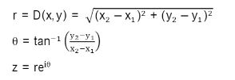

- Save coefficients in ‘dat’ file
- Create template for fingerprint database
- Calculate Euclidean distance ($D_{min}$) between saved fingerprint image and test fingerprint.
- Minimum ($D_{min}$) is compared to template to compile a result, whether ‘match’ or ‘no match’. [56] [57]

2.6.2 The NIR Spectroscopy algorithm
NIR spectroscopy has become the method of choice to quantify particular factors found in test liquid examples. Absorption in a near-infrared light range of 750nm to 2500nm can identify and measure alcohol content. The process of discovering the absorption spectrum of each blood analyte can be obtained by assigning wavelengths of 2- to 2.4-$μm$ .Ethanol and other types of analyte have unique characteristics of which different measurement algorithms can be applied. In the case of identifying alcohol within the dermal layer, an algorithm based upon Beer’s law can be employed:
ΔA(λ) = Δc ε(λ)l

ΔA = Relates to changes in the absorbance spectra.
Δc = Changes in analyte concentration.
ε = Absorptivity spectrum of an analyte.
/ = The path length of light through the medium.
λ = Chosen wavelength.

Using this formula in NIR spectroscopy can provide highly accurate and relevant results.

2.6.2.1 Baseline evaluation method
To measure the contributing alcohol and the absorption level , the baseline evaluation method can also be applied. This evaluation takes into account three specific wavelengths and compares the results to the baseline. This algorithm is based on the subtraction of background absorbance that has occurred from the measured spectra.
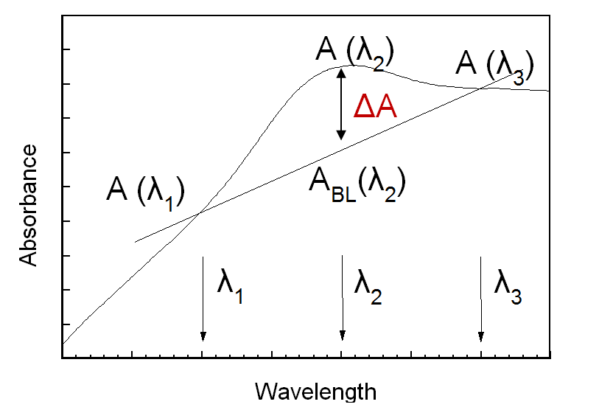
[Fig 2.1] Baseline evaluation method at multiple wavelengths.

A background crossing of the absorption spectrum at two wavelength points λ1 and λ3 is employed. The ΔA (changes to absorbance spectra) identifies the difference of λ2 to the originally calculated baseline is evaluated. The final output is then related to the quantity of alcohol received from the subject sample [fig 2.1]. [58] [59]

2.6.2.2 Standard Error Measurements in Spectroscopy
The expectation of accurate and precise measurements through spectroscopy is considered a certainty, however, the correct result depends on many environmental factors that may be unforeseen. Therefore, a margin for error is taken into account and the results gathered are not regarded as complete unless this ‘error’ is included. The error margin follows statistical rules which includes composition of 20% and a margin of +/- 0.2%. To gather a detailed outcome, test measurements that surround the ‘true’ result are recorded. Standard deviation is employed to perform spectroscopy measurements and relies on smaller mean values to acquire more precise measurements. The expression (formula) that equates the standard deviation and the standard error and ensures accurate readings is as follows:
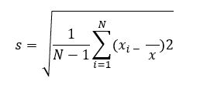


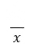
Symbol s representing standard deviation, where is the mean value of all measurements, are the individual measured values and N is the number of measurements made [60] [61].

2.6.3 The Breath test algorithm
Using distant spectroscopy to investigate the volume of alcohol in the breath of a subject, an algorithm that separates the merging elements must be used to acquire an accurate result. The dilution of dispelled air and the ambient air is estimated along with the measurement of carbon dioxide and ethanol that is located at the same sensing location. Taking sample readings from the continual air that is gathered by the sensor, detection measurements for the carbon dioxide and the ethanol are collected, respectively.
The presence of a CO2 peak is used as a marker of breath above the typical degree or background level. If a similar peak of alcohol (EtOH) is detected at the same point in time, the BrAC algorithm can be implemented using the following formula:
BrAC = ${EtOH}_{meas}*DF= {EtOH}_{meas}* \frac{CO_{2et} -CO_{2background}}{CO_{2meas}-CO_{2background}}$
- Meas = Measured peak values.
- CO2et = The end tidal CO2 concentration, which is typically 4.8 ± 0.5%.
- DF = Dilution factor ranging from close contact to larger distances from mouth.
- CO2 background = Concentration that is typically less than 0.1 Vol%.
The standard measurement for BrAC is mg/L, which correlates to blood alcohol concentration levels (BAC,%). To highlight the approximate relation between the two, 1mg/L BrAC = 0.2%BAC, therefore, the legal limit in the US is 0.08% BAC which in comparison, is 0.4mg/L BrAC.
The standard measure for alcohol within the breath of a subject is not infallible and attempts to tamper with results are a possibility. Variable breathing patterns can be implemented to reduce the accuracy of the measurement along with the gas exchange duration. To reduce the impact of these variations, a weighted average equation can be used to calculate the results. The following formula exhibits the weighted average calculation:
BrAC = $\frac{1}{DF}* {EtOH}_{meas}+\left(1- \frac{1}{DF}\right)*BrAC$
The carbon dioxide tracer gas is lowered to produce less diluted samples, and the standard BrAC algorithm is used as a baseline from which the new weighted measures can be collected. [62] [63] [43] [42] [64]

2.7 Alternate objectives for fingerprint technology
The fingerprint has provided a positive source of information relating to human recognition and has become an instrument relevant to forensic science. Further investigations are underway to push the boundaries of what can be detected through the human skin. Currently, fingerprint technology has been implemented to carry out mundane tasks, such as allowing access to buildings, vehicles, safe boxes, where only an exact copy of the stored fingerprint is needed, to more established identity attributes like student enrolment or a perpetrator of a crime [65].
Bioanalytics has now experienced extensive changes over the years due to advances in technology, and further intentions are being considered.
Similar to alcohol detection, identifying drug use has become a possibility through fingerprint skin layers, even to the extent that it can be separately identified as ingested or touched. The test relies on the presence of benzoylecgonine, which is a primary ingredient of cocaine, but further investigation into other substances is ongoing [66] [67]. Drug abuse measurements are typically analysed through the urine, blood, or saliva of a subject, but more recently, it has been shown that drug metabolites have been discovered in sweat. Deposits of sweat can be found within the pores of the finger and successful tests have been carried out on several types of addictive substances such as cocaine, morphine, and cotinine, that is found in tobacco products [68].

2.8 Conclusion
Significant progress has been made in the development of DADSS sensor technology, and as field tests suggest, has the potential to be used on a more widespread basis in passenger vehicles. While the results gained from testing are positive, ongoing trials are currently underway to continue the on-road use of the prototype sensors. As DADSS are a non-profit organisation, they rely on funding from the world’s leading auto manufacturers to invest in the project and between research, testing and investment the availability has not reached the public domain [69]. Future research could investigate public opinion and how such devices will affect those who will be using them. Such research could contribute to a more direct choice on which form of technology would be better suited to motorists and device integration into consumer lifestyle.

3. Methodology and Development

3.1 Development methodology
To successfully complete a project that is set to a timescale, a management plan needs to be put in place to ensure targets are met. Scrum was used as the system of approach. Based on the Agile method, the philosophies that could lead to satisfactory results were Divided in to 6 categories: Requirements, plan, design, develop, release and monitor. The advantage of using this method is the opportunity to breakdown the workload into smaller projects that could be tackled concurrently [fig2.0]. Weekly project meetings with the appointed supervisor helped maintain progress, with beneficial ideas and suggestions [70].
Although Scrum was the main development methodology, on several occasions a change to the waterfall approach had to occur. This was due to difficulties with installing several components that did not respond to the code straight away. It was impossible to move on to the next section of the prototype until certain obstacles had been resolved, which caused repercussions to the timescales that was given to other tasks. Waterfall methodology is based on a sequential system that encompasses the ideology of complete one task before moving to the next.

[Fig 2.2] Scrum methodology – Breakdown of the target stages for the project.

3.2 Questionnaire research methodology
To expand on the idea of a technological deterrent that will prevent drivers from driving under the influence of alcohol, it was necessary to gauge consumer popularity for such a device. The process chosen was a survey in the form of multiple choice questions, created using google forms. Due to circumstances relating to a pandemic, face to face contact was forbidden, which narrowed the choice down to communication from a distance.
The questions that were chosen had to relate to the participant on a more personal level, to discover if a technological deterrent would have prevented a particular incident that had occurred to them. This would highlight a possible demand for the key and determine if the product would be a viable commodity. The developing technology that was currently in the testing phase with the DADSS would also be implemented into the car key. It was crucial to gauge opinions from the responders to confirm that the researched technology would be relevant and selecting this as the issue for investigation was the correct course of action.

3.2.1 Pilot survey
Before distributing the questionnaire to the public via social media, a pilot example of 15 questions was created and supplied to a credible source for proof-reading. Alterations to several questions were necessary to guarantee public understanding and clarity (the suggestions to modify the questions can be found in the appendix of this report). Once the survey was ready, a link was posted on social media, enabling the public to not only answer the survey, but allow them to also share the survey to a wider audience.
The final survey that would collect the data required to gather the public perspective can be found below along with the reason behind each question:
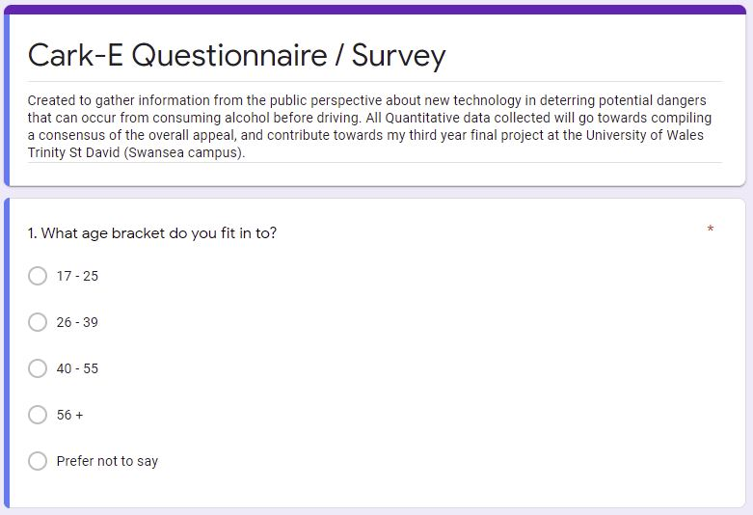
Q1 – To gauge the age of the responder, as competency with technology can be a factor with a more mature group.
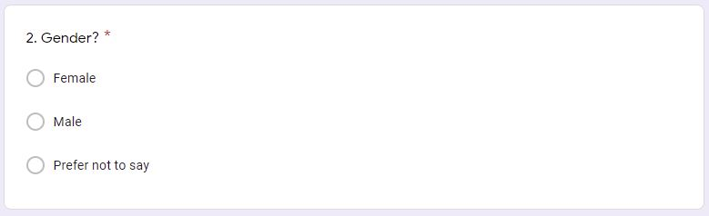
Q2 – Requiring gender was intended to separate the two demographics to see how a particular group would feel towards the subject of the questionnaire.
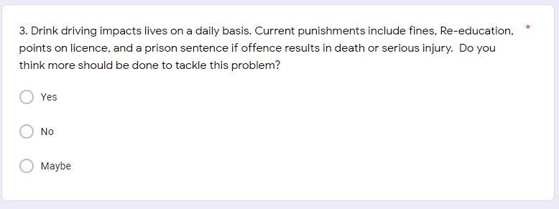

Q3 – To identify the opinion of the participant and document their views on the implementation of current deterrents.
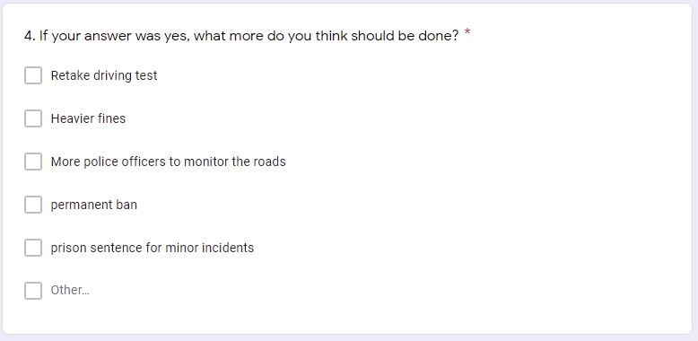
Q4 – Gives the responder options for firmer punishments if the current deterrents were inadequate. It also allows the participant to give an example, if the option they require is not available.
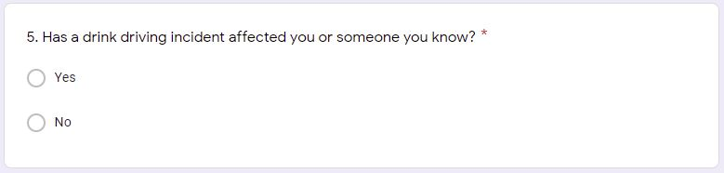

Q5 – Determine if the responder has been a victim or a perpetrator of drink driving. Further information on the issue can be given optionally.
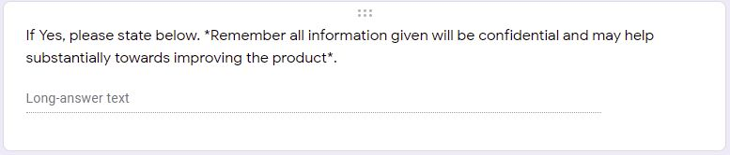

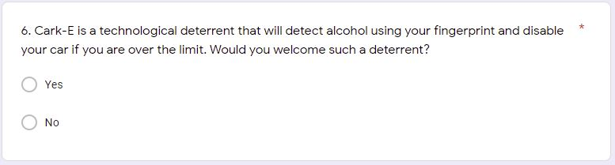

Q6 – Identify whether the concept of the product would be popular with the participants.
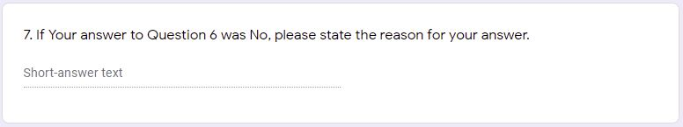

Q7 – Further details as to why the concept would not be a positive step in deterring drink drivers can be given by the responders. This could be crucial information, as the answers could either change or alter the concept.

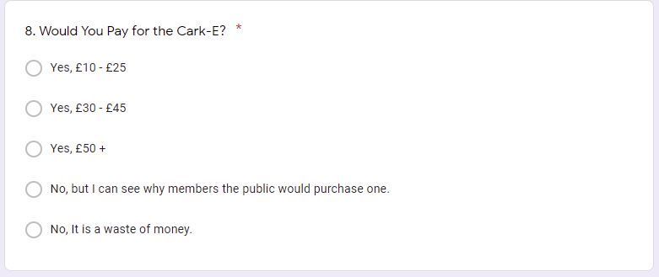
Q8 – It was important to identify whether the issue of drink driving was important enough for the participant to purchase the product and if so, at what price.
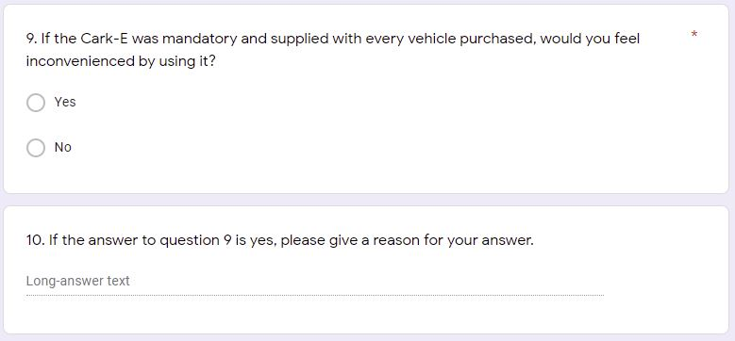

Q9/Q10 – Some members of the public are not computer savvy, and shy away from new types of technology. It was important to see if all age groups would be patient enough to handle the product to deter drink driving.
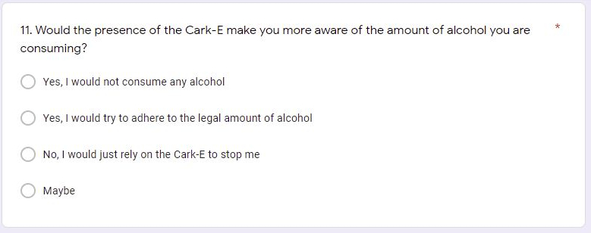

Q11 – This question was raised to determine if the presence of the key, would in fact be the main deterrent, and stop the user from drinking altogether while having to drive.
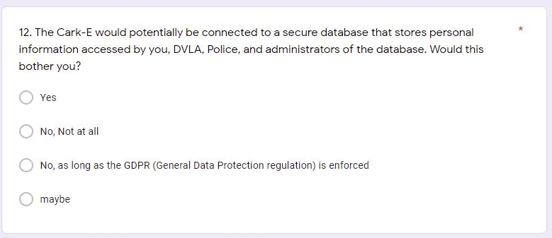

Q12 – Personal information would be stored on a connected database, and possible worries of confidentiality may occur. It was important to gauge public opinion on this, as their have been documented problems with data leaks in the past.
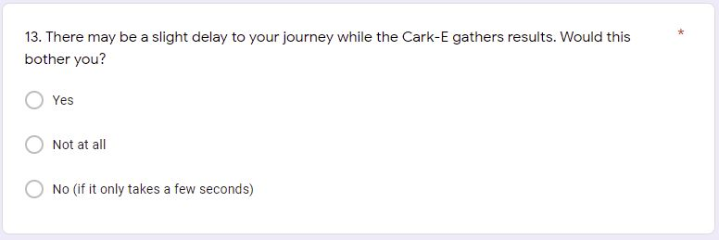

Q13 – depending on the technology that would be implemented, a short delay may occur. This will emerge if breath testing is used within the product. NIR touch technology will be almost instant.

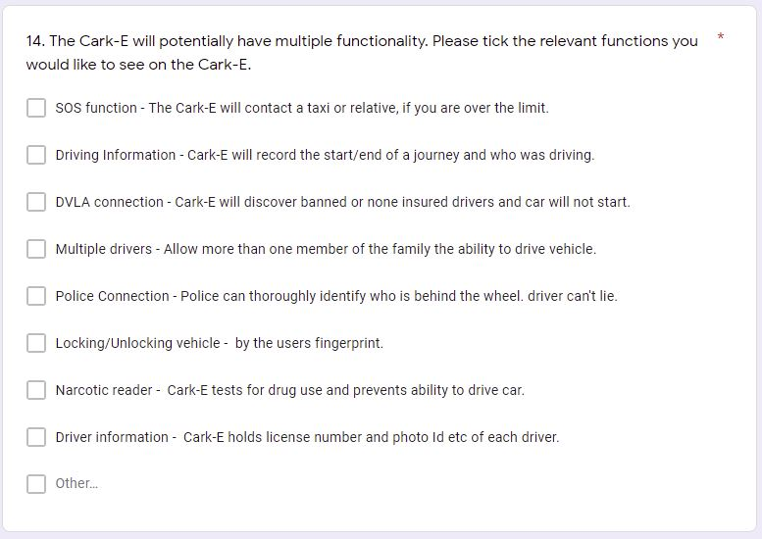

Q14 – By giving the responder the option to choose functionality, it will be possible to produce a product that will be tailored to the user. This will result in a useable product and not packed with wasted functions that are not required.
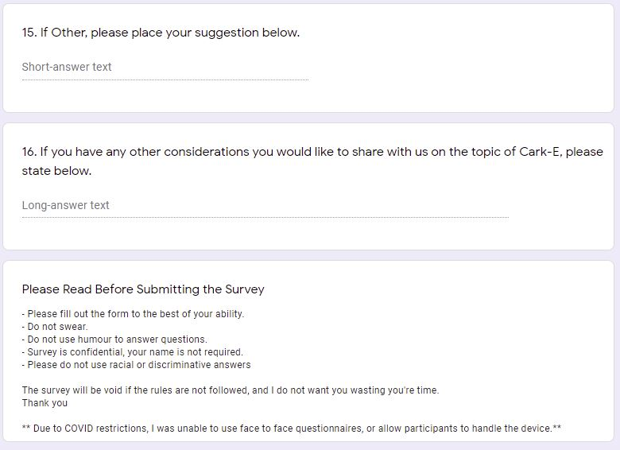

Q16 – The responders are given the chance to communicate any problems or positives that the car key could deliver. This may highlight any unforeseen issues that were not discovered at the beginning and an opportunity to rectify them.

3.2.2 Questionnaire results
As the questionnaire was primarily accessible through Facebook only, the 40 participants that completed the survey stemned from members of the associate group. One Clear demographic that emerged from the final outcome was the gender variation. With 67.5% of respondents being of the female persuasion, to 32.5% being male, this definitely lead to an influenced result. The reason for this lean could merely be down to the subject matter. As the questionnaire is based on a potential safety product, it is possible that the maternal instinct females possess has been the driving factor and the wanting to keep people safe was the influence. But let it be known that this is the opinion of the researcher and may be void of fact. The results/responses to the survey can be found in full within the appendix of this report, but other points of interest can be found in the following summary along with possible reasons for the outcome:
- Over 50% of the responders were between 17-25, it is possible that younger people feel more comfortable using technology and are more interested in the latest appliances.
- 85% think more should be done to tackle drink driving.
- 95% would welcome the concept that was given to them.
- 65% would purchase the product.
- 67.5% of the responders would stop drinking all together if the concept deterrent were in their presence.
- 57.5% would allow personal data to be accessed by authorised sources, as long as the general data protection regulation was enforced.
The survey did, however, highlight concerns about the mechanics of the product and involvement of external sources that could interfere with the outcome. The issues raised and the solutions are as follows:
Issue 1 - “You couldn’t stop someone else using their finger to start the car”.
Solution – The key will be registered to the main user, who’s fingerprint will be stored in a database, the fingerprint scanner will know if it is an authorised print or not, and act accordingly.
Issue 2 – “The alcohol in hand sanitiser would give a false reading”.
Solution – Any substances that are found on the surface of the skin will have no effect on the outcome. The NIR alcohol scanner reads the dermal layer, deep within skin tissue and not the visible outer layer.
Issue 3 – “What if the product malfunctions and the driver is wrongly accused of being over the limit”.
Solution – The product will have a guarantee like any other product, but also a helpline if assistance is needed. Spare keys will also be available , whether it is purchased or supplied with the vehicle.

3.3 Implements required for development
Considering all the aspects that will be involved in developing the drink driving deterrent concept, the creation relies on to main factors: The software that will be used to code the product and the hardware that will be used to create the physical features.

3.3.1. Hardware
Based on what components are readily available to the public at reasonable cost, the decision was made to research the range of Arduino products. Using another platform such as Raspberry Pi had been debated, but after considering the tasks involved in the project, the Raspberry Pi was to excessive.
Raspberry Pi is an all-purpose computer running on a Linux operating system, which can handle more complicated projects and run multiple programs at once. The option to connect a computer monitor, mouse, keyboard and other peripherals are available with the Pi, with the functionality that is equivalent to the home PC. But for the purpose of this project, a microcontroller motherboard that can run one program at a time in a continual loop and nothing more is necessary [71].
Arduino is an open source electronics platform that creates inexpensive microcontroller boards and connectors, while also allowing independent organisations such as Adafruit to make compatible components. Due to the advantages of cross-platform capabilities, the Arduino is versatile and ideal for entrepreneurial endeavours [72].

3.3.2. Software
To code the deterrent and make it operational, numerous software options were available. Eclipse, Netbeans, Xcode and Qt Creator are more than capable of editing and debugging the source code and are amongst the more popular programs [73]. Arduino boards and components work in conjunction with C++ libraries and can be expanded to the AVR C programming language. Therefore, Visual Studio 2019 or Visual Studio Code can be used for backend programming and has several development features to work with [74]. Arduino also features a downloadable IDE software program, that can be taken advantage of, if the user feels uncomfortable with C++ programming functionality.
The user interface also had to be considered, as the product would need the option to register, and store user information. This would need two forms of program, a website, and a database. The decision to create a user friendly webpage was filtered down to two options based on past knowledge and experience. Visual Studio 2019 is highly versatile and can be used to create a standard html page or employed to produce a more advanced .NET application. The other possibility is to use Notepad++ that is a diverse program that allows the possibilities of employing multiple languages. With an easy layout and with links to PHP, Notepad would be easily adaptable to the current project.
One of the key principles of the product is the ability to store information that has been received from the user relating to personal identifying information, journey time and including the levels of alcohol that is within their system. This will be achieved by populating a database that is structured to store all the vital information and will follow GDPR legislation (information on GDPR legislation is included in the appendix of this report). SQL is a language used in developing database management systems. Although there are many versions of the SQL language, they all support the commands set by the ANSI standard [75]. Therefore, two versions of SQL were considered: MySQL and phpMyAdmin. The latter, due to the administration of MySQL over the web, and support for most of the MySQL features [76].

4. Design and implementation
Taking all the gathered research into consideration, it had been decided that the development of a biometric system that could potentially reduce or prevent drink driving would need to achieve certain criteria:
- Store Driver information.
- Non-invasive alcohol testing.
- Small and easy to use.
- Difficult to falsify.
- Possibility of adaption to all vehicles.
- Minimal internal technology required (car).
The concluding concept that would fulfil all the specified requirements would be a biometric car key that could measure the alcohol content in the drivers fingerprint. Not only would the fingerprint scanner read alcohol measurements, but it would also be used for authentication and authorisation of the driver. For the key to function as a deterrent, connection to the vehicles ECU (Electronic Control Unit) system would need to be involved. If the alcohol reading is above the legal limit the key would send a signal to the ECU. This would then prevent the immobiliser from disengaging, making the vehicle unresponsive. Further information on functionality will be explained in greater depth in the following sections.

4.1 Design Concept for biometric deterrent
Developing a clear understanding of what is required from the product, is a very important task at the beginning of the design and planning stage. Choosing what functionality is a priority from the non-deliverables can be the differences between a successful or failed project. To create a prioritised list of functions, the MoSCoW method was utilised. All proposed elements of the design are put into categories which stipulates what requirements should be done first, which will come at a later date and which functions will be excluded [77].
Must Have | Should Have | Could Have | Won’t Have
Fingerprint authentication | Vehicle API | Wi-Fi connection | DVLA Link
Alcohol Reader | Bluetooth connection | SOS Call Function | Police Link
LCD screen | GPS Tracker | Medical Records | ECG Connection
Database | Charging Capabilities | Voice Recognition
Easy to use website | Time Stamp Journey | Public Transport Finder
Size and shape of a car key
[Fig 2.3] MoSCoW list of requirements
Within the timeframe, it is beneficial to concentrate on the most important specifications of the key and commit all resources in to making them happen. The Minimum Usable SubseT (MUST) are the core functions of the key that the project will guarantee to deliver. Without those functions they will be no project. The Should and Could Have [Fig 2.3] are requirements that would benefit the overall appeal but are not vital to the solution of the key. They are desirable functions and possible additions at a later date but are currently not viable within the timeframe. Conditions under the term ‘Won’t have’ are functions that help clarify the scope of the project and are highlighted in that category to avoid reintroduction. As in the case of the biometric car key, getting GDPR permissions for the type of information stored on the DVLA/Police database would not be given without the appropriate authorisation. Additionally, the onboard computer that operates the ECG inside the vehicle, would not have the correct upgrades installed within the completion time of the project.

4.1.2 Design Decisions
Having chosen the primary functions that are required for baseline operation, a blueprint prototype was created identifying the dimensions of the key. The Sketch image designs also showcase the potential exterior of the key if mass produced using smaller components [Fig 2.4]. This design example also recognises the ‘must have’ elements of the MoSCoW method:
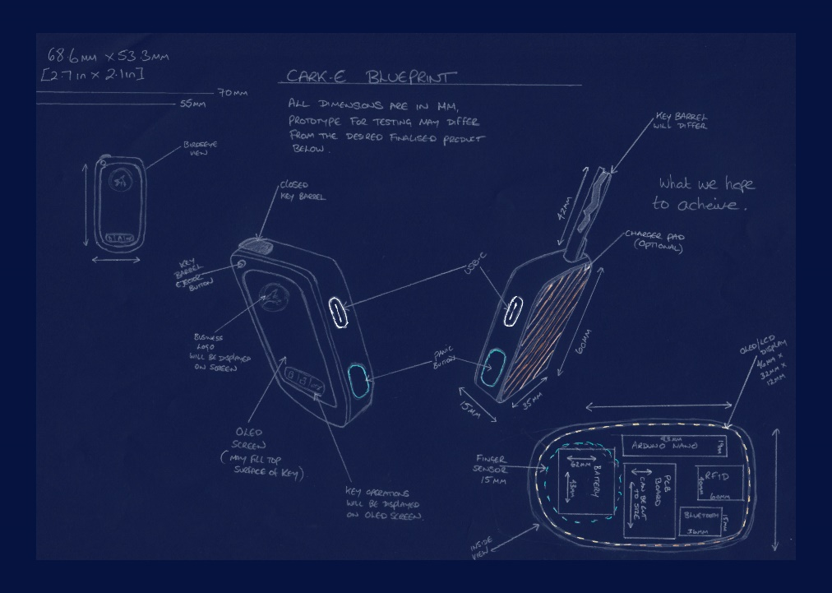
The LCD screen would display information that is relevant to the driver, such as the steps in which the user would be identified and tested for alcohol. The results of the test would then be displayed, indicating the drivers ability to drive or not. In Relation to fingerprint verification, the user would need to enrol the print to allow the key to differentiate between main user and any other allowed drivers on the system. Once authorisation is complete the driver will be given a unique ID that will be linked to their name, address and other details that will be required within the database. When the key is utilised for a journey, a timestamp will be initialised recording who is driving and how long for. In case of an accident this information can be vital to identify who was behind the wheel when the point of impact occurred. For a member of the public to drive a vehicle that has been registered previously, they too must be registered to the key via the fingerprint. If not, the vehicle will not allow them to drive.

[Fig 2.4] Design blueprint for the Car key deterrent.
The next step would be the initialisation of the main deterrent process, the alcohol reader. The fingerprint scanner is divided in to two functions, driver recognition as previously mentioned and a non-invasive alcohol reader. The user will be once again required to place a fingerprint on to the scanner, where it will take a reading of the alcohol content within the dermal layers of the skin. This will maintain the compact size of the key and reduce the amount of components needed within it. The NIR fingerprint scanner can gain accurate measurements which will reduce false readings and acquire the result quickly. Where most manufacturers of alcohol deterrents are also focused on in-car breathalysers, the aim of this product is to reduce cumbersome technology within the vehicle and to reduce the inconvenience that drivers may feel before every journey. The main premise is for the key to become second nature to the user, and not a product that causes trepidation.
To establish the role of the database, information regarding the user and data that is captured by the key have to be planned to ensure cohesion. Using Entity relationship diagrams [Fig 2.5] can provide visual links between the tables and that database management, creation and maintenance will be achieved. The KeyUser entity table contains attributes that are directly related to the owner of the product and will be used to access the website. All other entity tables will include data relating to the vehicle or information that is produced by the car key. Through Primary and foreign keys all tables will converge and provide the necessary material to authenticate each user.
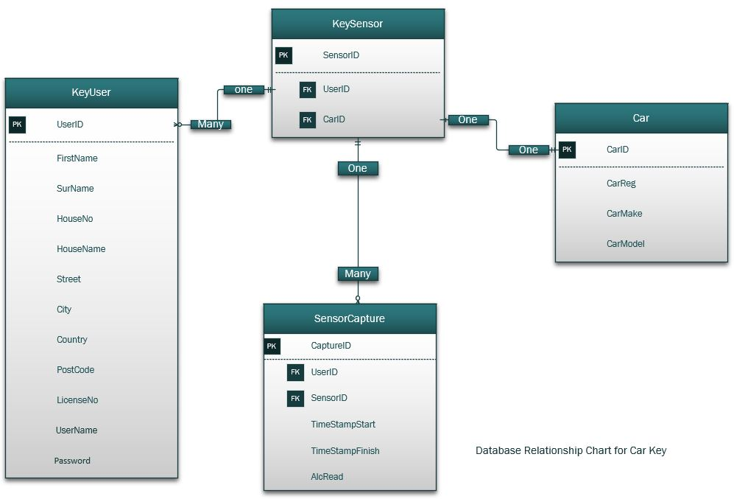
[Fig 2.5] ERD – Entity Relationship Diagram for car key database.

For the necessary user information to populate the database, an input mechanism is required to bridge the connection between the two. A web application that is database driven is a critical tool for any organisation, due to the dynamic capabilities and the potential to store large amounts of data.
In relation to the car key, the webpage will be used for multiple purposes, ranging from branding to highlighting the features of the product. To increase popularity amongst those who lack confidence in computing, the design for the webpage would require simple navigation and an ergonomic layout. The target audience for the car key is extensive with a wide age group . According to Age UK, 6.9 million people over the age of 55 have never used the internet, and this data is backed by Citizens Advice who estimated that 20% of the UK have zero to limited abilities [78] [79]. With this in mind, the website that accompanies the car key has to be straightforward as not to put off buyers.
The concept website design is made up a home page that will display a navigation bar which will take the user to different sections of the page. These sections include:
- A signup/login page that connects to the database via a HTML form.
- An informative segment detailing what the key can potentially do.
- About page, explaining who created the product.
A webpage and database event diagram can be found in the appendix of this report. This offers visualisation between the tasks carried out and the outcome of those tasks. The diagram is based on the sign up and login events.

4.2 Implementation of the product
On the completion of the designing phase, the next step would encompass all that is involved in the implementation of the car key. The following section describes the process and development of the project and how a successful outcome was achieved. As the project was split in to two key areas; electronic and software, an in-depth breakdown for each was formulated.

4.2.1 Electronic components – Creating the Car key
The first step to create a working prototype, was to source a capable microcontroller that would produce enough processing power to operate the key and allow for any future upgrades. The Arduino Mega 2560 was the board of choice, as it contained 8 times more memory space than the other models in the range. This allowed for a larger amount of code to be uploaded to the board and that it could handle several components concurrently when connected to it.
Re-examining the MoSCoW method emphasized the 3 components that would play a pivotal role in bringing the product to life, they were; NIR Fingerprint scanner, LCD screen and the appearance of a standard car key.
- Car key Shell – Attaining a universal car key that had dimensions big enough to house the fingerprint scanner and the LCD screen was a big priority at the start of the project. Once one had been found, the shell was manipulated to insure a secure fit for the components using a Dremel drill.
- NIR fingerprint scanner – The initial idea was to have a fingerprint scanner that could serve a dual purpose, (i) fingerprint authentication and (ii) a dermal alcohol reader. But due to the high-cost involved it was simply out of the question. Instead, steps were taken to separate the two functions for the progression of the project. The preferred touch alcohol reader had to be amended to an MQ3 breath reader.
- MQ3 – This sensor is a popular choice for Arduino enthusiasts due to cost efficiency and ease of use. The sensor measures alcohol concentration present in the air and uses a Metal Oxide semiconductor to produce those measurements [80]. This option appeared to be a workable replacement to the alcohol touch sensor.
- Fingerprint authentication scanner – As a substitute fingerprint scanner, the R503 was chosen for the stability and rugged structure of the reader [Fig 2.6]. With a light indicator ring that would change colour if the fingerprint were accepted or declined, it would have been ideal from a visual point of view. This reader also had the flexibility to scan a fingerprint under different conditions such as wet fingertips or cracked older skin [81]. But issues concerning the compatibility of the Arduino library and the need for a shield board, prevented the utilisation of the R503 and the R307 scanner was employed instead.

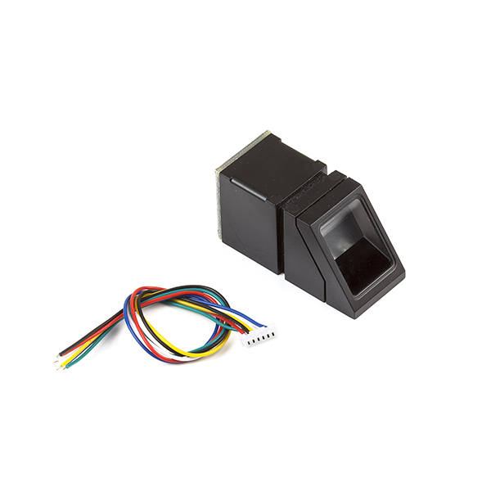
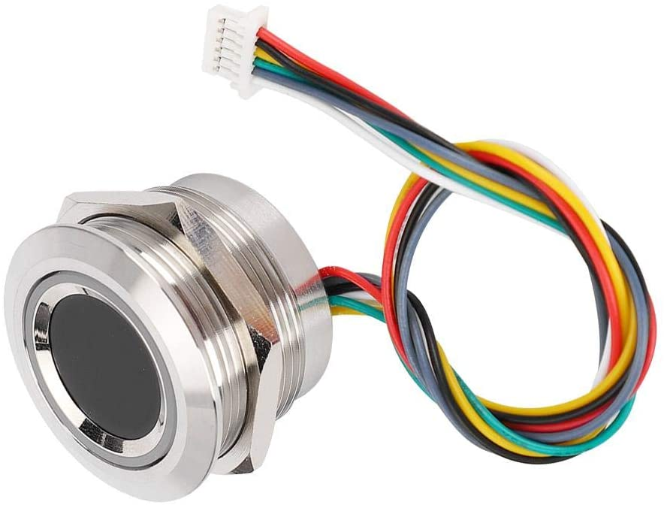

[Fig 2.6] R503 fingerprint authentication scanner and the R307 replacement. [82] [83]

- R307 Fingerprint scanner - Although this scanner is too large to fit into the shell of the car key, the interface that the R307 uses is similar to most fingerprint scanners [Fig 2.6]. This means that compatibility to most libraries used in sketches will adapt well to this reader [84]. Unfortunately, the size hampers the look of the key, but for the purpose of a working prototype the alteration had to occur. As in [Fig 2.7] the desired outcome for the final product was originally fitted with the R503 scanner that aesthetically suited the product and allowed accommodation for the LCD screen. However, due to the changes made to the system, the key shell will not be utilised.
- ST7789 LCD screen – The decision to choose the ST7789 LCD screen was based on multiple reasons. The screen can come in several different sizes depending on the project at hand and after measuring the dimensions of the key shell, it was decided that the 1.3 inch screen would suit the project better. This screen would also be a sufficient size to display the messages that needed to be viewed by the user. With a full colour resolution of 240 X 240 pixels (57600 pixels) it could also display any graphical information should an upgrade be warranted.
Connecting the screen to the Arduino board also brought along unforeseen problems. As the screen is 3.3v the connector would simply plug into the 3.3v port on the Arduino Mega, but due to lack of understanding about voltage through data lines, five screens had blown through the process. Arduino Mega boards uses 5 volts through data lines and the screen only requires 3.3v. To overcome this dilemma, resistors had to be used to drop the 5v from the board to the 3.3v needed by the screen [85].

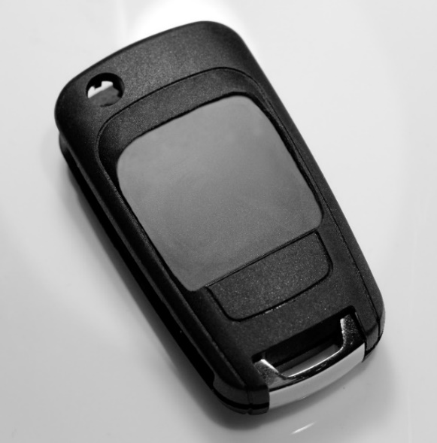
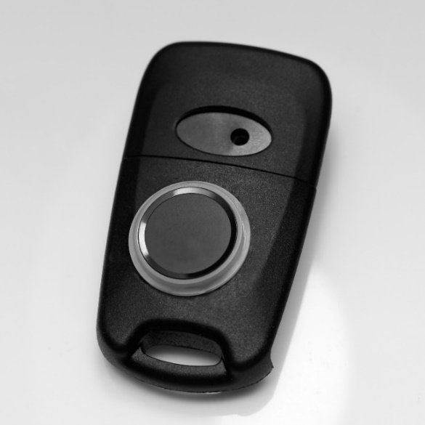

[Fig 2.7] Key construction using the R503 scanner and the ST7789 LCD screen.

Once all the components were chosen and ready to be connected, a design for electronics hardware was created. Fritzing is an open source application that enables designers and engineers to schema a prototype while the construction is occurring or prior to commencing. By introducing the car key schema [Fig 2.8] it was easier to find the route for each connector to the port destination. Following cables of the same colour can become tricky when viewing the circuit in reality [Fig 2.9]. Creating the schema can also be used as a guide for future projects or for other potential engineers who are at an intermediate stage.
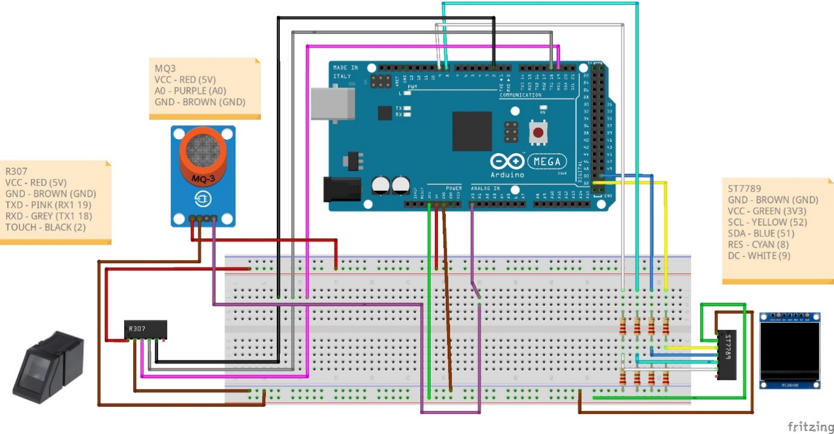

[Fig 2.8] Fritzing circuit schema diagram for the car key.
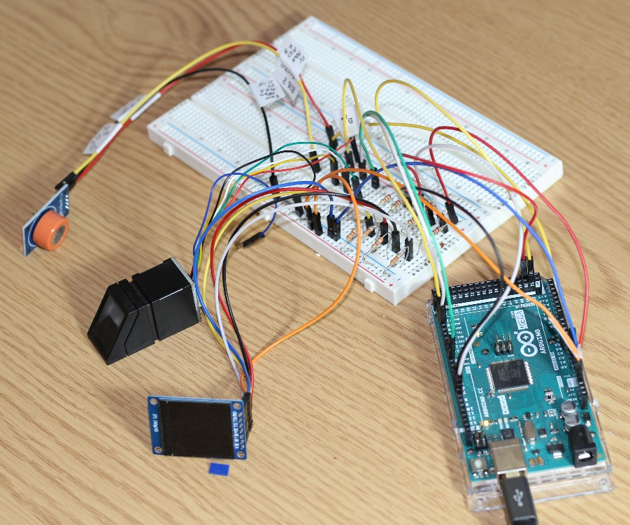

[Fig 2.9] The final prototype created using the Fritzing diagram.

4.2.1.1 Coding the key
Once the prototype has been constructed and the cables have been connected correctly it will now need software code to make it operational. It requires the uploading of two sketches for the key to perform the intended tasks, into the Arduino Mega. Using Arduino IDE software, the first sketch was for the enrolment of the fingerprint. Before the user can be given authorisation to use the key, a replica fingerprint must be uploaded to the database held in the fingerprint scanner. The user must tap the same finger three times for the scanner to create an acceptable copy. This code was executed successful and can be found in the appendix of this report.
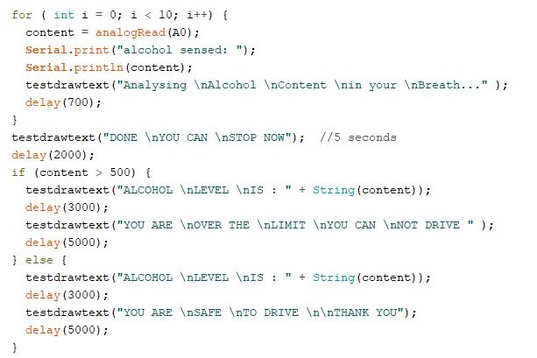
The next sketch had to include all the functionality the key would possess , this included the breathalyser, screen, and fingerprint actions. In the sketch, a series of loops and switches are performed for success and failure events for the MQ3 and Fingerprint scanner, as they require input from the user [Fig 3.0]..

[Fig 3.0] For loop and IF statement for measuring and displaying alcohol level.
If no readings can be taken from the user, they will be notified either through the serial monitor or the LCD screen. Arduino IDE supports the C/C++ language which allows the programmer to use identical statement structures. Due to the change in fingerprint scanner it was necessary to hardcode example users by creating a switch function for the fingerprint ID [Fig 3.1]. This can be extended to the amount of users required, but ideally, this function would be connected to the website signup form to create a fluid operation and allocate the ID automatically. The complete Arduino code can be found in the appendix of this report.
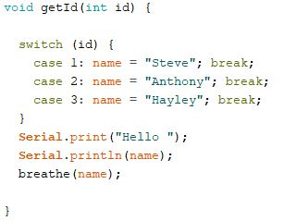

[Fig 3.1] Switch function for hardcoded users.

4.2.2 Database and Website implementation
Originally, the software development framework that had been chosen to create the database and website was .NET, for authorisation and authentication purposes. But this preference was altered because of the lack of admin to customer relation that was to be included on the website. The decision was made to opt for a general purpose scripting language that could manage HTML and database programming. The ideal language was PHP.
For both the HTML and PHP programming, Notepad++ was employed. The motivation behind the use of Notepad++ was due to previous assignments implementing PHP with HTML and having no compatibility issues.
For the website design, a decision was made to avoid using several pages to display information that would be the customary requirement for a website. The reason for this was to create a slick webpage that would be simple for the user to navigate around. Although the navbar displays multiple icons [Fig 3.3], only the privacy policy and the signup page will take the customer to separate pages. The other options will simply take the user to different sections of the same page. The background image was chosen to give visual appeal to the website

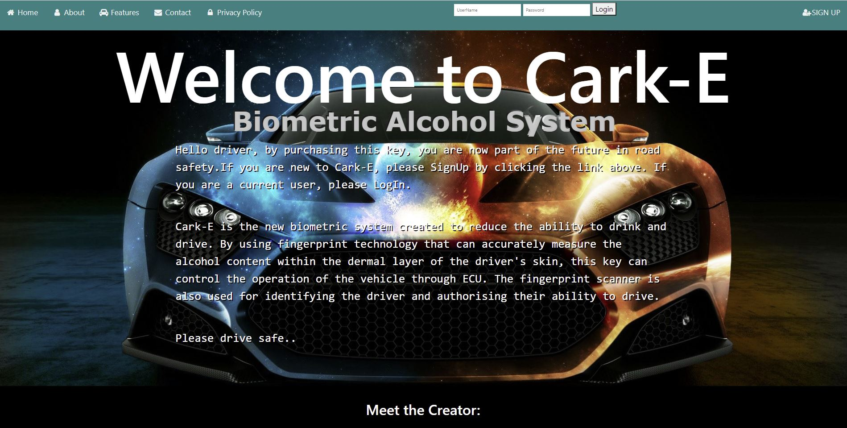

[Fig 3.3] Main webpage, displaying navbar.
The privacy policy page contains details on the GDPR (general data protection regulation), as this data is vital for the consumer to understand. The car key requires personal information from the customer such as name, address and driving licence number and it is essential to know the rules and regulations about sharing private information.
The signup page contains the form that is used to populate the PHPmyadmin database with new customer details. The details entered will also contain the login and password needed every time the user needs to enter their account. With regards to the SQL coding, to populate the required table in the car key database the INSERT INTO query was utilised. All sections of the form are NOT NULL which indicates all data must be entered. Once the submit button is pressed, the information is passed to the SQL database [Fig 3.4]. Although four tables were created in phpMyAdmin, unfortunately two will not be implemented. The keysensor table and sensor capture, relied heavily on the original fingerprint scanner that could transfer print data via the esp32. But as this never came to fruition, the two tables could not be populated.
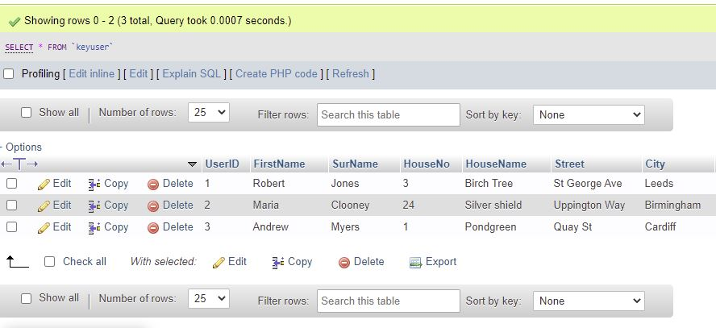

[Fig 3.4] SQL database, populated by customer data.

5. Evaluation of findings

5.1 Functional testing of the prototype
With the prototype fully assembled and the code uploaded to the Arduino Mega, alcohol measurement tests were carried out to identify any inaccurate results that may occur. It has previously been documented that certain products can give false positives and a misdiagnosis of intoxication given. A selection of common products [Fig 3.2] were chosen for testing and the test results are as follows:
*Note - The MQ3 reader must be powered up and requires 24-48 hrs before use. As the MQ3 can measure the natural vapour in the air, the reader must get accustomed to the surroundings first to acquire accurate results.*
*Note – Between each test, a time duration of 10 minutes was given to allow the MQ3 reader to return to stabilised state.*
*Note – The alcohol reader has been set to 500 ppm ( parts per million), a result over this setting will give an intoxicated result.*

Test Case | Subject | Starting Level | Final Level | Expected Result | Actual Result
Throat sweet | A | 289 | 488 | Safe | Safe
 | B | 240 | 451 | Safe | Safe
Alcohol | A | 267 | 741 | Drunk | Drunk
 | B | 345 | 787 | Drunk | Drunk
Mints | A | 301 | 509 | Safe | Drunk
 | B | 218 | 493 | Safe | Safe
Yeast products | A | 263 | 312 | Safe | Safe
 | B | 266 | 401 | Safe | Safe
Mouthwash | A | 288 | 473 | Safe | Safe
 | B | 300 | 477 | Safe | Safe
Aftershave | A | 267 | 814 | Safe | Drunk
 | B | 228 | 824 | Safe | Drunk
Liqueurs (Mild) | A | 298 | 602 | Safe | Drunk
 | B | 291 | 522 | Safe | Drunk
Liqueurs | A | 307 | 701 | Drunk | Drunk
 | B | 254 | 621 | Drunk | Drunk

Test conditions were identical for both subjects which included waiting times between each test, same volume of product and equal distance from MQ3 reader. Although the starting level was in an acceptable range, it was impossible to get the same reading for every test, due to vapours in the environment it was conducted in. All items were consumed by the test subject except for:
- Alcohol – This was placed in a medicine cup and placed by the MQ3 reader. A measurement was taken from the alcohol vapour. For accuracy and continuity two readings were taken and recorded.
- Aftershave – This was placed on two perfume testing strips and held by the MQ3 reader. The aftershave used was highly concentrated, which might be the reason for the high level outcome.
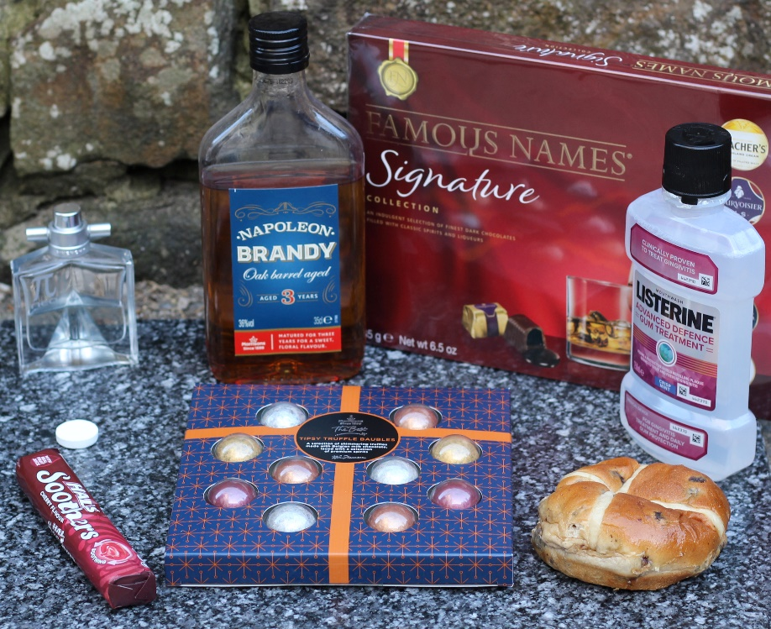

[Fig 3.2] Products to test breathalyser

5.2 Test case – Car key website and database
When the code for the Car key was completed, a series of tests were carried out, to ensure that user functionality was operating successfully. The compiled data is then recorded in a program test case table.
Program test cases can be implemented after the completion of each coded function, which allows the programmer to rectify any errors before moving to the next function for testing. or an entire test can be conducted once the coding has been completed [86].
In the instance of the car key, the test was carried out on code completion, and the findings were as follows:
Test Case ID | Test Case Objective | Prerequisite | Steps | Expected Output | Actual Output | Status
WS_01 | Check main page links to access webpage sections. | Go to website. | 1.select individual links to monitor functionality. | Each link will take the user to different sections of the webpage. | Each link takes user to different sections of the webpage. | Pass
WS_02 | Check sign up page link on navbar. | Go to website. | 1.Select Sign up link on navbar. | The link will allow access to the sign up page. | The link allows access to sign up page. | Pass
WS_03 | Successful login after User sign up. | User has successfully signed up. | 1.Enter login username.  2.Enter password.  3. click login button. | Successful login, displaying ‘welcome (username). ‘ | Correct login details were entered, and welcome message appeared. | Pass
WS_04 | Check for unauthorised login. | Go to website. | 1.Enter login username.  2.Enter password.  3.click login button. | Website should not accept login details. | Website does not allow login from unauthorised user via login form. | Pass
WS_05 | Check welcome (username) is visually pleasing. | Go to website. | 1.Enter login username.  2.Enter password.  3.click login button. | Welcome message should match visually to the rest of the webpage. | Unable to style the php code, so welcome message does not match the webpage. | Fail
WS_06 | Fill in ‘Contact us’ form and submit message. | Go to website. | 1.Enter name  2.Enter last name  3.Enter subject message  4.Enter email address  5.Submit form | Contact us query should be successfully sent. | The contact us form is not setup as the business side does not exist. An error occurs. | Fail
WS_07 | Check Facebook link will direct user to Facebook page. | Go to website. | 1.Click on Facebook link at bottom of page. | Link should access Facebook page | Link successfully directs user to Facebook page | Pass
WS_08 | Check privacy policy link will direct user to GDPR information. | Go to website. | 1.Click on link to privacy policy on the navbar. | Privacy policy link on navbar should direct user to privacy policy page. | Link to privacy policy was successful. | Pass
DB_01 | Check signup page populates User table in database. | Click sign up link on navbar to access page. | 1.Fill in sign up form with customer details.  2.Click submit button.  3.Access PHPmyAdmin through browser. | Information that was submitted through sign up page has populated database | Information populated database successfully | Pass
DB_02 | Check signup page populates car table | Click sign up link on navbar. | 1. Fill in sign up form with customer details.  2.click submit button | Car information populates the database | Car information successfully populates the database | Pass

5.3 Cark-E User feedback
Even though two users were selected for the test case described in section 5.1, in fact, several subjects had sampled the prototype. Due to Covid -19 restrictions put in place by local government, the test subjects were close friends and family to the author of this report and were the only willing participants to take part. Once each test were completed, a questionnaire was given to the person involved to fill out. The overall results were positive, although due to problems with the fragile cables, movement was limited and any slight pulling, would make the screen unreadable.
Five out of six subjects had accurate readings, with only one having the wrong measurement recorded. The users were not given any strict rules to abide by and they were tested in the condition they arrived in. To clarify, they were not told to drink alcohol for the test. In the instance of the incorrect measurement, different substances could have had an impact on the result. Such interference could be caused by mouthwash or aftershave, but as the tests were not under strict conditions, this possible influence was not avoided.

5.3.1 Choosing the test questions
To understand public opinion in an honest environment, there is no better way to collect the data, than using questionnaires. The information collected can ultimately have an effect on the direction the product is taken, and can improve the performance, look and appeal of the item.
The reasoning behind the questions that accompanied the test are explained below:
1. What was your Initial impression of the prototype?
Although the prototype does not look like the final product, it was necessary to gauge the participants opinion on it. Once an explanation was given after the initial observation, the responders were very impressed with the technology that was involved.
2. Was it simple to use and did you feel comfortable with it?
The most important feature to deliver was to make the key as simple as possible to use. The age of the participants varied and a perspective from each one was very important. The product has to be as easy as possible for the users who may feel intimidated by technology.
3.Did you have a successful test?
After the test was completed, it was necessary to measure the reliability of the system. This question also included the overall functionality of the car key.
4. Did the alcohol reader produce a measurement that could be classed as accurate?
As the participants would not be tested for any possible interfering substances, only the responders would know if the measurement would be accurate. The result of this question would rely on the honesty of the participant.
5. Did the outcome match your expectations?
This question was to determine the scope between the responders original opinion and the opinion after having tested it. It gives the option to include further comments relating to the product or regarding matters of confidence in the programming and circuitry.
6. What did you like MOST about the prototype?
It was important to identify key features that the responders felt were a positive to the key. If the key were to go through upgrades, it is vital to know what to keep.
7. What did you LEAST like about the prototype and why?
To gather information in a similar way to how question 6 would perform. However, this question would highlight factors that were not liked by the public. In future products, it would be possible to remove functions that the responders took a dislike to.

8. If the prototype were available on the market, would you purchase a Cark-E based on the test?
After testing the key, the user had an opportunity to change their thoughts and feeling towards the key. This could be a positive or negative change, but it would easier to gauge public opinion on the success or failure of the key on the open market.
9. What other functions would you like to see on the Cark-E?
A similar question was asked in the social media questionnaire when the key was in concept stages. But after a practical test and allowing the user to evaluate the size, functionality and playability of the key, it was possible that the enthusiasm for this technology may spur further ideas.
10. Rate you overall satisfaction.
This would display the enjoyment, interest and pleasure the users had while testing the key. The best way to probe for an answer would be to use a checkbox style question.

5.3.2 Test results
Once each test was completed, the participant was given further information on the car key, to give a better understanding of what the product should look like, and how it will operate. A questionnaire was then supplied to participant that required honest and open answers regarding the performance of the test. The responder was given time in private to fill out the questionnaire, to avoid any outside influence that may compel the participant to respond differently. On completion, the forms were handed over for analyse.
Due to data protection laws it was vital to inform the user prior to testing, that information such as their name will be used within this report. From all participants verbal permission was granted.
The resulting questionnaires from the six participants are as follows:

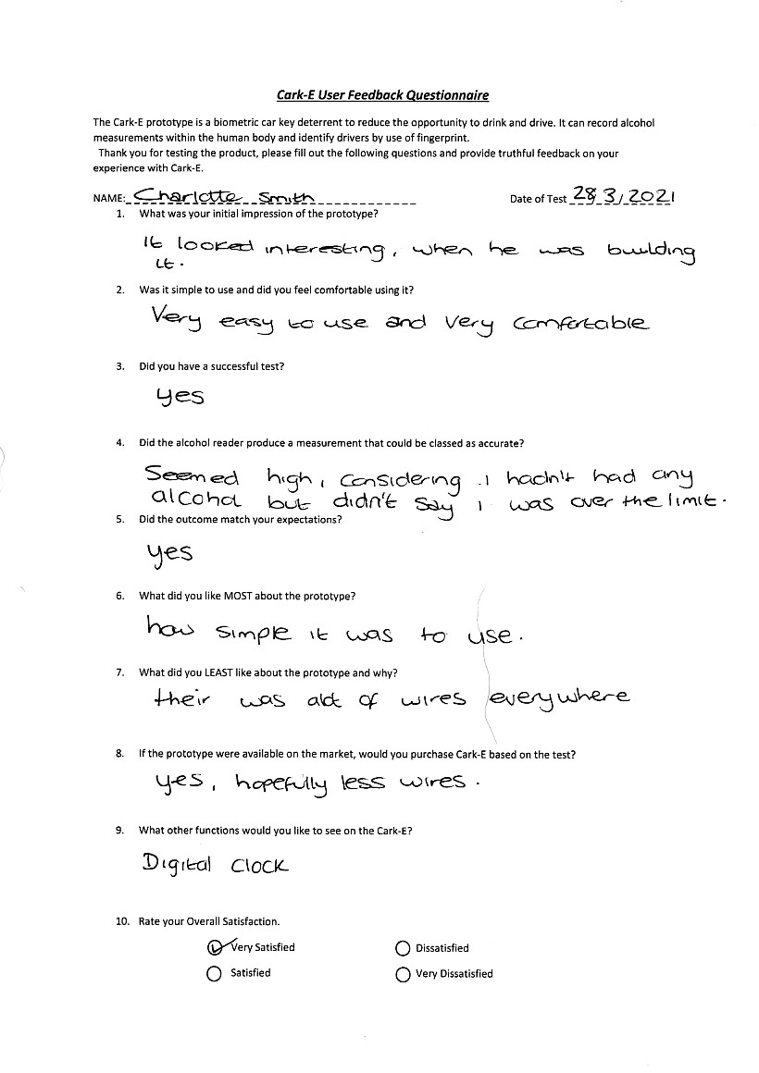

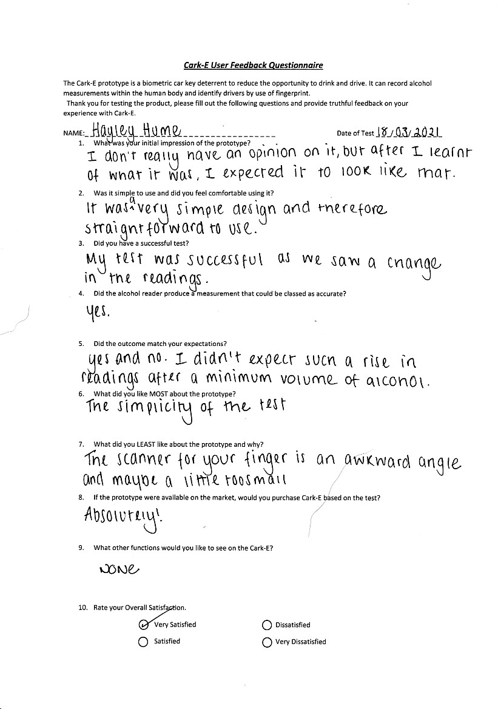

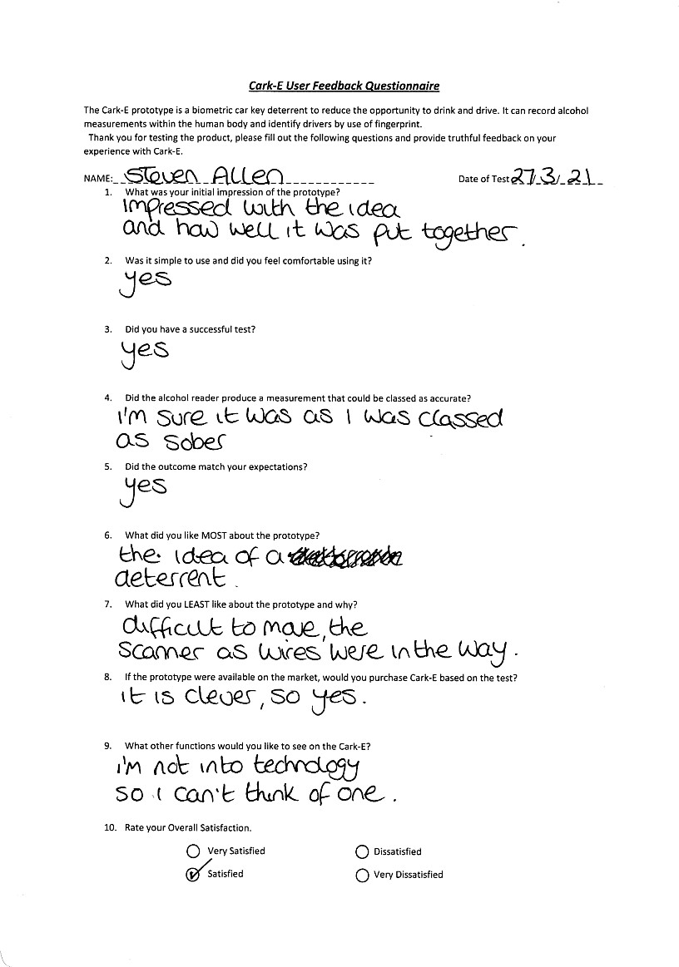

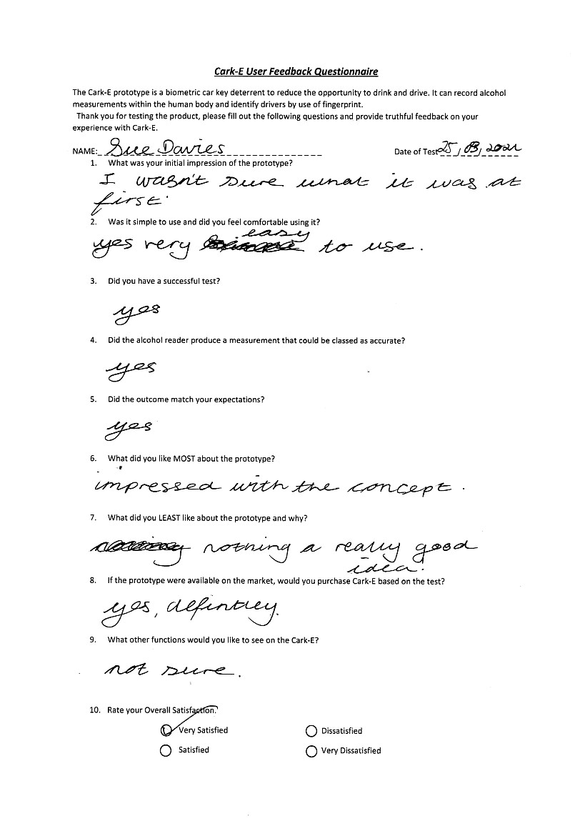

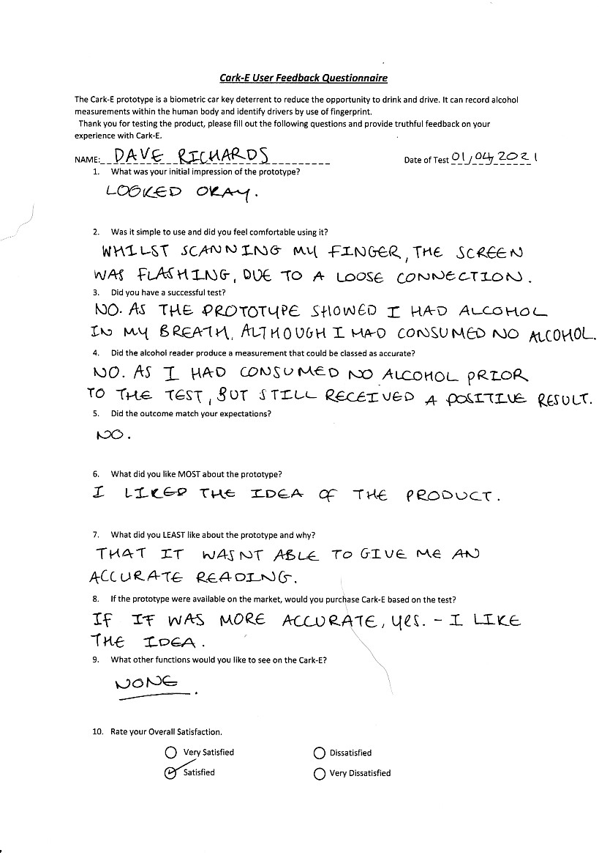

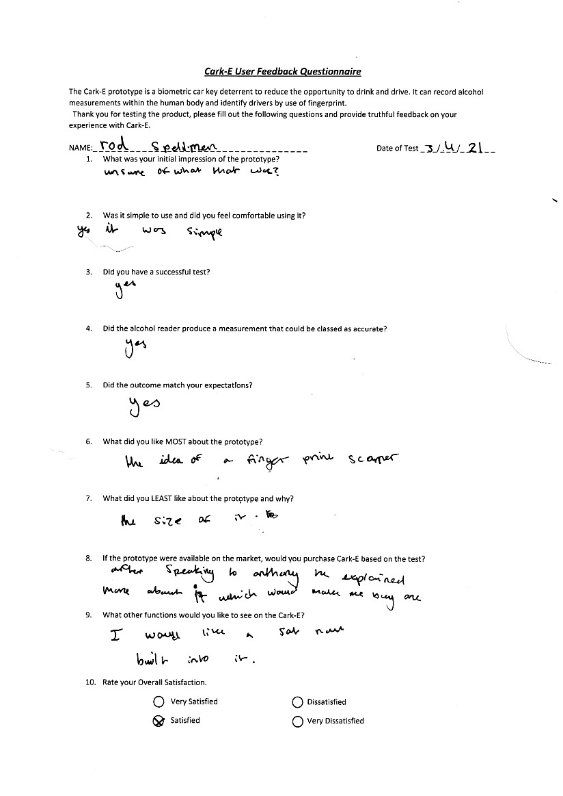

5.4 Overall evaluation
This study explored the involvement of software and electronic engineering in the creation of a deterrent to limit the opportunity to drink and drive, thus reducing injury or fatalities on the roads. The objectives that had been set, were:
- To investigate the literature related to historical and current attempts to prevent drink driving using psychosocial and physical means;
- Research was carried out to identify different attempts taken by elected governments to reduce drink driving. This objective was met as a breakdown of technology, laws and punishments were included in this report.
- To build and test a tangible prototype device;
- A successful prototype was created that tracked the desired MoSCow principles. Although changes to Arduino components had to be made to secure a working product, the changes hardly affected the testing outcome. The only drawback was the volatile MQ3 reader was too sensitive to natural vapours in the environment. But this was a problem that had to be endured.
- To evaluate the potential user acceptance and effectiveness of such a device.
- Using the research gathered from organisations that are producing similar prototypes, it was possible to see the positive effects that creating such a device would bring. As the DADSS have advanced further through the testing phase, and are now installing the technology into test vehicles, the resulting effect of demobilising the car was monumental. But it was also necessary to determine what the public thought about such a deterrent. By creating a questionnaire and making it available on social media gave the public an opportunity to discover this type of technology. With forty responses to the questionnaire and the vast majority offering positive feedback provided enough evidence to suggest that evaluating user acceptance was successful.

The complexity to build a non-invasive product that would also gauge public trust and interest is far more advanced than initial thought. There are many variables that must be taken into consideration for the car key to be a mainstream product. As the concept relies on one operating function to achieve another, malfunction was a concern highlighted by the survey. A backup process would need investigating in the instance that a failure in the technology does not allow a member of the public to drive the vehicle. Upgrades would also need to be available, if any changes to data protection, government alcohol guidelines and any new key features occur. Security features that allow the key to become blocked to avoid data breach if the key is misplaced.
The concept that has been created unfortunately contains slightly large components such as breadboards, Arduino Mega board, and the biometric readers. For this key to stand any chance on the market, smaller circuitry that is available (but at a cost) must be used to make it more compact and portable. Car manufactures would need to program on board computers that connect to the ECU of the vehicle, to override the ignition, if the user were deemed to be over the limit.
The above conclusions have been shaped from the created concept, other manufactures however, have reached their own conclusions on which breathalyser technology should be implemented. Both preferred methods involve built-in deterrents, which are currently still in the testing phase. From testing a breath method through the completed car key, continual agreement with a more non-invasive touch sensor that measures alcohol though skin would be more ideal. As the research shows, there is less scope for false positives and the user would feel less inconvenienced as the system would react quicker.
The aim of the project was to create a potential replacement for the ineffective approach taken by government legislation and police enforcement, by exploiting researched documentation. The ideology behind the concept was not to create an avant-garde product, but to build on the precursor and improve it. The aims and objectives that were established at the projects inception were accomplished through hard work and research, and that a comprehensible product was the conclusion.
The theory and inventiveness behind the car key were bold and ambitious, but overall, a working device was achieved. More could possibly be done to improve the car key in the way of functionality, but the capabilities of the author were reached. A new skill had to be learned quickly and taking this into consideration, there were no possible improvements that could be made to the device. All the components and facilities that were available, had been fully taken advantage of, and gaining knowledge of materials and circuitry helped in understanding new areas of engineering. If extended courses on electronics and IOT’s were available over the academic years, it would have had a profound effect on the final project.

6.Conclusion
This report has been used to discuss in depth, the flaws in drink driving deterrents that are currently in operation and a system that could be employed to deter or prevent driving while intoxicated. The design processes involved creating a biometric car key that could measure the content of alcohol within the finger of the driver. The system would also use fingerprint identification to only allow specified drivers to use the vehicle.
The design was slightly altered from the originally planned prototype, due to availability issues with components and high pricing levels. Although certain changes had to occur, it did not present any significant changes to the system or the desired outcome. Instead of the NIR touch alcohol sensor being incorporated into the device, the MQ3 breathalyser was the alternative option. The readings given from the breathalyser module could be temperamental, as this style of reader had to become accustomed to the vapour in the environmental surroundings. However, this design was purely a concept prototype to show the potential it had as a deterrent and was never intended to be the final product. Having completed the coding for the key using Arduino IDE software, the outcome was a success. Each component did the intended operation and all information that was considered important to the user was displayed correctly. The website that accompanied the product connected to the phpMyAdmin SQL database to allow a user to Sign up and Login into a new account. The design for the site had to be easily navigated and simple for users that are not computer savvy, as the key would be used by customers of all ages.
While conducting research that would corroborate the intention of this report, it was evident that certain organisations were also attempting such a deterrent. The DADSS is a culmination of road safety organisations and electronic component manufactures who have invested time and resource into two types of alcohol measurement systems; Touch and Breath deterrents. Although both technologies are still going through testing and design, both are in-car formats and both have been classed as non-invasive. However, just because no blood sample is taken, the opinion given in this report is that if it requires thought or can contribute to mild disruptions, then to a degree it is invasive. The car key would include touch dermal sensors like the in-car counterpart, but like a driver uses the key fob to lock or unlock a vehicle, the same unconscious action with an instant measurement would be the aim.

6.1 Recommendations and Future work
In light of the current deterrent research described in previous chapters and direct knowledge of creating a working prototype, recommendations relating to this and other organisational projects are:
Cark-E Project
- Include more functions from the MoSCoW table – for example, introduction of Wi-Fi and Bluetooth could be beneficial to increase functionality of the key and for charging capabilities.
- Employ smaller components to create the product – by using smaller components, the key would visually be comparable to the original blueprint and allow for a smaller and more compact item.
- Increase functionality of the website – currently the website has minimum functionality and only utilises standard features such as Login and Signup. The inclusion of a vehicle API that supplies the details of the car, an upgrade key page, and a histogram of travel information would be an asset to the webpage.

DADSS Project
- Use of portable technology – Similar to the Cark-E project, a smaller handheld device would benefit the physical and mental deterrent needed to stop drink drivers. If the user had the deterrent at all times, it would increase the awareness of needing to operate it, which may lead to reduced consumption of alcohol. It could also provide the ability of self-testing while frequenting a public house to ensure the alcohol limit is not surpassed.
- Added functionality – Instead of just testing for alcohol, the system could provide alternative arrangements for the inebriated. This could take the form of an SOS call to a family member or taxi service and give a GPS location of the driver. Furthermore, the DADSS would benefit from several functions that were highlighted in the MoSCoW table created for the car key project.

7.Reflection
Upon reflection of the biometric alcohol deterrent project, the main question to answer would be: if I had to do it all over again, would I do the same project? Clearly, the answer to this is a definite yes. Looking at present day and historical attempts to reduce drink driving, not enough has been done to stop it. With the technology that is available today, it should be possible to wipe it out altogether, but it still remains.
During the project, I had the chance to use electronics, which previously had never been an option. As a novice, it was interesting to learn the fundamentals of the Arduino circuitry and has inspired me to try new projects and create my own IOT’s. It took some time to understand voltage and how it was distributed around the board, which was the main reason I destroyed several screens in the process. If my knowledge of Arduino had been more advanced, I think a lot more features would have been possible. But in the period of time that was allocated and the circumstances we currently find ourselves in, it was beyond my capabilities.
My focal point for the project was the creation of the key and the capability of taking alcohol measurements, which led to the website taking a slightly less important role. Although the main requirements were met, such as easy navigation, display styles and login/Signup form, more could have been done. The DVLA vehicle API would have been a good addition to the site, but I just could not get it to work.
On a more personal note, this project has been a great experience and has taught me more than just coding. It has given me skills that I can take and adapt to any life situation and not just work related. It is by far the longest project I have endured and due to Covid-19 it has sometimes felt like a lonely one to. But it has also given me the opportunity to become self-reliant and manage situations that I usually would not. Time management has been a big element to completing this project on time, having to organize work, home-schooling, moving to a new house and university assignments and giving each the right amount of time they deserve.
During the academic year, I have had to apply various soft skills to ensure my targets were met and all tasks were achieved by the completion date:
- Problem-solving – during the implementation tasks, I had to overcome problems with coding the key and linking the website with the database. Figuring out why all the LCD screens used for the key would not work was a major hurdle, but I successfully resolved those issues.
- Decision-making – at every stage, a decision had to be made. From first deciding what the main premise of the project would be, to choosing components for the key and styling for the website. With decision making, it is knowing when to change the planned direction, if it is not going according to what you had originally intended and not be resigned by the change.
- Leadership – Although I did not have a team to lead, I had to lead myself. I had to control my situations to maintain a high work ethic, as it can be very easy to leave matters till the last minute. Time management and leadership for me went hand in hand, I set time restraints and pushed myself to get through them.
- Open to criticism – When creating a product, it is evident that not everyone is going to like it. I have learnt to not take constructive criticism to heart and use it to create a positive outcome.
- Stress management – I have never been the type of person to become stressful but trying to complete assignments in a university environment has caused slight anxiety problems. To control this I have learnt to sit back and relax whenever a problem in the project arose and look at it logically. Take frequent breaks to refresh and have days away from the project to enjoy with family.

Overall, this project has been a really good experience and I have learnt new skills that I will take to other future projects and I have also become better at skills I already had. The basic skills like reading and writing needed to be used throughout and I have gained more patience for the both of them.

8.References

[1] | Drink Driving.org, “Drink driving in the UK,” 2020. [Online]. Available: https://www.drinkdriving.org/drink_driving_information_breathalysers_modern.php. [Accessed 9 Dec 2020].
[2] | Brake, “More than 5,000 repeat drink-drive offenders in past 4 years,” 22 Aug 2019. [Online]. Available: https://www.brake.org.uk/how-we-help/raising-awareness/our-current-projects/news-and-blogs/more-than-5-000-repeat-drink-drive-offenders-in-past-four-years. [Accessed 29 Oct 2020].
[3] | M. Davis, “Half a million people have been done for drink driving and a tenth are repeat offenders,” 8 Dec 2019. [Online]. Available: https://www.express.co.uk/news/uk/1214595/drink-driving-ban-motorists-reoffend-DVLA. [Accessed 27 Oct 2020].
[4] | Department for Transport, “Reported road Casualties in Great Britain: final estimates involving illegal alcohol levels,” National Statistics, 2018.
[5] | Drink driving.org, “Breathalyzers in History,” 2020. [Online]. Available: https://www.drinkdriving.org/drink_driving_information_breathalysers_early.php#:~:text=A%20Dr%20E%20Bogen%20who,(blood%20alcohol%20concentration%20levels).&text=A%20Professor%20Robert%20F%20Brokenstein,invented%20the%20breathalyzer%20in%201954.. [Accessed 23 Nov 2020].
[6] | Mothers Against Drunk Driving (MADD, “About us,” 2020. [Online]. Available: https://www.madd.org/about-us/. [Accessed 6 Nov 2020].
[7] | Campaign Against Drink Driving (CADD), “CADD,” 2020. [Online]. Available: https://www.cadd.org.uk/about-cadd.html. [Accessed 9 Nov 2020].
[8] | Drink Driving.org, “Police breathalyzers,” 2020. [Online]. Available: https://www.drinkdriving.org/drink_driving_information_breathalysers_approved.php. [Accessed 8 Nov 2020].
[9] | Fathers Against Drunk Driving (FADD), “About Us,” 2020. [Online]. Available: http://www.faddintl.org/about-us.html#info. [Accessed 12 Nov 2020].
[10] | Law Reform, “Road Traffic Act 2016,” 2016. [Online]. Available: https://revisedacts.lawreform.ie/eli/2016/act/21/front/revised/en/html. [Accessed 2 Dec 2020].
[11] | DrinkAware, “drink driving and the legal alcohol limit,” 2021. [Online]. Available: https://www.drinkaware.co.uk/facts/alcohol-and-the-law/drink-driving-and-the-legal-alcohol-limit#:~:text=The%20law%20and%20drink%20drive%20limits%20in%20the%20UK,-What's%20the%20drink&text=In%20England%2C%20Wales%20and%20Northern%20Ireland%2C%20the%20alco. [Accessed 23 Jan 2021].
[12] | J. Lewsey, D. F. Mackay, M. Robinson and et.al, “An evaluation of the effects of lowering blood alcohol concentration limits for drivers on the rates of road traffic accidents and alcohol consumption:a natural experiment,” The Lancet, vol. 393, no. 10169, pp. 321-329, 12 Dec 2018.
[13] | J. Salmon, “Drink-drive limit in England and Wales won't be lowered - because it hasn't cut deaths in Scotland,” 14 May 2019. [Online]. Available: https://www.dailymail.co.uk/news/article-7025505/Drink-drive-limit-England-Wales-wont-lowered-cut-deaths-Scotland.html. [Accessed 20 Dec 2020].
[14] | Drink Driving.org, “New Drink Driving Laws,” 2020. [Online]. Available: https://www.drinkdriving.org/new_limit_laws.php. [Accessed 19 Dec 2020].
[15] | M. A. Simon and P. Gregory, Biometrics for Dummies, New Jersey: John Wiley & Sons, 2008.
[16] | L. K. Nadeau, “Tracing the History of Biometrics,” Oct 23 2012. [Online]. Available: https://www.govtech.com/Tracing-the-History-of-Biometrics.html. [Accessed 15 Sept 2020].
[17] | Biometrics Institute, “Types of Biometrics,” [Online]. Available: https://www.biometricsinstitute.org/what-is-biometrics/types-of-biometrics/. [Accessed 15 Sept 2020].
[18] | Simply BodyLanguage, “What are fingers called,” 2012. [Online]. Available: https://www.simplybodylanguage.com/finger-names.html#:~:text=The%20finger%20bone%20segments%20(the,Bottom%20segment%3A%20Proximal%20phalanx. [Accessed 10 Jan 2021].
[19] | recogtech, “How does vein pattern recognition work?,” 2021. [Online]. Available: https://www.recogtech.com/en/knowledge-base/vein-pattern-recognition. [Accessed 16 Jan 2021].
[20] | T. I. Yang, C. C. Tseng and C. S. Koong, “A User Authentication Scheme Using Physiological and Behavioral Biometrics for Multitouch Devices,” The Scientific World Journal, vol. 2014, 24 Jul 2014.
[21] | I. Alsaadi, “Physiological Biometric Authentication Systems, Advantages, Disadvantages and Future Development: A Review,” International journal of Scientific and Technology Research, vol. 1, no. 1, Dec 2015.
[22] | V. S. j. B. L. D. B. Ridder D. Trent, “Comparison of spectroscopically measured tissue alcohol concentration to blood and breath alcohol measurements,” Journal of Biomedical Optics, vol. 14, no. 5, 1 Sept 2009.
[23] | W. Q. e. a. Ferrari Marco, “Time-resolved Spectroscopy of the Human forearm,” Journal of Photochemistry and Photobiology, vol. 16, no. 2, pp. 141-153, 1992.
[24] | L. D. B. R. T. e. a. Hull L. Edward, “Comparison of spectroscopically measured finger and forearm tissue ethanol concentration to blood and breath ethanol measurements,” Journal of Biomedical Optics, vol. 16, no. 2, 2011.
[25] | Series in medical Physics and Biomedical Engineering, Handbook of Optical Sensing of Glucose in Biological Fluids and Tissues, T. V. Valery, Ed., CRC Press, 2008.
[26] | S. .. Kollias .N, “Optical Non-Invasive Approaches to Diagnosis of Skin Diseases,” Journal of Investigative Dermatology Symposium Proceedings, vol. 7, no. 1, pp. 64-75, Dec 2002.
[27] | K. .. Qassem .M, “Cosmetics,” Review of Modern Techniques for the Assessment of Skin Hydration, pp. 1-28, 9 Mar 2019.
[28] | M. .. e. a. Kielhorn .J, “Dermal Absorption,” United Nations Environment Programme , International Labour Organization, Hanover, 2006.
[29] | J. F. Dlugos and T. J. L, “Materials Characterization: UV/Vis/NIR Spectroscopy,” PerkinElmer, Waltham, 2019.
[30] | The NIDA Blog Team, “The Science of Drug Testing: How Alcohol Breath Tests Work,” National Institute on Drug Abuse, 2016.
[31] | I. .. e. a. Ozoemena .K, “Fuel cell based breath-alcohol sensors: Innovation-hungry old electrochemistry,” Current Opinion in Electrochemistry, vol. 10, pp. 82-87, 2018.
[32] | BMJ Publishing group, “Alcohol breath testing,” The bmj, vol. 3, 14 Dec 2002.
[33] | Y. .J, “what should you do if your blood pressure medication has been recalled,” 5 Aug 2019. [Online]. Available: https://www.health.harvard.edu/blog/what-should-you-do-if-your-blood-pressure-medication-has-been-recalled-2019080517434. [Accessed 9 Dec 2020].
[34] | China Xinghe Yeast, “Super Quality Bread Yeast,” [Online]. Available: https://www.xingheyeast.com/instant-dry-yeast/low-sugar-yeast/super-quality-bread-yeast.html. [Accessed 9 Dec 2020].
[35] | Hoxton Street Monster Supplies, “Zombie Fresh Mints,” [Online]. Available: https://www.monstersupplies.org/products/zombie-mints. [Accessed 9 Dec 2020].
[36] | B. .M, “Substances that can affect a breath test,” Jan 2017. [Online]. Available: https://www.alcolizer.com/wp-content/uploads/2017/01/12660_WhitePaper_Substances-that-Can-Affect-A-Breath-test_LR.pdf. [Accessed 11 Dec 2020].
[37] | A. K. Zaouk, E. Traube and R. Strassburger, “Driver Alcohol Detection System For Safety (DADSS) - A Status Update,” NHTSA, QinetiQ, Alliance of Automobile Manufacturers, 2014.
[38] | R. J. Zettl, “The Determination of Blood Alcohol Concentration by Transdermal Measurement,” Alcohol Monitoring Systems inc, Colorado, 2002.
[39] | NHTSA National Highway Traffic Safety Administration, “In-Vehicle Alcohol Detection Research,” NHTSA, 2016.
[40] | R. Fournier, A. Zaouk, M. Wills and e. al, “ASSESSING SYSTEM IMPLEMENTATION READINESS OF THE DRIVER ALCOHOL DETECTION SYSTEM FOR SAFETY (DADSS) TO REDUCE ALCOHOL-IMPAIRED DRIVING IN A REAL-WORLD DRIVING PILOT DEPLOYMENT PROJECT,” in NHTSA 26th ESV Conference, Eindhoven, 2019.
[41] | M. Willis, A. Zaouk and e. al, “Driver alcohol detection system for safety (DADSS) - A non-regulatory approach in the research and development of vehicle safety technology to reduce alcohol-impaired driving - A status update,” 2019.
[42] | B. Hok, H. Pettersson and J. Ljungblad, “Unobtrusive Breath Alcohol Sensing system,” in 24th International Technical Conference on the Enahnce Safety of Vehicles, 2015.
[43] | A. Zaouk, M. Wills, E. Traube and e. al., “Driver Alcohol Detection System for Safety - A status Update,” NHTSA, 2015.
[44] | nanoplus, “Nanosystems and Technologies,” 2020. [Online]. Available: https://nanoplus.com/. [Accessed 15 Dec 2020].
[45] | TruTouch Technologies, “Our Technology,” 2020. [Online]. Available: http://tttinc.com/. [Accessed 16 Dec 2020].
[46] | L. Cech, B. Ver Steeg, D. Treese and e. al., “Introduction of a Solid State, Non-Invasive Human Touch Based Alcohol Sensor,” NHTSA, 2015.
[47] | DADSS, “Touch-Based Technology,” 2020. [Online]. Available: https://www.dadss.org/wp-content/uploads/2019/04/DADSS_Touch-Based_041519-1.pdf. [Accessed 18 Dec 2020].
[48] | N. Eddy, “Only some biometrics security will be Automotive Solutions,” 25 Apr 2019. [Online]. Available: https://www.tu-auto.com/only-some-biometrics-security-will-be-automotive-solutions/. [Accessed 12 Jan 2021].
[49] | SEAT, “SEAT displays the Leon Cristobal at the Smart City Expo, the safest car in its history,” 14 Nov 2017. [Online]. Available: https://mundoseat.seat.com/mediacenter_netstor/seat-media-center/Img/2017/11/2017-11-14/141117_Smart_City_Expo_EN.pdf. [Accessed 12 Jan 2021].
[50] | KEA Technologies inc, “Science, Technology, Innovation,” 2020. [Online]. Available: https://www.keatechinc.com/. [Accessed 21 Nov 2020].
[51] | SenseAir, “Our Applications,” 2020. [Online]. Available: https://senseair.com/. [Accessed 21 Nov 2020].
[52] | Consumer Reports, “Takata Airbag Recall:Everything you Need to Know,” 20 Jan 2021. [Online]. Available: https://www.consumerreports.org/car-recalls-defects/takata-airbag-recall-everything-you-need-to-know/. [Accessed 20 jan 2021].
[53] | i-micronews, “Takata-Trutouch develops alcohol detection system for cars,” 12 Jul 2016. [Online]. Available: https://www.i-micronews.com/takata-trutouch-develops-alcohol-detection-system-for-cars/. [Accessed 28 Dec 2020].
[54] | S. J. Russell and P. Norvig, Artificial Intelligence : A Modern Approach, New Jersey: Prentice-Hall, 1995.
[55] | T. H. Cormen, C. E. Leiserson, R. L. Rivest and e. al., Introduction to Algorithms, 4th ed., Mcgraw - Hill, 2003.
[56] | R. Jaiswal and G. Saxena, “Biometric Recognition System (Algorithm),” in EMIE - International Conference on Advances in Electrical Measurements and Instrumentation Engineering, Cochin, India, 2017.
[57] | Y. Chen and J. C. Fondeur, Biometric Algorithms, Springer, 2015.
[58] | Anton Paar, “Near Infrared Spectroscopy (NIR),” 2021. [Online]. Available: https://wiki.anton-paar.com/uk-en/near-infrared-spectroscopy-nir/. [Accessed 23 Feb 2021].
[59] | R. Abbink and C. Gardner, “Getting under the Skin,” 1 Sept 2003. [Online]. Available: https://spie.org/news/getting-under-the-skin?SSO=1. [Accessed 18 Feb 2021].
[60] | Hitachi High-Tech Analytical Science, “An Introduction to Statistics for Spectroscopy,” 19 Sept 2019. [Online]. Available: https://www.azom.com/article.aspx?ArticleID=18479. [Accessed 4 Feb 2021].
[61] | Statistics How to, “What is Standard Error of Measurement,” 7 Nov 2016. [Online]. Available: https://www.statisticshowto.com/standard-error-of-measurement/. [Accessed 8 Dec 2020].
[62] | J. Ljungblad, B. Hok and M. Ekstrom, “Development and Evaluation of Algorithms for Breath Alcohol Screening,” Sensors (Basel), 1 Apr 2016.
[63] | J. Ljungblad, B. Hok and et.al, “Passive in-vehicle driver breath alcohol detection using advanced sensor signal acquisition and fusion,” Traffic Injury Prevention, vol. 18, no. 1, pp. 31-36, 2017.
[64] | B. Hok, J. Ljungblad and et.al, “Unobtrusive and Highly Accurate Breath Alcohol Analysis Enabled by Improved Methodology and Technology,” J Forensic Investigation, vol. 2, no. 4, Oct 2014.
[65] | National Forensic Science technology center, “A simplified guide to Fingerprint Analysis,” 2013. [Online]. Available: http://www.forensicsciencesimplified.org/prints/index.htm. [Accessed 4 Mar 2021].
[66] | M. J. Bailey, M. Hudson, M. Jang and et.al, “On the relevance of cocaine detection in a fingerprint,” Scientific reports, vol. 10, 6 Feb 2020.
[67] | S. M. R. Wille, “Fingerprint Drug Analysis: Overcoming Pitfalls and Heading Toward the Future?,” Clinical Chemistry, vol. 64, no. 6, 1 Jun 2018.
[68] | M. Hudson, J. Patel, S. Hines and et.al, “Drug screening using the sweat of a fingerprint,” Analytical Toxicology, vol. 43, no. 2, Mar 2019.
[69] | DADSS, “Frequently Asked Questions,” 2021. [Online]. Available: https://www.dadss.org/faq. [Accessed 28 Mar 2021].
[70] | K. Rubin, Essential Scrum, Michigan: Pearson Education, 2013.
[71] | R. Teja, “What are the differences between Raspberry Pi and Arduino?,” 5 Apr 2021. [Online]. Available: https://www.electronicshub.org/raspberry-pi-vs-arduino/. [Accessed 19 Apr 2021].
[72] | Arduino, “What is Arduino?,” [Online]. Available: https://www.arduino.cc/en/guide/introduction. [Accessed 4 Mar 2021].
[73] | SCAND, “What are the best C and C++ IDEs for Software Developers?,” 5 Nov 2020. [Online]. Available: https://scand.com/company/blog/best-c-and-c-plus-plus-ides-for-software-developers/. [Accessed 19 Apr 2021].
[74] | Microsoft, “Visual Studio 2019,” 2019. [Online]. Available: https://visualstudio.microsoft.com/vs/. [Accessed 12 Mar 2021].
[75] | w3schools, “Introduction to SQL,” 2021. [Online]. Available: https://www.w3schools.com/sql/sql_intro.asp. [Accessed 18 Mar 2021].
[76] | Phpmyadmin, “Bringing MySQL to the web,” 2021. [Online]. Available: https://www.phpmyadmin.net/. [Accessed 18 Mar 2021].
[77] | Agile Business Consortium, “Moscow Prioritisation,” 2021. [Online]. Available: https://www.agilebusiness.org/page/ProjectFramework_10_MoSCoWPrioritisation. [Accessed 18 Mar 2021].
[78] | M. Green and P. Rossall, “Age UK Digital Inclusion Evidence Report,” Age UK, 2013.
[79] | R. Sanders, “Digital Inclusion, Exclusion and Participation,” Iriss, 2020.
[80] | Last Minute Engineers, “How MQ3 Alcohol Sensor Works?,” 2021. [Online]. Available: https://lastminuteengineers.com/mq3-alcohol-sensor-arduino-tutorial/. [Accessed 29 Mar 2021].
[81] | Adafruit, “Rugged Panel Mount Fingerprint Sensor R503,” 2021. [Online]. Available: https://www.adafruit.com/product/4651. [Accessed 28 Mar 2021].
[82] | Amazon, “R503 circular capacitive Module,” 2021. [Online]. Available: https://www.amazon.com/Nuolate2019-Fingerprint-Capacitive-Identification-Indicator/dp/B08LVHZDHZ. [Accessed 28 Mar 2021].
[83] | rhydolabz, “Finger Print Sensor R307,” 2021. [Online]. Available: https://www.rhydolabz.com/miscellaneous-other-widgets-c-205_124/finger-print-sensor-r307-ttl-uart-p-2631.html. [Accessed 28 Mar 2021].
[84] | Grow, “Grow R307 Fingerprint Module,” 2021. [Online]. Available: http://en.hzgrow.com/product/103.html. [Accessed 29 Mar 2021].
[85] | Simple Projects, “Interfacing Arduino with ST7789 Display,” 1 Jun 2019. [Online]. Available: https://simple-circuit.com/arduino-st7789-ips-tft-display-example/#:~:text=This%20Arduino%20tutorial%20shows%20how,cost%20and%20easy%20to%20use.. [Accessed 23 Jan 2021].
[86] | GeeksforGeeks, “How to prepare test case report for a Project,” 11 Oct 2018. [Online]. Available: https://www.geeksforgeeks.org/how-to-prepare-test-case-report-for-a-project/. [Accessed 15 Mar 2021].
[87] | Engineering Funda, “Distributed feedback Laser or DFB Laser,” 11 Jun 2019. [Online]. Available: https://www.youtube.com/watch?v=RElv_08NfXA. [Accessed 2 Jan 2021].
[88] | M. S. Nixon and A. S. Aguado, Feature Extraction and Image Processing for Computer Vision, Elsevier Ltd, 2013.
[89] | MathWorks, “Image Thresholding,” 2021. [Online]. Available: https://uk.mathworks.com/discovery/image-thresholding.html. [Accessed 25 Feb 2021].
[90] | UCLA, “Illustrated Glossary of Organic Chemistry,” [Online]. Available: http://www.chem.ucla.edu/~harding/IGOC/A/analyte.html. [Accessed 26 Feb 2021].
[91] | B. Wojdyla, “How it works: The computer inside your car,” 21 Feb 2012. [Online]. Available: https://www.popularmechanics.com/cars/how-to/a7386/how-it-works-the-computer-inside-your-car/. [Accessed 9 Mar 2021].
[92] | Arduino, “Arduino Forum,” [Online]. Available: https://forum.arduino.cc/. [Accessed 2020 - 2021].
[93] | Visual Paradigm, “What is Sequence Diagram?,” 2021. [Online]. Available: https://www.visual-paradigm.com/guide/uml-unified-modeling-language/what-is-sequence-diagram/. [Accessed 6 Apr 2021].
[94] | Lucidchart, “UML Sequence Diagram Tutorial,” 2021. [Online]. Available: https://www.lucidchart.com/pages/uml-sequence-diagram. [Accessed 5 Apr 2021].
[95] | GDPR.EU, “What is GDPR,” 2021. [Online]. Available: https://gdpr.eu/what-is-gdpr/. [Accessed 4 Apr 2021].
[96] | Information Commisioner's Office, “The GDPR principles,” 2021. [Online]. Available: https://ico.org.uk/for-organisations/guide-to-data-protection/guide-to-the-general-data-protection-regulation-gdpr/principles/#the_principles. [Accessed 4 Apr 2021].
[97] | Amazon, “LCD Digital Police breath breathalyser,” 2021. [Online]. Available: https://www.amazon.co.uk/Digital-Breathalyzer-Analyzer-Detector-Portable/dp/B073FLYR3L. [Accessed 12 Mar 2021].

9. Appendices

- Definitions page
- Arduino code
- Website code
- Webpage and Database Sequence diagram
- GDPR (General Data Protection Regulation)
- Flowchart of operation
- Questionnaire Results
- Pilot survey
- Website screenshot examples

Appendix A – Definitions
To define certain technical terms that are included in this report, a statement with the exact meaning of the word are outlined below:

- BAC – Blood alcohol concentration
- PEM – Proton-exchange Membrane
- Ethanol – The only form of alcohol that can safely be consumed.
- Oxidation – A chemical process in which an element gains oxygen or loses electrons.
- Cathode – Defined by the flow of current. Negatively charged electrode, and Attracts positive charge
- Anode – Defined by the flow of current. Positively charged electrode, and attracts electrons
- Meas – Measured peak values
- CO2et – End tidal CO2 concentration
- Pharmacokinetics – Ways that drugs and metabolites are absorbed ,distributed and eliminated from the body.
- Pharmacodynamics – Physiological effects of drugs and their actions on the body.
- BrACs – Breath alcohol concentrations
- TAC – Total antioxidant capacity
- µm – Micrometre equal to 0.001mm or 0.000039 inch. Minute distances such as infrared radiation wavelengths. Also known as Micron.
- Interlock Device – Breathalyser within a vehicle. Requires the driver to blow or breathe into the device before operating a vehicle.
- Distal phalanx – Tip section of the human finger
- DFB Laser – Distributed feedback laser. Instead of using two mirrors to reflect light, it is one grated mirror to reflect a narrow band wavelength to produce a single frequency [87].
- Minutiae – Specific points on a fingerprint.
- Sobel Mask - used in image edge detection. When the central pixel is doubled it determines the edge vector form [88].
- Thresholding – Type of image segmentation, in which changes to pixels can be made to analyse images easier. Transformation from greyscale into binary image occurs [89].
- Analyte – A substance whose chemical compounds are identified and measured [90].
- ECU – The Electronic control unit of a vehicle, is used to control the engine, transmission, and any other electronic equipment [91].

Appendix B – Arduino Code
The following code was used in the creation of the device known as Cark-E. The first program is the executable code that is uploaded to the Arduino Mega, which allows the functionality of the car key. The other is the enrolment code that will be required to store the fingerprint of the user and allow authorisation. [92]

Car key functionality code
#include <Adafruit_GFX.h> // Core graphics library
#include <Adafruit_ST7789.h> // Hardware-specific library for ST7735 / ST7789
#include <SPI.h>
#if defined(ARDUINO_FEATHER_ESP32) //if ESP32 WIFI / Bluetooth board is used the pin screen setup would be this.
#define TFT_CS 14
#define TFT_RST 15
#define TFT_DC 32

#elif defined(ESP8266) // If the ESP8266 WIFI board is added, the pin screen setup would be this.
#define TFT_CS 4
#define TFT_RST 16
#define TFT_DC 5

#else //Pin screen setup for the standard Arduino Mega

#define TFT_CS 10
#define TFT_RST 8
#define TFT_DC 9

#endif

// For 1.3" TFT with ST7789 library:
Adafruit_ST7789 tft = Adafruit_ST7789(TFT_CS, TFT_DC, TFT_RST);

int content = 0;
String name = ""; //Users

#include <Adafruit_Fingerprint.h>

#define mySerial Serial1 // i am using the serial port, not software serial

Adafruit_Fingerprint finger = Adafruit_Fingerprint(&mySerial);

void setup()
{
Serial.begin(9600); // displays messages and setup through serial monitor
while (!Serial);
delay(100);
Serial.println("\n\nCark-E finger detect test");

// set the data rate for the sensor serial port
finger.begin(57600);

if (finger.verifyPassword()) {
Serial.println("Found fingerprint sensor!");
} else {
Serial.println("Did not find fingerprint sensor :(");
while (1) {
delay(1);
}
}
tft.init(240, 240, SPI_MODE3); // intialise the screen using SPI_MODE 3 datamode
tft.setRotation(2);
// pinMode(TFT_BACKLIGHT, OUTPUT);
//digitalWrite(TFT_BACKLIGHT, HIGH); // Backlight on

Serial.println(F("Initialised"));

uint16_t time = millis();
tft.fillScreen(ST77XX_BLACK);
time = millis() - time;

Serial.println(time, DEC);
delay(500);

finger.getTemplateCount();
Serial.print("Sensor contains "); Serial.print(finger.templateCount); Serial.println(" templates"); //amount of fingerprints saved on the scanner
Serial.println("Waiting for valid finger...");
testdrawtext("Welcome to Cark-E \n\nThe\nBiometric\nAlcohol\nSystem "); //Displays on LCD screen
delay(5000); //Delays are times between each operation

}

void loop() {
testdrawtext("Place your\nFinger \non the \nScanner ");
delay(2000);
//getFingerprintIDez();
getFingerprintID();
delay(50); //don't need to run this at full speed.
}

uint8_t getFingerprintID() {
uint8_t p = finger.getImage();
switch (p) {
case FINGERPRINT_OK:
Serial.println("Image taken");
break;
case FINGERPRINT_NOFINGER:
Serial.println("No finger detected");
return p;
case FINGERPRINT_PACKETRECIEVEERR:
Serial.println("Communication error");
return p;
case FINGERPRINT_IMAGEFAIL:
Serial.println("Imaging error");
return p;
default:
Serial.println("Unknown error");
return p;
}

// OK success!

p = finger.image2Tz();
switch (p) {
case FINGERPRINT_OK:
Serial.println("Image converted");
break;
case FINGERPRINT_IMAGEMESS:
Serial.println("Image too messy");
return p;
case FINGERPRINT_PACKETRECIEVEERR:
Serial.println("Communication error");
return p;
case FINGERPRINT_FEATUREFAIL:
Serial.println("Could not find fingerprint features");
return p;
case FINGERPRINT_INVALIDIMAGE:
Serial.println("Could not find fingerprint features");
return p;
default:
Serial.println("Unknown error");
return p;
}

// OK converted!
p = finger.fingerFastSearch();
if (p == FINGERPRINT_OK) {
Serial.println("Found a print match!");
} else if (p == FINGERPRINT_PACKETRECIEVEERR) {
Serial.println("Communication error");
return p;
} else if (p == FINGERPRINT_NOTFOUND) {
Serial.println("Did not find a match");
testdrawtext("Sorry,\nNo Match\nPlease \nTry Again");
delay(3000);
return p;
} else {
Serial.println("Unknown error");
return p;
}

// found a match!
Serial.print("Found ID #"); Serial.print(finger.fingerID);
Serial.print(" with confidence of "); Serial.println(finger.confidence);// how accurate the fingerprint is to the one saved
getId(finger.fingerID);
return finger.fingerID;
}

// returns -1 if failed, otherwise returns ID #
int getFingerprintIDez() {
uint8_t p = finger.getImage();
if (p != FINGERPRINT_OK) return -1;

p = finger.image2Tz();
if (p != FINGERPRINT_OK) return -1;

p = finger.fingerFastSearch();
if (p != FINGERPRINT_OK) return -1;

// found a match!
Serial.print("Found ID #"); Serial.print(finger.fingerID);
Serial.print(" with confidence of "); Serial.println(finger.confidence);
getId(finger.fingerID);
return finger.fingerID;
}

void testdrawtext(String text) { //display setup

//tft.setTextWrap(false);

tft.fillScreen(ST77XX_BLACK);
tft.setCursor(0, 0);
tft.setTextColor(ST77XX_WHITE);
tft.setTextSize(4);
tft.setTextWrap(true);
tft.print(text);
}
void breathe (String name) {
testdrawtext("welcome \n" + (name));
delay(5000);
testdrawtext("Please \nBlow into the \nMQ3 Reader");
delay(3000);

for ( int i = 0; i < 10; i++) {
content = analogRead(A0);
Serial.print("alcohol sensed: ");
Serial.println(content);
testdrawtext("Analysing \nAlcohol \nContent \nin your \nBreath..." );
delay(700);
}
testdrawtext("DONE \nYOU CAN \nSTOP NOW"); //5 seconds
delay(2000);
if (content > 500) {
testdrawtext("ALCOHOL \nLEVEL \nIS : " + String(content));
delay(3000);
testdrawtext("YOU ARE \nOVER THE \nLIMIT \nYOU CAN \nNOT DRIVE " );
delay(5000);
} else {
testdrawtext("ALCOHOL \nLEVEL \nIS : " + String(content));
delay(3000);
testdrawtext("YOU ARE \nSAFE \nTO DRIVE \n\nTHANK YOU");
delay(5000);
}
}
// Users already enrolled
void getId(int id) {

switch (id) {
case 1: name = "Steve"; break;
case 2: name = "Anthony"; break;
case 3: name = "Hayley"; break;
}
Serial.print("Hello ");
Serial.println(name);
breathe(name);

}

Arduino enrolment code
#include <Adafruit_Fingerprint.h>

#define mySerial Serial1

Adafruit_Fingerprint finger = Adafruit_Fingerprint(&mySerial);

uint8_t id;

void setup()
{
Serial.begin(9600);
while (!Serial);
delay(100);
Serial.println("\n\nCark-E Fingerprint sensor enrolment");

// set the data rate for the sensor serial port
finger.begin(57600);

if (finger.verifyPassword()) {
Serial.println("Found fingerprint sensor!");
} else {
Serial.println("Did not find fingerprint sensor :(");
while (1) { delay(1); }
}
}

uint8_t readnumber(void) {
uint8_t num = 0;

while (num == 0) {
while (! Serial.available());
num = Serial.parseInt();
}
return num;
}

void loop(){
Serial.println("Ready to enrol a fingerprint!");
Serial.println("Please type in the ID # (from 1 to 127) you want to save this finger as......");
id = readnumber();
if (id == 0) {// ID #0 not allowed, try again!
return;
}
Serial.print("Enrolling ID #");
Serial.println(id);

while (!getFingerprintEnrol());
}

uint8_t getFingerprintEnrol() {
int p = -1;
Serial.print("Waiting for valid finger to enrol as #"); Serial.println(id);
while (p != FINGERPRINT_OK) {
p = finger.getImage();
switch (p) {
case FINGERPRINT_OK:
Serial.println("Image taken");
break;
case FINGERPRINT_NOFINGER:
Serial.println(".");
break;
case FINGERPRINT_PACKETRECIEVEERR:
Serial.println("Communication error");
break;
case FINGERPRINT_IMAGEFAIL:
Serial.println("Imaging error");
break;
default:
Serial.println("Unknown error");
break;
}
}

// OK success!

p = finger.image2Tz(1);
switch (p) {
case FINGERPRINT_OK:
Serial.println("Image converted");
break;
case FINGERPRINT_IMAGEMESS:
Serial.println("Image too messy");
return p;
case FINGERPRINT_PACKETRECIEVEERR:
Serial.println("Communication error");
return p;
case FINGERPRINT_FEATUREFAIL:
Serial.println("Could not find fingerprint features");
return p;
case FINGERPRINT_INVALIDIMAGE:
Serial.println("Could not find fingerprint features");
return p;
default:
Serial.println("Unknown error");
return p;
}

Serial.println("Remove finger");
delay(2000);
p = 0;
while (p != FINGERPRINT_NOFINGER) {
p = finger.getImage();
}
Serial.print("ID "); Serial.println(id);
p = -1;
Serial.println("Place same finger again");
while (p != FINGERPRINT_OK) {
p = finger.getImage();
switch (p) {
case FINGERPRINT_OK:
Serial.println("Image taken");
break;
case FINGERPRINT_NOFINGER:
Serial.print(".");
break;
case FINGERPRINT_PACKETRECIEVEERR:
Serial.println("Communication error");
break;
case FINGERPRINT_IMAGEFAIL:
Serial.println("Imaging error");
break;
default:
Serial.println("Unknown error");
break;
}
}

// OK success!

p = finger.image2Tz(2);
switch (p) {
case FINGERPRINT_OK:
Serial.println("Image converted");
break;
case FINGERPRINT_IMAGEMESS:
Serial.println("Image too messy");
return p;
case FINGERPRINT_PACKETRECIEVEERR:
Serial.println("Communication error");
return p;
case FINGERPRINT_FEATUREFAIL:
Serial.println("Could not find fingerprint features");
return p;
case FINGERPRINT_INVALIDIMAGE:
Serial.println("Could not find fingerprint features");
return p;
default:
Serial.println("Unknown error");
return p;
}

// OK converted!
Serial.print("Creating model for #"); Serial.println(id);

p = finger.createModel();
if (p == FINGERPRINT_OK) {
Serial.println("Prints matched!");
} else if (p == FINGERPRINT_PACKETRECIEVEERR) {
Serial.println("Communication error");
return p;
} else if (p == FINGERPRINT_ENROLLMISMATCH) {
Serial.println("Fingerprints did not match");
return p;
} else {
Serial.println("Unknown error");
return p;
}

Serial.print("ID "); Serial.println(id);
p = finger.storeModel(id);
if (p == FINGERPRINT_OK) {
Serial.println("Stored!");
} else if (p == FINGERPRINT_PACKETRECIEVEERR) {
Serial.println("Communication error");
return p;
} else if (p == FINGERPRINT_BADLOCATION) {
Serial.println("Could not store in that location");
return p;
} else if (p == FINGERPRINT_FLASHERR) {
Serial.println("Error writing to flash");
return p;
} else {
Serial.println("Unknown error");
return p;
}
}

Appendix C – Website Code
Code that is required to successfully load the website and connect to the phpMyAdmin database is separated into the sections below.

Login.php code
<?php
session_start();//session access
include "connection.php";
$UserName = $_POST["un"]; // gets passed to form on Main page
$Password = $_POST["psw"];

$result = mysqli_query($conn, "SELECT * FROM keyuser WHERE UserName = '$UserName' AND Password = '$Password'")or die ("Failed to Connect to Database ".mysqli_error());

$numrows=mysqli_num_rows($result);

if ($numrows==1) // if user is indentified, they have access to the main page.
{
$_SESSION["username"]=$UserName;
header("location:Main.php");
}
else
{
header("location:Main.php");
// echo "Login Failed";
}
?>

Logout.php code

<?session_start();//access session
$_SESSION["username"]="";
// ob_end_clean();
session_destroy();
header("location:Main.php");
?>

Connection.php code
<?php
$servername = "localhost";
$username = "root";
$password = "";
$database = "carke";

$conn = mysqli_connect($servername, $username,$password,$database)or die ("Could not open");
?>

Cark-E style sheet.css code
/*WEBPAGE BACKGROUND DESIGN*/
#MainPage
{
background-image:url(../images/car_background.jpg);
background-color:black;
background-repeat: no-repeat;
background-position: center;
background-attachment: fixed;
background-size: cover;
height:100%;
}
/******************************************************/

/*NAVBAR DESIGN*/
.navbar-top
{
background-color:teal;
overflow: hidden;
}
.navbar-top a
{
float: left;
color: #f2f2f2;
text-align: center;
padding: 14px 16px;
text-decoration: none;
font-size: 17px;
}
.navbar-top a:hover
{
background-color:#006767;
color:yellow;
}
.right-side
{
float:right;
margin-left:400;
}
.middle-logo
{
margin-left:900;

}
/******************************************************/

/* HEADER SIZE 1 DESIGN*/
h1
{
text-align:center;
color:white;
font-size:10em;
}
/******************************************************/

/* HEADER SIZE 2 DESIGN*/
h2
{
border: 1px;
border-style: solid;
border-color: black;
padding:1em;
background-color:black;
text-align: center;
font-size: xx-large;
text-align:center;
color:white;
}
/******************************************************/

/*HEADER SIZE 3 DESIGN*/
h3
{
color:silver;
text-align:center;
text-shadow:2px 2px 0px black;
}
/******************************************************/

/*HEADER SIZE 4 DESIGN*/
h4
{
color:white;
}
/******************************************************/

/*GLIMMER EFFECT*/
@media screen and (max-width:600px)
{
.text-wrapper
{
position:fixed;
/*top:50%;*/
left:50%;
/*text-shadow: 10px white;*/

transform:translate(-50%,-50%);
font-weight:bold;
background:black -webkit-gradient(linear, left top, right top, from(black), to(black), color-stop(0.5, #fff)) 0 0 no-repeat;
background-size: 150px;
text-shadow: 3px 0px silver;
color: rgba(255,255,255,0.1);
-webkit-background-clip:text;
animation:animate 5s infinite;
font-size:60px;
font-family:verdana;

}
@keyframes animate
{
0%, 10%
{
background-position:-1000px;
}
20%
{
background-position:top left;
}
90%
{
background-position:top right;
}
100%
{
background-position:1000px;
}
}
}
/******************************************************/

/*MAIN PARAGRAPH ON HOMEPAGE*/
.para1
{
color:silver;
text-align:left;
font-family:monospace;
font-size:2em;
text-shadow:2px 2px 0px black;
}
/******************************************************/

/*PARAGRAPH DESIGN*/
p
{
color:white;
}
/*****************************************************/

/*PARAGRAPH ID4 DESIGN*/
#four
{
text-align:center;
font-size:2em;
text-shadow:2px 2px 0px black;
color:silver;
}
/******************************************************/

/*PARAGRAPH ID6 DESIGN*/
#six
{
font-size:2em;
text-align:center;
text-shadow:2px 2px 0px black;
}
/******************************************************/

/*PARAGRAPH ID7 DESIGN*/
#seven
{
text-align:center;
}
/*****************************************************/

/* DESIGN FOR MEET THE CREATOR SECTION*/
.container center
{
float:center;
}
.ant img
{
border-radius:50%;
height:400;
width:auto;
margin-left:410;
}
/*****************************************************/

/*COLUMN DESIGN*/
.column
{
float:left;
width:500;
height:auto;
padding:10px;
margin-left:100;
padding-left:30px;
}
/*****************************************************/

/*CONTACT FORM DESIGN*/
.column form
{

color:white;
border-radius: 5px;
background-color:silver;
padding: 10px;
}
*{
box-sizing: border-box;
}
input[type=text], select, textarea
{
width: 100%;
padding: 12px;
border: 1px solid #ccc;
margin-top: 6px;
margin-bottom: 16px;
resize: vertical;
}
input[type=submit]
{
background-color:teal;
color: white;
padding: 12px 20px;
border: none;
cursor: pointer;
}
input[type=submit]:hover
{
background-color:#006767;
color:yellow;
}

.side
{
float:left;
height:auto;
width: 500;
margin-top: 6px;

}

@media screen and (max-width: 600px)
{
.column, input[type=submit]
{
width: 100%;
margin-top: 0;
}
}
.column side,
{
float: left;
width: 50%;
margin-top: 6px;

}
/*****************************************************/

/*GO TO TOP OF PAGE DESIGN*/
.to-top
{
color:white;
}
/******************************************************/

/*FACEBOOK LINK AND LOGO DESIGN*/
.links
{

margin-left:910;
}

.fa-facebook
{

padding: 20px;
font-size: 30px;
width: 50px;

text-align: center;
text-decoration: none;
margin: 5px 2px;
background: #3B5998;
color: white;

}
/******************************************************/

/*SIGNUP FORM TEXT DESIGN*/
.signform
{
color:white;
}
/*****************************************************/

/*MAIN PAGE LOGIN DESIGN*/
.login input[type=text]
{

padding: 6px;
margin-top: 8px;
font-size: 10px;
border: none;
width: 150px;
}
.login
{
float:right;

}
/*****************************************************/

Submit.php code
<? include "connection.php";
// create variables
$UserID =$_POST['Uid'];
$FirstName =$_POST['Fn'];
$SurName =$_POST['Sn'];
$HouseNo =$_POST['Hnu'];
$HouseName =$_POST['Hn'];
$Street =$_POST['Stn'];
$City =$_POST['Cn'];
$Country =$_POST['Cnt'];
$PostCode =$_POST['Pc'];
$LicenceNumber=$_POST['Ln'];
$UserName =$_POST['Un'];
$Email =$_POST['email'];
$Password =$_POST['psw'];
$CarRegistration=$_POST['Cr'];
$CarMake=$_POST['Cmk'];
$CarModel=$_POST['Cm'];

$query="INSERT INTO keyuser(UserID,FirstName,SurName,HouseNo,HouseName,Street,City,Country,PostCode,LicenceNo,UserName,Email,Password)
VALUES($UserID,'$FirstName','$SurName','$HouseNo','$HouseName','$Street','$City','$Country','$PostCode','$LicenceNumber','$UserName','$Email','$Password')";

//echo $query;
$result=mysqli_query($conn,$query);

$query2="INSERT INTO car(CarRegistration,CarMake,CarModel)
VALUES('$CarRegistration', '$CarMake', '$CarModel')";

echo $query2;
$result2=mysqli_query($conn,$query2);

//header ("location:Main.php");
?>

SignUp.php code
<html>
<!--Icon Image-->
<link rel="icon" href="assets/images/Picture1.jpg">

<head>

<meta charset="utf-8">
<meta name=viewport content="width=device-width, initial-scale=1">

<!--Title for Webpage-->
<title>Cark-E SignUp</title>

<!--BOOTSTRAP-->
<link rel="Stylesheet" href="assets/bootstrap-4.3.1-dist/css/bootstrap.min.css"/>

<!--Stylesheet-->
<link rel="stylesheet" href="assets/css/CarkStyleSheet.css">

<!-- Icon library for Navbar-->
<link rel="stylesheet" href="https://cdnjs.cloudflare.com/ajax/libs/font-awesome/4.7.0/css/font-awesome.min.css">

</head>

<body id="MainPage">

<!--NAVBAR-->
<div class="navbar-top">
<a href="Main.php"><i class="fa fa-fw fa-home"></i> Home</a>
<a href="#about"><i class="fa fa-fw fa-user"></i> About </a>
<a href="#features"><i class="fa fa-fw fa-car"></i> Features</a>
<a href="#contact"><i class="fa fa-fw fa-envelope"></i> Contact</a>
<a href="Policy.php"><i class="fa fa-fw fa-lock"></i> Privacy Policy</a>
<a class="active" href="#"><i class="fa fa-fw fa-user-plus"></i> SignUp</a>
<div class="middle-logo">
<a class="navbar-brand" href="#"><img src="assets/images/colour-logo.png" width="auto" height="60" class="d-inline-block align-top" alt="Logo"> </a>
</div>
</div>

<div class="text-wrapper" style="margin-top:50"> Customer SignUp </div>
<br>
<br>
<br>
<br>
<!--Signup form-->
<div id="signup">
<p id="six">Please fill in this form to create an account with Cark-E.</p>
<br>
<div class="container">
<form class="signform" action="Submit.php" onsubmit="myFunction()" method="POST">

<label for="Uid"><b>fingerprint Id:</b></label>
<input type="number" placeholder="Id Number.." name="Uid" required><br> <!--Uid = UserID-->
<br>
<label for="Fn"><b>First Name of Vehicle Owner:</b></label>
<input type="text" placeholder="First Name.." name="Fn" required> <!--Fn = FirstName-->

<label for="Sn"><b>Surname of Vehicle Owner:</b></label>
<input type="text" placeholder="Surname.." name="Sn" required> <!--Sn = SurName-->
<br><br>
<br>
<label for="Hnu"><b>House Number:</b></label>
<input type="number" placeholder="House Number.." name="Hnu" required><br> <!--Hnu = HouseNo-->
<br>
<label for="text"><b>House Name:</b></label>
<input type="text" placeholder="House Name.." name="Hn" required> <!--Hn = HouseName-->

<label for="Stn"><b>Street:</b></label>
<input type="text" placeholder="Street Name.." name="Stn" required> <!--Stn = Street-->

<label for="Cn"><b>City:</b></label>
<input type="text" placeholder="City Name.." name="Cn" required> <!--Cn = City-->

<label for="Cnt"><b>Country:</b></label>
<input type="text" placeholder="Country.." name="Cnt" required> <!--Cnt = Country-->

<label for="Pc"><b>Postcode:</b></label>
<input type="text" placeholder="Postcode.." name="Pc" required> <!--Pc = PostCode-->

<label for="Ln"><b>License Number:</b></label>
<input type="text" placeholder="License Number" name="Ln" required> <!-- Ln = LicenceNo-->

<label for="Un"><b>UserName:</b></label>
<input type="text" placeholder="UserName.." name="Un" required> <!-- Un = UserName-->

<label for="email"><b>Email:</b></label>
<input type="text" placeholder="Enter Email.." name="email" required> <!--email = Email-->
<br><br>
<label for="psw"><b>Password:</b></label>
<input type="password" placeholder="Enter Password.." name="psw" required> <!-- psw = Password-->

<label for="psw-repeat"><b>Repeat Password:</b></label>
<input type="password" placeholder="Repeat Password.." name="psw-repeat" required><br> <!-- psw-repeat = RepeatPassword-->
<br>
<label for="Cr"><b>Car Registration:</b></label>
<input type="text" placeholder="Car Registration.." name="Cr" required> <!-- Cr = CarRegistration-->

<label for="Cmk"><b>Make of Vehicle:</b></label>
<input type="text" placeholder="Make of Vehicle.." name="Cmk" required> <!-- Cmk = CarMake-->

<label for="Cm"><b>Model of Vehicle:</b></label>
<input type="text" placeholder="Model of Vehicle.." name="Cm" required> <!-- Cm = CarModel-->
<div class="buttons">
<input type="submit" value="SignUp">
<input class="button" type="button" onclick="window.location.replace('Main.php')" value="Cancel" />
</div>
</form>
</div>
<script>
function myFunction()
{
alert("Signup was Successful, Welcome..");
}
</script>
</div>
<p id="seven">By creating an account you agree to our <a href="Policy.php" style="color:dodgerblue">Terms & Privacy</a>.</p>
<br>
<br>
<br>
<br>
<!-- Footer -->
<h2>Follow Us on:</h2>
<footer class="foot">
<div class="links">
<a href="https://www.facebook.com/Ddraig-Coch-Enterprise-102251561393117" class="fa fa-facebook"></a>
<p>Facebook</p>
</div>
<div class="w3-tooltip w3-right">
<span class="to-top">Go To Top</span>
<a class="button" href=""><span class="w3-xlarge">
<i class="fa fa-chevron-circle-up"></i></span></a>
</div>
<p id="seven">Powered by the Future &copy 2021</p>
</footer>
<link rel="stylesheet" href="assets/js/Java.js">
</body>
</html>

Main.php code
<?session_start();?>
<html>
<!--Icon Image-->
<link rel="icon" href="assets/images/Picture1.jpg">
<head>
<meta charset="utf-8">
<meta name=viewport content="width=device-width, initial-scale=1">
<!--Title for Webpage-->
<title>Welcome to Cark-E</title>
<!--BOOTSTRAP-->
<link rel="Stylesheet" href="assets/bootstrap-4.3.1-dist/css/bootstrap.min.css"/>
<!--Stylesheet-->
<link rel="stylesheet" href="assets/css/CarkStyleSheet.css">
<!-- Icon library for Navbar-->
<link rel="stylesheet" href="https://cdnjs.cloudflare.com/ajax/libs/font-awesome/4.7.0/css/font-awesome.min.css">
</head>

<body id="MainPage">

<!--NAVBAR-->
<div class="navbar-top">

<a class="active" href="#"><i class="fa fa-fw fa-home"></i> Home</a>
<a href="#about"><i class="fa fa-fw fa-user"></i> About </a>
<a href="#features"><i class="fa fa-fw fa-car"></i> Features</a>
<a href="#contact"><i class="fa fa-fw fa-envelope"></i> Contact</a>
<a href="Policy.php"><i class="fa fa-fw fa-lock"></i> Privacy Policy</a>

<?if (@$_SESSION["username"]!=""){echo "Welcome ".$_SESSION["username"];?><a href="logout1.php">LogOut</a><?}

else{?>
<div class="login">
<form action="login1.php" method="POST">
<input type="text" placeholder="UserName" name="un">
<input type="text" placeholder="Password" name="psw">
<button type="submit">Login</button>
</form>
</div>
<div class="right-side">
<a href="SignUp1.php"><i class="fa fa-fw fa-user-plus"></i>SIGN UP</a>
</div>
<?}?>
</div>

<h1>Welcome to Cark-E</h1>
<div class="text-wrapper"> Biometric Alcohol System </div>
<br>
<br>
<div class="container">
<div class="para1">
<p id="one"> Hello driver, by purchasing this key, you are now part of the future in road safety. If you are new to Cark-E, please SignUp by clicking the link above.
If you are a current user, please LogIn.</p><br>
<p id="two"> Cark-E is the new biometric system created to reduce the ability to drink and drive. By using fingerprint technology that can accurately measure
the alcohol content within the dermal layer of the driver's skin, this key can control the operation of the vehicle through ECU. The fingerprint scanner
is also used for identifying the driver and authorising their ability to drive.</p> <br>
<p id="three"> Please drive safe.. </p>
</div>
</div>
<br>
<br>
<br>

<!-- About the Creator -->
<h2>Meet the Creator:</h2>
<div class="container center " id="about">
<div class="row"><br>
<div class="ant">
<img src="assets/images/Captureantface.JPG" alt="Anthony">
<h3>Anthony Smith</h3>
<p id="four">Product and Web Designer</p>
<br>
<p id="five">I have been interested in computers since a very early age and it all started when i had my first computer in 1988. The Commodore 64 was the beginning
of home computing for me, and this sparked my interest in gaming and coding. Gaining IT qualifications and Comp A+ in my younger years, gave me the push to apply for
the undergraduate degree in software engineering at UWTSD Swansea. For the past four years, i have been studing different elements of computing, from C++ coding to web design.
<br><br>
Creating the Cark-E has been a joy to make, and a passion of mine, as i don’t think enough has been done to prevent accidents on the road that have occured from drink driving.
If this product is a little step in the right direction to deterring potential drink drivers, i know that it has all been worthwhile.</p>
</div>
</div>
</div>

<!-- Features-->
<h2>Cark-E Features:</h2>
<p id="six">The Cark-E Biometric System will contain many features, including: </p>

<div class="row" id="features">
<div class="column">
<img src="assets/images/breath.jpg" alt="Breath test" style="width:100%">
<h4>Breathalyser</h4>
<p id="seven"> Instead of the usual invasive breathalyser, the Cark-E will have a built in touch sensor. This will measure alcohol content through the dermal layer of the human skin.</p>
</div>
<div class="column">
<img src="assets/images/Key_front.jpg" alt="Key front" style="width:100%">
<h4>LCD Screen</h4>
<p id="seven"> This high resolution colour screen will display everything the user will need to know. It will display: current user, alcohol measurements, battery life, histogram of the journey and more..</p>
</div>
<div class="column">
<img src="assets/images/Key_back.jpg" alt="Key back" style="width:100%">
<h4>Fingerprint Reader</h4>
<p id="seven"> The NIR fingerprint reader will execute two functions; Identifying and authorising the user and taking alcohol measurements.</p>
</div>
</div>
<p id="six"> All wrapped in a small and portable size. </p>

<h2> Contact Us:</h2>
<div class="container" id="contact">
<div style="text-align:center">
<p>For more information or general queries, please use the submit form below:</p>
</div>
<div class="row">
<div class="side">
<img src="assets/images/logo.png" style="width:100%">
</div>
<div class="column form">
<form action="/action_page.php">
<label for="fname">First Name</label>
<input type="text" id="fname" name="firstname" placeholder="Your name..">
<label for="lname">Last Name</label>
<input type="text" id="lname" name="lastname" placeholder="Your last name..">
<label for="subject">Subject</label>
<textarea id="subject" name="subject" placeholder="message.." style="height:170px"></textarea>
<label for="email">Enter your email:</label>
<input type="email" id="email" name="email" placeholder="email..">
<input type="submit" value="Submit">
</form>
</div>

</div>
</div>
<br>
<!-- Footer -->
<h2>Follow Us on:</h2>
<footer class="foot">
<div class="links">
<a href="https://www.facebook.com/Ddraig-Coch-Enterprise-102251561393117" class="fa fa-facebook"></a>
<p>Facebook</p>
</div>
<div class="w3-tooltip w3-right">
<span class="to-top">Go To Top</span>
<a class="button" href=""><span class="w3-xlarge">
<i class="fa fa-chevron-circle-up"></i></span></a>
</div>
<p id="seven">Powered by the Future &copy 2021</p>
</footer>
<link rel="stylesheet" href="assets/js/Java.js">
</body>

</html>

Appendix D – Webpage and Database Sequence diagram
To explain in detail how operations are carried out within a certain event, sequence diagrams can be utilised to show the interactions that take place. Sequence diagrams are time focused and show the specific order that the interaction occurs. The vertical axis of the diagram represents time, and the horizontal lines are messages or collaborations that pass through time [93].
An example of the sequence diagram was designed for the interaction that a user would partake with a website and database [Fig 3.5].The diagram shows the sequenced steps that a customer would go through once a car key had been purchased. The first step would be to access the webpage and then to the sign up process. If this is successful, the next operation would be to login using the chosen username and password. The sequence diagram also displays errors or operations that have become problematic, like entering the wrong information at the validation stage.

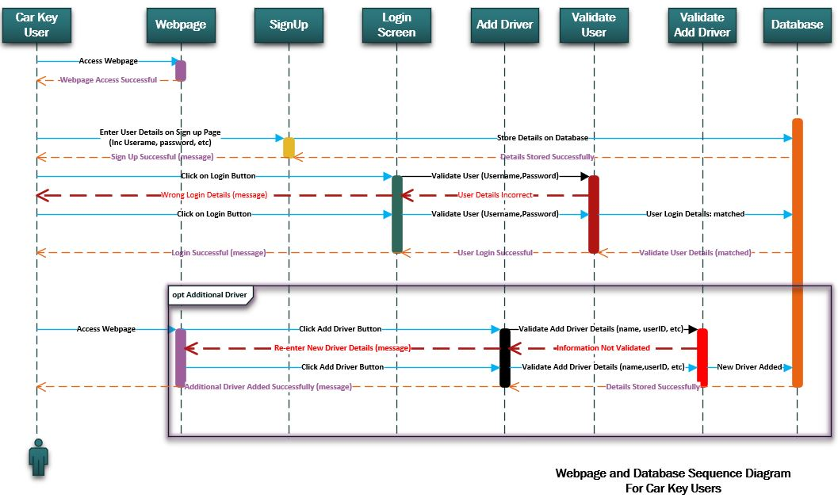

[Fig 3.5] Sequence diagram showing user and website interaction.

This diagram along with behaviour and structure diagrams fall under the UML (Unified Modeling language) banner that helps in the creation and notation of these type of diagrams. Software developers and other professionals use sequence diagrams to help understand requirements that a new system demands or to verify an existing process is functioning appropriately [94].

Appendix E – GDPR (General Data Protection Regulation)
Data protection regulations can vary from country to country, with each having their own set of laws and punishment guidelines. Currently the UK are a part of the General Data Protection established by the European Union and boasts to be the toughest privacy and security law in the world. Although the GDPR was passed by the EU ,the reach of the GDPR can impose any organisation around the world, as long as the data that is targeted is related to people of the EU [95].
The documentation that clarifies the requirements for organisations, relating to security and privacy information is bound in hundreds of pages. To summarise, there are seven fundamental values which have been highlighted in article 5 of the legislation, instructing how privacy data should be handled:
- Data minimisation – Personal data should be adequate, relevant and limited to what is necessary in relation to the purposes for which they are processed.
- Integrity and confidentiality (security) – Data is processed in a manner that ensures appropriate security of the personal data. Safety measures include protection against accidental loss, destruction or damage and unauthorised processing.
- Lawfulness, Fairness and transparency – Processed lawfully, fairly and in a transparent manner in relation to individuals.
- Purpose limitation – Data is collected for specified and legitimate reasons and not further processed in a manner that is incompatible with those purposes.
- Accuracy – Information should be kept up to data and accurate. All inaccurate data should be erased or rectified without delay.
- Accountability – The controller shall be responsible for and compliant with the data collected.
- Storage limitation – Data is kept for as long as is necessary and only for the purpose it was processed. [96]

Appendix F – Flowchart Operation (Key Interface)
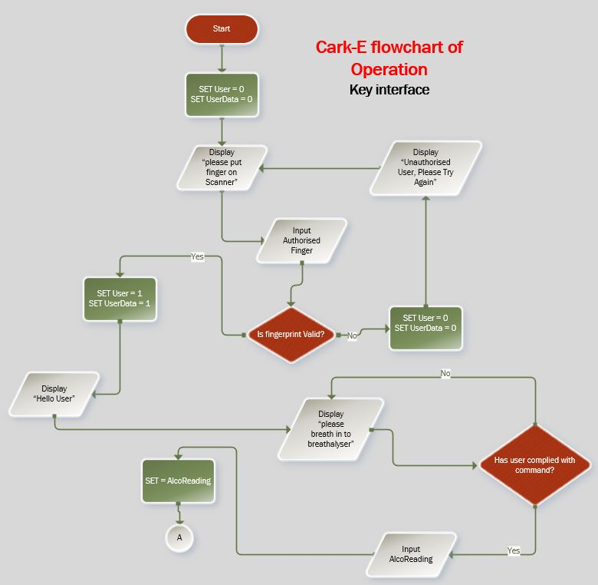

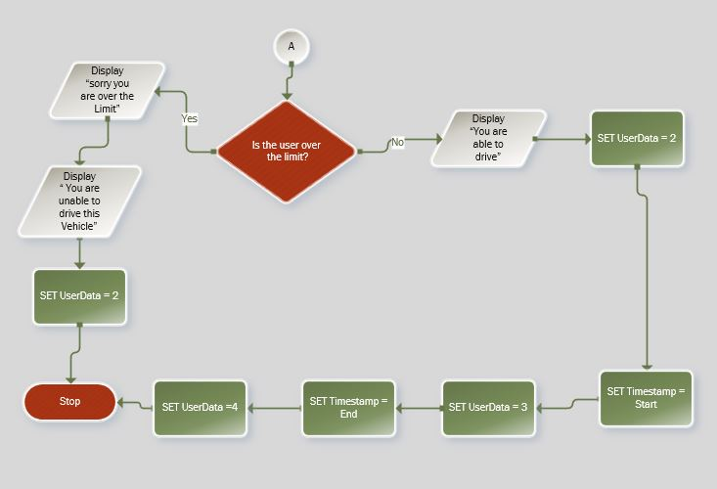

When planning the functionality of the key, and what information would be displayed for the user, a flowchart of operation was created. This identifies the process that occurs when a user places a finger on to the reader and the sequence of events that subsequently take place. The messages that display on the LCD screen may differ slightly from the example, but overall the operation plan was accurate.

Appendix G – Questionnaire Results
During the course of designing and planning the necessary features of the car key, it was appropriate to gauge the public viewpoint. This was achieved by allowing access to a questionnaire available on popular social media site. The following results were acquired from the survey and have been scrutinized in the methodology section of this report.
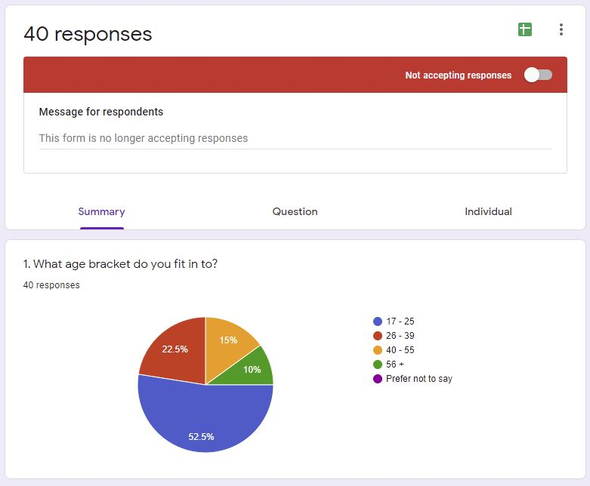
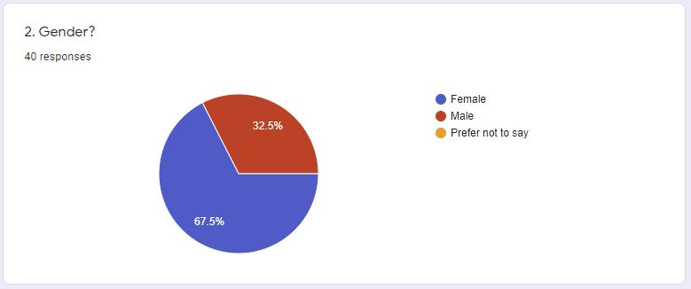

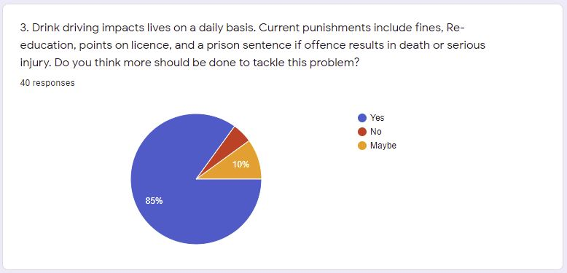
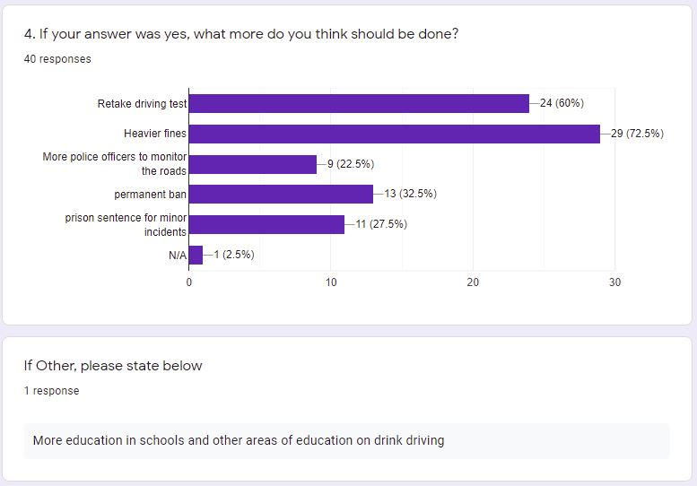
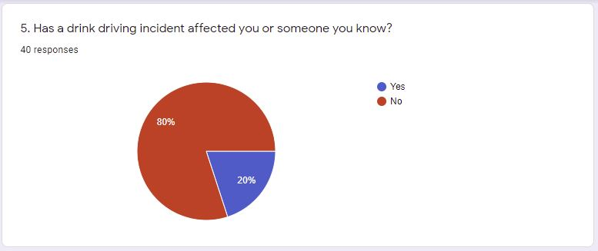
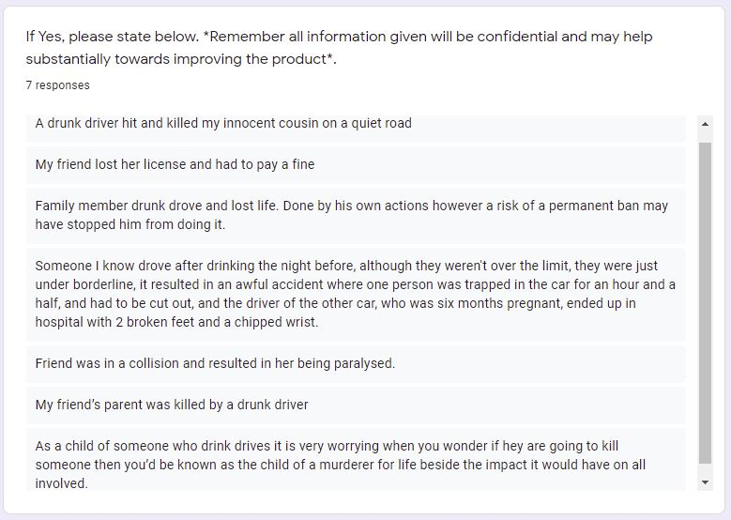
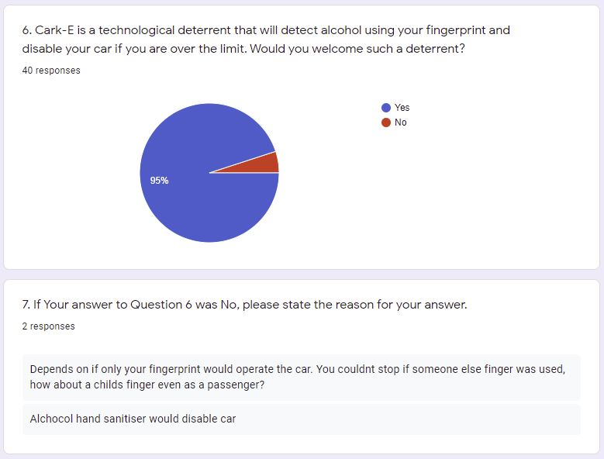
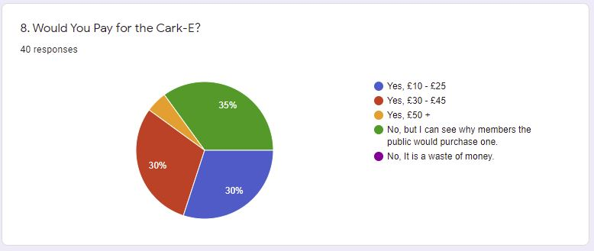
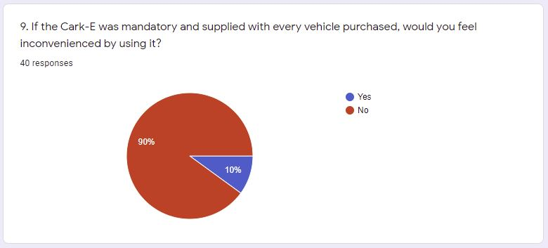
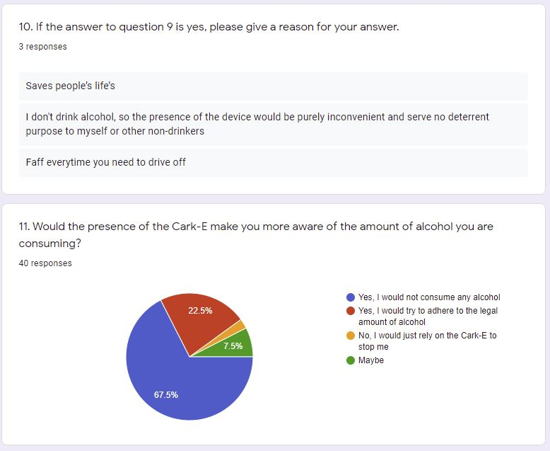
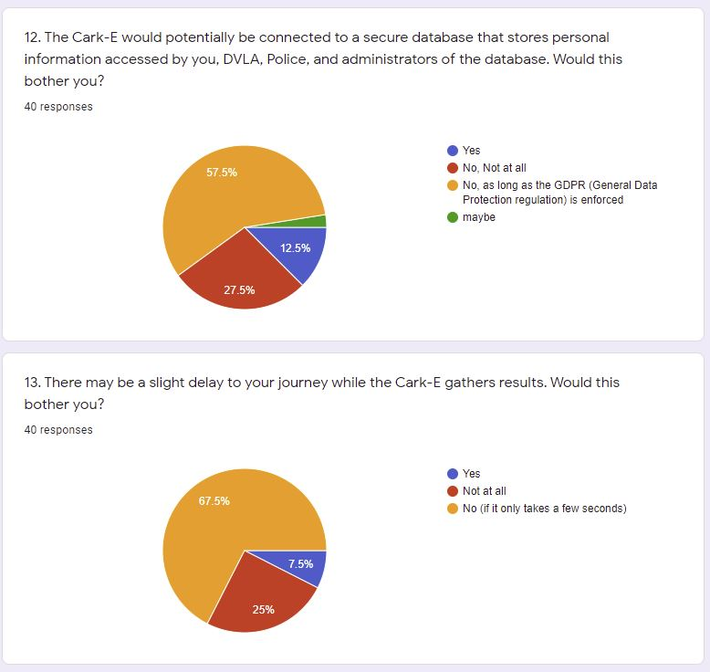
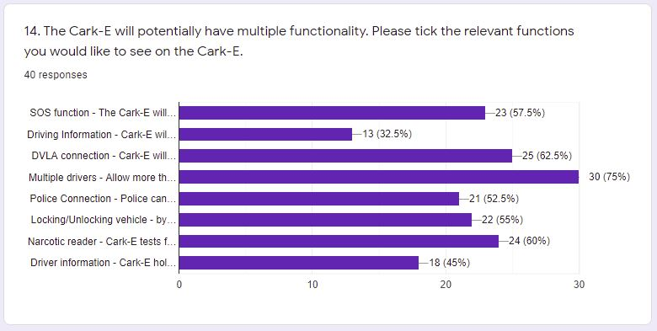
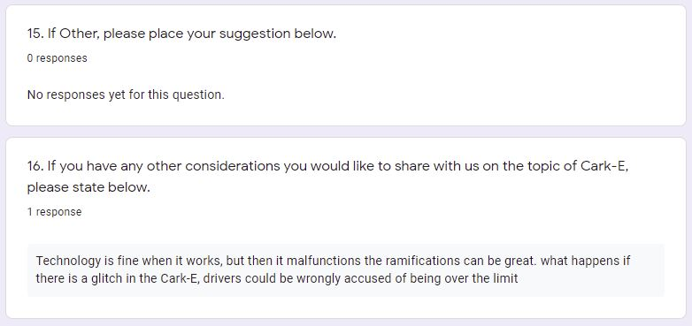

Appendix H – Pilot Survey
To gauge public opinion on the Cark-E, a questionnaire was created to allow access to the questions via social media. Before submitting the survey, it was essential that the validity of the questions be vetted by a credible source. The draft version of the survey was sent for appraisal and the following correspondence was received, stating justified alternations that would deliver a competent questionnaire to the public.

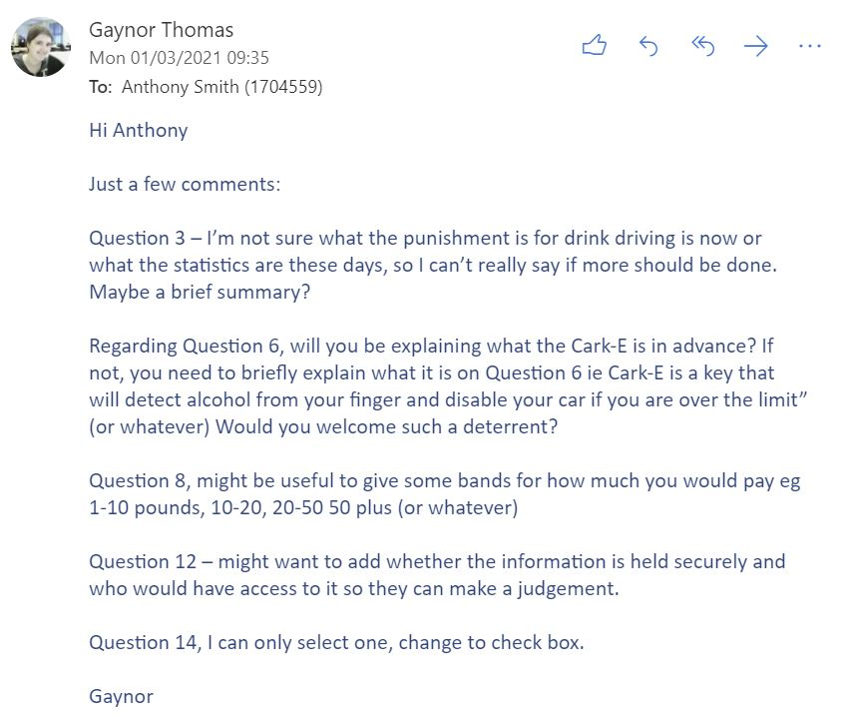
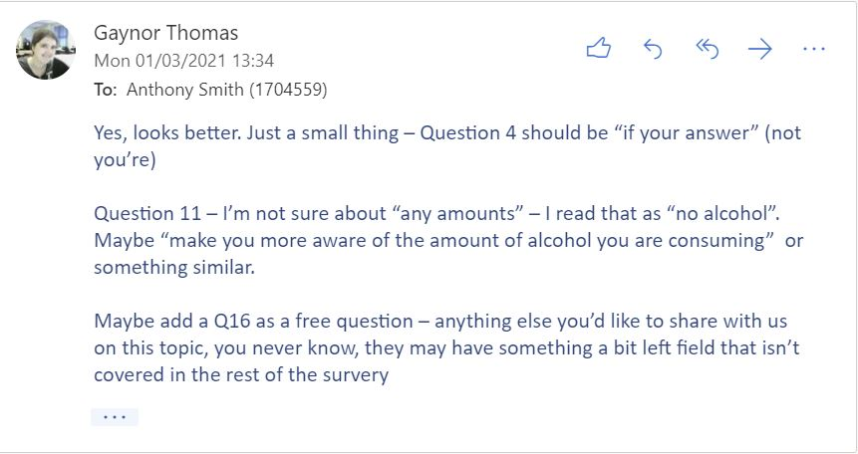

Appendix I – Website screenshot examples
The following screenshots are taken from the completed website, and show different sections that can be accessed by the user.

(1) Main screen on access to website.

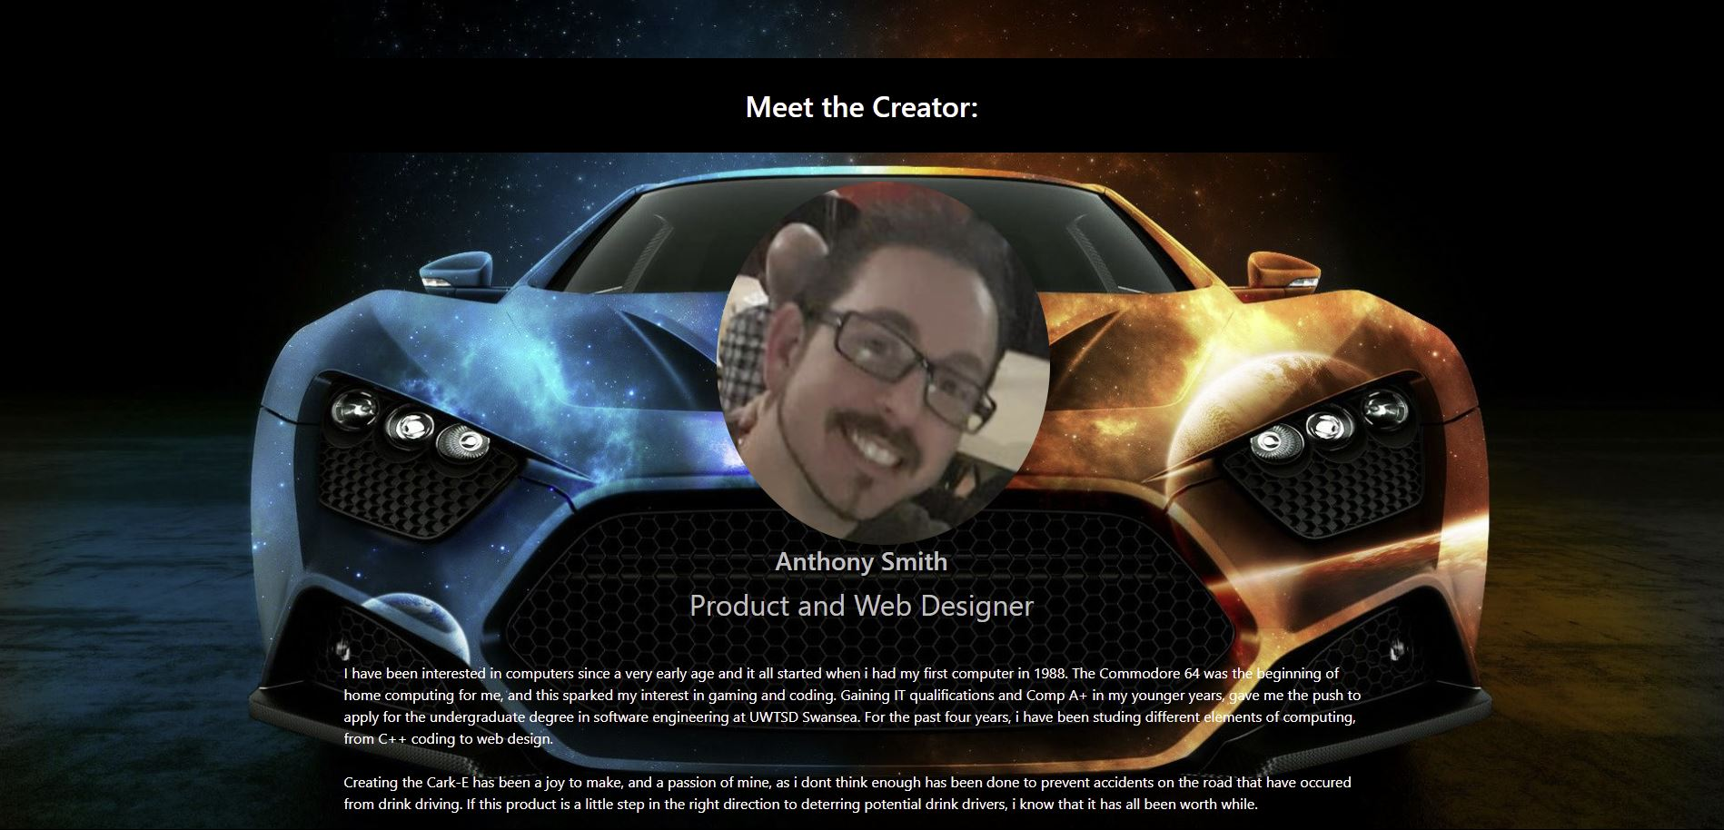

(2) By using the navbar to navigate around the website, selected portions can be visited by the user. The above screenshot is the ‘About’ link.

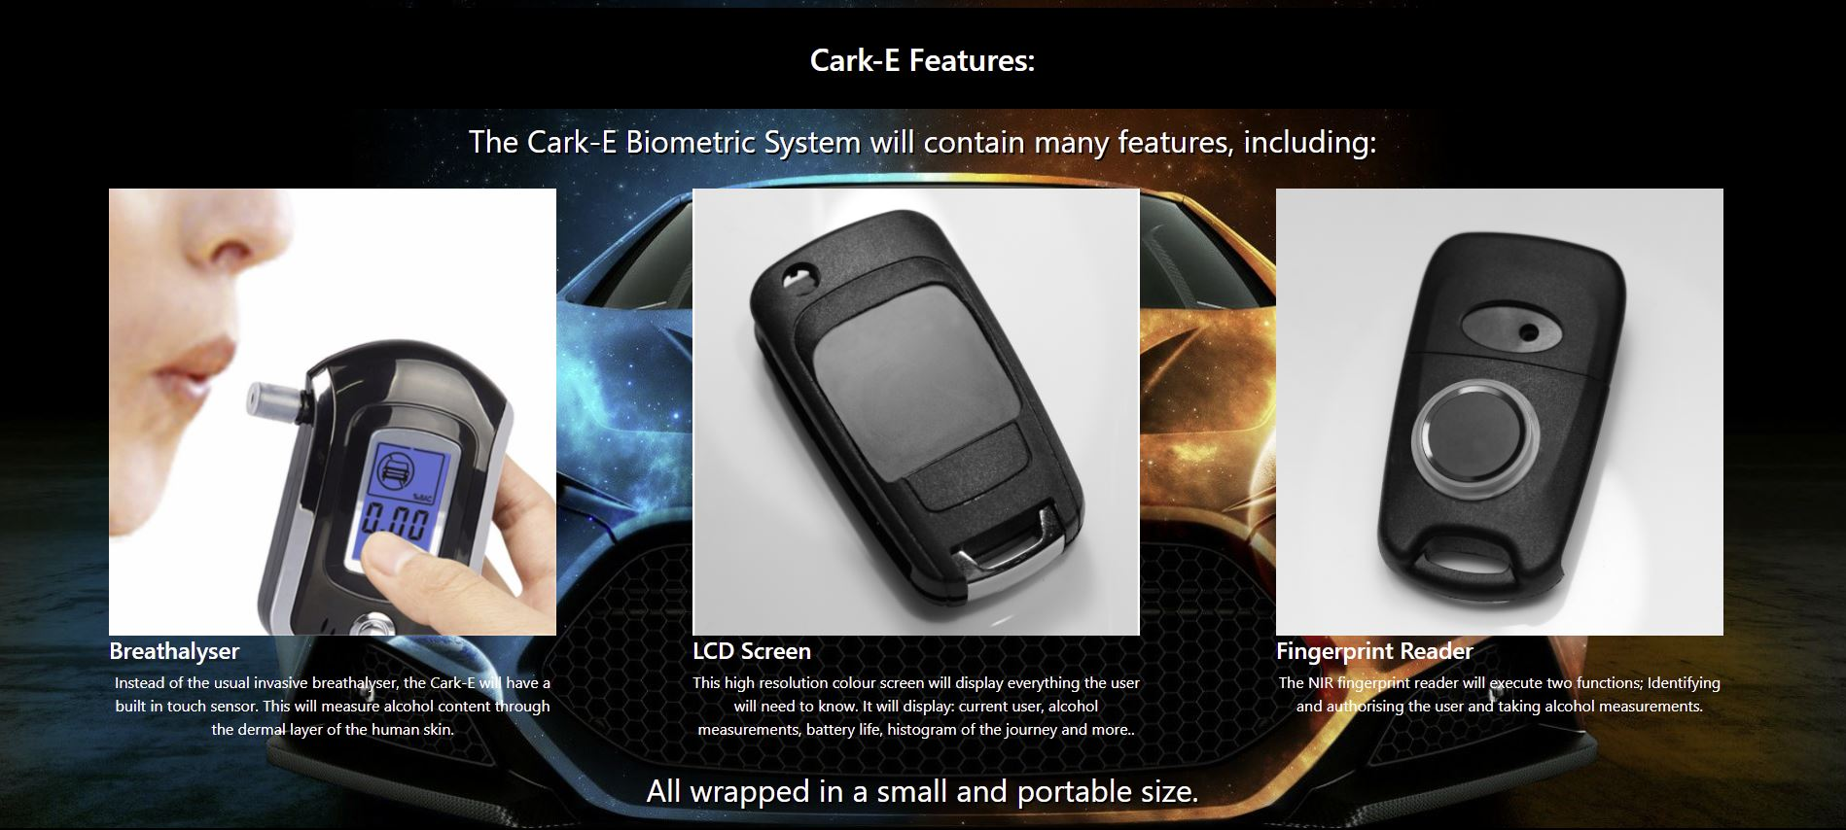

(3) The Features link explains what the main features of the product are. Using images to represent the functionality of the key, gives the user more idea of what to expect [97].
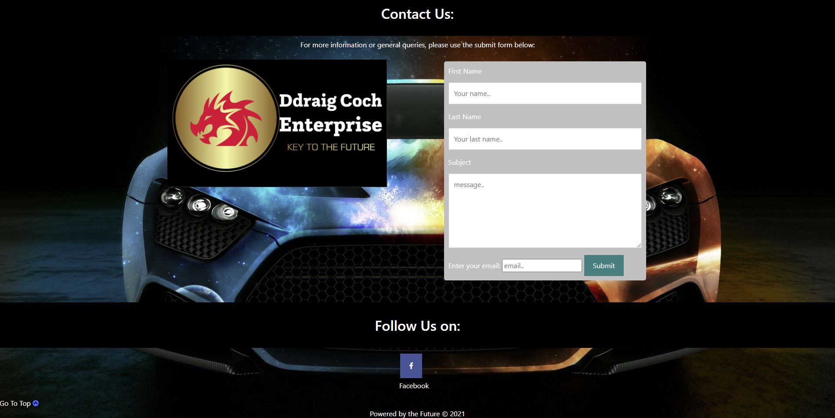

(4) The contact link allows any customer to contact the creators of the key with queries or if they are having difficulties using the product.

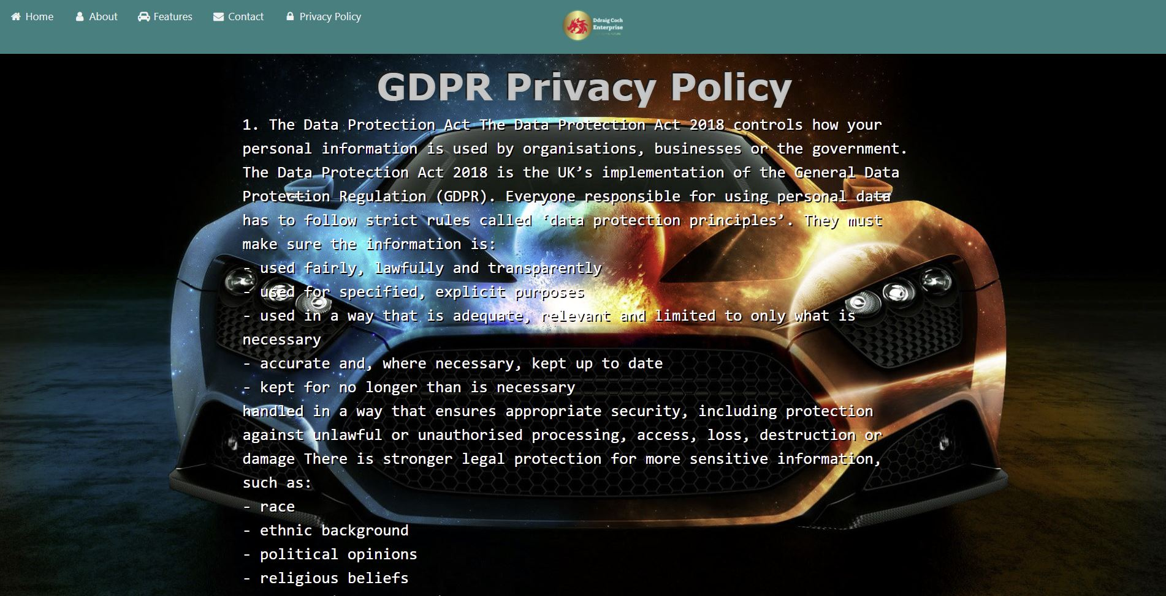

(5) The GDPR page allows the user access to the regulations that concern data protection. The GDPR used was created by the European union and covers any European around the world.
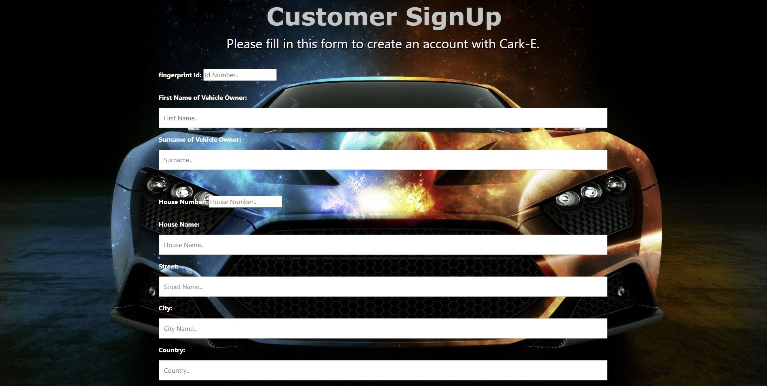

(6) Once a customer is in possession of the Cark-E, they would need to sign up and create a new account. The customer sign up form is used to connect to the Cark-E database and logs new user details such as name, address and driving licence.

