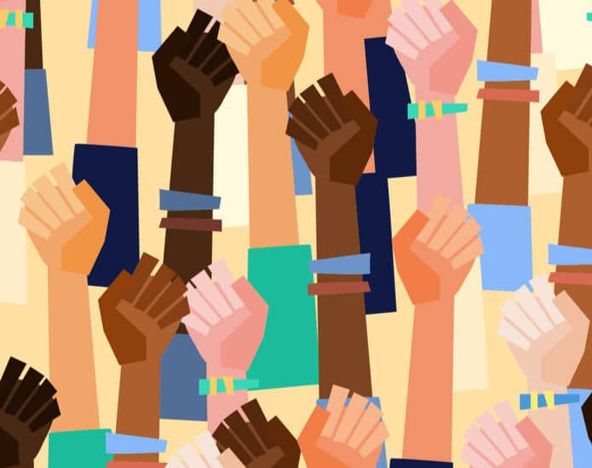
Introduction
Within this pamphlet you will find:
- What is equality?
- What is social justice and inclusion?
- Personal experience with social exclusion?
- Theories on social inclusion
- Social exclusion within education?
- Different groups and how they may become excluded
- What can you do if you become socially excluded or discriminated against?
With our world changing every day, we need to adapt and incorporate new ways of dealing with social inclusion and allow everyone to be included within society. Social exclusion can stem from generations of beliefs passed down from grandparents to parents to child etc.
The term we know as now ‘Social exclusion’ was first introduced by the UK conservative government in 1980. This term was adopted to signify that income poverty was becoming a forever growing issue. In 2021 income poverty is still a growing issue. (Mathieson et al., 2008)
Social exclusion does not only refer to poverty it refers to people’s different lifestyles. Disability, sexual orientation, beliefs, religion, and background all falls under social exclusion. People who discriminate towards people dependent on those factors are working towards social exclusion due to their narrow mindedness. We should be working towards allowing everyone to feel included in society.
In 2008 I noticed a lot more polish people were beginning to live in my hometown. All over the town I would hear people say, “Polish are taking our jobs.” Or “Polish are taking over the town.” As a child of 11 years old I saw this as a negative to society. As I was seeing others be negative towards these people, I began to get worried and concerned as I felt I would have to move home. This is not a good way to deal with social exclusion as we all deserve our place on this planet.

Personal experiences with social exclusion
Whilst I had made friends in Primary school, once we got to secondary school, we all managed to disband from each other a little due to us all being in different banded classes.
During this time in school, I made several new friends who did not stay as friends, at the beginning I was bullied within my class due to me not liking the same things as everyone else such as football and rugby. I preferred video games and Star Wars. When participating in PE the teachers just expected me to know the rules of both rugby and football. I felt like I was an outcast with people within my class, but I had never changed my likes or dislikes to be liked in school.
I also saw a young boy who was disabled and in my class, he had been picked on because he was different to all the other children in the class, the teachers would stand their ground and snub out any bullying towards this young boy, during the time of bullying I didn’t join in like most of the other children did as I knew how it felt to be and outsider within this social group.

Social
Inclusion
And
Equality
By
Kori Jones

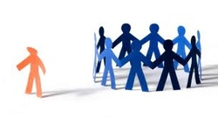

What is Equality?
The Oxford dictionary, defines equality as “the fact of being equal in rights, status, advantages, etc.” (www.oxfordlearnersdictionaries.com, n.d.)
Non equality comes from certain people not liking difference within other people this could be their religion, skin colour, country of origin and beliefs.
In 2010 an act was introduced call the equality act 2010. Before this act there were other previous acts which tried to deal with differences within others and these were Sex discrimination act 1975, Race relations 1976 and Disability discrimination act 1995. (Government Equalities Office and Equality and Human Rights Commission, 2013)
Within the World, discrimination towards others still exist even with laws in place. In recent news, a police officer in America has been tried for killing an African American man unlawfully.
In 2020 the events took place which saw the police officer kill a gentleman named George Floyd. The police officer (Derek Chauvin) kneeled on George Floyds neck, which lead to his death shortly after. (BBC News, 2020)
This act of cruelty affected everyone around the world, this caused the Black Lives Matter protests in London in 2020. (Adams, 2020)
Some people who are disabled can also be discriminated against which isn’t working toward them being equal to everyone else. With the Equality act 2010 in place, it allows everyone an equal chance to work within their wanted job, this stops companies from not giving you a job because you may be disabled or different to other candidates. (SNAP Cymru, n.d.)

Theories on social inclusion
I have done research on social inclusion and have found some theorists that have conducted research on social inclusion:
Dan Allman conducted research on social inclusion from a scientology standpoint. Dan Allman dives into many different theories from other theorists such as Pocock, Sibley, and Eisenberger and Lieberman. (Allman, 2013)
David Pocock believed that Social inclusion has a hierarchy. Pocock states many different other reasons for a hierarchy system such as economy, positions, and rituals of the higher class within the hierarchy. (Pocock, 1957)
Another theorist is David Sibley. Sibley believed that due to geographical places within the world people have been excluded which has caused these excluded people to go and use up some space within the world to create a new society. (Sibley, 1995)
Eisenberger and Lieberman are another pair of theorists who delved into the effects that social exclusion has on our emotions. These two theorists look into how humans make connections with other humans which works towards inclusion between people. (Eisenberger and Lieberman, 2004)
With each theorist delving into different ways that social inclusion can affect us as humans, all these different theories show us that all these points are the key to social inclusion and we should incorporate all of these theories to make a difference and allow everyone to be included in society, no matter on their background.

What is social inclusion?
Social inclusion is adapting society so everyone can make a difference. (The World Bank, 2018)
While social inclusion has a stable meaning, the word Social exclusion has not, all definitions of social exclusion have one thing in common, no participation in society is at the fore front of each definition, when referred to by scholars and government bodies. (United Nations, n.d.)
Social inclusion allows everyone no matter what their background is, to help society evolve to be more welcoming and diverse across all countries.
With society becoming more and more diverse regarding people’s sexual orientation and what gender you consider yourself as, society needs to adapt to these changes.
What is social justice?
Social justice is fairness within society. Racial inequality is one of the most common social justice problems within the world. (Soken-Huberty, 2020)
Within the world another source of inequality is gender inequality. This refers to the way women and men are not treated equally. (Soken-Huberty, 2020)
Within the UK the Asda supermarket came under fire in 2019 due to having a pay gap between men and women. Women would earn 94p for every £1 men earn. The staff took this to the courts and won the case. (gender-pay-gap.service.gov.uk, n.d.)
Within the year of 2021 inequality is still an issue in day-to-day life, whether it be racial or gender related etc.

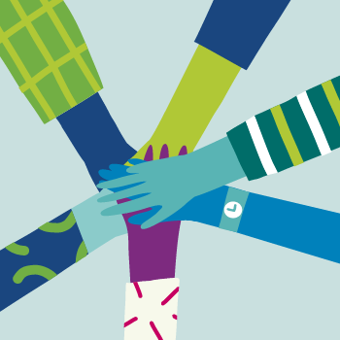

Racial discrimination and how people get excluded.
Racial discrimination is when people discriminate others dependent on their skin colour. Racial discrimination goes back thousands of years even before the slave trade. The slave trade did not help the racial discrimination. (The Red Card, n.d.)
It was normal for white people not to like others with different colour skin in the early 1900’s, this type of discrimination would have been passed down to their children and their grandchildren as this was seen as normal for the time.
This type of discrimination can cause exclusion, as there are still racist people in the world who do not like people with different colour skin as previously said it would have been passed along generations or learned from peers.
LGBTQ+ and how they get excluded.
Within recent years LGBTQ+ groups have begun to form all around the world in recent years as being a different sexuality other than straight has become more accepted. While in the 1950’s being gay/ lesbian was seen as a negative and people were against it.
Every year in June, in nearly every town they celebrate Pride. This celebration is to share love and friendship to everyone no matter what their sexuality is. (Pride month: What is it and why do people celebrate it? - CBBC Newsround, 2020)
Individuals within the LGBTQ+ community can be excluded in schools due to being different or family’s views on these individual. Children find it harder to come out as they may feel they may be bullied and not have friends after coming out in school. (Lyness, 2015)

Different groups and how they may become excluded.
There are many different diverse groups within this world. We have the LGBTQ+ group, gypsy/traveller group, People who have different colour skin, People who come from a different country and gender groups.
In this section I am going to be stating how these different groups get excluded from other groups within education and outside of the education system.
Gypsy travellers and how they get excluded.
Gypsy travellers are individuals who come from a traveller background or who travel to different towns/cities or countries. (Shelter Scotland, n.d.)
As these Gypsy’s have a different lifestyle in the sense they may live in a caravan, on a traveller site or travel with their families who provide fairs to areas within the UK. (Shelter Scotland, n.d.)
Within my experience with Gypsy’s in school I would fear them as they all stuck together and they had a reputation for fighting, the individuals with a gypsy background stuck together and created their own group. This is not all true for gypsies as some may just want to have a normal life and go to school. (The Independent, 2013)
Outside of education some people would associate gypsies as thieves or people who would collect scrap metal. Just like people within society we have thieves and people who will sell scrap metal for money, Gypsies also have these types of people but not everyone within the gypsy community are thieves, some just want to live life the best they can.

Social exclusion within education
Education can be one of the key features into social exclusion, due to the many different exams and banding systems. (Sparkes, 1999)
Within my time in secondary school, I remember not being happy as I was in a separate band to my other friends which worked towards my social exclusion. This would be because other people in different bands would not want to mix unless they have history with you.
Within an article written by Jo Sparkes she displays a table which shows how different grade that children have received has resulted in full time education, Government training, fulltime work, and exclusion. Within this tables it shows that children who received no grades were 38 and these children were out of fulltime work or unemployed, while children who received 5+ GCSE’s A-C there were a total of 3 who became excluded from work or unemployed. This shows us that no matter how well we do in school, this can result in exclusion from society. (Sparkes, 1999)
While we talk about banding systems and grading, these aren’t the only ways of exclusion within education, your sexual orientation ties in with this. Dependent on your preference some people may refrain from being friends from others as they may believe they may try to change their sexual preference. This will cause social exclusion, but during in recent years people of different sexual orientation have banded together and created a group called the LGBTQ+ which isn’t just for Gays, it’s for all walks of life. (Takacs, 2006)

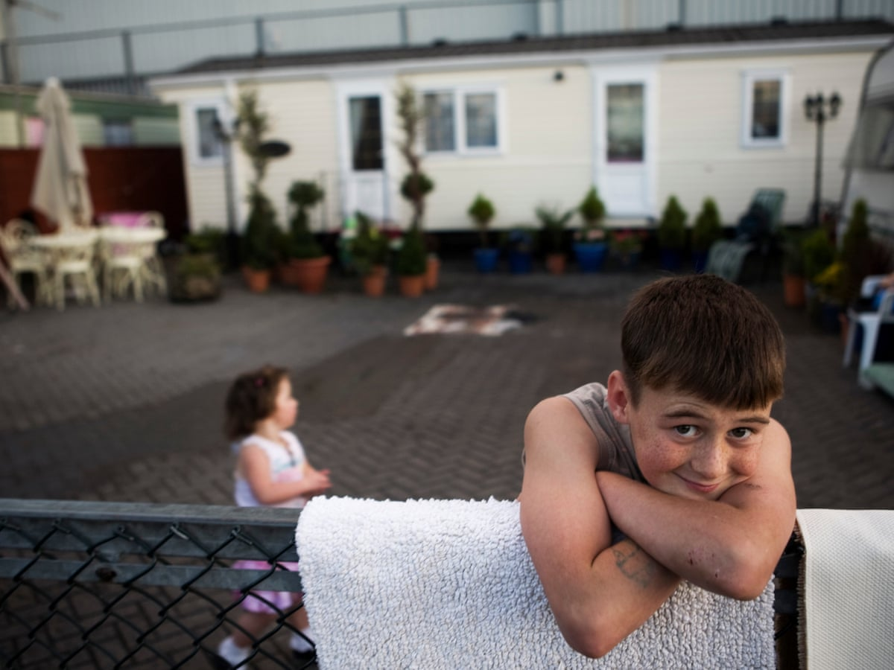

Gender groups in the 21st century and how they can be excluded.
Within the 21st century we are still fighting for equality between men and women. As previously stated regarding Asda. In some places of work there is still a pay gap. We are also still dealing with some people not respecting other genders as equal. History has shown that men become friends with men, and women become friends with women. (United Nations, 2015)
Recently I have found this is not the case as I have a mixed friend group which is mixed between male and females. This is gender equal group. There are some people in this world that do not agree with both male and females being friends or even be equal as they have been raised that one gender is more superior than the other.
Conclusion
To conclude I would like to make this world a better place one handshake/hug at a time. Everyone deserves to be spoken/treated in the right way. As a society we should move away from the negative names and we should turn more to the positive names such as friend or pal. As a white British male writing this I would be happy to learn a lot from people with other background of origin such as Asians, Europeans etc.
We should be happy to have these individuals within our country as this allows us to try their different collection of foods, drinks and lifestyle. I recently watched a video which showed me how people from Asia live, this video showed me that they save space within their home. This is a lifestyle I will be incorporating when I become a homeowner.
So next time you see a person crying, needing help or someone mentions a derogatory term towards an individual, do not be afraid to help them, or don’t be afraid to challenge the person who may be aiming the hate towards this individual. We all have a place on this earth, we are all human, this planet is our home and we can all make It a better place to live.
Recommendation
To move towards social inclusion, we should all think “Is this the way I would like to be treated?” By this one sentence it can help us think about if what we are talking or treating someone in the correct manner. Some shop owners chose to come here to pursue their dreams, lucky for them our country allowed their dream to happen. This world is a big place there is more than enough space for everyone.
What can you do if you become socially excluded or discriminated against?
If you feel excluded/ discriminated against in work, then there is something you can do about it.
You should begin by speaking to someone within the management team as they can assist you to deal with the situation. If you feel you haven’t been supported correctly then you can seek guidance from a union rep or if not, you can look into taking it further and make a claim to the courts of tribunal. (Government Digital Service, 2011)
Within education dealing with a situation such as exclusion and discrimination is different as some children may not feel they want to talk about how they’re feeling because they may be classed a ‘Snitch’, but if someone is excluded or discriminated against, you should always report it. If you feel you have been excluded within your friend group or discriminated against because of a change, you can speak to your teacher/lecturer who will assist you in what you should do next or help you in your case. If this does not help, then you can seek legal advice with citizens advice as discrimination is against the law and has an act called the Equality Act 2010. (www.citizensadvice.org.uk, n.d.)
We live in a time where the world is always changing. This is the time to make a difference. Do not just make a difference for you, make a difference for your future grandchildren.

People’s Country of origin and how they can be excluded.
People from different country of origin tend to receive a lot of discrimination which will also tie into them becoming excluded from society. This is because some people do not like change.
We can learn a lot from another person’s home country from the food, culture and family/country history. Without having a mixed society, us as baritones would probably just eat fish and chips every day. With these different cultures in our country, we now have different foods such as Chinese, Indian, kebabs, pizza and pasta.
In previous years we have not been accepting of change, so we used to exclude them, and they would then form their own groups within society. This is a negative, due to not seeing everyone as a human and treating them correctly.

References
Adams, T. (2020). “Now is the time”: London’s Black Lives Matter rally looks like a turning point. The Observer. [online] 6 Jun. Available at: https://www.theguardian.com/us-news/2020/jun/06/now-is-the-time-londons-black-lives-matter-rally-looks-like-a-turning-point.
Allman, D. (2013). The Sociology of Social Inclusion. SAGE Open, 3(1), p.215824401247195.
How Age Shifts Our View of Equality. (2020). Available at: https://seic.com/knowledge-center/how-age-shifts-our-view-equality.
Perraudin, F. (2018). Gypsies and Travellers in UK face housing crisis, charities warn. Available at: https://www.theguardian.com/world/2018/jan/18/gypsies-travellers-uk-housing-crisis-charities-warn.
The Red Card. (n.d.). Racism: A Brief History | Show Racism The Red Card. [online] Available at: https://theredcard.ie/racism-a-brief-history/.
BBC News (2020). The last 30 minutes of George Floyd’s life. BBC News. [online] 30 May. Available at: https://www.bbc.co.uk/news/world-us-canada-52861726.
Eisenberger, N.I. and Lieberman, M.D. (2004). Why rejection hurts: a common neural alarm system for physical and social pain. Trends in Cognitive Sciences, 8(7), pp.294–300.
gender-pay-gap.service.gov.uk. (n.d.). ASDA STORES LIMITED gender pay gap data for 2019-20 reporting year - GOV.UK. [online] Available at: https://gender-pay-gap.service.gov.uk/Employer/AV59NcZc/2019 [Accessed 6 May 2021].
Government Digital Service (2011). Discrimination: your rights. [online] GOV.UK. Available at: https://www.gov.uk/discrimination-your-rights/what-you-can-do.
Government Equalities Office and Equality and Human Rights Commission (2013). Equality Act 2010: guidance. [online] GOV.UK. Available at: https://www.gov.uk/guidance/equality-act-2010-guidance.
Johri, S. (2020). Enough is enough: Take a stand for equality and inclusiveness. Available at: https://www.tricentis.com/blog/stand-for-racial-equality/.
Lyness, D. (2015). Coming Out (for Teens) - Nemours KidsHealth. [online] kidshealth.org. Available at: https://kidshealth.org/en/teens/coming-out.html.
Mathieson, J., Popay, J., Enoch, E., Escorel, S., Hernandez, M., Johnston, H. and Rispel, L. (2008). Social Exclusion Meaning, measurement and experience and links to health inequalities A review of literature WHO Social Exclusion Knowledge Network Background Paper 1. [online] . Available at: https://www.who.int/social_determinants/media/sekn_meaning_measurement_experience_2008.pdf.pdf.
Pocock, D.F. (1957). Inclusion and Exclusion: A Process in the Caste System of Gujerat. Southwestern Journal of Anthropology, 13(1), pp.19–31.
Pride month: What is it and why do people celebrate it? - CBBC Newsround. (2020). www.bbc.co.uk. [online] 1 Jun. Available at: https://www.bbc.co.uk/newsround/52872693.
Shelter Scotland. (n.d.). About Gypsies/Travellers. [online] Available at: https://scotland.shelter.org.uk/housing_advice/finding_a_place_to_live/gypsiestravellers/about_gypsiestravellers [Accessed 11 May 2021].
Sibley, D. (1995). Geographies of Exclusion: Society and Difference in the West. [online] PhilPapers. Burns & Oates. Available at: https://philpapers.org/rec/SIBGOE [Accessed 21 Apr. 2020].
SNAP Cymru. (n.d.). Discrimination and Equalities Advice. [online] Available at: https://www.snapcymru.org/help-for-families/discrimination-and-equalities-advice/ [Accessed 9 May 2021].
Social exclusion. (n.d.).
Soken-Huberty, E. (2020). What Does Social Justice Mean? [online] Human Rights Careers. Available at: https://www.humanrightscareers.com/issues/what-does-social-justice-mean/.
Sparkes, J. (1999). Schools, Education and Social Exclusion. [online] Available at: https://eprints.lse.ac.uk/6482/1/Schools,_Education_and_Social_Exclusion.pdf.
Takacs, J. (2006). Social exclusion of young lesbian, gay, bisexual and transgender (LGBT) people in Europe. [online] . Available at: https://www.ilga-europe.org/sites/default/files/Attachments/social_exclusion_of_young_lesbian_gay_bisexual_and_transgender_people_lgbt_in_europe_april_2006.pdf.
The Independent. (2013). 5 Big Fat Myths about Gypsies, Travellers and Roma. [online] Available at: https://www.independent.co.uk/voices/comment/5-big-fat-myths-about-gypsies-travellers-and-roma-8609751.html.
The World Bank (2018). Social Inclusion. [online] World Bank. Available at: https://www.worldbank.org/en/topic/social-inclusion.
United Nations (n.d.). Identifying social inclusion and exclusion A. The concept of social inclusion. [online] . Available at: https://www.un.org/esa/socdev/rwss/2016/chapter1.pdf.
United Nations (2015). United Nations: Gender equality and women’s empowerment. [online] United Nations Sustainable Development. Available at: https://www.un.org/sustainabledevelopment/gender-equality/.
www.citizensadvice.org.uk. (n.d.). Taking action about discrimination in education. [online] Available at: https://www.citizensadvice.org.uk/family/education/discrimination-in-education/taking-action-about-discrimination-in-education/.
www.oxfordlearnersdictionaries.com. (n.d.). equality noun - Definition, pictures, pronunciation and usage notes | Oxford Advanced Learner’s Dictionary at OxfordLearnersDictionaries.com. [online] Available at: https://www.oxfordlearnersdictionaries.com/definition/english/equality?q=equality.
‌

