
EVALUATION OF BLENDED LEARNING AND CLASSROOM LEARNING ON STUDENT ATTAINMENT (REPORT), TASK 1.
ACADEMIC AND EMPLOYABILITY SKILLS

UNIVERSITY OF WALES TRINITY ST DAVID

STUDENT NAME: MAGDALENA SIEMIATKOWSKA
STUDENT ID: 2110059
EMAIL: 2110059@student.uwtsd.ac.uk
LECTURER: GIRIDHAR KATTI
MODULE: BMSW4001
December 6, 2021

Table of Contents

Introduction 2
Pros and cons of blended learning in the University Education Sector 4
Pros and cons of traditional classroom learning in the HE sector 7
Evaluation of both forms of teaching in the past & present-evidence and examples 8
Recommendations 11
Conclusions 12
References 13

Introduction

Learning in various ways today is most often used to define a learning environment that incorporates both online (or another distant learning) and in-person (student–teacher) interactions. It is thus possible for an online student to access a large portion of the course content and interact with their mentor constantly. However, they will also have the opportunities to join at least one face-to-face lecture or tutorial, or maybe even a long weekend or residential course, where the tutor and students can meet at exactly the same place and time (Press, 2021).
Blended learning has both advantages and disadvantages, and this research aims to highlight both. It will also talk through the reasons for the significant transformation in Higher Education and its issues. This study will explore the assets and liabilities of understanding the pros and cons of the adjustments and adaptation.
Secondly, it will consider how the increased use of blended learning is now the norm in school after the COVID-19 pandemic has driven novel teaching methods.
This report will explore the positives and negatives of hybrid learning in University Sector,alo compare it to traditional classroom instruction. It examines the evaluation of both previous and contemporary forms with facts and examples. It will discuss the obstacles adult learners face when balancing employment and personal obligations, especially those returning to university after a long absence. Finally, a recommendation is constructed based on a comprehensive investigation.
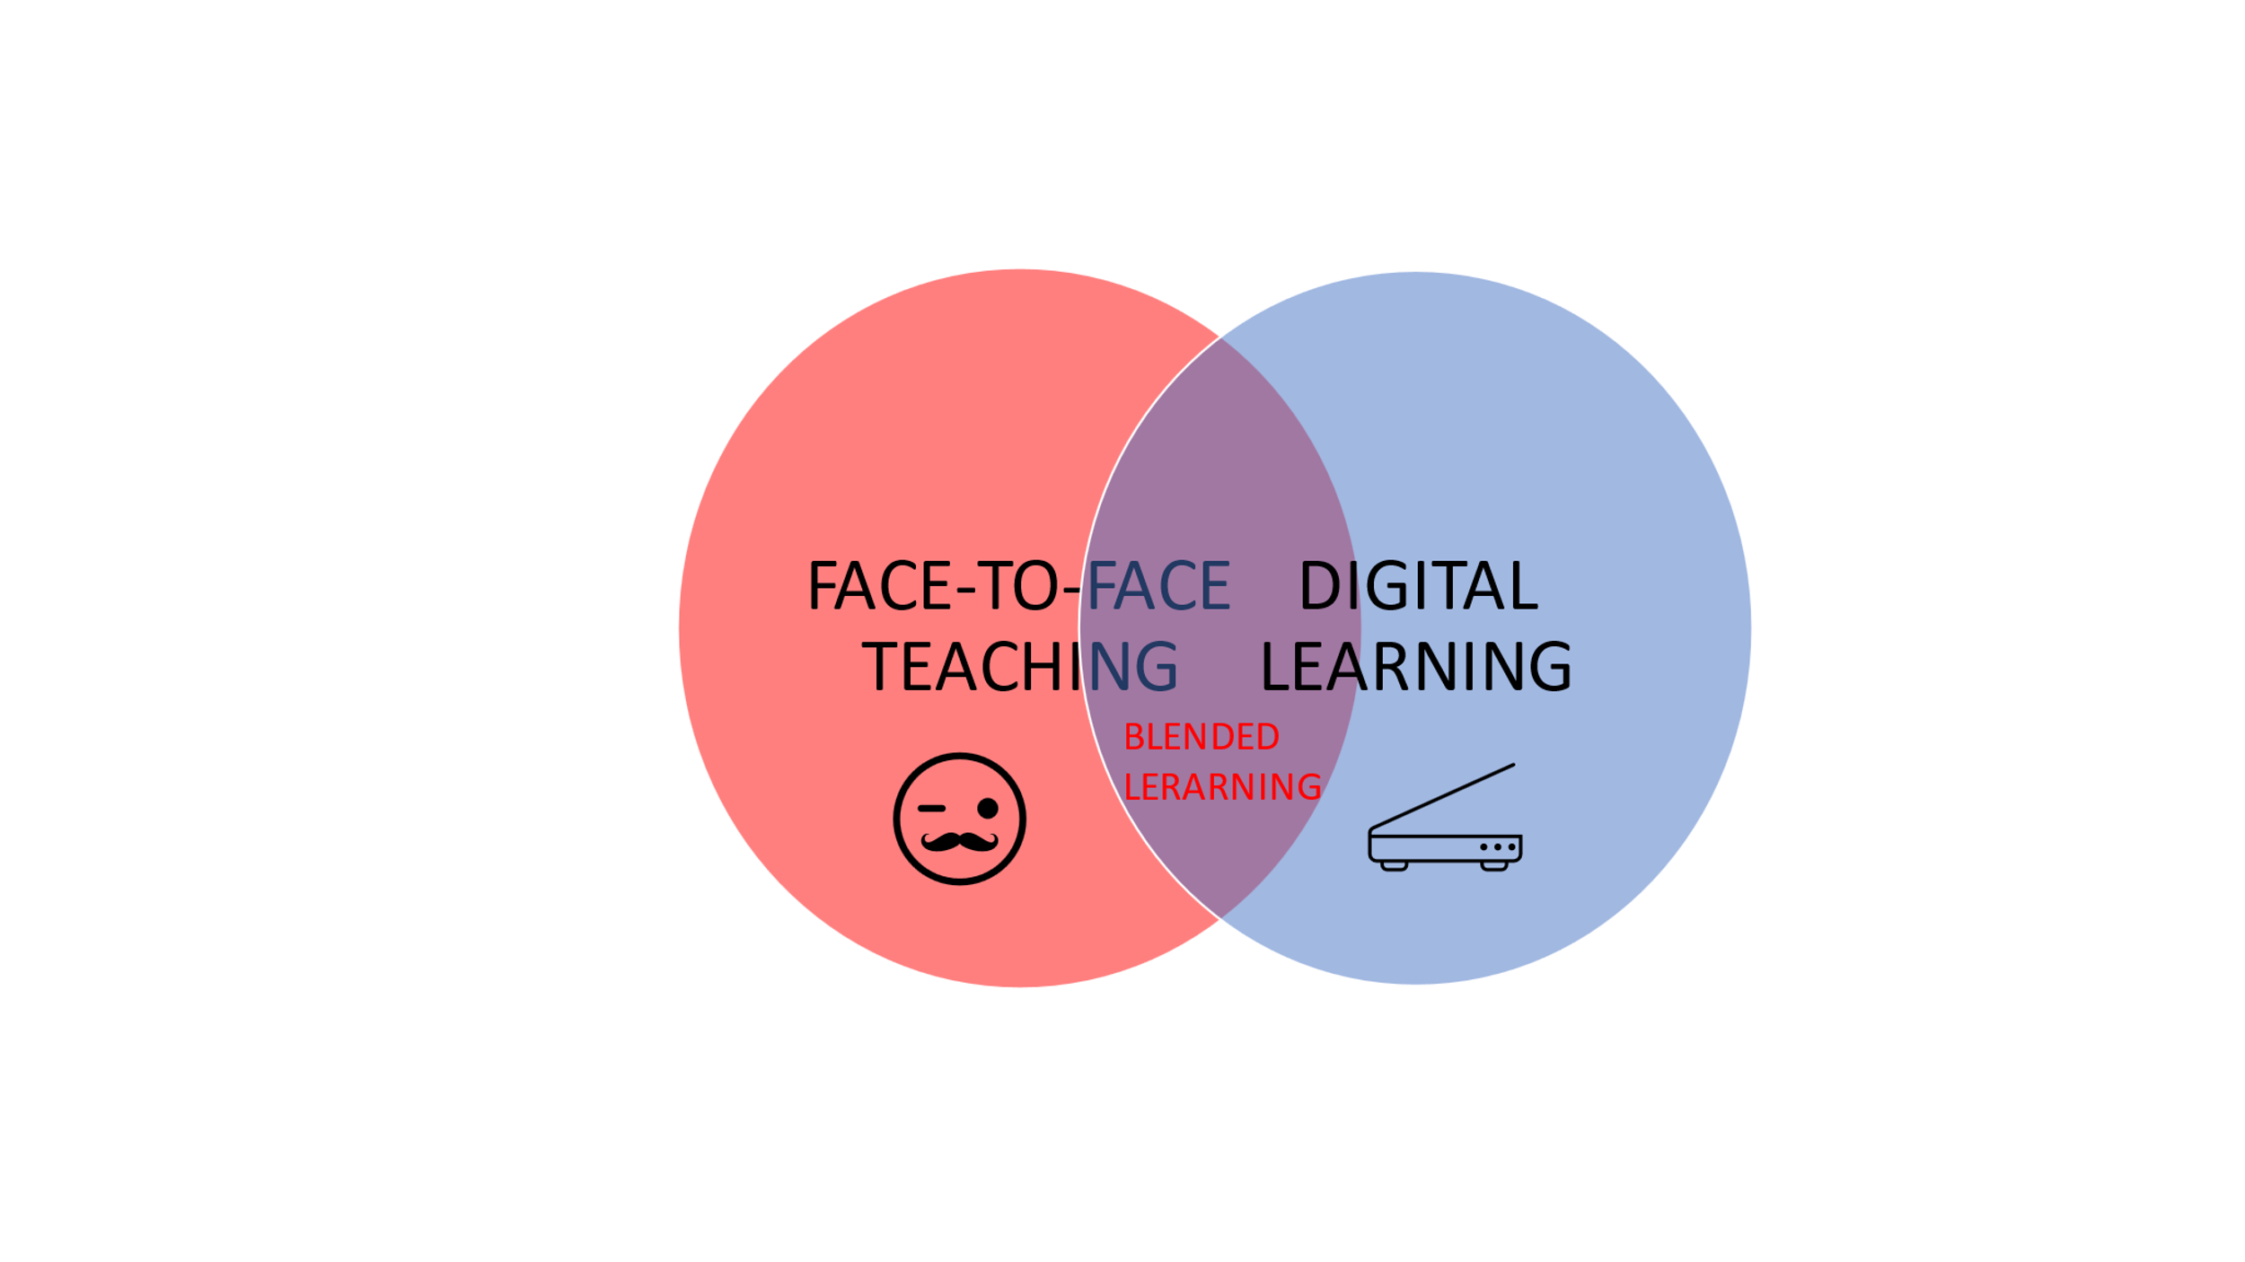Source: Author
Source: Author
BLENDED LEARNING

Source: Author

Pros and cons of blended learning in the University Education Sector

Mixed tuition settings allow teachers to create individualised education for each university student. Rich learning content encourages participation. This strategy allows students to express themselves while exploring themes (Hunt, 2016).
CONTENT
Source: Author

Although implementing combined learning has its problems, Garrison's study shows that science supports the notion of mixing in-person teaching with internet-based in order to increase academic achievement. In addition, it may assist students develop their own learning style and work in groups (Garrison, 2004). Adaptive Internet technology and face-to-face contact have improved education and knowledge transfer (Bonk, 2004). However, Paechter and Maier teach that blended learning fosters collaboration and open dialogue (Paechter & Maier, 2010).
Conforming to Kasraie & Alahmed, combining internet education with classroom conversations helps students better understand the material. They are also learning psychological and behavioural abilities (Kasraie, 2014). Higher education is noted for its diversity, with students from many ethnicities, cultures, cognitive styles, and language abilities. Uniqueness is aided by the enormous array of technological tools (Okaz, 2015). Creating a class using learning technology can aid with material interpretation, coaching, and assessment (Carmen, 2002).
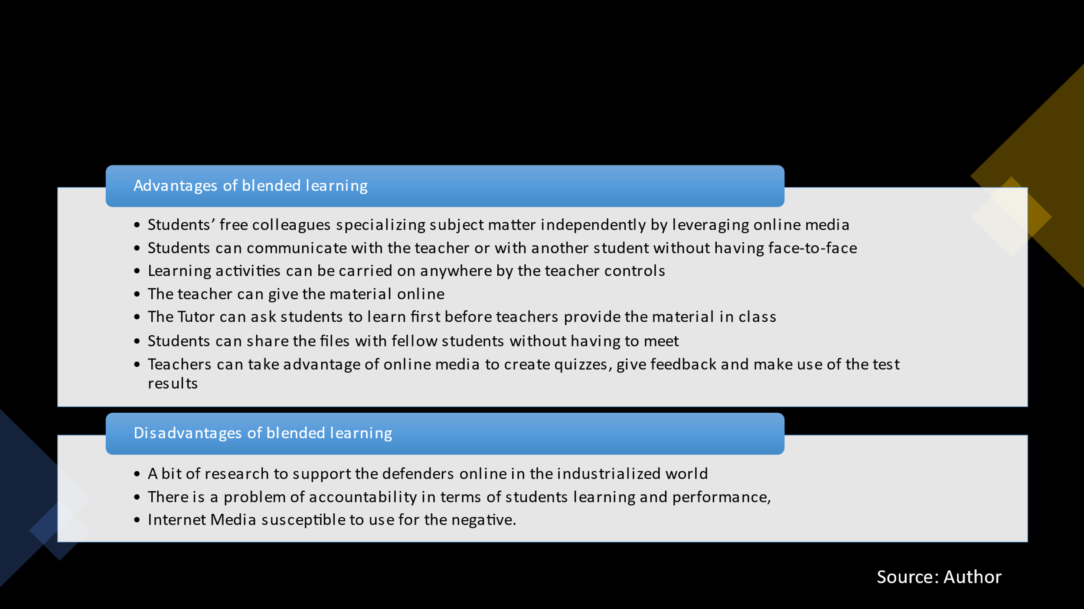

Carlton claims that blended classes are the best of both worlds. However, not everyone is suited to combining undergraduate studies. Unlike in-person programmes, blended classes provide more flexibility. A mix of online and in-person classes better suits individual learners' needs; listeners may benefit from reversing video lectures, while auditory students may benefit from viewing slides at their leisure. Those who benefit from face-to-face encounters can still communicate with lecturers and classmates. Taking a mixed programme might help students become more organised, but it can also cause issues for some.
Blended courses frequently require a computer that meets college standards and reliable broadband connectivity. For some students, taking a combined class may necessitate a new laptop or an upgrade. Depending on the curriculum, combination students may also need to buy the software (Carlton, 2021). A Hybrid degree allows people to learn subjects like experimentation, work-based learning, and clinical practice while still taking academic or hypothetical online courses. Blended programmes appeal to busy people who want to finish online while still connecting in person for supervision. They also help students build abilities that they may use in online classes. These adaptive classrooms provide learners with mobility and security (Randy D., 2007).
Online correspondence, lectures, and conferences are all possible. This allows all stakeholders to express their views and further debate the problem while saving money.
To get started, an individual will need a computer with internet access. This is a great benefit for most, but it may be a huge minus for those without access to technology (King, 2021). American experts claim that distance learning is as effective as conventional techniques. Online learners study most of the training materials on their own. This aids memory and comprehension. The opportunity to immediately apply what pupils learn at work also benefits in its retention. Adding cutting-edge technology to school also makes it more engaging and lively (Fox, 2020).
Sergiy Movchan reports that educators communicate using both physical and digital means. Emailing an instructor can be more efficient and effective than calling or writing.
Students in blended learning classes are not used to such challenges. The student is not responsible for travel or housing. They do not have to pay for a residence permit or international citizenship. Pupils must master all training topics. This demands drive, accountability, and awareness. Many cannot keep up with proper growth without discipline. Although not always possible, in-person or videotaped verification of a student's test or honours completion is now the most effective technique.
In blended classes, students rarely communicate with each other or teachers. Ineffective for improving relationships, self-esteem, or teamwork. Disciplines requiring many real-life circumstances are challenging to teach remotely.
Blended learning has several advantages, even if it is not yet comparable to traditional schooling. Among the most significant advantages of blended learning is the flexibility of learning. Students can study at their own pace and when convenient for them, allowing them to pursue other interests (Movchan, 2018).
Learners do not prefer blended learning for numerous reasons. Power outages top the list. Schools do not have emergency systems; thus, integrating gadgets and face-to-face instruction may not be practical. Another disadvantage is the slower reaction time in relation to in-person classroom engagement.Many people agree that they cannot interact with lecturers on a desktop. As part of their learning environment, they lose academic community (Vonderwell, 2003). As stated in Holley & Oliver, students in blended classes lack a sense of belonging and identity. Also, owing to different demographic backgrounds or deficiency of digital skills, many students may struggle to use online course materials (Holley & Oliver, 2010). Low self-directed thinking may also hamper mixed learning's effectiveness. Insufficient drive to study, fear of taking chances, or disrupting routine. In a traditional classroom, fostering social and cultural connections with peers is more suitable than a hybrid classroom. Diversity is vital in blended learning (Paechter & Maier, 2010).

Pros and cons of traditional classroom learning in the HE sector

Many students believe face-to-face interaction is vital to establishing a sense of belonging; individuals may agree that internet chat lowers their sense of community with their peers and teacher. Furthermore, online transactions require more experience than lectures, where the lecturer encourages participants (Grieve, 2013).
Blended teams outperform standard academic teams, although not much better, according to Daymond and Blau, as well as Yerby and Floyd (Daymont,2008 & Yerby, 2013), quoted in (Papadopoulou, 2010). Students focus better under time constraints. Throughout their adult lives, individuals will be required to execute duties in a specific time range. For example, assigning in-class assignments that must be finished quickly prepares students for the workplace. In a regular session, experts can promptly examine students' strengths and weaknesses. Traditional classrooms foster essential social skills development. Like most personal development, speaking in front of a large crowd requires pupils to connect with a viewer. Options abound in university: Seminars and college gatherings are enjoyed by students. Teaching approaches generate a better sense of community. Expenses for traditional teaching include travel to campus, housing, and classroom supplies. Active course-taking limits learners' ability to work on specific tasks, so they must organise all routine duties around student involvement. Traditional courses limit social interactions to small members. Their skillset is limited. In a traditional classroom context, pupils feel added pressure to speak, answer direct questions, or deduce a solution. On the other hand, blended learning helps pupils relax and communicate their analytical thinking (Dias & Diniz, 2014).
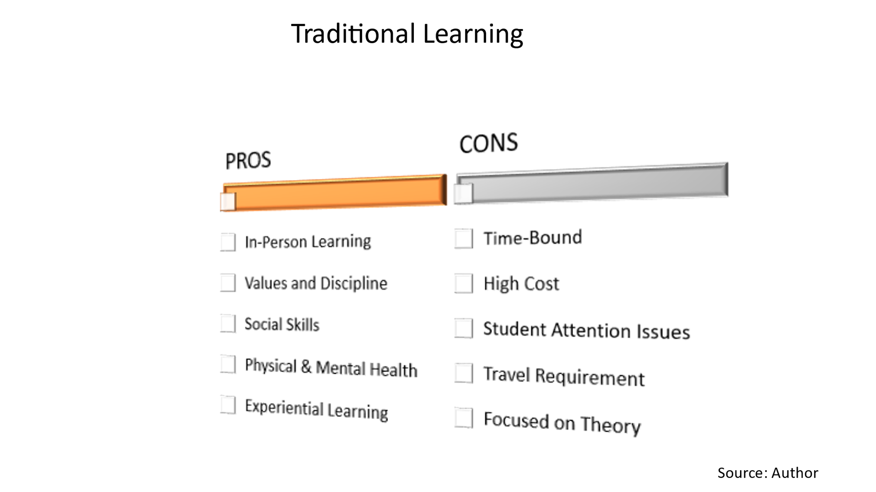

Evaluation of both forms of teaching in the past and present-evidence and examples

Blended learning in the past

These initiatives started about 2000. Cooney coined the phrase "blended learning." So he planned to blend study and fun in a preschool (Cooney, 2000). Voci and Young used online teaching in their professional progress teaching program to optimize all advantages (Voci, 2001). In line with Bonk, they investigated military training. The initial level used delayed web learning, then synchronised teaching in an interactive simulated chat environment, and finally oral learning (Bonk, 2002). Bayram Güzer and Hamit were the first to support web-based learning with traditional teaching without mentioning hybrid learning (Bayram Güzer, 2014).
For this reason, the period 2003-2006 is designated the Definition period. An essay by Russel T. Osguthorpe and Charles R. Graham from 2003 was highly cited. Their research shows that a mix of person-to-person and on stream is best because of students (Osguthorpe, 2003). One of the most often mentioned studies on blended learning is Garrison with Kanuka. Their research centured on how blended learning may be useful in higher education. They found that strategy, organisation, resourcing, timing and help benefit blended learning in higher education. Their findings show that blended tuition may be the future (Garrison, 2004). From history to characteristics to difficulties and potential research paths, Graham outlines blended learning in his book (Bayram Güzer, 2014). Years 2007-2009 brought an increasing trend in blended learning. Thirteen publications in literary intellectual periodicals were announced. During the Popularity period, scholars discovered two crucial factors. These are the respondents' views on blended learning and its effectiveness (Bayram Güzer, 2014).
Traditional students preferred the simplicity of blended learning sessions. They showed a greater appreciation for the subject and improved thinking skills. Teaching is more accessible to students in a conventional setting, according to one study. However, students' learning process may be questioned in a hybrid course, even if their logical skills improve (Chen & Jones, 2007). Akkoyunlu and Soylu also noted that learners preferred face-to-face interaction, indicating that classroom training is ideal. Both data supported face-to-face learning (Akkoyunlu, 2008). Chandra and Fisher studied participants' attitudes about mixed online training. They found that web-based learning environments were convenient, easy to use, promoted learning independence boosted pleasure, was noticeable, understandable, and intelligible. Also, students preferred to ask questions in person rather than via email (Chandra, 2009). Among the most important aspects of teaching is interacting with students in person.So and Brush (2008) examined 48 graduate students in a mixed school health course's perceptions of fulfilment, social involvement, and teamwork. Those that engaged well tended to be happier with the diverse learning setting and reported a great degree of involvement with others (So and Brush, 2008). Separation social connection are essential in online cooperative learning. In summary, programme format, psychological support, and transmission means were critical (Bayram Güzer, 2014).
Overall, students chose online interactive learning environments as successful in all four assessment exams. They did not want to sacrifice the program's face-to-face component. This is why the hybrid approach to education was developed.

Blended learning at the present

Miyazoe and Anderson explored discussion boards, blogs, and blogs in a mixed learning course for ESL in Tokyo. A survey form, an interview, written exercises were utilised to collect data from students in three blended classrooms. Using the qualitative approach, participants praised blended learning, using words like new, simple, and pleasant frequently. Blended learning was considered beneficial to the program (Miyazoe, 2010).
López-Pérez studied 1431 students who participated in blended active learning. He discovered that students liked integrated learning and that collaborative learning also improves exam grades, lowering attrition rates (López-Pérez, 2011). Chandra and Fisher investigated a collaborative web-based educational environment. Based on research findings, web-based learning settings were assessed as convenient, easy to use, encouraging learning independence, fostering positive peer interactions and increasing delight. Also, students preferred to ask questions in person rather than through the mail. One-on-one communication is one of preeminent critical stages of education (Chandra, 2009). Conforming to Barron, two years after the Covid-19 began, we already know the harm caused by the coronavirus pandemic on regional and worldwide levels. This year's coronavirus pandemic continues to spread. While the pandemic's long-term ramifications are still unknown, millions of schoolings have already been disrupted. This jeopardises the individual right to an excellent education and years of labour to ensure equal access to education for all. While schools close, disadvantaged individuals lose access to social services and safe spaces for women to express themselves and solve problems. Female groups are typical. As the Covid-19 infection mutates, hundreds of ladies are kept hidden and exploited. Many individuals, especially those living in poverty, see education as a means to a safe and affluent future. It resulted in some positives regarding blended learning, particularly in societies where the economic situation is more stable (example-United States). Students have easier access to electric devices and technologies than students from Third World Countries (Barron, 2021).

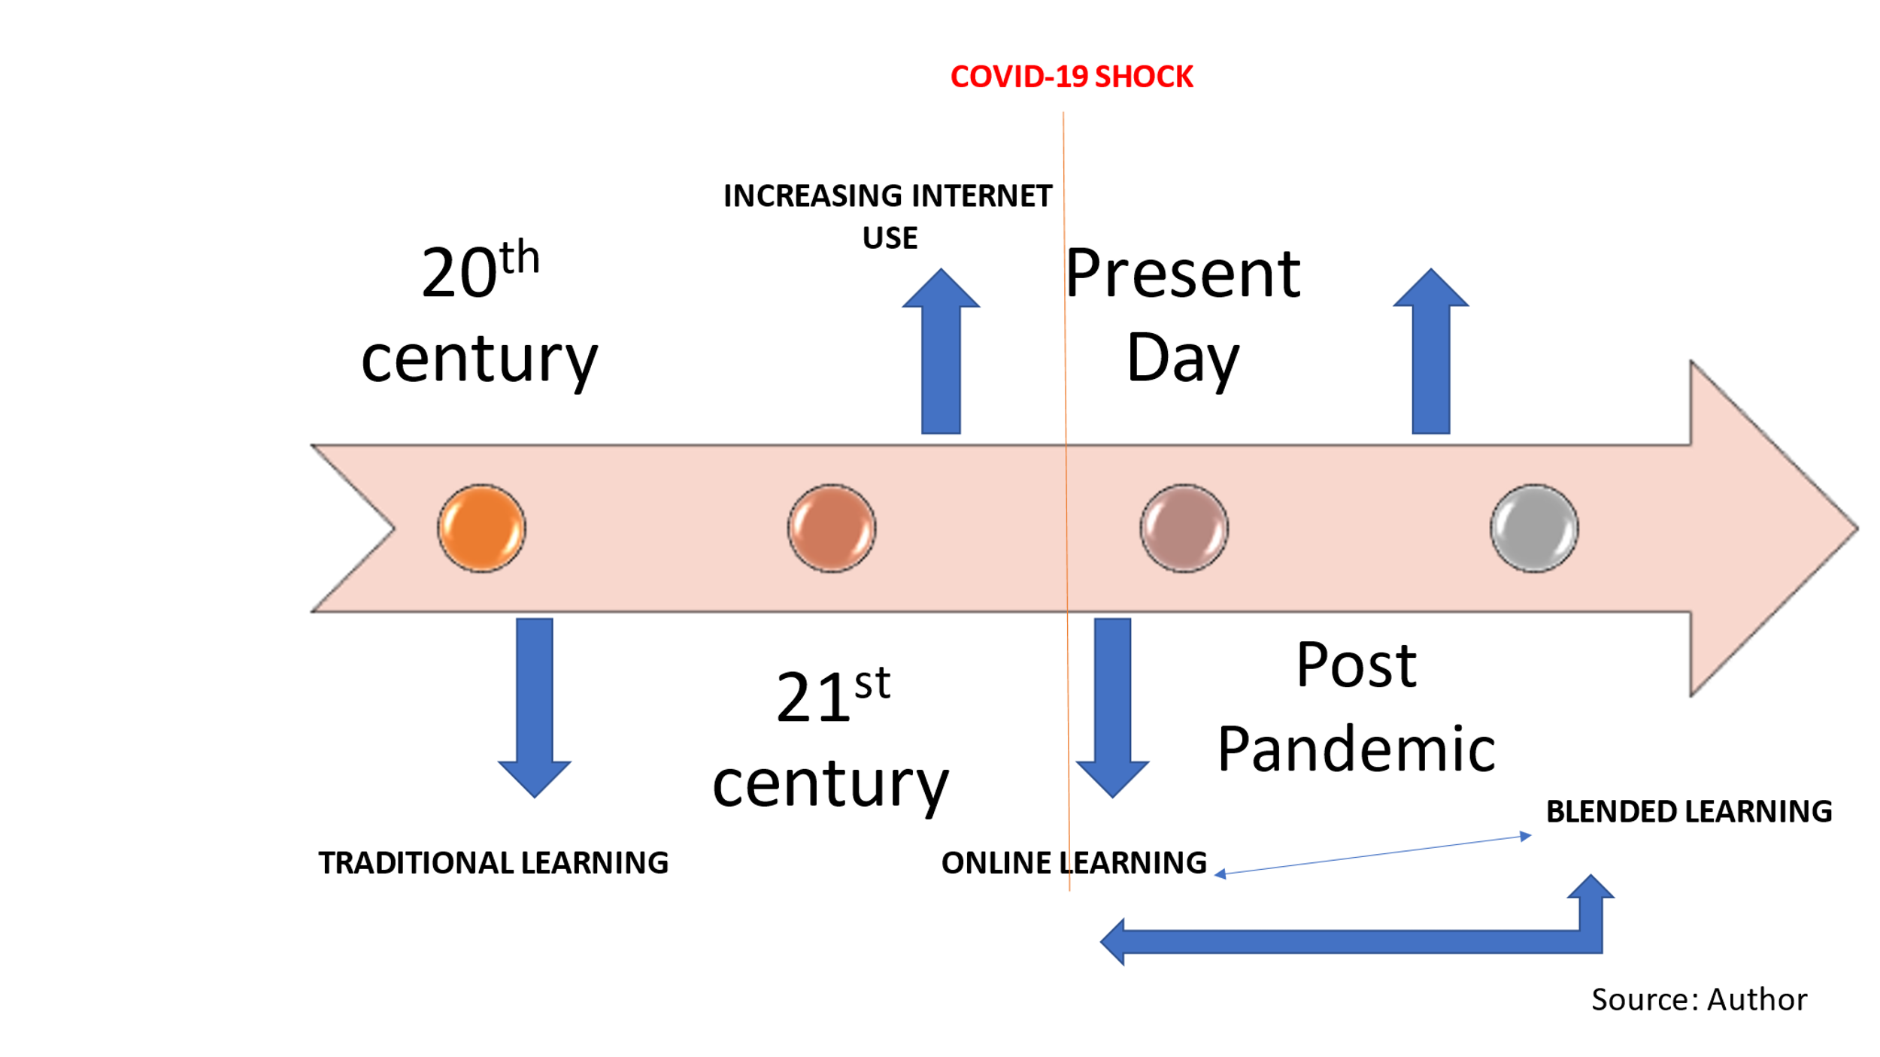

Recommendations

Successful blended learning is necessary to adopt effective technology-based learning strategies. Using participant attributes, plan aspects, and successful teaching as success criteria can help create effective in person and distance education systems. Most student and blended learning plan features are essential drivers of combined learning efficiency. Academic institutions should keep in mind the interplay between student characteristics, plan features, and academic achievement. The findings show that learners may engage in blended learning, particularly individual self-regulation.
Blended learning is meant to increase active understanding and research skills. This may help produce talented individuals with creative degrees who can meet the demands of the work market. Because learners are less surprised by innovation, blended learning holds more promise. Colleges and other educational institutions might continue to promote blended learning by providing integrated learning programs and services with adequate internet connectivity, especially in developing nations.
Students in both mixed and traditional classes do well, but blended courses demand more discipline.

Source: Author

Conclusions



Students found "blended learning" helpful, enjoyable, supportive, adaptive, and motivated in all the studies examined. However, these elements are not enough to foster student understanding.
Instructors using blended learning settings must encourage students to participate and develop strategies to promote social connection through cooperation to establish a positive learning environment. Moreover, combining direct or further study should be appropriately organised for the sake of maximising both benefits. Blended learning, like any other method, has pros and cons. Self-paced learning and coaching can be beneficial when properly handled. Because not all students are ready to learn on their own, the pros may be overstated.

Despite this, I believe the method's flaws are tolerable. It is a terrific alternative that gives some independence. Not to mention each solution is more suited to certain situations. A teaching approach can provide a dynamic teaching experience. However, blended learning is far more economical.
To summarise, consider each one individually before deciding which is the best.

References

Akkoyunlu, B. &. Y. S. M., 2008. A Study of Student's Perceptions in a Blended Learning Environment Based on Different Learning Styles. Educational Technology & Society, 11(1), pp. 183-193.
Anon., 2021. Coursera. [Online]
Available at: https://www.coursera.org/courses?query=blended%20learning
[Accessed 05 11 2021].
Barron, M., 2021. Worldbank.org. [Online]
Available at: https://blogs.worldbank.org/education/what-hybrid-learning-how-can-countries-get-it-right
[Accessed 03 11 2021].
Bayram Güzer, H. C., 2014. The Past, Present and Future of Blended Learning: An in Depth Analysis of Literature. Procedia - Social and Behavioral Sciences, Volume 116, pp. 4596-4603.
Bonk, C. J. &. G. C. R., 2004. Handbook of blended learning: Global Perspectives, local designs. San Francisco, CA. San Francisco: Pfeiffer.
Bonk, C. J., 2002. Learning from focus groups: an examination of blended learning. Journal of distance education. Journal of distance education, 17(3), pp. 97-118.
Carlton, G., 2021. The Best Schools Org. [Online]
Available at: https://thebestschools.org/magazine/hybrid-classes-pros-cons/
[Accessed 01 11 2021].
Carmen, J., 2002. Google Scholar. [Online]
Available at: https://scholar.google.com/scholar?q=Carmen,%20J.M.%20.%20Blended%20learning%20design:%20Five%20key%20ingredients,
[Accessed 02 11 2021].
Chandra, V. F. D., 2009. Students' perceptions of a blended web-based learning environment. Learning Environment Research, Volume 12, pp. 31-34.
Chen, C. C. & Jones, K. T., 2007. Blended Learning vs Traditional Classroom Settings: Assessing Effectiveness and Student Perceptions in an MBA Accounting Course. Journal of Educators Online, 4(1).
Cooney, M. G. P. &. O. M., 2000. Blurring the lines of play and work to create blended classroom learning experiences. Early Childhood Education Journal, 27(3), pp. 165-171.
Daymont, T. &. B. G., 2008. Student Performance in Online and Traditional Sections of an Undergraduate Management Course. Journal of behavioural and applied management., 9(3), p. 275.
Dias, S. B. & Diniz, J. A., 2014. Towards an Enhanced Learning Management System for Blended Learning in Higher Education Incorporating Distinct Learners' Profiles. Educational Technology & Society, 17(1), pp. 307-319.
Fox, A., 2020. eLearning Industry. [Online]
Available at: https://elearningindustry.com/advantages-and-disadvantages-distance-education-offer
[Accessed Saturday, July 2021].
Garrison, D. &. K. H., 2004. Blended learning: Uncovering its transformative potential in higher education. Internet and Higher Education, 7(2), pp. 95-105.
G, G., 1998. Learning by Doing: A guide to teaching and learning methods. Paperback. s.l.:s.n.
Grieve, R. a. I. M. a. W. K. a. T. G. A. a. M. J., 2013. Face-to-face or Facebook: Can social connectedness be derived online?. Computers in Human Behavior, 29 (3)(0747-5632), pp. 604-609.
Holley, D. & Oliver, M., 2010. Student engagement and blended learning: Portraits of risk. Computers and education, 54(3), pp. 693-700.
Hunt, V., 2016. eLearning Industry. [Online]
Available at: https://elearningindustry.com/pros-cons-blended-learning-at-college
[Accessed 30 10 2021].
Kasraie, N. &. A. A., 2014. Investigating the reasons institutions of higher education in the USA and Canada utilise blended learning. Mevlana International Journal of Education (MIJE), 4(1), pp. 67-81.
Khechine, H., Lakhal, S., Pascot, D. & Bytha, A., 2014. UTAUT model for blended learning: the role of gender and age in the intention to use webinars. Informing Science Institut, 10(3).
Khechine, H. L. S. P. B. A., 2014. UTAUT model for blended learning: the role of gender and age in the intention to use webinars. Interdisciplinary Journal of E-Learning and Learning Objects, Volume 10, pp. 33-52.
King, A. G., 2021. myskillcamp. [Online]
Available at: https://myskillcamp.com/en/article/discovering-blended-learning-and-why-it-works?ad_group_id=131414313767&ad_id=548810824316&utm_medium=adwords&utm_campaign=13349345895&utm_source=&utm_term=&hsa_acc=9287198496&hsa_cam=13349345895&hsa_grp=131414313767&hsa_
[Accessed 03 11 2021].
López-Pérez, M. P.-L. M. C. &. R.-A. L., 2011. Blended learning in higher education: Students' perceptions and their relation to outcomes. Computers & Education. 56(3), pp. 818-826.
Macan, T., 1990, 1994, 2000. College student's time management: Correlations with academic performance and stress, Construction of activity duration and time management potential, Taking breaks from work: an exploratory inquiry. Journal of Educational Psychology, Applied Cognitive Psychology, Journal of Psychology, pp. 82 (4), 760-768, 8, 155-168, 134,229-42.
Mekhitarian, S., 2021. The Essential Blended Learning PD Planner: Where Classroom Practice Meets Distance Learning. s.l.: SAGE Publications.
Miyazoe, T. &. A. T., 2010. Learning outcomes and students' perceptions of online writing: Simultaneous implementation of forum, blog and wiki in an EFL blended learning setting.. 38(2), pp. 185-199.
Movchan, S., 2018. Raccoon Gang. [Online]
Available at: https://raccoongang.com/blog/advantages-and-disadvantages-blended-learning/
[Accessed 04 11 2021].
Okaz, A. A., 2015. Integrating Blended Learning in Higher Education. Procedia - Social and Behavioral Sciences, 186(1877-0428), pp. 600-603.
Osguthorpe, R. G. C., 2003. Blended learning environments. Definitions and directions. The Quarterly Review of Distance Education. 4(3), pp. 227-233.
Paechter, M. & Maier, B., 2010. Online or face-to-face? Students' experiences and preferences in e-learning. The Internet and Higher Education, Volume 13(4), pp. 292-297.
Papadopoulou, A., 2010. LearnWorlds. [Online]
Available at: https://www.learnworlds.com/online-classes-vs-traditional-classes/
[Accessed 13 October 2021].
Press, O. U., 2021. Oxford Reference. [Online]
Available at: https://www.oxfordreference.com/view/10.1093/oi/authority.20110803095511813
[Accessed 20 11 2021].
Randy D., G. D. V. N. D., 2007. Blended learning in Higher Education: Framework, Principles, and Guidelines. s.l.: John Wiley & Sons.
Sethy, S. S., July 2008. Distance Education in the age of globalisation: An Overwhelming Desire towards Blended Learning. Turkish Online Journal of Distance Education-TOJDE, 9(1302-6488), p. DISTANCE EDUCATION IN THE AGE OF GLOBALISATION.
Voci, E. &. Y. K., 2001. Blended learning working in a leadership development programme. Industrial and Commercial Training. s.l.:s.n.
Vonderwell, S., 2003. An examination of asynchronous communication experiences and perspectives of students in an online course: a case study. The Internet and higher education, 6(1), pp. 77-90.
W.P.How, 2015. Master 4d Time Management: Delete, Delegate, Defer, Do. s.l.: CreateSpace Independent Publishing Platform.
Yerby, J. &. F., 2013. An Investigation of traditional education vs fully-online. Sais2013Proceedings, Volume 40.

