
The Evolution of Evidence: A Study of Forensics in British Policing
University of wales trinity saint david
Tanith coulson
2304246
dissertation
Abstract
Forensic science is widely regarded as a necessary tool in UK policing, with classic methods such as fingerprint analysis and DNA profiling perceived by the public as highly reliable. However, it also found that newer techniques, particularly digital forensics and emerging technologies such as artificial intelligence and facial recognition, are viewed with greater uncertainty due to concerns regarding accuracy, data misuse, and trust. This study examines the evolution of forensic techniques and their impact on evidence gathering in modern policing. The findings indicate that forensic science has improved the speed and accuracy of criminal investigations, although its effectiveness remains affected by interpretation errors and rapidly evolving technologies. Public perceptions of forensic reliability and effectiveness were collected through primary research, alongside a professional interview to provide insight into practical application. The results demonstrate strong public confidence in established forensic techniques, while confidence in newer approaches remain limited. Many participants associate forensic science with accuracy, yet concerns persist about potential errors and misuse. Overall, forensic science remains highly trusted, but emerging technologies are linked to uncertainty, highlighting the need for ongoing development, regulation, and public education.

Acknowledgements
I would like to take this opportunity to acknowledge and give my warmest thanks to my dissertation supervisor, Jane Davies. Thank you for your guidance and support throughout the last three years. I am extremely grateful for your encouragement and advice, particularly during final year.
I would also like to thank the University of Wales Trinity Saint David and all lecturers who have supported me throughout my studies.
To the girl who I have had the privilege of creating a lifelong friendship with, Milly Golledge, thank you for your support, encouragement, and friendship. Thank you for all the laughs, tears, and coffees we have shared together, I hugely appreciate everything you have done for me, and I wish you all the best for the future.
To my partner Daniel, thank you for your constant support and for believing in me throughout this process. I am incredibly grateful for your patience and encouragement. Thank you for helping me push through.
Finally, I would like to dedicate this degree to my parents, who sadly passed away before seeing me complete this journey. I hope I have made you proud, and I will carry your support with me throughout this achievement.

Declarations
This work has not previously been accepted in substance for any degree and is not being concurrently submitted in candidature for any degree.
STATEMENT 1
This dissertation is being submitted in partial fulfilment of the requirements for the degree of BA/BSc.
STATEMENT 2
This dissertation is the result of my own independent work/investigation, except where otherwise stated.
Other sources are acknowledged in the Reference Section.
STATEMENT 3
I hereby give consent for my dissertation, if accepted, to be available for photocopying and for interlibrary loan, and for the title and summary to be made available to outside organisations.
STATEMENT 4
I hereby give consent for my dissertation, if accepted, to be available on the university’s IT system to those who have consent to use the system.

Student’s Name: Tanith Coulson

Signed: TC

Date: 30/04/2025

Contents
Abstract ………………………………………………………………………………………1
Acknowledgements …………………………………………………………………………2
Declarations …………………………………………………………………………………3
Chapter One – Introduction
1.1. Background …………………………………………………………………………….6
1.2. Research Focus ……………………………………………………………………….7
1.3. Aims and Objectives …………………………………………………………………..7
1.4. Methods and Timescales ……………………………………………………………..8
1.5. Value of Research ……………………………………………………………………..9
1.6. Challenges ……………………………………………………………………………..9
1.7. Conclusion …………………………………………………………………………….10
Chapter Two – Literature Review
2.1. Introduction ……………………………………………………………………………10
2.2. Historical Development of Fingerprint Analysis and Its Use as Evidence ...……11
2.3. The Role and Effectiveness of DNA and Digital Forensics in UK Violent Crime Investigations ………………………………………………………………………………13
2.4. Future Developments in Forensic Methods and Their Impact on Investigations and Justice Outcomes ……………………………………………………………………15
2.5. Conclusion ……………………………………………………………………………17
Chapter Three – Methodology
3.1. Introduction ……………………………………………………………………………18
3.2. Research Strategy …………………………………………………………………...18
3.3. Data Collection ………………………………………………………………….……19
3.4. Data Analysis ………………………………………………………………...……….20
3.5. Limitations ………………………………………………………………….…………21
3.6. Conclusion ……………………………………………………………………………22
Chapter Four – Data Analysis
4.1. Introduction …………………………………………………………..………………23
4.2. Findings …………………………………………………………………..………….23
4.2.1. Trust in Traditional Forensic Methods ………………………………….……….23
4.2.2. Perceptions of Modern Forensic Techniques …………………………………..25
4.2.3. Attitudes Towards Emerging Technologies ……………………………………..32
4.3. Conclusion ……………………………………………………………………………33
Chapter Five – Conclusion
5.1. Introduction …………………………………………………………………………..34
5.2. Objective One …………………………………………………………………….../34
5.3. Objective Two ………………………………………………………………………35
5.4. Objective Three …………………………………………………………………….36
5.5. Recommendations ………………………………………………………………...36
5.6. Conclusion ………………………………………………………………………….37
References ……………………………………………………………………………....37
AI Acknowledgements ………………………………………………………………….44
Appendices
Appendix 1………………………………………………………………………………..45
Appendix 2………………………………………………………………………………..48
Appendix 3………………………………………………………………………………..49

- Introduction
  - Background
Forensic science applies scientific methods to lawful and criminal investigations. These methods have become central to modern policing, helping officers gather, analyse, and present evidence accurately in criminal cases. This involves the examination of crime scenes and the careful collection, analysis, and interpretation of evidence such as DNA, fingerprints, footwear impressions, digital data, and drug analysis (Home Office, 2016). Over time, forensic techniques have evolved, improving investigative accuracy and shaping the way evidence is used in court.
Fingerprint analysis is one of the earliest scientific methods adapted by police and has been used since the early twentieth century to link suspects to crime scenes with greater accuracy (Old Bailey Proceedings, 1902). Leadbetter (2005) further explains that since its initial acceptance as evidence in 1901, fingerprints have played a key role in identifying individuals and advancing the accuracy of criminal records. The introduction of DNA profiling in the late twentieth century transformed investigations, supporting more accurate identification, clearing innocent individuals, and making sure that true offenders were prosecuted (Cobain, 2016). Today, digital forensics plays a key role in criminal investigations, allowing police to recover and analyse data from computers, mobile devices, and networks in ways that can be used in court, supporting prosecutions and linking suspects to crime scenes (Muir and Walcott, 2021).
This study is important because forensic science has shaped the way policing is conducted, guiding how crimes are investigated and how evidence is used in court. The transition from historical forensic methods to modern techniques has not only increased investigative efficiency but also raised questions about data protection, ethics, accuracy, and the responsible use of forensic technology (Low, 2024). By placing this research within the context of British policing, it aims to understand the development of forensic science and its influence on policing and the justice system.

  - Research Focus
This study centres on the question: “How has the development of forensic techniques influenced policing methods in evidence gathering?” It focuses on the evolution of forensic science in UK policing and examines how specific techniques have evolved over time to shape investigative practices.
This dissertation considers forensic science across three broad periods, which are the past, present, and future. These will allow a better understanding of how these methods have formed policing approaches. Focusing on these periods allows the research to analyse historical advancements, assess modern practices, and consider potential future developments in forensic methods.
By setting this study within the context of British policing, the research intends to understand how forensic science has contributed to improving investigative accuracy, supporting prosecutions, and raising questions around ethics, reliability, and public faith.

  - Aim and Objectives
Aim:
The aim of this study is to explore how forensic techniques have evolved and how these advances have influenced evidence gathering in policing. This research is important because forensic science plays a key role in assuring accurate investigations and fair justice outcomes. By investigating key stages in the development of forensic methods, from early fingerprint identification to DNA profiling and digital forensics, the study will revive how these techniques have formed modern policing methods and their effectiveness in solving crimes.
Objectives:
- Investigate the evolution of fingerprints and its role in evidence.
- Evaluate the use of DNA and digital forensics by UK forces in solving violent crimes.
- Explore potential future developments in forensic methods and their impact on investigations and justice outcomes.

3. Method and Timescales
This research will use an online survey to explore public perceptions of the current and emerging forensic techniques in policing. The survey intends to understand how people view their effectiveness, reliability, and ethical use in modern policing. The survey is an effective method because it allows responses to be collected from a large and diverse group of participants. It will be accessible online, making it easy for participants from different age groups and backgrounds to take part, as the majority of people use the internet as a way to communicate and access information (Thompson, 2017). The survey will include mixed-methods research, allowing the collection of quantitative and qualitative data to provide a broad range of feedback, gathering statistical trends as well as individual insights (Banawa, 2025).
Quantitative responses will be analysed using basic statistical analysis to identify trends in public opinion, whereas qualitative responses will be reviewed for repeated themes and perspectives on the use of forensic techniques in policing. This combination will provide a strong view on how the public understands and evaluates the role of forensic evidence. In terms of timescale, the first stage of this research will involve finalising the survey design and gaining ethical approval. Once completed, the survey will be distributed over a three-week period to allow participants plenty of time to respond, followed by data collection and analysis during the following month. The final stage will focus on reviewing and interpreting the results in preparation for the dissertation findings.
To support this, a semi-structured interview will be conducted with a forensic professional. Interviews allow direct communication between the researcher and the participant, usually leading to more in-depth responses than questionnaires (Thompson, 2016). This will focus on their experiences with current forensic techniques and their views on how future developments may influence evidence gathering and investigations. This method has been chosen as it offers an accessible, efficient, and ethical way to collect both numerical and detailed qualitative data from the public, helping to answer the research question effectively.
  - Value of Research
This research is valuable because it explores how forensic techniques have developed and how these changes have influenced evidence gathering methods in policing. Forensic science is key to criminal investigations, directing how evidence is collected, analysed, and presented, but its reliability has been questioned at times. Recognising public confidence in forensic techniques is important because it affects trust between the police and public, as well as the criminal justice system. By examining how people view the current and future forensic methods, this study helps point out areas where the police can improve public understanding and secure transparency in the use of evidence.
While forensic science has improved criminal investigations, there are still cases where errors or incorrect interpretations have occurred. For instance, research indicates that around 21% of convictions involved false or misleading forensic evidence from 1970 to 2016, indicating that errors can still occur despite the systematic nature of the work (Helm, 2021). Using forensic techniques involves handing sensitive personal data, such as DNA and digital records, which brings ethical and privacy problems. Scott (2021) highlighted that the quality and consistency of forensic services were inadequate, posing a threat to public confidence in the criminal justice system, and urged the government to implement reforms to improve regulation and reliability.
  - Challenges
One key challenge includes participants’ existing knowledge of forensic science. The questionnaire relies on their knowledge, and as many forensic techniques are complex, such as digital forensics, some may not have a full understanding of how they are used in practice. This means responses may reflect general perceptions or media influence rather than informed knowledge, potentially affecting the overall reliability of the findings. However, as the research focuses on public perceptions, this will provide valuable insight into how forensic science is understood by the general public.
  - Conclusion
This research is important as it explores the development and importance of forensic science, and how it has shaped modern policing and evidence gathering. It also draws attention to ongoing challenges within its use, particularly around reliability and the chance of misinterpretation despite steady advancements (Helm, 2021). These challenges could influence how the public perceives forensic evidence and its reliability. Therefore, identifying these challenges is important to support improved regulation and ensure forensic techniques are used accurately and fairly within the justice system.

Chapter Two – Literature Review
2.1. Introduction
Forensic science has developed significantly over time and has become a valuable tool in British policing. McCartney (2006) suggests that forensic science can be understood as the application of natural and physical sciences to legal issues, particularly in supporting the resolution of criminal cases. The House of Lords Select Committee on Science and Technology (1992-93) emphasises its primary role is to serve the interests of justice by providing scientifically based evidence. The recognition of fingerprint evidence in 1902 marked a critical moment in the acceptance of scientific methods within the English court system, and by 1904 Scotland Yard was processing approximately 300 fingerprint cards a week (Kofman, 2016). This shows how quickly fingerprinting became part of policing and highlights the growing reliance on ways of identifying suspects. It also shows a broader move away from less reliable identification techniques towards approaches that could be more easily recorded, compared, and used as evidence in court.
The establishment of the first forensic laboratory in 1910 in Lyon by Edmond Locard (Courouge, 2025) further developed the use of science in criminal investigations and had a wider influence on policing practices. This contributed to the creation of the Metropolitan Police Laboratory in 1935 in England and Wales, and later the Forensic Science Service (Rodriguez and Baron, 2018). These developments helped to formalise forensic work within policing, making investigations more consistent and organised rather than relying on more informal or experience-based methods.
Since these early developments, forensic science has expanded to incorporate advanced techniques such as DNA profiling and digital forensic analysis, each reshaping investigative practice. However, they have also created new challenges, particularly around issues like quality, regulation, and overall effectiveness. This means that the effectiveness of forensic science is not just about how advanced the technology is, but also how well it is used today and regulated within the criminal justice system. This literature review aims to examine how key forensic techniques have developed over time, as well as the impact that changes have had on evidence gathering and justice outcomes in British policing.
2.2. Historical Development of Fingerprint Analysis and Its Use as Evidence
According to Roewer (2013), forensic genetic fingerprinting refers to the comparison of DNA obtained from an individual with that recovered from crime scene evidence, allowing for the identification or exclusion of suspects. The development of fingerprint identification can be traced back to the 1880s, with early work contributing to the understanding of fingerprints as a means of personal identification. McCartney (2006) notes that this was not the result of a single discovery but evolved through the contributions of multiple individuals, including Francis Galton and Edward Henry, who developed classification systems that allowed fingerprints to be used in policing. Early fingerprint identification became an important part of British policing after the Metropolitan Police Fingerprint Branch was set up in 1901. This implemented the Henry Classification System and replacing the previous method of Bertillonage, which relied on specific body measurements. Officers were trained in the system, allowing rapid identification of criminals.
An early example of its success is the conviction of Harry Jackson in 1902. Jackson was identified through a fingerprint left on a windowsill during a burglary in London. This marked the first known case in the UK where fingerprint evidence led directly to a criminal conviction (Passarella, 2024). This case illustrates the practical value of the system described by McCartney, demonstrating how scientific development translated into practical results in criminal investigations.
Statistical evidence supports the impact of Henry’s fingerprint system on policing efficiency. Leadbetter (2005) shows that under Bertillonage, the Metropolitan Police identified 152 individuals in 1898, gradually increasing to 503 by 1901. After the introduction of Henry’s fingerprint method in 1902, identification rates rose sharply with the Metropolitan Police identifying 1,032 individuals and provincial forces 690. Rates remained high in 1904, with the Metropolitan Police identifying 1,231 individuals and provincial forces identifying 1,104. These figures demonstrate the significant improvement in identification efficiency following the adaptation of Henry’s system compared to Bertillonage and clearly highlight why fingerprinting became a crucial tool in investigations. However, while fingerprinting improved identification processes, its effectiveness still depends on the quality of collection and interpretation, meaning errors can occur if procedures are not followed correctly.
While these early developments laid the foundation for fingerprinting as an identification tool, advancements in technology further enhanced its application. The first recorded publication on automated biometric recognition was by Mitchell Trauring in 1963, signalling the move towards faster and more accurate identification, including the analysis of fingerprints, voice, face, and signature (Jain, Nandakumar, and Ross, 2016). This shows how fingerprint analysis has continued to develop over time and highlights its growing importance in both policing and wider society, as they play a crucial role in law applications and investigative tools that help narrow the suspect list and as evidence in court.
The role of fingerprinting in evidence gathering developed within British policing during the mid-20th century, with the first mass fingerprint screening in Britain taking place in 1948, allowing fingerprints to be taken under court order. Police powers relating to fingerprint collection were later expanded under the Police and Criminal Evidence Act 1984, permitting the police to take fingerprints without a court order (Lynch et al., 2010). This development enabled police to collect fingerprint evidence more easily and from a wider range of individuals, strengthening its use as a key tool in criminal investigations.
In 1991, the Home Office introduced the Forensic Science Service (FSS), providing national support for investigations across England and Wales before its closure in 2012. As highlighted by Jones (2024), the FSS ensured that fingerprint evidence and other forensic techniques were processed reliably and consistently, making it easier for police to compare prints and identify suspects. The creation demonstrates how fingerprinting evolved from a localised tool to a standardised, national method of evidence gathering. While the FSS improved the consistency and reliability of forensic evidence it also played a key role in research and development within forensic science. According to Silverman (2011), FSS work contributed to advancements in forensics and had a wider impact beyond. However, concerns were raised that the closure may have weakened research capacity which suggests that although fingerprinting and other methods became more advanced over time, preserving consistent standards remain a challenge within modern policing.
2.3. The Role and Effectiveness of DNA and Digital Forensics in UK Violent Crime Investigations
Since its discovery by Alec Jeffreys at the University of Leicester in 1984, DNA profiling has become a key tool in criminal investigations (Aronson, 2005). The technique revealed that each individual has a unique DNA pattern, making it highly dependable for identification. Jeffreys’ research suggested the probability of two individuals sharing the same DNA profile was extremely low, estimated at 1 in 33 billion, highlighting why DNA evidence can be so powerful in investigations. Early DNA techniques, however, faced limitations, such as difficulties analysing small or degraded samples.
The development of DNA databases further transformed criminal investigations. These databases store DNA profiles from known individuals, including suspects and convicted offenders, alongside biological evidence collected from crime scenes. This allows police to identify potential suspects through matches, often referred to as cold hits, where a person is identified based on a database match (Toom, 2012). As a result, investigations have shifted from being suspect-led to more evidence-led, particularly in serious and violent crimes.
One of the earliest examples of DNA in practice was the Colin Pitchfork case in the 1980s. DNA evidence confirmed that the same individual committed two murders while also excluding an initial suspect who had confessed. Pitchfork was later convicted, making him the first person in the UK to be convicted using DNA profiling (Oosthuizen and Howes, 2022). This case demonstrates DNA’s ability to both identify offenders and prevent wrongful convictions. Since then, DNA has become a routine investigative tool used by police, often used alongside other forensic methods to strengthen the evidence base in violent crime cases.
Digital forensics has developed as a method in modern investigations. Raghavan (2012) defines it as the application of scientific principles and methods to analyse electronically stored information in order to reconstruct the sequence of events leading to an incident. In the UK, efforts to professionalise digital forensics began in 2004 through the Council for the Registration of Forensic Practitioners (CRFP), which established a digital forensics speciality requiring practitioners to demonstrate qualifications, ongoing training, and submit recent case reports (Sommer, 2011). According to Altheide and Carvey (2011), the process can be divided into three stages. The first being acquisition, which involves the collection of digital media to be examined, analysis examines the data, and presentation communicates findings to relevant parties.
Research suggests digital evidence is present in a considerable proportion of cases managed by forces in England and Wales. Studies of policing practice by Kovacs and Wilcox (2023) indicate that digital elements are involved up to 90% of cases, showing their widespread role in investigative work. While this highlights its importance, it also suggests that investigators may face increasing pressure to manage large volumes of data, which could impact the quality and speed of investigations. Digital devices, such as mobile phones and computers, can contain both physical and digital evidence, and Horsman (2021) argues that such devices can function as digital witnesses by recording and preserving detailed information about user behaviour and events.
Despite its usefulness, digital forensics is not free of challenges. Smit, et al. (2018) found that in a review of UK appeal cases, one-third of convictions were overturned due to issues with forensic evidence, including digital sources such as CCTV, SIM-card data, and web content. This indicates that if misinterpreted or mishandled, digital evidence can contribute to unsafe outcomes. DNA has improved criminal investigations and helped catch offenders, however the 2002 Hankin case highlights that relying on DNA alone can lead to wrongful suspicion if other evidence is not considered. According to Pascali, et al. (2003), issues such as mistakes in databases, misunderstanding population statistics, and depending too much on probability show that DNA evidence should be used carefully.
However, when used correctly, digital and DNA evidence can be highly effective in solving violent crimes. A clear example of this can be found in the murder of April Jones in 2012 where police gathered various forms of forensic evidence. Forensic analysis revealed blood and bone fragments at the suspect’s cottage, and while examining the suspect’s computer officers uncovered graphic images and digital material that contributed to building the case against him (Morris, 2013). This case highlights how combining DNA and digital forensics delivers a deeper understanding of violent crimes and strengthens the success rates of prosecution.
Overall, cases like Colin Pitchfork and April Jones show how forensic practice has developed over time. While DNA transformed the identification of offenders, digital forensics now provides a parallel source of evidence, capturing events and behaviours that DNA alone cannot. The integration of these tools demonstrates why police forces across the UK increasingly rely on both methods in serious and violent crime investigations, ensuring evidence is dependable and used to achieve justice for victims.
2.4. Future Developments in Forensic Methods and Their Impact on Investigations and Justice Outcomes
Building on earlier developments such as fingerprinting and DNA profiling, forensic science continues to evolve at a rapid pace. These ongoing developments are not only improving the accuracy of evidence gathering but are also reshaping the future role of forensic techniques within policing. Since 2014, police forces in England and Wales have trialled the use of Automated Facial Recognition (AFR), which is used for identity verification, retrospective or speculative identification, and live facial recognition (Purshouse and Campbell, 2022). AFR has the potential to support police investigations by rapidly identifying suspect and reducing reliance on manual identification methods, which may improve efficiency in fast-moving investigations. This is supported by recent figures from the Metropolitan Police, which reported that 2,067 of 2,077 alerts were confirmed matches, leading to 962 arrests in 2024-2025, alongside 4.6 million faces being scanned across England and Wales (Murphy and Bunn, 2026). This suggests that AFR is becoming more widely used in policing, although its long-term impact on accuracy and civil liberties remain an area of debate. This raises concerns about the balance between efficiency and civil liberties, particularly in relation to privacy and potential bias in automated systems. In addition, issues surrounding public trust, confidence, and the admissibility of forensic evidence within the criminal justice system present further challenges associated with the rapid adaptation of recent technologies (Scottish Police Authority, 2025).
Research commissioned through the Accelerated Capability Environment (ACE) further highlights how emerging technologies may enhance forensic science, including improving the detection and interpretation of trace biological materials (ACE, 2024). This indicates a growing shift towards integrating digital approaches into traditional methods, suggesting that future developments may improve both the speed and accuracy of evidence assessment.
One of the key drivers of these developments is the rapid expansion of connected and digital technologies. Montasari and Hill (2019) estimate that there are up to 50 billion Internet of Things (IoT) devices worldwide, with projections suggesting around 10 devices per person. This growth is significant when considering alongside the rise in digitally enabled crime, with the Office for National Statistics (2017) reporting an estimated 3.6 million cases of fraud and 2 million computer misuse offences in a single year. More recent data indicates that fraud continues to increase, with approximately 4 million incidents reported in 2025, representing an 8% rise on the previous year. In addition to this, research from 2023 suggests that artificial intelligence (AI) is likely to contribute to further increases in fraud and scam-related offences (London Assembly, 2026). As a result, digital forensic evidence has become the core of modern investigations.
The House of Lords Science and Technology Committee (2019) found that around 80% of crime cases now contain a digital element, such as mobile phone data, CCTV, or social media activity. However, this increased reliance on digital evidence has also created operational pressures, particularly due to a backlog of approximately 20,000 devices awaiting examination. This highlights that while digital evidence provides significant opportunities, it also creates challenges in terms of workload, processing, and timely analysis.
In response to these challenges, there has been growing interest in the use of AI within forensics. Tynan (2024) argues that AI has the potential to improve efficiency in digital forensics by processing large volumes of data more quickly than traditional methods, which could help reduce delays. Hamilton (2023) notes that AI has already been used in policing contexts for over two decades, including systems such as the Offender Assessment System. However, despite these benefits, concerns remain regarding transparency and reliability. According to Muir and Walcott (2021), digital devices often contain vast amounts of data, placing significant pressure on investigative resources and increasing the risk of delay or oversight.
Furthermore, the use of AI raises concerns around accountability, as many systems operate as black boxes, meaning their decision-making processes are not fully transparent or easily explained, as noted by Tynan (2024). As a result, while AI and digital technologies have the potential to improve efficiency and consistency in forensic investigations, issues surrounding reliability, ethics, and justice outcomes remain key challenges for future development.
2.5. Conclusion
Overall, forensic science has undergone many transformations within British policing, evolving from early identification techniques such as fingerprinting to advanced scientific and digital methods. The introduction of fingerprint analysis marked the beginning of systematic, evidence-based policing which was later strengthened by developments such as the Forensic Science Service. Similarly, DNA profiling revolutionised criminal investigations by improving the accuracy of offender identification and reducing the risk of wrongful convictions, while also contributing to more evidence-led policing approaches.
More recently, the development of digital forensics has further expanded investigative capability, particularly through the analysis of mobile phones, CCTV, and online activity. However, the literature also highlights challenges associated with the increasing volume of digital evidence, including resource pressures, delays, and concerns regarding reliability and interpretation.
Looking forward, emerging technologies such as AI and AFR indicate a continued shift towards automation and data-driven policing. While these developments may improve efficiency and investigative capacity, they also raise concerns regarding transparency, accountability, and their impact on justice outcomes. This suggests that forensic science is becoming increasingly integrated with digital and automated systems, shaping both current policing practices and the future of evidence gathering within British.
Chapter 3: Methodology
3.1. Introduction
Following on from the previous chapter, this research examines the evolution of forensic science within British policing, with a particular focus on the development and application of fingerprint analysis, DNA profiling, and digital forensic techniques. This research is structured around three key objectives: to investigate the evolution of fingerprint evidence, to evaluate the use of DNA and digital forensics in solving violent crimes within UK forces, and to explore potential future developments in forensic science and their impact on criminal investigations and justice outcomes.
This research adopts a mixed methods approach, combining both quantitative and qualitative data collection techniques. The use of both methods allows for a broader understanding of the research topic by capturing public perceptions alongside professional insight. This approach also combines the strengths of both methods while helping to reduce their individual limitations, allowing for a more meaningful interpretation of the data collected (McKim, 2017). The literature review highlighted that although forensic technologies have advanced significantly, there remains a gap in understanding how these developments are perceived by the public, particularly due to ongoing concerns around trust and the use of forensic evidence (Scottish Police Authority, 2025). Therefore, this research aims to address this gap by analysing both forms of data.
3.2. Research Strategy
A mixed methods research strategy was used, consisting of a structured questionnaire and a semi-structured interview. This approach was selected as it enables the collection of both quantitative and qualitative data, allowing for a more comprehensive understanding of the research problem. The use of mixed methods is supported by Saunders et al. (2023), who suggests that combining different research methods can improve the depth and reliability of findings. Similarly, Bryman et al. (2007) highlight that integrating both quantitative and qualitative approaches allow research to develop a more complete understanding of issues.
The questionnaire was used to gather quantitative data from members of the general public regarding their perceptions and understanding of forensic science. This was particularly relevant to the research objectives, as it allowed for the collection of a broad range of opinions on fingerprint analysis, DNA profiling, and digital forensics. In contrast, the semi-structured interview provided qualitative data from a professional working within the forensic field, offering a more detailed and informed perspective on the application and relevance of forensic methods in modern policing.
The questionnaire was distributed online using convenience sampling, which allowed for efficient data collection within a limited timeframe. As a result, 49 responses were collected. This method was chosen due to its accessibility and practicality, as it enabled participants to complete the questionnaire at their own convenience. The combination of these two methods also allowed for comparison between public perceptions and professional perspectives, strengthening the overall depth of the research.
The use of mixed methods also directly supports the research objectives, as the questionnaire captures public understanding of fingerprinting, DNA, and digital forensics, while the interview provides expert insight into the application and reliability of these techniques in practice. This combination allows for comparison between public perception and professional understanding, which is what this study aims for.
3.3. Data Collection
Data was collected using two primary methods: an online questionnaire and a semi-structured interview. The questionnaire was designed to gather both quantitative and limited qualitative data on participants’ perceptions of forensic science. It included a combination of closed-ended questions, which produced measurable responses, and open-ended questions, which allowed participants to provide more detailed opinions.
The questionnaire was distributed using an online platform, enabling participants to access and complete it remotely, allowing for wider reach and efficient data collection from a larger sample (Kuphanga, 2024). This method is considered a cost-effective way of collecting data from larger populations and can improve accessibility for respondents (Marshall, 2005). Responses were collected over a set period until a sufficient number of participants had been reached for analysis.
The questionnaire used a convenience sampling technique, where participants were selected based on ease of access and willingness to participate (Golzar, Tajik, and Noor, 2022). This method is commonly used in research due to its speed, simplicity, and cost-effectiveness. However, convenience sampling is subject to bias and does not allow findings to be generalised to the wider population, as results only reflect the sample selected (Wright, 2017). Despite this limitation, it was considered the most appropriate for this study due to time constraints and the focus on public perceptions rather than statistical representation.
In addition to the questionnaire, a semi-structured interview was conducted with a professional working within the forensic field. This method was selected as it allows for the collection of rich, detailed qualitative data and enables participants to expand on their responses in their own words (Xu, Wang, and Qian, 2025). The interview followed a flexible structure, allowing the participant to expand on their responses while still addressing key topics relevant to the research objectives. This approach enabled the collection of in-depth qualitative data, particularly in relation to the practical application of forensic techniques and their role within criminal investigations. The interview was recorded with consent and later transcribed to ensure accuracy and to support the analysis process.
3.4. Data Analysis
Quantitative data collected from the questionnaire was analysed using descriptive statistical techniques. Responses to closed-ended questions were organised into percentages and presented using tables and graphs. This allowed for the identification of patterns and trends in public perceptions of forensic science, specifically in relation to fingerprint analysis, DNA profiling, and digital forensic techniques. The use of visual representations made it easier to compare responses and identify key findings.
Qualitative data collected from both open-ended questionnaire responses and the semi-structured interview was analysed using thematic analysis. This method involves identifying and analysing patterns or themes within data (Kiger and Varpio, 2020). The data was reviewed to identify recurring ideas and key points which were then grouped into broader themes, such as levels of trust, awareness, and perceptions of reliability.
Due to the differences in background knowledge between the general public and the professional participant, qualitative data from the questionnaire and interview was initially analysed separately. This ensured that each set of data was interpreted within its appropriate context. However, where related questions were asked in both the questionnaire and the interview, a comparative analysis was conducted. This allowed for the identification of similarities and differences between public perceptions and professional perspectives.
The final stage of analysis involved comparing findings from both data sources. This comparison helped to highlight gaps in public understanding, particularly in relation to the limitations and application of forensic techniques in investigations. It also provided insight into how professional knowledge differs from public perception, which directly supports the overall aims of the research. This analysis involved identifying similarities and differences between questionnaire responses and interview findings where comparable questions were asked. This approach helped to highlight differences between public understanding and professional perspectives on forensic science, particularly in relation to the reliability and application of DNA and digital forensics.
3.5. Limitations
This research is subject to several limitations. Firstly, the sample size for the questionnaire was small, with 49 participants, which limits the extent to which the findings can be generalised to the wider population. Another limitation of this study is that many participants in the questionnaire demonstrated a limited level of knowledge regarding the use of forensic science. This may have affected the depth and diversity of responses, as participants provided similar answers rather than a wide range of perspectives.
In contrast, the interview provided more detailed insight. However, it was conducted with only one professional, meaning that the findings reflect a single expert perspective rather than a broader range of professional views. As a result, while the study benefits from both public and professional input, the overall diversity of perspectives remains limited.
Furthermore, the questionnaire distributed online, which may have influenced the quality of their responses. Participants completing the questionnaire remotely may have not fully engaged with the questions or may have provided less detailed answers compared to a controlled research setting. The use of convenience sampling also presents a limitation, as participants chose to take part and may already had an interest in forensics or crime. This may have resulted in a sample that is not fully representative of the general population, potentially introducing bias into the finding.
In addition, although qualitative data was analysed using thematic analysis, the interpretation of responses is subject to researcher bias. The process of identifying and grouping themes relies on the researcher’s judgement, which may influence how the data is interpreted. Despite these limitations, the research still provides useful insight into the relationship between public perceptions and professional perspectives on forensic science and its key role in British policing.
3.6. Conclusion
The methodology was appropriate for the aim of this research as it allowed for both public perceptions and professional insight to be explored. The combination of survey and interview data will be able to provide both statistical trends and deeper insight into perceptions of forensic science.

Chapter Four – Data Analysis
4.1. Introduction
This chapter presents the findings and analysis of primary data collected for this study. The aim of this section is to outline and interpret the results gathered from both the questionnaire and semi-structured interview in relation to the research objectives. This data was gathered using an online questionnaire completed by 49 members of the public, along with an interview with a Senior Manager within the Scientific Support Unit. The purpose of this chapter is to present the key findings from both research methods and analyse them in relation to the research aims.
The findings are organised into sections based on the main objectives, bringing together the quantitative and qualitative results from the questionnaire. The interview findings are also included to provide a professional perspective and add further depth to the analysis. This approach aims to highlight any similarities or differences between public opinions and professional insight, as well as identifying any gaps in understanding. Finally, the findings will be compared with the literature review to explore how they align with, or differ from, existing research on forensic science.
4.2. Findings
4.2.1. Trust in Traditional Forensic Methods
This section will explore public perceptions of traditional forensic methods such as fingerprint analysis.
The questionnaire first collected demographic data to provide context for the sample. The results showed that the largest population of participants were aged 25-29 (24%), followed by those aged 45-49 and 50-54 (both 18%). Smaller proportions were observed across the remaining age groups, with each of the other categories representing 8% or less of responses. The sample was varied in age, although there was a stronger representation of participants aged 25-29 and 45-54. This may have influenced the findings, as different age groups may have varying levels of awareness and understanding.
Figure 1: Age distributions of participants
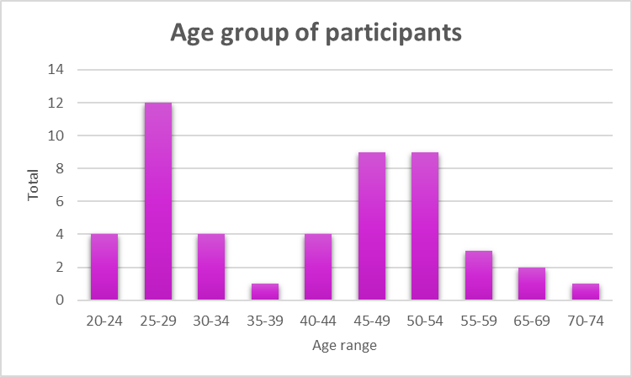

Participants were asked to rate the reliability of fingerprint analysis as a forensic method. As shown in Figure 6, 61.2% of respondents considered it as very reliable, while 32.7% selected somewhat reliable. Only a small proportion selected neither (2%) or were unsure (4.1%). These results show that fingerprint analysis is viewed as a highly reliable tool.
Figure 6: Public perceptions of the reliability of different forensic methods
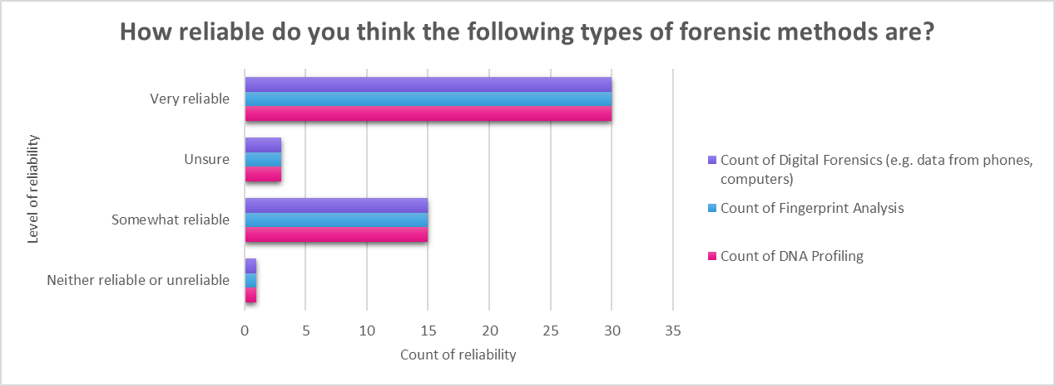

Despite the high levels of perceived reliability, qualitative responses revealed some concerns surrounding fingerprint analysis. Some participants mentioned the possibility of human error or misinterpretation, suggesting that while fingerprinting is widely trusted, it is not seen as completely flawless.
However, the interview findings present a more reinforced perspective. The specialist explained that fingerprint analysis remains a well-established method within forensic science and is supported by strict quality assurance and verification procedures to ensure accuracy before results are confirmed. Both public perceptions and professional insights suggest that traditional forensic methods, particularly fingerprint analysis, are viewed as highly reliable and continue to play a key role in criminal investigations.
The literature review highlights that fingerprint analysis is one of the earliest and most established forensic methods used in British policing, valued for its reliability in identifying suspects (McCartney, 2006). This is reflected in the findings of this study, where Figure 6 highlights 61.2% of respondents rated fingerprints as very reliable and 32.7% as somewhat reliable. Quantitative responses also supported this, although some participants raised concerns about human error and misinterpretation. The interview reinforces this view, with the specialist describing fingerprinting as a stable and well-tested method supported by strict quality control and verification processes.
4.2.2. Perceptions of Modern Forensic Techniques
This section explores public perceptions of modern forensic methods, including DNA analysis and digital forensics.
Participants were asked how familiar they were with forensic evidence used by police. The results showed that 47% reported being familiar with evidence, while 23% indicated they were not familiar. A further 16% of participants reported being very familiar, whereas a smaller proportion (14%) stated they not familiar at all. This suggests a moderate level of awareness among the public. While some respondents have a general understanding of techniques, there are still noticeable gaps in knowledge.
Figure 2: Familiarity with forensic evidence – DNA analysis and digital tools
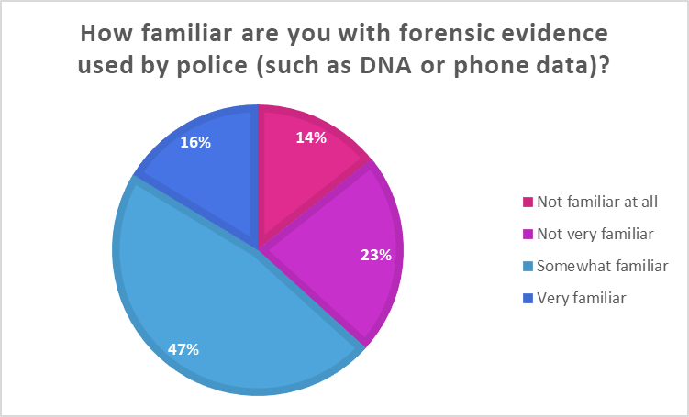

As shown in Figure 3, when asked whether they expect forensic evidence to be involved when hearing about violent crimes in the news, the results showed that 94% agreed, while 4% indicated they were unsure. A smaller proportion (2%) stated they did not expect forensic evidence to be involved.
This strong expectation highlights how closely forensic science is associated with modern policing and serious crime investigations, most likely influenced by media portrayals and public awareness of DNA-based evidence.
Figure 3: Public expectation of forensic evidence in violent crime investigations

The questionnaire asked participants how comfortable they were with surveillance technologies such as CCTV, Ring doorbells, and self-checkout cameras. Results showed that 84% reported feeling comfortable, while 10% were unsure and 6% felt uncomfortable.
This indicates a prominent level of acceptance of surveillance technologies within everyday life, due to their role in enhancing safety and supporting criminal investigations. However, the presence of some uncertainty suggests that concerns around privacy and data use still remain.
Figure 4: Public comfort with surveillance technologies in everyday settings

Participants were also asked about their trust in forensic evidence when used in criminal investigations. As shown in Figure 5, 45% reported high trust, while 43% indicated they had some level of trust. A further 10% reported neutral, and 2% little trust. This indicates that trust in forensic evidence remains high. However, this level of confidence is slightly lower than the higher levels of importance and fairness seen in earlier results.
Figure 5: Public trust in forensic evidence used in criminal investigations.
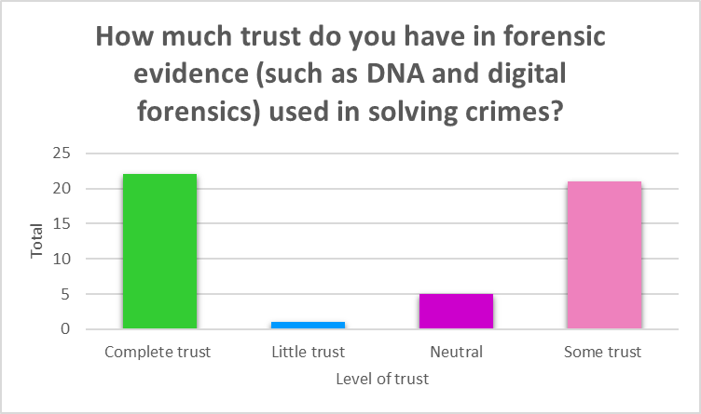

As mentioned previously, the questionnaire explored perceptions of reliability across different forensic methods. As seen in Figure 6, DNA profiling was rated as very reliable by 61.2% and somewhat reliable by 30.6% which is similar to the results of fingerprint analysis. In contrast, digital forensics showed more uncertainty, 42.9% of participants rated it as very or somewhat reliable, while 8.2% selected neither and 6.1% were unsure.
These findings suggest that while methods such as DNA are strongly trusted, newer digital techniques are viewed with more uncertainty. This could be because digital forensics is still developing and people may be less familiar with it compared to more established techniques.
Figure 8 highlights how important respondents believe forensic evidence is in solving crimes. The majority (84%) considered it to be extremely important, while 12% selected somewhat important. A smaller proportion (4%) reported feeling neutral.
This overall level of importance helps explain why traditional methods such as fingerprint analysis continue to contribute to a sense of familiarity and confidence among the public.

Figure 8: Perceived importance of forensic evidence in criminal investigations
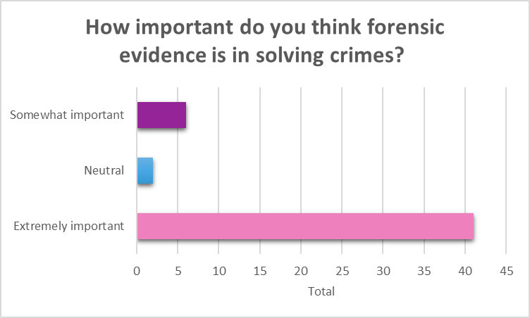

Building on this, participants were asked whether they believe forensic evidence helps make the criminal justice system fairer. The majority of respondents (92%) agreed, while 6% were unsure and an exceedingly small proportion (1%) disagreed. This highlights that forensic evidence is not only seen as important, but also as a key factor in promoting fairness and objectivity in criminal investigations.
Figure 9: Perceived impact of forensic evidence on fairness in the justice system
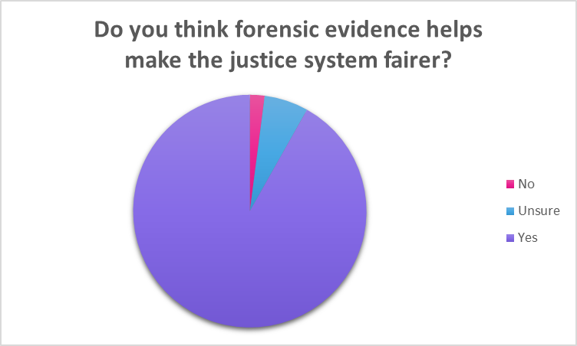

Finally, participants were asked how confident they are that forensic evidence leads to correct outcomes in criminal cases. The results shown in Figure 10 indicate that the majority of participants (61%) reported being somewhat confident, while 27% were extremely confident. A further 8% selected neutral and 4% expressed lower levels of confidence.
This suggests that, while overall confidence in forensic evidence is high, it is not absolute. Compared to the strong views on importance and fairness, these results highlight a more cautious perspective when considering if forensic evidence always does lead to accurate outcomes.
Figure 10: Public confidence in forensic evidence leading to correct criminal justice outcomes.

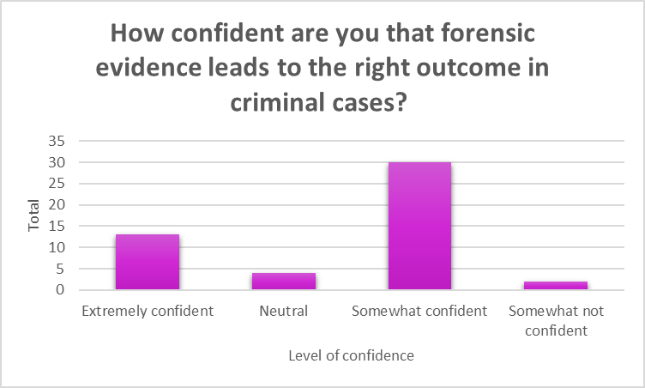

Qualitative responses help to explain this variation in trust and confidence. While some participants expressed strong belief in forensic evidence, with one stating “DNA cannot lie,” others highlighted important limitations.
Some participants expressed concerns in relation to digital forensics, with participants questioning whether devices could be accessed or used by individuals other than the owner. This uncertainty may help explain the lower levels of confidence observed in digital methods compared to newer techniques. Others expressed concerns about the potential for evidence to be tampered with or misused, suggesting that despite the levels of trust in forensics being high, awareness remains of its limitations and potential risks.
The interview findings provide further insight into these perceptions. The professional explained that DNA evidence is continuously developing, with new techniques being introduced to improve accuracy and analysis. However, they also highlighted that DNA results are based on probabilities rather than definite confirmation. This suggests that while DNA is a highly valuable forensic tool, it is not without limitations and must be interpreted carefully within investigations. In relation to digital forensics, the interviewee noted that this area presents ongoing challenges due to the rapid pace of technological change. Tools and methods must be regularly updated and validated, which may contribute to the uncertainty reflected in public responses.
The literature emphasises that the primary role of forensic services is to support the justice system by providing scientifically based evidence for legal decision-making (House of Lords Select Committee on Science and Technology, 1992-93). This is reflected in the questionnaire results, where Figure 8 shows that 84% viewed forensic evidence as very important, and Figure 9 shows that 92% believe it makes the justice system fairer. This suggests strong public trust in forensic science as a tool for achieving justice.
However, the literature also identifies that issues with forensic evidence have contributed to unsafe outcomes in some cases if not handled correctly (Smit et al., 2018). As seen in Figure 10, 61% of respondents reported being somewhat confident in forensic evidence leading to correct outcomes, only 27% were extremely confident. These highlight the lower levels of confidence the public have in digital forensic techniques compared to more established forensic methods such as fingerprinting. The interview similarly noted that digital forensics is constantly evolving and requires ongoing validation. This reinforces the idea that, while digital forensics offers many benefits, it also introduces ongoing challenges in maintaining accuracy and reliability, which may contribute to the uncertainty reflected in public perceptions.

4.2.3. Attitudes Towards Emerging Technologies
This section explores perceptions of emerging forensic technologies, particularly artificial intelligence (AI), and their potential impact on future policing.
In figure 7, participants were asked if they trusted police to use emerging digital tools when solving crimes. The results showed that 55% expressed uncertainty, while 29% indicated that they trust the use of such technologies. A smaller proportion (16%) reported a lack of trust.
These findings indicate that there is a clear level of uncertainty surrounding the use of AI in policing, suggesting that confidence in newer technologies is not yet fully established.
Figure 7: Public trust in police use of emerging digital technologies
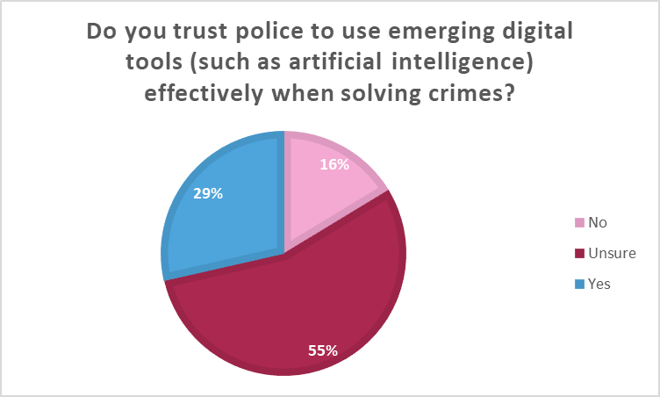

Qualitative responses help provide some insight. Some participants highlighted that AI is still developing and therefore cannot be relied upon due to the lack of human judgement and understanding. Others were concerned about potential errors, misinterpretations, or the possibility of systems being compromised. These responses suggest that unfamiliarity and perceived risks contribute to the uncertainty shown in the results.
Findings from the interview provide a more balanced perspective. The specialist explained that AI has the potential to improve efficiency within investigations, particularly when processing large volumes of digital data. However, it was also noted that such technologies introduce new risks and must be carefully validated and checked to ensure accuracy. The need for human oversight remains important to prevent errors and maintain reliability.
In contrast, the literature highlights that digital forensics plays a significant role in modern investigations, with digital elements present in up to 90% of cases (Kovacs and Wilcox, 2023) and the use of AFR leading to 962 arrests in 2024-2025. This is reflected in Figure 7, where the majority of respondents (55%) expressed uncertainty about the use of emerging technologies in policing, with participants also raising concerns around hacking, data misuse, and access to devices. However, the Scottish Police Authority (2025) claim there are issues surrounding public trust, confidence, and the admissibility of forensic evidence within the criminal justice system. This highlights that although digital forensics is widely used in investigations, issues around trust and reliability continue to influence both public perception and across the criminal justice system.
Overall, both public and professional perspectives suggest that while AI offers clear benefits for the future of forensic science, there remains a level of caution surrounding its use. This highlights that trust in emerging technologies is still
developing.

4.3. Conclusion
In conclusion, the findings from this research have indicated that forensic methods are trusted by the public and seen as dependable, particularly more traditional methods such as fingerprint analysis. In contrast, newer methods such as digital forensics and AI are viewed with more uncertainty, with some participants raising concerns about accuracy, misuse, and how these technologies are applied in practice. Despite this, forensic evidence is still widely considered to be particularly important in supporting investigations and helping to achieve fairer outcomes in the criminal justice system. The interview findings support these results, as the professional also emphasised the reliability of traditional methods, whilst recognising that newer technologies require ongoing testing, validation, and careful use. Overall, these findings highlight a gap between public perception and professional understanding, especially around newer techniques. They also support the literature review by reinforcing key ideas around reliability, development, and the challenges faced with modern forensic science, all of which will be drawn together in the concluding chapter.

Conclusion
5.1. Introduction
The aim of this dissertation was to develop an understanding of how forensic techniques have evolved and how these developments have influenced evidence of evidence gathering in UK policing. To achieve this, three main objectives were set:
- Objective 1: Investigate the evolution of fingerprint and its role in evidence.
- Objective 2: Evaluate the use of DNA and digital forensics by UK forces in solving violent crimes.
- Objective 3: Explore potential future developments in forensic methods and their impact on investigations and justice outcomes.
5.2. Objective One
The research found that fingerprint analysis has developed over time through the contributions of multiple individuals (McCartney, 2006) and became a valuable tool for identification in policing, with the Metropolitan Police identifying 1,231 individuals in 1904 (Leadbetter, 2005). This shows how fingerprinting became embedded in evidence gathering. The development of forensic techniques continued, with early automated biometric recognition in 1963 also including fingerprint analysis (Jain and Ross, 2015).
The primary research supports this. The questionnaire showed that most participants considered fingerprint analysis to be very reliable, with only a small number expressing uncertainty. However, some qualitative responses raised concerns around human error and subjectivity, suggesting it is not completely flawless. The interview findings supported this view, with the specialist explaining that fingerprint analysis is a consistent method supported by strict quality assurance and verification processes.
Overall, both the literature review and findings suggest that fingerprint analysis continues to be a trusted and effective method of evidence gathering. While limitations are recognised, it continues to play a key role in evidence gathering. This highlights the importance of maintaining strong quality control procedures to ensure continued confidence in its use.
5.3. Objective Two
Research found that DNA has become a key tool in criminal investigations due to its ability to accurately identify individuals, with the probability of two people sharing the same DNA profile being extremely low (Aronson, 2005). The development of DNA databases has strengthened this further, allowing police to identify suspects through matches and supporting a more evidence-led approach (Toom, 2012). However, the literature also highlights limitations, as issues such as interpretation and over-reliance on statistical evidence can lead to errors if not used carefully (Pascali et al., 2003).
In contrast, digital forensics has become increasingly important, with digital evidence now present in up to 90% of cases (Kovacs and Wilcox, 2023). While this shows its growing role in policing, research also highlights challenges linked to large volumes of data and risk of misinterpretation, with some cases being overturned due to issues with forensic evidence (Smit et al., 2018).
The primary research reflects these points. The questionnaire showed that DNA evidence is viewed as highly reliable, with strong confidence in its use. However, digital forensics was viewed with more scepticism, with concerns around data misuse, hacking, and misinterpretation. The interview also supported this, stating DNA remains reliable, while digital forensic is still developing and requires ongoing validation.
Overall, both the literature and findings suggest that although DNA and digital forensics are essential in modern policing, they are more complex than traditional methods and require careful use. This highlights the importance of combining different types of evidence to support accurate and reliable outcomes in investigations.

5.4. Objective Three
The primary research suggests that there is uncertainty surrounding emerging forensic technologies such as artificial intelligence (AI) and automated facial recognition (AFR). The questionnaire showed that many participants were unsure about trusting the police to use these technologies effectively. While some recognised potential benefits, such as improving efficiency and faster data processing, qualitative responses raised concerns about accuracy, misuse, and lack of human judgement.
These findings reflect the literature, which suggests that technologies such as AFR have the potential to improve the speed and efficiency of investigations through rapid identification of suspects (Purshouse and Campbell, 2022). However, it also highlights concerns around privacy, bias, and the impact on civil liberties, alongside wider issues of public trust and transparency in automated systems (Scottish Police Authority, 2025). This is further supported by the interview findings, where they explained that while AI may improve efficiency in handling digital evidence, it requires careful implementation and ongoing validation due to concerns around reliability and accountability.
Overall, the literature and research suggest that although emerging technologies such as AI and facial recognition offer potential benefits, they are currently associated with uncertainty. This indicates that while forensic science is moving towards more advanced digital systems, further development is needed to ensure these technologies are reliable, transparent, and trusted before wider use in policing.
5.5. Recommendations
- Professional interviews – gather more specialists to interview and gather a wide range of responses.
- Respondents – have a wider range of participants complete the questionnaire to gather information from different perspectives.
- Open ended questions – have more open-ended questions to gather various perspectives of information.
- AI in forensics – sources that look at the use of AI in forensics and how this impacts the future.
5.6. Conclusion
This research is important as it highlights how forensic science continues to play a key role in evidence gathering, while also identifying areas that require further development. Although traditional methods such as fingerprinting remain highly trusted, newer techniques like digital forensics and AI are associated with greater uncertainty. This suggests a need for improved transparency, regulation, and public understanding. Ensuring these methods are used accurately and responsibly is essential to maintain confidence and support fair and effective justice outcomes.

References
‌‌Accelerated Capability Environment (2024). Exploring new and innovative forensic approaches. GOV.UK. Available at: https://www.gov.uk/government/case-studies/exploring-new-and-innovative-forensic-approaches. (Accessed 4 April 2026).
Altheide, C. and Carvey, H. (2011) Digital forensics with open source tools. Waltham, USA: Elsevier.
‌Aronson, J.D. (2005). DNA fingerprinting on trial: the dramatic early history of a new forensic technique. Endeavour. 29(3), pp.126–131. doi: https://doi.org/10.1016/j.endeavour.2005.04.006. (Accessed 29 March 2026).
‌Banawa, R. (2025). Mixed-Methods Research: Combining Qualitative and Quantitative Data. Nielsen Norman Group. Available at: https://www.nngroup.com/articles/mixed-methods-research/. (Accessed 9 April 2026).
Bryman, A., Becker, S. and Sempik, J. (2008) ‘Quality Criteria for Quantitative, Qualitative and Mixed Methods Research: A View from Social Policy’, International Journal of Social Research Methodology, 11(4), pp. 261–276. Available at: https://doi.org/10.1080/13645570701401644 (Accessed 11 April 2026).
Cobain, I. (2016). Killer breakthrough – the day DNA evidence first nailed a murderer. The Guardian. Available at: https://www.theguardian.com/uk-news/2016/jun/07/killer-dna-evidence-genetic-profiling-criminal-investigation. (Accessed 30 October 2025).
Golzar, J., Tajik, O., and Noor, S. (2022). Convenience sampling. ResearchGate. doi:https://doi.org/10.22034/ijels.2022.162981. (Accessed 1 May 2026).
Golzar, J., Tajik, O., and Noor, S. (2022). Convenience sampling. ResearchGate. doi:https://doi.org/10.22034/ijels.2022.162981. (Accessed 1 May 2026).
‌Hamilton, M. and Ugwudike, P. (2023). A ‘black box’ AI system has been influencing criminal justice decisions for over two decades – it’s time to open it up. The Conversation. Available at: https://theconversation.com/a-black-box-ai-system-has-been-influencing-criminal-justice-decisions-for-over-two-decades-its-time-to-open-it-up-200594. (Accessed 5 April 2026).
‌Helm, R. (2021). Unreliable witness testimony biggest cause of miscarriages of justice over the past 50 years, study suggests. University of Exeter Law School. Available at: https://news-archive.exeter.ac.uk/homepage/title_855937_en.html. (Accessed 30 October 2025).
Home Office (2016). Forensic Science Strategy. A national approach to forensic science delivery in the criminal justice system. Available at: https://assets.publishing.service.gov.uk/media/5a8160f740f0b62302696fc6/54493_Cm_9217_Forensic_Science_Strategy_Accessible.pdf (Accessed: 30 October 2025).
‌Horsman, G. (2021). Digital evidence and the crime scene. Science & Justice, 61(6), pp.761–770. doi:https://doi.org/10.1016/j.scijus.2021.10.003. (Accessed 2 April 2026).
House of Lords Science and Technology (2019). Rebuilding forensic science for criminal justice: an urgent need. Available at: https://publications.parliament.uk/pa/ld5901/ldselect/ldsctech/256/256.pdf. (Accessed 5 April 2026).
Jain, A.K., Nandakumar, K. and Ross, A. (2016). 50 years of biometric research: Accomplishments, challenges, and opportunities. Pattern Recognition Letters, 79(79), pp.80–105. doi:https://doi.org/10.1016/j.patrec.2015.12.013. (Accessed 27 March 2026).
‌Jones, P. (2024). Forensic Science Service (FSS). EBSCO Research. Available at: https://www.ebsco.com/research-starters/science/forensic-science-service-fss. (Accessed 28 March 2026).
Kapageorgiadou, C., Zhang, V., Johnston, M., Amoako, N., Maclennan, E., Hughes, M., Flowe, V. and Nic, H. (2024). Open Research Online. Available at: https://oro.open.ac.uk/98210/1/Trust%20in%20Forensic%20Science%20Evidence%20Project%20Launch%20Event%20Report%202024.pdf. (Accessed 30 October 2025).
Kiger, M. E. and Varpio, L. (2020) ‘Thematic analysis of qualitative data: AMEE Guide No. 131’, Medical Teacher, 42(8), pp. 846–854. Available at: https://doi.org/10.1080/0142159X.2020.1755030. (Accessed 12 April 2026).
‌Kofman, A. (2016). The Anthropometric Detective and His Racial Clues. The Public Domain Review. Available at: https://publicdomainreview.org/essay/the-anthropometric-detective-and-his-racial-clues/. (Accessed 26 March 2026).
Kuphanga, D. (2024). Questionnaires in Research: Their Role, Advantages, and Main Aspects. ResearchGate. doi:https://doi.org/10.13140/RG.2.2.15334.64325. (Accessed 11 April 2026).
‌Leadbetter, M.J. (2005). Fingerprint Evidence in England and Wales – The Revised Standard. Medicine, Science, and the Law. 45(1), pp.1–6. doi:https://doi.org/10.1258/rsmmsl.45.1.1. (Accessed 27 March 2026).
‌London Assembly. (2026). The impact of AI on online fraud in London. Available at: https://www.london.gov.uk/who-we-are/what-london-assembly-does/london-assembly-press-releases/impact-ai-online-fraud-london. (Accessed 30 March 2026).
Low, N. (2024). Use of digital, scientific, and other technologies by the police and wider criminal justice system. Available at: https://post.parliament.uk/use-of-digital-scientific-and-other-technologies-by-the-police-and-wider-criminal-justice-system/. (Accessed 30 October 2025).
Marshall, G. (2005). The Purpose, Design and Administration of a Questionnaire for Data Collection. Radiography, 11(2), pp.131–136. Available at: https://www.sciencedirect.com/science/article/pii/S1078817404001208 (Accessed 10 April 2026).
McCartney, C. (2006) Forensic identification and criminal justice: forensic science, justice, and risk. Devon: William Publishing.
‌McKim, C.A. (2017). The Value of Mixed Methods Research. Journal of Mixed Methods Research, 11(2), pp.202–222. doi:https://doi.org/10.1177/1558689815607096. (Accessed 10 April 2026).
‌Montasari, R. and Hill, R. (2019). Next-Generation Digital Forensics: Challenges and Future Paradigms. IEEE Xplore. doi: https://doi.org/10.1109/ICGS3.2019.8688020. (Accessed 3 April 2026).
Morris, S. (2017). April Jones murder: how detectives pieced together her final hours. The Guardian. Available at: https://www.theguardian.com/uk/2013/may/30/april-jones-murder-final-hours. (Accessed 2 April 2026).
Muir, R., and Walcott, S. (2021). Unleashing the Value of Digital Forensics. Available at: https://www.police-foundation.org.uk/wp-content/uploads/2010/10/value_of_digital_forensics.pdf. (Accessed 30 October 2025).
‌Murphy, J., and Bunn, S. (2026). Facial recognition technology in policing. Available at: https://post.parliament.uk/facial-recognition-technology-in-policing/#heading-2. (Accessed 4 April 2026).
‌Office for National Statistics (2017). Crime in England and Wales – Year ending September 2016. Available at: https://www.ons.gov.uk/peoplepopulationandcommunity/crimeandjustice/bulletins/crimeinenglandandwales/yearendingsept2016. (Accessed 4 April 2026).
Old Bailey Proceedings Online (www.oldbaileyonline.org, version 9.0) September 1902. Trial of HARRY JACKSON (42) (t19020909-686). Available at: https://www.oldbaileyonline.org/record/t19020909-686 (Accessed: 30 October 2025).
‌Oosthuizen, T. and Howes, L.M. (2022). The development of forensic DNA analysis: New debates on the issue of fundamental human rights. Forensic Science International: Genetics, 56(102606), p.102606. doi:https://doi.org/10.1016/j.fsigen.2021.102606. (Accessed 1 April 2026).
‌Pascali, V.L., Lago, G. and Dobosz, M. (2003). The dark side of the UK National DNA Database. The Lancet, 362(9386), p.834. doi:https://doi.org/10.1016/s0140-6736(03)14261-4. (Accessed 29 April 2026).
‌Passarella, C. (2024). Criminal Identification and Fingerprint Technology in England and Norway at the Dawn of a New Era. Available at: https://doi.org/10.32064/25.2024.14. (Accessed 27 March 2026).
Lynch, M., Cole, S.A., McNally, R., and Jordan, K. (2018). Truth Machine, The Contentious History of DNA Fingerprinting - Google Play. Available at: https://play.google.com/books/reader?id=EVmr3kyB7ewC&pg=GBS.PA13.w.2.0.88_80&hl=en_GB. (Accessed 27 March 2026).
‌Purshouse, J. and Campbell, L. (2021). Automated facial recognition and policing: a Bridge too far? Legal Studies. 42(2), pp.1–19. doi:https://doi.org/10.1017/lst.2021.22. (Accessed 3 April 2026).
‌Raghavan, S. (2012). Digital forensic research: current state of the art. CSI Transactions on ICT, 1(1), pp.91–114. doi:https://doi.org/10.1007/s40012-012-0008-7. (Accessed 2 April 2026).
‌Rodriguez, J., and Baron, M. (2018). Forensic science around the world. ResearchGate. Available at: https://www.researchgate.net/profile/Jose-Gonzalez-Rodriguez-4/publication/358022691_Forensic_Science_in_UK_Part_I_Historical_Development_and_Current_Status/links/61ebf11a5779d35951c80485/Forensic-Science-in-UK-Part-I-Historical-Development-and-Current-Status.pdf?origin=journalDetail&_tp=eyJwYWdlIjoiam91cm5hbERldGFpbCJ9. (Accessed 26 March 2026).
‌Roewer, L. (2013). DNA fingerprinting in forensics: past, present, future. Investigative Genetics. 4(1), p.22. doi:https://doi.org/10.1186/2041-2223-4-22. (Accessed 26 March 2026).
Saunders, M.N.K., Lewis, P., and Thornhill, A. (2023) Research methods for business students. Ninth edition. Harlow, England: Pearson. Available at: https://www-vlebooks-com.uwtsd.idm.oclc.org/Product/Index/3107562?page=0&startBookmarkId=-1. (Accessed 9 April 2026).
Scott, E. (2021). Forensic science and the criminal justice system. lordslibrary.parliament.uk. Available at: https://lordslibrary.parliament.uk/forensic-science-and-the-criminal-justice-system/. (Accessed: 30 October 2025).
‌Silverman, B. (2011). Research and Development in Forensic Science: a Review. Home Office. Available at: https://assets.publishing.service.gov.uk/media/5a75a634e5274a545822d230/forensic-science-review-report.pdf. (Accessed 28 March 2026).
‌Sommer, P. (2011). Certification, registration, and assessment of digital forensic experts: The UK experience. Digital Investigation, 8(2), pp.98–105. doi: https://doi.org/10.1016/j.diin.2011.06.001. (Accessed 2 April 2026).
‌Stratton, S.J. (2021). Population Research: Convenience Sampling Strategies. Prehospital and Disaster Medicine, 36(4), pp.373–374. doi:https://doi.org/10.1017/S1049023X21000649. (Accessed 8 April 2026).
‌Thompson, K. (2016). Interviews in Social Research: Advantages and Disadvantages. ReviseSociology. Available at: https://revisesociology.com/2016/01/23/interviews-in-social-research-advantages-and-disadvantages/. (Accessed 9 April 2026).
Toom, V. (2012). Forensic DNA databases in England and the Netherlands: governance, structure and performance compared. New Genetics and Society, 31(3), pp.311–322. doi:https://doi.org/10.1080/14636778.2012.687133. (Accessed 29 March 2026).
Tynan, P. (2024). The integration and implications of artificial intelligence in forensic science. Forensic Science, Medicine, and Pathology. doi:https://doi.org/10.1007/s12024-023-00772-6. (Accessed 5 April 2026).
‌Wilson-Kovacs, D., and Wilcox, J. (2022). Managing Policing Demand for Digital Forensics through Risk Assessment and Prioritization in England and Wales. Policing: A Journal of Policy and Practice, 17. doi:https://doi.org/10.1093/police/paac106. (Accessed 1 April 2026).
‌Wright, K.B. (2017). Researching Internet-Based Populations: Advantages and Disadvantages of Online Survey Research, Online Questionnaire Authoring Software Packages, and Web Survey Services. Journal of Computer-Mediated Communication, 10(3). doi:https://doi.org/10.1111/j.1083-6101.2005.tb00259.x. (Accessed 8 April 2026).
‌Xu, Z., Wang, Y., and Qian, Y. (2025). The design and application of in-depth interviews in primary care research. Chinese General Practice Journal, 2(2), p.100062. doi:https://doi.org/10.1016/j.cgpj.2025.100062. (Accessed 9 April 2026).

AI Acknowledgement
I acknowledge the use of ChatGPT (https://chatgpt.com/) on 7 April 2026 to identify areas with weak transitions and feedback. I also generated a structure to follow for Methodology. The following prompts were used:
1. Could you be critical and give me some feedback on my literature review? Do the objectives flow into each other?
2. Please show how I could structure a Methodology chapter?
I confirm that I have not presented any AI generated text as my own work. I confirm I have copies of my drafts, notes, and other resources I used before, and after the use of AI tools which I may be asked to provide in evidence.

Appendices
Appendix 1
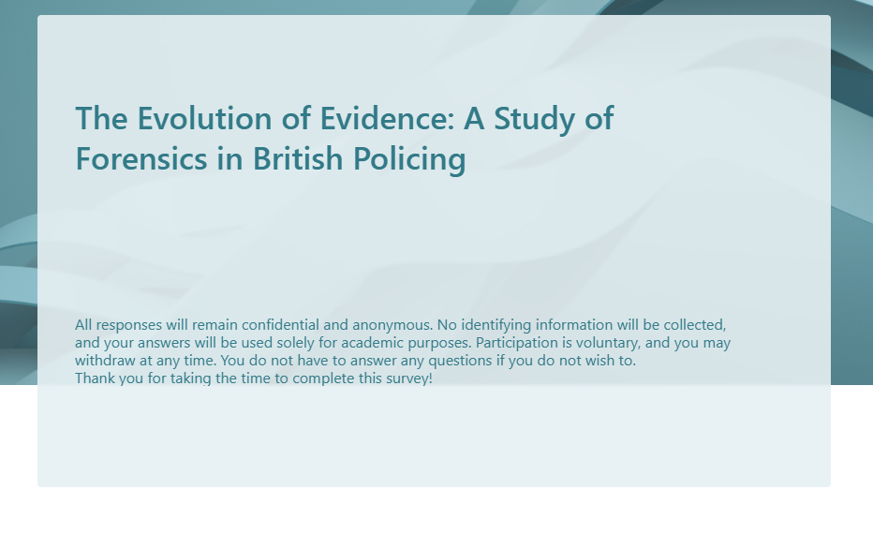
Dissertation Questionnaire



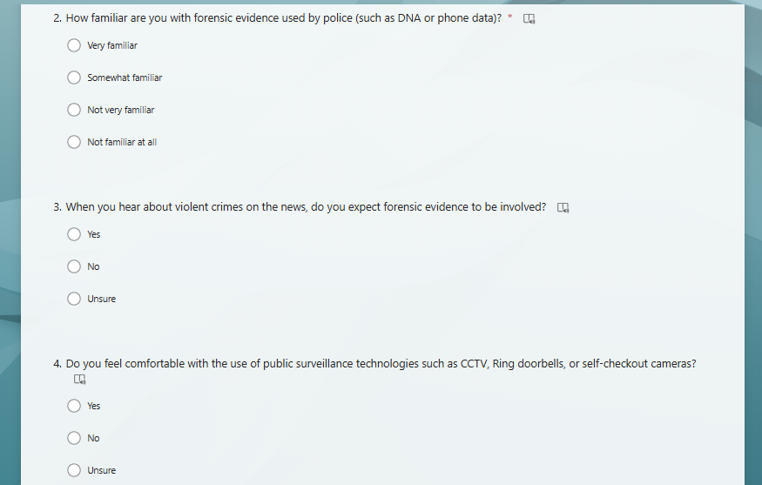

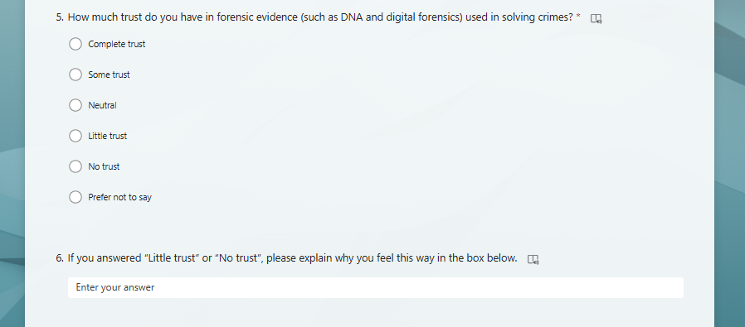

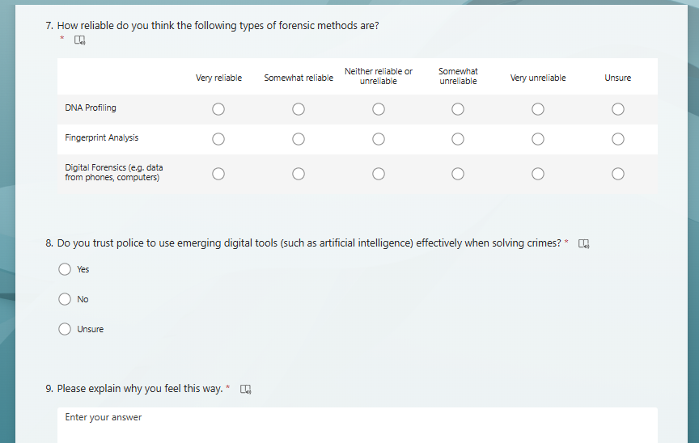

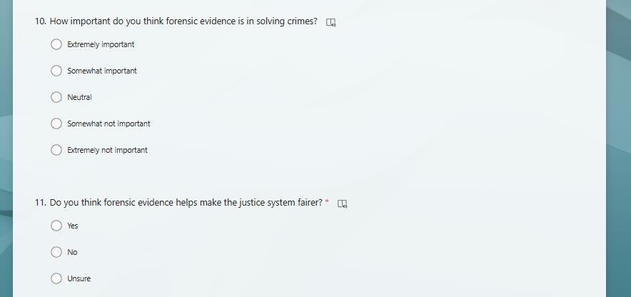

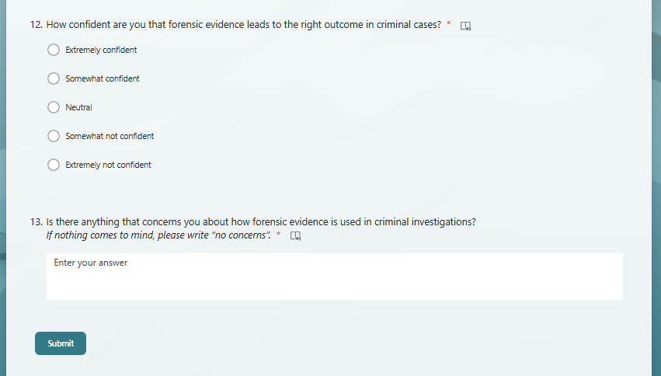

Appendix 2
Interview Questions
Question 1: Could you briefly explain your role within forensic services and how long you have worked in this area?
Question 2: How reliable would you say current forensic methods like DNA profiling and fingerprint analysis are in modern policing?
Question 3: From your experience, are there any limitations or risks when it comes to the reliability of forensic evidence?
Question 4: Are there any common misunderstandings that you think the public has about how forensic evidence is used in investigations?
Question 5: What future developments in forensic methods (such as DNA, fingerprints, or digital forensics) do you think will have the biggest impact on investigations?
Question 6: In your opinion, how might developments in forensic technology affect justice outcomes in the future?
Question 7: Do you think artificial intelligence improves the reliability of forensic evidence, or does it create new risks?
Question 8: What do you think the biggest challenge is or ethical concerns are facing forensic services in the future?
Question 9: If you could change one thing about how forensic science is currently used in policing, what would it be and why?

Appendix 3
Interview Transcript
Interviewer: Could you briefly explain your role within forensic services and how long you have worked in this area?
Participant: I am currently a Senior Manager for Scientific Support Unit and what that is, is the headquarters labs department. That includes the central submission unit and forensic submissions where they deal with all of our work coming in and out of the unit and being sent off to external labs. Then we have got the Fingerprint Development Unit who will apply chemical treatments to exhibits from quantities to enhance fingerprints and footwear marks.
The fingerprint bureau then does an analysis of any rigged detail on fingerprints, footwear, that we obtain and then compare that with the suspects from that particular crime scene. There is a separate footwear unit as well that specialise in the footwear side of things. We have the DNA clean room, so if any items are seized from a crime scene that has not been swabbed for DNA for a reason, we can have that opportunity to swab them for DNA and not lose any evidence.
We have a photography unit who manage the crime scene images and also can assist with crime scene photography when needed. There are other branches of forensic services that include digital forensics, forensic collision investigations, CSI who examine the crime scenes, and then we also have a quality team, and we have a quality [unclear] will help us make sure that we’re doing all that we need to do for those regulations.
I worked in forensics for 17-18 years, initially going in as an administrative role, looking at custody biometrics, looking at footwear and fingerprints and then moved around various departments including [unclear], DNA clean room, fingerprint enhancement. I have been in this role for almost five years, but I have worked across Gwent, Dyfed, and South Wales Police too.
Interviewer: How reliable would you say that current forensic methods like DNA profiling and fingerprint analysis are in modern policing?
Participant: They are essential really, they are used in quite a lot and obviously are not the only evidence, but they are used quite a lot in crimes and can be pivotal to an initial charge and then subsequently conviction. Fingerprints are a well-established analysis tool; it has not really changed that much. I think a fingerprint is a fingerprint, obviously it has been modernised by automating systems, we can search marks and pick potential matches, but we will always have the human intervention to check those. DNA is one that is progressing the most over the last 10 – 20 years, and it continues to progress quite rapidly so there are lots of new techniques that we come across. The external labs, who are responsible for doing all these analysis work and evaluating works, always look for ways to improve it and introducing techniques, which they do all the time.
DNA I suppose is a little bit different to fingerprints. With fingerprints, it is a match or it is not, whereas DNA is more a probability, so they use the DNA databases to give us probabilities of that match. That match is maybe one in a billion, but it is that person [unclear], excellent result, so it may be one in 28,000 which is not as great as a result, however it is still a decent match and both are used a lot in crimes.
Interviewer: From your experience, are there any limitations or risks when it comes to the reliability of forensic evidence?
Participant: I think there is always risks. The introduction of the Forensic Science Regulators Code of Practices, acquired all forensic practitioners to be [unclear], reduces that risk massively because it means that everybody has to work to a set quality management system and procedures. We audited internally; we audited externally every year.
So that reduces the risk because you have got that external body who is assessing you and making sure you are adhering to all of those statute regulations. I know things have happened in the past of various places before those regulations came in, which is why there was a need for improvement. As for the risks involved, we had managed those with good quality processes, so for example [unclear] fingerprints. If a fingerprint is identified to somebody, that does not go through just one person, it goes through two people before it can be confirmed. A report is written that is peer reviewed before it goes out too. If there is any kind of complex marks, it makes it a bit more difficult; we up that to three people. Three checks to make sure we are reducing that risk again. We have [unclear] processes, our staff have a particular training plan, competency checked every year, we have what we call proficiency tests so that the external provide a mock case with a known result and we run that through a normal process and then the outcome will be assessed as to what result we obtain and what result we should have obtained. There is a lot of processes like that, that make sure we are reducing risks as much as possible.
Interviewer: Are there any common misunderstandings that you think the public has about how forensic evidence is used in investigations?
Participant: Possibly, certainly how forensic evidence is recovered and dealt with is probably skewed because of TV shows. Everybody likes a bit of CSI in Miami and those types of shows, which are not always a true portrayal of what happens.
The classic one is the fingerprint uploaded to a system, and it searches through lots of prints and then you have got a match, and then you are going to arrest the person. Though it is not quite how it goes so that is definitely sort of misunderstood by the public. As for how it has been used within criminal investigations, I think there’s a basic understanding of, a print match or a DNA match, but probably not really a full understanding of the complexities involved.

Interviewer: What future developments in forensic methods (such as DNA, fingerprints, or digital forensics) do you think will have the biggest impact on investigations?
Participant: It’s difficult to say what would have the biggest impact, things are always developing. There’s a lot of things happening at the moment, so we’ve taken the fingerprints and it’s a match to the person, but there’s lots of work going on [unclear] we get from fingerprints. So very much university based at the moment, and not in the current policing world, but perhaps looking at traces of drugs on fingerprints, because if you have left your fingerprints and you’ve left sweat or contaminants behind, is whether there’s traces of drugs there, can we get DNA profiles from that depending on what is there. And even then, as far as looking at a person’s biometric data such as hair colour, eye colour, and skin colour, that kind of detail from any trace of DNA we get.
DNA is always developing. For example, we’ve had one recently whereby it’s quite difficult sometimes for scientists to tell what the source of the DNA is. So, for example, it’s quite easy to say it’s [unclear], but perhaps it wasn’t clear whether because they contain the same kind of constituents, the saliva and [unclear], you couldn’t tell those apart as easily. There’s a new technique that has been released quite recently, that allows scientists to definitively say that’s a vaginal fluid rather than saliva. So that’s quite interesting and that could be a game changer because that could help in sexual assault cases.
Digital forensics is not my area; I am not the best I will confess. However, well you know yourself that phones are always updating, and the challenge in that area is getting the technology they use to download data and analyse that data with every software update need [unclear]. That’s an ongoing issue for them and all our methods have to be validated before we can use them. They’re just on a continual cycle of validation, whereas that’s not so much for physical forensics, because once you’ve validated how to analyse a fingerprint, it doesn’t really change much. I [unclear] see that digital world is continually changing, so that is a challenge for them.

Interviewer: In your opinion, how might developments in forensic technology affect justice outcomes in the future?
Participant: It could improve them as technology moves on, we get better techniques, obviously that can affect the outcome, because in that example of the saliva and vaginal fluid, if they couldn’t be distinguished, we couldn’t necessarily say what the source is and then potentially, wouldn’t support, perhaps a victims account of what has happened. If we can distinguish between those two fluids, then potentially it would or wouldn’t support either way. It gives us a clearer picture of what has or has not happened. It’s the same as digital, as we get better technology to break into different software platforms, that’s when you’re going to improve things.
Currently when you talk about the world and the child exploitation images, which is a lot of digital forensic work, they are currently developing AI technology that can grade those images. At the moment there is a human being on the end of that, who are going through all those images, having to grade what they are because depending on the number and the classification, will depend on a sentence if someone is found guilty.
But to be able to have AI technology, what can that do for us? A) it is better for the wellbeing of the staff, but B) will speed up the process, because the signs [unclear], the [unclear] at the moment, and we could be talking millions of images. So, I think that will assist greatly, and it could be that at the moment, if there are a million of images, we grade a certain percentage to have the good overview of what category they are. We have to perhaps draw a line somewhere because it can take somebody, well, nine months to go through all of those images. But perhaps with AI it could be done quicker, therefore we would have a full analysis of those rather than perhaps a representative analysis.

Interviewer: My next question blends into what you’ve just said, but do you think artificial intelligence improves the reliability of forensic evidence, or does it create new risks?
Participant: Yeah, I’d say both, really. There’s uses for it, as I just said. But there will always be risks introduced with that. I think that’s really the importance of validation work, quality checking work, even if we did have that tool to do A, B and C for us, I think we would still have to [unclear] of those cases, make sure that we’re quality checking them. A human being is just looking to make sure that’s correct and nothing’s gone wrong.
Interviewer: What do you think the biggest challenge is or ethical concerns are facing forensic services in the future?
Participant: Ethical concern at the moment is around DNA, and you know the genealogy website, ancestry, those things. Now, the US have decided to start searching their criminal crime stings against the genealogy profiles and they have been doing that for a little while. We haven’t yet done that in the UK, but I guess that possibly with the Home Office and National Crime Agency, going to somewhere like the Human Rights Court to decide whether we can or cannot do that. Obviously, that would give greater opportunities to identify perpetrators of crime. On the other hand, if individuals have signed up and provided their DNA profiles for a different reason and not given consent to be searched against legal criminal databases, it’s whether that is legal or not, ethically right, or wrong. That’s probably a good example.
One of the challenges as well is our [unclear] and the rules have changed slightly, so there’s a new version of the Code of Practice released in October, which has changed things ever so slightly but could have a big impact. For example, before that, if you were a lab and you had five processes accredited and two processes not, because you hadn’t validated them yet when you report on them, you just put in your report – whether you accredited for that or not. So that was quite straightforward. It’s changed slightly in that if you don’t hold the accreditation for two of them, but you do for all five, all of a sudden, you have to declare that you’re not accredited or you’re not complying with the Code of Practice. I think that challenge is when those reports enter the Criminal Justice System is to make sure that the CPS defence lawyers, all understand what that means or why it’s being declared that way.

Interviewer: If you could change one thing about how forensic science is currently used in policing, what would it be and why?
Participant: That’s a good question. I think I would like police officers to have a better knowledge of forensics. Obviously, they have a lot of things they have to learn to do in training. Forensics is just a small part of that. I suppose the reason because sometimes we are asked to complete work but maybe isn’t in the best route to take or isn’t really relevant to the investigation or there’s things that are misunderstood. So, I suppose that would massively improve things.
We kind of had gatekeepers in place so when we have a submission request come through to us, that person was then looking at that submission and gatekeep it and go, right, well they’ve asked for this, but actually we think that this would be a better route and then we have that conversation with the investigation team, which works and that’s how we make sure that we’re doing the best we can, or we’re not losing forensic opportunities. That obviously slows the process down because there’s that step, whereas if perhaps the forensic training was a bit more enhanced, then we, well not say we wouldn’t need that step, but certainly that step would probably be smoother and maybe less things being picked up. I think that would be a good improvement.
Well, I suppose, another thing happening in the forensic communities because of all the accreditation requirements, there is a lot of working groups being set up. There is one for enhancing DNA, and that is really good because it brings together people in that discipline from all forces into a working group, so you can have those conversations like we have had this challenge, how does everyone else deal with this? It is that kind of information sharing that is really good. I think, you know, we are doing more and more of that, which is lovely to see.

