Portfolio for ECEY4014

Contents:
Part 1: Personal Development Plan & Personal Reflection pages 2-3
Part 2: Academic Poster page 4
Part 3: Written Essay pages 5-9
Reference List: page 10-11

AI Acknowledgement:
I confirm that I have not presented any AI generated content as my own original writing. I used Grammarly to review my written work and assist with the correction of spelling, grammar and punctuation, helping to improve the accuracy and clarity of my writing. All final written work in my portfolio has been produced independently and reflects my own academic thinking and evaluation.

ECEY4014: The Professional Practitioner
No | Improvement and Development Goals | Success Criteria | The actions I will take to achieve the goal | Timelines | What will this help me to achieve? | Achievements  (3 monthly review)
1 | Short term: Improve my wellbeing and establish a manageable routine. | Maintain regular meals, three weekly walks, and make time for protected rest. | Plan simple meals, walks with Freddie and discuss sharing responsibility with Freddie’s dad. Review what is realistic each week and adjust when needed. | Establish by November 2026. To be reviewed weekly. | Greater resilience, energy and patience when caring for Freddie and supporting children at work. | Review pending. Assess progress in January 2027.
2 | Medium term: Balance university study, work and family responsibilities. | Submit assignments on time, complete planned study sessions and protect family time. | Use a weekly planner, divide assignments into smaller tasks and study during suitable naps or agreed childcare. Allow flexibility for unexpected demands. | Achieve by January 2027. To be reviewed weekly. | Better organisation, reduced pressure and greater consistency in my personal and professional responsibilities. | Review pending. Assess progress in January 2027.
3 | Long term: develop confident professional communication and maintain appropriate boundaries. | Seek monthly feedback and record weekly reflections showing improvements in practice. | Observe experienced colleagues, practise active listening, maintain confidentiality and ask for guidance when unsure. Use feedback to identify changes and apply them. | By the end of my first academic year. Review monthly. | Stronger professional relationships, confidence and accountable practice. | Review pending. Assess progress in January 2027.

Personal Reflection:
Studying early years education and care whilst working as a teaching assistant and caring for Freddie requires me to balance several responsibilities. My experience working in a primary school has shown me the importance of patience and teamwork. Becoming a mother has also helped me appreciate parents’ feelings, although I must avoid assuming every family shares my experiences.
My main personal challenge is managing time without neglecting my wellbeing or relationships. I can feel overwhelmed when studying, work and childcare compete for my attention. Planning smaller tasks around Freddie’s routine should help, but I need flexibility because his needs can change. Asking my partner for support and protecting family time will make this approach more sustainable. Rest and regular meals should also support my concentration and patience at work.
Professionally, I want to communicate confidently, while recognising the limits of my role. Listening carefully, using appropriate language and seeking feedback will help me build trusting relationships with children, colleagues and parents. I must maintain confidentiality and professional boundaries, including when using social media. Respectful behaviour, punctuality and suitable clothing will help me model professionalism.
One limitation of my plan is that completing tasks does not automatically demonstrate improvement. I will therefore consider how my actions affect practice, rather than simply recording activities. For example, feedback may show whether my explanations are clearer, while reflections may identify occasions when I needed support. If my study routine repeatedly disrupts rest or family time, I will revise it. This will help me develop realistic habits instead of setting expectations I cannot sustain.
Weekly reflections and monthly feedback will help me evaluate progress. At my three month review, I will assess which habits are manageable and adjust goals where necessary. I want greater confidence and consistency while protecting time for Freddie and maintaining my responsibilities as a practitioner.

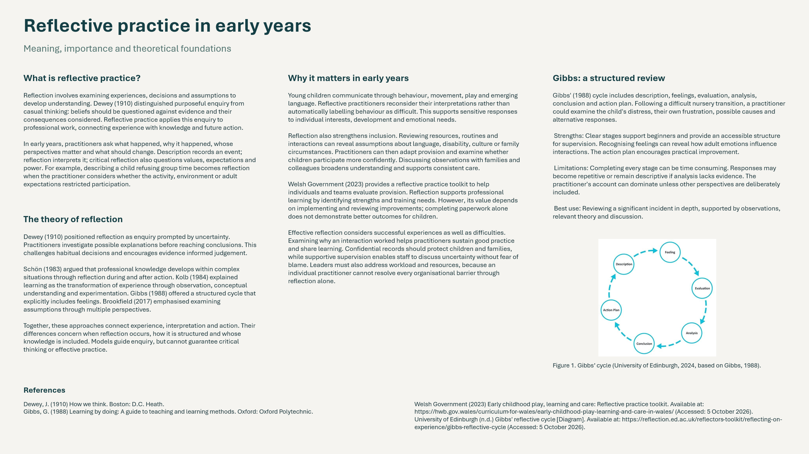
Part 2: Academic Poster
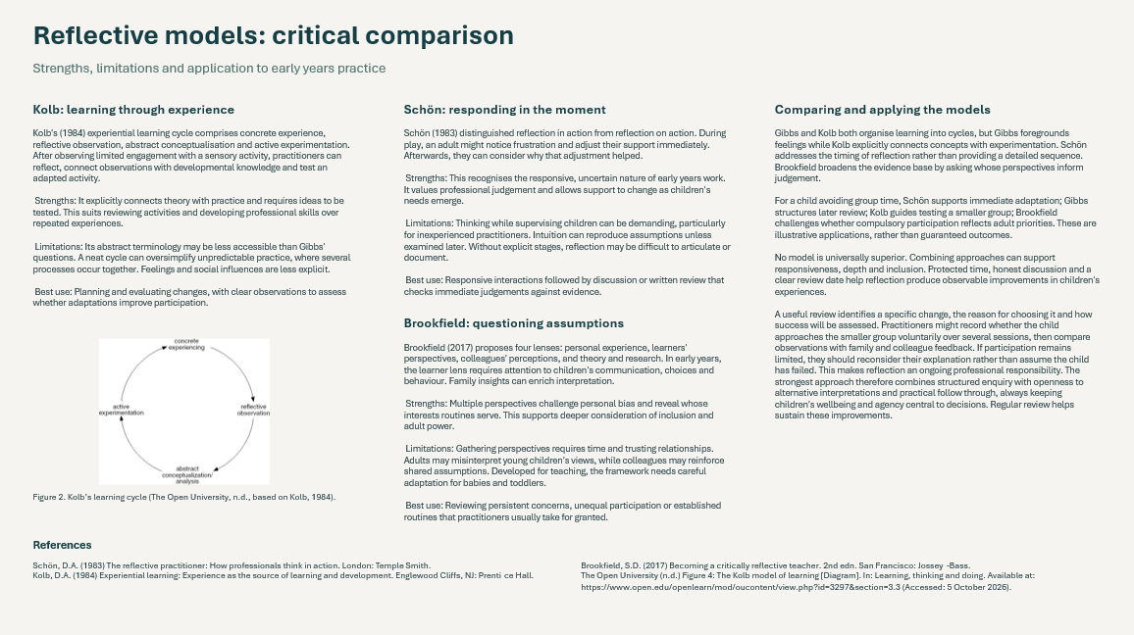
Part 3: The Significance of Professional Practice in Meeting the Individual and Inclusive Needs of Children
Introduction
Professional practice is crucial in early years education, helping to ensure that children are given the right care, support, and learning opportunities tailored to their unique needs. A professional is someone who shows the necessary knowledge, skills, values, and sense of responsibility to fulfil their role effectively. In early years settings, this means upholding high standards of care, adhering to policies, safeguarding confidentiality, and supporting children's wellbeing and development. Practitioners are also expected to be patient, empathetic, and respectful, while understanding that each child develops differently and at their own speed.
The Welsh Government (2024) emphasises the importance of providing high quality, inclusive learning experiences that support children's individual development. This highlights the responsibility of professionals to create environments where all children feel safe, respected and valued, regardless of their abilities, backgrounds or circumstances.
Professional practice covers several key areas, such as communication, building positive relationships, safeguarding, teamwork, and reflecting on practice. These elements help ensure that children consistently get the support they need and have equal opportunities to join in with learning. This essay will look at why professional practice matters, especially by focusing on communication and relationships, and will consider how these factors help meet both the individual and inclusive needs of children.

The Importance of Professional Practice
Professionalism within early years education involves more than simply completing daily responsibilities. Practitioners must demonstrate appropriate behaviour, professional judgement and a commitment to children's development and wellbeing. This includes understanding individual differences, recognising additional learning needs and adapting approaches to ensure that every child can participate meaningfully.
The Welsh Government (2023) identifies the importance of reflective practice and developmentally appropriate experiences within early childhood education. This suggests that professionals should regularly evaluate their approaches and consider whether their practice is meeting children's needs effectively. For example, if a child struggles to participate in a group activity, a practitioner may reflect on the reasons behind this and introduce alternative approaches, such as smaller group activities or additional visual support.
However, professionalism also requires practitioners to recognise their limitations and seek advice when necessary. Working collaboratively with colleagues and other professionals can provide additional knowledge and strategies to support children with more complex needs. This demonstrates that effective professional practice is not solely dependent on individual knowledge but also on a willingness to learn and improve.
Safeguarding is another essential responsibility. Practitioners must recognise potential concerns, follow appropriate reporting procedures and maintain professional boundaries. Establishing a safe environment enables children to feel secure and confident when exploring new experiences. Therefore, professional practice is significant because it establishes the standards and responsibilities necessary to protect children's welfare while supporting their learning and development.

The Importance of Communication in Professional Practice
Effective communication is one of the most important aspects of professional practice because it enables practitioners to understand children's needs, feelings and experiences. Communication involves both verbal and nonverbal interactions, including spoken language, facial expressions, gestures, body language and listening.
According to the Welsh Government (2022), communication is fundamental to children's development and supports relationships, learning, play and social interaction. This demonstrates that communication is not simply a method of exchanging information but an essential part of children's emotional, social and cognitive development.
Within early years settings, practitioners should communicate using language appropriate to each child's age, understanding and developmental stage. For example, younger children may benefit from simple instructions, visual prompts and gestures, whereas older children may be encouraged to express their opinions through conversations and questions.
Effective communication also involves active listening. When practitioners listen carefully and respond appropriately, children are more likely to feel respected and valued. This can encourage children to develop confidence in expressing their thoughts, asking questions and communicating their needs.
However, communication approaches that work effectively for one child may not be appropriate for another. Children with additional learning needs, speech and language difficulties or limited English or Welsh language experience may require alternative communication methods. These could include visual timetables, picture cards, signing or additional processing time.
Adapting communication methods demonstrates inclusive professional practice because it removes potential barriers to participation. Rather than expecting every child to communicate in the same way, practitioners recognise individual differences and provide suitable support.
Communication is also essential when working with parents and carers. Parents often have valuable knowledge about their child's routines, interests, development and emotional needs. The Education Endowment Foundation (2018) identifies parental engagement as an important influence on children's learning outcomes, although the effectiveness of different approaches can vary.
For example, regular communication between practitioners and parents may help identify changes in a child's behaviour or development. This allows appropriate strategies to be introduced consistently between home and the educational setting.
Nevertheless, communication with families must remain professional, respectful and confidential. Practitioners should avoid making assumptions about family circumstances and recognise that some parents may experience barriers to communication. Providing flexible opportunities for discussion and using accessible language can help develop more inclusive partnerships.
Therefore, effective communication contributes towards professional practice by strengthening understanding, supporting children's development and encouraging collaboration between everyone involved in their care.

The Importance of Positive Relationships
Positive relationships are another significant aspect of professional practice because they contribute towards children's emotional security, confidence and sense of belonging. Young children rely on consistent and supportive interactions with adults to develop trust and feel comfortable within unfamiliar environments.
The World Health Organization, UNICEF and World Bank Group (2018) emphasise that nurturing and responsive care is essential for healthy early childhood development. This highlights the importance of practitioners providing emotional support alongside educational opportunities.
Within early years settings, positive relationships can be developed through consistent routines, encouragement, reassurance and showing genuine interest in children's experiences. For example, greeting children warmly when they arrive, listening to their concerns and celebrating their achievements can help establish trust.
When children feel secure in their relationships with practitioners, they may become more willing to explore their environment, participate in activities and develop independence. The Welsh Government (2022) also recognises that secure relationships contribute towards children's sense of belonging within educational environments.
However, developing positive relationships requires practitioners to understand that children have different emotional needs and experiences. Some children may settle into an educational setting quickly, while others may experience separation anxiety or require additional reassurance.
For example, a child who becomes distressed when separating from their parent may benefit from a consistent key person, familiar routines and a comforting activity. These approaches can help the child gradually develop confidence and feel emotionally secure.
Positive relationships are particularly important when supporting children who have experienced challenging circumstances or require additional emotional support. Practitioners should demonstrate sensitivity and avoid interpreting behaviour without considering the child's individual circumstances.
Although supportive relationships are essential, practitioners must also maintain professional boundaries. Being approachable and caring should not compromise safeguarding responsibilities or appropriate professional conduct.
Consequently, positive relationships contribute towards inclusive practice by helping children feel accepted, supported and emotionally prepared to engage in learning.

Meeting Individual and Inclusive Needs
Inclusive practice involves ensuring that all children have equal opportunities to participate, regardless of their abilities, backgrounds, cultures or individual circumstances. However, equality does not necessarily mean treating every child identically. Instead, practitioners must recognise that some children require additional support or adaptations to access the same opportunities.
The Welsh Government (2024) emphasises the importance of removing barriers and providing inclusive experiences that respond to children's individual circumstances. This demonstrates that inclusion should be embedded within everyday professional practice rather than treated as an additional responsibility.
For example, a practitioner may adapt a creative activity for a child experiencing difficulties with fine motor skills by providing larger equipment or alternative materials. Similarly, a child with communication difficulties may benefit from visual instructions and additional time to respond.
These adaptations allow children to participate alongside their peers while developing their confidence and independence. However, practitioners must ensure that additional support does not unnecessarily limit children's opportunities to make choices or attempt activities independently.
Communication and relationships are closely connected to successful inclusion. Without effective communication, practitioners may struggle to recognise children's preferences, abilities or concerns. Similarly, without trusting relationships, children may feel uncomfortable expressing when they require support.
Collaboration with parents, colleagues and relevant professionals can further strengthen inclusive practice by providing a more complete understanding of each child's needs. Nevertheless, practitioners should continually evaluate whether the strategies introduced are effective, rather than assuming that one approach will work for every child.
This demonstrates the importance of professional judgement, flexibility and reflection when creating learning environments where all children feel included.

Conclusion
In conclusion, professional practice is essential in ensuring that children receive appropriate care, support and learning opportunities that reflect their individual and inclusive needs. Professionalism requires practitioners to demonstrate knowledge, responsibility, empathy and a commitment to continuous improvement.
Effective communication allows practitioners to understand children's needs, encourage participation and develop meaningful partnerships with families. Similarly, positive relationships provide the emotional security and trust that children require to develop confidence, independence and a sense of belonging.
Although communication and relationships are fundamental, their effectiveness depends on practitioners recognising individual differences and adapting their approaches accordingly. Through reflective practice, collaboration and inclusive strategies, early years professionals can create supportive environments where every child has the opportunity to develop and achieve their potential.

Reference List:
Brookfield, S.D. (2017) Becoming a critically reflective teacher. 2nd edn. San Francisco: Jossey-Bass.
Dewey, J. (1910) How we think. Boston: D.C. Heath.
Education Endowment Foundation (2018) Working with parents to support children's learning. London: Education Endowment Foundation. Available at: https://educationendowmentfoundation.org.uk/education-evidence/guidance-reports/supporting-parents (Accessed: 20 October 2026).
Gibbs, G. (1988) Learning by doing: A guide to teaching and learning methods. Oxford: Oxford Polytechnic.
Kolb, D.A. (1984) Experiential learning: Experience as the source of learning and development. Englewood Cliffs, NJ: Prentice Hall.
Schön, D.A. (1983) The reflective practitioner: How professionals think in action. London: Temple Smith.
The Open University (n.d.) 'Figure 4: The Kolb model of learning' [Diagram]. In: Learning, thinking and doing. Available at: https://www.open.edu/openlearn/mod/oucontent/view.php?id=3297&section=3.3 (Accessed: 5 October 2026).
University of Edinburgh (2024) Gibbs' reflective cycle [Diagram]. Available at: https://reflection.ed.ac.uk/reflectors-toolkit/reflecting-on-experience/gibbs-reflective-cycle (Accessed: 5 October 2026).
Welsh Government (2022) Enabling learning. Cardiff: Welsh Government. Available at: https://hwb.gov.wales/curriculum-for-wales/designing-your-curriculum/enabling-learning (Accessed: 20 October 2026).
Welsh Government (2023) Early childhood play, learning and care: Reflective practice toolkit. Available at: https://hwb.gov.wales/curriculum-for-wales/early-childhood-play-learning-and-care-in-wales/ (Accessed: 5 October 2026).
Welsh Government (2023) Written statement: Publication of a quality framework for early childhood play, learning and care in Wales and supporting materials. Cardiff: Welsh Government. Available at: https://www.gov.wales/written-statement-publication-quality-framework-early-childhood-play-learning-and-care-wales-and (Accessed: 20 October 2026).
Welsh Government (2024) Written statement: The Early Childhood Play, Learning and Care in Wales Plan. Cardiff: Welsh Government. Available at: https://www.gov.wales/written-statement-early-childhood-play-learning-and-care-wales-plan (Accessed: 20 October 2026).
World Health Organization, United Nations Children's Fund and World Bank Group (2018) Nurturing care for early childhood development: A framework for helping children survive and thrive to transform health and human potential. Geneva: World Health Organization. Available at: https://www.who.int/publications/i/item/9789241514064 (Accessed: 20 October 2026).

