
PROGRAMME: MASTER OF BUSINESS ADMINISTRATION
MODULE: INTERNATIONAL MARKETING: PRINCIPLES AND PRACTICES
MODULE CODE: LCMB7026
LECTURER: Taonga Kaonga Sobere-Snithers
ASSIGNMENT TITLE: INTERNATIONAL MARKETING: PRINCIPLES AND PRACTICES
STUDENT NAME: SAURABH BISHT
STUDENT NUMBER: 2433287

Executive summary
The objective of developing this report is to analyse and evaluate marketing strategies of Coca-Cola in two different countries, the UK and Canada. Strategic beliefs of Coca-Cola reflects that the renowned beverage company have been valuing marketing leadership, branding, and product selection, responsible manufacturing along with citizenship. This company has started to invest in the digital marketing aspect following influencer marketing and social media engagement for shaping UK consumer preferences. On the other hand, decreased employability and R&D budget are the negative elements that push Coca-Cola’s strategic marketing aspects implementation backward. Moreover, some similarity and differences have been observed in Coca-Cola’s current marketing practices in the UK and Canada.

2. Table of Contents
3.Introduction 4
4. Brand overview 4
5. Comparison of the socio-cultural context of Country A (the UK) and Country B (Canada) 5
5.1 Socio-cultural context of Coca-Cola in the UK 5
5.2 Socio-cultural context of Coca-Cola in Canada 8
6.Comparison of Brand’s STP strategies in UK and Canada 10
6.1 Comparing Segmentation in both UK and Canada 12
6.2 Comparing Targeting in both UK and Canada 12
6.3 Comparing Positioning in both UK and Canada 13
7. Comparison of Marketing Mix Strategies in UK and Canada 14
7.1 Coca-Cola’s 7Ps Marketing Mix of UK and Canada 14
8. Evaluation of the performance of marketing strategies 19
9. Evaluation of marketing ethics practice 21
9.1 Ethical practices in the UK 21
9.2 Ethical practices in the Canada 21
9.3 Comparative evaluations on ethical practices 22
10. Recommendation and Conclusion 23
Recommendations 23
Conclusion 24
11. References 25
12. Appendices 34
Appendix 1: UK employment rate 34
Appendix 2: Employment rate of Canada 34
Appendix 3: FY24 Unit Case Volume of Coca-Cola 36
Appendix 4: 7Ps of Marketing Mix 37
Appendix 5: Strategic Recommendations 38

3.Introduction
International marketing is considered as the strategy of promoting, advertising and selling products or services of a brand in foreign countries. Extending the business, widening the consumer market and promoting a brand name are the common aims of international marketing (Lubis and Muniapan, 2024). The main objective of developing this report is to analyse and evaluate marketing strategies of Coca-Cola in two different countries, the UK and Canada respectively. This report has contained socio-cultural context, brand’s STP strategies, and marketing Mix Strategies considering these two foreign countries. Theoretical aspects and tools such as PESTLE, 7Ps marketing and others have been used in this report for evaluating the marketing performance of Coca-Cola in the selected foreign markets. Annual sales, number of branches, market share, social media engagement and brand awareness are the main factors of comparison between marketing strategies of Coca-Cola in the UK and Canada. Lastly, Coca-Cola is also provided suggestions for improving international marketing structure in future.

4. Brand overview
Coca-Cola is one of the leading beverage brands belongs to the US industry and it offers signature cola, water coffee and other soft drink items. The mission of Coca-Cola includes “Refresh the World and Make a Difference” (Coca-colacompany, 2025). Coca-Cola is recognised to focus on body and spirit as well as making a sustainable business in the worldwide beverage industry. Contributing to people's lives, this brand has taken the aim of improving the economy along with driving a green planet. In addition, the strategic beliefs of Coca-Cola include branding, marketing leadership, product selection, responsible manufacturing as well as citizenship. It has been recognised that Coca-Cola’s beverage items are available in more than 200 countries (Coca-colacompany, 2025). The wide distribution along with strategic marketing aspects has made Coca-Cola powerful in the operating market. At present, Coca-Cola has more than 700,000 employees in the manufacturing, packaging and distribution segment.
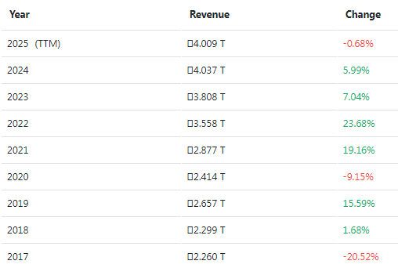
Figure 1: Global revenue of Coca-Cola
(Source: Companiesmarketcap, 2025)
The above figure has highlighted the global revenue of Coca-Cola from the past 10 years. It has been recognised that the total revenue of Coca-Cola was increased from GBP 3.808 trillion to GBP 4.156 trillion from 2023 to 2024 (Companiesmarketcap, 2025). Coca-Cola’s current revenue is GBP 4.009 trillion in 2025. The product diversification, wide business and unique brand portfolio have made Coca-Cola different from the others brands. “Smartwater alkaline 9.5+ pH”, “Flashlyte” and “Jack Daniel's & Coca-Cola” are some successful innovations of Coca-Cola (Coca-colacompany, 2025). The marketing investment of Coca-Cola has been shifted towards digital, retail and live marketing and experiences. This brand is currently working on reducing plastic usage as well as waste from its production process. The aspect of recycling has been used in Coca-Cola for contributing in the sustainable aim. In addition, this business organisation has taken the initiative of achieving net-zero carbon emissions within 2040 (Coca-colacompany, 2025). Therefore, the science-based target manufacturing process has been included in the operational practices of Coca-Cola which can promote its brand value in future.

5. Comparison of the socio-cultural context of Country A (the UK) and Country B (Canada)

5.1 Socio-cultural context of Coca-Cola in the UK
Factors | Description | Impact on Coca-Cola
Political | Political stability: The UK political stability has dropped from 0.53 to 0.51 from 2022 to 2023 (The global economy, 2023). | Negative
Economical | Inflation: The UK inflation has increased by 3.8% from 3.6% in 2025 (Statista, 2025). | Negative
Social | Employment rate: The UK employment rate at present is 75.2% (Statista, 2025). | Positive
Technological | R&D: The R&D budget in the UK was increased by GBP 16.1 billion to GBP 17.4 billion from 2022 to 2023 (Gov UK, 2025). | Positive
Legal | Business law: “The Company Act 2006” has provided the guidelines conducting operational practices fairly in the operating market (Gov UK, 2025). | Positive
Economical | Sustainability aims and inclination towards sustainability: The UK gov has called the action to Net Zero 2050 through Green Industrial Revolution (Gov UK, 2025). | Positive
Table 1: PESTLE of the UK
(Source: Self-developed)
Analysis
The socio-cultural context of a country is directly related to the marketing activities of an international brand as it shapes industrial growth, labour market and consumer preferences. Based on the views of Rosário and Raimundo (2021), market competitiveness has been defined through the social and cultural factors which enable strategic marketing effectiveness within a brand. The above table has highlighted the social-cultural situation of the UK indicates the decreased political instability and increased inflation rate. As per the views of Hajarath and Vummadi (2024), political instability in a country promotes the risk of business failure as well as disrupting operational practices. Similar to this context, Coca-Cola can face political barriers while conducting product innovation or growth projects in the UK. Coca-Cola has started to invest in the digital marketing aspect through influencer marketing and social media engagement in the UK for shaping consumer preferences (Coca-colacompany, 2025). Political risk can create barriers between target customers and marketing campaigns of Coca-Cola. On the other hand, the increased inflation rate of the UK has pointed out the lower purchasing power of citizens (Statista, 2025). It can lower the effectiveness of digital marketing practices of Coca-Cola in the UK industry.
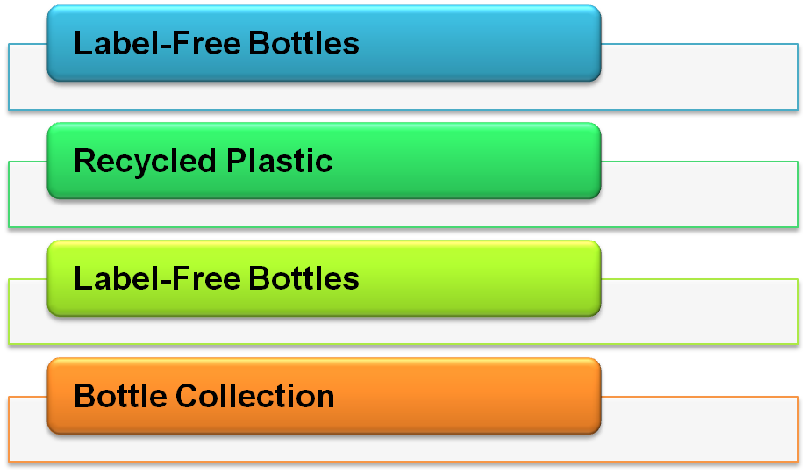
Figure 2: Coca-Cola’s sustainability initiative inspired by UK Gov sustainability plan
(Source: Data taken from Coca-colacompany, 2025)
The budget of international or strategic marketing practices of Coca-Cola in the UK can be increased because of inflation rate. The risk of financial uncertainty in the UK can demotivate Coca-Cola from conducting international marketing practices. However, the employment rate as well as the research and development budget of the UK have been increased [Refer to appendix 1]. Coca-Cola can get the opportunity of conducting digital marketing in an effective manner depending on the R&D budget. Hiring potential members from the UK labour market, Coca-Cola has already developed an effective marketing structure. Agustian et al.(2023) have stated that skilled employees are one of the key factors for marketing success in a company. The Company act of the UK has supported Coca-Cola to conduct the international marketing practices ethically by contributing in social and environmental wellbeing. In addition, the UK government has provided the chance of establishing business by adding the path of sustainability (Gov UK, 2025). It has been recognised that Coca-Cola has used recycled materials for beverage bottles in Great Britain (Coca-colacompany, 2025). Therefore, the international marketing strategies of Coca-Cola has been affected both positively and negatively through the UK social-cultural context.

5.2 Socio-cultural context of Coca-Cola in Canada
Factors | Description | Impact on Coca-Cola
Political | Political stability: Canada ranks 2nd among G7 countries that indicates its low corruption (Invest Canada, 2025). | Positive
Economical | Inflation: Annual inflation of Canada is increased from 1.7 to 1.9% in the ongoing year (Yahoo, 2025). | Negative
Social | Employment rate: Employment rate of Canada has been decreased from 60.90% to 60.70% in 2025 (Trading economics, 2025). | Negative
Technological | R&D: The percentage of the research and development budget of Canada was decreased in 2025 than 2023 because of economic uncertainty after the pandemic situation (World bank, 2025). | Negative
Legal | Business law: “Canada Business Corporations Act 1985” has provided the guidelines conducting operational practices fairly in the operating market (GC Canada, 2025) | Positive
Economical | Sustainability aims and inclination towards sustainability: Canadian Government has announced the initiatives of achieving the UN SGDs for addressing the economic and environmental challenges (Canada, 2025). | Positive
Table 2: PESTLE of Canada
(Source: Self-developed)
Analysis
The socio-cultural factors that can possibly impact the international marketing strategies of Coca-Cola are highlighted in the above table. The good governance of political stability has provided the opportunity of business expansion through strategic markets to Coca-Cola. For instance, Coca-Cola has used the localised context as well as flavour of beverage for product innovation and marketing in Canada (Coca-colacompany, 2025). “Toronto Maple Leafs and Montreal Canadian’s” are the business partners of Coca-Cola in the Canadian market for marketing and promotions. However, the increased inflation rate has made a critical challenge to Coca-Cola in ensuring financial stability in this geographical location. The consumer price index of Canada in 2025, August has indicated the lowered purchasing power of individuals (Rabinovitch et al. 2025). In addition, the decreased employability rate along with R&D budget are the negative elements that push Coca-Cola’s strategic marketing plan implementation backward [Refer to appendix 2].
Integration of emerging tools and technologies such as big data and AI, companies have promoted its digital marketing (Hamamah et al. 2024). The stagnant R&D budget can create issues for Coca-Cola in improving the tech advancement in the marketing segment of Canada. The fair legal rules in business construction and current culture of sustainability work as motivational factors to Coca-Cola in strategic marketing implementation. For instance, Coca-Cola has already launched 500 ml beverage bottles made with virgin PET plastic (Coca-colacompany, 2025). The circular economic initiative of Coca-Cola has attracted the responsible consumer in Canada in an effective manner.

6.Comparison of Brand’s STP strategies in UK and Canada
STP Elements | Company A: United Kingdom (UK) | Company B: Canada
Segmentation | - Focusing on young demographics such as millennials, Gen Z, urban consumers and health-conscious groups due to sugar tax  - Major psychographic focus on lifestyle | - Families, multi-cultural communities and young people (Rao, 2025).  - The geographic segmentation shows for strong territory with different strategies for urban and rural regions
Targeting | - Young and health-conscious customers, urban markets and affordable through convenience-store promotions (coca-cola, 2025).  - The experiential campaigns like sports or music sponsorship | - Families and community-oriented groups, bilingual and multicultural populations like sports fans  - Focusing on balanced millennials, Gen Z and tradition-lover consumers
Positioning | - Coca-Cola Zero Sugar as a product, positioned around lifestyle and sustainability considering 100% recyclable packaging (Coca Cola, 2022).  - Original coke positioned secondary | - Coca-Cola Original remains flagship positioning as part of Canadian heritage, community and national identity  - Inclusive positioning shows to multi-cultural and bilingual audiences
Table 3: STP for UK and Canada
(Source: Self-made)

6.1 Comparing Segmentation in both UK and Canada
The segmentation has been strongly shaped by regulation and consumer lifestyle trends in the UK. The 2018 introduction of the soft drinks industry levy (Sugar tax) has led Coca-Cola Zero Sugar and Diet Coke to receive strong promotion for targeting especially wellness-driven customers (Cobiac et al. 2024). Furthermore, the demographics such as London and Manchester are priority zones where the trends towards fitness and sustainable living dominate (London Government of UK, 2025). “UK soft drinks industry review by Mintel” has shown that consumers nowadays prefer soft drinks with greater health benefits over any sort of supplements and vitamins and it is the testament of consumers’ faith as per “Food as medicine ethos” (store. Mintel, 2025).
As discussing the segmentation in Canada which is wide and low regulated. Coca-Cola has continued to cater to traditional indulgence seekers who prefer the original formula while simultaneously appealing for youth, trend-sensitive consumers by Coke Zero (Coke Canada, 2021). The families from the central segment in Canada where Coca-Cola is marketed as part of communal experiences such as barbecues, hockey matches and national holidays as well (Lombardo, 2024). Canada’s multi-cultural and bilingual influences Coca-Cola to integrate segmentations by reflecting ethnic diversity and regional languages particularly in Quebec (Rao, 2025).
Hence, comparing both countries for Coca-Cola’s segmentations, while UK’s segmentation is highly health and regulation focused, Canada’s segmentation shows cultural inclusivity, family orientation and geographic diversity. The UK narrows focus to urban, younger a dwell-ness-minded groups, on the other side, Canada enhances appeal to national traditions and cultural groups.

6.2 Comparing Targeting in both UK and Canada
Coca-Cola has targeted three major groups in the UK such as health-conscious individuals seeking low sugar options. Another group is youth and young adults who have engaged in digital campaigns and sponsorships of football or e-sports (Jonwal, 2025). Lastly, the general consumer has reached by affordability-based supermarket and convenience-store promotions. The COVID-19 campaign such as ‘Open like never before’ has aligned aggressively with the young urban consumers, framing the company as an optimistic and socially aware brand (Coca-Cola, 2025).
On the other hand, Canada’s targeting differs by showing high focus on families and community groups. The National campaigns often highlight the shared experiences by positioning Coca-Cola as a unifying element at gatherings and holidays (Coca-Cola, 2025). The sponsorship of Canadian sports, particularly ice hockey to link with this communal appeal as well (Coca-cola, 2025). Hence, comparing both countries in respect to targeting, UK targeting prioritises health-conscious and digitally active young people whereas Canada has adopted a community and family focused strategy which has integrated multicultural inclusivity. Both countries have focused on young consumers but the UK leans to health and affordability while Canada has integrated traditional and diversity.

6.3 Comparing Positioning in both UK and Canada
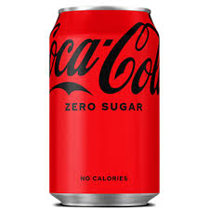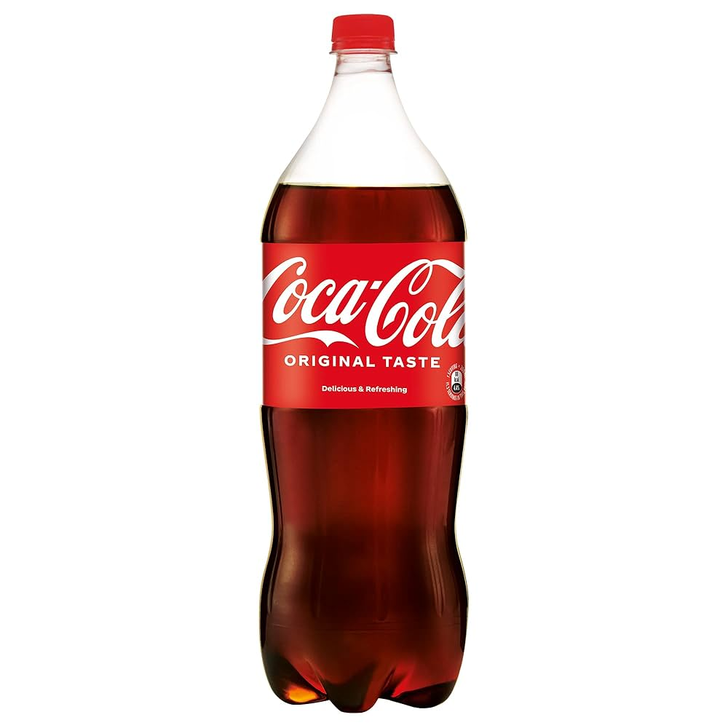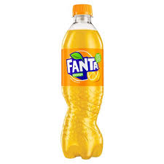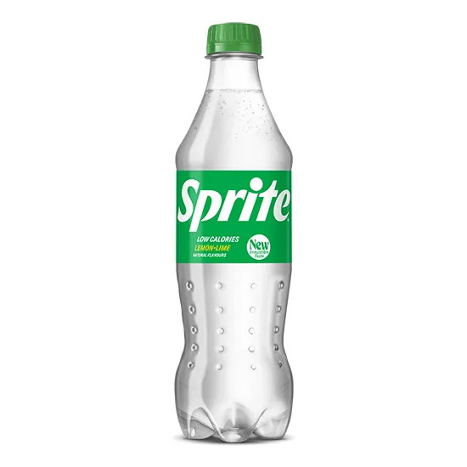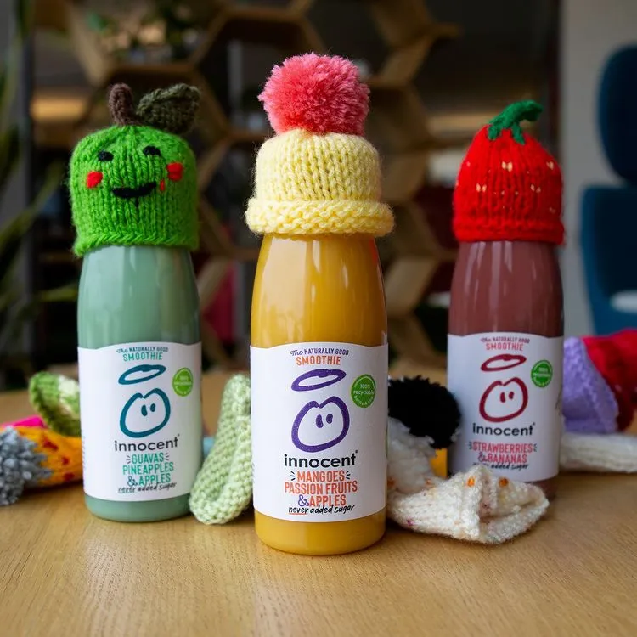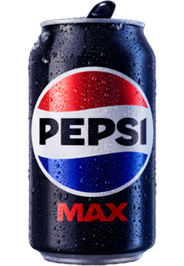
High Health consciousness
Low Price
High Price
Low Health consciousness
Figure 3: Positioning map for the Company A- UK
(Source: Self-made)
Coca-Cola has positioned itself primarily as a lifestyle and wellness brand in the UK. Coca-Cola Zero Sugar has been treated as the major considering equal or greater visibility than the original products. Coca-Cola has utilised the ‘Taste the Feeling’ campaign for promoting both enjoyment as well as responsibility in the UK (Stibbe, 2023).
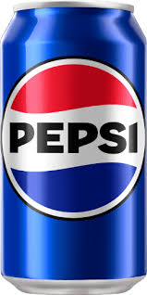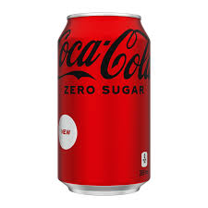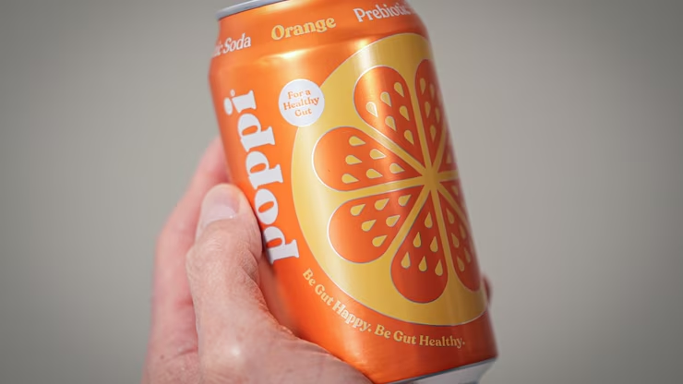
High Tradition and culture
Low Inclusivity or Community appeal
High Inclusivity or Community appeal
Low Tradition and culture
Figure 4: Positioning map for the Company B- Canada
(Source: Self-made)
The brand has presented itself as a symbol of unity, heritage and cultural celebrations in Canada. Furthermore, Coca-Cola Original has remained the major product closely tied to Canadian holidays, sporting events like hockey and national pride. Coca-Cola has also enhanced their strengths with emotional bon to Canadian consumers by reinforcing their long-term brand reputations as part regular life (Coca-Colabranding, 2025). Marketing often has drawn on Canadian imagery such as red and white branding, hockey and Canada Day celebrations (de Souza Tavares and Silitonga, 2023). Comparing the UK positioning has focused on wellness, sustainability and product variety while Canada has highlighted tradition, heritage and inclusivity. The UK has elevated Coca-Cola Zero Sugar as their central product, whereas Canada has continued to foreground the original formula as a national icon.

7. Comparison of Marketing Mix Strategies in UK and Canada

7.1 Coca-Cola’s 7Ps Marketing Mix of UK and Canada
7Ps of Marketing Mix | Description for the UK | Description for the Canada
Product | Coca-Cola’s product line includes water, soft drinks, coffee, juice drinks, adult soft drinks, alcohol-based drinks and sports and energy drinks in the UK to ensure products for everyone (Coca Cola, 2025). | Coca-Cola’s product lines include Coca‑Cola, Coke Zero, Diet Coke, Fanta, Sprite, Barq's, POWERADE, FUZE Iced Tea, DASANI, vitaminwater, Core Power and fairlife for Canadians (Coca Cola, 2025).
Price | Coca-Cola’s pricing strategy relies on offering high-cost products with various quality as the rate of Coca-Cola increased by 11% at the end of 2023 in the UK (Reuters, 2023). | Coca-Cola follows a high pricing strategy that is similar across the global market including Canada.
Place | Coca-Cola’s products are available online and offline markets to ensure maximum market availability in the UK. | Coca-Cola’s all products can be purchased by the Canadian customers from online and offline markets at the same time.
Promotion | ‘Fantasy Challenge’ is a considerable pack promotion of Coca-Cola in the UK through which it is trying to involve football fans with the brand (Coca Cola, 2025). | “Ultimate Fan Prize” is a current promotional activity of Coca-Cola for engaging Canadian Fan-base with the brand (Coca Cola, 2025).
People | Coca-Cola has adopted a collaborative, diversity and inclusive working environment for its UK-based people to empower all (Coca Cola Company, 2025). | Coca-Cola is committed to involve and train disabled people to be engaged with the brand as a part of its workforce through improving competency in Canada (Coke Canada, 2025).
Process | Coca-Cola considers manufacturing, marketing and selling quality products in its operation process (Coca Cola Company, 2025). | Coca-Cola operates its business by considering local scale to strengthen its supply chain practices accordingly in the global markets such as Canada (Coca Cola Company, 2025).
Physical Evidence | Coca-Cola’s product packaging and brand logo are key physical evidence of the company. | Coca-Cola is available in offline stores with a unique packaging and logo style.
Table 4: Comparison of Coca-Cola’s Marketing Mix Strategies in the UK and Canada
(Source: Self-Developed)
Analysis
The above table showcases the country-based comparison of Coca-Cola’s current marketing practices between the UK and Canada. As per the views of Jain et al. (2022), the application of marketing mix is helpful for business brands to understand and develop their controllable marketing variables to enhance target marketing practices accordingly. Based on the above-presented country comparison of Coca-Cola's marketing mix, it can be said that the product lines are similar in both the UK and Canada. Similarly, it has been found that Coca-Cola has increased its product price in its global market to gain competitive advantages (Reuters, 2023). This implies that the company is following a competitive pricing strategy by increasing product prices even during the increasing cost of living crisis.
According to a recent statistical survey, 57% of UK-based households acknowledged an increase in living cost in 2025 (Clark, 2025). This implies that the current pricing strategy for Coca-Cola brands is not affordable for its target markets such as the UK and Canada while customers are struggling with increasing living costs. This can be considered as a challenging issue for the company in terms of satisfying its people such as customers. However, it has been found that Coca-Cola has adopted an inclusive work culture in the UK and Canada to increase employee engagement rate. For example, the UK-based Coca-Cola brand supports collaborative work culture with diversity and inclusion to empower all the employees (Coca Cola Company, 2025). Similarly, Coca-Cola has adopted an inclusive work culture for engaging more Canadian employees including disabled persons to drive production capacity to satisfy all category employees (Coke Canada, 2025). This supports a similar people management strategy of this brand in the UK and Canada.
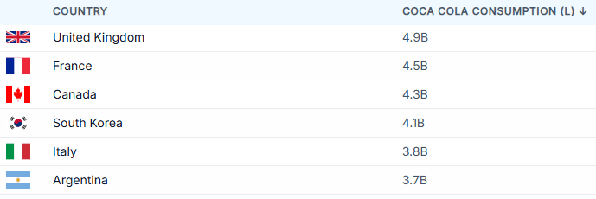
Figure 5: Coca-Cola Consumption Rates in the UK and Canada
(Source: World Population Review, 2025)
According to the country comparison, Coca-Cola products are available in the online and offline distribution channels in the UK and Canada to ensure maximum product availability in the market. However, the product availability among the customers is different in the UK and Canada based on the effectiveness of different distribution practices. For example, Coca-Cola’s consumption rate in the UK reached 4.9 billion in 2025 which is comparatively higher than in Canada while the rate reached 4.3 billion in Canada (World Population Review, 2025). This implies that Coca-Cola has different product placing, marketing and customer management practices in the UK and Canada which have significant impact on its country basis consumption rate. On the other hand, Coca-Cola follows a unique brand logo and packaging design for its local and global-level business operations that supports comparatively similar physical evidence management strategies.
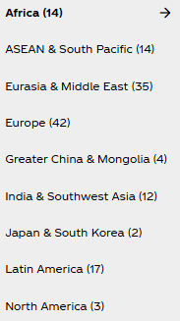
Figure 6: Coca-Cola stores in Different Countries
(Source: Coca-Cola, 2025)
Coca-Cola’s products placing strategies are different in the UK and Canada based on the local customer and market demands. It has been found that Coca-Cola has more than 50 sales distribution centres with 5 manufacturing facilities in Canada as of 2025 (Coke Canada, 2025). In comparison, Coca-Cola has 5 manufacturing sites with 3600 employees in the UK (Coca Cola, 2025). In addition to this, the promotional and operational process of Coca-Cola are quite similar in the UK and Canada as the impacts of its promotional activities and operational performance are quite the same. For example, Coca-Cola brand acquired a 6% increase in its revenue and 5% increase in sales as of 2024 (Coca Cola Company, 2025). Further, it helps to address the positive impact of its current marketing practices at the global market while the sales and market revenue increased. Globally, Coca-Cola is struggling with changing environmental requirements such as reducing carbon emissions through reducing the use of virgin plastics to meet ethical standards (Recycling Today, 2024). Therefore, the lack of ethical consideration in the packaging approach of the brand can affect its brand value in the global market including the UK and Canada.

8. Evaluation of the performance of marketing strategies
The marketing performance of Coca-Cola within both foreign countries such as the UK and Canada has been recognised by exacting the popularity or sales rate. As per the views of Hoskins et al. (2021), increased popularity or sales rate has denoted the marketing success of a brand in the geographic location. The above figure has highlighted 98% of the UK consumers prefer Coca-Cola than other beverage brands (Statista, 2025). The total sales rate of Coca-Cola is GBP 4.009 trillion access the world (Companiesmarketcap, 2025). Popularity of this company in Canada can be defined through its local partnership strategies such as business agreements with JA Canada (Newswire, 2025). The custom-design effects in marketing along with commitments towards sustainability have promoted Coca-Cola’s marketing success in both the UK and Canada. Considering the popularity of Coca-Cola along with consumer preferences, the UK marketing strategies are more successful.
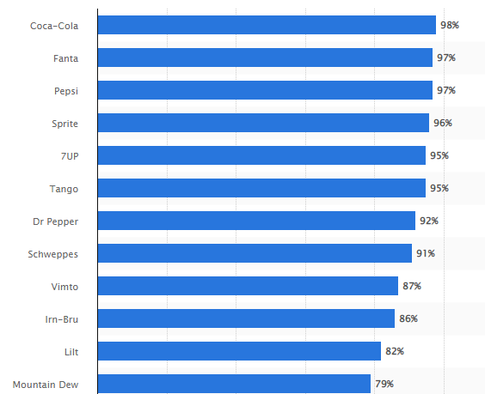
Figure 7: Popularity of Coca-Cola in UK
(Source: Statista, 2025)
It has been recognised that Coca-Cola holds 42% of market share of non-alcoholic beverage brands across the world (Coca-colacompany, 2025). In Canada, a wide portion of economic contribution has been conducted by the sales of Coca-Cola. Coca-Cola is a dominant player in the Canadian beverage market with a large amount of market share [Refer to appendix 3]. On the other hand, Coca-Cola is a leading revenge brand in the UK that holds the majority of market share in the operating market. Success of marketing strategies of Coca-Cola in Canada as well as the UK have been recognised from the market share. On the other hand, a wide range of distribution segments of Coca-Cola are available in the UK and Canada. The biting and distribution partners working style have created differences between the operating and franchising model of Coca-Cola within these two segments. For instance, Coca-Cola Canada Bottling Limited is the bottling partner of the brand, whereas “Coca-Cola Europacific Partners (CCEP)” in Great Britain handles the bottling segment (Coca-colacompany, 2025). Depending on the localisation activities, the UK marketing strategies can be more successful than Canada as the bottling activities totally depend on a fatality-oriented business.
Social media engagement and brand awareness are two factors behind successful marketing strategies of Coca-Cola. Based on the views of Hoskins et al. (2021), engaging more customers in a specific location, a brand has promoted sales and ensured success of marketing strategies. 98% of the UK population have ideas about the beverage items of Coca-Cola (Statista, 2025). On the other hand, Coca-Cola focuses on personal preferences of the Canadian target segment and delivers successful campaigns like “Share a Coke” (Coca-colacompany, 2025). This has indicated the social media engagement and brand awareness of Coca-Cola in Canada. It has been stated from the above segment that the unique marketing strategies have brought marketing success to Coca-Cola within both the UK and Canadian market. However, the social and cultural factors have shifted to the marketing success of Coca-Cola differently. As per the views of Srivastava and Sivaramakrishnan (2022), the market size and popularity are the key context of international marketing success for a brand. The UK market of Coca-Cola is larger than the Canadian market that promotes the revenue stream respectively. Thus, Coca-Cola’s marketing strategies can be considered as effective in the UK from a global perspective.

9. Evaluation of marketing ethics practice
Ethical marketing is highly critical in the global market scenarios, particularly for the multi-national brands such as Coca-Cola. The company has faced different results in different countries regarding health concerns, sustainability commitments, transparency and responsible advertising. Coca-Cola’s ethical practices in both the UK and Canada show both shared challenges and country-specific differences shared by regulation, culture and consumer expectations.

9.1 Ethical practices in the UK
The Soft Drinks Industry Levy which is known as Sugar tax in 2018 has placed ethical marketing across the UK. Coca-Cola has responded to promote Coca-Cola Zero Sugar and Diet Coke as healthier substitutes highlighting their responsibility for adaptations on public health priorities (Agarwala, 2024). Ethical evaluation reflects this move has often aligned with customer welfare; however, the brand has promoted their high-sugar original formula by underscoring public health targets (Blomdahl and Ana, 2025). The marketing campaigns have been carefully framed to highlight customer choice rather than simply reducing sugar which has raised questions about the sincerity of Coca-Cola’s health messaging.
Advertising to the young people has also raised ethical concerns. While Coca-Cola has claimed not to market directly for the children under 12, which has high presence at music festivals, sports sponsorships and digital platforms indirectly targets the young populations who are vulnerable to this lifestyle branding (Coca-cola, 2024). The ethical challenges have been enhanced in balancing brand promotions with the requirements to avoid unhealthy consumption patterns as well.
Coming to the perspectives of sustainability, Coca-Cola has made commitments for reducing their environmental footprint including to adopt 100% recyclable plastic bottles and pledging carbon neutrality targets (Coca Cola, 2022). These initiatives are ethically significant especially as plastic pollution and climate change dominate consumer discourse. However, the environmental groups have argued that Coca-Cola has remained one of the World’s largest plastic polluters by enhancing doubts about whether their sustainability marketing reflects ethical corporate responsibility towards ‘greenwashing’ (Morunga, 2023). The tension between promotional claims and actual environmental performances is a continuous ethical issue in the UK market.

9.2 Ethical practices in the Canada
Coca-Cola’s ethical challenges are considered more around cultural inclusivity, national identity and health in Canada. The brand has positioned Coca-Cola Original as a major focus to Canadian heritage by aligning the drink to hockey events, Canada Day and family events (The Coca-Cola Company, 2025). While this has made emotional connections, this has enhanced ethical questions about whether tying high-sugar beverages to national traditions normalises the unhealthy consumptions. Unlike the UK, Canada has no nationwide sugar tax, in which Coca-Cola has faced fewer regulatory pressures (Waugh et al. 2024). However, public health has advocated criticizing the company for not taking stronger steps for reducing sugar consumption in their flagship brand products.
Advertising ethics are particularly significant in Canada’s multi-cultural society. However, the inclusivity campaigns often overlap with high brand promotions that may exploit cultural symbols for commercial gain. For example, this has utilised the national pride and community spirit in marketing could be interpreted as emotional manipulations especially when linking to the product with well-documented health risks. Hence, the environmental ethics in Canada has the same concerns as in the UK. Coca-Cola has promoted initiatives to enhance the recyclability of packaging by lowering carbon emissions (The Coca-Cola Company, 2024). However, the reports have continued to associate Coca-Cola with plastic waste pollutants in Canadian communities. However, recycling programs exist, consumer groups question whether Coca-Cola’s sustainability commitments go far enough considering the production scales as well as distributions.

9.3 Comparative evaluations on ethical practices
The comparison between the two countries has shown different ethical priorities. Coca-Cola’s ethics are more shaped as per the governmental regulations and public health arguments, especially the sugar tax and rising consumer awareness of health and wellness in the UK. The ethics centre on cultural and community values where Coca-Cola’s integration into traditions has raised questions about their influence on social norms in Canada. These ethical contexts in the UK and Canada have highlighted continuous criticisms around advertising practices especially indirect marketing to young audiences and emotional branding strategies. The company’s global brand reputation as one of the leading plastic polluters undermines their ethical positioning suggesting the gap between marketing promises and corporate performances. Therefore, Coca-Cola’s ethical credibility depends on campaigns as well as the tangible and measurable progress to reducing sugar, reducing waste and addressing health issues.

10. Recommendation and Conclusion

Recommendations
Recommendation 1: Reduction of products cost by considering cost of living crisis
Coca-Cola’s pricing strategy is poor in respect to its target market requirements. Coca-Cola increased its product prices in the global supply network (Reuters, 2023). Hence, the company should consider the growing cost of living crisis while improving the product pricing strategy. In this stage, the company can reduce product costs to gain competitive advantages from engaging more customers at the global market including the UK and Canada.
Recommendation 2: Implementation of advanced technology with technically skilled employees
Coca-Cola’s technological potential is quite low at the global market in respect to shifting market demands to investing in research and developments. Biotech revolution and maximise cyber security are some current trends of the technological field which must be considered by the modern business firms (Forbes, 2024). Through considering these current technological trends, Coca-Cola brand can improve its technological potential at the global market as it supports innovation in the production process. In this stage, the company has to involve technically skilled workforces instead of only focusing on diversity and inclusion to drive production efficiency according to the changing market demands.
Recommendation 3: Reduce the use of virgin plastics to bring sustainability
Reducing the use of virgin plastics in production is a new challenge for Coca-Cola brand across its global-level business operations. According to current changing environmental requirements, lowering virgin plastics can reduce carbon emissions in the production to meet the SDG goals (Recycling Today, 2024). Through this production approach, Coca-Cola can rescue its environmental impact which is required to develop a positive brand image in front of its target market across the globe. In this stage, the brand can combine technological solutions with natural resources to minimise the use of plastics in products packaging design. This can help the company in improving sustainability to gain more competitive advantage in the global market.

Conclusion
According to the country-based comparison, it has been found that Coca-Cola can face a positive impact of political, legal and environmental factors at the Canadian market. However, negative impacts of economic, social and technological factors have been identified in Canada. On the other hand, negative impacts of the UK's political and economic factors have been identified with positive impacts of social, technological, legal and environmental factors. In addition to this, effective social media marketing practices, engagement and brand awareness have been identified as key successful factors of Coca-Cola. The positive impact of its improved marketing practices such as promotional activities and placing strategies have been found on its market revenue and sales rate in the global market. Furthermore, 7Ps of marketing mix between UK and Canada demonstrated poor packaging and people management approach of Coca-Cola due to its lack of concern for sustainability and technological innovation. However, it has been found that Coca-Cola consumption rate in the UK is comparatively higher than in Canada. Therefore, it can be said that marketing practices of Coca-Cola have to be improved based on the changing market requirements in the UK and Canada to gain competitive advantages.

11. References
Agarwala, N. (2024). ‘Diet Coke: Healthy Alternative or Stealthy Poison? - Design Ethics - Medium’. Medium. Available at: https://medium.com/design-ethics/diet-coke-healthy-alternative-or-stealthy-poison-fe630c928fb7 (Accessed: 19 September 2025)
Agustian, K., Pohan, A., Zen, A., Wiwin, W. and Malik, A.J., (2023). ‘Human resource management strategies in achieving competitive advantage in business administration’. Journal of Contemporary Administration and Management (ADMAN), 1(2), pp.108-117. Available at: https://doi.org/10.61100/adman.v1i2.53
Blomdahl, R. and Ana, B., (2025). ‘Ultra Processed Food-Towards Healthier Supermarkets: Assessing Consumer Value and the Need for Socially Sustainable Value Propositions in Swedish Supermarkets’. Available at: https://www.diva-portal.org/smash/record.jsf?pid=diva2%3A1977715&dswid=2421
Canada, (2025). ‘Canada and the Sustainable Development Goals’. Available at: https://www.canada.ca/en/employment-social-development/programs/agenda-2030.html (Accessed: 19 September 2025)
Clark, (2025). ‘Cost of living crisis in the UK - statistics & facts’. Available at: https://www.statista.com/topics/9121/cost-of-living-crisis-uk/?srsltid=AfmBOorCs1_K8gMLdnexBR2SR5fi57AXs08ih8ehsHb8IUrOkEds9rRZ#topicOverview (Accessed: 19 September 2025)
Cobiac, L.J., Rogers, N.T., Adams, J., Cummins, S., Smith, R., Mytton, O., White, M. and Scarborough, P. (2024). ‘Impact of the UK soft drinks industry levy on health and health inequalities in children and adolescents in England: An interrupted time series analysis and population health modelling study’. PLoS medicine, 21(3), pp.e1004371–e1004371. Available at: https://doi.org/10.1371/journal.pmed.1004371
Coca Cola (2022). ‘Sustainability’ | Coca-Cola. www.coca-cola.com. Available at: https://www.coca-cola.com/in/en/sustainability (Accessed: 19 September 2025)
Coca Cola Company, (2025). ‘Coca‑Cola Reports Fourth Quarter and Full Year 2024 Results’. Available at: https://www.coca-colacompany.com/media-center/coca-cola-reports-fourth-quarter-and-full-year-2024-results (Accessed: 19 September 2025)
Coca Cola Company, (2025). ‘LIFE AT COCA-COLA’. Available at: https://www.coca-colacompany.com/careers/life-at-coca-cola (Accessed: 19 September 2025)
Coca Cola Company, (2025). ‘THE COCA-COLA SYSTEM’. Available at: https://www.coca-colacompany.com/about-us/coca-cola-system (Accessed: 19 September 2025)
Coca Cola, (2025). ‘Coca-Cola Europacific Partners is the world’s largest independent Coca-Cola bottler’. Available at: https://www.cocacolaep.com/gb/ (Accessed: 19 September 2025)
Coca Cola, (2025). ‘Coca-Cola launches Fantasy Premier League challenge on-pack promo to unite football fans’. Available at: https://www.cocacolaep.com/gb/news-and-stories/coca-cola-launches-fantasy-premier-league-challenge-on-pack-promo-to-unite-football-fans/ (Accessed: 19 September 2025)
Coca Cola, (2025). ‘Coca‑Cola: Made by Canadians, For Canadians’. Available at: https://www.coca-cola.com/ca/en/media-centre/news/made-by-canadians-coca-cola-story#:~:text=Delicious%2C%20Refreshing%2C%20and%20Made%20by,supporting%20Canadians%20and%20local%20businesses. (Accessed: 19 September 2025)
Coca Cola, (2025). ‘Our Coca-Cola Brands’. Available at: https://www.yourcoca-cola.co.uk/c/brands/ (Accessed: 19 September 2025)
Coca Cola, (2025). ‘Promos & Offers’. Available at: https://www.coca-cola.com/ca/en (Accessed: 19 September 2025)
Coca-cola (2024). ‘Does Coca-Cola market to children?’ Coca-cola.com. Available at: https://www.coca-cola.com/ca/en/about-us/faq/does-coca-cola-market-to-children (Accessed: 19 September 2025)
Coca-cola (2025). ‘Does Coca-Cola sponsor local sports team in Canada?’ Coca-cola.com. Available at: https://www.coca-cola.com/ca/en/about-us/faq/does-coca-cola-sponsor-local-sports-team-in-canada (Accessed: 19 September 2025)
coca-cola (2025). ‘Open Like Never Before - Latest Campaigns | Coca-Cola GB’. www.coca-cola.com. Available at: https://www.coca-cola.com/gb/en/offerings/open-like-never-before--coca-cola-and-george-the-poet-unite-to-s (Accessed: 19 September 2025)
Coca-Cola (2025). I’conic ‘Share a Coke’ is Back for a New Generation’. The Coca-Cola Company. Available at: https://www.coca-colacompany.com/media-center/iconic-share-a-coke-is-back-for-a-new-generation (Accessed: 19 September 2025)
Coca-Cola, (2025). ‘Select Your Location’. Available at: https://www.coca-cola.com/country-selector#tabs-98314583b9-item-ad6b67a957-tab (Accessed: 19 September 2025)
Coca-Colabranding (2025). ‘cocacolabranding’. Coca Cola Emotional Branding Strategy. Available at: https://cocacolabranding.wordpress.com/author/cocacolabranding/ (Accessed: 19 September 2025)
Coca-colacompany, (2025). ‘About Us’. Available at: https://www.coca-colacompany.com/about-us (Accessed: 19 September 2025)
Coca-colacompany, (2025). ‘REFRESH THE WORLD. MAKE A DIFFERENCE’. Available at: https://investors.coca-colacompany.com/about#:~:text=Refresh%20the%20World.&text=Our%20vision%20for%20growth%20has,the%20communities%20we%20call%20home. (Accessed: 19 September 2025)
Coca-colacompany, (2025). ‘Sustainability’. https://www.coca-colacompany.com/about-us/sustainability
Coca-colacompany, (2025). ‘The Coca‑Cola Company Evolves Voluntary Environmental Goals’. Available at: ://www.coca-colacompany.com/media-center/the-coca-cola-company-evolves-voluntary-environmental-goals#:~:text=The%20company%20offers%20beverages%20in,Design%20and%20Partner%20to%20Collect.&text=The%20company%20is%20focused%20on,factors%20that%20will%20affect%20implementation. (Accessed: 19 September 2025)
Coca-colacompany, (2025). ‘The Coca‑Cola Company is always innovating and exploring the future of best-in-class brands and experiences’. Available at: https://www.coca-colacompany.com/media-center/the-coca-cola-company-is-always-innovating-and-exploring-the-future-of-best-in-class-brands-and-experiences (Accessed: 19 September 2025)
Coca-colacompany, (2025). ‘The Coca‑Cola Company Launches 100% Recycled Plastic Bottles* Across Canada’. Available at: https://www.coca-colacompany.com/media-center/coca-cola-launches-100-rpet-bottles-across-canada#:~:text=The%20Coca%E2%80%91Cola%20Company%20Launches,%E2%80%9CRecycle%20Me%20Again%E2%80%9D%20messaging. (Accessed: 19 September 2025)
Coke Canada (2021). ‘Coke Canada | Your Local Bottler’. cokecanada.com. Available at: https://cokecanada.com/ (Accessed: 19 September 2025)
Coke Canada, (2025). ‘Accessibility & Disclosure’. Available at: https://cokecanada.com/accessibility-disclosure/ (Accessed: 19 September 2025)
Coke Canada, (2025). ‘Find A Location’. Available at: https://cokecanada.com/our-company/locations/ (Accessed: 19 September 2025)
Companiesmarketcap, (2025). ‘Revenue for Coca-Cola (KO)’. Available at: https://companiesmarketcap.com/inr/coca-cola/revenue/#google_vignette (Accessed: 19 September 2025)
de Souza Tavares, W. and Silitonga, R.U. (2023). ‘The Coca-Cola Company advertising history illustrated through phonecards’. International Journal of Arts and Humanities, 4(1), pp.137–146. Available at: https://doi.org/10.25082/ijah.2023.01.002
Forbes, (2024). ‘The 5 Biggest Technology Trends For 2025 Everyone Must Be Ready For Now’. Available at: https://www.forbes.com/sites/bernardmarr/2024/09/23/the-5-biggest-technology-trends-for-2025-everyone-must-be-ready-for-now/ (Accessed: 19 September 2025)
GC Canada, (2025). ‘Laws’. Available at: https://laws-lois.justice.gc.ca/eng/acts/c-44/index.html (Accessed: 19 September 2025)
Gov UK, (2025). ‘Legislations’. https://www.legislation.gov.uk/ukpga/2006/46/contents (Accessed: 19 September 2025)
Gov UK, (2025). Research and development expenditure. Available at: https://www.ons.gov.uk/economy/governmentpublicsectorandtaxes/researchanddevelopmentexpenditure (Accessed: 19 September 2025)
Gov UK, (2025).Sustainability Reporting Guidance 2025-26. Available at: https://www.gov.uk/government/publications/sustainability-reporting-guidance-2025-26/sustainability-reporting-guidance-2025-26 (Accessed: 19 September 2025)
Hajarath, K. and Vummadi, J., (2024). ‘Enhancing supply chain resilience: Proactive strategies for disruptive events’. International Journal of Supply Chain Management, 9(3), pp.1-11. Available at: https://doi.org/10.47604/ijscm.2633 (Accessed: 19 September 2025)
Hamamah, A., Al-Haimi, B. and Tajuri, W., (2024). ‘Navigating the Marketing Landscape: Artificial Intelligence and Big Data Role in Digital Marketing’. Int. J. Acad. Res. Bunsiness Soc. Sci, 14(10), pp.2285-2299. Available at: https://doi.org/10.6007/IJARBSS/v14-i10/23346 (Accessed: 19 September 2025)
Hoskins, J., Verhaal, J.C. and Griffin, A., (2021). ‘How within-country consumer product (or brand) localness and supporting marketing tactics influence sales performance’. European Journal of Marketing, 55(2), pp.565-592. Available at: https://doi.org/10.1089/big.2022.0307 (Accessed: 19 September 2025)
Investcanada, (2025). ‘STABILITY’. Available at: https://www.investcanada.ca/stability (Accessed: 19 September 2025)
Jain, R., Jain, S. and Jain, S., (2022). ‘Analyzing and exploring the effectiveness of each element of 7Ps of marketing mix’. International Journal of All Research Education and Scientific Methods (IJARESM), 10(1), pp.2455-6211. Available at: https://www.researchgate.net/profile/Riddhisha-Jain/publication/357657009_Analyzing_and_Exploring_the_Effectiveness_of_Each_Element_of_7Ps_of_Marketing_Mix/links/61d84cdfb6b5667157d148c7/Analyzing-and-Exploring-the-Effectiveness-of-Each-Element-of-7Ps-of-Marketing-Mix.pdf (Accessed: 19 September 2025)
Jonwal, S. (2025). ‘Coca-Cola Case Study: Inside Its Iconic Marketing Strategy’. Young Urban Project. Available at: https://www.youngurbanproject.com/coca-cola-case-study/ (Accessed: 19 September 2025)
Lombardo, C. (2024). ‘Coca-Cola celebrates community spirit through contesting and a caravan’. Strategyonline.ca. Available at: https://strategyonline.ca/2024/11/27/coca-cola-community-spirit-contest-caravan/ (Accessed: 19 September 2025)
London Government of UK (2025). ‘London Environment Strategy’. london.gov.uk. Available at: https://www.london.gov.uk/sites/default/files/london_environment_strategy_0.pdf (Accessed: 19 September 2025)
Lubis, M. and Muniapan, B., (2024). ‘International Market Development Strategies for Enhancing Global Expansion in the Export Industry’. Involvement International Journal of Business, 1(1), pp.14-28. Available at: https://doi.org/10.62569/iijb.v1i1.3
Morunga, A.M. (2023). ‘Unbottling the truth: Coca Cola’s role in plastic pollution’. Greenpeace. Available at: https://www.greenpeace.org/aotearoa/story/unbottling-the-truth-coca-colas-role-in-plastic-pollution/ (Accessed: 19 September 2025)
Newswire, (2025). ‘JA Canada, Coke Canada Bottling and The Coca-Cola Company Partner to Advance Youth Employability in Canada Français’. Available at: https://www.newswire.ca/news-releases/ja-canada-coke-canada-bottling-and-the-coca-cola-company-partner-to-advance-youth-employability-in-canada-877115943.html (Accessed: 19 September 2025)
Rabinovitch., A. (2025). ‘Canada’s inflation rate ticked up slightly in August: StatCan’. Available at: https://globalnews.ca/news/11430152/consumer-price-inflation-statistics-canada-august-2025/ (Accessed: 19 September 2025)
Rao, D. (2025). ‘Opinion – Multiculturalism in Canada: Lacking Purpose and Intent in Law and Policy’. E-International Relations. Available at: https://www.e-ir.info/2025/06/13/opinion-multiculturalism-in-canada-lacking-purpose-and-intent-in-law-and-policy/ (Accessed: 19 September 2025)
Recycling Today, (2024). ‘Coca-Cola’s shift in packaging goals troubles environmental groups’. Available at: https://www.recyclingtoday.com/news/coca-colas-shift-in-packaging-goals-troubles-environmental-groups/ (Accessed: 19 September 2025)
Reuters, (2023). ‘Coca-Cola to push ahead with price hikes as PepsiCo hits pause’. Available at: https://www.reuters.com/business/retail-consumer/coca-cola-sees-annual-profit-above-estimates-resilient-demand-price-hikes-2023-02-14/ (Accessed: 19 September 2025)
Rosário, A. and Raimundo, R., (2021). ‘Consumer marketing strategy and E-commerce in the last decade: a literature review’. Journal of theoretical and applied electronic commerce research, 16(7), pp.3003-3024. Available at: https://doi.org/10.3390/jtaer16070164 (Accessed: 19 September 2025)
Srivastava, M. and Sivaramakrishnan, S., (2022). ‘A bibliometric analysis of the structure and trends of customer engagement in the context of international marketing’. International Marketing Review, 39(4), pp.836-851. Available at: https://doi.org/10.1108/IMR-06-2021-0204 (Accessed: 19 September 2025)
Statista, (2025). ‘Inflation rate in the UK 2015-2025’. https://www.statista.com/statistics/306648/inflation-rate-consumer-price-index-cpi-united-kingdom-uk/ (Accessed: 19 September 2025)
Statista, (2025). ‘Leading soft drink brands ranked by brand awareness in the United Kingdom in 2024’. Available at: https://www.statista.com/statistics/1346279/most-well-known-soft-drink-brands-in-the-uk/ (Accessed: 19 September 2025)
Statista, (2025). ‘UK employment’. Available at: https://www.statista.com/statistics/281992/employment-rate-in-the-united-kingdom/#:~:text=In%20July%202025%2C%20the%20employment,measures%20revised%20in%20early%202025 (Accessed: 19 September 2025)
Stibbe, A. (2023). ‘Taste the feeling: an ecolinguistic analysis of Coca-Cola advertising’. Journal of world languages, 10(2). Available at: https://doi.org/10.1515/jwl-2023-0027
store.mintel, (2025). ‘UK Soft Drinks Industry Review 2025’. store.mintel.com Available at: https://store.mintel.com/report/uk-soft-drinks-review-market-report(Accessed: 19 September 2025)
The Coca-Cola Company (2024). ‘The Coca-Cola Company Evolves Voluntary Environmental Goals’. Coca-colacompany.com. Available at: https://www.coca-colacompany.com/media-center/the-coca-cola-company-evolves-voluntary-environmental-goals (Accessed: 19 September 2025)
The Coca-Cola Company (2025). ‘Made by Canadians, for Canadians: The Coca-Cola Canada Story’. Coca-cola.com. Available at: https://www.coca-cola.com/ca/en/media-centre/news/made-by-canadians-coca-cola-story (Accessed: 19 September 2025)
Theglobaleconomy, (2023). ‘United Kingdom: Political stability’. Available at: https://www.theglobaleconomy.com/United-Kingdom/wb_political_stability/ (Accessed: 19 September 2025)
Tradingeconomics, (2025). ‘Canada Employment Rate’. Available at: https://tradingeconomics.com/canada/employment-rate (Accessed: 19 September 2025)
Waugh, A., Thille, P., Roger, K., Bombak, A., Mann, K. and Riediger, N. (2024). ‘Coke’s not a food’: A critical discourse analysis of sugar-sweetened beverage tax acceptability by white residents from an upper-middle class neighborhood in Winnipeg Manitoba’. Heliyon, 10(9), pp.e30089–e30089. Available at: https://doi.org/10.1016/j.heliyon.2024.e30089
World Population Review, (2025). ‘Coca Cola Consumption by Country 2025’. Available at: https://worldpopulationreview.com/country-rankings/coca-cola-consumption-by-country (Accessed: 19 September 2025)
Worldbank, (2025). ‘Research and development expenditure (% of GDP)’. Available at: https://data.worldbank.org/indicator/GB.XPD.RSDV.GD.ZS?locations=CA (Accessed: 19 September 2025)
Yahoo, (2025). 'Unthreatening' inflation reading makes Bank of Canada rate cut tomorrow 'obvious course of action'. Available at: https://uk.finance.yahoo.com/news/unthreatening-inflation-reading-makes-bank-of-canada-rate-cut-tomorrow-obvious-course-of-action-144221063.html (Accessed: 19 September 2025)

12. Appendices

Appendix 1: UK employment rate
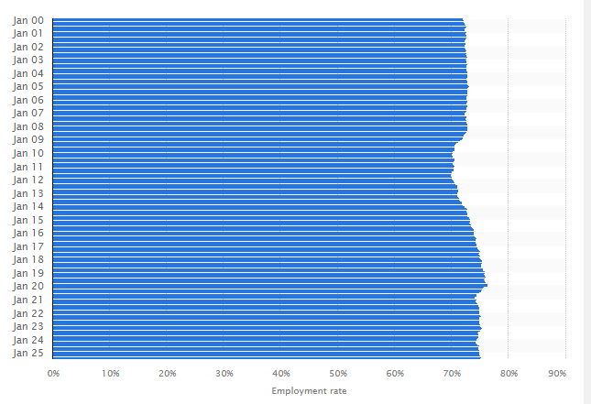jwi
(Source: https://www.statista.com/statistics/281992/employment-rate-in-the-united-kingdom/#:~:text=In%20July%202025%2C%20the%20employment,measures%20revised%20in%20early%202025)

Appendix 2: Employment rate of Canada
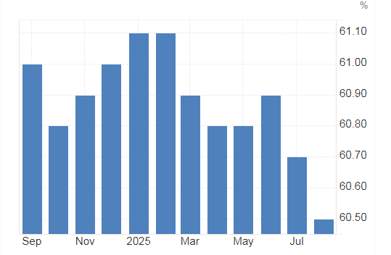
(Source: https://tradingeconomics.com/canada/employment-rate)

Appendix 3: FY24 Unit Case Volume of Coca-Cola
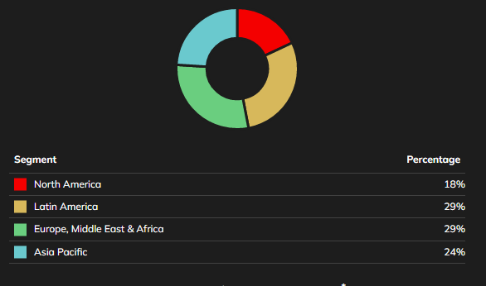
(Source: https://investors.coca-colacompany.com/about/segments)

Appendix 4: 7Ps of Marketing Mix

(Source: Created by Learner)

Appendix 5: Strategic Recommendations

x
(Source: Created by Learner)

