Personal Reflection – St Fagan’s

St Fagan’s, The National Museum of History is an open-air museum based in St Fagan’s, west of Cardiff. My first impressions of the museum are that its purpose is to represent Welsh culture, lifestyle, architecture, and people; to highlight and celebrate this. It was incredibly vast and is not your typical museum, where things are kept behind glass windows; things have been preserved but also more available to interact with, rather than just to look at and observe.
The museum also gave an impression of highlighting its ‘Welshness’ by showing aspects of the history of Wales. Most of the signs were in Welsh first then English, the buildings and nearly everything in the museum is from Wales and/or linked to Wales, which shows it being proud of Welsh culture. However, it also shows some of the Welsh tragedies, such as the Welsh not and Aberfan.

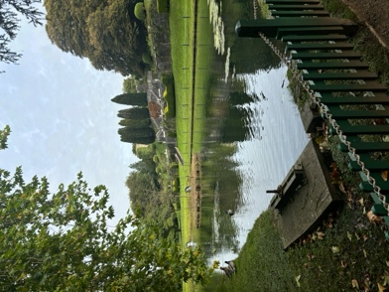
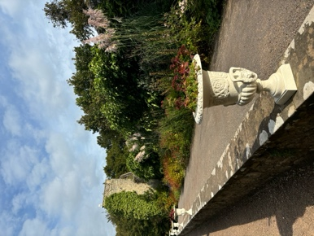
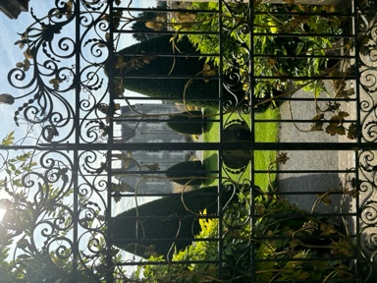
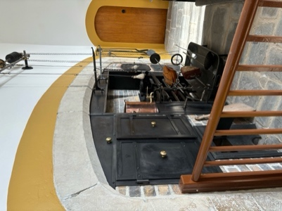
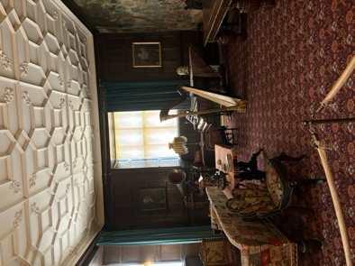
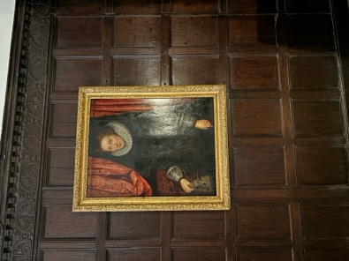
When I first arrived, I visited the Castle at St Fagan’s. The route to the castle was quite interesting, as at most museums I have visited in the past, such as the Tower of London and Warwick Castle, once you have been through the visitors centre, normally the castle is right in front of you. However, here you had to make a right turn and pass-through a tunnel to reach the Castle. I initially found this very weird as it meant that the Castle was almost split off from the rest of the cite. However, this now could be viewed as the museum splitting of the anglicised part from the Welsh part. This is because St Fagan’s Castle was previously owned by the Earls of Plymouth until it was sold to the National Museum of Wales in 1947, and this aristocratic family was an English family that used it as summer house. Even their title was Plymouth, which is a city in Devon, England not Wales. Therefore because of this factor, it could be viewed that the museum was split like this to represent the historical divide between Wales and England.
Alongside this, the Castle was extremely pretty, it had moats, organised floral gardens, bespoke and detailed fountains and statues and ornate gates, which is highly typical of an English castle, however the exterior of the castle surprised me. Normally when you think of a castle you think of high towers and walls with small windows and arrow slits, but it instead had the appearance of a manor house. But the inside did appear as a castle, with it being dark and dingy with old paintings, artifacts and tapestries, and the kitchen containing an old fireplace with a spit and high ceilings and chimneys.

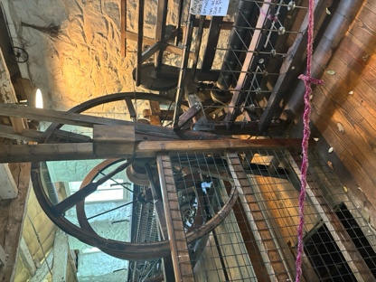
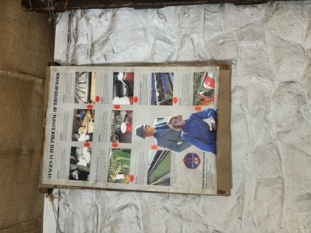
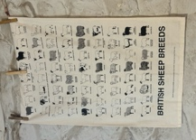
Next, I went and saw the Esgair Moel Woollen Mill. This was built in 1760 in Powys then erected at St Fagan’s in 1952. As per the title it is a mill used to create wool that would be later turned into blankets, shawls, and flannel for making clothes and knitting. I found this really interesting as it teaches you about the process of turning wool from sheep into yarn through the use of key industrial age inventions such as the Spinning Jenny (as seen in the first photo). I was really surprised to see this machine in there as from the date the mill was built in, the Spinning Jenny was a relatively new invention (invented in 1764-5) so I would have thought that in this mill they would be still spinning wool by hand. Alongside this, I found it really interesting to learn about the different breeds of sheep from the poster in the mill, however I was a tiny bit disappointed that they didn’t mention Shaun the Sheep on there for a laugh.

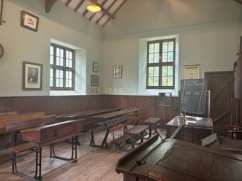
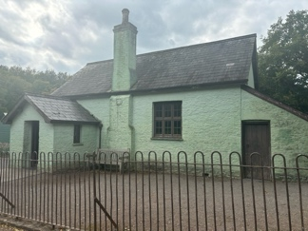

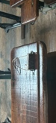
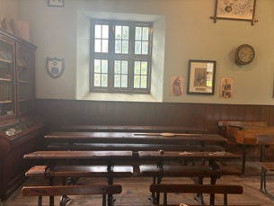
Afterwards, I visited the Maestir School which was from Maestir near Lampeter (by the Falcondale Hotel). It was built in 1880 but the furnishings date from 1890. It was really interesting to see a Victorian school in its original state, particularly as my Junior school, Southfield Junior School in Highworth, has some buildings that date from the Victorian period too, however it now resembles a modern classroom apart from the walls and windows. It was really interesting finding out how a Victorian school functioned and how children learnt from rote, which is still partially implemented into the modern-day education system but now alongside direct instruction and problem solving, and the curriculum was very colonialised with them learning about the British Empire. This would have most likely been extremely difficult and confusing for the young children to learn, as they were being taught how great the empire is, but at the same time, the Welsh was being deemed as racially inferior, and persecuted, by Welsh being banned in schools through the implementation of the Welsh Not, resulting in corporal punishment being used if you were wearing it at the end of the day. However corporal punishment wasn’t just implemented for speaking Welsh, left-handed individuals were made to wear a finger trap to force them to write right-handed, as being left-handed was deemed as a sign of the devil; plus whipping and the chalkboard rubber being thrown at you were common punishments for misbehaviour. Finding out all this was really interesting from a historical perspective it demonstrated the curriculum of the Victorian era was taught and how students were predominantly taught about the Empire, but also the punishment system of this era through the use of the cane and finger traps. It also demonstrated the persecution of the Welsh, by the English through the implementation of the Welsh Not, as previously stated. On an emotional level, it made me really grateful that I was born and educated in the 21st Century without the fear of these punishments. Although I am not from Wales myself, I think its fantastic that Welsh students are now being encouraged to learn Welsh from a young age and eventually become bilingual, alongside Welsh culture being commonly celebrated and taught in schools widely, and across the world.

Overall, I thoroughly enjoyed the field trip to St Fagan’s and could talk about many more places I visited while I was there. I found it extremely interesting to learn about the history of the museum but also the wider history of Wales, and its culture, language, and people, and will most definitely return in the future.

