ECIE4012
Principles of Learning and Teaching

Portfolio

Chantelle Fahey
2104239

Blog 1
Demonstrate your understanding of a theory of learning from the following list: Bruner, Skinner, Piaget, Vygotsky, Froebel

Mrs Jones meets Skinner: Chaos, Children, Compliance and Conditioning
Chantelle, Fahey
November 2025

Last Friday I stumbled into a delightful whirlwind of chaos, that could only be described as a comedy of errors. What should have been a joyful embrace of that Friday feeling (Woop Woop) quickly turned into a bewildering experience as I stepped into Mrs Jones’ classroom, wandering if I had accidentally teleported into a circus.
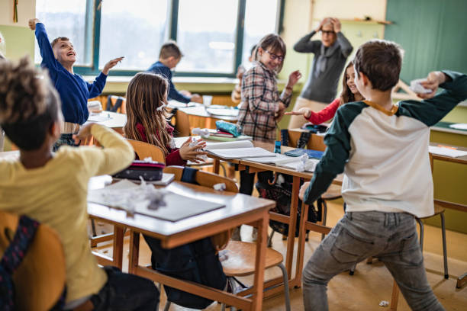
Picture this! Patrick’s paper aeroplane skimming past Sofia’s head like a missile, Jayden sat in the corner channelling his inner rockstar, tapping his pen continuously on the desk, Brooke discussing party outfits (which in my day dad would definitely disapprove) and poor Asha rocking with her hands covering her ears at breaking point! Not to mention poor Mrs Jones, staring off into the distance, probably sending a silent prayer to the heavens; ‘God give me a sign’. Relatable?
(The, 2020)
But in that moment the epiphany happened. Mrs Jones captured their attention, it was either going to be a trip to the isolation room, or an early pack-up at the end of the lesson with a game of Blooket (I mean who doesn’t love a quiz!) And just like that the classroom had transformed into a serene paradise.
Well folks, that right there is Operant-conditioning at its glory! If the godfather of Behaviourism had walked into class at that very moment, perhaps Mrs Jones would have gained a gold star herself!

So what is Operant conditioning?
Really, it’s just a fancy way of saying our learning is heavily influenced and sustained by the consequences of our actions. Based on Law and Effect (Drew, 2024), American psychologist B.F.Skinner believed behaviour can be modified through reinforcement or punishment. In a nutshell, the more positive consequences, the likelihood positive behaviour will iterate, but the more negative consequences will weaken or eliminate negative behaviours reoccurring (Pritchard, 2018). Really, it's like a game of tug-of-war, a golden star or detention as the rope, which end will the pupil pull towards?


(Freepik, 2025)

The Good Vs Bad

Positive Reinforcement: Providing a pleasant reward to strengthen behaviour (Praise, Stickers, Certificates, Points, Free-time)
Negative Reinforcement: Withdrawing something unlikeable to strengthen behaviour (A pupil completing their task on time, not having to stay in during breaktime).
Positive Punishment: Adding something unpleasing to reduce behaviour (Student detention, having extra homework as a result of disruption)
Negative Punishment: Removing a pleasant stimulus to weaken behaviour (Confiscating a students phone, loss of breaktime, detention, moving seats, exclusion, phone call home).
(Gray and Macblain, 2015)

Why it works…...and why it doesn’t
Advantages
- It can create structured learning environments with clear routines, boundaries, and expectations, which can support autistic learners and enhance the engagement and focus among ADHD students, for example (Mohamed Nawi and Nordin, 2025).
- If immediate and constructed praise is given to a student it can enhance intrinsic motivation and foster a love of learning. It enhances student persistence in overcoming challenges, aids in skill mastery, and facilitates progress monitoring, while fostering awareness of achievement. (Dowling, 2014; Northey, 2024) I mean, what would you rather… a ‘Good job’ …or… ‘Waw, you’re choice of colours in that picture really contrast each other, that is very creative of you’?
- Rewards and pleasure are associated with the release of Dopamine in the brain, enhancing student happiness and satisfaction, which in turn leads to improved performance (Hu, 2004).

Disadvantages
- It can decrease intrinsic motivation with students becoming reliant on completing a task or behaving in a certain way just to gain a reward, rather than genuinely doing the right thing! ‘Do this and you get this’ kinda attitude. Does this really teach our students empathy and the impact of their actions? (Brandt, 2014; Persike, 2023). Or the memorisation of 4x5=20, but not knowing why this is the answer?
- It doesn’t address underlying root causes of behaviours and can often exacerbate behaviour. For students with ACES, punishments such as isolation rooms may perpetuate the cycle of trauma, by reinforcing a sense of rejection, or not being ‘good enough’ (Jones et al., 2023). Or students with ADHD finding it difficult to sit still for too long!
- For students who don’t receive a reward, it may increase fear and anxiety resulting in masking, hiding their mistakes in order to fit in. Creating a fixed mindset and a destruction to their confidence (Persike, 2023).
- It can create a competitive atmosphere within the classroom as well as favouritism if particular students receive an over lavish of rewards, especially as students often compare their achievements to others. (Hu, 2004; Dowling, 2014).
- An over lavish of praise can become devalued. ‘It doesn’t matter what I what write, Miss will say it’s good anyway!’ (Dowling, 2014).

Finally, what have we learned…(Apart from needing more patience and coffee?)

Although there are some positive points, many fearless critics argue Skinner oversees human behaviour, focussing simply on what we see – missing out all the important stuff inside our heads and pretty much the things that make us us….thoughts, emotions, and feelings (Hreha, 2023). It could be argued some approaches could be stepping on the toes of UNCRC (1989) legislations, which advocate for the rights of children to play and have their voices heard, and there we are giving them detention during playtime…Eeek! Whilst many school policies and government legislations recognise behavioural techniques as good practices (Welsh Gov, 2012), we must be mindful it doesn’t work in isolation. Think of it as a sandwich, and behaviourism is the bread, which is okey if you’re a plain Jayne, but imagine adding many other ingredients (pedagogies, theories), now that is an extravaganza!
Humanist
Social-Constructivist
Behaviourism
Constructivism
Behaviourism

(Boiko, 2025)
Blog 1: References

Boiko, M. (2025). Delicious sandwich cut out. [online] Vecteezy. Available at: https://www.vecteezy.com/vector-art/50275309-delicious-sandwich-cut-out [Accessed 22 Nov. 2025]

Brandt, R. (2014). Punished by Rewards?: A Conversation with Alfie Kohn - Alfie Kohn. [online] Alfie Kohn. Available at: https://www.alfiekohn.org/article/punished-rewards-article/ (Accessed: 22 Nov 2025).

Dowling, M. (2014). Young Children’s Personal, Social and Emotional Development. SAGE.

Drew, C. (2019). Behaviorism in Education | Ultimate Student Guide (2019). [online] The Helpful Professor. Available at: https://helpfulprofessor.com/behaviorism/ (Accessed: 22 Nov 2025).

Gray, C. and Macblain, S. (2015). Learning theories in childhood. 2nd ed. London: Sage.

Hreha, J. (2023). Reinforcement Theory - The Behavioral Scientist. [online] https://www.thebehavioralscientist.com. Available at: https://www.thebehavioralscientist.com/glossary/reinforcement-theory (Accessed: 22 Nov 2025).

Hu, J. (2024). Operant Conditioning in Child Psychology: Understanding the Influence of Rewards and Punishments on... [online] ResearchGate. Available at: https://www.researchgate.net/publication/379916359_Operant_Conditioning_in_Child_Psychology_Understanding_the_Influence_of_Rewards_and_Punishments_on_Childrens_Behavior (Accessed: 22 Nov 2025).

Jones, R., Kreppner, J., Marsh, F. and Hartwell, B.K. (2023). Punitive behaviour management policies and practices in secondary schools: A systematic review of children and young people’s perceptions and experiences. Emotional and Behavioural Difficulties, [online] 28(2-3), pp.1–16. doi:https://doi.org/10.1080/13632752.2023.2255403 (Accessed: 22 Nov 2025).

Freepik. (2025). Children tug war Images - Free Download on Freepik. [online] Available at: https://www.freepik.com/free-photos-vectors/children-tug-war [Accessed 22 Nov. 2025].

Mohamed Nawi, S.N.A. and Nordin, M.N. (2025). B.F. SKINNER’S LEARNING THEORY AND TEACHING STRATEGIES FOR SPECIAL EDUCATION STUDENTS. Special Education [SE], 3(1), p.e0043. doi:https://doi.org/10.59055/se.v3i1.43 (Accessed: 22 Nov 2025).

Northey, A. (2024). Why is intrinsic motivation key to a Thinking School? - Thinking Matters. [online] Thinking Matters. Available at: https://www.thinkingmatters.com/views/why-is-intrinsic-motivation-key-to-a-thinking-school (Accessed 22 Nov 2025).

Persike, C. (2023). The Dark Side of Rewards, Part 1: Why Incentives Do More Harm Than Good in the Classroom - Alliance Against Seclusion and Restraint. [online] endseclusion.org. Available at: https://endseclusion.org/2023/05/06/the-dark-side-of-rewards-why-incentives-do-more-harm-than-good-in-the-classroom/ (Accessed: 22 Nov 2025).

Pritchard, A. (2018). Ways of Learning: learning theories for the classroom. 4th ed. London ; New York: Routledge, Taylor & Francis Group.

The, I. (2020). Large group of school kids making chaos during a class in the... [online] iStock. Available at: https://www.istockphoto.com/photo/chaos-in-the-classroom-of-elementary-school-gm1216522890-354761530?searchscope=image%2Cfilm [Accessed 22 Nov. 2025].

UNICEF (1989). UN convention on the rights of the child (UNCRC). [online] unicef. Available at: https://www.unicef.org.uk/what-we-do/un-convention-child-rights/ (Accessed: 22 Nov 2025).

Welsh Government (2012). Practical approaches to behaviour management in the classroom: a handbook for classroom teachers in primary schools information. [online] Available at: https://www.gov.wales/sites/default/files/publications/2018-12/practical-approaches-to-behaviour-management-in-the-classroom-a-handbook-for-classroom-teachers-in-primary-schools.pdf. (Accessed: 22 Nov 2025).

Blog 2
Demonstrate your understanding of a theory of learning from the following list:
Bruner, Skinner, Piaget, Vygotsky, Froebel. The theory must be different to Blog 1.

Lev Vgotsky-The Mozart of Education: Short lived, but his legacy lives on
Chantelle Fahey
25 November 2025

“If you want to go fast, go alone, but if you want to go further go together” (Goldberg, 2016)

Such a fitting quote for my experience last Wednesday afternoon, where students were given the task to create a descriptive piece of writing about a mythical creature. Within 10 minutes Ben had written a page off topic, and from his description, you’d think Mr James was a 3 headed fire breathing dragon (which when he shouts, he’s not far wrong), and on the other side of the classroom Ella staring blankly at a page, as if Mr James had given the task in Spanish (I’d feel the exact same).

However, I sat beside Ella, and asked her:
‘What does your creature look like?’,
‘Where does it live?’
‘How do people feel when they see it, what does it do?’
And just like that, the key in the ignition had turned the brain on, and away she was, pen to paper, scribbling faster than Husain Bolt in a 100m sprint.

This folks, is the principle of Lev Vygostky’s socio-cultural theory. He believed social, cultural interactions influences cognitive development and that students learn best and construct knowledge through meaningful interactions, imitation, guided, and collaborative learning with a more knowledgeable other (Cherry, 2025).

Who was this Mozart of Education?
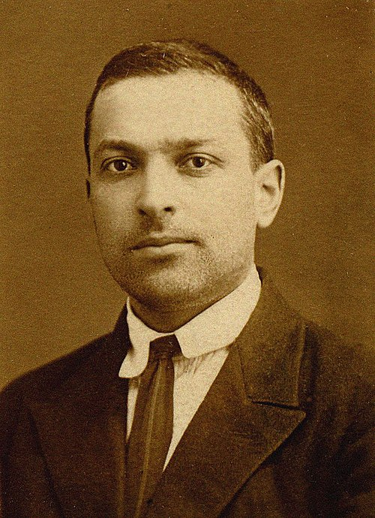
Lev Semyonovich Vygotsky was a Russian Jewish psychologist born in 1896. Through a lottery system, he attended Moscow University, where he developed an interest in the humanities, social sciences, the arts, law, education, and psychology—as if one subject weren't enough. Regretfully, Vygotsky passed away in 1934 at the age of 37. The Soviet Union exiled and concealed Vygotsky's writings, and it wasn't until the early 1970s that they were published and translated into what has influenced many scholars to this day (Avella, 2022). Unfinished theories and translations of his work have drawn criticism claiming they lead to misinterpretations (Van de Veer, 2020).
(Xiair World, 2025)
(Xiair World, 2025)

The Zone of Proximal Development (ZPD)
The zone of proximal development is a key component of Vgotsky's theory. A student's present and potential abilities are connected by the ZPD. It is separated into three distinct zones:
- what a student can do without assistance(This is too easy!) ,
- what they can do with assistance (Oh, I get it now), and
- what they can't do (Argh, I’m doomed!).
According to Vygotsky, the fundamental idea is that what a student performs with assistance today, they will be able to do on their own tomorrow (McLeod, 2025).

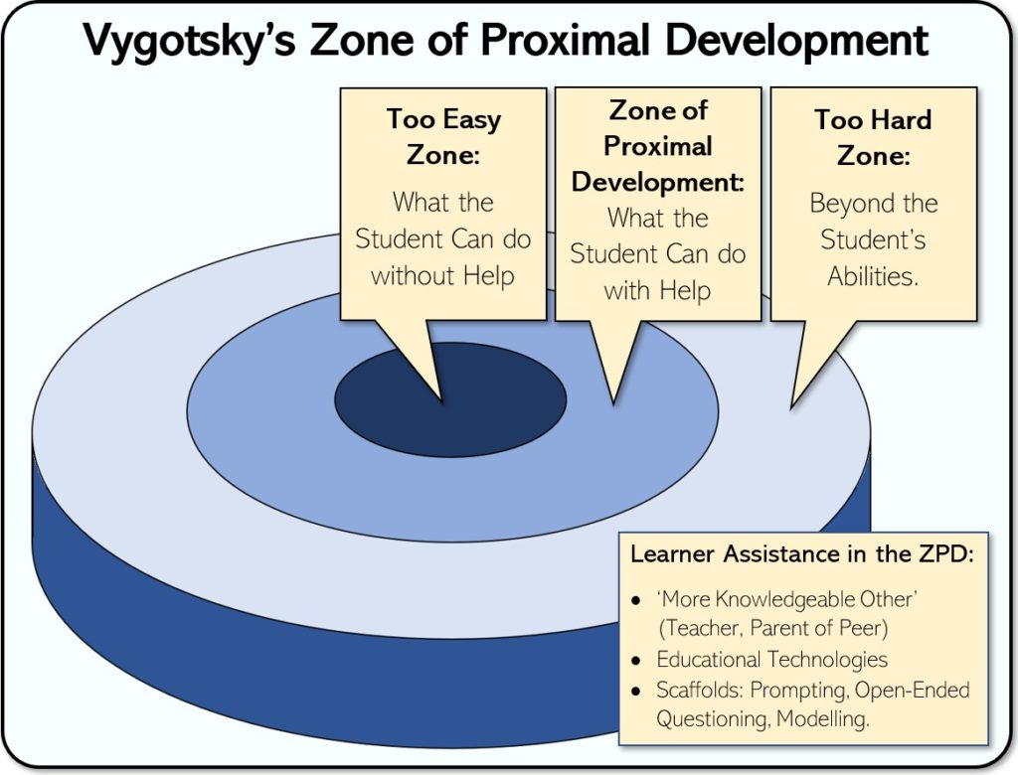
(Helpfulprofessor.com, 2023)

The More Knowledgeable Other (MKO)
MKO..No it’s not a new boy band, it’s the concept Lev Vygotsky refered to as someone or something who is more knwoledgeable than the student, who supports them (also reffered to as ‘scaffolding’) through the ZPD, by providing demonstrations, modelling, guidance, prompting or questioning to help them acehvie what they can’t alone (Gray and Macblain, 2015). An MKO can simply be:
- A Teacher
- A peer
- Sentence Starters
- Youtube Tutorial
- TikTok video of a craky toddler dropping his cars off a sofa explaing gravity (Welcome to the 21st Century).

Langauge and Thought
Language internalisation drives cognition growth, according to Vygotsky. He believed students engage in social speech (interacting with others), which becomes private speech (directed to oneself and spoken aloud - child explaining what they are doing), into inner speech (internal and silent thought used for planning, reasoning, and abstract thinking) (McLeod, 2025).

In action > During a numeracy intervention focussed on division, Miss used a segmented toy pizza, to support Tom’s understanding. When asking what is 10 divided by 2, Miss would in turn say 1 piece for me, 1 piece for you, until they were equally shared and Tom knew the asnwer. Tom verbally repeated the process, which later turned in a mental process he used to solve equations in future lessons.

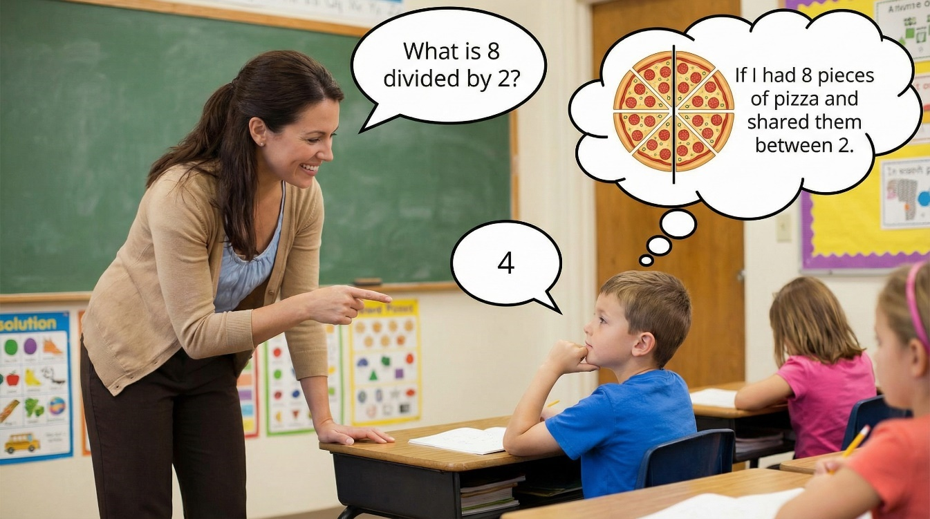

(artlist.io, 2016)

Vygotsky believed we are born with four elementary mental functions; Attention, Memory, Sensation and Perception and with social interaction develop into higher order mental functions (McLeod, 2024).

Language and social interactions help children in problem-solving, emotional expression, behaviour regulation, and enhancing creativity and critical thinking, along with mastering new skills through repetition (Mahato et al., 2023; Van de Veer, 2020). Additionally, it is suggested that memory reflects thought; engaging students in interesting ways promotes better retention and strengthens neural pathways (Bates, 2019).

So next time, Tommy is yapping away in the corner of class just bear in mind he may just be utilising his private speech and not just deciding what he’s having for lunch!

Blog 2: References
artlist.io. (2016). Image to Image AI: Smart AI Image Generator from Images | Artlist. [online] Available at: https://artlist.io/image-to-video-ai/kling-1-6/creations. (Accessed: 26 November 2025).

Avella, F. (2022). Lev Vygotsky Sociocultural Theory. YouTube. Teachings in Education. Available at: https://www.youtube.com/watch?v=_fWm7cF8-WM. (Accessed: 22 November 2025).

Bates, B. (2019). Learning Theories Simplified. 2nd ed. London: Sage.

Cherry, K. (2025). Lev Vygotsky’s Life and Theories. [online] Verywell Mind. Available at: https://www.verywellmind.com/lev-vygotsky-biography-2795533. (Accessed: 26 November 2025).

Goldberg, J. (2016). It takes a village to determine the origins of an African proverb. [online] NPR.org. Available at: https://www.npr.org/sections/goatsandsoda/2016/07/30/487925796/it-takes-a-village-to-determine-the-origins-of-an-african-proverb. (Accessed: 26 November 2025).

Gray, C. and Macblain, S. (2015). Learning theories in childhood. Los Angeles: Sage.

Helpfulprofessor.com. (2023). Available at: https://helpfulprofessor.com/wp-content/uploads/2019/05/Vygotsky-Zone-of-Proximal-Development-1024x780.jpg. (Accessed: 26 November 2025).

Mahato, M., Mission, R., Math, S., Howrah, W. and Bengal (2023). The Crucial Role of Language Learning in Education: Fostering Communication, Cognitive Growth and Cultural Understanding. IJNRD.ORG IJNRD2308329 International Journal of Novel Research and Development (www.ijnrd.org) d116 |, [online] 8(8), p.117. Available at: https://www.ijnrd.org/papers/IJNRD2308329.pdf. (Accessed: 27 November 2025).

McLeod, S. (2024). Vygotsky’s Theory of Cognitive Development. [online] ResearchGate. Available at: https://www.researchgate.net/publication/383395354_Vygotsky. (Accessed: 26 November 2025).

McLeod, S. (2025). Vygotsky’s sociocultural theory of cognitive development. [online] Simply Psychology. Available at: https://www.simplypsychology.org/vygotsky.html. (Accessed: 26 November 2025).

Van de Veer, R. (2020). Vygotsky’s theory. [online] ResearchGate. Available at: https://www.researchgate.net/publication/339136533_Vygotsky. (Accessed: 27 November 2025).

Xiair World. (2025). Lev Vygotsky Theory Shaping The Future Of Preschool Learning Spaces - Professional Daycare Furniture Manufacturer｜Xiair World. [online] Available at: https://xiairworld.com/lev-vygotsky-theory/ (Accessed: 26 November 2025).

Blog 3
Identify, discuss, and evaluate the theoretical approaches to learning linked to your theories from Blogs 1 and 2.

Battle of the Matrix: Social-constructivist vs Behaviourist
Chantelle Fahey
December 2025




Vygotsky Vs Skinner

(Deepimg.io, 2025)

Teaching is a bit like the sci-fi film The Matrix, rather than dodging bullets and agents, you’re weaving around deadlines, targets, data, behaviour management and PPA! Well in today’s pedagogy blog, we will be delving into the virtual battlefield of two major influencers who have helped shape education. The warrior of social constructivism Lev Vgotsky, and the defender of Behaviourism B.F.Skinner.

Let’s dive straight in and compare both agents……
 | Vygotsky | Skinner
Focus of theory | Learning is socially and culturally constructed with others which enhances cognitive development (McLeod, 2025) | Behaviour modification, through positive/negative reinforcement and punishment, known as ‘Operant Conditioning’. (McLeod, 2025).
Key concepts | Zone of Proximal Development (ZPD), More Knowledgeable other (MKO), Scaffolding, Language and social interaction. Social, inner and private speech.  (McLeod, 2025) | Reinforcement (Positive or negative), punishment, memorisation & imitation (McLeod, 2025).
View of learning | Learning is a social process, shaped by social and cultural contexts.  Vygotsky believed we are born with 4 basic functions; attention, sensation, perception and memory, which through social interaction, experiences and rich language environments develop into higher order functions such as metacognition, problem-solving, logic reasoning, critical thinking and self-regulation (McLeod, 2024). Vygotsky emphasises learning was a search for meaning in the world, whereby knowledge and understanding is constructed through a learner’s experience (Weegar and Pacis, 2012). | Learning is referred to as a change in observable behaviour; a process deriving from the connections produced from a stimuli-response relationship, in which the desire to learn is dependent on these relationships (Weegar and Pacis, 2012).  Skinner believed meaning existed in the world which was unrelated to personal experience (Weegar and Pacis, 2012).
Role of Learner | An active learner constructs knowledge through social interactions and experiences, guided by a more knowledgeable other through their ZPD (McLeod, 2025). | A passive learner whose behaviours are shaped by external consequences; positive or negative. Behaviourists place emphasis on learning skills in isolation through direct instruction (Weegar and Pacis, 2012).
Role of Teacher | Facilitator who guides and scaffolds a learner within their ZPD. They reduce the scaffold (bridging the gap between what someone can do alone and with support). as a learner becomes more competent at completing a task independently (McLeod, 2025). | Provides positive or negative consequences to shape desired behaviours.  Skinner also emphasised feedback from teachers could cultivate learning attitudes amongst students, and test scores/grades could promote awareness to students about their learning and performance, whether it is accurate or not (Rabbani et al., 2023)
Role of environment | Vital - Social interactions, cultural tools and traditions to a community enhance cognitive development in learners. Vygotsky believed the environment has a dynamic relationship with a learner (McLeod, 2025). | Vital – Skinner believed a controlled environment was central to behaviour modification, indicating a favourable and positive environment relying on extrinsic motivation from rewards and reinforcement can persist in the replication of learned behaviours (Weeger and Pacis, 2012).
Role of Language | Crucial. Social interactions with others (social speech) develop into private speech (talking to oneself) which later become internalised (private speech) as verbal thought, which helps learners plan, organise, solve problems and self-regulate (McLeod, 2025). | Not essential. Skinner believed language was developed through reinforcement, repetition and memorisation known to him as ‘Drill and Practice’ which instilled cultivated habits within the learner (Ng’andu et al., 2013).
Motivation | Vygotsky believed learners have a ‘choice’ in how they behave, and the influences and schemas learners construct help them make sense of their choices. To him motivation was not just simply enhancing interest but being able to make decisions, persist in challenge and exerting effort (Williams and Burden, 1997). | Skinner exerted students’ actions are the result of external factors, such as rewards, which motivates learners (Williams and Burden, 1997).
Applied in education | Experiential and discovery learning, collaborative learning, guided learning, open-ended enquiry with questioning, Problem-solving involving critical thinking. | Rewards, Praise, Stickers, Detention, punishment, behaviour modification and classroom management. Didactic learning.

What does this mean for our agents…?

In a nutshell, we have 2 agents who have their own take on the learning battlefield. On one side you have skinner, who believed learning was all about a change in actions as a result of reinforcement or punishment (Do your work, you get a cookie!)(Weegar and Pacis, 2012) and on the other side Vygotsky who emphasised thinking develops socially and culturally before becoming internalised (McLeod, 2025)(hmmm…talking in class now enhances cognition?).

Skinner claimed the mind has nothing to do with how people behave, ignoring mental processes such as feelings, thoughts and intentions (Weeger and Pacis, 2025). Whereas today many critics advocate that behaviour is a form of communication and reveals a number of underlying issues to ones actions (Warren, 2023).

Praise and rewards can be a good approach to managing classroom behaviour and creating order and motivating students (Hu, 2024)(I mean who doesn't love a sticker to collage one's exercise book). However, such approach can create an atmosphere of competition, fear and an over reliance on extrinsic motivation than intrinsic motivation (Persike, 2023). The use of punishment may also go against UNCRC rights (1989) which advocate for children's voices and wishes to be heard.

Vygotsky claimed we be become ourselves through others, and by engaging with others and looking at alternative perspectives, we can grow and foster social cohesion within society (Pappas, 2014). Some criticise an over reliance of guided practice may cause children to develop 'disorganised knowledge' or 'misinterpretation' (Chatterton, 2020).

I mean like any sci-fi film, you're always going to have people who back the goodie, or the baddie and with both theorists they both have advantages and flaws. And education isn’t about implementing one standalone theory but utilising them in conjunction with one another (Ng’andu et al., 2013). So, you’re best-off backing both…………



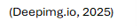

Blog 3: References

Chatterton, S. (2020). Devised from Pupil Preferences. Cambridge Educational Research e-Journal, [online] 7, pp.191–231. doi:https://doi.org/10.17863/CAM.58320.(Accessed: 9 December 2025).

Deepimg.io. (2025). Free Image to Image AI Generator: Convert Images Online. [online] Available at: https://deepimg.io/image-to-image-ai-generator/ [Accessed 6 Dec. 2025].

Hu, J. (2024). Operant Conditioning in Child Psychology: Understanding the Influence of Rewards and Punishments on... [online] ResearchGate. Available at: https://www.researchgate.net/publication/379916359_Operant_Conditioning_in_Child_Psychology_Understanding_the_Influence_of_Rewards_and_Punishments_on_Childrens_Behavior (Accessed: 9 December 2025).

McLeod, S. (2025). Operant conditioning: What it is, how it works, and examples. [online] Simply Psychology. Available at: https://www.simplypsychology.org/operant-conditioning.html. (Accessed: 8 December 2025).

McLeod, S. (2024). Vygotsky’s Theory of Cognitive Development. [online] ResearchGate. Available at: https://www.researchgate.net/publication/383395354_Vygotsky. (Accessed: 8 December 2025).

McLeod, S. (2025). Vygotsky’s sociocultural theory of cognitive development. [online] Simply Psychology. Available at: https://www.simplypsychology.org/vygotsky.html. (Accessed: 8 December 2025).

Ng’andu, K., Hambulo, F., Haambokoma, N. and Milingo, T. (2013). The contribution of behavioral theories of learning to education. [online] ResearchGate. Available at: https://www.researchgate.net/publication/341313372_The_Contribution_of_Behavioral_Theories_of_Learning_to_Education.(Accessed: 9 December 2025).

Pappas, C. (2014). Instructional Design Models and Theories: The Sociocultural Learning Theory. [online] eLearning Industry. Available at: https://elearningindustry.com/sociocultural-learning-theory. (Accessed: 9 December 2025).

Persike, C. (2023). The Dark Side of Rewards, Part 1: Why Incentives Do More Harm Than Good in the Classroom - Alliance Against Seclusion and Restraint. [online] endseclusion.org. Available at: https://endseclusion.org/2023/05/06/the-dark-side-of-rewards-why-incentives-do-more-harm-than-good-in-the-classroom/ (Accessed: 9 December 2025).

Rabbani, L., Alarabi, K., Alsalhi, N., and Almarashdi, H. (2023). EDUCATIONAL EXPERIENCE BEHAVIOURIST VS. CONSTRUCTIVIST VIEWS OF FEEDBACK: PROVISIONS AND IMPLICATIONS. [online] 36(01), pp.197–206. doi:https://doi.org/10.6035/artseduca.3612. (Accessed: 9 December 2025).

UNICEF (1989). UN convention on the rights of the child (UNCRC). [online] unicef. Available at: https://www.unicef.org.uk/what-we-do/un-convention-child-rights/ (Accessed: 9 December 2025).

Warren, C. (2023). Understanding and supporting children’s behaviour. [online] SEND Network. Available at: https://send-network.co.uk/posts/understanding-and-supporting-children-s-behaviour. (Accessed: 9 December 2025).

Weegar, M.A. and Pacis, D. (2012). A Comparison of Two Theories of Learning -- Behaviorism and Construct ivism as applied to Face-to-Face and On line Learning. [online] undefined. Available at: https://www.semanticscholar.org/paper/A-Comparison-of-Two-Theories-of-Learning-and-ivism-Weegar-Pacis/2cb0b3019f04cfbf790d0ed8fa39f603bcfa4f7e. (Accessed: 9 December 2025).

Williams, M. and Burden, R. (1997). Motivation in language learning : a social constructivist approach. Recherche et pratiques pédagogiques en langues de spécialité - Cahiers de l’APLIUT, 16(3), pp.19–27. doi:https://doi.org/10.3406/apliu.1997.1201. (Accessed: 9 December 2025).

Blog 4
Draw on experiences from your own setting to identify resources and strategies used to support effective teaching and learning, linking back to your chosen theories in Blogs 1 & 2

Marshmallow Madness: Learning theory meets Classroom Practice
Chantelle Fahey
13th December 2025
Thursday afternoon, in a chaotic, noisy science classroom, Dr Holmes assigned the students a task within groups of building structures using dried spaghetti, marshmallows and Sellotape, testing their strength with a fan replicating the force of a Hurricane (This terms topic). You’re probably thinking this sounds, messy, sticky, and a total disaster, but behind this chaos is actually a perfect example of how learning theory meets effective classroom practice.
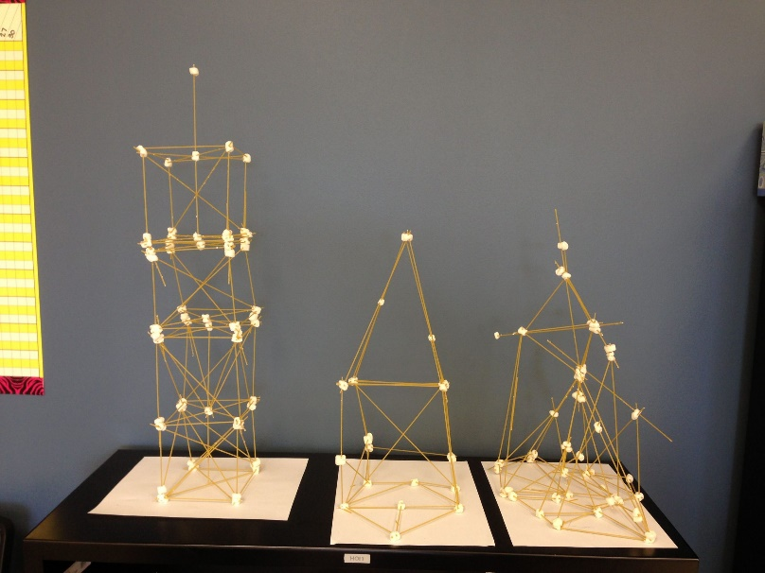
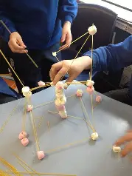

(Weebly.com, 2025)
(Lessonplanslearning.com, 2025)

Vygotsky’s Social side of the storm
Central to Vygotsky’s theory is the belief children learn in a social matrix through interactions with others (Gray and MacBlain, 2015). Let’s break this down for Dr Holmes:
- Collaborative learning can foster communication, various perspectives and mutual respect amongst diverse students (Kyriacou, 2009).
- The sharing of ideas and questioning from Dr Holmes can implement ‘Sustained shared thinking’ amongst learners enhancing higher level thinking, and challenging students beyond their comfort zone (Ray, 2025)

‘What do you think will make your tower sturdier?’
‘Why do you predict your hypothesis?’

- Access to chrome books, for students to research ideas, a WAGOLL demonstration Dr Holme’s created at the beginning of the lesson, verbal and visual prompts, along with a word bank on the board with terms such as ‘force’, ‘gravity’, ‘hypothesis’ can scaffold learners through their ZPD (McLeod, 2025),

Skinner’s Behavioural side of the storm
Central to Skinner’s theory is the belief children learn though response to stimuli such as reinforcement or punishment, known as ‘operant conditioning’ (McLeod, 2025). In Dr Holmes lesson:
- Continuous feedback, praise (from teachers and peers) and the issue of Positive Classroom points motivated students to engage in the task enhancing performance (Hu, 2024).
- For students whose tower collapsed, such response encouraged them to rethink and recreate their designs, though trial and error and persist through challenges (Williams and Burden, 1997).
- During the experiment, one student decided to start a marshmallow fight, which was short lived when Dr Holmes removed him from the experiment to write an essay on force. Such punishment, motivated other students to engage in positive behaviour through imitation (McLeod, 2025). However, it could be argued, such approach fails to look at the reasoning behind one’s actions, preventing the chance of improvement (Rabbani, 2023).

What makes it effective learning and teaching?
Effective teaching includes giving clear explanations, maintaining class focus, offering a variety of learning activities, keeping momentum, encouraging participation, quickly meeting students' needs, monitoring progress, providing constructive feedback, and facilitating experiential and discovery-based tasks that encourage long-term shared thinking, independence, creativity and meaningful learning experiences built on previous knowledge (Kyriacou, 2009; Pollard et. al 2014).

Dr. Holmes's students were really interested and motivated from within. They wanted to know more. Some students even asked questions to start conversations, including

"Have you ever been in a hurricane?
What would you do if you were?"

This level of focus and concentration on a task is called Csikszentmihalyi’s ‘state of flow" (Wainwright et al., 2019).

Experiential learning theory is central to this and supports Vygotsky's notion. Leavers (2000) suggested that profound learning transpires inside the students' Zone of Proximal Development (ZPD). He goes on to say that a rich environment with scaffolding can lead to deep engagement and good mental health. Involvement correlates with motivation and intrigue, resulting in a more profound and intense learning experience (Laevers, 2000).

Some scholars believe that memory is the residue of thought, and that developing tasks that engage students to think about subject matter in an interesting way boosts their capacity to remember it (Bates, 2015).

(Deepimg.io, 2025)

Welsh Government & Policy approval
Dr Holme’s marshmallow mayhem implemented rights-respected practice underpinned by the UNCRC (1989):
- Article 12: Students can express their own thoughts and suggestions about design decisions through the experiment.
- Article 13: Students were urged to express themselves in a creative and scientific manner.
- Article 29: Students' personalities, skills, and talents were developed as a result of the work.

Additionally, Dr Holmes implemented many of the pedagogical principles of good teaching and learning underpinning the Welsh Curriculum (Donaldson, 2015). For instance:
- He used a variety of teaching techniques supported by the theories of Vygotsky and Skinner.
- He taught a session that reinforced topics from multiple subject areas, such as geography, science, expressive arts, D&T, reading, and digital competency.
- He supported autonomy.
- He expanded on knowledge from earlier lessons.
- He encouraged problem-solving and critical thinking.
- He promoted collaboration.

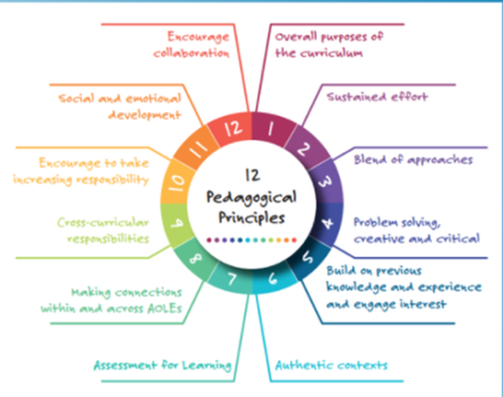

(PANT Y RHEDYN,
2024)

What started out as a frantic Thursday afternoon turned into a profoundly educational encounter. So next time you see marshmallows and pasta see theory in action! Whether you work as a Skinnerian sticker dealer or a Vygotskian scaffolder, the goal is ultimately is to create something stronger than marshmallow towers—that is, to build students' minds.

Blog 4: References
Bates, B. (2015). Learning Theories Simplified. SAGE.

Deepimg.io. (2025). Free AI Image Generator: Convert Text to Image Online. [online] Available at: https://deepimg.io/ai-image-generator/. (Accessed: 12 December 2025).

Donaldson, G. (2015). Successful Futures Independent Review of Curriculum and Assessment Arrangements in Wales. [online] Available at: https://www.gov.wales/sites/default/files/publications/2018-03/successful-futures.pdf. (Accessed: 12 December 2025).

Gray, C. and MacBlain, S. (2015). Learning Theories in Childhood. 2nd ed. SAGE.

Hu, J. (2024). Operant Conditioning in Child Psychology: Understanding the Influence of Rewards and Punishments on... [online] ResearchGate. Available at: https://www.researchgate.net/publication/379916359_Operant_Conditioning_in_Child_Psychology_Understanding_the_Influence_of_Rewards_and_Punishments_on_Childrens_Behavior (Accessed: 12 December 2025).

Kyriacou, C. (2009). Effective Teaching in Schools. Oxford University Press, USA.

Laevers, F. (2000). Forward to Basics! Deep‐Level‐Learning and the Experiential Approach. Early Years, 20(2), pp.20–29. doi:https://doi.org/10.1080/0957514000200203. (Accessed: 12December 2025).

Lessonplanslearning.com. (2025). Available at: https://lessonplanslearning.com/wp-content/uploads/2020/05/marshmallow-towers-to-build-teamwork-among-students-scaled.jpg (Accessed 11 Dec. 2025).

Pollard, A., Black-Hawkins, K., Gabrielle Cliff Hodges, Dudley, P., James, M., Linklater, H., Swaffield, S., Swann, M., Turner, F., Warwick, P., Winterbottom, M. and Mary Anne Wolpert (2014). Reflective Teaching in Schools. 4th ed. A&C Black.

McLeod, S. (2025). Operant conditioning: What it is, how it works, and examples. [online] Simply Psychology. Available at: https://www.simplypsychology.org/operant-conditioning.html. (Accessed: 12 December 2025).

McLeod, S. (2025). Vygotsky’s sociocultural theory of cognitive development. [online] Simply Psychology. Available at: https://www.simplypsychology.org/vygotsky.html. (Accessed: 12 December 2025).

PANT Y RHEDYN. (2024). Y CWRICWLWM/THE CURRICULUM. [online] Available at: https://pantyrhedyn.weebly.com/y-cwricwlwmthe-curriculum.html. (Accessed: 12 December 2025).

Rabbani, L., Alarabi, K., Alsalhi, N., and Almarashdi, H. (2023). EDUCATIONAL EXPERIENCE BEHAVIOURIST VS. CONSTRUCTIVIST VIEWS OF FEEDBACK: PROVISIONS AND IMPLICATIONS. [online] 36(01), pp.197–206. doi:https://doi.org/10.6035/artseduca.3612. (Accessed: 13 December 2025).

Ray, N (2025). Unlocking Deeper Learning: A Guide to Asking Questions Using Bloom’s Taxonomy. [online] Edu.com. Available at: https://www.edu.com/blog/unlocking-deeper-learning-a-guide-to-asking-questions-using-bloom-s-taxonomy [Accessed 12 Dec. 2025].

UNICEF (1989). UN convention on the rights of the child (UNCRC). [online] unicef. Available at: https://www.unicef.org.uk/what-we-do/un-convention-child-rights/ (Accessed: 12 December 2025).

Wainwright, N., Goodway, J., Whitehead, M., Williams, A. and Kirk, D. (2019). Playful pedagogy for deeper learning: exploring the implementation of the play-based foundation phase in Wales. Early Child Development and Care, 190(1), pp.43–53. doi:https://doi.org/10.1080/03004430.2019.1653551. (Accessed: 12 December 2025).

Weebly.com. (2025). Available at: https://harakeke2013.weebly.com/uploads/1/7/4/8/17482969/544356_orig.jpg (Accessed 11 Dec. 2025).

Williams, M. and Burden, R. (1997). Motivation in language learning : a social constructivist approach. Recherche et pratiques pédagogiques en langues de spécialité - Cahiers de l’APLIUT, 16(3), pp.19–27. doi:https://doi.org/10.3406/apliu.1997.1201. (Accessed: 12 December 2025).

